DEVELOPING EMOTIONAL INTELLIGENCE SKILLS FOR THE WORKPLACE

Title: Why building an emotionally intelligent workforce should be a business priority in this current volatile economic environment and how employers can train and develop their existing staff to make them an emotionally intelligent workforce?

Student : Ana Maria Stanciu 2018244
Module : BMSW6106
Lecturer: Amare Desta
Executive Summary
This report aims to focus on the development of emotional intelligence and its importance in analysing the need for workplace requirements to be able to perform better. The report has highlighted the application of several theories with the main focus on providing support to their employees to increase the rise of productivity. Communication and training are the key works of that theory to enhance the opportunity of the business via skill development of the employees. The individual’s needs have been evaluated through the model to enhance the engagement ratio. Apart from that, different theoretical models associated with emotional intelligence have also been evaluated in this secretion of the report along with their application in a detailed manner altogether. Moreover, a few recommendations have also been given in this section of the report that any individual can take in order to enhance the overall emotional intelligence quotient.
Table of Contents
Task 1: Individual report 4
Introduction 4
a) Background of the organisation 4
b) Illustrate the key models of emotional intelligence 4
c) Application of emotional intelligence 8
d) Models of emotional intelligence 11
e) Recommendations to better the systems and processes that may enable better collaboration and connectedness between people 14
Conclusion 15
Task 2: Poster 16
Introduction 16
Reflection on own emotional intelligence 16
How to use or reason out about my own emotion(s) 17
Explore how to improve and capitalise on your own emotional intelligence or EI. 18
Conclusion 19
References 21
Appendix 23

Task 1: Individual report

Introduction
As stated by Kanesan and Fauzan (2019), emotional intelligence can be considered as the ability to manage both emotions and understanding at the same time to make effective decisions while socialising with people. There are multiple key elements associated with emotional intelligence such as self-awareness, self-regulation, motivation, empathy and social skills which are very critical in analysing the needs of a person. The following report will highlight different aspects associated with emotional intelligence and its importance in defining strong characteristics while in the workplace. Apart from that, different theories associated with emotional intelligence along with their application have also been elaborated in this report as well for a better understanding of the topic.

a) Background of the organisation
As opined by Kotsou et al., (2019, p. 160), Delloite is a British multinational professional software service network firm which is considered to be one of the largest brands in this scape across the whole globe in terms of revenue margin. Most importantly, it comes within the big four accounting firms alongside EY, KPMG and PwC. Having said that, the company was established back in 1845 which is almost 178 years ago with its headquarters situated in London, England. The company is situated in 79 countries across various continents. As per reports, the company was able to generate a revenue margin of $59.3 billion during the financial year 2022. Primary key services that the company provides to its consumers are audit, software intelligence, consulting, financial advisory, data security, inventory management and risk management. As of today, the company has a total employee base of almost 415,000 individuals all across the globe.

Figure 1: Official Logo of Delloite
(Source: deloitte.com, 2023)

b) Illustrate the key models of emotional intelligence
Ability model
As proposed by Goleman (2021), the ability model is mainly a type of emotional intelligence theory that talks about emotion being a useful source of information that helps in making effective decisions and navigating social environments. As per this model, people may be different in their ability to process emotional information and their ability to connect emotionally while socialising. According to this particular model, emotional intelligence mainly consists of four types of abilities such as detecting emotions through faces, harnessing or facilitating emotions, emotional literacy and emotional management. Perceiving emotion is a fundamental aspect of emotional intelligence as it allows all other types of emotional processing.
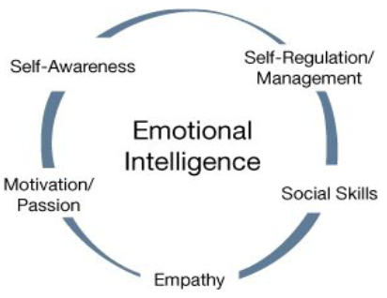
Figure 2: Ability model of Emotional Intelligence
(Source: insidehr.com.au, 2023)
Apart from that this model also talks about the importance of using different emotions to help with various cognitive activities like thinking and problem-solving to be able to make effective decisions while working in the workplace. After the recent pandemic, having different soft skills such as emotional intelligence has been very much in demand than ever before. As per this theory, employees having more emotional intelligence are considered to more agile and much better during business survival. Having said that working in a company like Delloite requires a lot of emotional intelligence aspects as it eventually leads to enhancement of intelligence quotient or IQ.
Trait model
According to Drigas and Papoutsi (2018, p. 45), the trait model of emotional intelligence talks about a set of emotional self-perceptions that are important in personality hierarchy which eventually measures how emotionally intelligent a person is while making different decisions. As per this theory, emotional intelligence is a trait that must be investigated within the context of the personality framework to analyse how much intelligence a person holds in order to make social interactions with others. According to this theory, the definition of emotional intelligence includes behavioural tendencies and self-perceived ability which refers to the cognitive abilities for controlling understanding and emotion while interacting with someone.
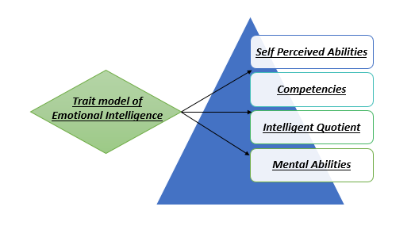
Figure 3: Trait model of emotional intelligence
(Source: Self-created)
While working within the workplace, the extent or strength of one's belief in the ability of an individual to complete tasks and achieve goals is known as self-efficacy. The trait model firmly believes that emotional intelligence from an individual perspective is inherently subjective and eventually gets influenced by competencies, mental abilities and critical thinking while working within a workplace like Delloite. Being in a multinational organisation that only deals with modern cutting-edge technology, it is important for a person to be emotionally strong and competitive so that establishing a secure position within the workplace can become much easier.
Mixed model
Goleman's Performance Model
As per Schuller (2018, p. 40), Goleman’s performance management model is a mixed-formed emotional intelligence framework that talks about emotional intelligence being a potential competency that includes self-awareness, self-regulation, social ability, empathy and motivation. As per this theory, emotional competencies are considered to be learned capabilities that should be nourished on a constant basis in order to achieve exceptional performance. While working in a multinational organisation like Delloite, the emotional capital from an individual’s perspective should be taken seriously as it eventually influences the performance at work, the well-being of an individual and social cohesion which are important elements in social interaction.
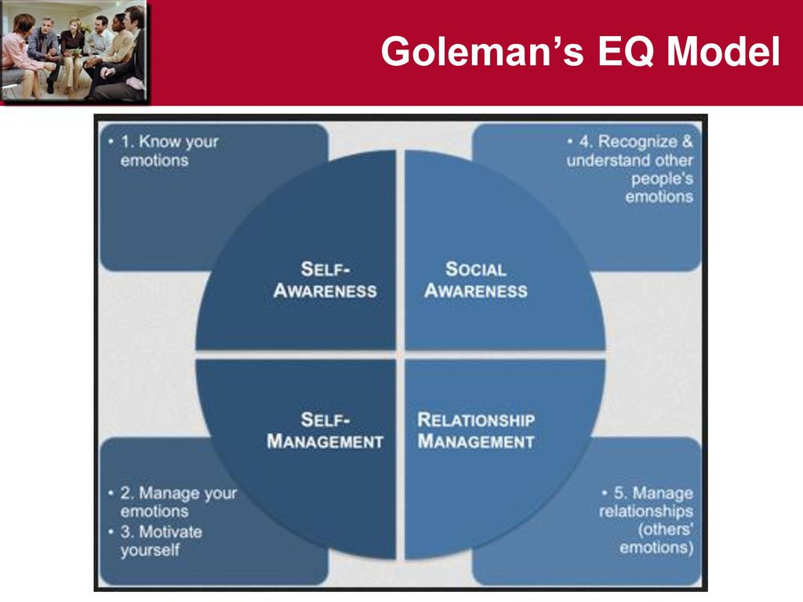
Figure 4: Goleman's Performance Model of Emotional Intelligence
(Source: slideplayer.com, 2023)
Based on these attributes the intelligence quotient of an individual gets derived which is considered to be the most important element while working within a workplace. Additionally, a company like Deloitte is all about managing technological advancement in order to provide the best-suited business solutions to clients. Thus, emotional intelligence as well as intelligence quotient is very important to be able to use creativity as well as improvisation in order to do a task in a proficient manner.
Bar-On's Model
As per the views of Hodzic et al., (2018, p, 140), Bar-On's model of emotional intelligence is mainly a mixed form of emotional intelligence theory that is widely recognised as a framework for assessing emotional and social functioning. The role of both emotional and social characteristics is very important for the psychological well-being and success of an individual while being in a workplace. As per this theory, a total of five domains of emotional intelligence are there such as interpersonal domain, intrapersonal domain, adaptability domain, stress management domain and general mood domain which perfectly demonstrates the understanding and emotional aspects of an individual in order to make decisions in case of social interaction.
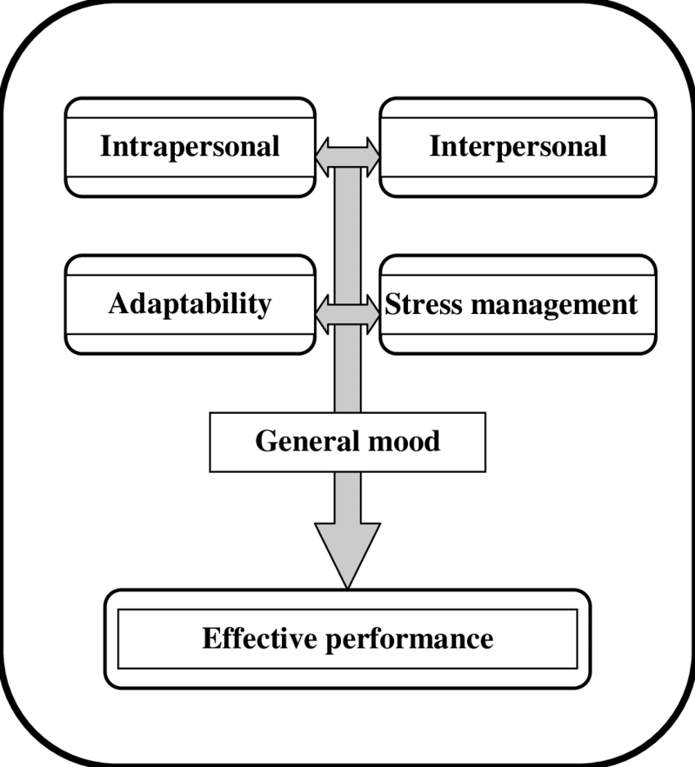
Figure 5: Bar-On's Model of Emotional Intelligence
(Source: insidehr.com.au, 2023)
Additionally, self-perception, emotional awareness and self-regard are considered to be some of the crucial factors that influence overall decision-making as well as the intelligence quotient portion of an individual through emotional intelligence. Most importantly, according to this theory, while working in an organisation like Deloitte, empathy, social responsibility, flexibility, problem-solving, optimism and self-actualization are the most important traits that one should be looking at to be able to create a sustainable position within the corporate culture of the company. This particular theory emphasises the emotional and social functions of an individual that is involved with psychological well-being and success which is an important aspect of being socially happy.

c) Application of emotional intelligence
Analyse the importance of developing emotional intelligence in the workplace
Developing emotional intelligence has become one of the most crucial elements that make an individual strong enough to deal with different external situations that can potentially hamper the intelligence quotient. Most importantly, being in a workplace like Deloitte, one should be emphatic enough to deal with different emotional aspects of work life so that collaboration can become much faster as far as the working is concerned. Similarly, after the recently concluded pandemic, different soft skills like emotional intelligence have become inevitable which makes an individual agile enough to perform accurately for the overall betterment of the organisation. Additionally, there are multiple key importance associated with implementing emotional intelligence within the work of Deloitte which will be demonstrated further.
Better collaboration and communication between people
Controlling emotional intelligence is all about improving the overall collaboration as well as communication between different individuals working within a workplace. Having said that, as per Bar-On’s model of emotional intelligence, self-perception, emotional awareness and self-regard are some of the most crucial factors that help an individual in assessing the requirements of intelligence quotient. Thus, it can be said that with improved emotional intelligence as per the above-concluded models, the collaboration between different individuals can be enhanced up to a large scale which eventually enhances the overall productivity for a company like Deloitte which operates within the technological segment of an industry. Hence, for the enhancement of productivity which has become very crucial after the pandemic, emotional intelligence has been one of such key elements that define a person and whether that individual would become successful in the long run or not.
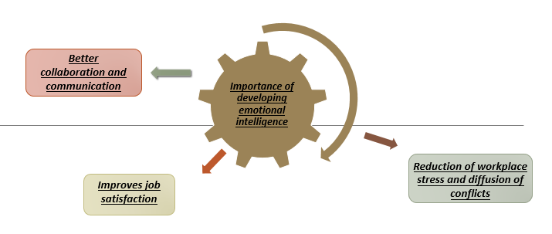
Figure 6: Importance of developing emotional intelligence in the workplace
(Source: Self-created)
Reduction of workplace stress and diffusion of conflicts
As stated by Mattingly and Kraiger (2019, p. 150), reduction of workplace stress should be the top priority for any employee to remain competitive while working for an organisation like Delloite. As per Goleman’s performance model, self-awareness, self-regulation, social ability, empathy and motivation are some of the key elements that get directly involved with the emotional intelligence aspect of an individual. Having said that, controlling workplace stress through awareness and social regulation an individual can significantly decrease workplace stress up to a certain extent. Most importantly, the way communication happens, if the stress margin gets reduced, can ultimately help in defusing the conflicts among the employees of an organisation. This helps in assessing the needs of an organisation like Deloitte so that productivity can be enhanced eventually. Thus, it can be said that the reduction of workplace stress and diffusion of conflict are two of the most required aspects that can be controlled with the hope of regulating the emotional intelligence of different individuals.
Improves job satisfaction
The job satisfaction level of an individual directly depends on the working environment of a workplace which can get better if communication takes place accurately and there remain no conflicts between different individuals. Having said that, job satisfaction is an important element that primarily improves the motivation level of employees which helps in enhancing the overall productivity from an organisational perspective. Similarly, the way emotional intelligence can influence the overall understanding of an individual also determines how the person would behave with others while working. As per the above-depicted models, different elements associated with emotional intelligence are equally important in maintaining the understanding and emotional status of an individual while making any decision in case of workplace interaction. Moreover, for a company like Deloitte, it can be referred to as the most important element that should be looked after very carefully to enhance its overall revenue margin to remain competitive in the long run.
Illustrate the relationship between emotional intelligence, effective management communication and business advantage
As per the views of Kant (2019, p. 446), emotional intelligence and effective management communication are important in assessing business needs up to a large extent. Having said that, controlling the emotional intelligence aspects can eventually result in better communication and collaboration between different individuals working within a workplace in that scenario no conflict would take place at all. Hence, it can be said that the importance of emotional intelligence holds an important role in assessing the importance of culture in providing opportunities to different individuals. Post-COVID-19 Covid maintaining productivity was the most crucial element as businesses were struggling to manage the profit margin as a whole. Having said that, Deloitte is an organisation that operates within the technical segment of the industry which requires effective communication and collaboration to become a successful one in terms of revenue.
As per the above-mentioned theory, the employee can be able to become self-aware, self-regulated, socially able, empathetic and motivated all the time then the decision-making in the business can become much easier to some extent. All of these would eventually help the organisation in managing the overall collaborative approach with every single person by managing the conflict in a prominent manner. For example, if there is any kind of contradiction between decision-making occurs within the workplace of Deloitte, controlling emotional intelligence would become much more helpful in managing the workplace activity. Thus, it can be stated that managing the workplace culture would require certain aspects associated with both emotional intelligence as well as business understanding so that conflict between all individuals can be minimised between each other. Hence, from all of these, it can be said that emotional intelligence and business management communication are interrelated to each other which is an essential element in making business decisions for having a competitive advantage over others.

d) Models of emotional intelligence
Critical evaluation of the model
Ability Model
After the epidemic situation, Deloitte will use the ability to help its staff become more emotionally intelligent. With this strategic initiative, the Deloitte workforce will be better prepared to handle the rapidly changing nature of remote working and shifting workplace dynamics. According to Zhang and Xi, (2021, p. 200), employees will take part in workshops and especially specialised training programmes that highlight effective communication, empathy and self-awareness through the use of this Ability model. It would be important to monitor advancement and make constant improvements to the program. These endeavours will be evaluations and feedback loops. The dedication of Deloitte to improving the emotional intelligence of its staff will be crucial in assuring the success of its workers and the company's capacity to provide value to customers in a constantly shifting business environment.
Trait Model
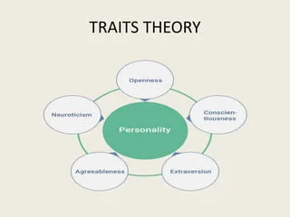
Figure 7: Traits Theory
(Source: Slideshare.net, 2023)
As per Lee and Wong (2019, p. 855), in the future, Deloitte will use the Trait model to help its employees become more emotionally intelligent. Deloitte hopes to develop a more staff-centric approach by putting this concept into practice, which will strengthen relationships and provide a deeper comprehension of the requirements and feelings of their clients. As part of this project, Deloitte's staff-facing teams would get specialised training in emotional intelligence, which would help them relate to customers more deeply, comprehend their issues, and respond to them with empathy. According to Gómez-Leal et al., (2022, p. 20), this kind of strategy would increase customer loyalty and happiness. Deloitte will continuously improve its efforts by adjusting to the dynamic and ever-changing landscape of employees' expectations and emotional interactions through continuous assessments and feedback methods. Deloitte's dedication to improving the emotional intelligence of its customer-facing staff members will surely add to its position as an acknowledged expert and partner in the industry as the business environment grows more and more customer-driven.
Mixed model (Goleman's Performance Model, Bar-On's Model)
In the years to come, Deloitte should think about implementing a hybrid model that combines components of Bar-On's and Goleman's performance models to improve the emotional intelligence of its staff. Deloitte would be able to develop a comprehensive programme that covers the internal and external components of emotional intelligence thanks to this holistic approach. Goleman's emphasis on individual competencies and Bar-On's emphasis on social and personal well-being would be combined by Deloitte to create a comprehensive framework that would help staff members gain a better knowledge of their emotions and interpersonal abilities. The opinion of Singh et al., (2022, p. 2258) this would produce a workforce that is more emotionally knowledgeable, better able to control their emotions, and able to build deeper connections with clients. The Mixed model would include customised training, tools for self-evaluation, and continuous assistance to make sure that workers improved their emotional intelligence and performed better overall. Deloitte would gain an advantage over its clients by being recognised as a pioneer in developing emotional intelligence in its personnel as a result of its dedication to this strategy.
Illustrate the extent to which they are appropriate in meeting the development needs of the individual
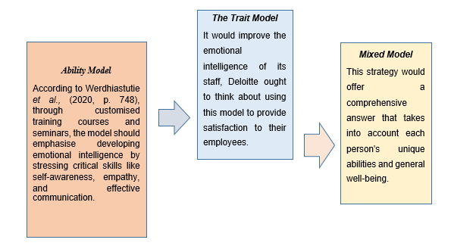
Figure 8: The process of meeting the development needs
(Source: Self-Developed)
Ability Model to meet the development needs of individuals
As per Prentice et al., (2020, p. 410), the ability model would be a perfect fit for addressing each person’s development needs. It ought to be put into practice in the future to give Deloitte employees the fundamental abilities needed to navigate the dynamic and constantly shifting business environment. According to Werdhiastutie et al., (2020, p. 748), through customised training courses and seminars, the model should emphasise developing emotional intelligence by stressing critical skills like self-awareness, empathy, and effective communication. This strategy would enable Deloitte staff members to have a deeper understanding of their feelings as well as those of their clients and co-workers. They would be able to enhance teamwork, forge closer bonds with one another, and deliver top-notch customer service. By emphasising ability-based growth, Deloitte would cultivate an environment that encourages emotional intelligence, leading to more resilient, engaged, and adaptive workers who can flourish in their positions and contribute to the long-term success of the organisation.
The Trait Model to meet the development needs of individuals
The process of meeting the specific development needs of Deloitte employees in the future would be a great fit for the Trait model. It would improve the emotional intelligence of its staff, Deloitte ought to think about using this model to provide satisfaction to their employees. Emotional intelligence is derived from a variety of qualities, including empathy, flexibility and self-awareness, all of which are strongly emphasised in the approach. Deloitte would enable its staff to learn and enhance these fundamental emotional competencies by creating development programs that integrate the Traits model. A workforce that is more self-aware, sympathetic and flexible would result from this approach and success in a fast-paced work environment is contingent upon it (Eccles and Wigfield, 2020). Deloitte would give staff members the tools they need to hone these qualities via a combination of instruction, self-assessment instruments and continuity assistance. This strategy would contribute to long-term success continuing the staff members as well as the company by assisting workers in excellent positions, cultivating great client relationships and improving their general wellbeing.
Mixed Model to meet the development needs of individuals (Goleman's Performance Model, Bar-On's Model)
Deloitte organisation to effectively handle the development needs of its workers, a Mixed Model integrating components from Bar-On's Model and Goleman's Performance Model should be implemented. This strategy would offer a comprehensive answer that takes into account each person's unique abilities and general well-being. Deloitte would prioritise developing social skills, self-awareness, and empathy in line with Goleman's model, as well as emotional balance, stress reduction, and adaptability in line with Bar-On's model. Deloitte would enable its staff to acquire a broad range of emotional intelligence skills which are essential for both personal and professional development by providing a thorough approach. Deloitte would establish an atmosphere where workers can flourish through individualised training, evaluations, feedback, and support systems, improving client interactions, career advancement, and general well-being.

e) Recommendations to better the systems and processes that may enable better collaboration and connectedness between people
Organising knowledge & skill enhancement workshops
Better collaboration and connectedness between people for implementing company values to high EQ behaviours requires proper communication between each other so that effective coordination can take place in an effective manner altogether. For this, it is highly recommended that an organisation career development workshop would eventually help the employees to communicate with each other in an efficient manner in order to up skill their knowledge. For this, it can be said that system arrangements regarding skill development can be a crucial element in analysing the requirements of the workforce. Moreover, it would also help the organisation manage its overall productivity by enhancing the employee engagement level up to a certain extent. For a company like Deloitte, managing the workplace culture through organising seminars and workshops would eventually help in analysing the needs of the employees so that they are able to coordinate more with each other in order to enhance their own development to remain competitive in the long run.
Arranging feedback sessions for employees in case of business decision-making
As per Papoutsi et al., (2021, p. 50), involving employees more in business decision-making can eventually help in employee engagement up to a certain extent. Most importantly, asking employees about their requirements would make them feel important which also enhances the collaborative nature from their perspectives. Emotional intelligence, as well as managerial communication, can be referred to as an important element that requires effective collaboration to enhance the overall understanding and coordination for the overall betterment of an organisation in the long run. For Deloitte, it would be very much required that they arrange career development workshops as well as different feedback sessions for their employee in order to take decisions from their perspective so that achieving better collaboration and communication post-pandemic period become much easier up to a large extent.
Communication strategy
The company would focus on an effective communication strategy to maintain sustainability in the working environment. Through the process of communication, the management could easily support their employees and for that effect, the productivity also rises in the company. Through the process of effective communication, the completed situation in the work field would dissolve and the aim of the company would be easily fulfilled via this process (Ma et al., 2020, p. 90). Effective communication would also help to address the employee’s point of view which would help to increase the business opportunity typo enhance the profit outcome ratio.

Conclusion
The above-concluded report has illustrated different aspects associated with emotional intelligence and its importance while working in a workplace. During the post-pandemic period, the work climate demanded soft skills like emotional intelligence to remain competitive while working within a workplace. Having said that, emotional intelligence can be referred to as the combination of emotional as well as social skills that generally influence a person's overall capacity to cope effectively with different external situations. Analysing the needs of different individuals is very important to determine how much intelligence quotient a person holds. Moreover, a few recommendations have also been given in this section of the report that can help an individual in managing both emotions and understanding while working in a workplace. Further, different important theories and farmworkers associated with emotional intelligence have also been mentioned in this section of the report as well which perfectly denotes how this particular attribute is required for a person to become successful in the corporate world.

Task 2: Poster

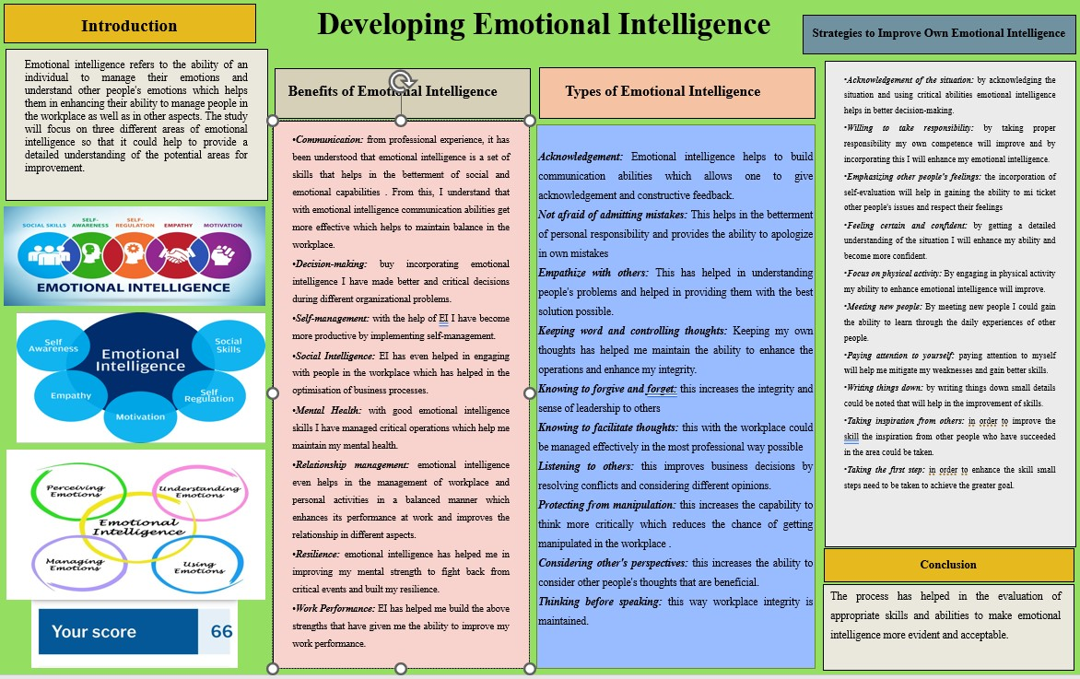

References
Task 1
deloitte.com, 2023. deloitte. [Online] Available at: https://www2.deloitte.com/us/en.html
Drigas, A.S. and Papoutsi, C., 2018. A new layered model on emotional intelligence. Behavioral sciences, 8(5), p.45. https://www.mdpi.com/2076-328X/8/5/45
Eccles, J.S. and Wigfield, A., 2020. From expectancy-value theory to situated expectancy-value theory: A developmental, social cognitive, and sociocultural perspective on motivation. Contemporary educational psychology, 61, p.101859. https://www.sciencedirect.com/science/article/am/pii/S0361476X20300242
Goleman, D., 2021. Leadership: The power of emotional intelligence. More than Sound LLC. http://dspace.vnbrims.org:13000/jspui/bitstream/123456789/4733/1/Leadership%20The%20Power%20of%20Emotional%20Intellegence.pdf
Gómez-Leal, R., Holzer, A.A., Bradley, C., Fernández-Berrocal, P. and Patti, J., 2022. The relationship between emotional intelligence and leadership in school leaders: A systematic review. Cambridge Journal of Education, 52(1), pp.1-21. https://www.researchgate.net/profile/Janet-Patti/publication/352409286_The_relationship_between_emotional_intelligence_and_leadership_in_school_leaders_a_systematic_review/links/6126691fb266254415a6fdc5/The-relationship-between-emotional-intelligence-and-leadership-in-school-leaders-a-systematic-review.pdf
Hodzic, S., Scharfen, J., Ripoll, P., Holling, H. and Zenasni, F., 2018. How efficient are emotional intelligence trainings: A meta-analysis. Emotion Review, 10(2), pp.138-148. https://journals.sagepub.com/doi/abs/10.1177/1754073917708613
insidehr.com.au, 2023. Emotional Intelligence. [Online] Available at: https://www.insidehr.com.au/an-emotionally-intelligent-workforce/
Kanesan, P. and Fauzan, N., 2019. MODELS OF EMOTIONAL INTELLIGENCE: A REVIEW. e-BANGI Journal, 16(7). http://journalarticle.ukm.my/20058/1/34511-107724-1-SM.pdf
Kant, R., 2019. Emotional intelligence: A study on university students. Journal of Education and Learning (EduLearn), 13(4), pp.441-446. http://edulearn.intelektual.org/index.php/EduLearn/article/view/13592
Kotsou, I., Mikolajczak, M., Heeren, A., Grégoire, J. and Leys, C., 2019. Improving emotional intelligence: A systematic review of existing work and future challenges. Emotion Review, 11(2), pp.151-165. https://journals.sagepub.com/doi/abs/10.1177/1754073917735902
Lee, C. and Wong, C.S., 2019. The effect of team emotional intelligence on team process and effectiveness. Journal of Management & Organization, 25(6), pp.844-859. https://www.cambridge.org/core/journals/journal-of-management-and-organization/article/effect-of-team-emotional-intelligence-on-team-process-and-effectiveness/DA8E000DE53658F3524931439E58D7F0
Ma, D., Shlezinger, N., Huang, T., Liu, Y. and Eldar, Y.C., 2020. Joint radar-communication strategies for autonomous vehicles: Combining two key automotive technologies. IEEE signal processing magazine, 37(4), pp.85-97. https://arxiv.org/pdf/1909.01729
Mattingly, V. and Kraiger, K., 2019. Can emotional intelligence be trained? A meta-analytical investigation. Human Resource Management Review, 29(2), pp.140-155. https://www.sciencedirect.com/science/article/pii/S1053482218301840
Papoutsi, C., Drigas, A. and Skianis, C., 2021. Virtual and augmented reality for developing emotional intelligence skills. Int. J. Recent Contrib. Eng. Sci. IT (IJES), 9(3), pp.35-53. https://pdfs.semanticscholar.org/cd7a/8b0f6853fab7fa4ad47a926a91712a9a802d.pdf
Prentice, C., Dominique Lopes, S. and Wang, X., 2020. Emotional intelligence or artificial intelligence–an employee perspective. Journal of Hospitality Marketing & Management, 29(4), pp.377-413. https://www.tandfonline.com/doi/abs/10.1080/19368623.2019.1647124
Schuller, D. and Schuller, B.W., 2018. The age of artificial emotional intelligence. Computer, 51(9), pp.38-46. https://ieeexplore.ieee.org/abstract/document/8481266/
Singh, A., Prabhakar, R. and Kiran, J.S., 2022. Emotional Intelligence: A Literature Review Of Its Concept, Models, And Measures. Journal of Positive School Psychology, 6(10), pp.2254-2275. https://journalppw.com/index.php/jpsp/article/download/13616/8820
Slideshare.net, 2023. Traits theory, its contributions and its limitations to predict human differences (no date) PPT. Available at: https://www.slideshare.net/BernardAhThauTan/traits-theory-its-contributions-and-its-limitations-to-predict-human-differences (Accessed: 01 November 2023).
Werdhiastutie, A., Suhariadi, F. and Partiwi, S.G., 2020. Achievement motivation as antecedents of quality improvement of organizational human resources. Budapest International Research and Critics Institute-Journal (BIRCI-Journal) Volume, 3, pp.747-752. https://pdfs.semanticscholar.org/8bd0/8806b8509359e02b0ecf4a903995fa7a8fb6.pdf
Zhang, F. and Xi, L., 2021. An evaluation model for the innovation and entrepreneurship thinking ability of college students based on neural network. International Journal of Emerging Technologies in Learning (iJET), 16(2), pp.188-204. https://www.learntechlib.org/p/218932/article_218932.pdf

