DATABASE MANAGEMENT SYSTEMS
Vet Clinics
“Pet Care”
Polina Tomova
Student ID 1813109
Renuga Jayakumar

Table of contents

- Creating tables, primary and foreign keys …………………………… 3
- Creating quieries ………………………………………………………….. 3
- APPENDIX ………………………………………………………………….. 5

- Creating tables, primary and foreign keys
Vet Clinics “ Pet Care” is a company that has several locations in East, West, North, South UK. Its required to create the appropriate tables and fill them with the required information.
For creating the tables in the database we use “CREATE TABLE “tablename” statement. To fill the tables with information we use the statement “INSERT INTO “Tablename(entities)” VALUES”. While filling the information we have to be careful of what data type we use.
We have to produce the correct PRIMARY and FOREIGN KEYS for the appropriate tables.
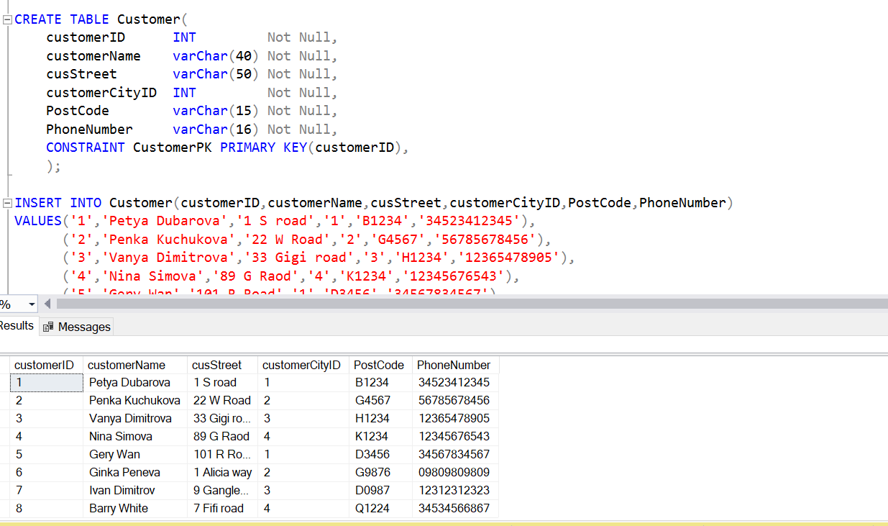

- Creating quieries

In our database we can create a report and check for example how
many patients were cats.
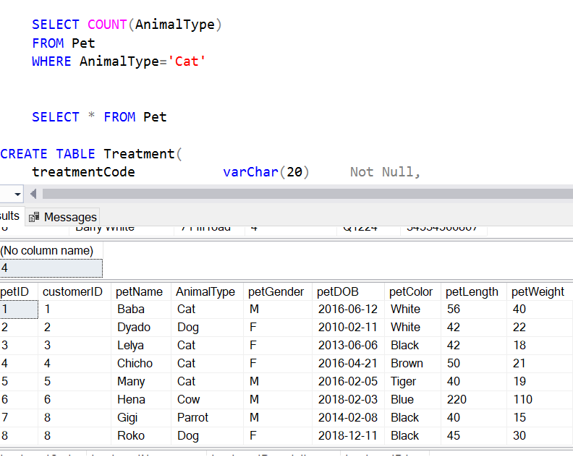

- APPENDIX

CREATE DATABASE PetCare;
BEGIN TRANSACTION
CREATE TABLE Region(
regionID INT Not Null,
regionName varChar(30) Not Null,
CONSTRAINT RegionPK PRIMARY KEY(regionID)
);

INSERT INTO Region(regionID,regionName)
VALUES('1','East'),
('2','West'),
('3','North'),
('4','South');

SELECT * FROM Region

CREATE TABLE City(
cityID INT Not Null,
cityName varChar(30) Not Null,
regionID INT Not Null,
CONSTRAINT CityPK PRIMARY KEY(cityID),
CONSTRAINT regiondIDFK FOREIGN KEY(regionID) REFERENCES Region(regionID)
);

INSERT INTO City(cityID,cityName,regionID)
VALUES('1','London','1'),
('2','Cardiff','2'),
('3','Manchester','3'),
('4','South Hampton','4');

SELECT * FROM City

CREATE TABLE VetClinic(
clinicNO INT Not Null,
clinicName varChar(30) Not Null,
clinicAddress varChar(60) Not Null,
cityID INT Not Null,
postcode varChar(15) Not Null,
telNo INT Not Null,
openMonFri varChar(20) Not Null,
openSat varChar(20) Not Null,
openSun varChar(20) Not Null,
CONSTRAINT VetClinicPK PRIMARY KEY(clinicNo),
CONSTRAINT cityIDFK FOREIGN KEY(cityID) REFERENCES City(cityID)
);

INSERT INTO VetClinic(clinicNO,clinicName,clinicAddress,cityID,postcode,telNo,openMonFri,openSat,openSun)
VALUES('1','PetCare1','Langley road','1','A123','23309778901','9-6','10-5','10-1'),
('2','PetCare2','Baster road','2','B123','23456789012','9-6','10-5','10-1'),
('3','PetCare3','Bibi road','3','C123','34567890123','9-6','10-5','10-3'),
('4','PetCare4','Kinley road','4','D123','45678901234','9-6','10-5','Closed');

SELECT * FROM VetClinic

CREATE TABLE Customer(
customerID INT Not Null,
customerName varChar(40) Not Null,
cusStreet varChar(50) Not Null,
customerCityID INT Not Null,
PostCode varChar(15) Not Null,
PhoneNumber varChar(16) Not Null,
CONSTRAINT CustomerPK PRIMARY KEY(customerID),
);

INSERT INTO Customer(customerID,customerName,cusStreet,customerCityID,PostCode,PhoneNumber)
VALUES('1','Petya Dubarova','1 S road','1','B1234','34523412345'),
('2','Penka Kuchukova','22 W Road','2','G4567','56785678456'),
('3','Vanya Dimitrova','33 Gigi road','3','H1234','12365478905'),
('4','Nina Simova','89 G Raod','4','K1234','12345676543'),
('5','Gery Wan','101 R Road','1','D3456','34567834567'),
('6','Ginka Peneva','1 Alicia way','2','G9876','09809809809'),
('7','Ivan Dimitrov','9 Gangley road','3','D0987','12312312323'),
('8','Barry White','7 Fifi road','4','Q1224','34534566867');

SELECT * FROM Customer

CREATE TABLE Pet(
petID INT Not Null,
customerID INT Not Null,
petName varChar(40) Not Null,
AnimalType varChar(40) Not Null,
petGender char(10) Not Null,
petDOB DATE Not Null,
petColor varChar(20) Not Null,
petLength INT Not Null,
petWeight INT Not Null,
CONSTRAINT PetPK PRIMARY KEY(petID),
CONSTRAINT customerIDFK FOREIGN KEY(customerID) REFERENCES Customer(customerID),
);

INSERT INTO Pet(petID,customerID,petName,AnimalType,petGender,petDOB,petColor,petLength,petWeight)
VALUES('1','1','Baba','Cat','M','2016-06-12','White','56','40'),
('2','2','Dyado','Dog','F','2010-02-11','White','42','22'),
('3','3','Lelya','Cat','F','2013-06-06','Black','42','18'),
('4','4','Chicho','Cat','F','2016-04-21','Brown','50','21'),
('5','5','Many','Cat','M','2016-02-05','Tiger','40','19'),
('6','6','Hena','Cow','M','2018-02-03','Blue','220','110'),
('7','8','Gigi','Parrot','M','2014-02-08','Black','40','15'),
('8','8','Roko','Dog','F','2018-12-11','Black','45','30');

SELECT COUNT(AnimalType)
FROM Pet
WHERE AnimalType='Cat'

SELECT * FROM Pet

CREATE TABLE Treatment(
treatmentCode varChar(20) Not Null,
treatmentName varChar(40) Not Null,
treatmentDescription varChar(100) Not Null,
treatmentPrice MONEY Not Null,
CONSTRAINT TreatmentPK PRIMARY KEY(treatmentCode),
);

INSERT INTO Treatment(treatmentCode,treatmentName,treatmentDescription,treatmentPrice)
VALUES('MEA','Taking measurments','General measurements','50.00'),
('VAC','Vaccination','Put vaccine to pet','107.23'),
('SRK','Surgery','The pet needs knee surgery','879.50'),
('EUT','Euthanasia','Put animals to sleep','450.00');

SELECT * FROM Treatment

CREATE TABLE Visits(
visitID INT Not Null,
petID INT Not Null,
clinicNo INT Not Null,
visitDate DATE Not Null,
AmountPaid MONEY Not Null,
CONSTRAINT VisitsPK PRIMARY KEY(visitID),
CONSTRAINT petIDFK FOREIGN KEY(petID) REFERENCES Pet(petID),
);

INSERT INTO Visits(visitID,petID,clinicNo,visitDate,AmountPaid)
VALUES('1','1','1','2019-11-21','50.00'),
('2','2','2','2019-11-21','107.23'),
('3','3','3','2019-11-01','879.50'),
('4','4','4','2020-07-24','450.00'),
('5','5','1','2020-05-15','107.23'),
('6','6','2','2019-10-18','879.50'),
('7','7','3','2019-10-05','50.00'),
('8','8','4','2018-11-06','879.50');

SELECT * FROM Visits

CREATE TABLE Treatment_Detail(
treatmentsID INT Not Null,
visitID INT Not Null,
treatmentCode varChar(20) Not Null,
treatmentPrice MONEY Not Null,
CONSTRAINT Treatment_DetailsPK PRIMARY KEY(treatmentsID),
CONSTRAINT visitIDFK FOREIGN KEY(visitID) REFERENCES Visits(visitID),
CONSTRAINT treatmentCodeFK FOREIGN KEY(treatmentCode) REFERENCES Treatment(treatmentCode),
);

INSERT INTO Treatment_Detail(treatmentsID,visitID,treatmentCode,treatmentPrice)
VALUES('1','1','MEA','50.00'),
('2','2','VAC','107.23'),
('3','3','SRK','879.50'),
('4','4','EUT','450.00'),
('5','5','VAC','107.23'),
('6','6','SRK','879.50'),
('7','7','MEA','50.00'),
('8','8','SRK','879.50');

SELECT * FROM Treatment_Detail

commit;

CREATE LOGIN Polina WITH PASSWORD = 'Polina ';
CREATE USER Polina for login Polina;
GRANT CONNECT TO Polina;
CREATE USER Masha WITHOUT LOGIN;
CREATE USER Penka WITHOUT LOGIN;

GRANT
SELECT,UPDATE,DELETE
ON Pet to Polina;

GRANT SELECT,UPDATE,INSERT,DELETE
ON Pet to Masha;

GRANT SELECT ON Pet to Penka;

