UNIVERSITY OF WALES TRINITY SAINT DAVID
LONDON CAMPUS
Assignment 2
Learning in the Digital Era
Video Link: Present your Video Link here (Upload your video presentation on You Tube or OneDrive/any other platform of your choice and then share that link here).
Please be sure to give unrestricted access to your video presentation so that your work can be marked by the examiner.
Module Name: Learning in the Digital Era
Module Code: ACCA 4025

Student Name:Benson Obinna
Student ID:2532486
Group:

Lecturer’s Name: Koushik Modak

Slide 1 COVER PAGE

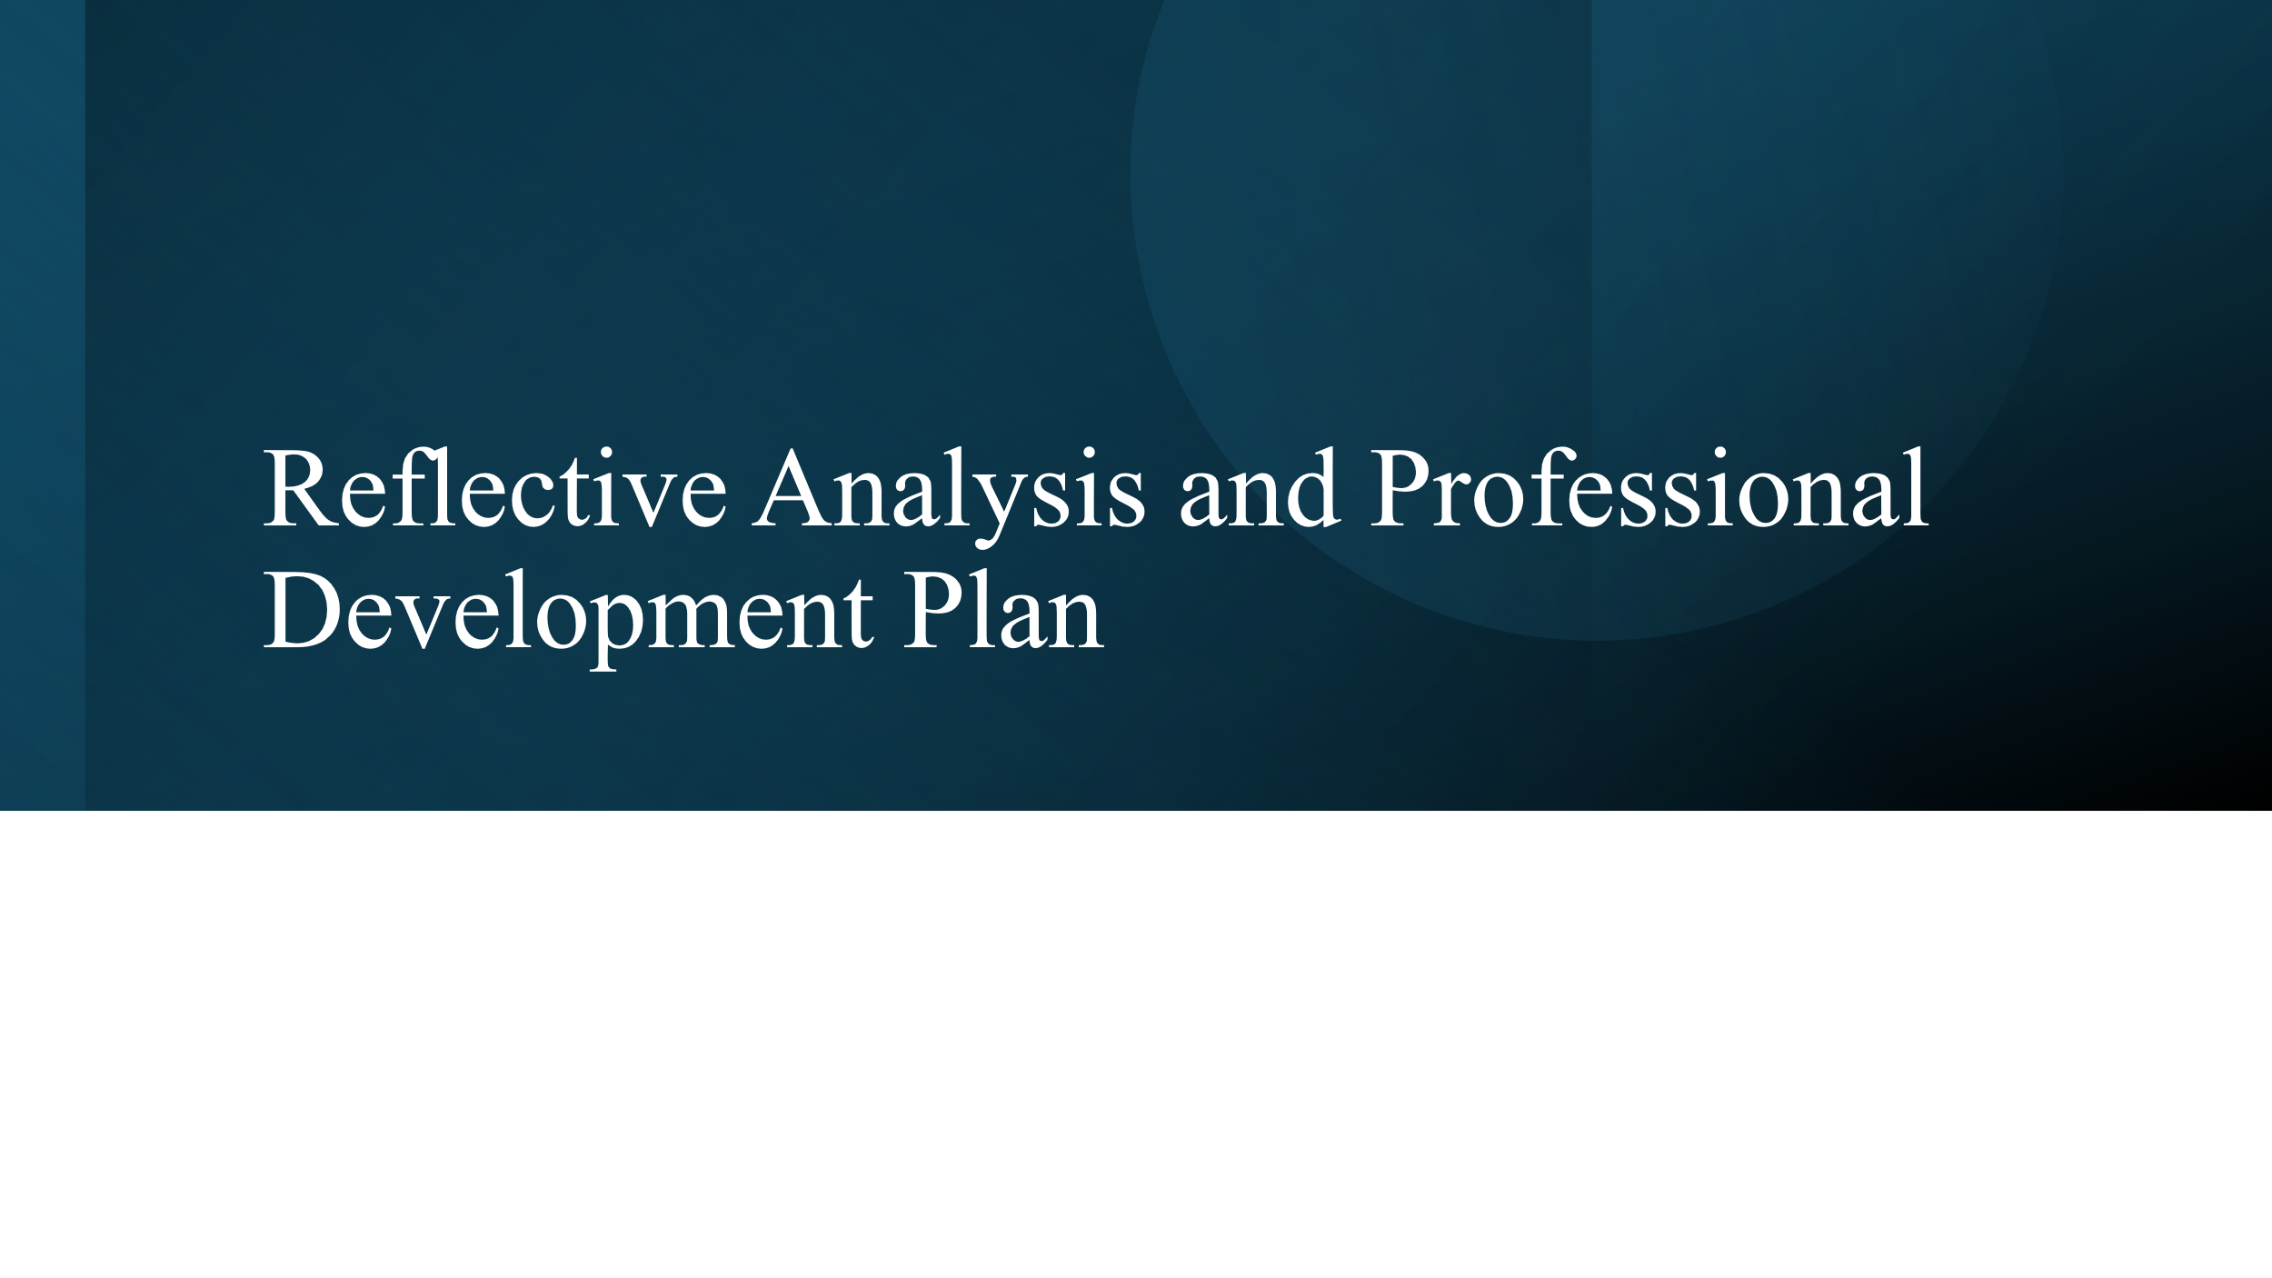
Slide 2

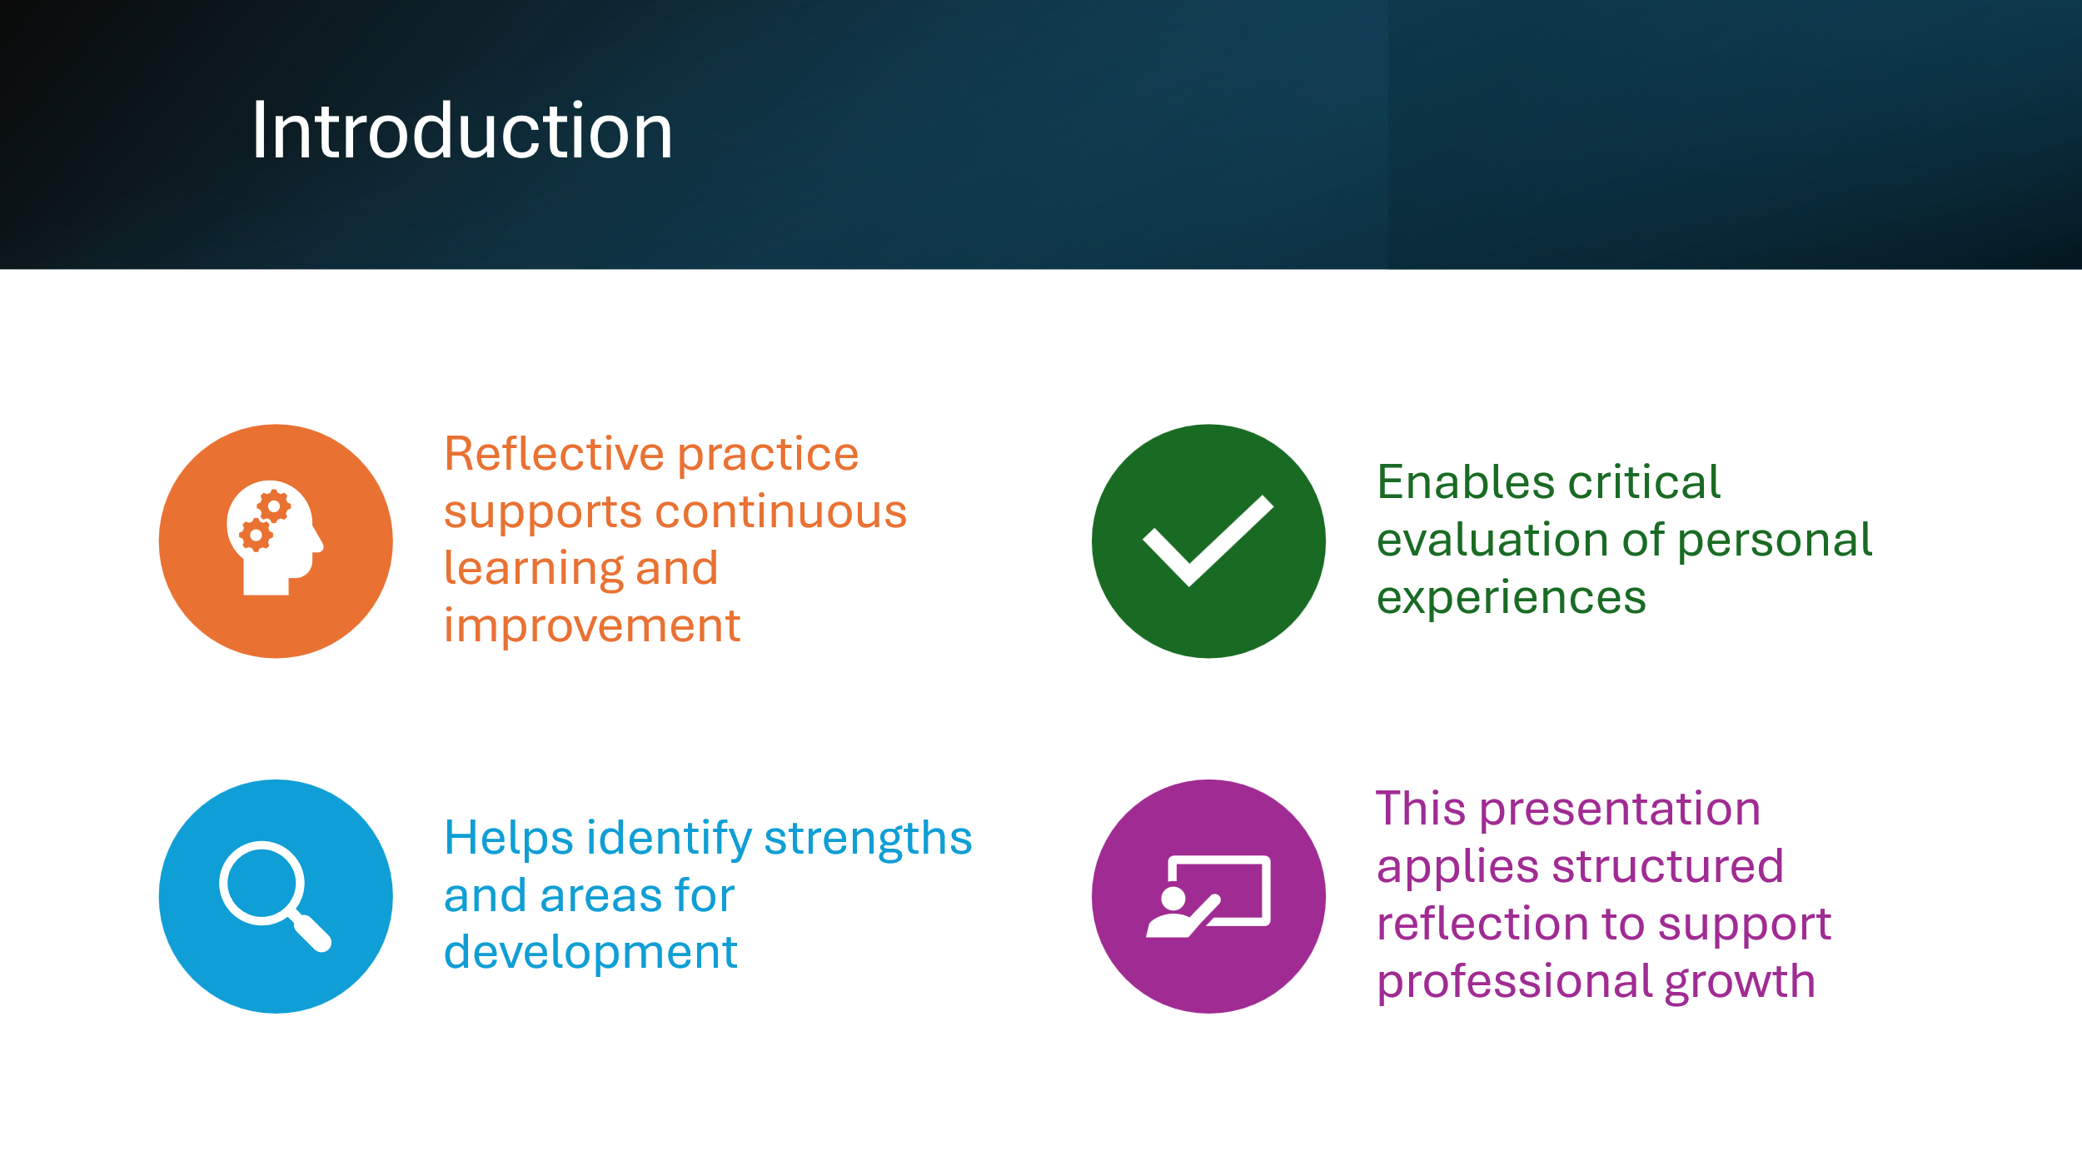
Slide 3
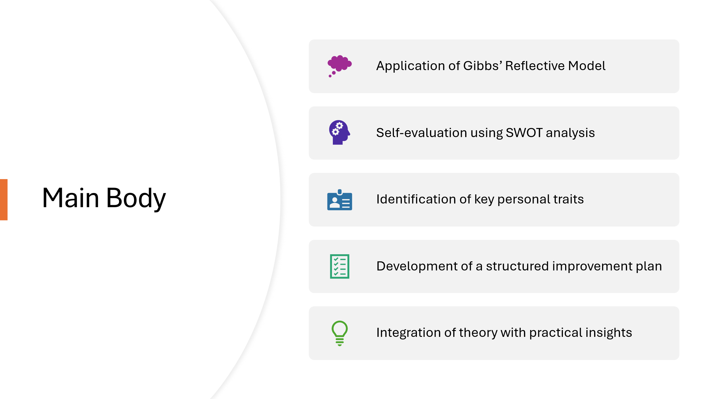

Slide 4
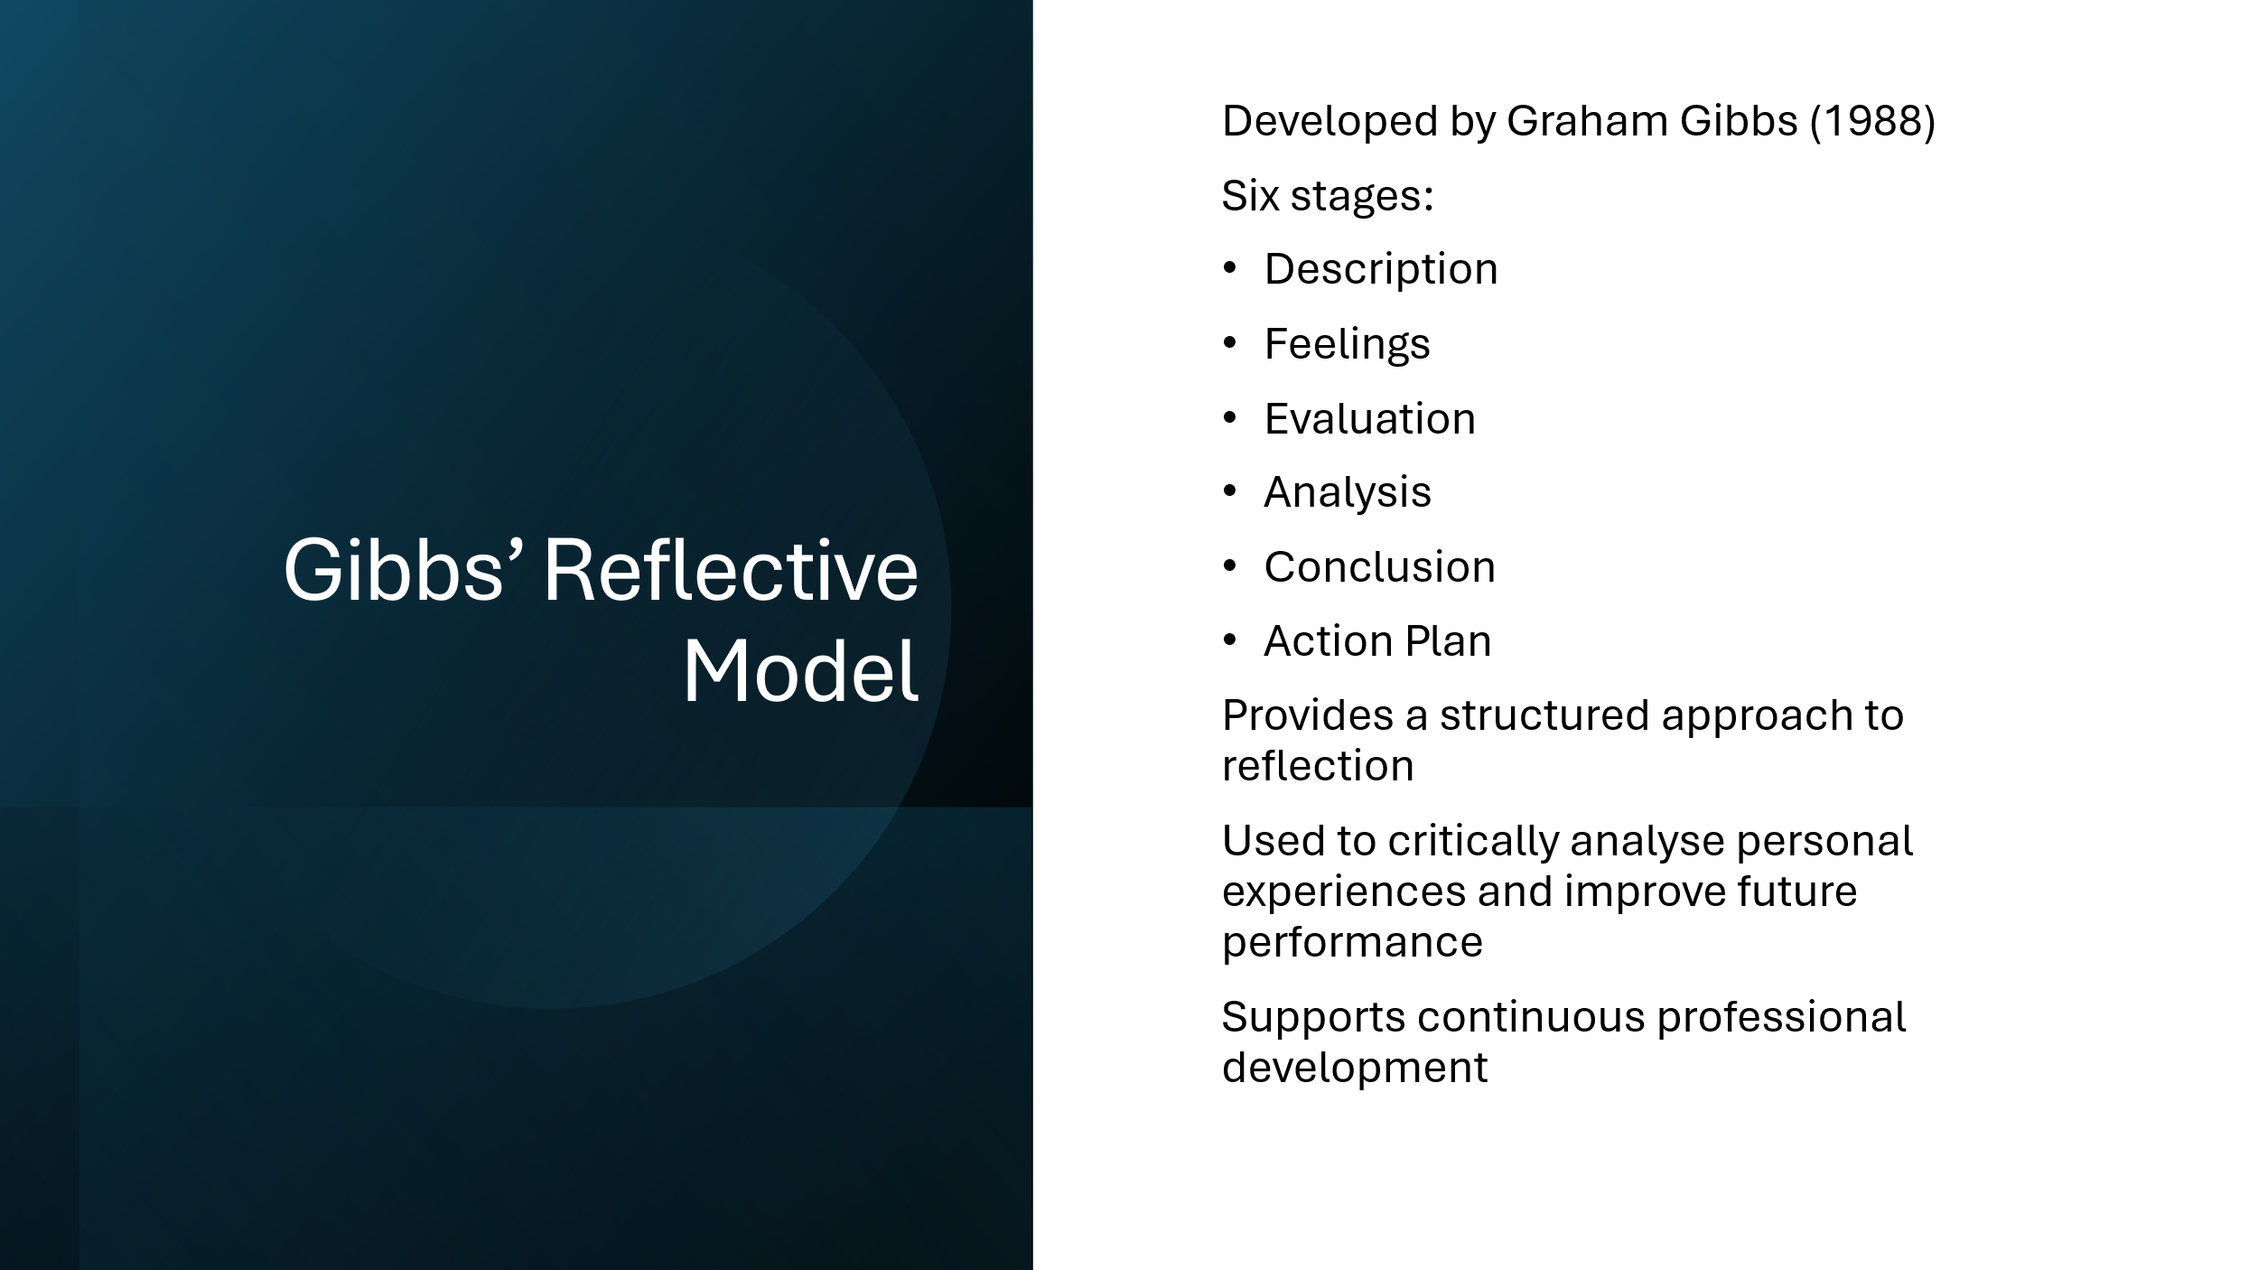

Slide 5
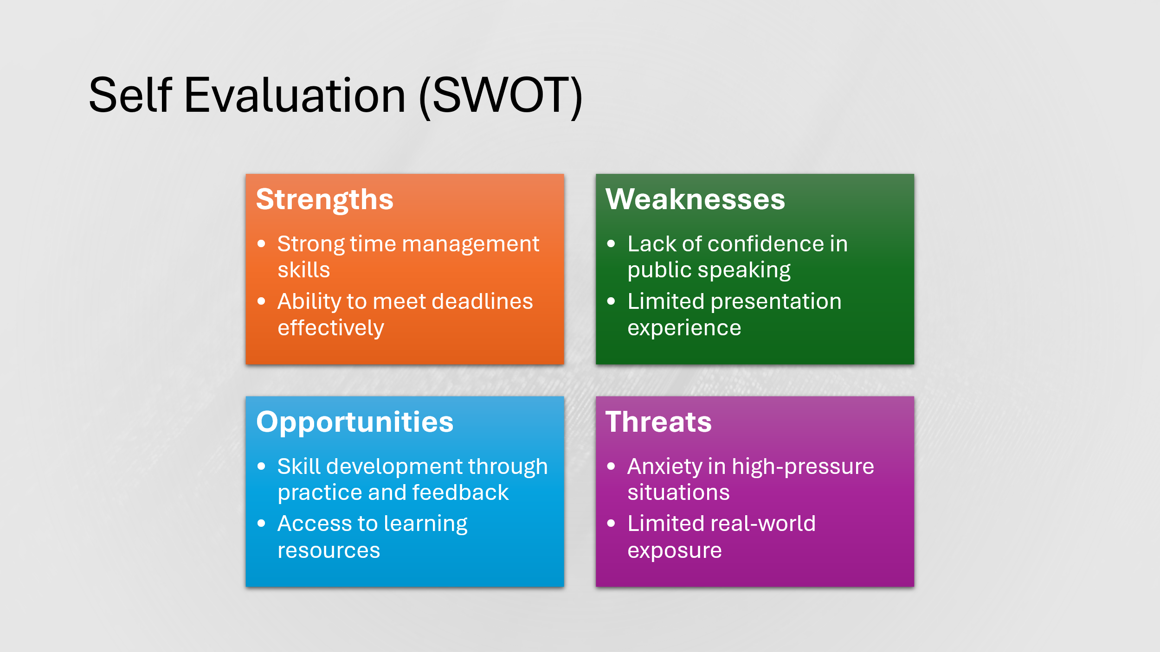

Slide 6
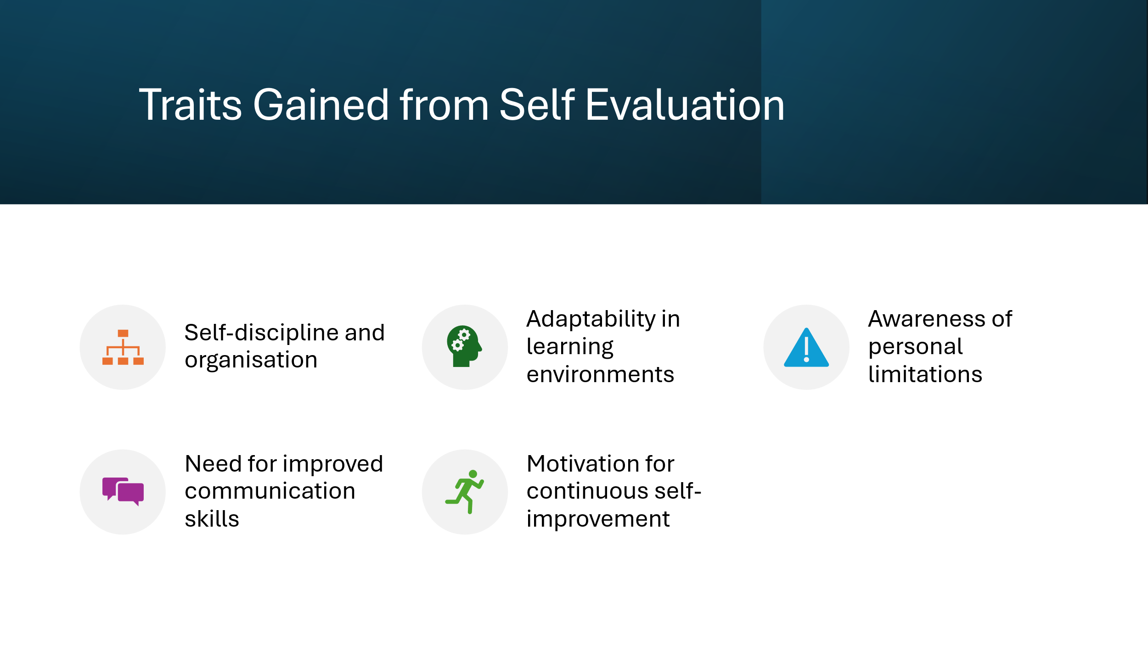

Slide 7
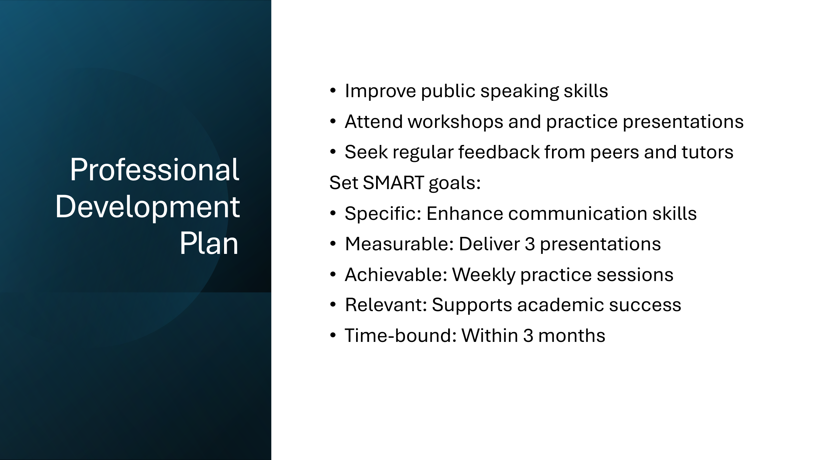

Slide 8
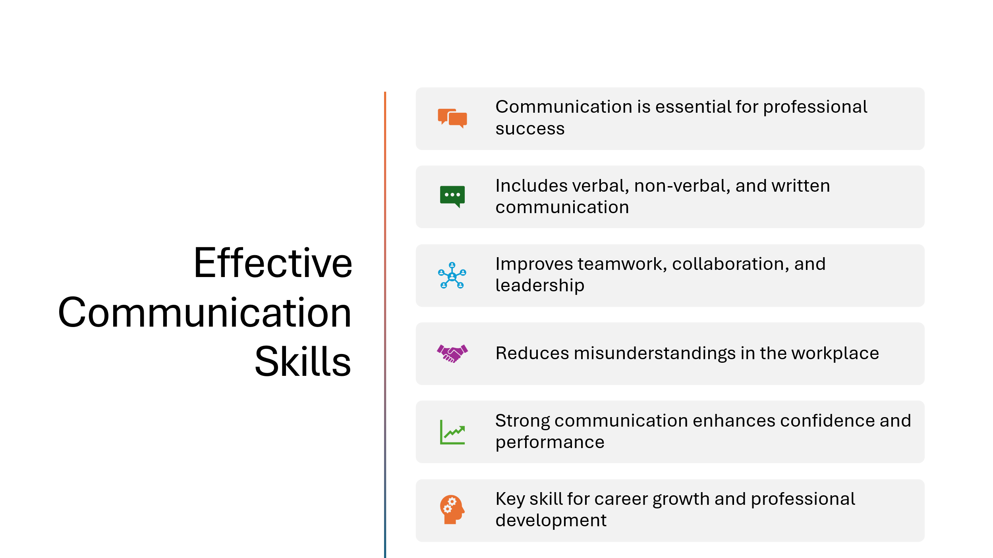

Slide 9
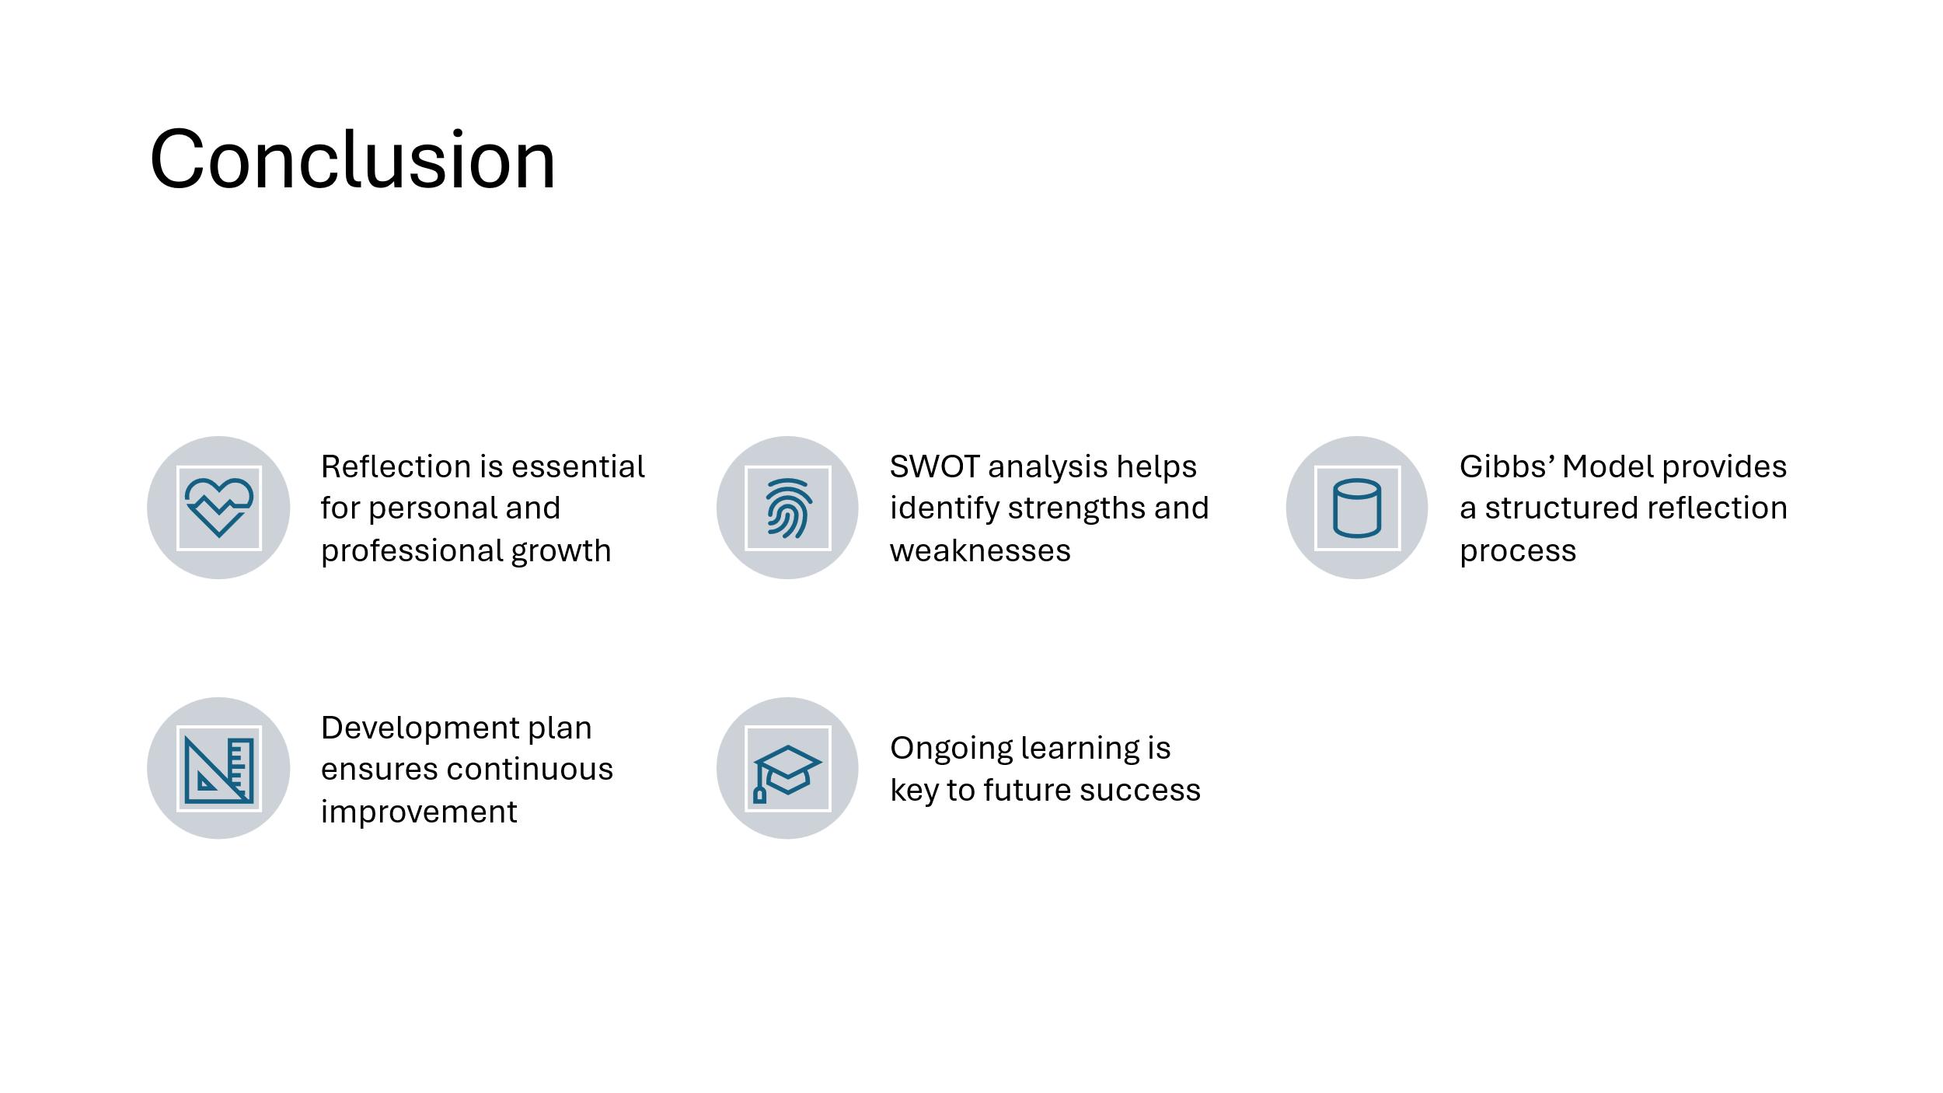

Slide 10
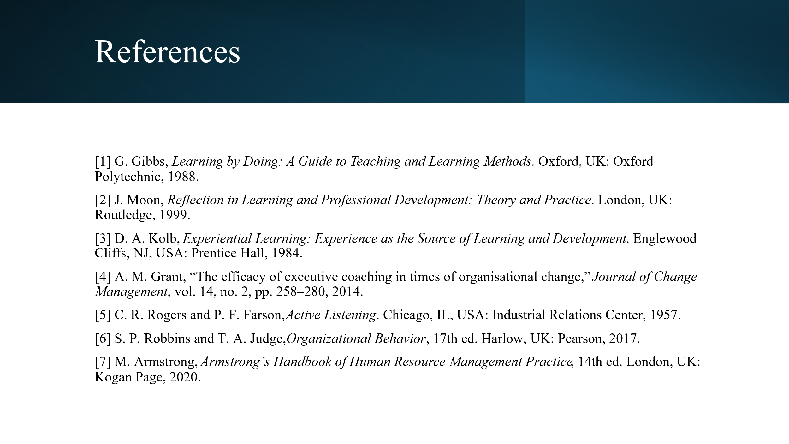

ATTN
TO WHOM IT CONCERN
I WAS HAVING ISSUES WITH MY LAPTOP CAMERA AND COULDN’T UPLOAD A LINK, INSTEAD I HAVE WRITTEN OUT THE NOTES FOR EACH SLIDES THAT I WAS MEANT TO EXPLAIN IN MY YOUTUBE VIDEO. THANK YOU

Slide 1: Cover Page
Good morning, My name is Benson Obinna
Today, I will be presenting my reflective analysis and professional development plan, it was meant to be a YouTube video but unfortunately for me I could not upload a link due to my laptop camera being faulty so instead I have decided to write it out in notes for better understanding.
The purpose of this presentation is to critically evaluate my personal and academic skills using
established theoretical frameworks. Specifically, I apply Gibbs’ Reflective Model to structure
my reflection and a SWOT analysis to systematically assess my strengths, weaknesses,
opportunities, and threats.
Based on this evaluation, I then develop a Professional Development Plan that outlines specific
and measurable strategies for improvement. This approach ensures that my reflection is not
only descriptive but also actionable and aligned with my long-term professional goals.
Slide 2: Introduction
Reflective practice is widely recognised as a critical tool for continuous learning and
professional development. It allows individuals to move beyond simply experiencing events to
actively analysing and learning from them.
Through reflection, individuals can identify both strengths and areas for improvement, enabling
more informed decision-making and better future performance.
In an academic and professional context, reflection supports the development of key skills such
as critical thinking, self-awareness, and adaptability.
In this presentation, I adopt a structured reflective approach to evaluate my current capabilities
and align them with my future academic and career objectives.
Slide 3: Main Body
The main body of this presentation combines both theoretical frameworks and personal
analysis to ensure depth and academic rigor.
Gibbs’ Reflective Model is used as a structured framework to guide the reflection process,
ensuring that my analysis moves beyond simple description to deeper evaluation and critical
thinking.
In addition, SWOT analysis is used as a practical tool to assess my internal strengths and
weaknesses, as well as external opportunities and threats.
By integrating these approaches, I am able to link theory with practice and ensure that my
reflection leads to meaningful and actionable outcomes.
Slide 4: Gibbs’ Reflective Model
Gibbs’ Reflective Model, developed in 1988, provides a systematic and structured approach to
reflection through six key stages: description, feelings, evaluation, analysis, conclusion, and
action plan.
One of the main strengths of this model is that it encourages deeper levels of thinking by
guiding individuals from simply describing an experience to critically analysing it and
identifying ways to improve.
In this assignment, I apply Gibbs’ model to reflect on my academic experiences, particularly
focusing on my performance and skill development.
By following this structured approach, I am able to identify not only what happened, but also
why it happened and how I can improve in the future. This makes the reflection process more
meaningful and effective in supporting continuous development [1].
Slide 5: Self Evaluation (SWOT)
To complement my reflective analysis, I conducted a SWOT analysis to evaluate my current
skills and capabilities.
One of my key strengths is effective time management. I am able to prioritise tasks and meet
deadlines consistently, which supports my academic performance.
However, a significant weakness is my lack of confidence in public speaking. This affects my
ability to communicate ideas clearly during presentations.
In terms of opportunities, I have access to various resources such as workshops, online
materials, and peer feedback, which can support my development.
At the same time, external pressures such as performance anxiety and limited real-world
experience may act as threats that hinder my progress.
This structured evaluation provides a clear foundation for identifying areas that require
improvement.
Slide 6: Traits Gained
Based on the SWOT analysis, several important personal traits have been identified.
I demonstrate strong self-discipline and organisational skills, which are essential for managing
academic responsibilities effectively. I am also adaptable and open to learning, which allows
me to respond positively to challenges.
However, the analysis also highlights the need to improve my communication and confidence,
particularly in public speaking situations.
This suggests that while I have a solid foundation of strengths, my overall development
depends on addressing these limitations. Recognising these traits is important, as it enables me
to focus on targeted improvement rather than general development.
Slide 7: Professional Development Plan
Based on the identified weaknesses, I developed a Professional Development Plan to support
my growth.
A key focus of this plan is improving my public speaking and communication skills. To achieve
this, I will engage in regular presentation practice, participate in class discussions, and seek
constructive feedback from peers and instructors.
This plan follows the SMART framework, ensuring that my goals are specific, measurable,
achievable, relevant, and time-bound. For example, I aim to deliver at least three structured
presentations within the next three months.
By implementing this plan, I expect to gradually build confidence and improve my
communication abilities, which are essential for both academic success and future career
development.
Slide 8: Unit 4 Topic
The selected Unit 4 topic is effective communication skills in professional development.
Communication is a fundamental skill that influences nearly all aspects of professional life,
including teamwork, leadership, and problem-solving. It involves not only verbal
communication, but also non-verbal cues such as body language and active listening.
Effective communication helps to reduce misunderstandings, improve collaboration, and
enhance overall productivity in the workplace.
This topic is particularly relevant to my personal development, as it directly relates to my
identified weakness in public speaking. By improving my communication skills, I can enhance
both my confidence and my ability to perform effectively in professional environments.
Slide 9: Conclusion
In conclusion, this presentation highlights the importance of reflective practice in supporting
personal and professional development.
By applying Gibbs’ Reflective Model and SWOT analysis, I was able to critically evaluate my
strengths and weaknesses and gain a deeper understanding of my capabilities.
More importantly, this reflection was translated into a structured Professional Development
Plan, ensuring that the insights gained lead to measurable improvement.
This process demonstrates that continuous reflection, combined with practical action, is
essential for achieving long-term success.

