

How a school develops one aspect of its SDP: a report that critically reflects on the actions, impact, and evidence base.

Module: ECAD7003 - Where Am I Teaching?

Component 2

Student Number: 2200685

Word Count: 2731

CONTENTS
Targets 1

Introduction 2

Literature Review 2

Developing an Action Point 5

Reflection and Evaluation 7

Conclusion 8

Reference List 10

Appendix 14

Targets
 | Target | What I have done in this assignment
Target 1 | It is worth linking your findings to the next steps in your professional standards. | I have made sure to refer to my next steps in my career and include how I will use this new knowledge to evidence professional standards.

Component 2
How a school develops one aspect of its SDP: a report that critically reflects on the actions, impact, and evidence base.

Introduction
This assignment will critically examine and reflect upon one aspect of a school development plan (SDP). In line with BERA guidelines (2018) and conducting this research with an “ethic of respect” (p.5), the focus school and staff will remain anonymous throughout. Subsequently, the focus school will be referred to as school Y.

School Y is located in a deprived area of South Wales (My Local School, 2022). It is a single-form entry school with 210 pupils on roll (My Local School, 2022). 69.7% of pupils are eligible for free school meals (eFSM), well above the national average of 21% (My Local School, 2022; Welsh Government, 2022b). School Y also identifies 50.9% of its pupils as having additional learning needs (ALN) (My Local School, 2022). The school has a low percentage of pupils from minority ethnic backgrounds and most pupils speak English as their home language (My Local School, 2022).

This assignment will discuss one component of school Y’s SDP with close reference to its actions, their impact, and the evidence base for this. The school’s SDP has four areas from which objectives stem (School Y, 2022). The area of ‘care, support and guidance’ has two objectives: objective 3.1 “our school is a place where parents are supported to thrive”, which will be the focus, and objective 3.2 “our school is at the heart of our community” (appendix 1) (School Y, 2022, p.17-18).

Literature Review
Every school in Wales is required to contribute to self-improvement and create an SDP which outlines how the school will encourage learner progress and wellbeing (Welsh Government, 2014b; 2022a). The fundamental purpose of a SDP is to provide the best possible learning experiences, regardless of background, and enable learners to develop towards the four purposes (Welsh Government, 2022a; 2022d).

Recently, the Welsh Government (2022a) has moved toward a self-evaluation framework whereby schools now have the responsibility of evaluating their school within their own context, underpinned by a wide range of evidence, to plan for improvement. The self-evaluation process will enable schools to identify strengths and areas of potential development, keeping the progression, attainment, and wellbeing of all learners at its core (Welsh Government, 2022a). This process should be self-reflective and honest, but also continuous (Estyn, 2019).

The Welsh Government (2018) also developed a framework for an ‘ideal’ school working towards the Curriculum for Wales (OECD, 2018). The Schools as Learning Organisations (SLO) model is built upon the foundations of the four purposes, which feed into every aspect of a school (appendix 2) (Welsh Government, 2018). Under the SLO model schools must become an integrated part of the community and work together to achieve their visions (Welsh Government, 2018). All stakeholders within a learner’s education should be involved in the process to create honest and valuable improvement plans (Welsh Government, 2018).

An important stakeholder within a learner’s education is the parent/caregiver. The Welsh Government (2015; 2022e) has called for all schools in Wales to become community focused as the ability to realise high standards rests upon effectively engaging with parents and the wider community. Epstein (2001) highlights that family, school, and community all simultaneously impact a child’s development, are interconnected and must be looked at as a partnership, which is further supported by Bronfenbrenner’s Ecological Systems Theory (appendix 3) (Bronfenbrenner, 1979; Mcleod, 2023). Therefore, for the Welsh Government (2015) family and community engagement (FaCE) is extremely important.

Unfortunately, in deprived areas schools face barriers to parental engagement (Welsh Government, 2014a; Axford et al, 2019). Often, parents' own experiences of school become a barrier and some feel they lack adequate knowledge to support their children (Welsh Government, 2014a; Axford et al, 2019). However, Charles Desforges (2014) claims that family engagement has six times the influence than the quality of schools, with Broadfield (2006) supporting this and stating parental engagement can make 30% of a difference in a child’s learning, with school only making 5% difference (quoted by Teacher C, 2023). Research has shown that if a school is to be successful in mitigating the impact of poverty, a national priority, there must also be a strong relationship between school and family (Welsh Government, 2022d; 2022e).

Parental engagement in every school will look extremely different, each school must create parental engagement strategies that work for them (Welsh Government, 2022e). There are many different frameworks that schools can follow to build effective parental engagement (Goodall, 2022). Reynolds notes a difference between parental ‘involvement’ which relates to school-led activities such as, parents evening and school trips, and parental ‘engagement’ which are more self-directed and can include support from the school and having a real interest in learning (Goodall, 2022). Both are beneficial but schools should aim for true engagement in order to create a successful partnership (Goodall and Vorhaus, 2011).
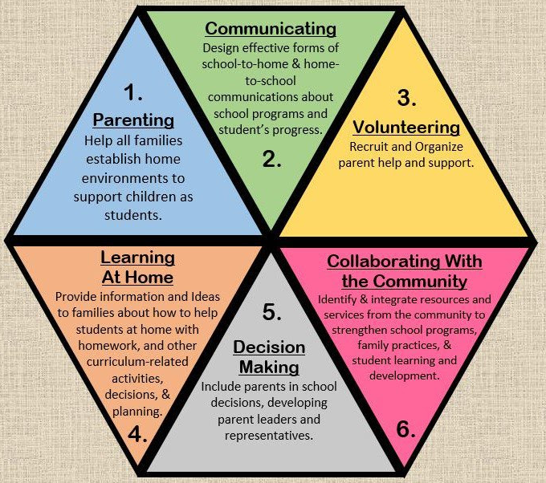
Epstein created an easily accessible, widely used, parental engagement framework (image referenced in appendix 4), in which the progression from parental ‘involvement’ to ‘engagement’ is clear (Axford et al, 2019; Goodall, 2022). However, Epstein (2010) noted it does not “ensure an effective program of partnerships”, therefore schools must learn what is effective for them (p.2). Additionally, Goodall (2022) argues that approaches to parental engagement must be family-centric rather than school-centric, like Epstein’s model. All strategies must reflect the school context and not take a generalised approach (Welsh Government, 2022e; Goodall, 2022).
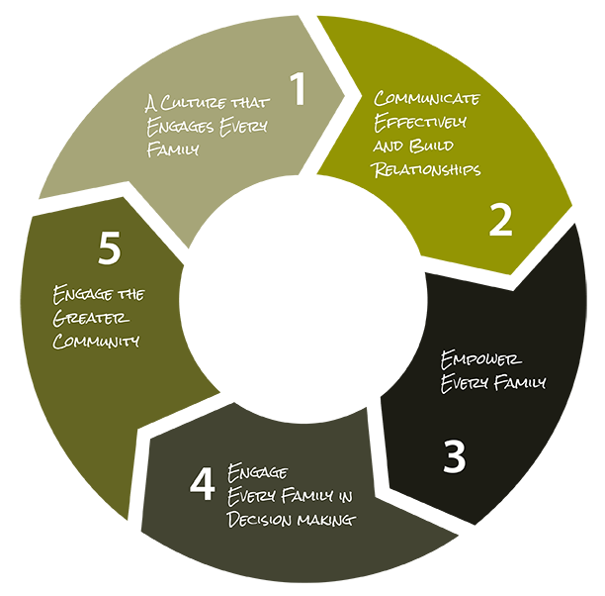
Dr Steve Constantino (2023) however, focuses on continual engagement and created a 5-step logic model (image referenced in appendix 5). The logic model sets out 5 hierarchical processes which keep family at the centre (Constantino, 2023). Step 1 focuses on creating collective beliefs and attitudes, committed to ensuring families are a foundational aspect of improvement (Constantino, 2023). This can then be built upon by creating effective communication and building strong relationships, encouraging families to recognise themselves as essential members of their child’s learning (Constantino, 2023). Families are then consulted in decision making and work in partnerships with the school (Constantino, 2023). The final step for schools is to engage the wider community (Constantino, 2023).

The benefits of FaCE have been widely acknowledged, especially within deprived areas where schools face many barriers (Welsh Government, 2014a; Axford et al, 2019). A school must find strategies which work for their context and work towards creating their own framework for parental engagement (Welsh Government, 2022e; Goodall, 2022). It is helpful for a school to use a model to understand the process of parental engagement, especially when just starting out, but the school must always centre their priorities on their learners and their context (Welsh Government, 2022e; Goodall, 2022).

Developing an Action Point
Within school Y’s SDP each area of development has an assigned leader and staff members are given specific responsibilities (School Y, 2022). Each area has several objectives which are further broken down into key results and initiatives (appendix 1), clearly outlining the process needed to achieve results, which are officially monitored in December and assessed in March (School Y, 2022). School Y also undertakes an annual self-evaluation process, all staff members attend a school improvement INSET day to assess progress (Teacher A, 2023). Harris (2002) emphasises the need to involve all stakeholders in these decisions to create a shared belief and vision. In accordance with this, school Y also involves parents through questionnaires which highlights parents' opinions but also whether there is an area of need which is not yet being addressed (Teacher A, 2023). All information is then collated by the senior leadership team (SLT) and a new SDP is written for the following year (Teacher A, 2023). The Welsh Government (2015; 2022e) has put great emphasis on the need to engage families and communities, involving them in the creation of a SDP is an example of this, and also allows school Y to work towards the SLO model (Welsh Government, 2018).

The school has undertaken much research into FaCE, realises the impact of effective parental engagement and strives towards creating an environment where families thrive and are able to engage in their child’s learning (Welsh Government, 2015; Teacher A, 2023). Unfortunately, the school is impacted by the link between poverty and low parental engagement rates, which they hope to reform (Teacher A, 2023). Furthermore, as part of the SLO model school Y works with a cluster of 5 primary schools which feed into the local comprehensive school, who as a whole, also identified the need for FaCE improvement across all schools in the area (Teacher B, 2023). Research has stated that in Wales learners living in the most deprived areas are five times more likely to leave school not in employment, education, or training (Welsh Government, 2014a). If Wales is to succeed in creating lifelong learners, the impact of poverty needs to be mitigated with the Welsh Government (2015) calling families “powerful levers” in this bid (p.5) (Estyn, 2020). For school Y if parents ‘thrive’ they are more ready to ‘show up’ for their children and engage in school life (Teacher A, 2023).

In addition, school Y also struggled with poor attendance (Teacher A, 2023). It has been shown that vulnerable learners, eFSM learners and learners with ALN, which the school has a high percentage of, are more likely to have poorer attendance records (Rowlands, 2022). The Welsh Government (2014a) states that eFSM learners are four times more likely to be persistently absent than their peers, which was unfortunately exacerbated by the effects of COVID-19 (Dauncey, 2023; Hughes, 2023). School Y believes that by increasing parental engagement and supporting parents to thrive, creating a more positive attitude to school, learners will benefit and attendance will increase (Welsh Government, 2014a; Teacher A, 2023). Parents and schools need to work as a partnership for the benefit of the learner (Goodall and Vorhaus, 2011; Rowlands, 2022).

In order to identify this area of need school Y used a lot of ‘soft’ data, which Williams (2017) calls for (Teacher A, 2023). For example, the school has a family engagement officer who feeds back to SLT any concerns or needs of parents (Teacher A, 2023). All staff also have a responsibility to highlight any concerns or conversations they may have had with families that may require further support (School Y, 2022). For school Y developing relationships with parents not only benefits the learner, but it also allows school to understand their families’ needs and provide the correct support (Teacher A, 2023). School Y hopes that building these strong bonds with families will allow them to support parents to thrive, in turn improving learner outcomes and wellbeing, which Egan (2013) argues has the greatest impact. This data is also used to analyse the impact of initiatives, along with the number of families that engaged with activities and whether these activities were expanded as a result (Teacher A, 2023). Through the process of continual self-evaluation school Y have been able to collect parents’ feedback and increase their offer of future sessions within that same academic year, providing immediate support for those in need (Teacher A, 2023). This will then increase trust from parents as they feel listened to and are therefore more likely to engage in the future (Williams, 2017).

Reflection and Evaluation
It is noticeably clear within school Y that parents are valued and engagement is a driving force. All staff members seem very aware of the barriers to parental engagement and the context in which the school is situated. It is also clear that the belief that parents are key to learner outcomes and wellbeing is present, and therefore there is a big push to involve parents more. One example of involvement is parents are invited to termly “celebrations of learning” (Teacher A, 2023). It is important however, for these sessions to be valuable and not just a ‘bolt-on’ activity to tick a box, they must be worthwhile for both the learner, the school, and the parents (Goodall and Vorhaus, 2011).

In addition, robust systems of attendance monitoring have been implemented (School Y, 2022). Teacher A (2023) stated this has been working so far, and attendance has increased, but the school is not yet at their target of 90%. It is clear that more work into improving attendance needs to be done, Rowlands (2022) argues that through increasing parental engagement, attendance will improve as the parents place increasing value on education. This initiative is set to continue, parental engagement is gradually increasing therefore school Y is hoping this will begin to reflect in attendance rates in the near future (Teacher A, 2023).

Furthermore, school Y introduced a cooking afternoon for parents and siblings of high-tariff pupils giving them a safe space to decompress and have an afternoon focused on building relationships (Teacher A, 2023). This was immensely successful and was expanded to support further families (Teacher A, 2023). This initiative of connecting family, learner, and school through something not entirely school related broke the barrier for some reluctant parents (Teacher A, 2023). This could be a way for school Y to engage more families, Williams (2017) argues that moving away from focusing on literacy and numeracy involvement but focusing more on ‘non-threatening’ activities allows families to feel more comfortable within the school environment and paves the way for future and further engagement with school.

If we refer back to Dr Steve Constantino’s (2023) logic model it is clear to see that school Y is working their way towards having successful FaCE. They are building strong relationships with families and communicating effectively, which Constantino (2023) argues will lead to families eventually seeing themselves as essential components in their child’s learning, in turn benefiting learner outcomes and school improvement. The school is currently in the process of managing the balance between parental ‘involvement’ and ‘engagement,’ and teaching staff are having ongoing professional learning to help them understand how to bridge that gap (Teacher, 2023). However, learning support assistants have not yet been involved in this training. It is particularly important that all staff are on the same page when it comes to parental engagement, with the Welsh Government (2015) calling for a whole-school approach. Even though it is clear support staff understand the need for parental engagement, it would be beneficial for them to also be involved in upskilling themselves in techniques and developing their understanding, to further the school’s vision.

It is crucial to remember the school context and the community which it serves (Welsh Government, 2022e). Each school will take a different approach to FaCE and rightly so. School Y must take a graduated approach towards involving parents in order to successfully achieve long-term engagement. It must be a continual process and one that all staff engage in (Cedo, 2015; Welsh Government, 2015). Once parents are successfully engaged, the school can look to effectively engage with the community (Constantino, 2023). This target is already a part of their SDP however, the initiatives within the target are still very parent based (appendix 1). School Y must focus on achieving long-term, effective parental engagement and then they can expand to engage the wider community, as Constantino (2023) and Epstein (2010) suggests, in order for both to be successful and to effectively work towards improving learner outcomes.

Conclusion
This research has increased my understanding of the impact that deprivation can have on learner outcomes and wellbeing. It has also developed my understanding of the importance of FaCE and how important parental engagement is in a child’s education. It has highlighted the link between deprivation and barriers to parental engagement, furthering my knowledge. I will use this newly developed understanding in my future career and will now be well-equipped for parental interactions and understanding how they can benefit the learner. This will evidence the pedagogical descriptor, of the Professional Standards for Teaching and Leadership (PSTL), “involving partners in learning,” something which I hope to continue throughout my career (Welsh Government, 2019, p.27).

This research also evidences the importance of “supporting formal leadership roles” and “exercising corporate responsibility,” within the leadership strand of the PSTL (Welsh Government, 2019, p.58, p.60). I have developed my understanding of how a school creates its SDP and how it is achieved throughout the year. I have also demonstrated understanding of the responsibilities of every member of staff in supporting the improvement and working towards the successful fulfilment of the SDP.

Reference List
[School Y]. (2022). [School Y] School Development Plan. South Wales: [School Y].

Axford, N. Berry, V. Lloyd, J. Moore, D. Rogers, M. Hurst, A. Blockley, K. Durkin, H. and Minton, J. (2019). How Can Schools Support Parents’ Engagement in their Children’s Learning? Evidence from Research and Practice. London: Education Endowment Foundation. Available at: https://educationendowmentfoundation.org.uk/evidence-summaries/evidence-reviews/parental-engagement/. (Accessed on: 14/03/23).

British Educational Research Association [BERA]. (2018). Ethical Guidelines for Educational Research. Fourth Edition. London: BERA.

Bronfenbrenner, U. (1979). The Ecology of Human Development: Experiments by Nature and Design. Cambridge and London: Harvard University Press.

Cedo, K. (2015). Family Engagement: An impetus for student success. Scholastic Edu. Available at: https://edublog.scholastic.com/post/family-engagement-impetus-student-success (Accessed on: 04/04/23).

Constantino, S. (2023). Engage Every Family: Five Simple Principles. Available at: Family Engagement - Dr. Steve Constantino (drsteveconstantino.com). (Accessed on: 29/03/23).

Dauncey, M. (2023). “Estyn: schools have ‘coped well’ but things aren’t ‘back to normal’ yet”. Senedd Research. Available at: Estyn: schools have “coped well” but things aren’t “back to normal” yet (senedd.wales). (Accessed on 01/04/23)

Desforges, Charles. (2014). ‘The Impact of Parental Engagement on Children’s Development and Achievement’. National Parents Council Primary Education Conference. Dublin, 14/06/2014. Available at: (30) NPC Conference 2014 - Professor Charles Desforges - YouTube (Accessed: 29/03/23).

Egan, D. (2013). Poverty and Low Educational Achievement in Wales: Student, Family and Community Interventions. Available at: Poverty and low educational achievement in Wales: student, family and community interventions (jrf.org.uk). (Accessed on 02/04/23).

Epstein, J. L. (2001). ‘Building Bridges of Home, School, and Community: The Importance of Design. Journal of Education for Students Placed at Risk, 6 (1&2). Pp.161-168. Available at: Building Bridges of Home, School, and Community: The Importance of Design (tandfonline.com). (Accessed on 15/03/23).

Epstein, J. L. and F. L. Van Voorhis. (2010). ‘School counsellors’ roles in developing partnerships with families and communities for student success.’ Professional School Counseling. 14(1). Available at: School Counselors’ Roles in Developing Partnerships with Families and Communities for Student Success (uwtsd.ac.uk). (Accessed on 04/04/23).

Estyn. (2019). A New Approach to Self-Evaluation Reports - but what does it mean for schools?. Available at: A new approach to self-evaluation reports – but what does it mean for schools? | Estyn (gov.wales). (Accessed on 03/04/23).

Estyn. (2020). Community schools: families and communities at the heart of school life. Available at: Community schools: families and communities at the heart of school life (gov.wales). (Accessed on 15/03/23).

Goodall, J. (2022). “A framework for family engagement: going beyond the Epstein Framework”. Wales Journal of Education. 24 (2). Available at: Goodall | A framework for family engagement : Going beyond the Epstein Framework | Wales Journal of Education (uwp.co.uk). (Accessed on 02/04/23).

Goodall, J and Vorhaus, J.(2011). Review of Best Practice in Parental Engagement, Department for Education. Available at:REVIEW OF BEST PRACTICE IN PARENTAL ENGAGEMENT (bath.ac.uk). (Accessed on 02/04/23).

Harris, A. (2002). School Improvement: What’s In It For Schools?. Routledge: London and New York.

Hughes, S. (2023). “Increased school - absence - how did the pandemic affect school attendance”. Senedd Research. Available at : Increased school absence – how did the pandemic affect school attendance (senedd.wales). (Accessed on 01/04/23).

Keany, M. (2019). ‘Framework on the Six Types of Parental Involvement’. School Leadership 2.0. Available at: Framework on the six types of parent involvement - School Leadership 2.0 (schoolleadership20.com). (Accessed on: 11/04/23).

Mcleod, S. (2023). Bronfenbrenner’s Ecological Systems Theory. Available at: Bronfenbrenner's Ecological Systems Theory - Simply Psychology. (Accessed on: 29/03/23).

OECD. (2018). Developing Schools as Learning Organisations in Wales. Available at:Developing Schools as Learning Organisations in Wales | Implementing Education Policies | OECD iLibrary (oecd-ilibrary.org). (Accessed on 01/04/23).

Rowlands, M. (2022). Attendance review - implications of the COVID-19 pandemic for school attendance. Available at: Numeracy Employer Engagement Grant: (gov.wales). (Accessed on 02/04/23).

Teacher A. (2023). Conversation with Zoe Cannon, 31/03/23.

Teacher B. (2023). Conversation with Zoe Cannon, 31/03/23.

Teacher C. (2023). Professional Learning Presentation attended by Zoe Cannon, 28/03/23.

Welsh Government. (2014a). Rewriting the future: Raising ambition and attainment in Welsh schools. Available at: rewriting-the-future-raising-ambition-and-attainment-in-welsh-schools.pdf (gov.wales). (Accessed at: 15/03/23).

Welsh Government. (2014b). School Development Plans. Available at: School Development Plans Guidance Document (gov.wales). (Accessed on 03/04/23).

Welsh Government. (2015). FaCE the challenge together: Family and community engagement toolkit for school in Wales. Available at: 150615-face-main-guidance-en.pdf (ioe.ac.uk). (Accessed on: 15/03/23).

Welsh Government. (2018). Schools in Wales as learning organisations. Available at: WG35678 (gov.wales). (Accessed on: 04/04/23).

Welsh Government. (2019). Professional Standards for Teaching and Leadership. Available at:https://hwb.gov.wales/api/storage/19bc948b-8a3f-41e0-944a-7bf2cadf7d18/professional-standards-for-teaching-and-leadership-interactive-pdf-for-pc.pdf. (Accessed: 04/04/23).

Welsh Government. (2022a). School Improvement Guidance: impact assessment. Available at: School improvement guidance: impact assessment | GOV.WALES. (Accessed on: 01/04/23).

Welsh Government. (2022b). Pupils Eligible for Free Schools Meals By Local Authority, Region and Year. Available at :Pupils eligible for free school meals by local authority, region and year (gov.wales). (Accessed on 01/04/23).

Welsh Government. (2022c). My Local School. Available at: Oak Field Primary And Nursery School (gov.wales). (Accessed on: 02/04/23).

Welsh Government. (2022d). School Improvement Guidance: Framework for Evaluation, Improvement and Accountability. Available at:School improvement guidance: framework for evaluation, improvement and accountability - Hwb (gov.wales). (Accessed on 01/04/23).

Welsh Governmnet. (2022e). Community Focused Schools: Information supporting the development of Community Focused Schools in Wales. Available at: Community Focused Schools | GOV.WALES. (Accessed on: 15/03/23).

Williams, D. (2017). Active Learning through Family Engagement: Improving family engagement through a process of reflexive action research. University of Wales Trinity Saint David. School of School justice and inclusion: Carmarthen. Available at: family-engagement.pdf (uwtsd.ac.uk). (Accessed on 02/04/23).

Appendix
Appendix 1
Area – Care, support and Guidance Lead – Louise Harris
Objective: | Key Results | Initiatives (who)
Our school is a place where our parents are supported to thrive! (3.1) | Improvement to overall attendance figures to above 90%  Target children and families supported – feedback from parents  All children to attend school twice a week. (Inclusion service once a week)  Developing positive relationships between parents and their children.  Developing life skills with parents and children together.  Parents feeling supported by school.  Siblings feel valued.... | Weekly Attendance monitoring processes in place.  Target children and families supported.  Conversations with families, provide support e.g., school nurse  Documented actions by school on My Concern e.g. House visits, phone calls.  Action Plan and offer for Family Work  Weekly cooking nurture club children with high tariff siblings
Our school is at the heart of our community! (3.2) | Increase in the number of families supported by Cadfield van.  No Oak Field child going hungry / families knowing where and how to access food support.  Increase the capacity of parents working together to run the BBB and uniform  Parents feeling supported and upskilled to run BBB opening times.  Establish a team of parent volunteers maintaining and developing the school’s food and growing offer.  Parents feeling valued as members of the Oak Field community.  Year 6 children are supported in their transition from Oak Field to secondary school. | Cadfield Van - JS advertise routes and times and timetable for Cadfield Van. ½ termly  BBB - Parents to run the BBB with appropriate support if needed.  KB to discuss opportunities with parents to run BBB.  JS to provide induction for parents.  Gardening  Parental ownership over allotments and planters.  Develop seasonal calendar of jobs across the school grounds.  Engagement in transition projects with Pencoedtre cluster schools – ABC of Opera and Treginnis Farm.  Transition plan to be created with Pencoedtre cluster heads  Transition questionnaire for parents and children

Appendix 2
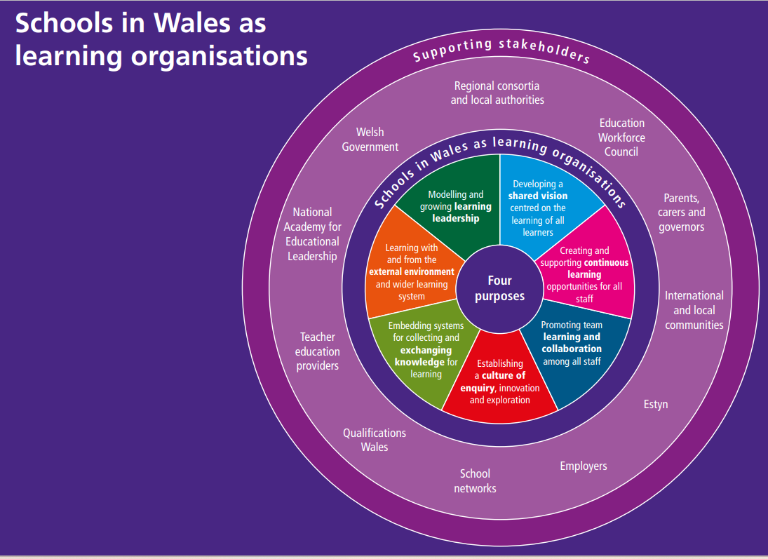
Welsh Government. (2018). Schools in Wales as learning organisations. Available at: WG35678 (gov.wales). (Accessed on: 04/04/23).

Appendix 3
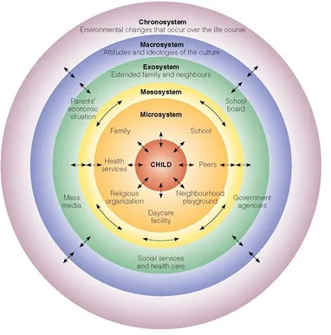
Mcleod, S. (2023). Bronfenbrenner’s Ecological Systems Theory. Available at: Bronfenbrenner's Ecological Systems Theory - Simply Psychology (Accessed on: 29/03/23).

Appendix 4

Keany, M. (2019). ‘Framework on the Six Types of Parental Involvement’. School Leadership 2.0. Available at: Framework on the six types of parent involvement - School Leadership 2.0 (schoolleadership20.com). (Accessed on: 11/04/23).

Appendix 5

Constantino, S. (2023). Engage Every Family: Five Simple Principles. Available at: Family Engagement - Dr. Steve Constantino (drsteveconstantino.com). (Accessed on: 29/03/23).

All identifiable characteristics have been blanked out within the reference list and the appendix however, turnitin removed this during the draft upload due to technical issues, apologies if this has happened once again.

