Female Character Representation in Concept Art in the Animation Industry.

Charlotte Holly Preston
Swansea College of Art, UWTSD
Cpreston.145222@student.uwtsd.ac.uk
Cpreston076@gmail.com

Keywords:
Female, Representation, functional, concept, design

Table of Contents:

  - . List of Illustrations_________________________________________________3

  - . List of Images_____________________________________________________4

  - . List of Tables______________________________________________________4

  - . Introduction______________________________________________________5

  - . 2 Methodology____________________________________________________5

  - . 3 project-specific Research__________________________________________7

  - . 3.1 Discussions of Progress__________________________________________7

  - . 3.2 An Awareness of Design__________________________________________8

  - . Proposed Outcomes of Further Research_______________________________9

  - . Conclusion________________________________________________________9

  - . Bibliography_____________________________________________________10

List of Illustrations:

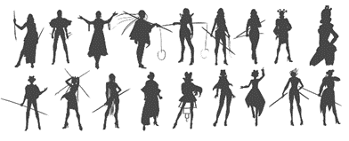
. Female character Silhouette concepts (Personal work). ---------------------------------------------------------6
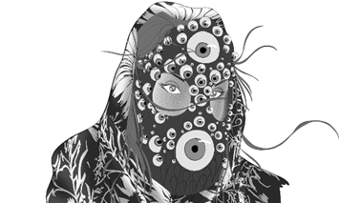
. VR Wizards Project, concept art (Personal work). -----------------------------------------------------------------8

List of Images:

- Lara Croft Development Concept Art (Концепт-арт, 2015)

- Adventure Time Flame Princess Concept Art (Sugar, 2012)

- Steven Universe: Art and Origins (Vignette, 2018)

- Steven Universe Opal Concept Art (Steven Universe Wiki, 2014)
5.) Adventure Time Marceline Concept Art (Sugar, 2012)

List of Tables

- 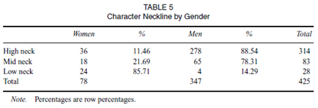 (Beasley and Standley, 2002)
- 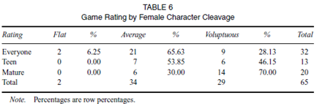(Beasley and Standley, 2002)

Introduction
This proposal shall explore the representation of female character design within the modern animation industry, through diverse designs, events and occasions in which female characters are used. There seems to be a shift in development, through conversations when creating female character concept designs. While this proposal explores the ways in which females have been represented there are also a multitude of concerns that stem from the messages that are being sent to the animation’s female and male audience. Through observing information gathered by Beasley and Standley, and many other researchers, the information will be used to try and find a solution to these design challenges through personal work, and through using art-based research. The results state a clear undeveloped amount of realism within many female character concepts that are currently largely widespread.

2 Methodology
The methodology of the paper will be researching into and exploring the design choices and outcomes of female character designs in the animation industry. Analysing and understanding the consequences of misrepresenting a large demographic. While looking into the statistics of male to female character ratio of designs that are functional over misrepresentation. Which leads into the question that the research will either confirm or deny, is the animation industry progressing in its representation of female character concepts. The key objectives that the paper will be outlining are the concerns to this topic and shall go through each of them in turn, including:
. Examining the use of female character designs in the animation industry,
. Gathering an audience’s perspective on the matter,
. Investigate the misrepresentation of female design,
. Gather statistics on these concerns,
. Suggest a possible solution,
. Study ways in which to correctly portray females in concept art through personal work.
The research will explore into ways and methods to solving this on-going issue and find ways to combat these problems, to both examine these problems and provide a clear solution to said questions.
When exploring this subject there are two main methodological choices to take into consideration, this being the difference between qualitative and quantitative research, both of which shall be explored when conducting the main research. The collection of qualitative data shall be gathered through conducting questionnaires and gathering language based research through the general public regarding this topic. While quantitative data shall be taking information from statistics and research conducted by researchers. While most research papers focus on a main out of the two, this paper shall use both methods of gathering the data needed to come to a strong conclusion, so the answer takes the words of the general public and compares the mathematical findings from the quantitative data to equate to an outcome.
When a concept artist does not fully understand the reality of designing characters for a large demographic, they create work that indirectly doesn’t correctly represent these people. The preferred outcome to this proposal would be to use the information to create female designs that feel functional and believable.
Although, several problems arise when discussing the topic of female character design due to many different opinions verses the factual information. There are those that can see the appeal of most female character design, such as Tomb Raider’s Lara Croft, while her design has many aspects of a female adventurer, she doesn’t retain a realistic functional design.
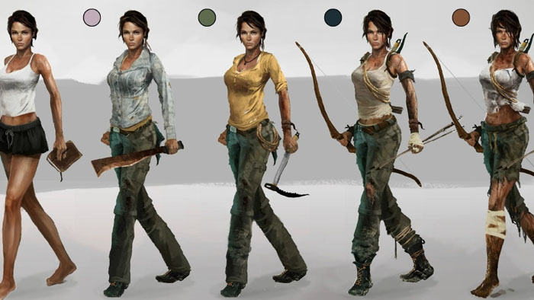
(Концепт-арт, 2015)
For the game to be set in a hyper-realistic world, the character’s design doesn’t show protection against her surroundings. While taking this into consideration, the dissertation shall be researching and experimenting into both a quantitative and qualitative strategy when collecting the information to analyse.
This approach to the research collection shall include both individual and group involved opinions when discussing the strategy and shall investigate collecting questionnaires, while also reading into academic papers written on the topic of female character design. Writers such as Kinzie and Joseph, Beasley and Standley, McNiff, Bolton, Buchan, Bradley, Bush, B and SP shall be used in evaluating the current circumstance. As a result, this uses both qualitative and quantitative data analysis.
Art-based research shall be used as the primary method for finding a solution as a way of understanding and examining the experience of both studies undertaken by researchers and the people who are both creating and affected by the representation of female character design. Through the exploration of female design in personal work, this will hope to take into account a more functional ideation for concepts.
The image below shows a few female character silhouettes from personal work that combats the typical design choices.
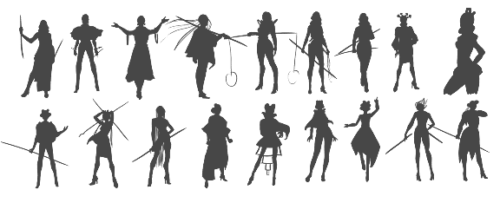
(C.Preston, 2018)
In the past decade the animation industry has been mid-way through a shift in design, specifically towards its female characters. As part of a massive shift many animation companies have been creating designs that still continually bastardise the female form.
Luckily, as animation productions for television have increased they have also become a staple in the socializing in a child’s life. One creative whose been making large progress for both female design and representation, is none other than Cartoon Network’s Rebecca Sugar. Being Cartoon Network’s first female to create an independent series on the network. Steven Universe that she creates shows a plethora of female characters that all break the mould with how female designs are usually tackled. The designs themselves are more about functionality than to sexualise a character.
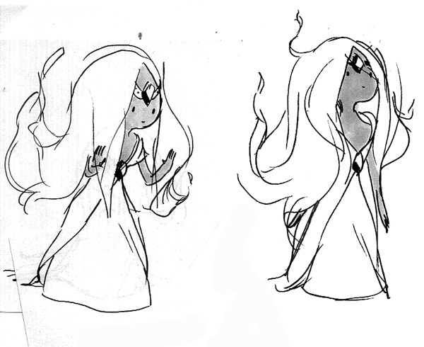
(Sugar, 2012)
This methodology has been structured and catered to effectively answer the research subject and question. While coming to this methodology structure there were many other alternatives to the methods that have been chosen, such as opinion, empirical, archival and analytic methods before resulting in the chosen two. This is partly to gather enough information to decide upon which method the paper should use before choosing one.

3 Project-Specific Research
While a large part of gathering research will be art-based, there are other methods that need to be explored to fully understand the scenario of this representation. Exploring the current creators of our time in the animation industry and their impact into the millennial generation and it’s target audience.

3.1 Discussions of Progress
Rebecca Sugar is Cartoon Network’s female front runner in the industry at current times with her work promoting a positive message for females and shall be analysed for her work and contribution to this positive movement throughout the paper. Sugar states multiple times in the “Steven Universe Art and Origins” book how “The crew makes the show” and that everyone in the crew weighs in on the show.
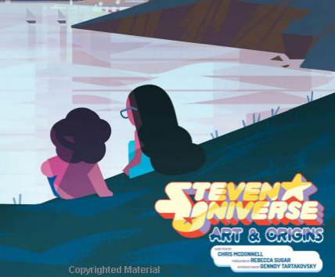
(Vignette, 2018)
The creator coming from a background of female dancers gave her a comprehensive understanding of movement and a realistic understanding of the female form in an everyday and realistic approach.
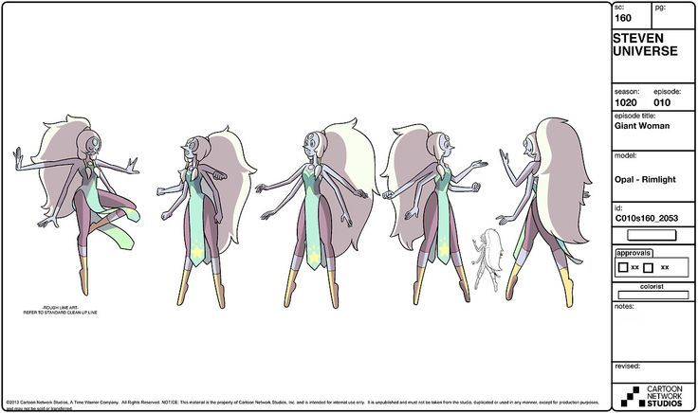
(Steven Universe Wiki, 2014)
Having a creative team that has a background of correctly representing women in other animated shows helps immensely. For example, Rebecca Sugar had previously worked on Cartoon Network’s Adventure Time. Along with fellow storyboard artist Hilary Florido who worked on another of Cartoon Networks animated series, “Regular Show”.
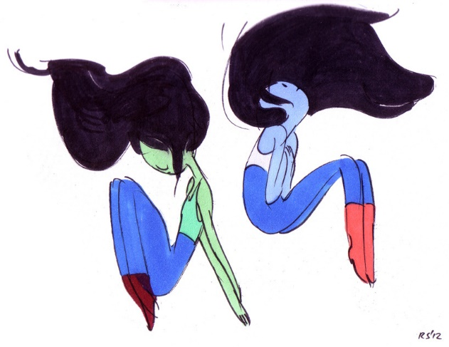
(Sugar, 2012)
“Adventure Time” a show, another of whose female characters aren’t visually sexualised or misrepresented. This being largely due to the creative team involving as many women as men.

3.2 An Awareness of Design
This is something that can be seen throughout the creative industries including both the animation and games industries. Many gaming and animated series characters have a lack of female characters within their stories, as an example out of an analysis of 47 selected games this concluded that only one in four gaming characters were female. These results while still not being its optimistic half, also concluded that these female characters were designed and clothed in a manner that exposed a considerably more amount of skin than the male characters and counterparts (Beasley and Standley 2002).
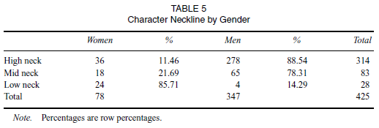
(Beasley and Standley, 2002)
There shows a clear divide when comparing clothing designs especially with the lower body, that are statistically different χ2(5) = 130.98, p < .05 (Beasley and Standley, 2002). Through primary statistics there also shows a statistic change in recent years, although there is still a significant divide in the representation of female characters throughout both the medium of the animation and games industry.
Through exploring the female form in personal work, one main goal is to correctly portray one gender in a more realistic and functional manner.
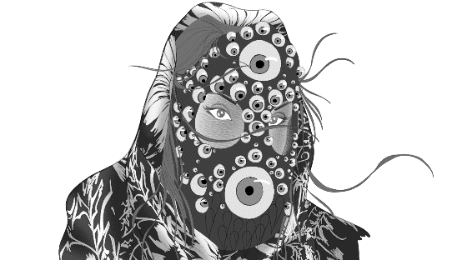
(CPreston, 2018)
As data shows that there is a clear connection between females and the narrative drive of the media in question. In most sources these “fabulations of women” aren’t created by women, and only projecting a pleasurable unreal outcome.
The comparison that Beasley and Standley speak of included heavily gendered clothing items such as skirts. While the cleavage of female characters had also been analysed.
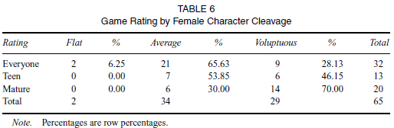
(Beasley and Standley)
Out of a collective of 71 females of whose cleavage is visible, 2.82% had been considered flat chested, 56.34% considered average, and 40.85% considered as voluptuous (Beasley and Standley, 2002). Many of these females that were classed as being voluptuous were unrealistically large. Beasley and Standley go on to state how 31% of these females are in games rated “E” for everyone. This ties into how the test conducted on elementary students noted themselves that female characters had been “gendered by design”. These results not only change girls and women’s attitudes towards games, there are also many other gender implications in topics as simple as confidence and setting technological literacy limitations (Kinzie and Joseph, 2018).

Proposed Outcomes of Further Research
Through planning out the method in which the paper shall be written and through basic research that has currently already been conducted as stated in the section before. The conclusion that both Beasley and Standley settled on was that there is a clear gender role stereotyping within the gaming and animation industries with female characters being considerably underrepresented in these cultures. The same set of results can be seen for the animation industry, with changes to these results only taking effect during the past 5 years becoming the most apparent, as with the release of Rebecca Sugar’s “Steven Universe (2013)”. These same set of results states that female characters that do appear in games are large busted and dressed in a way that emphasises their sexuality by drawing attention to their breasts (Beasley and Standley, 2002). They repeatedly state how this clear gender role discrimination in any media industry let it be games, animation or live action, is unacceptable. Although, this is still an ongoing problem, there has been development in recent years with female characters being designed more in a realistic and functional representation, giving a better look on the female gender and giving the audience more examples of female characters to begin to relate to personally. That ultimately brings a larger demographic of people to engage in the animation at hand.

Conclusion
Overall, there are many aspects to the paper that need to be taken into consideration when weighing up both the positive and negative connotations to the overall subject. Ranging from a key principle of animation: appeal to representing functional design and continuing to please the audience. While there are questions that have answered how the major bulk of the project will be executed, there are also many other elements that need to be investigated before stating a clear answer. This is what the research paper will be exploring, taking some of the research as stated previously and gathering more to make a clear and concise conclusion, this is what the main aim of the investigation shall be showing.

Bibliography:

Websites:
In text:
(Kinzie and Joseph, 2018)
(Beasley and Standley, 2002)
(McNiff, 2007)
(Bolton, 2016)
(Buchan, 2018)
(Bradley, 2018)
(Bush, 2018)
(B and SP, 2018)

- Kinzie, M. and Joseph, D. (2018). Gender differences in game activity preferences of middle school children: implications for educational game design. [online] Springer Link. Available at: https://link.springer.com/article/10.1007/s11423-007-9076-z [Accessed 22 Oct. 2018].
- Berrin Beasley. And Tracy Collins Standley. (2002) Shirts vs. Skins: Clothing as an Indicator of Gender Role Stereotyping in Video Games. [online] semantic scholar. Available at: https://pdfs.semanticscholar.org/a869/79702bd24d79e70d5c6ef75decacc70296ba.pdf [Accessed 22 Oct. 2018].
- McNiff, S. (2007). Art-Based Research. [online] Moz.ac.at. Available at: https://www.moz.ac.at/files/pdf/fofoe/ff_abr.pdf [Accessed 2 Nov. 2018].
- Bolton, C. (2016). Representation and Design Trends in Games. [online] Gamasutra.com. Available at: https://www.gamasutra.com/blogs/ClaireBolton/20161130/286551/Representation_and_Design_Trends_in_Games.php [Accessed 15 Oct. 2018].
- Buchan, S. (2018). The Animated Female Body, Feminism(s) and 'Mushi'. [online] SpringerLink. Available at: https://link.springer.com/chapter/10.1007/978-3-319-73873-4_11 [Accessed 2 Nov. 2018].
- Bradley, M. (2018). Living in the Liminal: Representation of Transgender and Nonbinary Identity in 'Steven Universe'. [online] Digital Commons @ Ursinus College. Available at: https://digitalcommons.ursinus.edu/media_com_hon/8/ [Accessed 15 Oct. 2018].
- Bush, J. (2018). Moana. [online] Available at: https://muse.jhu.edu/article/683746/summary?casa_token=WrlnadXB9HUAAAAA:sCs5_Ld8GkkPLX0vHzkXIXvEpblMrgoApzFTnrC63rFI9Zsnb5uGM3BNwWps9oryg5itkX252Hg [Accessed 30 Oct. 2018].
- B, M. and SP, K. (2018). Visual Media and Communication: A Conundrum of Gender Disparity in Animated World. [online] Globalmediajournal.com. Available at: http://www.globalmediajournal.com/open-access/visual-media-and-communication-a-conundrum-of-gender-disparity-inanimated-world.pdf [Accessed 2 Nov. 2018].

Images:

(Steven Universe Wiki, 2014)

(Sugar, 2012)

(Концепт-арт, 2015)

(Vignette, 2018)

(Sugar, 2012)

- Steven Universe Wiki. (2014). OPAL.jpg. [online] Available at: http://steven-universe.wikia.com/wiki/File:OPAL.jpg [Accessed 2 Nov. 2018].
- Sugar, R. (2012). Rebecca S Tumblr. [online] Rebeccasugar.tumblr.com. Available at: http://rebeccasugar.tumblr.com/image/28810472472 [Accessed 1 Nov. 2018].
- Концепт-арт, P. (2015). Tomb Raider, Lara Croft - Концепт арт, 36 изображений. [online] Концепт арт, постеры и дизайн | wArtBook. Available at: http://wartbook.ru/tomb-raider-concept-art/ [Accessed 1 Nov. 2018].
- Vignette. (2018). Steven universe Art and Origins. [online] Available at: https://vignette.wikia.nocookie.net/steven-universe/images/9/9e/16665023_452640061793218_1984120056830296637_o.jpg/revision/latest?cb=20170207114453 [Accessed 2 Nov. 2018].
- Sugar, R. (2012). RebeccaS page 40. [online] Rebeccasugar.tumblr.com. Available at: http://rebeccasugar.tumblr.com/page/40 [Accessed 2 Nov. 2018].

