Wireless Network Simulation

Paul M Lawrence (P152216) Undergraduate Student, Mcomp Computer Networks
University of Wales Trinity St David, Swansea, Mount Pleasant Campus
plawrence.152216@student.uwtsd.ac.uk

Abstract – The focus of this research paper is to examine 802.11 modulation techniques; Binary Phase Shift Keyring (BPSK), Quadrature Phase Shift Keyring (QPSK) and Quadrature Amplitude Modulation (QAM) there functionalities and limitations within various wireless technologies, further analysis and experimentation will then be carried out using 16-QAM. Using the knowledge gained from these experiments, an example design and simulation of a wireless sensor network (WSN) for a smart factory will be implemented with focus at the Media Access Control (MAC) and physical (PHY) layers with emphasis on throughput, noise and delay utilising QPSK as the modulation technique.

Keywords-component; 802.15.4, 802.11, M-ary, Quadrature Amplitude Modulation (QAM), Media Access Control (MAC), Physical Layer (PHY), Wirelss Sesnor Network (WSN), Fade, Path-loss, Throughput

- A Brief Introduction To 802.11 Wireless Technology

802.11 Wireless Local Area Network (WLAN) [1] technology has made digital communication alot more accessible, affordable and efficient for end users around the world since its conception by the Internet Engineering Task Force (IETF) [2] in 1997. In the last decade the Internet of Things (IoT) [3][4] has grown exponentially, it is estimated that there were 8.4 billion end devices connected to the Internet in 2017 and it is projected to increase to 26 billion by 2020 [5],these end devices are predominantly wireless enabled nodes, that range from wireless sensors [6] to smart phones and tablets.

Therefore 802.11 WLAN engineers are constantly looking at ways to create higher throughput, minimum delay, high signal-to-noise ratio (SNR) [7] and lower bit-error-rate (BER) [7] within WLAN hardware products to keep up with the increasing consumer demands in the wireless technology age we live in today.

Wireless technology is still regarded as in its infancy as there are lots of challenges that still need to be contended with; from the modulation/de-modulation [8] of data using various modulation techniques in order to increase throughput and reduce BER; to navigating the noise [9] that is created within the 802.11 frequency band from everyday objects i.e. microwave ovens, electronic wiring, other 802.11 enabled wireless devices etc, also dense physical objects obstructing wireless signals is a significant issue within wireless technology i.e. walls, buildings, hills, trees etc which interfere with the frequency wave transmitted resulting in lower SNR and higher BER. [10][9]

Wireless Modulation
Wireless modulation is a telecommunications [11] standard that can be used for both analogue and digital communications [12]. For the purpose of this paper digital modulation will be the focus. Modulation is a technique used to convert data into a frequency wave to be sent from one wireless node to another through the air and then converting the frequency wave back to its original state (data) at the other side using de-modulation shown in figure 1. [13][14]

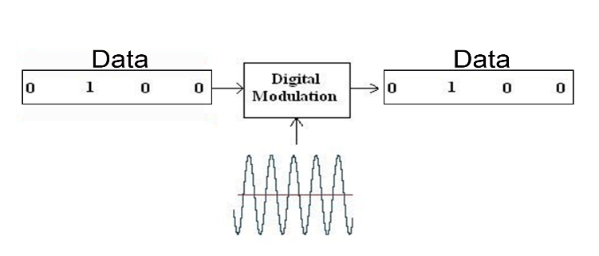
Figure 1: 802.11 Simplified Modulation Theory Example [15]
This is accomplished by mapping binary bits within a 360° constellation for the de-modulator to interpret at the other side, the more data that is sent per phase the more complex the symbol becomes that represents the data within its constellation, the greater the chance errors will occur during demodulation, this will be analysed in more detail later in the report. [8][13]

Microwaves are most commonly used within 802.11 wireless data transmission and operate within the 2.4 GHz frequency band that has 13 channels assigned (Europe) that overlap due to the small space that they operate within shown in figure 2 which results in high noise within this frequency space. The 5GHz frequency band that has 23 non-overlapping channels assigned.

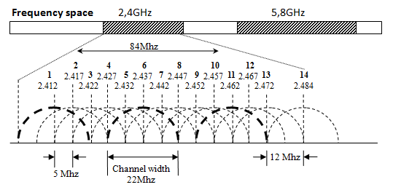
Figure 2: 802.11 WLAN 2.4GHz and 5GHz Frequency Band [16]
Because of this noise within the 2.4GHz frequency band, complex modulation techniques have a lower SNR and higher BER the further distance the carrier wave travels through the environmental noise. The advantages of using more complex modulation techniques is that they can carry more bits per symbol resulting in a higher throughput. The disadvantage is that they produce more errors the further they travel as they become corrupt by environmental noise. [17] [7] [10]

There are many types of narrow band modulation techniques and standards utilised within 802.11, 802.15.4 Wireless Sensor Network (WSN) [18] and 802.20 Wireless Wide Area Network (WWAN) [19]hardware, they each have their strengths/weaknesses and specific usages :

Binary Phase Shift Keyring (BPSK); This modulation standard is considered very basic because only a 1 or a 0 is represented per symbol per phase by 180° of phase shift by the carrier wave within its constellation shown in figure 3. BPSK was most commonly used for long distance communications between cellular towers due to its reliability, power transmission efficiency and higher data accuracy during de-modulation resulting in a high SNR and low BER.The disadvantages are that it has a very low bandwidth throughput because of the 1:1 Ratio of bits to signal carrier making it inefficient within modern digital communication. [20]–[22]

Within modern digital communications BPSK is often used within low powered wireless sensors that only transmit very small amounts of data due to its robustness, low power consumption and demodulation accuracy within high noise environments. [23][24]

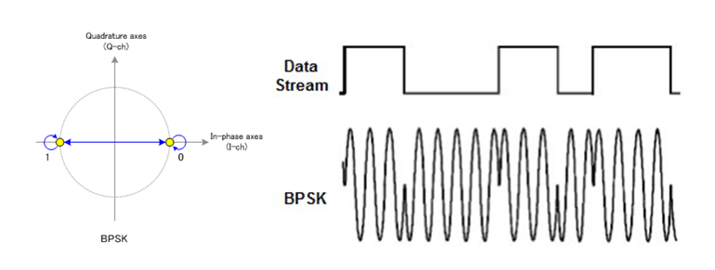
Figure 3: BPSK Constellation and Carrier Wave Example [25][26]
Quadrature Phase Shift Keyring (QPSK): This modulation standard is similar to BPSK in the fact that it uses phase to represent binary data but instead of its carrier wave representing 1 bit at a time, QPSK can transmit a pair of bits per symbol per phase represented at 45° intervals within its constellation giving it a 2:1 bit to signal carrier ratio shown in figure 4. The advantage of this modulation standard is that it has double the data throughput than BPSK but has a higher percentage of error during demodulation because of its four possible states as opposed to BPSK’s two, it’s also less power efficient during transmission because of this. [8], [27]–[29]

QPSK is most commonly used within low to medium powered sensors that transmit small amounts of data within a WSN. Because of QPSK’s low power consumption and low BER efficiency within high noise environments, it is considered a robust modulation technique within the WSN industry. [30]
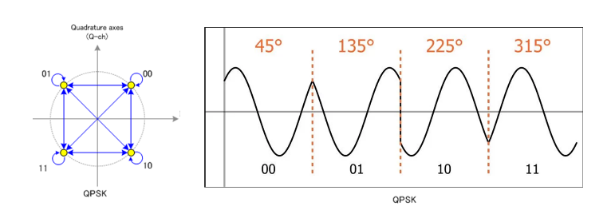
Figure 4: QPSK Constellation and Carrier Wave Example [26]
Quadrature Amplitude Modulation (QAM); 16-QAM modulation standard can represent 4 bits or a nibble per complex symbol using both phase and amplitude to achieve higher throughput, making demodulation a lot more complex compared to BPSK and QPSK. QAM’s constellation is similar to QPSK as bits are represented using degrees per phase, the added difference that QAM uses is that each phase can be represented by a different amplitude. Utilising amplitude within the QAM constellation allows more bits to be represented per symbol shown in figure 5. The advantages of 16-QAM is that it has double the throughput compared to QPSK and quadruple the throughput compared to BPSK giving it a 4:1 bit to signal carrier ratio. The disadvantage of this modulation standard is that the further the distance the wave travels the higher the BER and lower the SNR during demodulation due to distortion/corruption of the frequency carrier wave because of environmental noise combined with the fine margins between each symbol within its constellation. [8], [31], [32]

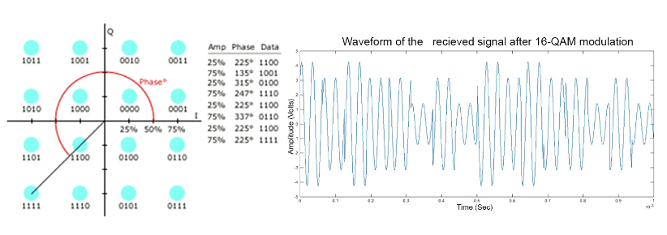
Figure 5: 16-QAM Constellation and Carrier Wave Example [26]
When more than four symbols are represented within a constellation using phase and amplitude it is referred to as M-ary modulation i.e. M-QAM etc with the M representing the number of symbols that can be represented within its constellation i.e. M= 16 creating 16-QAM, a simple formulae can be used to calculate how many symbols are represented within a constellation; M= 2 ^ K with the 2 representing binary and the K representing the number of bits per symbol, so 16-QAM would be M= 2^4, this formulae can also be reversed by using a logarithm operation to find K from M to learn the number of bits being transmitted per phase i.e. 16-QAM = log₂ (16) = K = 4 bits per symbol. [33][34]

QAM can be further segmented for higher throughputs by plotting more points within its constellation using the M-ary formula creating 32-QAM that can transmit 5 bits per phase and 64-QAM that can transmit 6 bits per phase shown in figures 6.

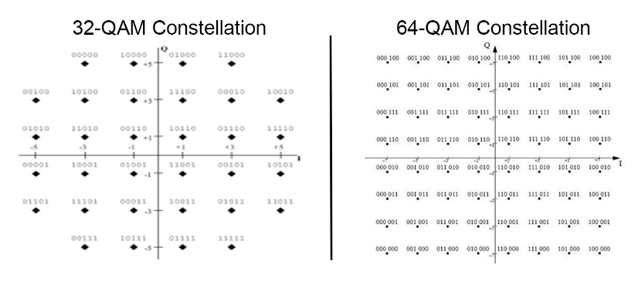
Figure 6: 32-QAM and 64-QAM Constellation Example [35][26]
This trend can be further increased for higher throughputs i.e. 128-QAM [36], 256-QAM [37] and higher.

However, the more complex the constellation becomes the less distance the signal can travel before becoming corrupt by environmental noise due to the high BER and low SNR for reasons previously discussed. Variants of QAM can be used for both digital and analogue modulation.

QAM is most commonly used by digital terrestrial television companies to deliver User Datagram Protocol (UDP) data such as voice and video that can handle a certain percentage of data loss during streaming, also it is often used within satellite communications for its high spectrum utilisation and throughput. [12] [38] [39]

Network Simulation Software
An experiment will be conducted to explore the relationship between SNR vs BER within QAM modulation using computer simulation software as opposed to mathematical proofs or using test-bed equipment. This approach is preferred because of time constraints, the lack of advanced mathematical/electrical engineering knowledge and the funds needed to develop the hardware required. The disadvantage of using simulation software as opposed to test-bed hardware is that a simulation won’t be 100% accurate to physical hardware due to various factors i.e. quality of hardware components, real time environment parameters etc. [40]

A mathematical proof although theoretically accurate, cannot factor in environmental noise and provide a graphical representation of the processes/tools utilised, also if variables need to be modified or added the proof would have to be re-written. However, using simulation software is considered a more efficient, modern and reliable way of performing multiple bespoke simulations in a fraction of the time and cost that legacy experiments were previously performed due to the increased computational power and capacity of modern computers/servers.

The advantages of industry approved simulation software such as ‘MATLAB: Simulink’ [40] is that the mathematics and electrical engineering theory used to create the simulation software has been developed by distinguished academics within their fields so there is less room for error within these areas of the experiment as opposed to a computer networks researcher who has no experience within these fields, whom only focuses on developing networking modulation theory for hardware products. Also, the tools/components, environmental factor simulation and libraries preinstalled within the simulation software package provide a much more robust, realistic and reliable testing field for researchers to develop and implement new theoretical designs before spending time and money creating a physical prototype that could fail.

QAM Experiment

The aim of this experiment is to compare the BER and SNR of 16-QAM within a simulated environment by increasing Additive White Gaussian Noise (AWGN) using ‘MATLAB: Simulink’ to identify and prove the relationship of SNR vs BER within higher throughput modulation standards theorised previously in this report.

- Rectangular QAM Simulation Design & Implementation

The 16-QAM simulation experiment was designed using ‘MATLAB: Simulink’ library blocks shown in figure 7.

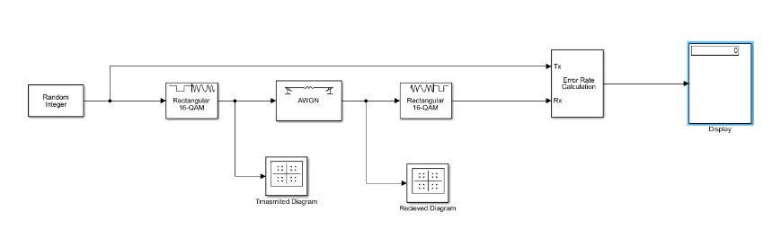
Figure 7: QAM Simulation Design 'MATLAB:Simulink' (Appendix-A) [41]

The components utilised to simulate a 16- QAM environment within ‘MATLAB: Simulink’ consisted of.:
Random Integer Generator; This block generates a frequency signal comprising of a sequence of random integers between 0 and 255. Configuration parameters for this block can be viewed in Table 1.

Parameter | Value
Set Size | 16 (M-ary)
Initial Seed | Auto
Sample Time | 1e-6
Samples Per Frame | 1024
Output Data Type | Double
Table 1:Random Integer Generator Configuration Parameters [41]
Rectangular QAM Modulator Baseband; This block modulates the signal from data to frequency using baseband 16-ary QAM (16-QAM). Configuration parameters for this block can be viewed in Table 2 and 16-QAM integer constellation can be viewed in figure 8.

Rectangular QAM Demodulator Baseband; This block demodulates the frequency signal generated by the modulator block back to data. Configuration parameters for this block can be viewed in Table 2 and the 16-QAM integer constellation can be viewed in figure 8.

Parameter | Value
M-ary Number | 16
Input Type | Integer
Constellation Ordering | Grey
Normalization Method | Peak Power
Peak Power | 1 Watt
Phase Offset (rad) | 0
Table 2: 16-QAM Modulator/ Demodulator Configuration Parameters [41]
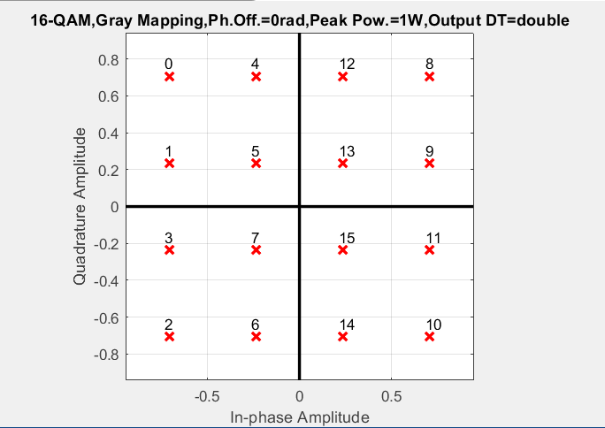
Figure 8: 16-QAM Experiment Integer Constellation [41]
QAM modulator and demodulator blocks were used from the MATLAB library because of the complexity of the modulation technique as it falls into the category of ‘Electrical Engineering’, networking researchers use this method due to the lack of knowledge within this industry in order to retrieve accurate results.

AWGN Channel; This block simulates environmental noise by adding white gaussian noise to the modulated signal. Configuration parameters for this block can be viewed in Table 3. [42]

Parameter | Value
Initial Seed | 0
Mode | SNR = (Eb/No)
Eb/No (dB) (SNR) | Will be varied during the experiment to compare SNR v BER. The starting value will be 0
Number Of Bits Per Symbol | 4
Input Signal Power | 1 Watt
Symbol Period | 1e-6
Table 3: AWGN Configuration Parameters [41]

For analysis of the data being simulated before AWGN is added and after, measuring blocks were added at various intervals of the design:
Transmitted Constellation Diagram; This block displays a scatter plot of the signal after modulation but before the AWGN is added.

Received Constellation Diagram; This block displays a scatter signal plot of the frequency signal after it has passed through AWGN.

Error Rate Calculation; This block counts and compares symbols that differ between the received signal and the transmitted signal.

Display; This block is situated at the end of the design and displays:

- The first value displays the BER.

- The second value displays the total number of errors.

- The third value displays the total number of bits processed during the simulation.

These values will be used to plot the SNR v BER graph after three experiments with varied Eb/No (DB).

- Conducting the Experiment

All configuration values will remain the same during the experiment apart from the Eb/No (DB) which will be altered during each experiment to compare the relationship between SNR v BER previously discussed in the report.

Simulation 1:

In this simulation the Eb/No was set to its lowest point of 0. The received constellation points shown in the scatter plot on the right side in figure 9 on first visual inspection had a high amount of environmental noise due to the low SNR compared to the transmitted signal shown within the scatter plot on the left side that only contained the coordinates of the data after modulation and before environmental noise was added.

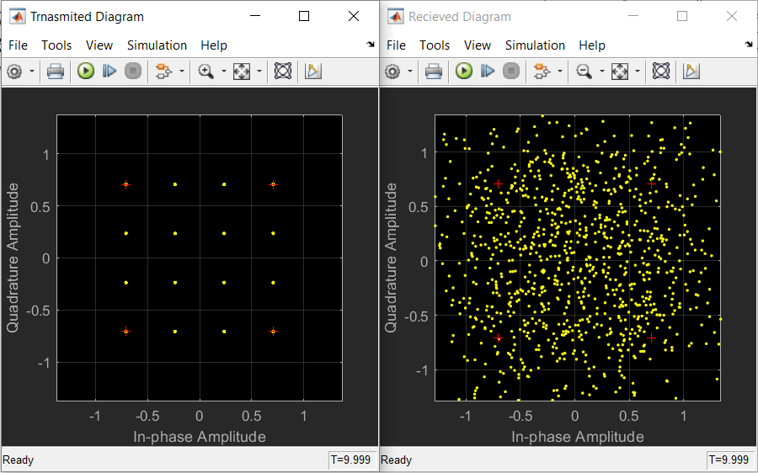
Figure 9: Simulation-1 16-QAM Transmitted and Received Constellation Scatter Plots Eb/No (dB) set to 0 [41]
The display output in figure 10 showed a high BER of 61% confirming the analysis of the received signal scatter plot in figure 9.

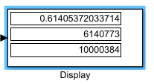
Figure 10: Display Output of the BER from Simulation 1 [41]
Simulation 2:

In this simulation the Eb/No was set to 10. The received constellation points shown in the scatter plot on the right side in figure 11 looked less noisy visually on first inspection compared to simulation 1 and the plots looked more grouped in comparison.

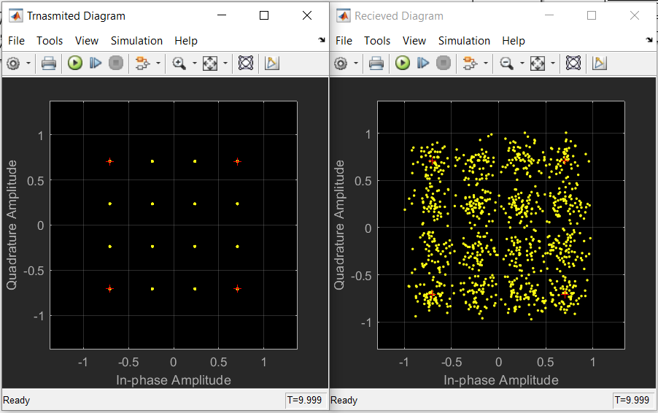
Figure 11: Simualtion-2 16-QAM Transmitted and Received Constellation Scatter Plots Eb/No (dB) set to 10 [41]
The display output from simulation-2 shown in figure 12 confirmed the initial visual findings from the scatter plots in figure 11. The BER had dropped to 5% with the Eb/No (dB) set to 10.

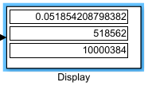
Figure 12: Display Output of the BER from Simulation 2 [41]
Simulation 3:

In this simulation the Eb/No was set to 20. The received constellation points shown in the scatter plot on the right side in figure 11 were tightly grouped visually on first inspection with a lot less scattered noise.

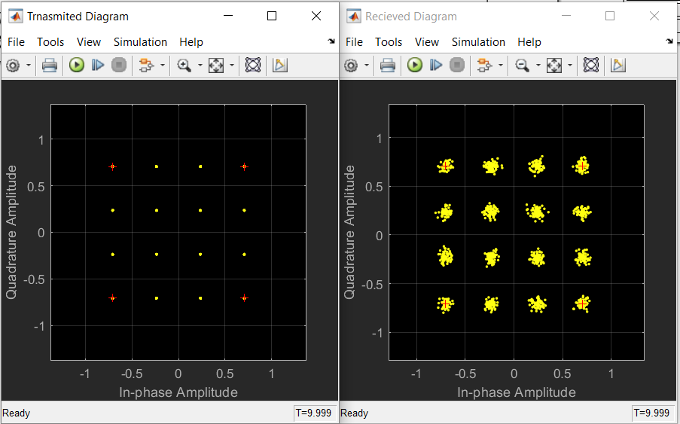
Figure 13: Simulation-3 16-QAM Transmitted and Received Constellation Scatter Plots Eb/No (dB) set to 20 [41]
The display output from simulation 3 shown in figure 14 confirmed the initial visual findings from the scatter plots in figure 13. There were no errors with the Eb/No (dB) set to 20.

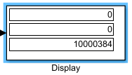
Figure 14: Display Output of the BER from Simulation 3 [41]
Correlating the Data:

To accurately plot the relationship for SNR v BNR within a graph, additional simulations were conducted from 0db until the BER percentage was at 0 to accurately identify and then plot the relationship within a graph shown in table 4.

Simulation Number | SNR - Eb/No (dB) | BER - Percentage
1 | 0 | 60%
2 | 1 | 57%
3 | 2 | 51%
4 | 3 | 45%
5 | 4 | 38%
6 | 5 | 32%
7 | 6 | 26%
8 | 7 | 19%
9 | 8 | 14%
10 | 9 | 8%
11 | 10 | 5%
12 | 11 | 3%
13 | 12 | 1%
14 | 13 | 0%
Table 4: Simulation Results SNR vs BER (0dB to 13dB) [41]

Using the data collected from simulations 1-14 shown in table 4 a graph was produced depicting the relationship between SNR v BER using ‘Microsoft Excel’ shown in figure 15.

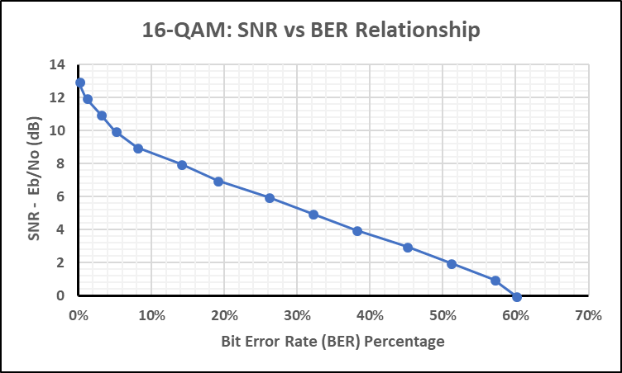
Figure 15: Line Graph Containing 16-QAM Experiments 1-14 SNR v BER Relationship [41], [43]

- Experiment Conclusions

After analysing the results, the experiment confirmed the hypothesised outcome of SNR v BER stated earlier in this report, that the higher the SNR the lower the BER within digital modulation.

Wireless Sensor Network - Smart Factory Simulation
As discussed previously in the report, WSN’s are becoming increasingly common within homes, offices, factory’s etc in order to provide a smart autonomous solution to monitor and control everyday appliances/machinery through a centralised server across a WAN and/or LAN for; security, safety, efficiency and environmental reasons. For the purpose of this report a WSN will be designed, simulated and analysed for a 50m x 25m diameter ‘Smart Factory’ to identify and understand the engineering challenges that need to be overcome to provide a robust WSN network that safely and securely meets end user’s needs. [4], [44], [45]
- Smart Factory Design

Using the knowledge gained from the 16-QAM modulation experiment and the modulation research, a WSN consisting of 802.15.4 Zigbee [46] Low-power Wireless Personal Area Network (LoWPAN) technology along with 802.11 WLAN technology will be designed and implemented using QPSK as the modulation standard because of its low power consumption and robustness within a high noise environment, as opposed to 16-QAM that proved to have a high BER within a noisy environment during simulation analysis and high power consumption identified during research. QAM modulation would not be effective within a noisy environment such as a factory that has low powered sensors implemented within its network in comparison to QPSK for reasons previously stated. [30][8]

802.3 wired LAN will be utilised for the backbone of the network using network simulation software ‘Netsim’. [47]

The smart factory WSN segment of the network will consist of 802.15.4 sensors located throughout the factory building that will control and monitor appliances through a centralised server: [48]
- Lighting.
- Internal/External doors.
- Occupancy.
- Motion.
- Fire Safety.

The smart factory physical layout will consist of four rooms that will contain the internetworking equipment, 802.11 end devices and 802.15.4 wireless sensors shown in figure 16:

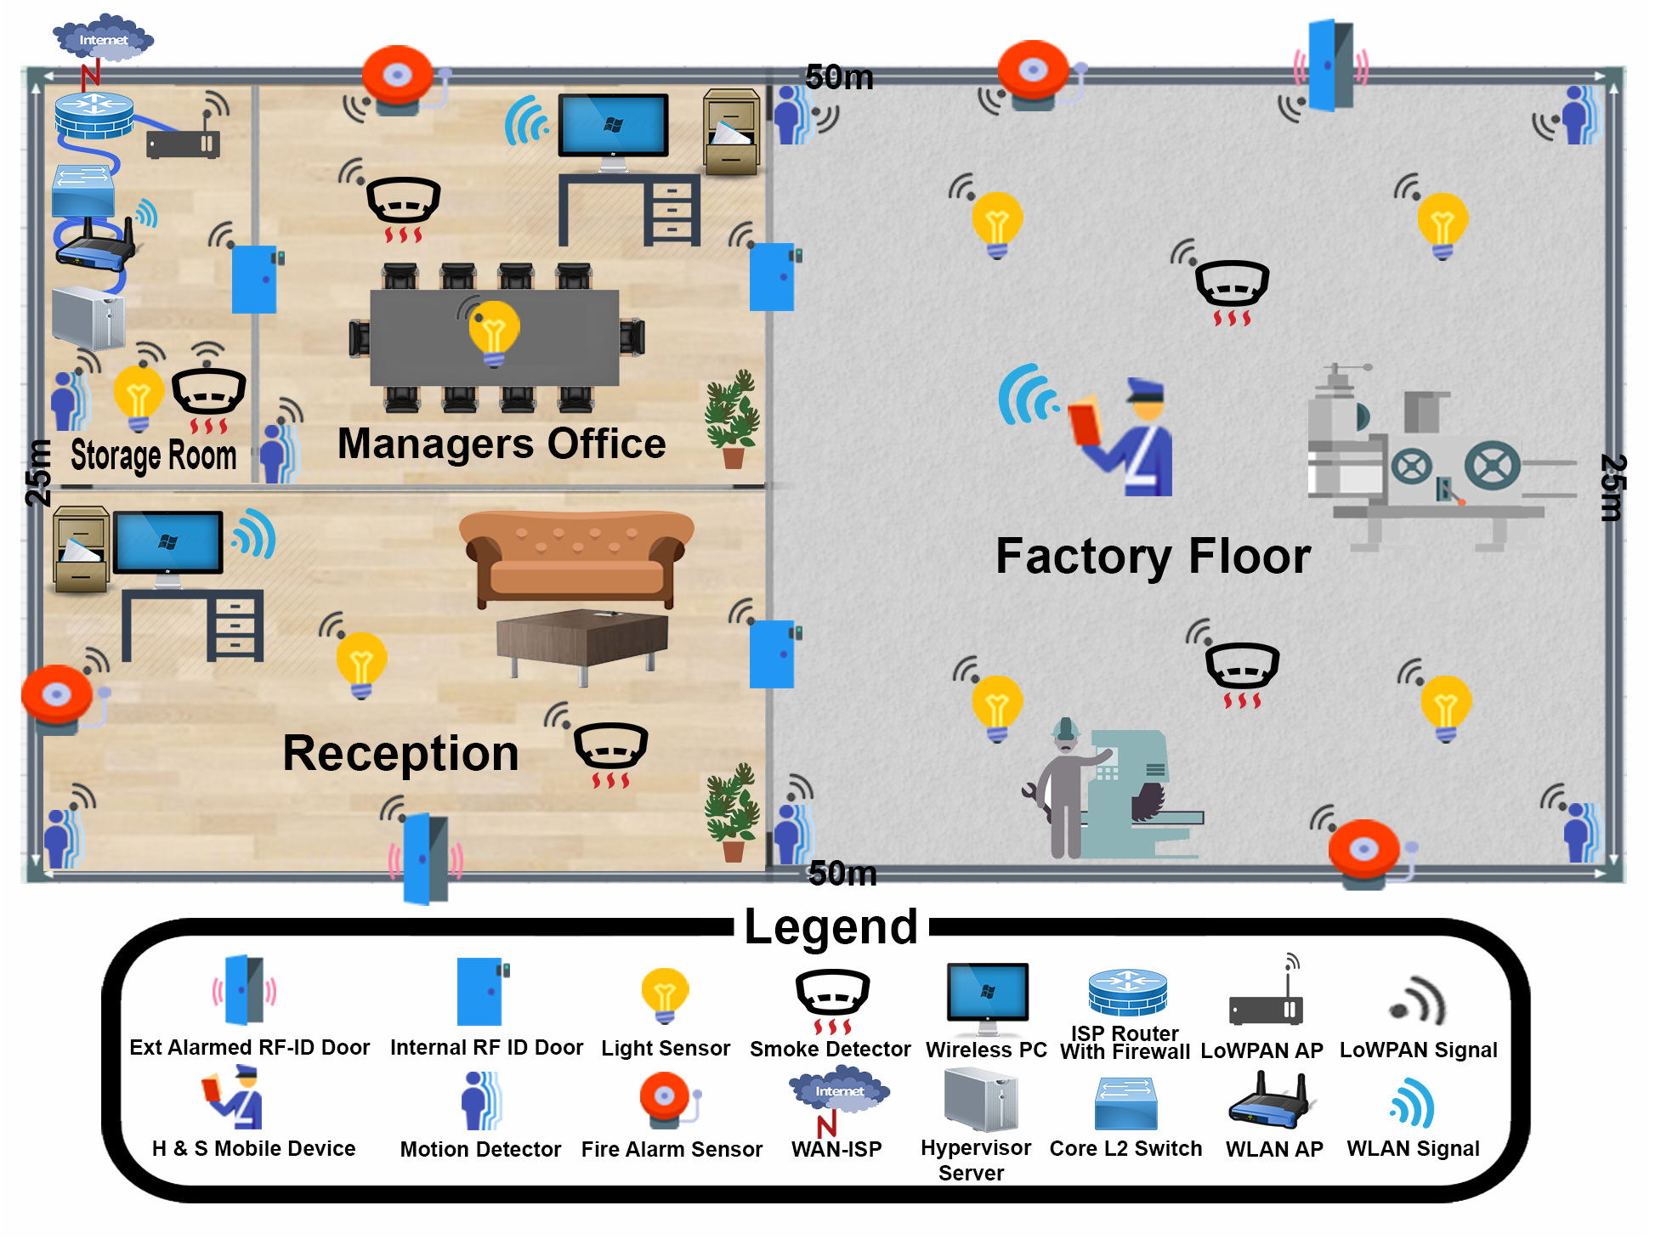
Figure 16:Smart Factory Physical Topology [49], [50]
Factory Floor: The factory floor consists of 802.15.4 sensors: 4 x light, 4 x motion detectors, 2 x smoke detectors with integrated sprinklers, 4 x fire alarms, 2 x internal RF ID secure doors, 1 x external RF ID [51] [52] alarmed secure door and 1 x Health and Safety (H&S) officers smart device that is 802.11 wireless enabled.

Managers Office: The managers office consists of 802.15.4 sensors: 1 x light, 1 x motion detector, 1 x fire alarm, 1 x smoke detector with integrated sprinkler, 2 x internal RF ID secure doors and 1 x 802.11 wireless PC.

Reception: The reception consists of 802.15.4 sensors: 1 x light, 1 x fire alarm, 1 x smoke detector with integrated sprinkler, 1 x motion detector, 1 x internal RF ID secure door, 1 x external RF ID alarmed secure door and 1 x 802.11 wireless PC.

Storage Room: The storage room consists of 802.15.4 sensors: 1 x light, 1 x motion detector, 1 x smoke detector with integrated sprinkler and 1 x internal RF ID secure door. The secure storage room also contains the internetworking equipment for the smart factory: 1 x 1GB Internet Service Provider (ISP) WAN connection, ISP facing router with integrated firewall, layer-2 managed switch, 802.11 AP, 802.15.4 LoWPAN AP and a Hypervisor server that consists of Windows server 2012 for the WLAN segment of the network and Linux-Free BSD for the control plane of the 802.15.4 segment of the network because of its low resource utilisation and efficiency.
- Connectivity

The 802.15.4 ZigBee sensors will wirelessly connect to a LoWPAN Access Point (AP) [53] that will feed the data collected from the sensors through the 802.3 wired backbone located in the secure storage room to the Linux- Free BSD server that will analyse, monitor and control the devices.

The logical configuration of the devices are as follows:

802.12.14 connectivity:

The 802.15.4 sensors will be hard wired into the buildings Alternating Current (AC) electricity using low powered cables and transformers to provide 6 amplitudes and 24 volts of power that the sensors require. A backup rechargeable battery will also be installed in case of power failure within the building.

- Motion Detectors and Lights

The motion detectors and lights will be logically paired for the server to make logical decisions whether to turn on the lights if motion is detected within a room or turn them off if no motion is detected over a period of 5mins. These sensors will be efficient for the staff, environmentally friendly and also save the factory money on electricity. [54]

- Smoke Detectors and Fire Alarms

The smoke detectors with integrated sprinklers will be logically paired with the fire alarms so that the server can make a logical decision to activate the sprinklers, sound the fire alarm and send a signal to the local fire station for emergency assistance in the event the smoke detectors detect high levels of carbon monoxide and/or nitrogen oxide within the building.

These sensors will be crucial in the event of an emergency within the factory where there is a higher probability of a fire occurring due to the nature of the business. Utilising a smart fire safety system could save lives because of the response time of the automated logical system as opposed to human reaction time, making the company more attractive for employees to work and will also reducing the company’s fire damage insurance. [55]

- Internal/External RF ID Doors

The internal/external door sensors will communicate with the server’s database to securely open the doors when the correct authorisation badge is presented to the RF ID pad and send an alert if a door has been accessed unlawfully. Using the database created by the doors for entry/exit, room occupancy can be calculated and then monitored for security/fire health and safety reasons. The external RF ID doors will also be alarmed when the building is empty utilising the occupancy database created within the server by the door sensor data.

For Health and Safety reasons to exit a door within the building an RF ID badge will not be necessary. However, the internal handle will be linked to the RF ID sensor to calculate occupancy. [56]

802.11 connectivity:

The WLAN segment of the network will also connect to the backbone via an 802.11 AP. This portion of the network will be utilised by wireless end devices used by the staff throughout the factory i.e. receptionist’s terminal, managers terminal and the health and safety officer’s smart device to access the company’s internal files located on the server. The Health and Safety officer will also have access to the WSN monitoring software ‘Solar Winds’ and the control plane interface for the sensor devices in the case of an emergency during office hours, so he/she can safely evacuate the building and provide a report to the fire officers on arrival to identify the location of the fire and if there is anyone still in the building and if so what room they are in utilising the occupancy monitoring strategy implemented from the RF ID doors, so they can be rescued quicker.

WAN remote connectivity:

A Virtual Private Network (VPN) [57], [58] will also be established using Advanced Encryption Standard (AES) -256-bit encryption [59] from the ISP router to an external security monitoring company ‘Warehouse Secure’ that will have access to the ‘Smart Factory’ monitoring software ‘SolarWinds’ [60], they will be responsible for the building security that will be linked to the WSN after office hours. Warehouse secure will only have access to the monitoring software and not the control plane of the WSN and the factory’s data for security and data protection reasons.

- Security

An ISP router with integrated firewall was utilised for added security at the WAN portion of the network to prevent unauthorised persons accessing the network remotely for malicious purposes, protecting the data housed within the network and the wireless sensor applications. [61], [62]

802.15.4 ZigBee variant was selected because it offers security and communication not just at layer-2 of the Open Systems Interconnections (OSI) model as other 802.15.4 standards offer but to the upper layers also, allowing granular control at the network, transport and application layers, permitting authorisation, authentication, encryption for security and routing between the devices which is more appropriate for industrial applications that are responsible for Health and Safety of workers. [63]

All 802.11 and 802.15.4 ZigBee communications will be encrypted using AES to prevent Man In The Middle Attacks (MITM) from rogue actors maliciously trying to capture the network traffic for personal gain. [64], [65]

Authentication, Authorisation and Accounting (AAA) [66] will be implemented for the 802.11 and 802.15.4 ZigBee traffic by using a Mobile Device Management (MDM) [67] Database (VMware – Airwatch) [68] housed within the Windows 2012 server to prevent unauthorised personnel accessing the network, this design implementation also prevents rogue devices being installed within the network, logs will also be created for network access analysis.

The Internetworking equipment is secured using Message Digest 5 (MD5) [69] encrypted passwords for accessing the devices via the console port. Secure SHell (SSH) [70] AES-256bit encryption has been configured at the Virtual Terminal Lines (VTY) for remote configuration/maintenance of the devices by the external network administration company.

The Internetworking equipment is stored in a locked RF ID room for physical security in which the manager and deputy manager only have access. When maintenance is performed by the external network administration company, the manager gives them temporary access.

Norton End Point security [71]has been chosen for antimalware and personal firewall of end devices because of its compatibility with the Airwatch MDM server that allows for autonomous installation and maintenance of end devices via the MDM server selected within the design.

- Simulation Brief

The aim of the WSN smart factory simulation using Netsim will be to analyse: [72], [73][74]

Throughput: Within networking throughput is defined as the amount of data being transmitted successfully from one node to the next. It is often measured in bits per second i.e. Megabits (Mb/s), Kilobits (Kb/s) etc.

Packet Loss: Packet loss within wireless networks can be defined as packets being dropped due to errors that is most commonly caused by a corrupt frequency carrier wave due to environmental noise.

Delay: Network delay is defined as how long a packet takes to go from its source node to its destination node. It is most commonly measured in milliseconds.

These variables will be tested and measured by altering the environmental noise:

Pathloss, Fade and Shadowing: Pathloss, fade and shadowing within wireless networks can be defined as the measurement of power density degradation over a distance between nodes during transmission due to propagation, obstacle absorption, natural wave expansion and diffraction. These factors are most commonly caused by the natural environment i.e. free space, air density etc, environmental electromagnetic noise and dense objects. [75]

- Netsim Smart Factory Simulations

To test the efficiency of the ‘Smart Factory’ network four experiments will be carried with the 802.11 wireless end devices and each logical pair of 802.15.4 ZigBee sensors previously identified in the design section of this report.

Experiments:

- Light Sensors and Motion Detectors (802.15.4)

- Smoke Detectors and Fire Alarms (802.15.4)

- Exterior and Interior RF ID Doors (802.15.4)

- 802.11 Wireless End Devices

Each experiment will be performed with and without pathloss, fade and shadowing through two simulations with the focus on the Media Access Control (MAC) sub layer [76] and Physical (PHY) layer [76] to analyses the effect that these environmental variables have on throughput, delay and packet loss. The data from each simulation will then be correlated into a graph to identify the relationship between these variables and if they will function efficiently within the network. The physical topology previously depicted in figure 16 was logically modelled within Netsim to conduct the experiments shown in figure 17

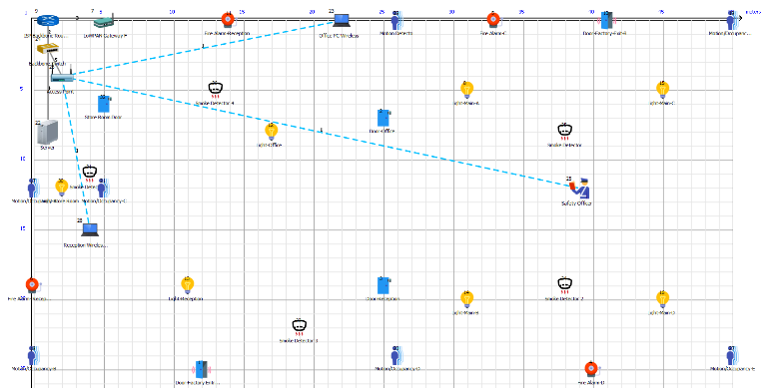
Figure 17: Netsim Logical Topology Design (Appendix-B) [77]
The configuration parameters for the simulation application, 802.15.4 sensors, the 802.11 wireless end devices and pathloss, fade and shadowing that will be applied during the experiments to simulate environmental conditions can be found in tables 5, 6, 7 and 8.

Application configuration settings:

Setting Name | Value
Start Time | 0
End Time | 1000000
Src_to_Dest | Show line
Encryption | AES
Random Startup | False
Packet Size
Distribution | Constant
Value (bytes) | 50
Inter_Arrival_Time
Distribution | Constant
Micro Seconds | 1000000
Table 5: Application Configuration Settings Within Netsim [77]
802.15.4 configuration settings: Interface ZigBee

Setting Name | Value
Network Layer
Network Protocol | IPv6
IP Address | 2001:DEAD:FACE:1::X
Prefix Length | 48
Default Gateway | 2001:DEAD:FACE:1::1
Datalink Layer
Protocol | IEEE 802.15.4
Ack Request | Enable
Max CSMA BO | 4
Max Backoff Expo | 5
Min Backoff Expo | 3
Max Frame Retries | 3
Physical Layer
Protocol | IEEE 802.15.4
Data Rate (kbps) | 250
Modulation Technique | QPSK
CCA Mode | Carrier Sense Only
Transmitted Power (dBm) | 1
Path Loss (dB) | 10
Antenna Gain | 1
Antenna Height (m) | 1
Reference Distance (m) | 8
Network Layer
Routing Protocol | ACDV
Table 6: 802.15.4 Configuration Settings Within Netsim [77]
802.11 configuration settings: Interface Wireless

Setting Name | Value
Network Layer
Network Protocol | IPv4
IP Address | 192.168.1.X
Subnet Mask | 255.255.255.0
Default Gateway | 192.168.1.254
Protocol | ARP
Arp Retry Intervals | 10
ARP Retry Limit | 3
Data Link Layer
Protocol | IEEE 802.11
IEEE 802.11e | Enable
Retry Limit | 4
RTS_Threshold (bytes) | 3000
Rate_Adaption | False
Physical Layer
Connected To | Access Point
Protocol Standard | IEEE 802.11n
No of Packets to Aggregate | 1
Transmission Type | HT
Transmitter Power (mW) | 100
Antenna Gain | 1
Antenna Height (m) | 1
Frequency Band (GHz) | 2.4
Table 7: 802.11 Configuration Settings Within Netsim [77]
Pathloss, Fade and Shadowing configuration settings:

Setting Name | Value
Link Type | Multipoint to Multipoint
Link Medium | Wireless
Link Mode | Half Duplex
Channel Characteristics | Pathloss, Fading and Shadowing
Path Loss Model | Indoor_Factory
Path Loss Exponent | 2.1
Fading Model | Rayleigh
Fadin Figure (m) | 1
Shadwing Model | LOGNORMAL
Standard Deviation (dB) | 5
Table 8:Pathloss, Fade and Shadowing Configuration Settings Within Netsim [77]
Any values not listed within the above tables can be assumed as the default settings.

All simulations were run for 1000 seconds.

Experiment-1: Motion Detectors and Light Sensors (802.15.4)
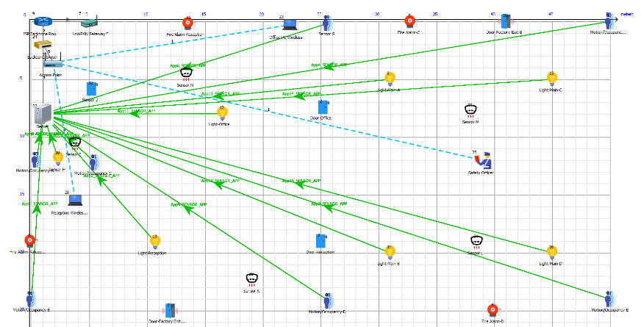
Figure 18: Experiment-1 Logical Topology [77]
Simulation 1a (Without Pathloss, Fade and Shadowing):

The data collected from simulation-1 was correlated into a graph for analysis shown in figure 19.

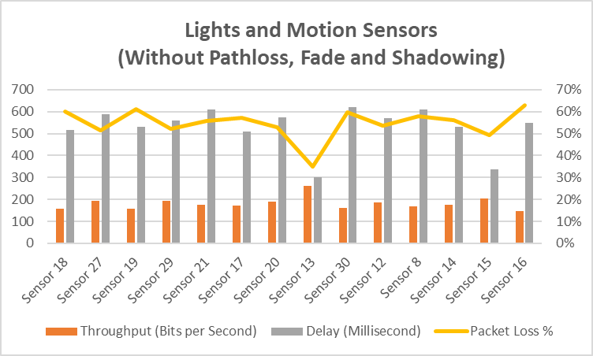
Figure 19: Simulation 1 Data Correlation [77] [43]
Simulation 2a: Without Pathloss, Fade and Shadowing

The data collected from simulation-1 was correlated into a graph for analysis shown in figure 22.

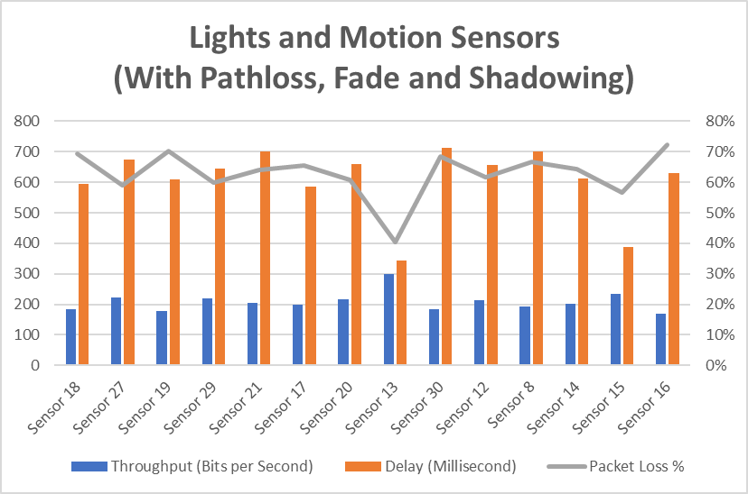
Figure 20: Simulation 2 Data Correlation [77] [43]
Experiment 1 analysis:

After analysing the results from the two simulations, there seems to be an average packet loss of 55% within this segment of the network without environmental noise added. After the pathloss, fade and shadowing is added the packet loss increases to an average of 65%. This may be down to the high delay of the packets reaching their destination over a distance or the LoWPAN access point dropping the packets because there is to much traffic being sent at once further deductions can be made from the rest of the simulations that contain less nodes.

Experiment-2: Smoke Detectors and Fire Alarms (802.15.4)

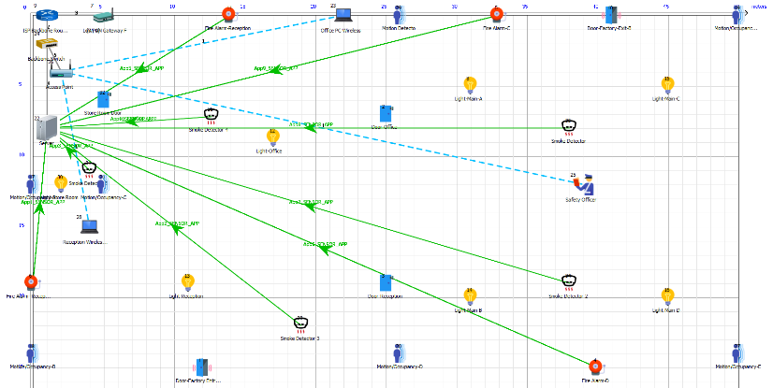
Figure 21: Experiment-2 Logical Topology [77]
Simulation 1b:

The data collected from simulation-1b was correlated into a graph for analysis shown in figure 22.

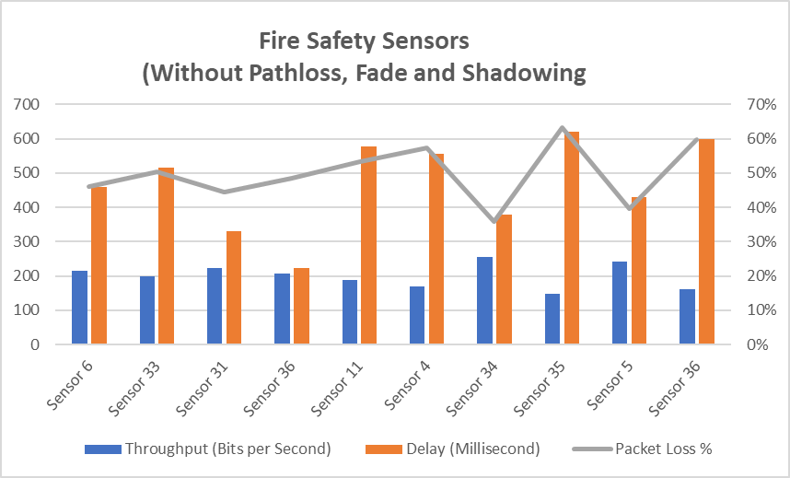
Figure 22: Simulation 1b Data Correlation [77] [43]

Simulation 2b:

The data collected from simulation-2b was correlated into a graph for analysis shown in figure 23.

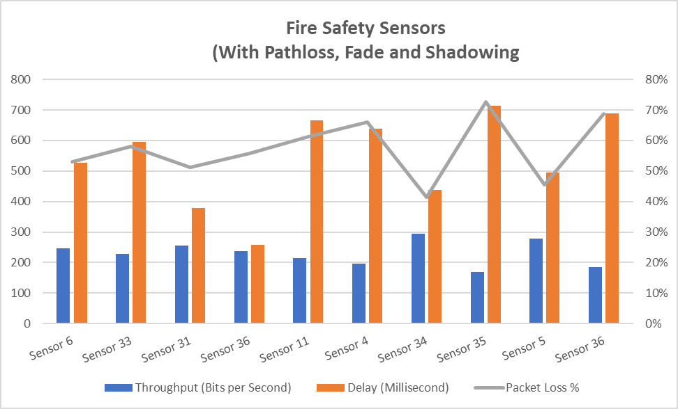
Figure 23: Simulation 2b Data Correlation [77] [43]
Experiment 2 Analysis:

After analysing the results from the two simulations, there seems to be an average packet loss of 50% within this segment of the network without environmental noise added and 58% after pathloss, fade and shadowing is added. This experiment dropped an average of 5% less packets compared to experiment 1, this could be because there is 4 devices fewer being utilised in this experiment as apposed to 14 within experiment 1 so the LoWPAN AP is not dropping as many packets.

Experiment-3: Exterior and Interior RF ID Doors (802.15.4)

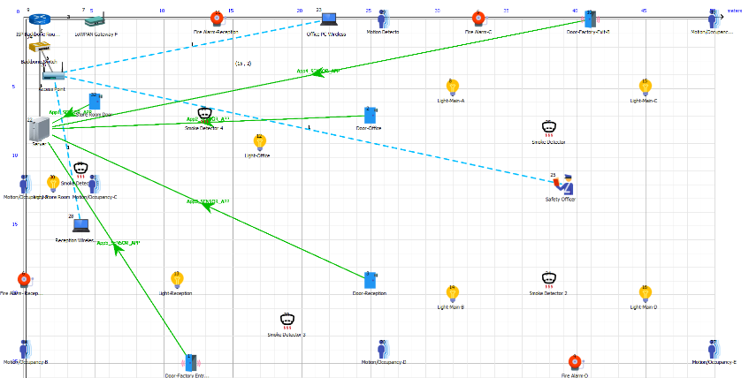
Figure 24: Experiment-3 Logical Topology [77]
Simulation 1c:

The data collected from simulation-1c was correlated into a graph for analysis shown in figure 25.

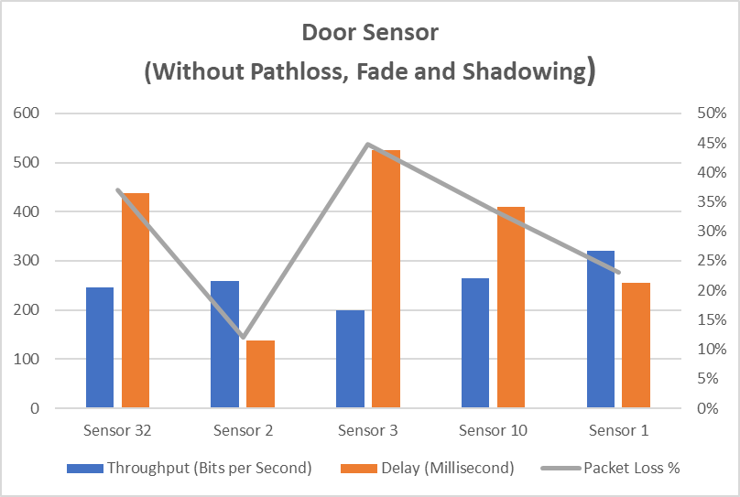
Figure 25: Simulation 1c Data Correlation [77] [43]
Simulation 2c:

The data collected from simulation-2c was correlated into a graph for analysis shown in figure 26 .

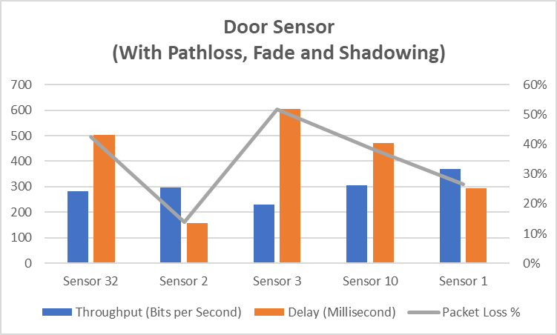
Figure 26: Simulation 2c Data Correlation [77] [43]

Experiment-3 Analysis:

After analysing the results from the two simulations, there seems to be an average packet loss of 30% within this segment of the network without environmental noise added and 35% after pathloss, fade and shadowing is added. This is a significant reduction compared to experiment 2 that had an average of 50% packet loss without environmental noise. This experiment did have 4 fewer nodes sending information to the LoWPAN AP this could be the reason the packet loss has improved within each experiment within the 802.15.4 segment of the network.

Experiment-4: 802.11 Wireless End Devices

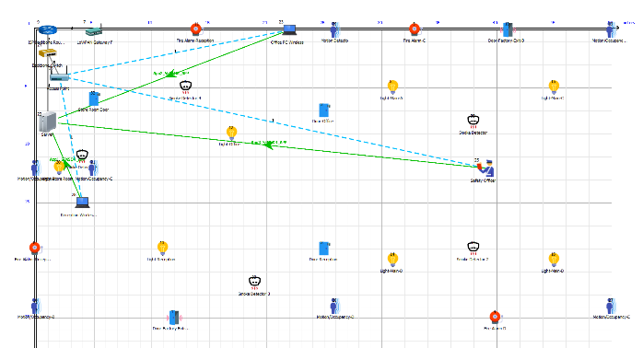
Figure 27:Experiment 4 Logical Topology [77]
Simulation 1d:

The data collected from simulation-1d was correlated into a graph for analysis shown in figure 28.

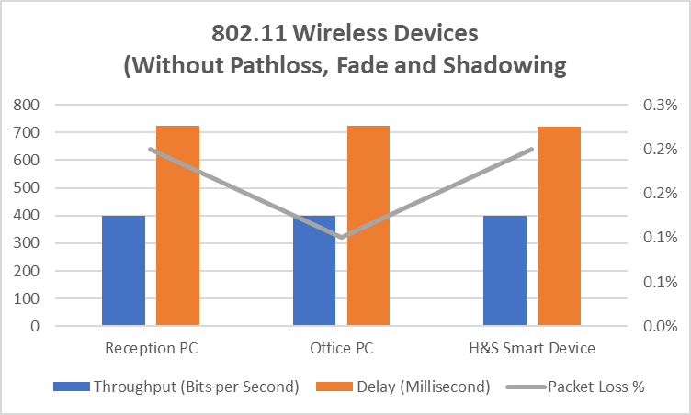
Figure 28:Simulation 1d Data Correlation [77] [43]
Simulation 2d:

The data collected from simulation-2d was correlated into a graph for analysis shown in figure 29.

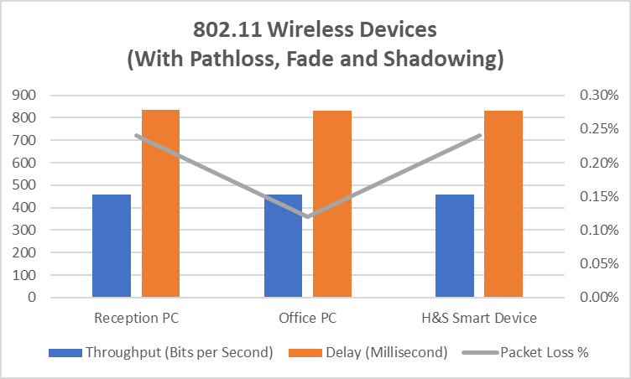
Figure 29: Simulation 2d Data Correlation [77] [43]

Experiment 4 Analysis:

The wireless segment of the network performed the best by a substantial amount, only dropping an average of 0.3% of packets with and without packet loss, fade and shadowing this could be because there were fewer nodes transmitting data to the AP as apposed to the other experiments that had a lot more nodes, it could also be that the 802.11 AP has more computational power than the 802.15.4 LoWPAN AP so dropped fewer packets because of this. The delay was higher than the 802.15.4 segment of the network, this could be because of the larger packets being sent within the 802.11 segment. Throughput was consistent across all three devices within this portion of the network compared to the 802.15.4 segment.

- Smart Factory - Experiment Data Correlation

After all the experiments were conducted the data collected from the experiments was then correlated to analyse the ‘Smart Factory’ network as a whole to see if any improvements could be made to make the network more efficient and reliable. The correlated graph from experiments 1-4 is shown in figure 30.

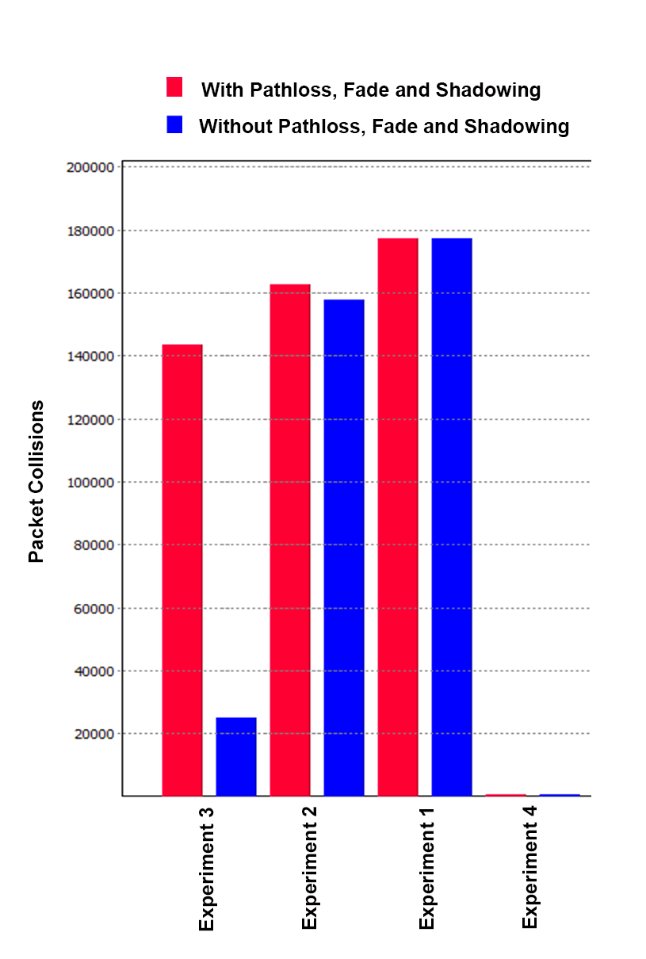
Figure 30: Packet Collisions within the Network During Simulations [77] [43]
After analysis of the packet collisions within the network it would seem that the packets that were being dropped were colliding with packets being transmitted by the other sensors causing packet loss. To reduce the packet collisions within the network the sensors would need to be either repositioned or additional LoWPAN AP’s could be installed for each segment of the network to reduce latency, improve throughput and minimise packet loss.

- Smart Factory Simulation Conclusion

After analysis of the data, environmental noise only had a 15% increase in packet loss and delay on the efficiency of the network.

A relationship was observed from the data gathered from the experiments that; the higher the throughput within a network, the lower the latency was. Also, a relationship between throughput and packet loss was observed from the experiment data that was; the higher the throughput between nodes the lower the packet loss was within the network.

The 802.11n nodes also performed a lot more efficient within the network compared to the 802.15.4 ZigBee nodes, this could be because of the higher power output of the 802.11n devices and maximum throughput of 450Mb/s as opposed to the low powered 802.15.4 nodes that only have a 256kbps data rate configured previously in the report.

Future considerations would be to carry out further simulations using multiple LoWPAN AP’s to decrease its overhead, reduce packet collisions, latency and the node to AP ratio that would in turn theoretically improve throughput. These further tests would need to be carried out before the sensors could be safely installed at the client’s premises.

Within a real-world scenario the network would need to first be modelled within simulation software and then planned/analysed further via an on-site survey of the sensors within their natural environment where there will be factory machinery and other appliances/devices creating noise that simulation software cannot model accurately, in order to truly minimise delay, packet loss and maximise throughput to make the network efficient to meet the client’s requirements.

Conclusions
Smart technology for homes, hospitals, businesses etc are becoming very popular within modern society, WSN’s are still in their infancy as previously discussed in the report so there are various security and safety considerations that are still being identified that could put people who are not knowledgeable within this field at risk. Therefore, cybersecurity professionals around the world are currently researching ways to fully secure this technology before people get their data stolen, privacy encroached and/or seriously hurt.

Future considerations within 802.15.4 would be to research and identify security flaws within this technology to help improve and further secure the IoT industry which could either help or harm humanity in the future.

References

[1] CISCO, “WLAN Radio Frequency Design Considerations,” Enterp. Mobil. 7.3 Des. Guid., pp. 1–36, 2011.
[2] I. Ishaq et al., “IETF Standardization in the Field of the Internet of Things (IoT): A Survey,” J. Sens. Actuator Networks, vol. 2, no. 2, pp. 235–287, 2013.
[3] S. Chen, H. Xu, D. Liu, B. Hu, and H. Wang, “A vision of IoT: Applications, challenges, and opportunities with China Perspective,” IEEE Internet of Things Journal, vol. 1, no. 4. pp. 349–359, 2014.
[4] T. Liu and D. Lu, “The application and development of IOT,” in Proceedings of 2012 International Symposium on Information Technologies in Medicine and Education, ITME 2012, 2012, vol. 2, pp. 991–994.
[5] J. Rivera and R. Van der Muelen, “Gartner Says the Internet of Things Installed Base Will Grow to 26 Billion Units By 2020,” Gartner, 2013. [Online]. Available: http://www.gartner.com/newsroom/id/2636073.
[6] S. Mukhopadhyay and H. Leung, Advances in wireless sensors and sensor networks. 2010.
[7] R. A. Shafik, M. S. Rahman, and A. H. M. R. Islam, “On the extended relationships among EVM, BER and SNR as performance metrics,” in Proceedings of 4th International Conference on Electrical and Computer Engineering, ICECE 2006, 2007, pp. 408–411.
[8] F. Xiong, “Digital modulation techniques,” in Library, 2000, pp. 1–40.
[9] C. Zhang, L. Lei, and T. Zhang, “Analyzing the cumulative interfering noise in multi-hop IEEE 802.11 networks,” in Proceedings - 2014 IEEE Computers, Communications and IT Applications Conference, ComComAp 2014, 2014, pp. 133–136.
[10] R. Bentler and L. K. Chiou, “Digital Noise Reduction: An Overview,” Trends Amplif., vol. 10, no. 2, pp. 67–82, 2006.
[11] A. Leven, “Telecommunication Circuits and Technology,” Telecommun. Circuits Technol., pp. 51–94, 2000.
[12] H. Aliakbarian, V. Volski, E. Van Der Westhuizen, R. Wolhuter, and G. a. E. Vandenbosch, “Analogue versus digital for baseband beam steerable array used for LEO satellite applications,” Antennas Propag. (EuCAP), 2010 Proc. Fourth Eur. Conf., pp. 1–4, 2010.
[13] B. C. J. Moore and A. Sek, “Effects of carrier frequency, modulation rate, and modulation waveform on the detection of modulation and the discrimination of modulation type (amplitude modulation versus frequency modulation),” J. Acoust. Soc. Am., vol. 97, no. 4, pp. 2468–2478, 1995.
[14] J. M. Supplee, E. a Whittaker, and W. Lenth, “Theoretical description of frequency modulation and wavelength modulation spectroscopy.,” Appl. Opt., vol. 33, no. 27, pp. 6294–6302, 1994.
[15] rfwirelss-world, “difference between analog modulation and digital modulation,” rfwirelss-world.com, 2012. [Online]. Available: http://www.rfwireless-world.com/Terminology/analog-modulation-vs-digital-modulation.html. [Accessed: 26-Apr-2018].
[16] Mikrotik, “Wireless Networks,” wiki.mikrotik.com, 2016. [Online]. Available: https://wiki.mikrotik.com/wiki/Testwiki/MikroTik_Wireless_Networks. [Accessed: 26-Apr-2018].
[17] N. Azmi et al., “Interference issues and mitigation method in WSN 2.4GHz ISM band: A survey,” in 2014 2nd International Conference on Electronic Design, ICED 2014, 2011, pp. 403–408.
[18] I. Howitt and G. Jore A., “IEEE 802.15.4: Low-Rate Wireless Personal Area Networks (LR-WPANs),” Wirel. Commun. Netw., vol. 2011, no. September, p. 314, 2011.
[19] W. Bolton, Y. X. Y. Xiao, and M. Guizani, “IEEE 802.20: mobile broadband wireless access,” IEEE Wirel. Commun., vol. 14, no. February, pp. 84–95, 2007.
[20] X. Tang et al., “Performance of BPSK subcarrier intensity modulation free-space optical communications using a log-normal atmospheric turbulence model,” in 2010 Symposium on Photonics and Optoelectronic, SOPO 2010 - Proceedings, 2010.
[21] G. M. Naidu, O. Sudhakar, and V. Sailaja, “Simulation of BPSK Modulation and Demodulation on System Generator,” Int. J. Sci. Eng. Res., vol. 1, pp. 37–39, 2013.
[22] K. Padmaraju et al., “Error-free transmission of microring-modulated BPSK.,” Opt. Express, vol. 20, no. 8, pp. 8681–8688, 2012.
[23] N. Bahl, A. K. Sharma, and H. K. Verma, “On the energy utilization for WSN based on BPSK over the Generalized-K shadowed fading channel,” Wirel. Networks, vol. 20, no. 8, pp. 2385–2393, 2014.
[24] T. Li et al., “Low-voltage, high speed, compact silicon modulator for BPSK modulation,” Opt. Express, vol. 21, no. 20, p. 23410, 2013.
[25] Quora, “How can digital information be represented by waves? - Quora,” quora.com, 2016. [Online]. Available: https://www.quora.com/How-can-digital-information-be-represented-by-waves. [Accessed: 26-Apr-2018].
[26] J. Chan, “BPSK,QPSK and QAM modulation,” circuitdesign.de, 2015. [Online]. Available: http://www.circuitdesign.de/products/tech_info/modulation/modulation_psk.asp. [Accessed: 26-Apr-2018].
[27] B.-E. Olsson and M. Skold, “QPSK transmitter based on optical amplitude modulation of electrically generated QPSK signal,” 2008 Asia Opt. Fiber Commun. Optoelectron. Expo. Conf., pp. 3–5, 2008.
[28] A. Bononi, M. Bertolini, P. Serena, and G. Bellotti, “Cross-phase modulation induced by OOK channels on higher-rate DQPSK and coherent QPSK channels,” J. Light. Technol., vol. 27, no. 18, pp. 3974–3983, 2009.
[29] L. Zhao, H. Shankar, and A. Nachum, “40G QPSK and DQPSK modulation,” Inphi Corp., pp. 1–18, 2008.
[30] A. El Oualkadi and D. Flandre, “HDL system-level design of O-QPSK receiver for 2.4-GHz band IEEE 802.15.4,” in Proceedings - 2007 International Conference on Design and Technology of Integrated Systems in Nanoscale Era, DTIS 2007, 2007, pp. 30–34.
[31] M. P. Fitz and J. P. Seymour, “On the bit error probability of QAM modulation,” Int. J. Wirel. Inf. Networks, vol. 1, no. 2, pp. 131–139, 1994.
[32] I. Lyubomirsky and W. A. Ling, “Digital QAM modulation and equalization for high performance 400 GbE data center modules,” in Conference on Optical Fiber Communication, Technical Digest Series, 2014.
[33] Y. H. Tanc and A. Akan, “Modulation identification of digital M-ary QAM signals by Hilbert-Huang Transform,” in Proceedings of the IEEE International Conference on Electronics, Circuits, and Systems, 2013, pp. 678–681.
[34] M. G. M. Hussain, Y. M. H. Shishter, and M. H. Al-Gharabally, “Ultrawideband impulse communications using M-ary digital modulation schemes,” in 2016 21st International Conference on Microwave, Radar and Wireless Communications, MIKON 2016, 2016.
[35] pinterest, “32 QAM and 64-QAM Constellation Diagram | Communication Systems | Pinterest | Communication system,” pinterest.co.uk, 2018. [Online]. Available: https://www.pinterest.co.uk/pin/829084612620870616/. [Accessed: 26-Apr-2018].
[36] A. S. Kashi et al., “Information rates for the SP 128-QAM and DP 16-QAM modulation formats,” in European Conference on Optical Communication, ECOC, 2015, vol. 2015–Novem.
[37] M. Nakazawa, S. Okamoto, T. Omiya, K. Kasai, and M. Yoshida, “256-QAM (64 Gb/s) coherent optical transmission over 160 km with an optical bandwidth of 5.4 GHz,” IEEE Photonics Technol. Lett., vol. 22, no. 3, pp. 185–187, 2010.
[38] B. Shen, J. Tian, Z. Li, J. Su, and Q. Zhang, “A High Performance QAM receiver for Digital Cable TV with Integrated A / D and FEC decoder,” Area, pp. 1276–1279, 2005.
[39] K. Nataraj, “ScienceDirect Bit Error Rate Analysis Using QAM Modulation for Satellite Communication Link,” Procedia Technol., vol. 25, pp. 456–463, 2016.
[40] uk.mathworks, “MATLAB - MathWorks - MATLAB &amp; Simulink,” uk.mathworks.com, 2018. [Online]. Available: https://uk.mathworks.com/products/matlab.html. [Accessed: 26-Apr-2018].
[41] P. U. Lawrence, “MATHLAB:Simulink QAM Simulation,” vol. 1, no. 1, p. 1, 2018.
[42] M. Isaka, “Oblivious transfer from the additive white Gaussian noise channel,” IEICE Trans. Fundam. Electron. Commun. Comput. Sci., vol. E93–A, no. 2, pp. 516–525, 2010.
[43] A. Katz, “Microsoft Excel 2010,” Style (DeKalb, IL), pp. 21–39, 2010.
[44] J. Lee, “Smart Factory Systems,” Informatik-Spektrum, vol. 38, no. 3, pp. 230–235, 2015.
[45] M. P. Poland, C. D. Nugent, H. Wang, and L. Chen, “Smart Home Research,” Int. J. Ambient Comput. Intell., vol. 1, no. 4, pp. 32–45, 2009.
[46] M. Banzi, “Zigbee Wireless Networking,” Chem. …, p. 130, 2011.
[47] Tetcos, “NetSim-Network Simulator &amp; Emulator | Home,” tetcos.com, 2018. [Online]. Available: https://www.tetcos.com/. [Accessed: 26-Apr-2018].
[48] H. Yasuura, C. M. Kyung, Y. Liu, and Y. L. Lin, Smart sensors at the IoT frontier. 2017.
[49] P. U. Lawrence, “Smart Factory Physical Topology - Adobe Photoshop CS5,” vol. 1, no. 1, p. 1, 2018.
[50] A. S. Incorporated, “Adobe Photoshop Cs5,” Methods, 2011.
[51] R. Want, A. Hopper, V. Falcão, and J. Gibbons, “The active badge location system,” ACM Trans. Inf. Syst., vol. 10, no. 1, pp. 91–102, 1992.
[52] T. M. McCoy, P. V. Brennan, and R. J. Bullock, “An RF-ID receiver using SAW filters for wideband synchronisation,” in Proceedings of the IEEE International Conference on Electronics, Circuits, and Systems, 2006, pp. 1204–1207.
[53] C. S. Park and J. H. Lee, “Security Bootstrapping for Secure Join and Binding on the IEEE 802.15.4-Based LoWPAN,” IEEE Internet Things J., vol. 4, no. 4, pp. 996–1005, 2017.
[54] E. Ronen and A. Shamir, “Extended functionality attacks on IoT devices: The case of smart lights,” in Proceedings - 2016 IEEE European Symposium on Security and Privacy, EURO S and P 2016, 2016, pp. 3–12.
[55] Y. C. Zhang and J. Yu, “A study on the fire IOT development strategy,” in Procedia Engineering, 2013, vol. 52, pp. 314–319.
[56] I. Lee and K. Lee, “The Internet of Things (IoT): Applications, investments, and challenges for enterprises,” Bus. Horiz., vol. 58, no. 4, pp. 431–440, 2015.
[57] F. Chen, K. Wu, W. Chen, and Q. Zhang, “The research and implementation of the VPN gateway based on SSL,” in Proceedings - 2013 International Conference on Computational and Information Sciences, ICCIS 2013, 2013, pp. 1376–1379.
[58] W. Huang and F. Kong, “The research of VPN on WLAN,” in Proceedings - 2010 International Conference on Computational and Information Sciences, ICCIS 2010, 2010, pp. 250–253.
[59] S. Gueron, Advanced encryption standard (AES) instructions set, no. July 2008. 2008.
[60] “Network Performance Monitor - Leading Monitoring Tool | SolarWinds.”
[61] H. M. Lynch, “Firewall fundamentals,” Inf. Syst. Secur., vol. 9, no. 5, pp. 1–11, 2000.
[62] M. D. Grammatikakis et al., “Security effectiveness and a hardware firewall for MPSoCs,” in Proceedings - 16th IEEE International Conference on High Performance Computing and Communications, HPCC 2014, 11th IEEE International Conference on Embedded Software and Systems, ICESS 2014 and 6th International Symposium on Cyberspace Safety and Security, 2014, pp. 1032–1039.
[63] H. Li, Z. Jia, and X. Xue, “Application and analysis of ZigBee security services specification,” in NSWCTC 2010 - The 2nd International Conference on Networks Security, Wireless Communications and Trusted Computing, 2010, vol. 2, pp. 494–497.
[64] Z. Wu, M. Cai, S. Liang, and J. Zhang, “An Approach for Prevention of MitM Attack Based on Rogue AP in Wireless Network,” Sensors & Transducers, vol. 183, no. 12, pp. 162–171, 2014.
[65] V. Kumar, S. Chakraborty, F. A. Barbhuiya, and S. Nandi, “Detection of stealth Man-in-the-Middle attack in wireless LAN,” in Proceedings of 2012 2nd IEEE International Conference on Parallel, Distributed and Grid Computing, PDGC 2012, 2012, pp. 290–295.
[66] S. A. J. Alabady, “Design and Implementation of a Network Security Model using Static VLAN and AAA Server,” 2008 3rd International Conference on Information and Communication Technologies From Theory to Applications. 2008.
[67] M. A. Harris and K. P. Patten, “Mobile device security considerations for small- and medium-sized enterprise business mobility,” Inf. Manag. Comput. Secur., vol. 22, no. 1, pp. 97–114, 2014.
[68] VMware, “Air-Watch VMware MDM Server,” air-watch.com, 2018. [Online]. Available: https://www.air-watch.com/solutions/mobile-device-management/. [Accessed: 26-Apr-2018].
[69] Z. Yong-Xia and Z. Ge, “MD5 research,” in 2010 International Conference on MultiMedia and Information Technology, MMIT 2010, 2010, vol. 2, pp. 271–273.
[70] D. J. Barrett and R. Silverman, SSH, The Secure Shell - The Definitive Guide. 2001.
[71] Symantec, “Endpoint Protection Small Business Edition | Symantec,” symantec.com, 2018. [Online]. Available: https://www.symantec.com/products/endpoint-smb. [Accessed: 26-Apr-2018].
[72] P. Michaud, “Demystifying multicore throughput metrics,” IEEE Comput. Archit. Lett., vol. 12, no. 2, pp. 63–66, 2013.
[73] Q. Zhang, V. B. Iversen, and F. H. P. Fitzek, “Throughput and delay performance analysis of packet aggregation scheme for PRMA,” in IEEE International Symposium on Personal, Indoor and Mobile Radio Communications, PIMRC, 2007.
[74] J. C. Bolot, “Characterizing end-to-end packet delay and loss in the internet,” J. High Speed Networks, vol. 2, no. 3, pp. 305–323, 1993.
[75] R. Zhi, H. Yong, C. Qianbin, and L. Hongbin, “Modeling and simulation of fading, pathloss, and shadowing in wireless networks,” in Proceedings of 2009 IEEE International Conference on Communications Technology and Applications, IEEE ICCTA2009, 2009, pp. 335–343.
[76] R. P. F. Hoefel, “IEEE 802.11n MAC improvements: A MAC and PHY cross-layer model to estimate the throughput,” in IEEE Vehicular Technology Conference, 2008.
[77] P. Lawrence, “Netsim - Smart Factory logical design and simulation,” 1, vol. 1, 2018.

Appendix -A

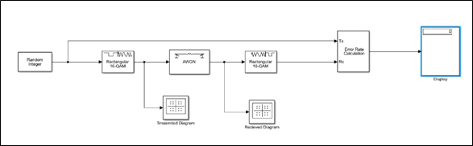

Appendix -B

