

ACMA 4013 SKILLS DEVELOPMENT IN THE WORKPLACE
ASSESSMENT COMPONENT 1: REFLECTIVE JOURNAL

Table of Contents
Introduction 3
Task 1: Application of innovation for implementing the world 3
Session 1: Innovation and Society 3
Session 2: Creating the Future 4
Session 3: Creativity and Society 4
Session 4: Theories of Innovation 5
Task 2: Storytelling as a creative solution 6
Session 1: Evidence behind telling stories 6
Session 2: Accessing competencies in stories 6
Session 3: Creation of own competency story 7
Session 4: Theories about the storytelling 7
Conclusion 9
Reference 10

Introduction
While involved in the workplace, everyone must develop working skills to determine organizational achievements [1]. In this journal, two particular topics have been chosen from different Units, which are reliable for synthesizing the knowledge regarding skill development. The application of innovations for changing the global system has been criticized here, which is advantageous for future generations. The importance of storytelling has been described, which is relevant for determining creative thinking by promoting proper collaboration.

Task 1: Application of innovation for implementing the world
The term 'innovation' indicates the invention of new objectives that are reliable for human beings to implement in their Society and daily life. Since ancient times, various innovations have been developed in every field, which are valuable from different perspectives [2]. Each innovation can change the global system, through which people become capable of introducing new gadgets for enhancing reliability in educational systems, marketing, finance, culture, health, entertainment, etc. I have observed that the usage of innovation causes the production of food and energy in a large manner, which is effective for developing global sustainability regarding the population. By introducing various innovations, people can implement their working sectors to increase their marketing share and customer satisfaction.

Session 1: Innovation and Society
Innovations are highly effective in improving societies' infrastructure, through which people adapt to new things regarding their daily activities. To enhance the societal movement, I have noticed that people would like to apply innovative technologies for their working progressions, through which they can determine their social needs [3]. It can ensure we lead a better life, where I can localize my livelihood in a suitable environment. Applying innovations is crucial for developing societies, through which we become aware of taking the right actions while involved in any unwanted situational hazards. Based on human history, it has been revealed that people can ensure economic growth, determining new working opportunities, marketing growth, and other factors through integrating innovations.

Session 2: Creating the Future
The application of innovations increases job opportunities for people, through which they can promote their income rate in association with the global economy. Nowadays, most innovations are associated with the technological components that develop various working sectors within societies. I became informed about various innovations like self-driving vehicles, robotics, artificial intelligence, microchips, gene predictions, etc [4]. It has been estimated that these innovations will be highly popular in the future, which can ensure the suitability of every human being. I have analyzed various information about artificial intelligence, which is trending, to determine the fast growth of every corporate zone. These innovations can criticize the people's needs regarding their societies, through which they can focus on the evidence for taking the right actions. Self-driving cars are relevant for everyone, which can implement transportation services, and people do not have to be involved in any situational hazards. The application of Microchips is vital for securing valuable information, through which I can develop my working proficiencies regarding my corporate field. Most people have determined their achievements by applying various innovations, which ensure around 84% faster company growth [5]. I believe innovations are significant for determining suitability in other future life spans.

Session 3: Creativity and Society
The innovations can enhance the importance of creative thinking for implementing the societies, through which people can develop various strategic actions for mitigating societal problems. Creative thinking determines that people can handle any situational hazards by applying innovations to access particular evidence based on cultural problems [6]. I think everyone should think with an open mind before making any decisions, which enhances the successful completion of every work in a creative manner. Creativity enhances my potential to ensure learning growth, allowing me to introduce various innovations from different perspectives. Since the previous era, people have been capable of developing various innovations by promoting their creative thinking, through which they can concentrate on the particular evidence for maintaining their global sustainability. Based on my observations, people would invent various technologies like Robotics, artificial intelligence-based tools, automated vehicles, etc., which can increase the production rates in the industries. In food companies, people have applied various scientific techniques like hybrid planting, genetic engineering, etc., through which they can increase the production rate of organic foods [7]. The innovation can promote evolutionary changes regarding their activities, enhancing suitability for their organizational work.

Session 4: Theories of Innovation
Rogers' innovation diffusion theory:In 1962, E.M. Roger developed the diffusion of innovation theory, in which he stated the evidence behind originating the ideas of innovations. By illustrating the model, he explored how people become influential in developing innovations that gain popularity by diffusing within societies. I have estimated that every innovation becomes popular if it is relevant for use within our daily activities.

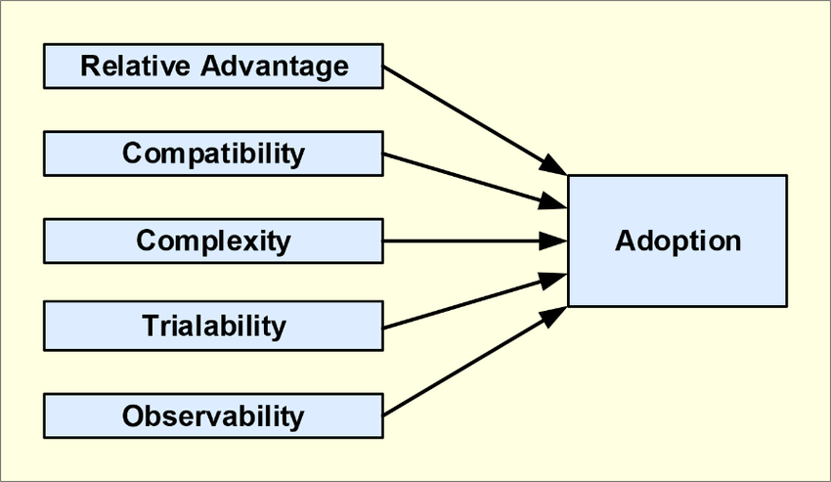
Fig: Rogers' innovation diffusion theory
Source: [8]

Task 2: Storytelling as a creative solution
Storytelling is a good habit for every living being, in which people can develop their own analytical and cognitive skills [9]. Since early childhood, I have learned the importance of telling a story, in which I can memorize every learning objective in a long-term manner. It is applicable for being informative about the previous historical eras, through which we get various ideas for developing our societal and cultural factors. Most of us think storytelling is relevant for entertainment purposes, in which we can imagine various unrealistic factors associated with reality. But, it is not only for entertainment factors; it is reliable for determining our memory power.

Session 1: Evidence behind telling stories
Everyone would like to tell stories to others, as it is associated with our emotional factors. Through telling stories, I can share various information in a creative manner, by which the people can memorize them via getting interested in the stories. Each story can explore valuable morals linked to our daily life span [10]. Understanding those morals can develop our critical thinking, through which I can make effective decisions aligning with the morals. Moreover, most of us would like to share our life experiences with others, through which I become motivated about the twists and turns of their life. It promotes me for being aware of my upcoming challenges though I can potentially handle them.

Session 2: Accessing competencies in stories
Storytelling can precise our cultural beliefs and learning goals regarding our societies, determining future livelihoods' reliability. It can promote the competencies within the individual group, in which everyone serves their evidence based on the particular story [11]. Based on my opinion, it is important to state proper discussions regarding the story's moral, through which I can analyze the stories in several ways related to others' feedback. In the 21st century, most listeners would like to read various historical stories, real-life stories, and other educational based contents, which includes valuable information for determining career goals. In various seminars, competency stories are stated in which the individual shares their life experiences, like business success, educational life, challenges regarding their livelihood, etc. Based on their stories, the audiences can state their feedback, which they link up with their life experiences. It creates various strategic ways regarding storytelling, in which I can set up various social and cultural activities within our global societies. I believe the formation of competency stories is reliable for achieving career goals, in which people become motivated to develop their working proficiencies.

Session 3: Creation of own competency story
The creation of my competency story is crucial based on five main domains that must be understood to serve their evidence [12]. While creating the story, first, I have to set up the plot, which determines the realistic point of view. Next, I have to select some characters linked up to create the story's plot. The point of view should be definite regarding the stories, which can grab the listeners' attention. I have to develop every storyline by linking with other variables, through which people can connect them with the previous parts. I can develop the competency story by following up on these particular elements. I should focus on the story's moral, which can frame the entire segment of the story effectively. The formation of the story must be evidence-based, which can enhance the discussions among the listener's group.

Session 4: Theories about the storytelling
Fisher's Narrative Theory: Walter Fisher has stated the importance of the narrative paradigm, which explores the effective ways of storytelling in a natural and argument-based way. It is reliable for developing competency stories that are more convenient for making solutions while involved in decision-making programs.
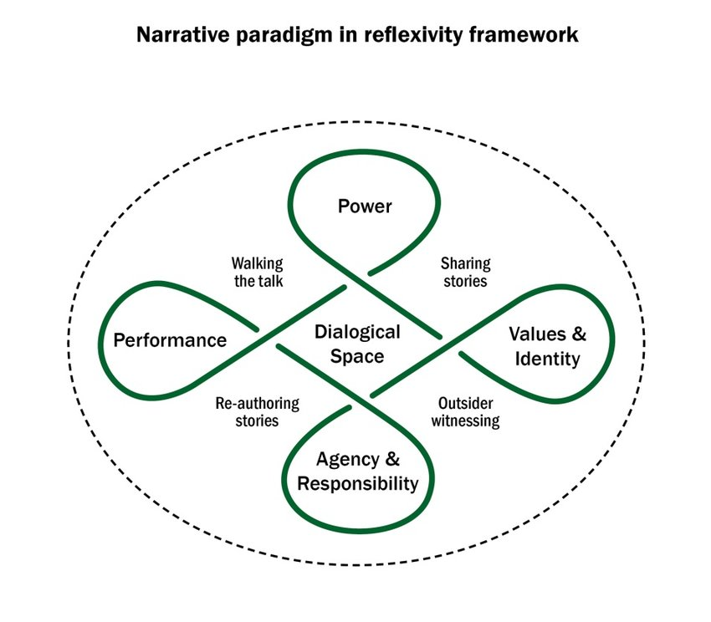
Fig: Narrative frameworks of the storytelling
Source: [13]

Conclusion
Innovations are reliable for upgrading the sustainabilities regarding the country zones, which is applicable for determining suitability in daily activities. Storytelling is beneficial for developing cognitive skills, through which I can analyze any situational problems to mitigate them creatively. The determination of a supportive network is reliable for promoting confidentiality, through which I can engage myself in various activities.

Reference
[1] Masood, T. and Egger, J., (2019). Augmented reality in support of Industry 4.0—Implementation challenges and success factors. Robotics and Computer-Integrated Manufacturing, 58, pp.181-195. Available: https://api.repository.cam.ac.uk/server/api/core/bitstreams/8b924336-5a8c-4a8e-8f1f-95d6ed15a095/content
[2] Adebayo, T.S. and Kirikkaleli, D., (2021). Impact of renewable energy consumption, globalization, and technological innovation on environmental degradation in Japan: application of wavelet tools. Environment, Development and Sustainability, 23(11), pp.16057-16082. Available at: https://doi.org/10.1007/s10668-021-01322-2
[3] Andersson, G., Titov, N., Dear, B.F., Rozental, A. and Carlbring, P., (2019). Internet‐delivered psychological treatments: from innovation to implementation. World Psychiatry, 18(1), pp.20-28. Available: https://doi/pdf/10.1002/wps.20610
[4] Lagna, A. and Ravishankar, M.N., (2022). Making the world a better place with fintech research. Information Systems Journal, 32(1), pp.61-102.Available: https://onlinelibrary.wiley.com/doi/pdf/10.1111/isj.12333
[5] Portuguez Castro, M. and Gómez Zermeño, M.G., (2020, October). Educational innovation supported by ICT to identify entrepreneurial skills in students in higher education. In Eighth International Conference on Technological Ecosystems for Enhancing Multiculturality (pp. 977-984). Available: https://pdfs.semanticscholar.org/bf26/5abf6649d1333a37b4afc067a7b86b258664.pdf
[6] Fraser, J.R., Quail, R. and Simkins, B. eds.,(2021). Enterprise risk management: Today's leading research and best practices for tomorrow's executives. John Wiley & Sons. Available: https://www.researchgate.net/profile/Betty-Simkins/publication/299904292_Enterprise_Risk_Management_An_Introduction_and_Overview/links/62ab5ef523f3283e3aeca997/Enterprise-Risk-Management-An-Introduction-and-Overview.pdf
[7] World Health Organization, (2022). Towards a global guidance framework for the responsible use of life sciences: summary report of consultations on the principles, gaps, and challenges of risk management, May 2022 (No. WHO/SCI/RFH/2022.01). World Health Organization. Available: https://apps.who.int/iris/bitstream/handle/10665/354600/WHO-SCI-RFH-2022.01-eng.pdf
[8] Al Hadwer, A., Tavana, M., Gillis, D. and Rezania, D., (2021). A systematic review of organizational factors impacting cloud-based technology adoption using Technology-organization-environment framework. Internet of Things, 15, p.100407. Available at: https://www.researchgate.net/profile/Madjid-Tavana/publication/351443429_A_Systematic_Review_of_Organizational_Factors_Impacting_Cloud-based_Technology_Adoption_Using_Technology-Organization-Environment_Framework/links/60983b51a6fdccaebd1d6091/A-Systematic-Review-of-Organizational-Factors-Impacting-Cloud-based-Technology-Adoption-Using-Technology-Organization-Environment-Framework.pdf
[9] Rice, C., LaMarre, A., Changfoot, N. and Douglas, P. (2020). Making spaces: Multimedia storytelling as reflexive, creative praxis. Qualitative Research in Psychology, 17(2), pp.222-239. Available: https://atrium.lib.uoguelph.ca/server/api/core/bitstreams/cf4321a8-86da-47d4-964d-c5485d7ba413/content
[10] Moradi, H. and Chen, H., (2019). Digital storytelling in language education. Behavioral Sciences, 9(12), p.147. Available:https://www.mdpi.com/2076-328X/9/12/147/pdf
[11] Gafour, O.W. and Gafour, W.A., (2020). Creative thinking skills–A review article. Journal of Education and e-Learning, 4(1), pp.44-58. Available: https://www.researchgate.net/profile/Walid-Gafour/publication/349003763_Creative_Thinking_skills_-A_Review_article/links/601aa8bf299bf1cc269e39b1/Creative-Thinking-skills-A-Review-article.pdf
[12] Flood, B., Smythe, L., Hocking, C. and Jones, M. (2019). Interprofessional practice: beyond competence. Advances in Health Sciences Education, 24(3), pp.489-501. Available: https://link.springer.com/article/10.1007/s10459-019-09879-4
[13] Norton, L. and Sliep, Y., (2018). A critical reflexive model: Working with life stories in health promotion education. South African Journal of Higher Education, 32(3), pp.45-63. Available: https://journals.co.za/doi/pdf/10.20853/32-3-2523

