Module number : LCLM6003
Student Name: Carmen Goulei
Student Number : 2310474
Lecturer Name Stephen Malone
Assignment Title:
Leading and Implementing Change (LIC)

Executive Summary
The strategic change needs addressed by this report are those of the Ford Motor Company, which is an international automotive company in the automobile industry that is changing rapidly due to electrification and growing integration of digital and stricter environmental regulations. The organisation is chosen as it is experiencing a two-fold strategic conflict; on the one hand, it needs to preserve profitability in its traditional commercial and internal combustion business, and, at the same time, the company invests huge sums in electric vehicle (EV) and software solutions. The external environmental forces are the increasing rate of EV adoption, the growing global competition posed by digitally native manufacturers, and the timing of regulatory deadlines to comply with the regulations to reduce emissions, which shortens the limited timeframe to adapt to the new environment and raises the cost of inaction for Ford.
The key change problem to be noted is the gap between short-term financial performance and long-term capability development, with the emerging EV operations documenting losses and legacy divisions providing the cash needed to finance transformation. In order to deal with such complexity, the report compares the Three-Step Model and Eight-Step Model of Lewin and Kotter with the McKinsey 7S framework, which is employed to diagnose internal alignment in comparison. An intermediate application has been suggested to trade urgency, behavioural transition and systemic coherence.
The suggested strategic change is the profitable scaling of EV and digital platforms and integrating the practise of reskilling the workforce, adaptive leadership, and collaboration between functions. The anticipated results are low EV loss margins, faster innovation processes and organisational agility. Financial effects revolve around disciplined capital allocation and productivity-driven funding instead of growing the debt, and cultural ones revolve around changing the risk-averse manufacturing culture towards experimentation and constant learning. The combination of the change plan will enable Ford to transform scale and brand equity into a technology-based competitive advantage that is sustainable, not incremental operational enhancement.

Table of Contents
Introduction 4
Organisational Background 4
Environmental Analysis 5
External Environment – PESTLE 5
Political and Economic Factors 5
Social and Technological Factors 5
Legal and Environmental Factors 6
Internal Environment – VRIO 6
Value 6
Rarity 6
Imitability 7
Organisation 7
Necessity and Triggers for Change 7
Performance gaps and strategic exposure 7
Digital disruption and competitor pressure 8
Workforce skills and innovation readiness 8
Change Management Models 8
Strategic fit and diagnostic requirement 8
Model 1: Lewin’s Three-Step Model (Unfreeze–Change–Refreeze) 9
Model 2: Kotter’s Eight-Step Model 9
Comparative lens: McKinsey 7S for organisational alignment 10
Judgement on best-fit approach for Ford 10
Leadership and Organisational Culture 10
Leadership demands created by Ford’s transformation 10
Transformational, transactional and servant leadership effectiveness 10
Judgement for Ford 11
Organisational Culture Evaluation 11
Schein’s three levels as a culture diagnosis for change risk 11
Culture as enabler or barrier to change execution 11
Judgement for Ford 12
Strategic Change Plan 12
Proposed change focus and rationale 12
SMART objectives aligned to Ford’s vision 12
Implementation phases and governance 13
Phase 1: Preparation (0–6 months) 13
Phase 2: Transition (6–24 months) 13
Phase 3: Stabilisation (24–36 months) 13
Financial plan and ROI logic 13
Communication and stakeholder engagement plan 14
Risk management and evaluation metrics 15
Conclusion 16
References 17

Introduction
Organisational environments have become such that competitive locations are rapidly transferred as a result of interwoven technological, regulatory, and social forces, and this implies that change is more appropriately considered an ongoing strategic potential and not a periodic project. The research evidence on VUCA conditions has shown that strategic agility and organisational learning are decisive in uncertainty, and the quality of diagnosis and response is more important than the speed of implementation when the various pressures interplay (Atanassova et al., 2025).
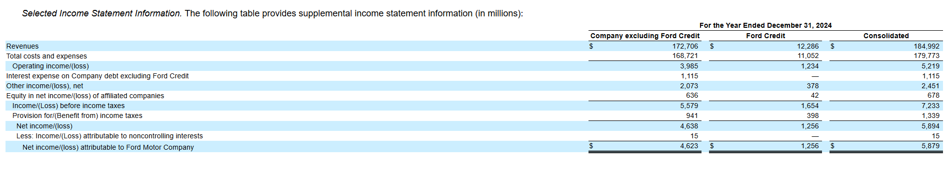
Figure 1 2024 supplemental information
Source: (Ford Motor Company, 2025)
The Ford Motor Company is the target of this report, as it has a quantifiable two-fold problem to maintain financial performance in the short term to fund the long-term change. As Ford reported in 2024, net income attributable to Ford of $5,879 million shows the financial interests of capital allocation between legacy and future capabilities (Ford Motor Company, 2025). At the same time, in 2023, the sales of electric cars worldwide reached nearly 14 million cars (approximately 18 % of all car sales), which increases the strategic cost of an untimely renewal (International Energy Agency, 2024).
It is in this context that leadership needs to organise commitment in the ambiguity, where models and frameworks are applied contextually by change managers, but not mechanically (Phillips and Klein, 2022).

Organisational Background
Ford Motor Company is working in a global automotive market where the value creation has speedily moved away from mechanical differentiation to electrification, software integration and low-carbon compliance, making the strategic value of adaptability over the size of production more and more important (International Energy Agency, 2024). In this transition, diversified product portfolio and repositioning of Ford under the Ford + strategy underpin its competitive relevance, which connects short term operational performance with long term capabilities renewal of vehicles, digital services and connected mobility experiences (Ford Motor Company, 2025). The purpose of the organisation set out by the organisation itself, to help build a better world where all people can move and realise their dreams, is an indication of an identity that is not limited to manufacturing but expands to encompass the wider mobility and creation of value to stakeholders.
At the organisational level, Ford is a large multinational with an estimated workforce of around 165,000 individuals in 2024, having huge manufacturing resources with a worldwide distribution network (Ford Motor Company, 2025). Regarding finances, the reported revenues of $184,992 million in 2024 indicate the strength of the demand and the ability to invest, but also indicate the vulnerability of transformation to the discipline of capital allocation (Ford Motor Company, 2026). Segment performance shows a strategic stressor: Ford Pro brought in a result of 9,015 million adjusted EBIT, and Ford Model e experienced a loss of 5,076 million, which represents the conflict between the traditional profitability and the new EV investment. With the market already accounting for approximately 18 % of the world's car sales, the sustainability of Ford hinges on the transformation of scale and brand equity into digitally enabled, cost-effective invention prior to the consolidation of competitive ecosystems.

Environmental Analysis

External Environment – PESTLE

Political and Economic Factors

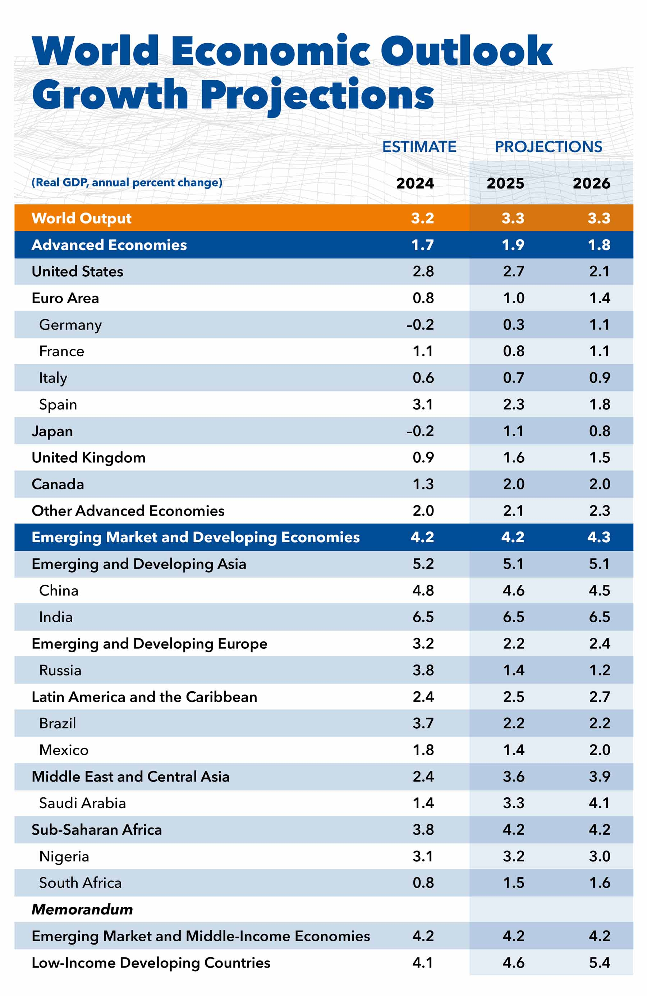
Figure 2 World Economic Outlook Growth Projections
Source: (International Monetary Fund, 2025)
Policy-led industrial change and geopolitical risk are also becoming part and parcel of the strategic environment of Ford, repricing supply chains, pushing mandated technology changes faster instead of letting them evolve gradually. As an example, the EU policy has officially stated the course of movement towards ending sales of new cars with CO₂ emissions by 2035, indicating that the regulatory paths have now become a part of product-life choices and long-cycle capital planning (European Commission, 2022). Simultaneously, industrial competition and trade specifically the size and export value of the Chinese EV manufacturers puts pressure on the need of incumbents to reduce costs more rapidly, to localise key components and establish durable chain of battery supplies as opposed to globalised optimisation (Reuters, 2026). On the economic front, Ford will experience fragile demand due to the constrained consumer purchasing power and credit conditions; the IMF estimates that global growth will be 3.3 % in 2025 and 2026, lower than the average 2000-2019, meaning that affordability will continue to be a pressure in high-end markets (vehicles) and hence tolerance will be lower to price increases associated with transition (International Monetary Fund, 2025).

Social and Technological Factors
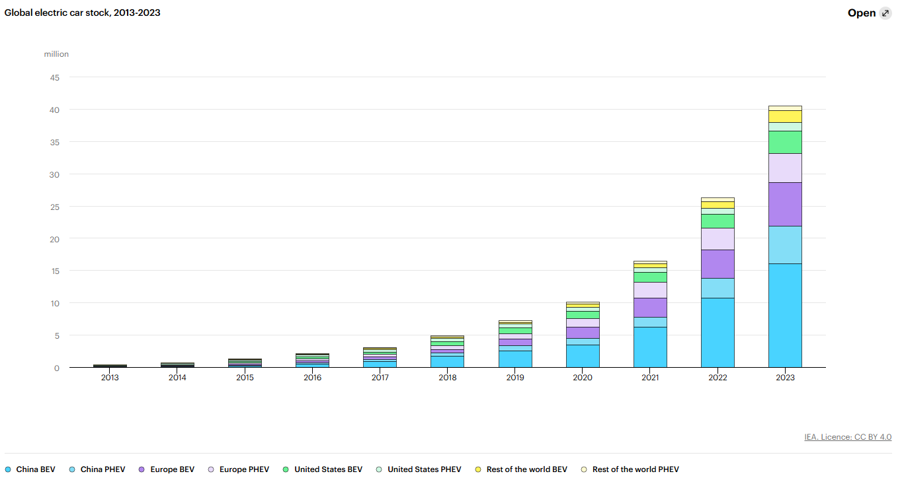
Figure 3 Rate of Technology Change
Source: (International Energy Agency, 2024)
Social pressures are drawing towards low-carbon mobility and frictionless digital experiences, which is shifting towards software-based value, trust and convenience instead of being purely mechanical differentiation. The rate of technology change is already quantifiable: the world was nearly selling 14 million electric cars in 2023 and 18% of all cars sold, which means that the industry has already progressed beyond the initial phase of technology adoption and has entered the mass-market segmentation phase, meaning that the major market competitors may soon lose their customer base to competitors with more advanced product portfolios and customer experiences (International Energy Agency, 2024). With this diffusion gauge gaining momentum, the strategic challenge facing Ford is not just model availability but also capability maturity in software, data and lifecycle service provision since EV competition is progressively characterised by platform economies of scale, update frequency and ecosystem associations instead of individual product releases.

Legal and Environmental Factors
Legal requirements are becoming increasingly stiff to the extent that sustainability is turned into an operating constraint of compliance with a direct impact on the product engineering, supplier selection and investment sequencing. In the United States, the new rule that was adopted by the EPA establishes tougher standards of harmful emission reduction to lower emissions beginning with model year 2027, which provides a time-framed compliance horizon that would require a faster implementation of technologies and a well-managed programme of governance (Environmental Protection Agency, 2024). Independent regulatory review suggests such requirements to be a 50 per cent and 44 per cent reduction in the mean tailpipe CO₂ emissions of light-duty and medium-duty vehicles, respectively, compared to model year 2026, signalling a step-change, not a further tightening of the belt (International Council on Clean Transportation, 2025).

Internal Environment – VRIO

Necessity and Triggers for Change

Performance gaps and strategic exposure
The operational necessity of a strategic change at Ford is informed by an objective lack of contact between the cash-generating historic business and the loss-making future bets, which renders transformation a survival imperative and not an optional upgrade. According to its annual report of FY2024, Ford disclosed net income attributable to Ford Motor Company of 5,879 million, but this topline strength hides internal disjunction among business segments that are operating at cross purposes (Ford Motor Company, 2025). The same filing indicates that Ford Pro is already profitable with a 9,015 million adjusted EBIT, and Ford Model e is still a loss-making enterprise with an adjusted margin of -131.8, indicating that Ford is not yet economically self-sufficient on a large scale (Ford Motor Company, 2025). This mismatch is a strategic risk as it suggests that the past cash flows have to continue to subsidise the future over a long period of time, and this means that the firm is more vulnerable to demand shocks, pricing wars and capital market tightening conditions that can rapidly reduce the transition runway of the firm.

Digital disruption and competitor pressure
The external adoption curve is narrowing the capability-renewal time frame of Ford, since the EV uptake is now in the mass-market wave rather than the initial adopter wave. According to the International Energy Agency (2024), nearly 18% of all cars sold in 2023 were electric (as compared to 14% in 2022), suggesting that the incumbents are rapidly experiencing increasing parity pressures in the cost, range, charging integration and user experience of EVs. Some of the empty space in the filing by Ford is dedicated to industrywide competitive pressures, which supports the thesis that the competitive foundation is already moving and subtracting first-generation EV margins instead of rewarding its participation by itself (Ford Motor Company, 2025). Competitor pressure, in the strategic sense, is growing to include digitally enabled companies, whose differentiation is based on the software-defined functionality and constant updating, and not just on the size of manufacturing, making the possibility of Ford falling behind in the innovation cycles even though it can scale to volumes more of a possibility.

Workforce skills and innovation readiness
Another catalyst is capability reconfiguration, as the automotive frontier is becoming more software-intensive, and necessitates new competence-forming processes that have culturally and structurally distinct requirements from traditional mechanical engineering. Burr (2024) demonstrates that incumbent car manufacturers have to actively develop internal software competence and supplement it with external cooperation, which means that the problem of innovation lag is often embedded in the architecture of skills and organisational structure and not only access to the technologies. As a result, the strategic change should include all three aspects: governance, incentives and reskilling at Ford to invest in the products, as the transformation spending can still run at a loss without bridging the competitiveness gap fast enough to ensure long term sustainability.

Change Management Models

Strategic fit and diagnostic requirement
The challenge of change at Ford is ambidextrous: the company has to protect profitable legacy business at the same time as developing a competitive electric-vehicle and software business under severe time constraints. Financial reporting shows disparity between healthy commercial results and ongoing EV losses, which means that Ford is running two parallel business logics and not a linear change programme (Ford Motor Company, 2025). This background is noteworthy since the choice of models should be based on the complexity of the problems, but not on hypothetical preference. The change at Ford is capital-intensive, culturally disruptive, and politically sensitive, which implies that the most efficient framework has to create urgency and alignment but be able to quickly adapt to the changes in regulatory and technological processes.

Model 1: Lewin’s Three-Step Model (Unfreeze–Change–Refreeze)
The Unfreeze-Change-Refreeze model by Lewin is a clear framework of behaviour to use in order to modify established routines, and this is especially well-known in manufacturing-based set-ups because hierarchies of norms can slow down speed. The unfreezing stage is particularly applicable to the case of Ford since the staff members previously focused on mechanical superiority will have to embrace a new competitive philosophy based on software and digital ecosystems. The empirical qualitative studies demonstrate that resistance increases when preparation is not actively developed, and this fact supports the proactive approach of communication and engagement techniques (Vasel, 2025). The weakness of Lewin, however, is that it is deemed to be linear because the concept of refreezing can be construed as stability, yet the EV environment at Ford demands constant repetition.

Model 2: Kotter’s Eight-Step Model
The model used by Kotter is quite compatible with the urgency of mobilisation of organisational energy at Ford, since leadership functions aimed at creating urgency, coalitions and short-term wins are operationalised. Empirically, it has been correlated that staged mobilisation is related to leadership credibility and readiness to change, with long-term impetus being based upon behavioural legitimacy as much as procedure sequencing (Mouazen, 2023). In the case of Ford, this focus of leadership is vital since change is a process that incorporates various stakeholders whose cooperation is key to defining the pace of execution. However, the sequential quality of Kotter can be inflexible to highly inflexible changes in rapid regulatory or market transitions, since flexibility is required, as Carreño (2024) writes, as its inflexibility can hinder long-term flexibility. The McKinsey 7S scheme is a complement to the two models as it identifies inconsistencies in strategy, structure, systems and skills, and it provides internal consistency in the implementation (Rosnerova et al., 2024).

Comparative lens: McKinsey 7S for organisational alignment
McKinsey 7S reinforces the Ford model decision-making process by using an alignment test with hard and soft positioning aspects of the strategy, structure, systems, shared values, style, staff and skills, such that failure in implementation is not attributed to the weakness of execution but to the misfit. Research has recently grouped 7S as a model of descriptive alignment that can be used to diagnose the factors of organisation that influence change performance to the greatest extent, which is applicable to Ford since the introduction of technology strategy will not be successful with incentives, skills and operating systems still focused on the old value logic (Rosnerova et al., 2024). As a comparative investment, 7S assists Ford in stipulating what needs to be changed within the organisation (skills architecture, decision rights, performance measures) to render the freezing phase of the Lewin model relevant and the victories phases of the Kotter model long-lasting.

Judgement on the best-fit approach for Ford
A hybrid approach, Kotter best suits urgency and mobilisation, Lewin's behavioural stabilisation, and McKinsey 7S organisational alignment since none of the models fits the speed and the systemic complexity of its strategic change.

Leadership and Organisational Culture

Leadership demands created by Ford’s transformation
The change agenda that is being implemented by Ford needs leaders to provide ambidexterity: maintain the cash flow of the old line of operations and create profitable EV and software under time pressure. This duality is evident in the FY2024 result of Ford, where Ford Pro brought in the income of 9,015m adjusted EBIT, and Model e brought in the revenue of 5,076m adjusted EBIT loss and an EBIT margin of -131.8%, meaning that the leadership needs to balance performance protection and capability renewal at the same time (Ford Motor Company, 2025). This setting promotes leadership beyond communication to execution architecture that focuses on speed of learning, capital discipline and workforce alignment since transformation risks cannot be addressed by only using operational control.

Transformational, transactional and servant leadership effectiveness
Transformational leadership applies as it enhances preparedness to disruptive change by influencing meaning, commitment and psychological safety that is essential in cases of role redesign and identity disruption among the employees. A peer-reviewed study's results on organisational change readiness reveal that transformational leadership is positively related to readiness outcomes, whereas transactional behaviours are more conditional based on the context and reinforcement mechanisms (Mekonnen et al., 2023). There is still a need for transactional type of leadership in the Ford environment since compliance, quality and safety cannot be envisioned into existence; it balances execution by having clear target goals, monitoring and accountability. The empirical evidence also indicates that various elements of leadership are consistent with various phases of the Kotter-type change processes and, therefore, Ford must possess a mixed repertoire, as opposed to a single leadership approach (Mouazen et al., 2023).

Judgement for Ford
A hybrid approach involving transformational leadership to drive commitment and innovation, and transactional discipline to ensure safety/quality and lower execution variance, coupled with servant-leadership behaviours, is the solution that can sustain trust throughout the restructuring and reskilling. This mixture is equivalent to the quantifiable segment divergence of Ford and to the intensity of the transition to EV/software (Ford Motor Company, 2025).

Organisational Culture Evaluation

Schein’s three levels as a culture diagnosis for change risk
The model developed by Schein (artefacts, espoused values, underlying assumptions) can be used to understand why the strategic case might be rational, but Ford can still meet resistance. Artefacts (plants, routines, quality systems, stage-gate governance) are indicative of a historically optimised culture towards scale manufacturing, and the espoused values are more towards digital capability and customer experience, with a portfolio restructuring and EV buildout of Ford (Ford Motor Company, 2025).

Culture as an enabler or barrier to change execution
The recent empirical studies suggest that organisational culture is a powerful determinant of change management performance and has an interaction with the leadership style, which means that the leadership approach used by Ford should be culturally literate instead of being model-driven (Abawari, 2024). A review of the organisational culture literature shows that the leaders are at the centre of establishing and strengthening behavioural norms, which implies that culture change is not an HR programme but a leadership practise that lies within the systems (Bogale, 2024). In the case of Ford, the cultural risk is that legacy assumptions, namely stability, hierarchy, and long development cycles, may adversely affect the operating cadence needed on EVs and software-defined products, particularly when external competition drives the timeline of innovation.

Judgement for Ford
Finally, Ford has the greatest enablers in the form of pride in engineering, discipline in operations and customer focus within commercial segments; this can be used to facilitate change once it is converted to software quality and high-paced training processes. But the identical strengths may turn into a limitation when they do not encourage experimentation or cross-functional digital cooperation, setting an innovation-lag trap at a time when the Model e economics require rapidity and cost learning (Ford Motor Company, 2025).

Strategic Change Plan

Proposed change focus and rationale
The strategic change plan created by Ford emphasises profitable expansion of EV and software business and safeguarding cash generation of commercial and legacy business as a result of FY2024 outcomes of the company: Ford Pro contributed to the company with a structural performance deviation of 9,015m adjusted EBIT meanwhile Ford Model e contributed to the company with an average of 5,076m adjusted EBIT loss (Ford Motor Company, 2025). This strategy thus focuses on renewing capability (software, battery cost, operating model speed) that bridges the profitability gap prior to EV adoption and regulation, condensing the runway of transition of Ford, considering that world electric car sales approached 14 million in 2023 and 18 per cent of all car sales (International Energy Agency, 2024).

SMART objectives aligned to Ford’s vision
Objective 1 (economic sustainability): Be able to reduce adjusted EBIT loss of Ford Model e by more than 30% by FY2027, based on FY2024, through battery cost-down, platform simplification and software-enabled revenue per vehicle (Ford Motor Company, 2025).
Objective 2 (capability speed): Reduce the end-to-end product development time by 20% on EV and software product features, through programme milestones and release cadence, by FY2027 to accelerate mass-market adoption of EVs (International Energy Agency, 2024).
Objective 3 (people capability): Reskill at least a quarter of targeted roles in software, data, battery and systems engineering by FY2027 by competency certification and deployment into cross-functional product teams, since change reactions and adoption outcomes are highly influenced by employee perceptions of support and readiness (Khaw et al., 2022).
Objective 4 (compliance readiness): Compliance-ready (model-year compliant) product and supplier compliance with the tougher US emission regime beginning MY2027, through fleet compliance monitoring and supplier qualification gates (Environmental Protection Agency, 2024).

Implementation phases and governance

Phase 1: Preparation (0–6 months)
Create a transformation governance office which combines portfolio investment choices, operating model redesign and people-side adoption, as evidence demonstrates that structured strategies and visible sponsorship lead to delivering success (Prosci, 2023). In this step, Ford is supposed to complete a capability map of software-defined vehicles (SDV), battery sourcing and data platforms and base segment economics and delivery bottlenecks on FY2024 performance as the baseline (Ford Motor Company, 2025).

Phase 2: Transition (6–24 months)
Implement cross-functional platform reset programme: consolidate EV structures, standardise software development modules and increase cross-functional product teams to accelerate learning cycle and secure Pro cash flows by operational excellence and service growth. This step must actively address resistance as a natural reaction, as recent resistance literature has underscored that resistance can have a significant negative effect on the performance of modern leaders unless they articulate meaning, lessen uncertainty and dilute local response (Warrick, 2023).

Phase 3: Stabilisation (24–36 months)
New routines should be institutionalised with new KPIs, decision rights and performance systems to ensure that gains continue after initial mobilisation since change reactions change over time and need to be reinforced to avoid regression (Khaw et al., 2022).

Financial plan and ROI logic
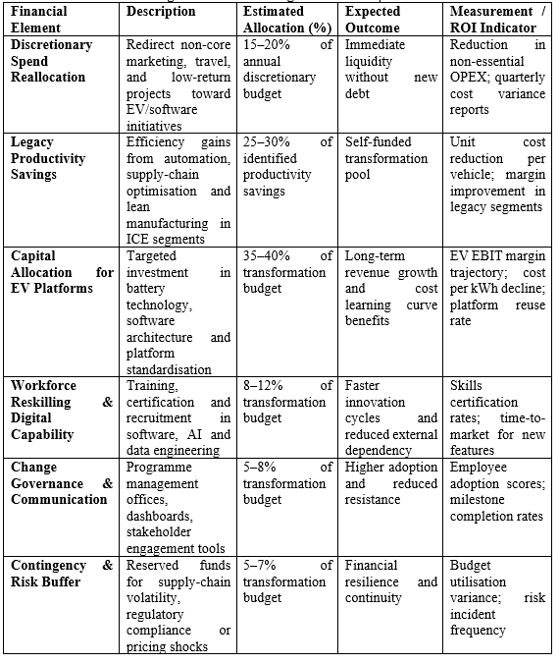
Figure 4 Financial Plan and ROI Logic – Indicative Budget Framework
Ford must ring-fence a transformation budget based on (i) discretionary spend reallocation, (ii) productivity savings in heritage activities and (iii) controlled capital allocation in line with quantifiable milestones. The logic of ROI associates the investment with the reduction of the gap in EV loss, as the results of the FY2024 segments demonstrate that Model e continues to make losses and makes it more dependent on Pro cash income (Ford Motor Company, 2025). The financial governance must demand quarterly value-realisation gates, providing funding only when the cost-down and delivery metrics get better, and not putting long-term investment and lack of learning into practice.

Communication and stakeholder engagement plan
Employees, unions, dealers, suppliers, regulators and fleet customers should be prioritised in stakeholder mapping as the transformation of Ford will involve both the systems with regard to operations and systems with regard to the market. Communication: It should be done hierarchically: strategic narrative, monthly executive briefing, bi-weekly manager toolkits to localise, weekly team updates to be executed more clearly, as transparency and frequency are both again related to reduced uncertainty and more positive change responses (Khaw et al., 2022).

Risk management and evaluation metrics
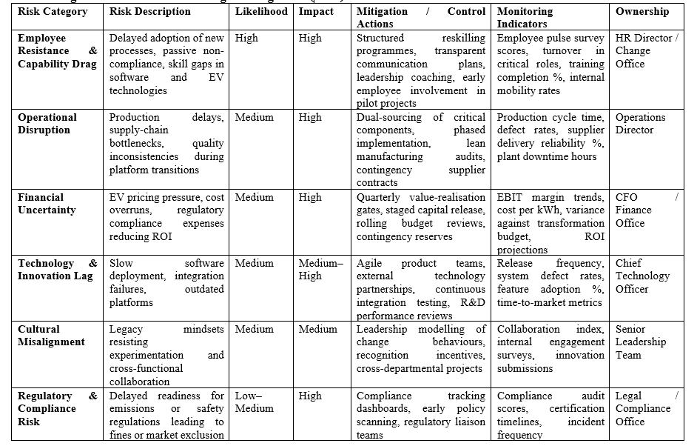
Figure 5 Risk Management Framework – Strategic Change Plan (Ford)
Among the major risks, there are (1) resistance and ability drag, (2) operational disruption in plants and supply chains and (3) financial uncertainty due to the pressure on pricing and timing of EV and regulations. Skills-based workforce planning, organised issue escalation, and contingency buffers on critical suppliers should be considered as risk controls, and leadership should proactively track the indicators of resistance that take the form of delay, passive non-compliance or quality erosion (Warrick, 2023). Dashboard-based evaluation (integrating financial, operational and people indicators) should be encouraged since KPI dashboards enhance organisational control when they are closely aligned to strategic goals and belong to cross-functional teams (Nunes et al., 2024).

Conclusion
The analysis proves that strategic change at the Ford Motor Company is not a frivolous addition, but a structural necessity due to the quantifiable performance drift, quicker technological shift and more rigid regulatory boundaries. The organisation scale and brand equity are still major strength but not enough to guarantee long-term competitiveness, as value creation is becoming more determined by the capabilities of software, economies of electrification, and ecosystem relationships. Thus, the key strategic challenge is to turn the old operational excellence into adaptive capability instead of sustaining the current practises.
The major facilitator of this change is leadership, not only with the help of visionary communication but also with the help of orderly governmental rule, coalition formation and balance between the rate of innovation and the reliability of execution. The behavioural architecture needed to maintain the momentum and protect the operational performance is the blended leadership strategy that incorporates transformational motivation with transactional control. Similarly, organisational culture defines whether strategic intent is converted into everyday practise; those cultures that encourage experimentation, cross-functional team work and lifelong learning enhance the ability to absorb change, and hierarchical bureaucracies and aversion to risk lengthen the adjustment processes.

References
Abawari, A.M. (2024) ‘The effects of organizational culture on change management through leadership styles’, Cogent Business & Management, 11(1). Available at: https://www.tandfonline.com/doi/full/10.1080/23311975.2024.2375623 (Accessed: 6 February 2026).
Al-Moaid, N.A.A. (2024) ‘Developing dynamic capabilities for successful digital transformation projects: the mediating role of change management’, Journal of Innovation and Entrepreneurship, 13(1). Available at: https://link.springer.com/article/10.1186/s13731-024-00446-9 (Accessed: 6 February 2026).
Atanassova, I., Bednar, P., Khan, H. and Khan, Z. (2025) ‘Managing the VUCA environment: The dynamic role of organizational learning and strategic agility in B2B versus B2C firms’, Industrial Marketing Management, 125, pp. 12–28. Available at: https://www.sciencedirect.com/science/article/pii/S0019850124002062 (Accessed: 6 February 2026).
Bogale, A.T. (2024) ‘Organizational culture: a systematic review’, Cogent Business & Management. Available at: https://www.econstor.eu/bitstream/10419/326237/1/10.1080_23311975.2024.2340129.pdf (Accessed: 6 February 2026).
Burr, W. (2024) ‘Competence building in software technologies: the case of German car manufacturers’, Technology Analysis & Strategic Management. Available at: https://www.tandfonline.com/doi/full/10.1080/09537325.2024.2392138 (Accessed: 6 February 2026).
Carreño, A.M. (2024) An Analytical Review of John Kotter’s Change Leadership Framework: A Modern Approach to Sustainable Organizational Transformation. SSRN (Date written: 19 September 2024). Available at: https://papers.ssrn.com/sol3/papers.cfm?abstract_id=5044428 (Accessed: 6 February 2026).
de la Torre, A., Galeano, L. and Pérez-Luño, A. (2025) ‘Dynamic capabilities and digital innovation: an empirical approach’, European Journal of Innovation Management. Available at: https://www.tandfonline.com/doi/full/10.1080/23299460.2025.2500154 (Accessed: 6 February 2026).
Ellström, D. (2022) ‘Dynamic capabilities for digital transformation’, Journal of Small Business and Enterprise Development, 15(2), pp. 272–? Available at: https://www.emerald.com/insight/content/doi/10.1108/JSBED-05-2021-0209/full/html (Accessed: 6 February 2026).
Environmental Protection Agency (2024) Final Rule: Multi-Pollutant Emissions Standards for Model Years 2027 and Later Light-Duty and Medium-Duty Vehicles. Available at: https://www.epa.gov/regulations-emissions-vehicles-and-engines/final-rule-multi-pollutant-emissions-standards-model (Accessed: 6 February 2026).
European Commission (2022) ‘Zero emission vehicles: first “Fit for 55” deal will end the sale of new CO₂ emitting cars in Europe by 2035’. Available at: https://ec.europa.eu/commission/presscorner/detail/en/ip_22_6462 (Accessed: 6 February 2026).
Ford Motor Company (2025) Annual Report (Form 10-K) for the fiscal year ended 31 December 2024. U.S. Securities and Exchange Commission. Available at: https://www.sec.gov/Archives/edgar/data/37996/000003799625000013/f-20241231.htm (Accessed: 6 February 2026).
Ford Motor Company (2025) Ford Motor Company 2024 10-K Report (fiscal year ended 31 December 2024). Available at: https://www.sec.gov/Archives/edgar/data/37996/000003799625000013/f-20241231.htm (Accessed: 6 February 2026).
Ford Motor Company (2026) ‘About Us: Our Purpose’. Available at: https://corporate.ford.com/about/purpose.html (Accessed: 6 February 2026).
International Council on Clean Transportation (2025) U.S. multi-pollutant emissions standards for model years 2027 and later light-duty and medium-duty vehicles. Available at: https://theicct.org/publication/us-multi-pollutant-emissions-standards-for-model-years-2027-and-later-ldv-mdv-apr25/ (Accessed: 6 February 2026).
International Energy Agency (2024) ‘Trends in electric cars’, Global EV Outlook 2024. Available at: https://www.iea.org/reports/global-ev-outlook-2024/trends-in-electric-cars (Accessed: 6 February 2026).
International Energy Agency (2024) Global EV Outlook 2024: Executive summary. Available at: https://www.iea.org/reports/global-ev-outlook-2024/executive-summary (Accessed: 6 February 2026).
International Monetary Fund (2025) World Economic Outlook Update, January 2025. Available at: https://www.imf.org/en/publications/weo/issues/2025/01/17/world-economic-outlook-update-january-2025 (Accessed: 6 February 2026).
Khaw, K.W., Courtois, A., Ridgway, J. and Stead, M. (2022) ‘Reactions towards organizational change: a systematic literature review’, Journal of Organizational Effectiveness: People and Performance. Available at: https://pmc.ncbi.nlm.nih.gov/articles/PMC9006211/ (Accessed: 6 February 2026).
Mekonnen, M., Xue, J., Gebremedhin, T. and Tessema, M. (2023) ‘The Effect of Transformational and Transactional Leadership Styles on Organizational Change Readiness’, Frontiers in Psychology, 14. Available at: https://pmc.ncbi.nlm.nih.gov/articles/PMC10336755/ (Accessed: 6 February 2026).
Mouazen, A.M., Hernández-Lara, A.B., Abdallah, F., Ramadan, M., Chahine, J., Baydoun, H. and Bou Zakhem, N. (2023) ‘Transformational and Transactional Leaders and Their Role in Implementing the Kotter Change Management Model Ensuring Sustainable Change: An Empirical Study’, Sustainability, 16(1), 16. Available at: https://www.mdpi.com/2071-1050/16/1/16 (Accessed: 6 February 2026).
Nunes, F., Alexandre, E. and Gaspar, P.D. (2024) ‘Implementing Key Performance Indicators and Designing Dashboard Solutions in an Automotive Components Company: A Case Study’, Administrative Sciences, 14(8), 175. Available at: https://www.mdpi.com/2076-3387/14/8/175 (Accessed: 6 February 2026).
Phillips, J. and Klein, J.D. (2022) ‘Change Management: From Theory to Practice’, TechTrends, 67(1), pp. 189–197. Available at: https://pmc.ncbi.nlm.nih.gov/articles/PMC9462626/ (Accessed: 6 February 2026).
Prosci (2023) ‘Best Practices in Change Management’. Available at: https://www.prosci.com/blog/change-management-best-practices (Accessed: 6 February 2026).
Reuters (2026) ‘EU proposals set to limit EV sales from 2035, says campaign group’. Available at: https://www.reuters.com/sustainability/climate-energy/eu-proposals-set-limit-ev-sales-2035-says-campaign-group-2026-02-02/ (Accessed: 6 February 2026).
Rosnerova, Z., Vetrakova, M., Sirec, K. and Kirchmayer, Z. (2024) ‘Comprehensive Study of Critical Areas of Change Management as a Starting Point for Leaders in the Area of Managing Human Resources in Organizations: The Case of the Visegrad Four’, Systems, 12(9), 342. Available at: https://www.mdpi.com/2079-8954/12/9/342 (Accessed: 6 February 2026).
Vasel, H. (2025) ‘Factors shaping the implementation of educational organizational change: An analysis of Lewin’s model in the context of teaching innovations’, International Journal of Educational Research Open. Available at: https://www.sciencedirect.com/science/article/pii/S2590291125003274 (Accessed: 6 February 2026).
Warrick, D.D. (2023) ‘Revisiting resistance to change and how to manage it: What has been learned and what organizations need to do’, Business Horizons, 66(4), pp. 433–441. Available at: https://www.sciencedirect.com/science/article/abs/pii/S0007681322001070 (Accessed: 6 February 2026).

