Autism
Written Report

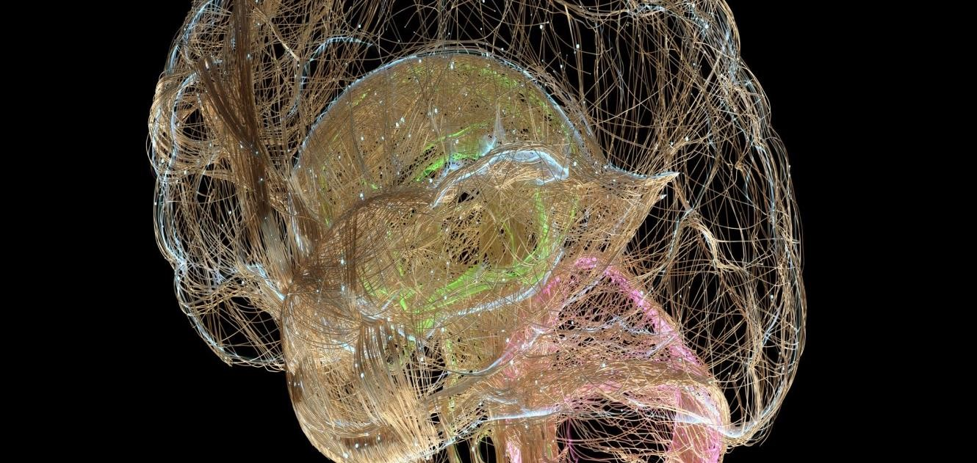

Student Name: Natalie Tully
Student Number: 2025743
Lecture: Alice Clayton
Module code: BMHP6006_BIRM

Introduction 3
Definition and Classification of Autism 4
Historical overview of Autism. 4
What is Autism? 4
Classification of Autism in the ICD 10 and DSM 5 5
Diagnosis 6
Adult Autism 7
ASD Diagnostic Evaluation 8
Sectioning 9
What is the difference between Asperger syndrome and Autism? 10
Drawbacks and potential problems with diagnostic labelling? 11
Treatments 11
Behaviour Approaches 12
Educational Approaches 12
Draw backs and Pros of ABA Therapy Treatment 13
Measurement of Rehabilitation 13
Benefits 13
Cognitive behaviour therapy 14
Conclusion and Recommendations 15
References 17

Introduction
This report's objective is to examine what autism is and how it is diagnosed in both children and adults. At the same time, exploring the importance of the need for knowledge and awareness of the condition which has grown into diverse levels over time, will be looking into broadening of the diagnostic criteria that define autism spectrum disorders.
Then looking into how the growing evidence is important for early diagnosis and intervention which calls for knowledge and abilities from all professionals dealing with young children, especially those involved in identifying early developmental issues.
Examining the drawbacks and potential problems with diagnostic labelling. This report will also carefully examine the therapeutic options offered, then finally investigate the rehabilitation measures and the impact on parent’s stress levels before finishing on recommendations.

Definition and Classification of Autism
Autism Spectrum Disorder (ASD), referred to as autism, is a genetic disorder. Individuals with autism have a unique way of thinking and feeling about the world. As a result, the individual may behave differently than most people and have different strengths and difficulties. Some aspects of autism and what you think, feel, and do, for example, may make it difficult for them to express themselves in social situations, but they may also be exceptionally knowledgeable and enthusiastic about topics that interest them (NHS Fife, 2023).

Historical overview of Autism.
As stated by Frith, (1989), the term “autism” was first used in 1912 by Swiss psychiatrist and psychologist Eugen Bleuler as a way of describing “an escape from reality.” The words' original meaning, described a severe withholding from social interactions, alluded to a core schizophrenic disorder (frith,1989).

What is Autism?
Autism is a developmental condition that affects a person's ability to interact with others and communicate throughout their lives. Around 700,000 adults and children in the UK (United Kingdom) are autistic, which is a prevalence of more than 1 in 100 persons who have autism spectrum disorder, a permanent developmental disease that usually manifests before the age of three (National Autistic Society, 2023).

Fig 1 (Devlin and Scherer, 2012).
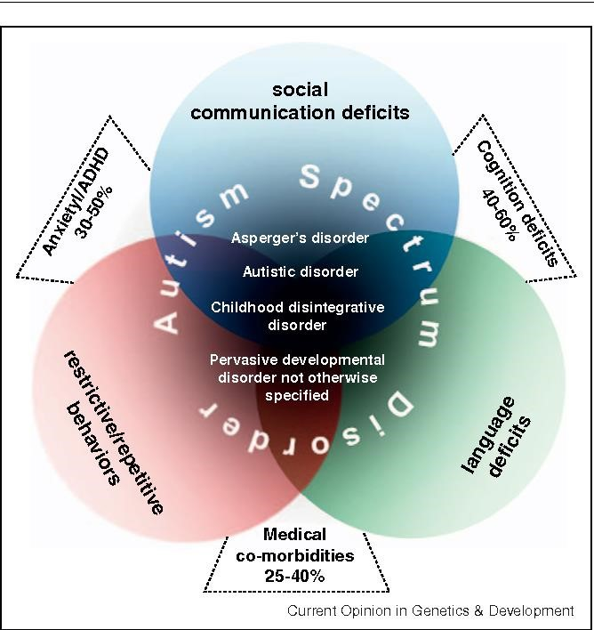
As the understanding of the disorder grows, the definition of autism may also alter in the coming years. Some individuals argue that the spectrum is too broad and that a person with autism who needs constant help cannot be compared to someone who dislikes bright lights in stores. Getting enough help from mental health, education, and social care services or being misunderstood by individuals close to them are two common issues faced by autistic persons and their families, regardless of their diverse support needs (autism.org.uk, no date).

Classification of Autism in the ICD 10 and DSM 5
ICD 10 (International Classification of Diseases) defines it as "A group of disorders characterised by qualitative abnormalities in reciprocal social interactions and patterns of communication and by a restricted, stereotyped, repetitive repertoire of interests and activities. These qualitative abnormalities are a pervasive feature of the individual's functioning in all situations" (icd.who.int, no date).
These are the ICD-10 Diagnosis Codes:
F84.0 Autistic disorder
F84.01 Childhood autism (Icd10data.com, 2019).
The DSM-5 Manual defines autism spectrum disorder as “persistent difficulties with social communication and social interaction” and “restricted and repetitive patterns of behaviours, activities or interests” (this includes sensory behaviour), present since early childhood, to the extent that these “limit and impair everyday functioning” (National Autistic Society, 2020).
Even though ICD 10 -11 and the DMS 5 both have their disadvantages and advantages; one example is relating to how different autism spectrum conditions are diagnosed.
The ICD11, for instance, describes and examines the absence of functional language in this condition.
The DSM-5, however, just asks the reader to consider this as a possibility. Classifications can be wrong, need updating, and can overlap diagnoses and the different opinions of various experts, which is the problem of low existing reliability and low diagnostic validity. This is why valid and complete classification can be extremely complicated (Exploring your mind, 2022).

Diagnosis
According to (GOV.UK, 2021), far too many autistic persons still have to wait a long time for a diagnosis and do not always get the care that is person centre to their requirements at an early enough period. Too many children with autism still experience difficulties in getting a diagnosis and receiving help after receiving one, including at school, and struggle to find employment in adulthood.
The lives of children with autism spectrum disorder (ASD) and their families can significantly improve with an early diagnosis. Making an ASD diagnosis, however, is not always simple. Since there is no laboratory test for it, clinicians must instead rely on studying the actions of young children and paying attention to the concerns of their parents (WebMD, 2016).
Getting a referral for a diagnosis of autism needs to be set up with a local autism multiagency strategy group, which is made up of managerial, commissioner, and clinical representation from child health and mental services, education, social care, parent and carer service users, and voluntary sector (NICE, 2011).
Various stages need considering and the appointee needs to lead professionals to manage the pathway for recognition, referral, and diagnosis of children and young people.
The autism team should be set up by a core team which includes:
- Paediatrician, child, and adolescent psychiatrist
- Speech and language therapist
- Psychologists who are experienced in working with autistic children and young people.
- Occupational therapist (NICE, 2011).
The diagnosis is different from childhood to adulthood, as early detection is paramount, a broadening of diagnostic criteria, and a rise in awareness of autism have led to a substantial number of individuals whose difficulties remained undetected until adulthood.
This leaves adults with a diagnosis of autism, which they do not understand due to not having the right framework in place, to make sense of their difficult life experiences, which shows the need for prompt diagnosis and provision of post-diagnostic support (Gellini and Marczak, 2023).
When given an autism diagnosis as an adult in the UK, levels of satisfaction with the diagnostic procedure varied; 40% of respondents expressed "very or quite" dissatisfaction, while 47% expressed "very or quite" happiness. A 2017 analysis indicated that only 3.5% of published research addressed adults. Research has primarily concentrated on autism in children, with adult research being understudied (Gellini and Marczak, 2023).
Being given a formal diagnosis is important as it gives clarity to the person and helps them understand their condition and access the resources and services.

Adult Autism
According to (Nationalarchives.gov.uk, 2013), “Autism is a lifelong developmental disability and although some people can live independently, others will have high dependency needs requiring a lifetime of specialist care.
There are approximately 400,000 adults with ASC in England, around half of whom have a learning disability.”
The symptoms of autism in children and adults are the same, but the characteristics of autism from person to person can be different.
They will need to be referred by a GP, to be assessed by a diagnostician who uses various tools to choose from as there are many different ones available. The tools will ask them a lot of questions about how they developed as a youngster, including questions on language and play. The diagnostician will let them know if they believe them to be autistic or not on the day of the evaluation, later by phone, or in a written report that they post.
These tools include the ADOS (Autism Diagnostic Observation Schedule), the ADI-R (Autism Diagnostic Interview Revised) the DISCO
(Diagnostic Interview for Social and Communication Disorders), and the 3Di (Developmental, Dimensional, and Diagnostic Interview).
The diagnostic manuals ICD-10 and DSM-5 have a list of autism criteria that the assessor compares them against (autism.org.uk, no date).

ASD Diagnostic Evaluation
As a result of the variety in symptom types and severity, diagnosing ASD is a complex procedure that cannot be solved by a single algorithm. This has meant in a clinical sense that no one behaviour, such as answering a name or paying attention together, disqualifies an ASD diagnosis.
Many traits that are commonly associated with ASD at some ages, particularly when identified by informants, may also be present in other medical conditions and are not specific to the diagnosis. According to parents and carers who took part in a study, stereotyped language was no more common in ASD-affected children than it was in normally developing children, children with other non-spectrum diagnoses who were under four, children without sophisticated language, and children with other non-spectrum diagnoses (Huerta and Lord, 2012).

There are several types of levels of ASD, (fig 2), which has increased with more clinical disorders that health professionals best fit under the category of autism spectrum disorders, which means the number of individuals with an autism spectrum disorder has become extremely high. Even with all the perspectives and knowledge available an ASD diagnosis today covers several disorders that were formerly classified independently, including Asperger syndrome, PDD-NOS, and autistic disorder. These conditions are now collectively referred to as autism spectrum disorder ( Advocates for Spectrum Knowledge, no date). Even with the DMS-5 removing Asperger syndrome as a distinct category, are putting all under one umbrella of autism spectrum disorders (autism.org.uk, no date).

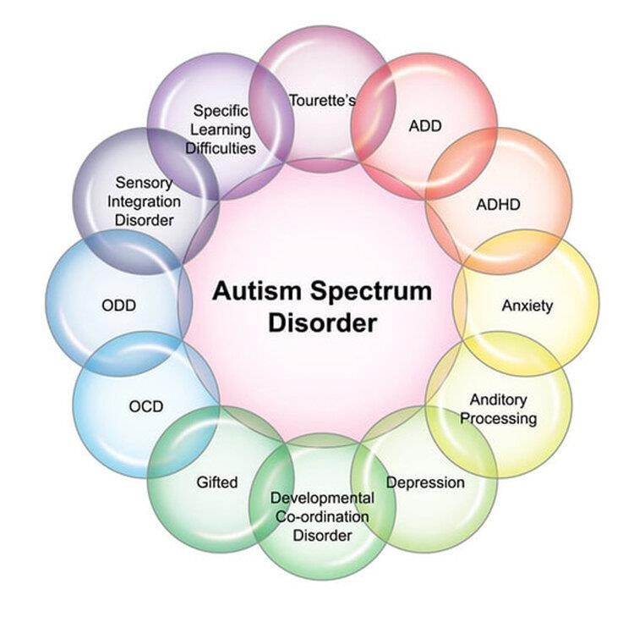
Fig 2 ( Advocates for Spectrum Knowledge, no date).

Sectioning
According to information submitted during a Health and Social Care Committee investigation, the majority of the 2,000 people with autism or a learning impairment who are now housed in secure inpatient settings could be managed in the community (LDT, no date). Inquiry that examines "sectioning" and the use of restraint as they relate to the slow improvement in how autistic people and people with learning difficulties are treated, Considering criticisms regarding human rights (LDT, no date).

The Mental Health Act of 1983 is used to detain the vast majority (90%) of autistic patients who are being held in hospitals. There have been advocates for improvements to the mental health law so that it upholds the rights of autistic people for years, along with hundreds of thousands of other activists. If implemented, these changes may reduce the number of autistic people who are unnecessarily admitted to mental institutions. Since their autism is poorly understood, autistic people who visit an ATU for mental health support may receive treatment that does not meet their needs or feel uncomfortable in the setting. This can make an autistic person feel worse rather than better and means they could spend years "trapped" inside an ATU, which is unacceptable (autism.org.uk, no date).

What is the difference between Asperger syndrome and Autism?
According to (Jewell, 2020) “Asperger’s syndrome was previously considered a “mild” or “high functioning” form of autism”. This indicates that those with an Asperger's diagnosis often exhibited behaviours that were considered hardly different from those of neurotypical people. The Diagnostic and Statistical Manual of Mental Disorders (DSM) first listed Asperger's in 1994.

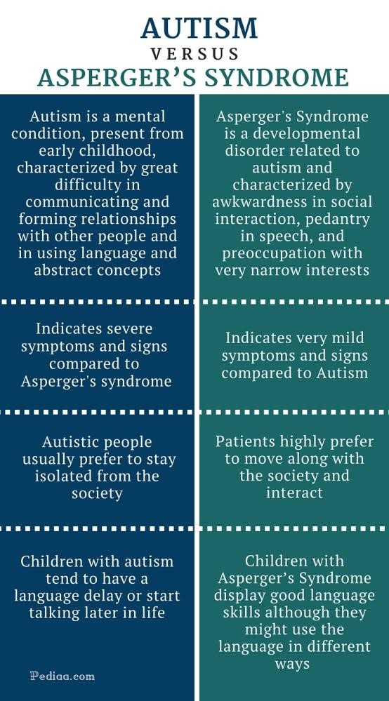Fig3

There are many similarities between both, people with Aspergers Syndrome do not have learning disabilities, however, can have other mental health conditions like anxiety, and they feel, hear, and see the world differently from other people, (fig 3) (Mencap, 2019).

Drawbacks and potential problems with diagnostic labelling?
Medical practitioners use diagnoses to categorise patients for both treatment and study. Despite their apparent benefits, diagnostic labels often function as cues for stigma and preconceptions. The stigma connected to the diagnosis of autism can negatively affect social connections, interactions with the medical community, and attitudes towards service use, the fear of being stigmatised and stereotyped is understandable as it occurs frequently, People frequently experience a fear of the unknown (Garand et al., 2009).
The implications of labels like autism and the related diagnostic procedures on the children to whom they are applied are not considered (Sims et al., 2021).
One of the biggest drawbacks to diagnostic labelling is that there are often barriers to receiving a diagnosis, this occurs when going to the GP because they are not psychiatrists; a referral could take up to 6 months to be seen.
The challenges or negative effects of a diagnosis, however, are frequently less talked about. This could involve greater psychological distress, a predilection for invasive therapies, an increase in sick role behaviour, and a restriction of independence (Garand et al., 2009).

Treatments
According to each child's specific needs, the type of treatment they will receive for their autism spectrum condition will vary. ASD is a spectrum disorder, meaning that some autistic children have mild symptoms while others have more severe ones. As a result, there are several therapies for ASD available. However, the outcome is always the same: symptom relief and improved learning and development, the best therapies will vary depending on the child's needs and circumstances (WebMD, 2016).

Treatments may be given in a range of venues, including educational, medical, community, or residential ones. Providers should communicate with one another, the person with ASD, and their family to ensure that treatment objectives and progress are meeting expectations (Centres for Disease Control and Prevention, 2019).

Behaviour Approaches
Behavioural strategies put a lot of emphasis on understanding what happens before and after behaviours to change them. Behavioural approaches have the best record for treating ASD symptoms. They are widely accepted by educators and medical professionals and are used in many schools and treatment centres. One well-known behavioural therapy for ASD patients is called Applied Behaviour Analysis (ABA). ABA encourages desired behaviour, while discrete trials deter unwanted behaviour to improve a variety of abilities. Progress is monitored and assessed.

Training (DTT) and Pivotal Response Training (PRT) are two ABA training methods.
- DTT teaches a desired behaviour or response using step-by-step procedures. The simplest elements of lessons are broken down and desired responses and actions are rewarded. Negative responses and actions are not taken seriously.

- PRT occurs in the environment. PRT aims to enhance a select number of "pivotal skills" that will facilitate the acquisition of numerous more skills, Forming communication with others is just one example of a vital talent (Centres for Disease Control and Prevention, 2019).

Educational Approaches
Educational interventions are given in a classroom setting. One type of educational strategy is known as the TEACCH approach, which stands for Treatment and Education of Autistic and Related Communication-Hazardous Children. The TEACCH programme was developed on the premise that people with autism benefit from consistency and visual learning. To improve academic and other outcomes, it gives teachers the chance to alter the way lessons are run. For instance, regular procedures could be described, shown, and put on display. Some learning stations can have restrictions. Verbal instructions can be supplemented with visual cues or firsthand examples (Centres for Disease Control and Prevention, 2019).

Drawbacks and Pros of ABA Therapy Treatment
One drawback of ABA therapy is that parents and autistic people think it is unethical. Using ABA therapy indicates that the child is abnormal or needs to improve. It demands that children conform to their "normal" peer group. Detractors claim that this strategy is abusive, unethical, and incorrect. The amount of time it takes, which could be up to 40 hours a week, parents feel it is too much stress put on the child. Critics also say that it takes away the ability to be themselves, for them to convert into what is socially acceptable to be Normal. On the other hand, ABA can help the child remain in school with support and they perform better. Also, ablest the child to develop more skills for instance social and emotional that match typical children,
- Daily Chores
- Motor skills
- hygiene skills (Applied Behaviour Analysis Programs Guide, 2019).

Measurement of Rehabilitation
The Treatment and Education of Autistic and Communication-Related Handicapped Children (TEACCH) approach has gained widespread acceptance throughout the world, but most of the earlier research has concentrated on using it to educate children with autism spectrum disorders (ASD) who are high-functioning or do not have intellectual disabilities.

Benefits
The TEACCH method is based on parents and caregivers collaborating closely with teachers.
arranging the environment to allow for deficiencies associated with autism.
The main elements of this structure education:
- Physical organisation of the environment by placing visual barriers and minimising distractions
- visual schedules to enable students to know and expect the occurrence of events.
- Enable to work independently, following a sequence of activities.
- Using visual instructions and organisation, allowing students to have clear steps to follow while considering the child's strengths while working with their visuospatial skills (Siu, Lin, and Chung, 2019).

Many tools can measure the success of treatments, but due to the heterogeneity of changes in symptoms which can be subtle, especially over brief periods which cannot be 100 percent accurate, several studies have shown improvements with early intervention programs for children with ASD but there are ongoing challenges.

- According to Grzadzinski, Janvier, and Kim, (2020), there are many measures used which have been criticized as having little validity as treatments but to design an effective rehabilitation programs, parents and experts should work together. It appears essential for rehabilitation to be identified by professionals.

Children's needs are parents' top priorities with ASD, according to research and studies, there is a behaviour that results in an elevated level of parental stress which would likely be a high rehabilitation priority for parents even when these behaviours are not part of a triad of core ASD symptoms, which in turn could affect child health.
Many reports have addressed the impact of parents suffering from elevated levels of stress caring for a child with ASD, which has a greater impact on the child’s rehabilitation for progressing further with treatments, as these services rely on input from the parents or caregivers.
According to an article based on parent stress adjustment, “Parents of children with autism spectrum disorder (ASD) report elevated levels of stress that can interfere with important child and family treatments. Limited past research considers how the caregiving experience and social determinants of health may contribute to treatment engagement and outcomes, …...” (Iadarola et al., 2017).
This article shows that parents need support programs and early intervention is needed for parents as well as the child with ASD for treatments and rehabilitation to work long term. Given the importance of parents' input, it is vital.
There is an understanding of the stresses within the family environment that can impact the child’s learning and rehabilitation programs should be developed through a collaborative approach between parents and professionals.

Cognitive behaviour therapy
Cognitive behaviour therapy is another form of therapy available, which based on the relationship between thoughts, feelings, and behaviours is a key theme.
The therapist, the patient with autism spectrum disorder (ASD), and/or the parents produce specific goals for the duration of therapy together. Numerous different therapy modalities are part of cognitive rehabilitation, which can be conducted by various rehabilitation specialists.
In people with brain damage or cognitive impairment, cognitive rehabilitation aims to compensate for cognitive deficits and regain normal functioning (Dandil et al., 2020).
Environmental variables such as poverty, substandard housing, low socioeconomic position, large families, incompatibility, parent-child conflicts, and family aggressiveness are some of the environmental causes of ASD in addition to biological ones. Most children and adults with ASD suffer cognitive skill delays, according to several studies.
A greater understanding of the cognitive phenotype will improve our comprehension of how genes, the brain, and behaviour interact, as well as give us more knowledge about treatments. Assessing and rehabilitating people with special needs and children's active memory is a critical cognitive skill. The cognitive executive/functional ability known as active memory is used for academic, behavioural, and social activities (Shahmoradi and Rezayi, 2022).
This is why most families use cognitive rehabilitation treatments to address their children's issues with executive functioning, attention, and memory as well as to enhance their learning and daily abilities. Given the difficulties in enhancing both children's and adults' health, focusing on new methods to enhance cognitive abilities appears to be the way forward.

Conclusion and Recommendations
As shown in this report it is evident that there is an apparent lack of understanding about Autism. There are several people still being admitted to hospitals with incorrect diagnoses and a lack of funding which in turn is affecting those that are being wrongly medicated.
There is currently a draft bill going through parliament to reform the mental health act, with this it would be hopeful that the changes requested would support people with autism and those around them.
Several improvements can be used to support people with Autism in practice, which in turn will support those suffering with Autism and offer support for their carer’s.

Some of the recommendations to support improvements include.

- More understanding and training on autism in all areas of professional setting
- Changes in law within the mental health act on of sectioning and hospitalise.
- Improving educational professionals’ understanding of autism and inclusive cultures within schools.
- Improving early detection and waiting lists
- More community's base support projects
- More support with parental stress management

.

References
autism.org.uk. (no date) Number of autistic people in mental health hospitals:
latest data. (online) Available at: https://www.autism.org.uk/what-wehttps://www.autism.org.uk/what-we-do/news/autistic-people-in-mental-health-hospitalsdo/news/autistic-people-in-mental-health-hospitals (Accessed: 19 July 2023).

autism.org.uk. (no date) What is autism. (online) Available at: https://www.autism.org.uk/advice-and-guidance/what-is-autism?gclid=EAIaIQobChMI2q_R06D3_wIVBbjtCh1_ogB7EAAYASAAEgI-U_D_BwE. (Accessed: 5 July 2023).

autism.org.uk (no date) Rarely an hour goes by that I dont think about what happened in hospital. (online) Available at: https://www.autism.org.uk/advicehttps://www.autism.org.uk/advice-and-guidance/stories/stories-from-the-spectrum-alexis-quinnand-guidance/stories/stories-from-the-spectrum-alexis-quinn (Accessed: 18 July 2023).

autism.org.uk (no date) The diagnostic assessment. (online) Available at: https://www.autism.org.uk/advice-and guidance/topics/diagnosis/diagnostichttps://www.autism.org.uk/advice-and-guidance/topics/diagnosis/diagnostic-assessmentassessment (Accessed: 19 July 2023).

Applied Behavior Analysis Programs Guide (2019) What Are the Advantages and Disadvantages of Treating Autism With ABA? - Applied Behavior Analysis Programs Guide. (online) Applied Behavior Analysis Programs Guide. Available at: https://www.appliedbehavioranalysisprograms.com/faq/what-are-the-advantages-and-disadvantages-of-treating-autism-with-aba/ (Accessed: 24 July 2023).
‌
Centers for Disease Control and Prevention (2019) Treatment and intervention services for autism spectrum disorder. (online) Centers for Disease Control and Prevention. Available at: https://www.cdc.gov/ncbddd/autism/treatment.htmlhttps://www.cdc.gov/ncbddd/autism/treatment.html (Accessed: 24 July 2023).

Dandil, Y., Smith, K., Kinnaird, E., Toloza, C. and Tchanturia, K. (2020) Cognitive Remediation Interventions in Autism Spectrum Condition: A Systematic Review.
Frontiers in Psychiatry, 11. Available at: https://doi.org/10.3389/fpsyt.2020.00722.

Devlin, B. and Scherer, S.W. (2012) Genetic architecture in autism spectrum disorder. Current Opinion in Genetics & Development, (online) 22(3), pp.229–237. Available at: https://doi.org/10.1016/j.gde.2012.03.002.

Exploring your mind. (2022) ICD and DSM: Similarities and Differences Between the Two Manuals. (online) Available at: https://exploringyourmind.com/icd-and-dsm/ (Accessed: 5 July 2023).

Frith, U. (1989) Explaining the enigma. (online) Blackwell. Available at: https://www.wiley.com/en-us/Autism%3A+Explaining+the+Enigma%2C+2nd+Edition-p-9780631229018 (Accessed: 24 July 2023).

Gellini, H. and Marczak, M. (2023) ‘I Always Knew I Was Different’: Experiences of
Receiving a Diagnosis of Autistic Spectrum Disorder in Adulthood—a MetaEthnographic Systematic Review. Review Journal of Autism and Developmental Disorders. Available at https://doi.org/10.1007/s40489-023-00356-8.

Garand, L., Lingler, J.H., Conner, K.O. and Dew, M.A. (2009) Diagnostic Labels,
Stigma, and Participation in Research Related to Dementia and Mild Cognitive Impairment. Research in Gerontological Nursing, (online) (2), pp.112–121.
Available at: https://doi.org/10.3928/19404921-20090401-04.

Grzadzinski, R., Janvier, D. and Kim, S.H. (2020) Recent Developments in Treatment Outcome Measures for Young Children With Autism Spectrum Disorder (ASD). Seminars in Pediatric Neurology, 34, p.100806. Available at: https://doi.org/10.1016/j.spen.2020.100806.

GOV.UK (2021) The national strategy for autistic children, young people, and adults: 2021 to 2026. (online) GOV.UK. Available at: https://www.gov.uk/government/publications/national-strategy-for-autistic-children-young-people-and-adults-2021-to-2026/the-national-strategy-for-autistic-children-young-people-and-adults-2021-to-2026 (Accessed: 10 July 2023).
‌
Huerta, M. and Lord, C. (2012) Diagnostic Evaluation of Autism Spectrum Disorders. Pediatric Clinics of North America, (online) 59(1), pp.103–111.
Available at: https://doi.org/10.1016/j.pcl.2011.10.018.

Iadarola, S., Pérez-Ramos, J., Smith, T. and Dozier, A. (2017) Understanding stress in parents of children with autism spectrum disorder: a focus on underrepresented families. International Journal of Developmental Disabilities, (online) 65(1), pp.20–30. Available at: https://doi.org/10.1080/20473869.2017.1347228.

icd.who.int. (no date) ICD-10 Version:2019. (online) Available at: https://icd.who.int/browse10/2019/en#/F84.1 (Accessed: 07 July 2023).

Icd10data.com. (2019) 2019 ICD-10-CM Diagnosis Code F84.0: Autistic disorder. (online) Available at: https://www.icd10data.com/ICD10CM/Codes/F01-F99/F80-F89/F84-/F84.0. (Accessed: 09 July 2023).

Jewell, T. (2020) Asperger’s vs. Autism: What’s the Difference? (online) Healthline. Available at https://www.healthline.com/health/aspergers-vshttps://www.healthline.com/health/aspergers-vs-autismautism#about-aspergers (Accessed: 28 July 2023).

LDT. (no date) Stop ‘sectioning’ people with a learning disability/autism. (online) Available at: https://www.learningdisabilitytoday.co.uk/stop-sectioning-peoplehttps://www.learningdisabilitytoday.co.uk/stop-sectioning-people-with-a-learning-disability-or-autism-when-they-are-in-crisiswith-a-learning-disability-or-autism-when-they-are-in-crisis (Accessed: 19 July 2023).

Mencap (2019) Autism and Asperger’s syndrome. (online) Mencap. Available at: https://www.mencap.org.uk/learning-disability-explained/conditions-linkedhttps://www.mencap.org.uk/learning-disability-explained/conditions-linked-learning-disability/autism-and-aspergers-syndromelearning-disability/autism-and-aspergers-syndrome (Accessed: 10 July 2023).

Nationalarchives.gov.uk. (2013) Available at:
https://webarchive.nationalarchives.gov.uk/ukgwa/20130104203954/http:/www. dh.gov.uk/en/Publicationsandstatistics/Publications/PublicationsPolicyAndGuidan ce/DH_113369 (Accessed: 16 July 2023).

National Autistic Society (2020) Diagnostic criteria - a guide for all audiences. (online) www.autism.org.uk. Available at: https://www.autism.org.uk/advice-andhttps://www.autism.org.uk/advice-and-guidance/topics/diagnosis/diagnostic-criteria/all-audiencesguidance/topics/diagnosis/diagnostic-criteria/all-audiences (Accessed: 12 June 2023).

National Autistic Society (2023) What Is Autism? (online) Autism.org.uk. Available at: https://www.autism.org.uk/advice-and-guidance/what-is-autism (Accessed: 5 July 2023).

NICE (2011) Recommendations | autism spectrum disorder in under 19s: recognition, referral, and diagnosis | Guidance | NICE. (online) Nice.org.uk.
Available at https://www.nice.org.uk/guidance/cg128/chapter/Recommendationshttps://www.nice.org.uk/guidance/cg128/chapter/Recommendations (Accessed: 13 July 2023).

Shahmoradi, L. and Rezayi, S. (2022). Cognitive rehabilitation in people with autism spectrum disorder: a systematic review of emerging virtual reality-based approaches. Journal of NeuroEngineering and Rehabilitation, 19(1).
Available at: https://doi.org/10.1186/s12984-022-01069-5.

Sims, R., Michaleff, Z.A., Glasziou, P. and Thomas, R. (2021). Consequences of a Diagnostic Label: A Systematic Scoping Review and Thematic Framework.
Frontiers in Public Health, 9(1). Available at: https://doi.org/10.3389/fpubh.2021.725877.

Siu, A.M.H., Lin, Z. and Chung, J. (2019). An evaluation of the TEACCH approach for teaching functional skills to adults with autism spectrum disorders and intellectual disabilities. Research in Developmental Disabilities, 90, pp.14–21.
Available at: https://doi.org/10.1016/j.ridd.2019.04.006.

Two Manuals. (online) Available at: https://exploringyourmind.com/icd-and-dsm/ (Accessed: 5 July 2023) (no date) What is autism. (online) Available at: www.autism.org.uk.

WebMD (2016) How Do Doctors Diagnose Autism? (online) Available at: https://www.webmd.com/brain/autism/how-do-doctors-diagnose-autism.

WebMD (2016) What Are the Treatments for Autism? (online) WebMD. Available at: https://www.webmd.com/brain/autism/understanding-autism-treatment.

