
Rotna Begum


STUDENT NUMBER | 2421635
MODULE CODE | LCLM4005
MODULE TITLE | EMPLOYABILITY AND CAREER DEVELOPMENT
LECTURER NAME | REBECCA STEWART
ASSIGNMENT TITLE | 1500 WORD IN CLASS

CONTENTS

- Task 1 - Identify key skills
- Task 2 - Self-Assessment/ Evidence of readiness SWOT Analysis
- Task 3 - My Employment Goals/ Personal Plan

Task 1.
Key Skills
Job 1 - Employment Coach (Business 2 Business UK)
This role requires strong communication, empathy, and organisational skills to support clients into work. Key abilities include active listening, coaching, goal setting, and creating tailored action plans. Proficiency in IT systems, record-keeping, teamwork, and integrity are essential for success. Business 2 Business (UK) Limited (n.d.)
Job 2 - Recruitment Consultant (Pioneer People)
The role demands persuasive communication, negotiation, and sales skills to connect clients and candidates effectively. Success depends on resilience, self-motivation, and time management in a fast-paced, target-driven environment. Leadership potential and ambition for career progression are key assets. Pioneer People – A learning organisation (n.d.)
Job 3 - Customer Engagement Officer (Hello Student)
Focused on customer service and sales, this role values adaptability, problem solving, and collaboration. Strong communication, attention to detail, and proficiency in Microsoft Office enable effective lead conversion, revenue growth, and long-term customer satisfaction. Hello Student Management Limited (n.d.)
Job - Employment Coach (AKG UK)
This position requires communication, coaching, and motivational skills to help individuals achieve sustainable employment. Organisation, time management, and analytical thinking are vital for managing caseloads and identifying barriers. Labour market awareness, IT skills, empathy, and resilience ensure success in a compliance-driven, people-focused setting. AKG UK (n.d.)
Employment Coaches need knowledge of employability coaching, labour market trends, and CRM systems to support clients through SMART goal setting and career development. Recruitment Consultants (Pioneer People) require commercial awareness, sales, negotiation, and recruitment process knowledge. The Customer Engagement Officer (Hello Student) must understand customer relationship management, sales conversion, and digital tools like Microsoft Office.
All roles share strong communication, empathy, motivation, and relationship building skills, supported by organisation, time management, and problem solving. IT proficiency and data accuracy highlight the importance of digital literacy, while resilience, adaptability, and teamwork ensure success in dynamic environments. Collectively, these roles demand a blend of communication, coaching, and technological expertise underpinned by emotional intelligence and a result focused mindset.

Task 2
Self-Assessment

Personal SWOT Analysis
STRENGHS  - One to one Support, with coaching. Action planning/ Job ready  - Excellent communication skills  - Good Teamwork  - Ability to deal with complex cases  - Experience with CRM and IT Systems | WEAKNESS  - Employability Law  - Limited Experience in Commercial/ Recruitment Agency target driven.  - Administrative Burden  - Potential Skill Gaps in Digital Coaching System keeps changing
OPPORTUNITIES  - Access to training and development programmes.  - Opportunity to network with professionals in employability, recruitment, and customer engagement sectors.  - Potential to improve digital and IT skills, including CRM systems and Microsoft Office, to increase efficiency. | THREATS  - High competition from other qualified candidates in the employability and Environment recruitment sectors.  - Pressure from target-driven environments could pose challenges while building confidence and resilience  - External labour market factors may affect job security or opportunities.
(Gürel and Tat, 2017).

I have used the SWOT analysis, which was first introduced by Gürel and Tat (2017), to identify and reflect on my personal strengths and areas for development. Through this analysis, I recognised that my strong interpersonal and communication skills, together with my ability to provide effective one-to-one support, align closely with the core requirements of both the Employment Coach and Customer Engagement Officer roles. These skills enable me to build trust, motivate participants, and create personalised support plans that help individuals progress toward their career goals. I also observed that my adaptability and problem-solving capabilities allow me to respond effectively to the diverse challenges that clients may face, including barriers to employment, confidence issues, and complex personal circumstances. However, I also identified the need to strengthen my understanding of employability law, as regulations frequently change. This will be a key focus within my action plan to ensure I can provide accurate and compliant advice. Additionally, while I have previous experience working in a target-driven environment, I aim to gain further experience in meeting performance metrics and adapting to commercial pressures to enhance my overall professional capability and confidence. I have also recognised the importance of continuous professional development in staying current with best practices and emerging trends in employment support. I am committed to regularly reviewing and reflecting on my practice to ensure I maintain high standards and continue to grow both personally and professionally.

Evidence of Job Readiness
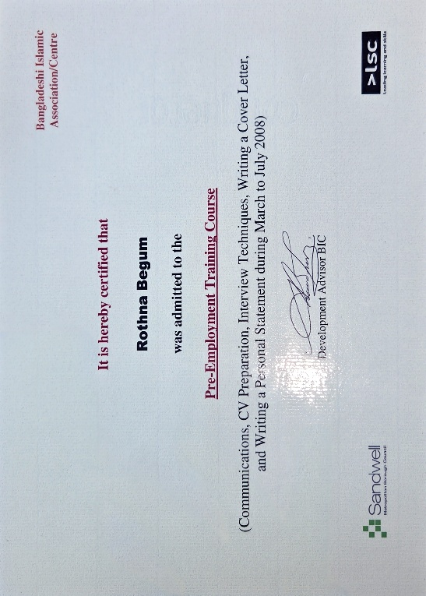
In terms of job readiness, my previous role as an Employability Support Worker equipped me with valuable experience in developing tailored action plans, providing one-to-one coaching, and delivering employability and interview training sessions. I am confident using but need some training for up-to-date CRM systems to manage client progress and match candidates to suitable roles. I continue to develop my skills through ongoing training, including my current Level 4 Skills at Work qualification with the University of Wales Birmingham. This formal education complements my practical experience by enhancing my theoretical knowledge of employability strategies, assessment techniques, and workforce development approaches. Additionally, my volunteer work with Human Appeal has strengthened my teamwork, resilience, and communication skills, further supporting my readiness for this career path. These experiences have also enhanced my cultural awareness and ability to engage effectively with diverse groups, which is particularly valuable in supporting clients from various backgrounds. I am committed to integrating feedback from colleagues and supervisors into my practice to continually improve the quality of support I provide. Please see the attached screenshot of my qualifications. Since obtaining these qualifications, I have continued to build on my training, actively seeking opportunities to broaden my skill set and remain proactive in developing a comprehensive understanding of the employment support sector.


Task 3.
Set Employment Goals
After reviewing my current skills and areas for improvement, I have identified several key developments needs to enhance my employability and career readiness:
- Limited knowledge of employability law
- Limited experience in commercial/target-driven environments
- Administrative burden
- Skill gaps in digital coaching or changing systems
To address my limited knowledge of employment law, I will complete the employment law training available on the University careers website to gain a stronger understanding of workplace regulations, including recruitment processes, equality and diversity requirements, and employee rights. This will not only help me provide accurate and compliant advice but will also enhance my confidence when supporting clients in making informed career decisions. Additionally, I plan to supplement this training with case studies and real-world examples to ensure that my knowledge is practical and applicable to different employment scenarios.
I am also gaining experience through voluntary work on a charity website to improve my commercial awareness. This experience allows me to understand the operational aspects of organisations, including fundraising targets, project delivery, and stakeholder engagement. Developing commercial awareness is essential for working in target-driven environments, such as the roles of Employment Coach or Customer Engagement Officer, where understanding organisational priorities and performance metrics directly impacts success. (JustGiving, 2025)
Managing administrative tasks effectively is another area for development. I plan to strengthen my leadership and management skills by enrolling in relevant modules at the University of Wales in 2026. Learning to prioritise tasks, streamline workflows, and maintain accurate records will not only reduce administrative burden but also improve overall efficiency in professional practice. (University of Wales Trinity Saint David Career Centre, n.d.)
Finally, according to the University of Wales Trinity Saint David Career Centre (n.d.), I will take part in online learning to build digital confidence and adaptability. As coaching and client management increasingly rely on technology, I aim to develop skills in using digital tools, CRM systems, and virtual coaching platforms. Becoming proficient in these areas will allow me to deliver more effective support to clients, track progress accurately, and adapt quickly to evolving workplace technologies.
This Personal Development Plan (PDP) provides a structured approach to improving my professional competence and preparing for future employment opportunities. By setting clear, achievable goals and actively pursuing targeted learning and experience, I am committed to continuous personal and professional growth. This reflective and proactive approach ensures that I am not only prepared for immediate career challenges but also positioned for long-term success in a dynamic and competitive employment landscape.

Personal Development Plan (PDP) (Rotna, 2025)
Development area | SMART Goal | Actions to achieve goal | Resources support needed | Time scale | Measure of success and progress
Employability Law | Gain up-to-date understanding of current employability legislation and worker rights | Attend an online short course or workshop on employability law. | CIPD Website  (CIPD n.d. 2025) | With in 1 month | Completion of training and ability to confidently advise clients on legal issues
Experience in Target-Driven Environment | Improve confidence and performance in achieving monthly and quarterly targets | Set personal weekly goals aligned with organisational KPIs. Volunteer Charity work | (JustGiving 2025: Reach 25: Rotna & Ruksana Tanzania Deployment)  (JustGiving, 2025) | Within 3 months | Meeting or exceeding monthly targets consistently for 3 months
Administrative and Time Management Skills | Attend leadership and management course and volunteer charity work | Attend university of Wales 2026  Online IT training | Career website  (University of Wales Trinity Saint David Career Centre, n.d.) | With in 6 months of starting the course and 1 month with volunteer job. | Exam board marking/  Mangers feedback.
Professional Growth and Confidence | Gain up-to date IT software’s to help with my roles | Online training | Career Website  (University of Wales Trinity Saint David Career Centre n.d. 2025) | 1 month | Helping peers

Job 1.
(Hello Student Management Limited n.d.)
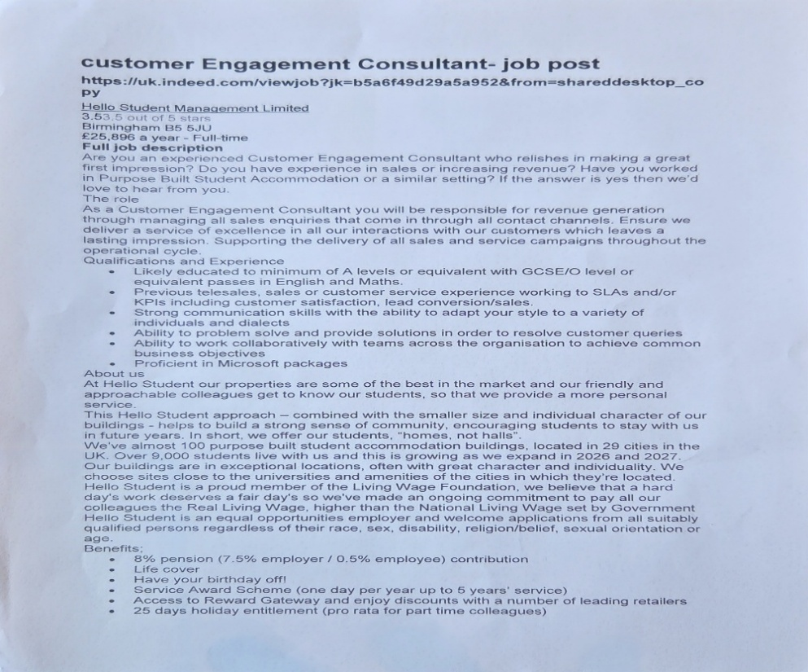
Job 2.
(Business 2 Business (UK) Limited n.d.
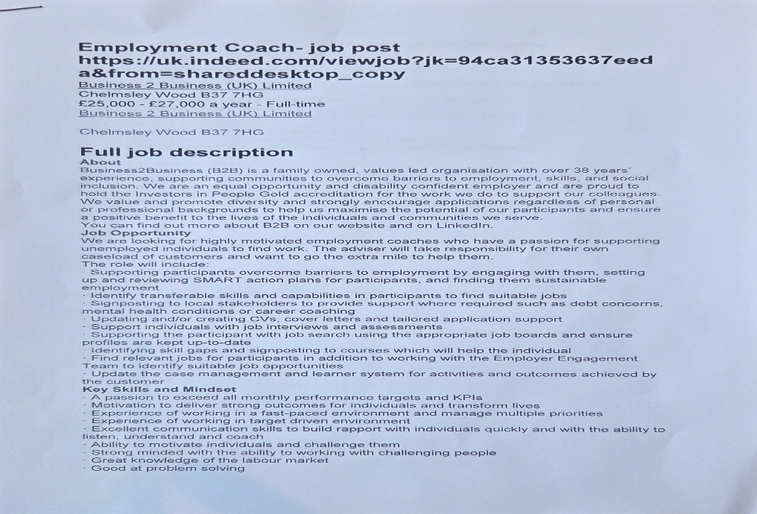

Job 3.
(AKG UK n.d.)
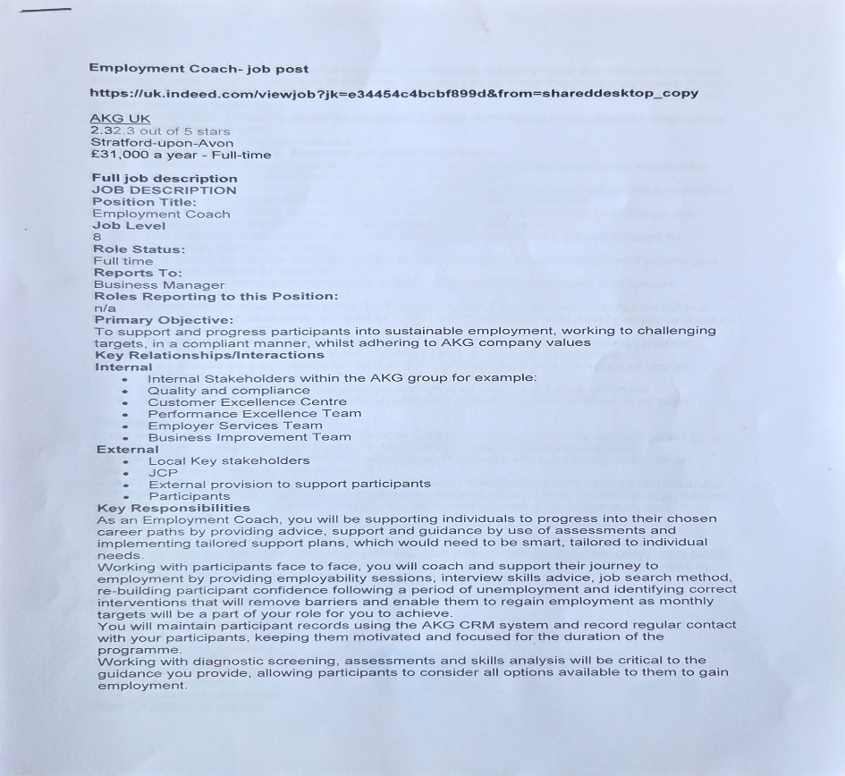

Job 4
(Pioneer People – A learning organisation n.d.)
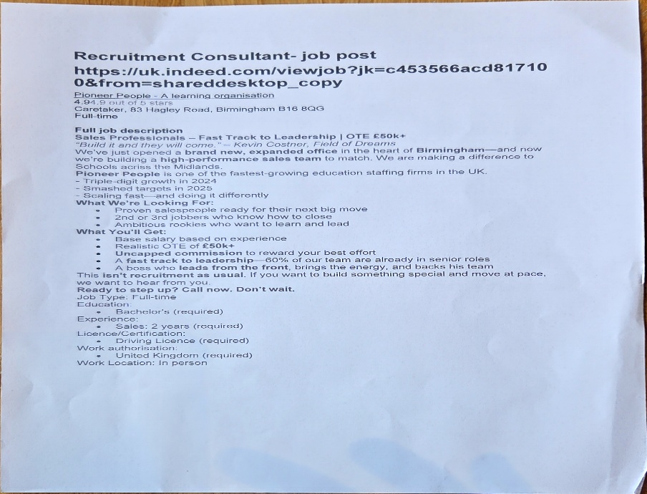

REFERENCES

- Gürel, E. and Tat, M., 2017. SWOT analysis: A theoretical review. The Journal of International Social Research, 10(51), pp.994–1006. Available at: https://doi.org/10.17719/jisr.2017.1832 [Accessed 4 November 2025].
- University of Wales Trinity Saint David Career Centre (n.d.) e-learning hub: gallery category 118. Available at: https://uwtsd.careercentre.me/resources/elearning/Hub.aspx?redirect=/e-learning/category/gallery/118 (Accessed: 8 November 2025).
- University of Wales Trinity Saint David Career Centre (2025) Welcome. Available at: https://uwtsd.careercentre.me/resources/elearning/Hub.aspx?redirect=/e-learning/category/gallery/118 (Accessed: 6 November 2025).
- University of Wales Trinity Saint David Career Centre (n.d.) Labour Market Information (LMI). Available at: https://uwtsd.careercentre.me/LMI (Accessed: 6 November 2025).
- JustGiving (2025) Reach 25: Rotna & Ruksana Tanzania Deployment. Available at: https://www.justgiving.com/page/rbtanzania (Accessed: 6 November 2025).
- Chartered Institute of Personnel and Development (CIPD) (n.d.) Employment law. Available at: https://www.cipd.org/uk/knowledge/employment-law/ (Accessed: 6 November 2025)
- Access UK Ltd. (2025) Welcome. Available at: https://uwtsd.careercentre.me/pulse/?SUV4ZHoyYmc2SCt2S3RjQklDUDVRQT090 (Accessed: Sep 08, 2025).
- Employment Coach [job posting]. Indeed. Available at: https://uk.indeed.com/viewjob?jk=94ca31353637eeda&from=shareddesktop_copy (Accessed: 6 November 2025).
- Recruitment Consultant [job posting]. Indeed. Available at: https://uk.indeed.com/viewjob?jk=c453566acd817100&from=shareddesktop_copy (Accessed: 6 November 2025).
- Customer Engagement Consultant [job posting].Indeed. Available https://uk.indeed.com/viewjob?jk=b5a6f49d29a5a952&from=shareddesktop_copy (Accessed: 6 November 2025).
- Employment Coach [job posting]. Indeed. Available at: https://uk.indeed.com/viewjob?jk=e34454c4bcbf899d&from=shareddesktop_copy (Accessed: 6 November 2025).
- Rotna (2025) Personal Development Plan. Unpublished personal document.

