

Please Find the following attached.
- Cover Letter
- Curriculum Vitae
- Indeed, screen shots job description

LCLM 4005 London
By: Ms Sukhpreet Grewal
RESSELLE CALULOT FLORES
Email: 2514957@student.uwtsd.ac.uk

HR TEAM
amanda@hrteamservices.com
HYBRID WORK
18.07.2026

Dear Ms Amanda,
I wish to apply for the role of BUSINESS DEVELOPMENT MANAGER, currently being advertised on Indeed.com Please find enclosed my CV for your consideration.
As you can see from my attached CV, I have over 10 years of experience in the business development, sales, and customer relationship management industry, and I believe my proven ability to identify new business opportunities, build strong client relationships, and consistently achieve sales targets during this time make me the right/perfect candidate for the role.
In my previous and current role in business field at Small World Financial Services and at sales independent retail company, I have been responsible for developing new business opportunities, managing key client accounts, negotiating contracts, identifying market trends and working closely with cross-functional teams to achieve business objectives.
During this experience, I have developed excellent communication, negotiation, and relationship-building skills, as well as the ability to analyse market opportunities, develop strategic sales plans, and deliver measurable business growth. I have also learned how to manage multiple priorities, work effectively under pressure, and provide outstanding customer service while maintaining long-term client relationships.
All of this, coupled with my enthusiasm and dedication, strong leadership, commercial awareness, strategic thinking, problem-solving ability and results-driven approach, has helped increase revenue, strengthen customer relationships, and contribute to the overall success of my organisation.
I am confident that I can bring this level of success with me to your organisation and help the hr team build upon its reputation as a leading and innovative organisation within the industry. With my previous experience and expertise, I believe my contribution will have a positive impact on business growth, customer satisfaction, and overall organisational success.

Thank you for taking the time to consider my application. I look forward to the opportunity to discuss my application further and demonstrate how my skills and experience would benefit your organisation.

Yours sincerely,
Resselle Calulot Flores

RESSELLE CALULOT FLORES
Email: 2514957@student.uwtsd.ac.uk

PERSONAL SUMMARY

I am a hard-working, well-mannered and friendly with a positive attitude to work. Able to uphold high standards of customer service and speed whilst at the same time adhering to a company’s regulations and procedures. Experience of working in a fast-paced retail environment and having a proven track record of working under pressure for instance i.e. When long queue firm or when unexpected mishaps occur such as wrong details or inputs. A quick learner who can quickly obtain a good knowledge for all the products available.

OBJECTIVES
Applying for a position where I can use my communication and problem-solving skills to contribute to team success and professional growth.

Motivated professional aiming to work in a growth-oriented organisation where I can apply my skills and gain valuable experience.

KEY SKILLS AND COMPETENCIES

- Enjoy working with people.
- Able to follow a routine and adhering to procedures.
- Engaging in continuous learning to broader knowledge and experience.
- Highly focused on providing care to people with a good experience.
- Able to remain calm and relaxed under pressure.
- Reliable, totally trustworthy and honest.
- Speak and understand English very well.
- Fluent in Tagalog and Ilocano Language
- Speak basic and Understand languages such as Spanish and Bulgarian.

WORK EXPERIENCE
- 2023 September to Present - Personal Assistant Private Household
- 2015 March until 2023 August - Business Admin at Small World Financial Services
- 2018. to 2022 - Working in Independent Business in Cookware (SALADMASTER) Team Leader
- 2012 January to 2015 February - Maternity Leave
- 2004 January to 2011 December - Childcare Nanny
- 2001 January to 2003 December - Assistant Quality control (Philippines)

EDUCATION AND QUALIFICATION

- BA Leadership and Management- First Year at UWTSD London 2025-Present
- Business Administration - Level 2 Capital City College 2024-2025
- AAT Sage Accounting Training Level 2 at COHENEL online 2022
- Functional Skills NVQ English and Mathematics at COHENEL 2013 – 2014
- Qualification in CHILDCARE Level 3 at Harvey College London 2012
- Childcare Level 2,3 at Darnley Carrer Academy 2007 – 2009
- Fashion and Design Textile College Philippines 1998-2000
- Secondary School Philippines – Graduated
- Primary School Philippines - Graduated

REFERENCES- Available on request

JOB DESCRIPTION from INDEED.com
Link.
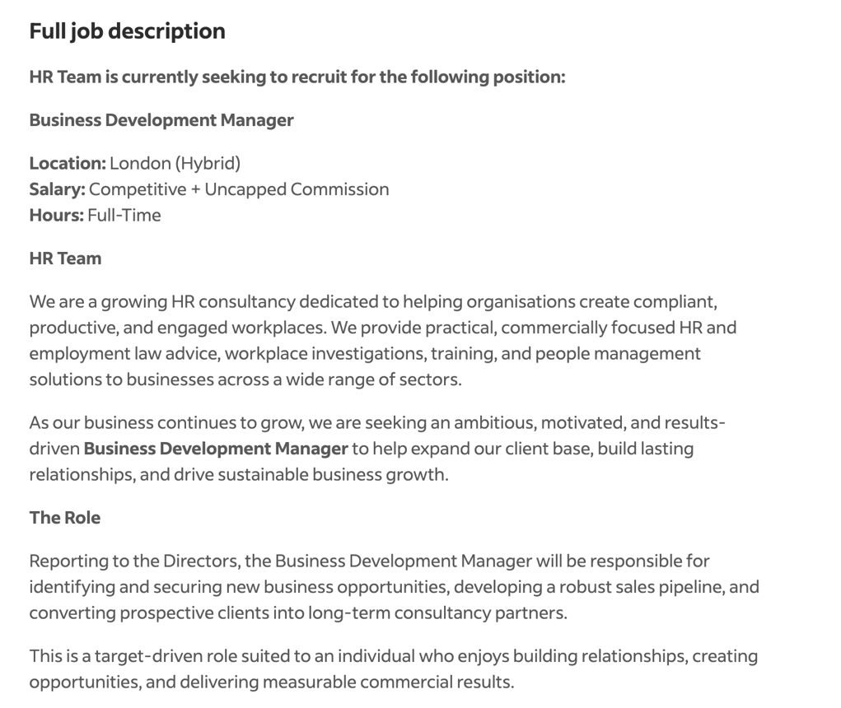
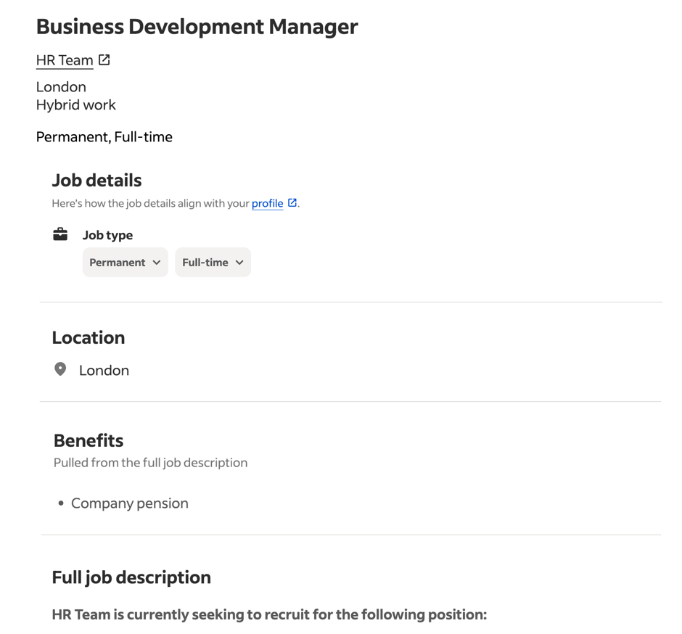
https://uk.indeed.com/viewjob?jk=5594bc1f0d507f31&from=shareddesktop_copy


