MSC ENGINEERING PROJECT MANAGEMENT
ACHA 7024
IMPROVING SUPPLY CHAIN PERFORMANCE
Table of Contents
1. Introduction 3
2. FMEA Analysis 4
3. Steps for resilient supply chain 8
Step 1: Strategic boosting of inventory and stockpiling 8
Step 2: Dual-sourcing and suppliers’ qualification 9
Step 3: Geographic diversification with nearshoring supplies 10
Step 4: Supply chain visibility growth with digitalised technology 11
Step 5: Supplier’s relationship development and financial support 11
Step 6: Collaborative and flexible manufacturing plan 12
4. Conclusions and suggestions for future research 13
Conclusion 13
Suggestions for improvement 14
References 16

1. Introduction
Failure Modes and Effects Analysis (FMEA) is a process used to identify failures in a product, process or service using team-based methods. The identification and assessment of risks help mitigate them in future with significant and futuristic alternative options. In this report, Toyota’s international supply chain issues and disruptions are considered for developing a FMEA analysis. Three areas of supply chain disruption involving semiconductor supplies, single source component acquisition and international freight and logistics congestion are considered. Supply chain, being a connected series of activities, is concerned with planning, coordination and controlling resources, parts and finished products from suppliers to customers (Hugos, 2024). Based on the two different flows of material and information in organisations, supply chain management (SCM) adversities arise.
Toyota was blind in a significant portion of its supply chain which led Executive Vice President, Shinichi Sasaki, to be in illusion of full control over the supply chain (Integrated Report, 2021). Based on the lack of supply chain mapping, Toyota faced critical supply chain disruption and loss of tier 1 suppliers. Considering the over confidence and ignorance of supply chain mapping, existing international supply chain challenges and their mitigation processes is comprehensively presented in this report. The FMEA analysis identifies key failures using scores of severities, occurrence and detection to compute Risk Priority Numbers (RPN) of three challenges in Toyota. Based on the identified RPN and previous improvement initiatives, six steps to practically improve Toyota’s international supply chain problems are presented.

2. FMEA Analysis
POTENTIAL FAILURE MODES & EFFECTS ANALYSIS (PROCESS F.M.E.A) |  |  |  |  |  |  |  |  |  |  |  |  |  | FMEA REF: 02
Title: Toyota Supply Chain Process FMEA |  |  |  |  |  |  |  |  |  |  | Team: Supply Chain Management |  |  | Page: 2
Process: | Supply Chain Procurement |  |  |  |  |  |  |  |  |  |  |  |  | Date:7.11.25
Subsystem: | International Supplies and logistic support |  |  |  |  |  |  |  |  |  |  |  |  | Action Results
Function  Description  (Ref.) | Potential  Failure Effect  Mode of  Failure |  | SEV | ▼ | Potential Cause of Failure | OCC | Current Controls | DET | R PN |  | Recommended Action | Responsibility/  Target Date | Actions Taken | S E V | OCC | D E T |  | R P N
Procuring semiconductors and critical ICs across globe | Severe semiconductor deficiency and allocation limitations | Production delay; supply disruption | 9 |  | Capacity limitation from global semiconductor constrains and geopolitical issue | 7 | Long-term contract with semiconductor suppliers on priority | 6 |  | 378 | Multi-suppliers chain and prepaid long-term contracts | Toyota purchasing and procuring target expansion (2023-2025) | Suppliers’ engagement improved with premium-based payment and partnerships | 5 | 4 | 3 | 60
Single source component acquisition | Single-suppliers engagement failure | Disrupted assembly line at specific plants | 8 |  | Reliance on single supply source and lean inventory policy | 6 | JIT practice and periodic audits done | 5 |  | 240 | Alternate suppliers list developed for dual sourcing | Global supplier’s development and Target supplier qualification program introduced (2024-2025) | Support program enabled deeper dual supplier collaboration | 4 | 3 | 2 | 24
International freight and ports logistics | Delayed shipping of containers leading to port congestion | Late spare parts delivery leading to sequencing issues and high freight handling cost | 7 |  | Disrupted global logistic supplies and labour shortage | 6 | Logistics partnership and freight contracts for safe lead times introduced | 6 |  | 252 | Multi-modal routing introduced; inventory boosted with long-term contracts and digital tracking | Logistic operations automation; Freight and logistic supply improvement target of 2023-2025 | Logistic visibility increased for flexible routing during 2021 to 2023 disruptions | 5 | 4 | 4 | 80

Table 1: FMEA Analysis of Toyota’s Supply Chain Disruption
(Source: Liu, 2023 and Batth 2021)

3. Steps for resilient supply chain

Step 1: Strategic boosting of inventory and stockpiling
Inventory disruption and supply problems during supply chain disruption can be addressed by building a robust supply chain with an interconnected pipeline of providers (Mustafeezurrehmanet al., 2025). For example, it is necessary to identify the interconnected pipeline of suppliers via which items, money, and information are transferred. Supply chain velocity can be used to determine how long it takes for the first inputs in the list of semiconductor suppliers to reach end customers. The supply chain value delivery made feasible by supply chain resilient mapping is depicted in figure 1 below.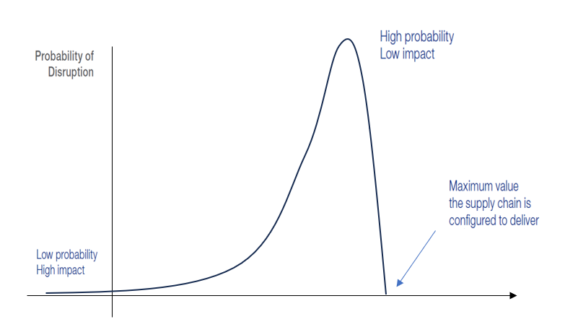
Figure 1: Supply Chain Value Delivered
(Source: Self-developed; Influenced from Lecture: Supply Chain vulnerability and Supply Chain Resilience.pptx, slide 21)
Based on high disruption possibilities in Toyota's international supply chain from semiconductors supply bottlenecks, velocity in the supply chain can help boost inventory. For instance, supply chain value growth using velocity and resilient mapping ensure high probability and low impact positioning of desired supplies (Mustafeezurrehmanet al., 2025). This has been initiated in Toyota using its multi-supplier’s chain and long-term contract institutions which reduced RPN from 378 to 60 (Refer to FMEA Analysis Table 1). Similarly, the use of supply chain velocity and mapping to boost its semiconductor inventory can help identify top five disruption triggers and ensure long-term contracts with existing suppliers.

Step 2: Dual-sourcing and suppliers’ qualification
Imports and foreign supplier engagement in businesses are frequently limited by supply chain disruptions, including freight, transportation, and component scarcity in globalized networks. Gehrig and Stenbacka (2023) assert that supply chains of globalized corporate networks are significantly impacted by geopolitical threats. Geopolitical and environmental hazards ultimately led to the recognized supply chain risks of semiconductor supply interruption, single component shortage, and multi-supplier chain involvement in Toyota. For example, Toyota's multi-modal routing in its logistics supply chain reduced its RPN and enhanced long-term contracts with progressive IT logistics initiatives starting in 2023(Liu, 2023). However, the logistics visibility with flexible routing during 2021 to 2023 disruption had limited influence on retaining multiple suppliers overseas. Figure 2 below represents the process of dual sourcing and suppliers qualification steps that can help Toyota in retaining its international suppliers engagement and multi-modal routing.
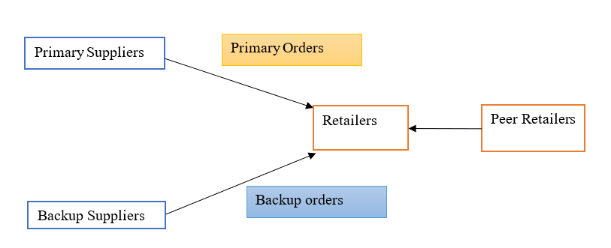
Figure 2: Dual sourcing mode in transportation of logistics and commodities
(Source: Self-developed; Influenced from Gehrig and Stenbacka, 2023)
The self-developed image represents the process of dual sourcing that contains both primary and backup suppliers' engagement with retailers for a longer period. As opined by Hamdouchet al. (2023), dual or generally termed multi-sourcing process is analysed as strategy to hedge supply chain risks in geopolitical context. Based on the supply’s disruption with COVID-19 pandemic influence on international aspects from 2020 to 2022, the inclusion of dual sourcing with a form detailing qualified suppliers can help pre-define the target suppliers across the globe for Toyota.

Step 3: Geographic diversification with nearshoring supplies
The main attraction of nearshoring in supply chains is geographical proximity that facilitates collaboration and project management. According to Martínez-Muñoz (2025), similarities in time zones allow for easy communication and effective team coordination. However, enhancing cultural and linguistic understanding improves quality of work and improves misunderstandings among globalised suppliers and retailers. Similarly, the competitive strategy to generate regional development and competitiveness in international shores depends on stimulated suppliers and logistics utilisation (Fernández-Miguel et al., 2022). Considering the flexible routing procedure adopted in Toyota during 2021 to 2023, limited logistics operation improvement was done due to long-term contracts inflexibility among suppliers. This reduced the RPN in FMEA table by 172 points from 252 to 80. However, its relevance to boosting flexible supplies and logistics was restrictive due to pre-developed contracts with suppliers for a long-term. As a result, economic stability with ease of developing and operating business with intellectual property protection in Toyota became important.
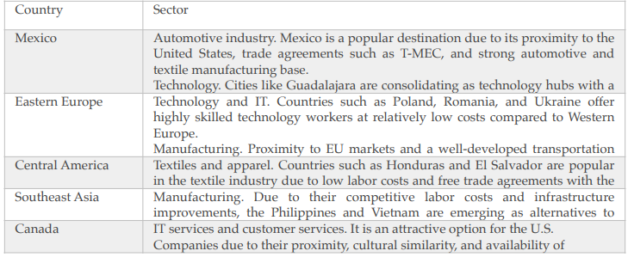
Figure 3: Countries and Industries adopting nearshore practices in supplies
(Source: Martínez-Muñoz, 2025)
For instance, figure 3 above reflects the examples of different sectors and countries adopting nearshoring to improvise logistics and supplies in a globalised network. Developing regions of Mexico and Southeast Asia were observed to adopt nearshoring in its automotive and manufacturing industries. Similarly, Toyota’s initiative of nearshoring in the automotive industry can enable popular proximity in destinations of the USA and trade agreements for better automotive supplies even during disruptions.

Step 4: Supply chain visibility growth with digitalised technology
Three steps comprise risk mitigation based on supply chain disruptions: proactive steps prior to the disruption, reactive activities during the interruption, and post-recovery steps. Better visibility is required due to Toyota's supply chain vulnerabilities, which include restricted single source component acquisition and supply delays for semiconductors. A supply chain list can be developed, for example, by utilizing IT systems to enhance real-time awareness of current spare capacity and inventories for single source components. According to Sharma et al. (2024), Honda increased its visibility and volatility of supply chain with big data analytics. Similarly, testing business continuity plans, critical components and supply chain nodes using automation and big data analytics can help transform traditional supply chain processes into modern data-centric ones.
The initiative taken by Toyota to update its international suppliers’ list with dual sourcing had restricted growth due to traditional support programs for supplier collaboration. An example of commercial and defense vendor management from the traditional Japanese supply system in Keiretsu showed the need for a different dual sourcing approach arising from vendor pressure (Finkenstadtet al., 2023). It showed limited realistic influence on supply chain and vendor list upgrades for enabling disruption free supply chain visibility in the company. As an impact, incorporation of advanced or digital technology like big data in supply chain visibility ensures better target suppliers’ collaboration. It will eventually help Toyota to address disruption in the assembly line of specific plants without focusing independently on lean inventory policy.

Step 5: Supplier’s relationship development and financial support
Suppliers; relationship development considering buyers initiating mapping process ensures inviting tier suppliers to join the supply chain of companies. The method of cascading invitation in which buyers’ initiatives mapping processes are used to motivate supplier engagement are effective for relationship development. As stated by Nath and Eweje (2021), tier one suppliers are highly motivated on products or service supplies which are in high demand in the market. Considering the key success of automation to link all suppliers in the supply chain, Toyota can eventually upgrade its nearshore suppliers list with cascading invitations. The mitigation step formerly adopted in Toyota of alternative suppliers list development had disruption due to geopolitical and environmental risks from external aspects.
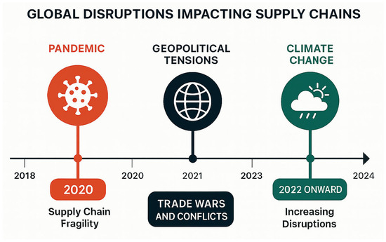
Figure 4: International disruptions affecting supply chains from 2018 to 2024
(Source: Setyadiet al., 2025)
The figure 4 above highlights the major disruptions in supply chains arising from pandemic in 2020 to geopolitical tensions in 2021 and climate change as of 2022 and onwards. This timeline shows the events underscore urgent need for resilient-backed and sustainability-based operational redesigns. As opined by Setyadiet al. (2025), supply chains are no longer evaluated based on their ability to reduce expenses and deliver products on time. Rather the capability to reduce negative externalities and positive contributions to society and planets are accounted for. Based on the multi-suppliers listing and alternative suppliers list planning, decreasing RPN to zero is impossible in Toyota. Eventually, shifting from linear and transactional supply networks into regenerative systems with cascading invitations and financial support of discounts can help retain a variety of supplies.

Step 6: Collaborative and flexible manufacturing plan
Considering supply chain disruptions for multi-plant supplies bottlenecks in Toyota, the flexible manufacturing process can help address existing issues. According to Sang et al. (2021), adopting a collaborative and flexible manufacturing plan helps cater to different requirements of customers in a globalised market. In the case of Toyota, the use of Black box optimisation for flexible manufacturing can help optimise the complex production and supplies systems. The BBO process aggressively helps optimise areas including environment, material design and chemical process synthesis (Bajaj et al., 2021). Eventually, this process in flexible manufacturing can help Toyota reduce reliance on overseas suppliers for its single components and develop them in house with local producers. The image below represents the process that can be utilised in Toyota’s international supply chain process for managing flexibility in both collaboration and manufacturing plans.
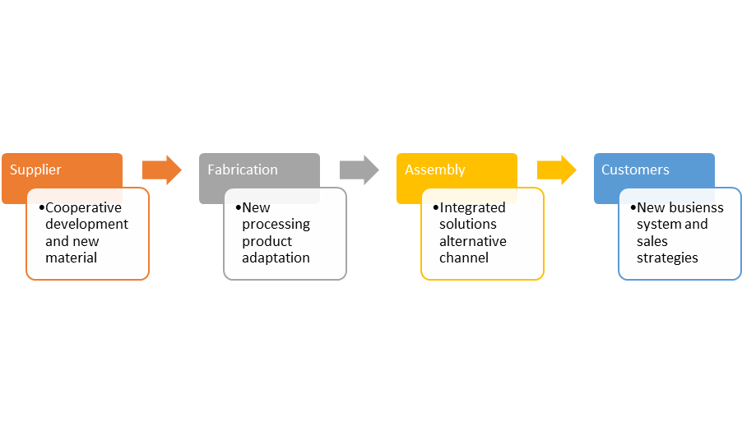
Figure 5: Four Step process of Flexible manufacturing
(Source: Sang et al., 2021)
The four step flexible manufacturing process represents the suppliers to customers operation starting with fabrication and assembly of integrated solutions. Inclusion of alternative channels in suppliers list is expected to help Toyota reduce its RPN by 20 points in six months. This is due to the reduction of international supplies sourcing cost and pre-determined products or product adoption in cooperative development of new materials.

4. Conclusions and suggestions for future research

Conclusion
It is concluded that Toyota’s supply chain management initiatives against semiconductor and single component supplies disruption were restrictive. The alternative suppliers list and dual-list development approach during disruption of 2021 to 2023 resulted in restrictive RPN reduction. It was identified that determining the interconnecting pipeline of suppliers through which information, cash and products are sent needs to be enhanced. Consideration of supply chain velocity to take time for initial inputs in the supply chain of semiconductor suppliers list and reach end-users in the first step was suggested. On the other hand, an initiative using multi-suppliers and long-term contracts to reduce RPN in Toyota was initiated. However, their impact and resilience on the current supply chain shows limited improvement. The use of supply chain velocity and mapping to boost its semiconductor inventory has identified top five disruption triggers and ensures long-term contracts with existing suppliers.
Furthermore, the logistics visibility with flexible routing during 2021 to 2023 disruption had limited influence on retaining multiple suppliers overseas in Toyota. Based on this context, adoption of dual sourcing for primary and backup suppliers including Black Box manufacturing for flexible operations in supplies has been identified. All the six steps were evaluated based on existing FMEA analysis values of RPN that shows critical impact and improvement analysis in Toyota’s international supply chains. The suggestions to improve supply chain disruptions in future are presented in the following parts using strategic initiatives.

Suggestions for improvement
Operational Actions using sustainable supply chain and operations development: Apart from production and manufacturing strategies in Toyota, the need for operational analysis as reactive steps to minimise damage is essential. For instance, actions to ensure safety of employees for continued operations is important. The company can assess possible impact of pandemic, geopolitical and climate risk impacts disrupting supply chain in the process. As per Negri et al. (2021), considering sustainable options to retain international supply chain integration in business require proactive operational measures. For instance, Kia Motors adopted sustainable supplies with Supplier code of Conduct to monitor supply operations (Kia Sustainability Report, 2024). This can be done with critical supplier failure analysis and evaluation of components affecting current available capacity of Toyota.
Strategic action using test-bed and post mortem exercise to identify future risks: Strategic action to expose future supply chain disruption is recommended to improve the future operations and supplies in the company. For instance, exposing supply chain disruption with a test-bed for Toyota can increase suppliers’ resilience. While disruption can cause extreme financial implications, post mortem exercises to draw learnings from past experiences are helpful. This will ensure the same mistakes are not repeated and BCP will reassess the disruption detection system and supply chain risks possibilities in upcoming years.
Controlling damage with failure points capturing: Toyota is also suggested to collect feedback of disruption mitigation actions previously and currently implemented in operation. The coordination with insurance providers and recovery of any supply chain losses can significantly contribute to disaster management. Finally, the company will be able to capture failure points and reuse learnings with a cause-and-effect analysis to improve disruptions of semiconductors and single components supplies in the company.

References
Bajaj, I., Arora, A. and Hasan, M.F., (2021). Black-box optimization: Methods and applications. In Black box optimization, machine learning, and no-free lunch theorems (pp. 35-65). Cham: Springer International Publishing. Available at:https://link.springer.com/chapter/10.1007/978-3-030-66515-9_2(Accessed: 2 November 2025)
Batth, V., (2021). Toyota motor corporation: Just in time (jit) management strategy or beyond. Journal of Case Research, 12(1), pp.18-27. Available at:https://www.researchgate.net/profile/Vijaya-Batth-2/publication/373337402_Toyota_Motor_Corporation_Just_in_Time_JIT_Management_Strategy_or_Beyond/links/64e71be40453074fbda96fd1/Toyota-Motor-Corporation-Just-in-Time-JIT-Management-Strategy-or-Beyond.pdf(Accessed: 6 November 2025)
Fernández-Miguel, A., Riccardi, M.P., Veglio, V., García-Muiña, F.E., Fernández del Hoyo, A.P. and Settembre-Blundo, D., (2022). Disruption in resource-intensive supply chains: reshoring and nearshoring as strategies to enable them to become more resilient and sustainable. Sustainability, 14(17), p.10909. Available at: https://www.mdpi.com/2071-1050/14/17/10909(Accessed: 3 November 2025)
Finkenstadt, D., Braunlich, K. and Guinto, P., (2023). Commercial and Defense Vendor Management: A Comparison of Competitive Procurement Below the Prime-Subcontract Competition–How real is it?. Acquisition Research Program. Available at:https://www.dair.nps.edu/handle/123456789/4853(Accessed: 4 November 2025)
Gehrig, T. and Stenbacka, R., (2023). Dual Sourcing and resilient supply chains: the case of essential resources. Atlantic Economic Journal, 51(4), pp.223-241. Available at:https://link.springer.com/content/pdf/10.1007/s11293-023-09782-9.pdf(Accessed: 2 November 2025)
Hamdouch, Y., Boulaksil, Y. and Ghoudi, K., (2023). Dual sourcing inventory management with nonconsecutive lead times from a supply chain perspective: a numerical study. Or Spectrum, 45(3), pp.1013-1041. Available at: https://link.springer.com/content/pdf/10.1007/s00291-023-00720-4.pdf(Accessed: 4 November 2025)
Hugos, M.H., (2024). Essentials of supply chain management. John Wiley & Sons. Available at:https://www.researchgate.net/profile/Michael-Hugos/publication/319321782_Key_Concepts_of_Supply_Chain_Management/links/619ec4f1f1d6244571694a61/Key-Concepts-of-Supply-Chain-Management.pdf(Accessed: 4 November 2025)
Integrated Report, (2021). Integrated Report of Toyota 2021. Available at: https://www.aichi-steel.co.jp/_assets/dl/ir/library/integrate_report/2021_all@en.pdf (Accessed: 2 November 2025)
Kia Sustainability Report, (2024). Kia Sustainability Report 2024. Available at: https://worldwide.kia.com/int/files/company/sr/sustainability-report/sustainability-report-2024-int.pdf(Accessed: 6 November 2025)
Liu, P., (2023). Application of modern logistics information technology in automobile logistics: a case study of toyota motor corporation. Adv Ind Eng Manag, 12(2), pp.91-96. Available at: https://aiem.com.my/wp-content/uploads/2023/06/Vol.-12-No.-2-2023-91-96.pdf(Accessed: 6 November 2025)
Martínez-Muñoz, E., (2025). Nearshoring: increase resilience and reduce dependence on distant markets. The Role Of Creativity And Governance: Building Strength After Challenges, p.159. Available at: https://www.researchgate.net/profile/Jose-Sanchez-Gutierrez/publication/393435618_THE_ROLE_OF_CREATIVITY_AND_GOVERNANCE_BUILDING_STRENGTH_AFTER_CHALLENGES/links/68694970b991270ef301b8f5/THE-ROLE-OF-CREATIVITY-AND-GOVERNANCE-BUILDING-STRENGTH-AFTER-CHALLENGES.pdf#page=165(Accessed: 2 November 2025)
Mustafeez ur rehman, M., Mubarik, M.S., Ahmed, S. and Wasim, S.M., (2025). Smart and Resilient Supply Chains: Role of Smart Supply Chain Mapping. In Smart Supply Chain Management: Design, Methods and Impacts (pp. 205-228). Singapore: Springer Nature Singapore. Available at: https://www.researchgate.net/profile/Sobia-Jamil-3/publication/389536495_Leveraging_Open_Innovation_for_Smart_Supply_Chain/links/681c6f0760241d514025119c/Leveraging-Open-Innovation-for-Smart-Supply-Chain.pdf#page=211(Accessed: 4 November 2025)
Nath, S.D. and Eweje, G., (2021). Inside the multi-tier supply firm: exploring responses to institutional pressures and challenges for sustainable supply management. International Journal of Operations & Production Management, 41(6), pp.908-941. Available at:https://www.emerald.com/insight/content/doi/10.1108/IJOPM-09-2020-0651/full/html(Accessed: 5 November 2025)
Negri, M., Cagno, E., Colicchia, C. and Sarkis, J., (2021). Integrating sustainability and resilience in the supply chain: A systematic literature review and a research agenda. Business Strategy and the environment, 30(7), pp.2858-2886. Available at:https://onlinelibrary.wiley.com/doi/pdfdirect/10.1002/bse.2776(Accessed: November 2025)
Sang, G.M., Xu, L. and de Vrieze, P., (2021). A predictive maintenance model for flexible manufacturing in the context of industry 4.0. Frontiers in big Data, 4, p.663466. Available at:https://www.frontiersin.org/journals/big-data/articles/10.3389/fdata.2021.663466/pdf(Accessed: 3 November 2025)
Setyadi, A., Pawirosumarto, S. and Damaris, A., (2025). Toward a resilient and sustainable supply chain: Operational responses to global disruptions in the post-COVID-19 era. Sustainability, 17(13), p.6167. Available at: https://www.mdpi.com/2071-1050/17/13/6167(Accessed: 2 November 2025)
Sharma, V., Sharma, K., Kumar, M. and Chatterjee, P., (2024). Supply chain efficiency and performance measurement in the automotive sector: Content analysis and future research directions. Journal of Decision Analytics and Intelligent Computing, 4(1), pp.121-135. Available at: http://jdaic-journal.org/index.php/about/article/view/64(Accessed: 3 November 2025)

