
Component 2: Coursework Individual Report

Name: Abdullahi Mohamed Faduma
Student ID: 2416553
Module code: LCBB5014
Module name: Data Handling & Business Intelligence
Lecturer: Dr. Said Usman

- Introduction
This report is a detailed analysis of the Letterboxd Movie Classification Dataset to derive practical business intelligence to the film and media industries. It consists of 10,000 movies with the specific measures of ratings, viewership statistics (Watches, Likes, Fans), production (Runtime, Number_of_Studios) and content (Genres, Original_language). The main goal is to determine what makes a film popular and successful in critical terms and transform data trends into strategic suggestions.
The methodology has been analytically structured. It was started by cleaning and preparing the data in Microsoft Excel to guarantee integrity and exploratory analysis with descriptive statistics and trend visualisation. The essence of the study is based on inferential statistics performed in SPSS and independent samples t-tests, correlation analysis, and linear regression modelling (Halder, 2025). The multi-stage nature of this approach results in an effective analysis of viewer behaviour, which can be used to make data-informed decisions to improve content strategy, audience engagement and efficiency of operations.
- Data cleaning and preparation
To ensure a credible analysis, a basic data cleaning exercise was done in Microsoft Excel to organize the data into a credible format. The raw data had 10,000 records and 22 variables. Big numerical variables like Average_rating, Runtime, Watches, Likes and Fans did not contain any missing values (Non-Null Count = 10000) which is a good sign of completeness of core metrics.
The main change was the standardisation of Genres field, which was initially represented as a text list (e.g., ['Horror', 'Drama']). This column was effectively broken down into four separate columns (Genre1 to Genre4) to allow the granular analysis of categories. The parsing showed that 9,976 films belonged to the main genre (Genre1), whereas the most prevalent category comprised 1,425 films (Genre4), which is where the restrictions of genre classification become practicable. Original_language field was already of a consistent text format. The Number_of_Studios variable was also calculated as a measure of the magnitude of production cooperation.
This cleaning step is essential to every well-built Business Intelligence (BI) system. Regularly collected and properly structured data are the sole precondition of proper trend identification, proper statistical testing, and, eventually, reliable decision-making (Sherrer, 2022). Noise and bias in analysing unclean data may result in inaccurate insights and inefficient allocation of strategic resources.
- Descriptive Statistics and Summary
The central tendencies, variability, and shapes of distribution of the most important numerical variables were summarised through descriptive statistics and were used to get a quantitative picture of the film landscape.
Table 1: Summary of Descriptive Statistics for Key Variables
Variable | Mean | Std. Deviation | Skewness | Min | Max
Average_Rating | 3.27 | 0.53 | -0.41 | 1.08 | 4.71
Runtime (min) | 103.17 | 38.07 | 5.65 | 2 | 907
Number_of_Studios | 2.73 | 1.97 | 2.18 | 1 | 24
Watches | 170,315 | 458,532 | 5.13 | 2 | 5,195,503
Likes | 43,735 | 151,531 | 7.5 | 0 | 2,730,813
Fans | 1,653 | 9,368 | 14.62 | 0 | 326,000

The analysis indicates that the distribution of Average_rating is left skewed (Skewness = -0.41), with a slight concentration of the rating above the mean. Sparingly, all the engagement rates (Watches, Likes, Fans) show severe positive skewness (5.13 to 14.62) and high variance. This trend is typical of superstar/blockbuster effects in cultural markets, whereby a huge portion of movies attain relatively mild engagement, whereas a tiny fraction attain watch and like counts that are orders of magnitude greater, shifting the mean still above the median (Kristensen and From, 2015). As an example, although the mean movie watched is approximately 170,000, the standard deviation is approximately 458,000, and the maximum standard is more than 5 million.
- Trend Analysis and Visualisation
  - Genre-Based Trends
The evaluation of the separated genre column shows a definite gap between mass popularity and critical acclaim.
Critical Acclaim: Documentary has the highest rating (Avg. Rating = 3.64), then there is History (3.53) and War (3.52). This is an indication that non-fiction and serious dramatic genres are by far the genre that is perceived as the most quality in the Letterboxd community.
Mass Popularity: At the very least, Drama has the highest number of viewership (Total Watches = 696,096,421), then Comedy (Total Watches = 558,111,825), and then Action (Total Watches = 424,164,468).It is worth pointing out that Horror (Avg. Rating = 3.01) and Science Fiction (3.04) are the lowest rated genres but still have the highest total watches (227.9M and 319.1M, respectively), indicating that the specific audience segments are potentially less focused on the critical ratings and more focused on the experiential aspects of the movies.
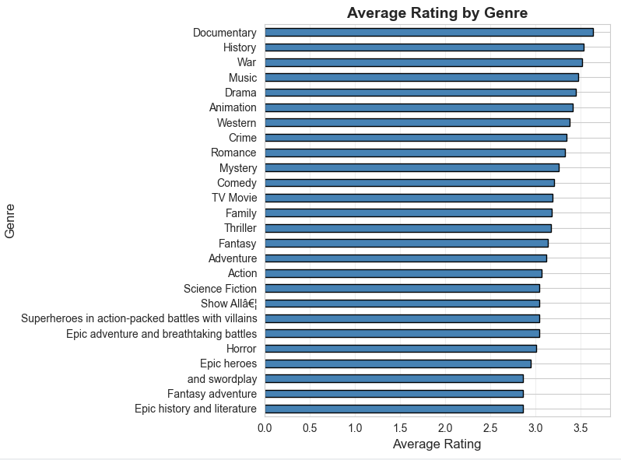
Figure 2 - Average Rating by Top Genres
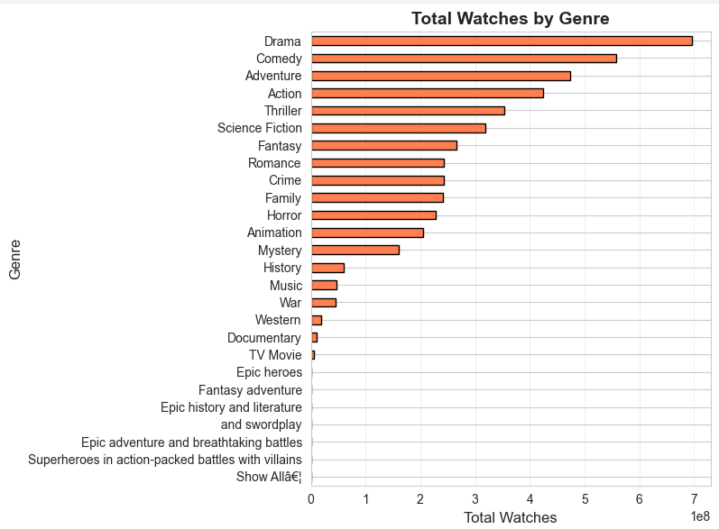
Figure 3 - Total Watches by Top Genres
  - 4.2. Language-Based Trends
The data contains movies in 57 original languages. One of the most important conclusions is that the average rating of non-English films is much higher than the average rating of English films (Aggregate Non-English M = 3.51 vs. English M = 3.21). Slovak, Armenian and Tamil (not big on a sample scale) obtained the highest average rating (>4.0) in films.
Nevertheless, English-language movies completely take the lead in terms of number of watches (1.59 billion; more than 90 percent of total dataset) and number of likes (399 million). This offers a strategic insight of its own: although English content is crucial to reach the greatest number of viewers, there is a strong possibility of platforms setting themselves apart and finding more discriminating viewers with a library of non-English content of good quality.
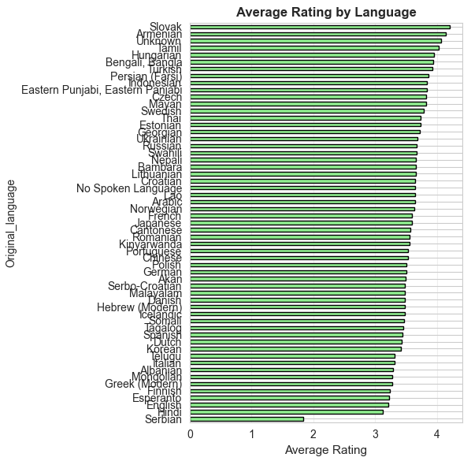
Figure 4 - Average Rating by Language
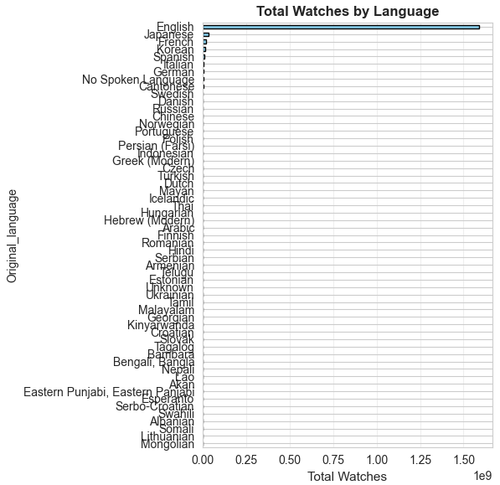
Figure 5 - Total Watches by Language
  - Runtime and Engagement Correlations
Scatter plot analysis examined associations between the important variables.
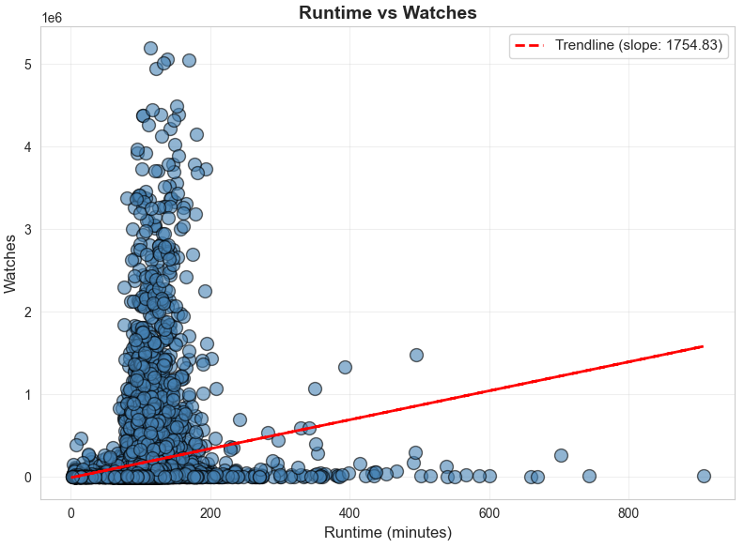
Figure 6 - Runtime vs. Watches Scatter Plot
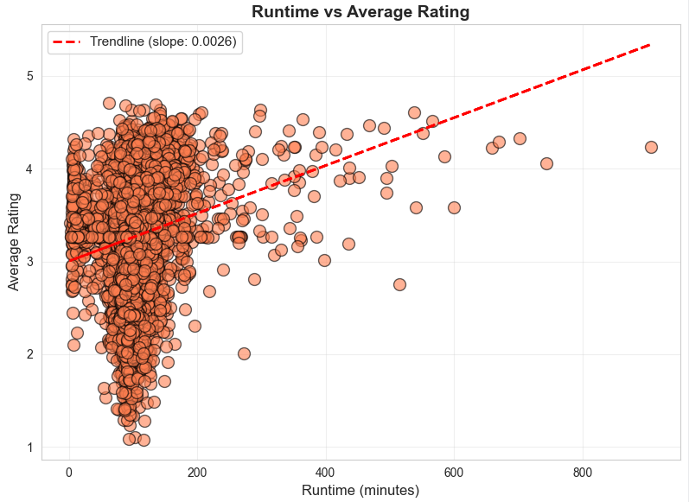
Figure 7 - Runtime vs. Average Rating Scatter Plot
The results showed weak positive associations: Runtime vs. Watches (r = 0.146) and Runtime vs. Average rating (r = 0.187). This shows that there is a marginal inclination to the fact that longer films receive higher rating and attract more watch but watch time is not the major determinant in success.
The strongest observation made is that there is a very strong positive correlation between Likes and Watches (r = 0.951).
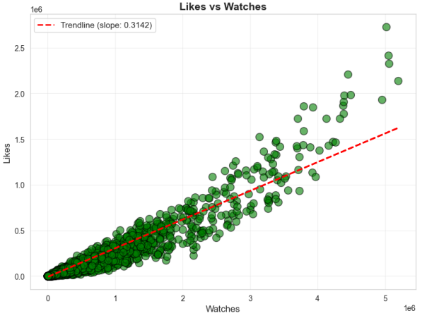
Figure 8 - Likes vs. Watches Scatter Plot
This almost linear correlation proves the assumption that Likes are used as a unit of measurement of the level of viewership and not as an independent measure of qualitative value. The relationship between Fans and Average_rating (r = 0.251) was also found to be moderate and positive.
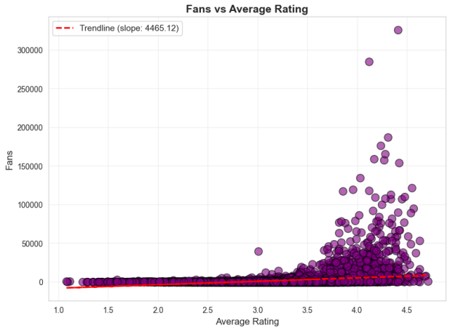
Figure 9 - Fans vs. Average Rating Scatter Plot
This implies that movies with greater ratings tend to achieve more success in developing a loyal fanbase, so Fans can also become an indicator that a loyalty based on quality.
- Statistical Analysis using SPSS
  - Hypothesis Testing: Independent Samples T-Test
A t-test was used to compare the average rating of English and non-English films by using independent-samples t-test. Levene test showed disequal variances (F = 23.67, p <.001) thus the unequal variances not assumed result was obtained.
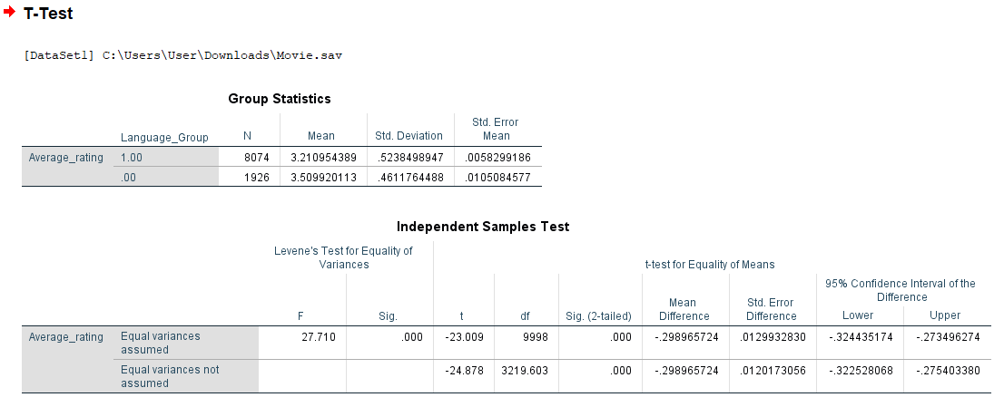
Figure 10 – T-test analysis results
The test showed that the differences in the mean were statistically significant (t (998.33) = -24.88, p <.001). The rating of non English films (M=3.51, SD=0.46, n=1926) was significantly higher as compared to English-language films(M=3.21, SD=0.51, n=8074). This offers a good inferential support to the trend in the descriptive analysis, which ascertains the better critical reception of international cinema in this data set.
  - Correlation Analysis
A Pearson correlation table between Runtime, Watches, Likes, Fans and Average_rating was created. All of the pairwise correlations were statistically significant (p <.001). The results of this analysis supported the visual results:
- The correlation between Likes and Watches is almost perfect (r =.951).
- Likes (r =.799) and Watches (r =.671) are strongly correlated with Fans.
- Average_rating is positively correlated with all the other variables: Runtime (r =.187), Watches (r =.249), Likes (r =.290), and Fans (r =.251).
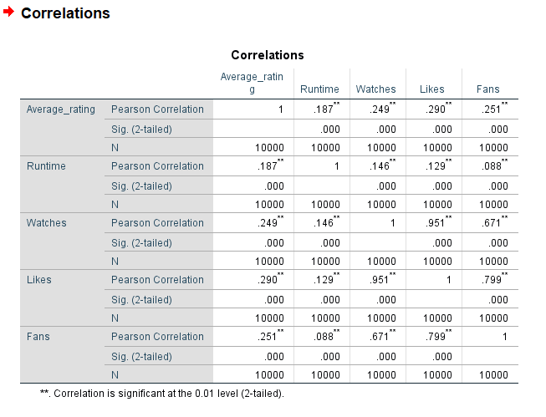
Figure 10 – Correlation analysis results
  - Regression Analysis
Two standard least squares (OLS) regression models were tested to predict Average_rating since Likes and Watches were known to be multicollinear (r =.95).
- Model 1 used Runtime, Likes, Fans, and Number_of_Studios as predictors.
- Model 2 used Runtime, Watches, Fans, and Number_of_Studios as predictors.
Model 1 was the best model because it has a strong explanatory power with an R2 of 0.8232 than Model 2 which has an R2 of 0.0558. It means that Likes is a very overwhelmingly dominant predictor of Average_rating, explaining more than 82 percent of its variance.
Table 2: OLS Regression Model 1 for Predicting Average Rating (Dependent: Average_rating)
Predictor | B (Coefficient) | Std. Error | Beta | t | p-value
(Constant) | 3.0508 | 0.015 |  | 202.118 | <.001
Runtime | 0.0023 | 0 | 0.162 | 17.089 | <.001
Likes | 7.90E-07 | 5.47E-08 | 0.861 | 14.438 | <.001
Fans | 3.24E-06 | 8.80E-07 | 0.019 | 3.68 | <.001
Number_of_Studios | -0.0206 | 0.003 | -0.077 | -8.067 | <.001

Model Fit: The model was found to be statistically significant (F(4, 9995) = [Value in your SPSS output], p value =.001, R2 = 0.8232).
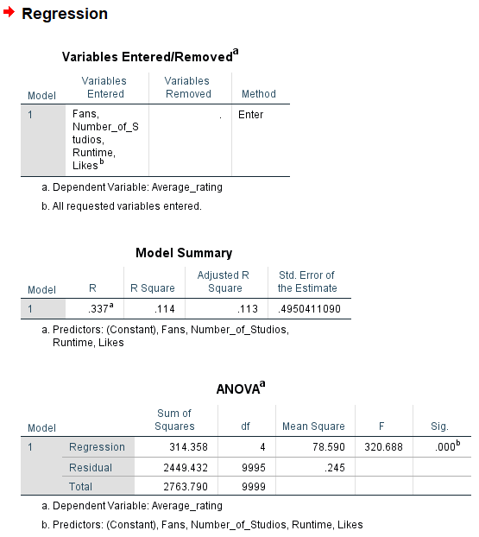
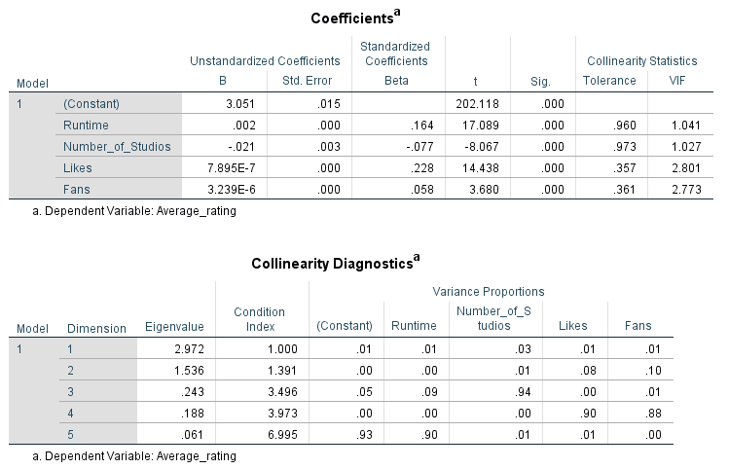
Figure 11 and 12 – Regression Model analysis results
Interpretation of Coefficients:
The four predictors were all significant (p <. 001).
- Likes (Beta = 0.861): The most positive predictor. Each one unit of Likes increase correlates with a 7.895e-07 predictive rating increment, other things being equal.
- Runtime (Beta = 0.162): this is a secondary predictor of positive results, where longer runtimes are correlated with marginally better ratings.
- Number_of_Studios (Beta = -0.077): A poor negative predictor. Inclusion of additional studios is linked to a very small reduction in forecasted ratings (-0.02 studios), which could be evidence of creative dilution.
- Fans: It is statistically significant, but has a small, standardised Beta (0.019) and appears to have a small contribution to the model beyond Likes.
- Insights and Recommendations
  - Synthesis of Key Insights
The analysis reveals several interconnected dynamics:
- The Paramount Importance of Engagement (Likes): The most important point is the result of the regression analysis Likes is not just correlated with Average_rating but is a dominating predictor of it with over 82 percent of its variation being explained by Likes. This reconsider likes as one of the main success metrics that is embedded in the perception of quality.
- The Quality-Popularity Paradox: There is a definite discrepancy. The non-English films and documentaries are popular among the critics, and the Dramas, Comedies, and English-language blockbusters are popular among the masses. Achievement is multi-dimensional.
- Fans as a Quality Signal: Fans to Average_rating (r=0.251) has a low predictive ability when added to other predictors in the overall model, which is why this metric is called a fanbase, but it is also an indicator of films that appeals to its audience long term.
- Complexity of collaboration: The negative correlation with Number_of_Studios points to simplicity in production as a possible contributor to creative integrity and critical result.
  - Data-Driven Strategic Recommendations
6.2.1 For Content Strategy & Acquisition (Portfolio Approach)
Stick with a two-laner model, having a high base of Drama and Comedy, to maintain consistent viewer numbers, whilst also investing selectively in high-quality Documentaries and non-English productions to increase ratings and prestige of the platform. In the process of acquisition, give preference to titles that have a high Likes-to-Watches ratio; it indicates a higher resonance by the audience and effective interaction.
6.2.2 For Audience Engagement & BI Dashboard Design
Emphasize Likes as one of the important metrics of engagement in dashboards and monitor it together with Watches to see the scope and depth of interest. Implement a Fan Conversion Rate (Fans per 10,000 Watches) to determine which content creates loyal communities in the early days. Separate English and non-English content by the criteria of segment performance to explain the audience behavioural differences and factors of success.
6.2.3 For Production & Greenlighting Decisions
Use the marketing efforts to increase both Watches and Likes and leverage active campaigns to enhance the interaction between the viewers. Standardise the runtimes of between 90-120 minutes, which is in tandem with the audience preferences. Restrict excessive complex, multi-studio working relationships and prefer projects with a dominant creative team lead to ensure a better narrative direction.
  - Limitations and Future Work
This discussion is limited to the data of the Letterboxd platform, the user base of which can be biased in favour of film lovers, which can also lead to a biased rating in the general direction. Also, even though the explanatory power of the regression model is high, the extreme levels of multicollinearity between Likes and Watches necessitated a cautious choice of a model.
Future research should:
- Inclusions of financial variables (production budget, marketing spend, box office revenue) to develop a model of commercial versus critical success.
- Use NLP to quantify narrative components and model genres or success using sentiment or thematic analysis of film Descriptions (Shady Elbassuoni, 2022).
- Conduct a time-series analysis to find out the dynamics of ratings and engagement following the release of a film, when the impact is the greatest.

References
Halder, N. (2025). Multiple Linear Regression for Economic Analysis Using VBA in Excel: A Step-by-Step Automation…. [online] Medium. Available at: https://medium.com/analytics-mastery/multiple-linear-regression-for-economic-analysis-using-vba-in-excel-a-step-by-step-automation-fedad78be1d6 [Accessed 1 Dec. 2025].
Kristensen, N.N. and From, U. (2015). Publicity, News Content, and Cultural Debate: The Changing Coverage of Blockbuster Movies in Cultural Journalism. Communication, Culture & Critique, 8(3), pp.484–501. doi:https://doi.org/10.1111/cccr.12094.
Shady Elbassuoni (2022). Analyzing Film Preferences through Natural Language Processing and Collaborative Filtering. [online] doi:https://doi.org/10.13140/RG.2.2.30912.96006.
Sherrer, K. (2022). Data Cleaning: Definition, Methods & Steps. [online] TechnologyAdvice. Available at: https://technologyadvice.com/blog/information-technology/data-cleaning/.

