Activity 1: Assignment 1 Task 3a
Effective Teamwork is the result of communication, collaboration and having a clear vision and goal for the end project. This achieved by having a cohesive unit of individuals who all clearly understand their roles and can contribute effectively. This stage is a result of member understanding each other’s differences and appreciating them, understanding that these differences are different skill sets that can help achieve optimal performance[1].
One of the barriers to effectively reaching the performance stage of the teamwork model is showing an inattention to results. This occurs when an individual is more focused on their own personal success rather than achieving the team focused objectives. By doing this it can undermine accountability as a unit and limit the overall achievement as you are no longer all on the same page. A way to overcome this is by celebrating team success as a priority and correctly acknowledging contributions. This helps to focus members on the shared vision and to see their individual efforts as part of the greater goal of the team.
Another risk for teams is Groupthink- a phenomenon where the desire to maintain harmony leads members to avoid conflict and not wish to express ideas that go against the flow even if they truly believe in them[2]. This can reduce creativity and impede problem-solving resulting in a less-than-optimal performance. Preventing Groupthink requires encouraging constructive criticism and seeking alternative perspectives from the members of the team, which can be done with open dialogue sessions built into the team working process. Promoting open discussion and critical thinking can result in a strengthening of decision quality and help to find innovative ideas. As Janis (1982) argues in his foundational work on Groupthink, cohesive groups must guard against the tendency to prioritise agreement over good judgement if they are to function effectively[2].
Progress Monitoring is a tool utilised by many high performing teams. If you think of a sports team many have in-depth analytics trackers and regular training sessions to discuss and help extract the best performance possible. Deadlines can be missed when objectives lack clarity or tasks are not divided into manageable milestones. Regular check-ins and having a clearly defined project outline help to enhance accountability in keeping the project on track to delivering its objectives, whilst including additional strategies such as Gant Charts help to track progress. Breaking larger tasks into smaller, trackable components further supports motivation and reduces procrastination as this gives the team many small wins rather than the long slog to an end objective[3].

References
[1] B. W. Tuckman, "Developmental sequence in small groups," Psychol. Bull., vol. 63, (6), pp. 384–399, 1965. . DOI: 10.1037/h0022100.
[2] I. L. Janis, "Groupthink," EMR, vol. 36, (1), pp. 36, 2008. . DOI: 10.1109/EMR.2008.4490137.
[3] D. Boddy, Management : An Introduction. 2017.

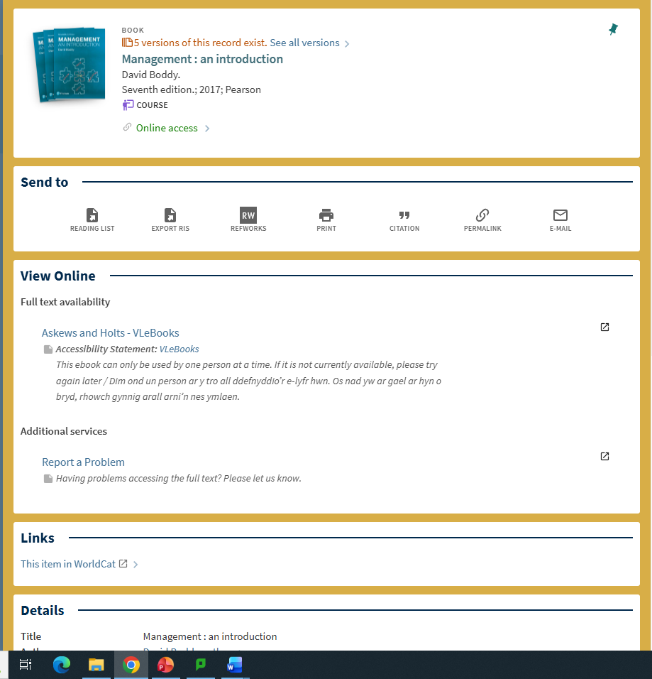
Upon finding an appropriate reference, Click the button labelled RefWorks after setting up a RefWorks Account.

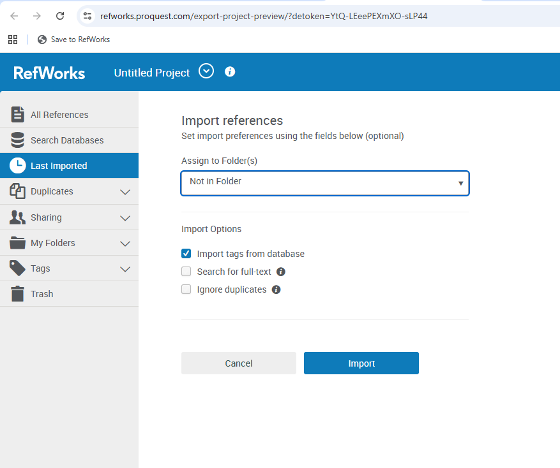You can then assign this reference to an appropriate folder for the project you are working on and then import.

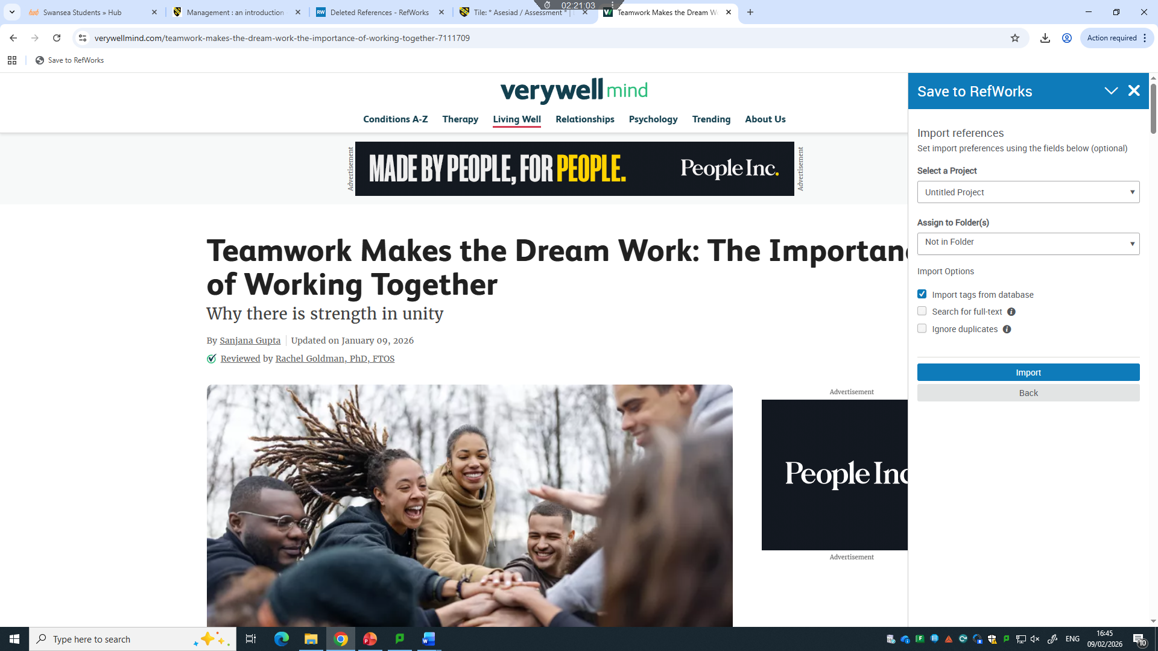
Alternatively, if using an online reference, you can use the refworks extension for your browser to save the reference with all the necessary information populated.

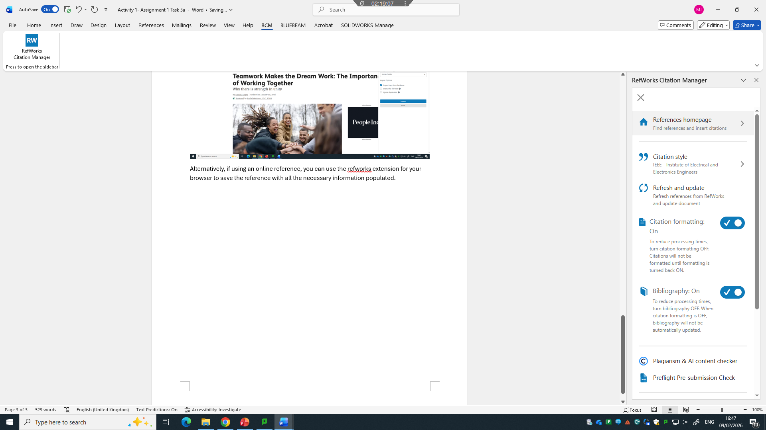
You can then use the RCM in word to ensure the citation style is correct, auto generate a bibliography and automatically format your citations once added. This is all linked to your online refworks account.

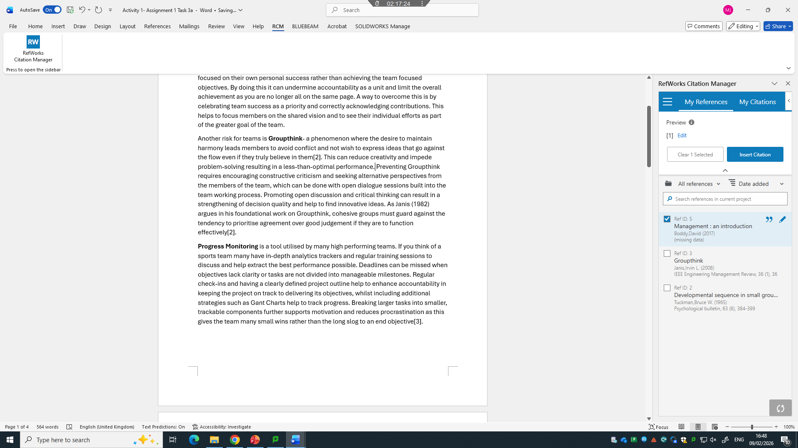
You then select the area in your report you wish to insert the citation, select the appropriate reference and click insert citation in the manager screen. This will then include the in-text citation and update the bibliography if selected.

References for insertion are displayed based on any filters you have applied in the manager.

