PPT Notes

BMIH4003
Hospitality and Guest Services

AS1

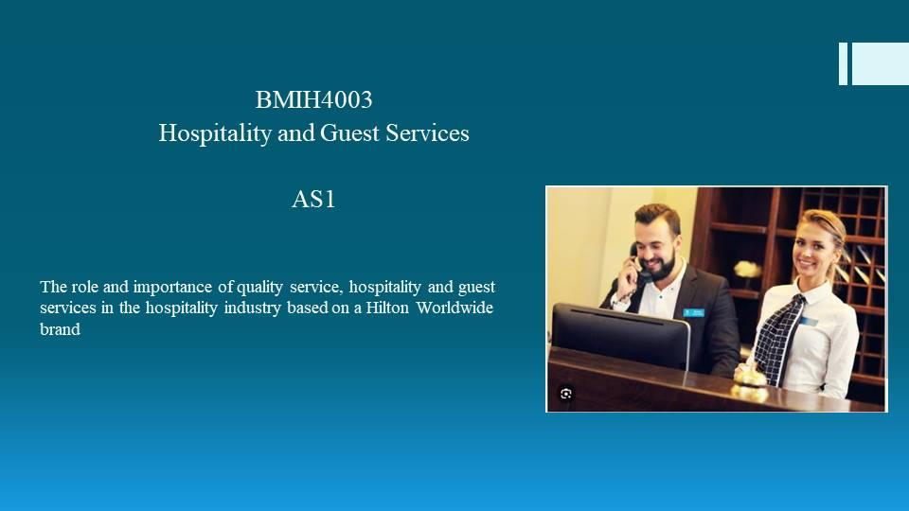
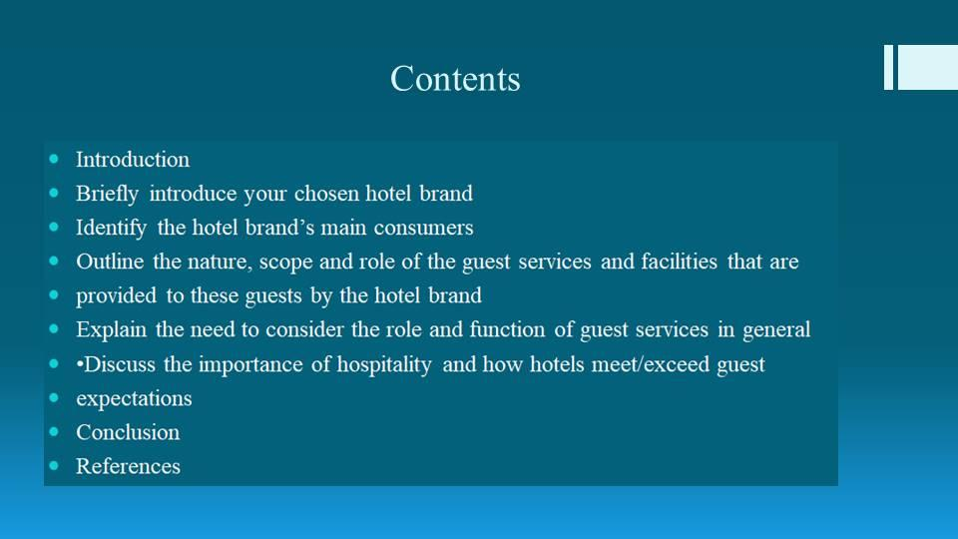
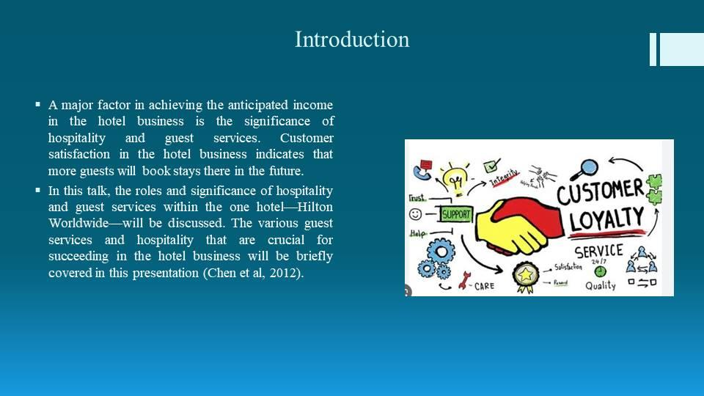
A major factor in achieving the anticipated income in the hotel business is the significance of hospitality and guest services. Customer satisfaction in the hotel business indicates that more guests will book stays there in the future. In this talk, the roles and significance of hospitality and guest services within the one hotel—Hilton Worldwide—will be discussed. The various guest services and hospitality that are crucial for succeeding in the hotel business will be briefly covered in this presentation (Chen et al, 2012).
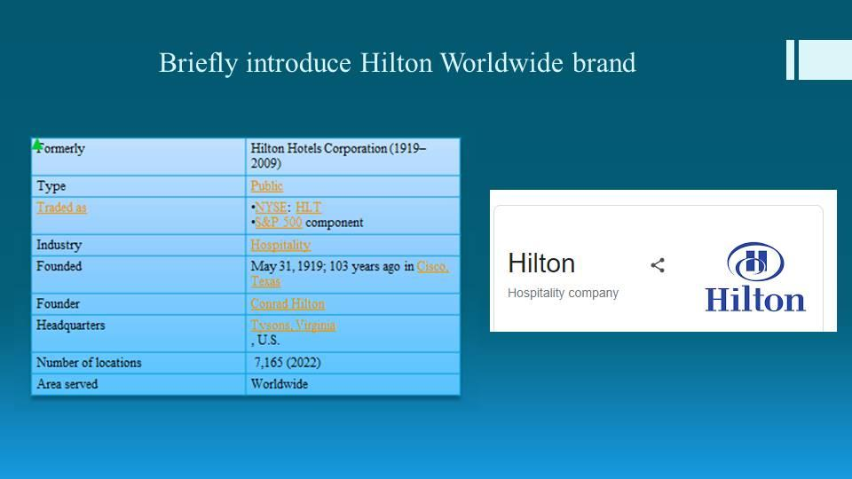
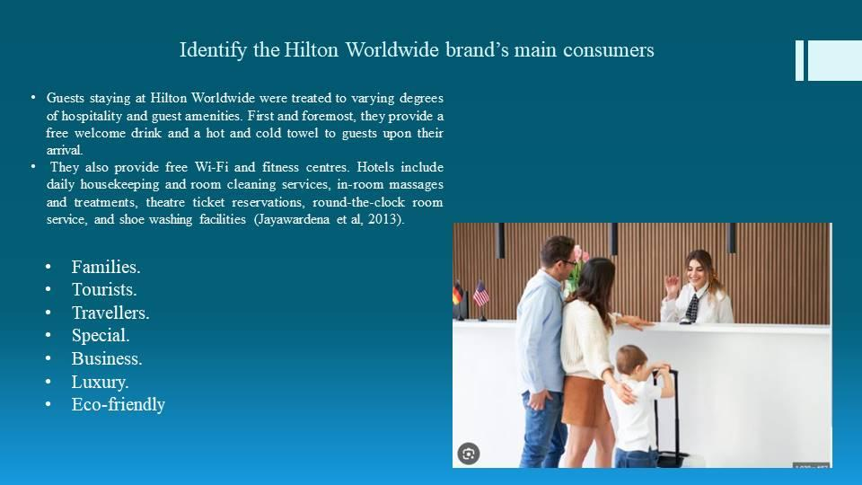
1. Slide: Various visitor kinds get services that enhance their quality of stay at one hotels.
Complimentary drink as soon as you arrive
Free wireless internet
Workout facilities
Treatments and massages provided in-room
Bookings for theater tickets
Room service available around-the-clock
Daily housekeeping and nightly departure
Cleaning shoes (chen et al., 2012)

Guests staying at Hilton Worldwide were treated to varying degrees of hospitality and guest amenities. First and foremost, they provide a free welcome drink and a hot and cold towel to guests upon their arrival. They also provide free Wi-Fi and fitness centers. Hotels include daily housekeeping and room cleaning services, in-room massages and treatments, theater ticket reservations, round-the-clock room service, and shoe washing facilities (Jayawardena et al, 2013).
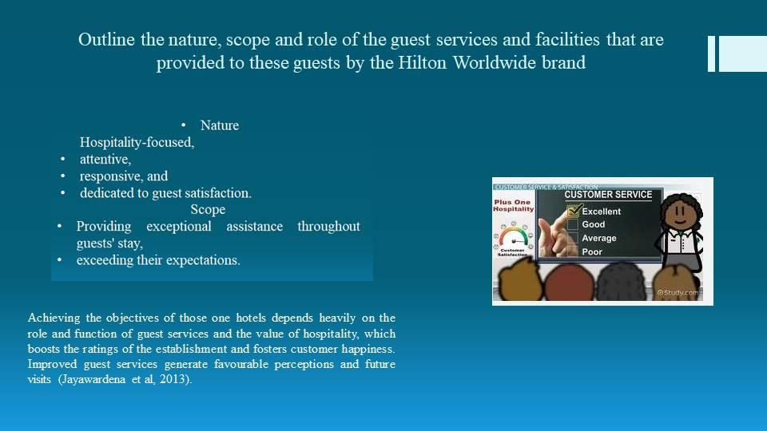
2. Slide: The purpose and role of guest services, the value of hospitality, and how hotels uphold these principles.
The provision of guest services boosts client happiness.
The quality of the hotel's guest services is maintained.
Being welcoming makes a positive first impression on clients.
A welcoming environment encourages repeat business from the client (Jayawardena et al, 2013).

Achieving the objectives of those one hotels depends heavily on the role and function of guest services and the value of hospitality, which boosts the ratings of the establishment and fosters customer happiness. Improved guest services generate favorable perceptions and future visits (Jayawardena et al, 2013).
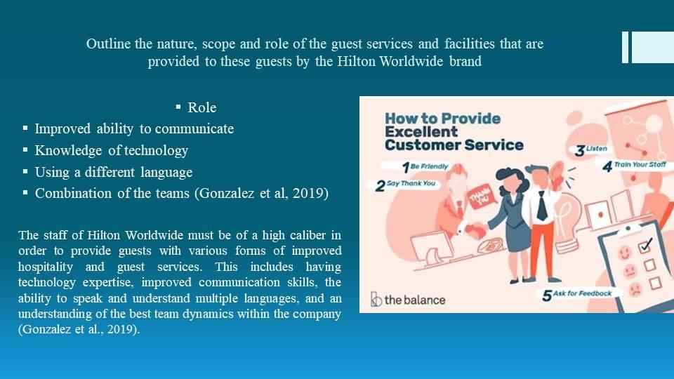

Slide 3: A discussion of the different abilities needed by team members to guarantee that these services are provided to a high caliber
Improved ability to communicate
Knowledge of technology
Using a different language
Combination of the teams (Gonzalez et al, 2019)

The staff of Hilton Worldwide must be of a high caliber in order to provide guests with various forms of improved hospitality and guest services. This includes having technology expertise, improved communication skills, the ability to speak and understand multiple languages, and an understanding of the best team dynamics within the company (Gonzalez et al., 2019).
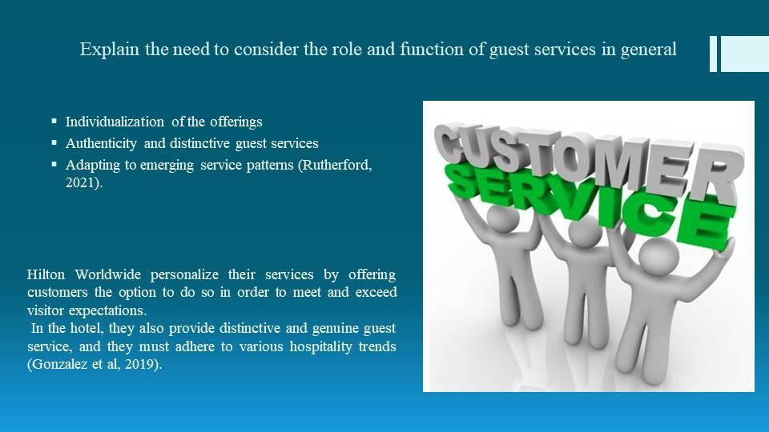

4. Slide: Meeting visitor expectations in light of emerging market trends
Individualization of the offerings
Authenticity and distinctive guest services
Adapting to emerging service patterns (Rutherford, 2021).
Hilton Worldwide personalize their services by offering customers the option to do so in order to meet and exceed visitor expectations. In the hotel, they also provide distinctive and genuine guest service, and they must adhere to various hospitality trends (Gonzalez et al, 2019).
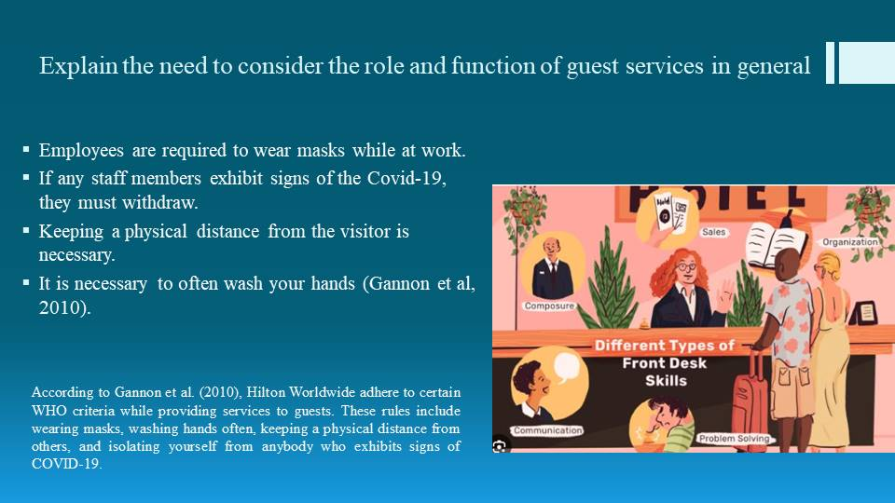

5. Slide: How do these hotels now provide the services that are displayed to clients in light of current post-pandemic guidelines?
Employees are required to wear masks while at work.
If any staff members exhibit signs of the Covid-19, they must withdraw.
Keeping a physical distance from the visitor is necessary.
It is necessary to often wash your hands (Gannon et al, 2010).

According to Gannon et al. (2010), Hilton Worldwide adhere to certain WHO criteria while providing services to guests. These rules include wearing masks, washing hands often, keeping a physical distance from others, and isolating yourself from anybody who exhibits signs of COVID-19.
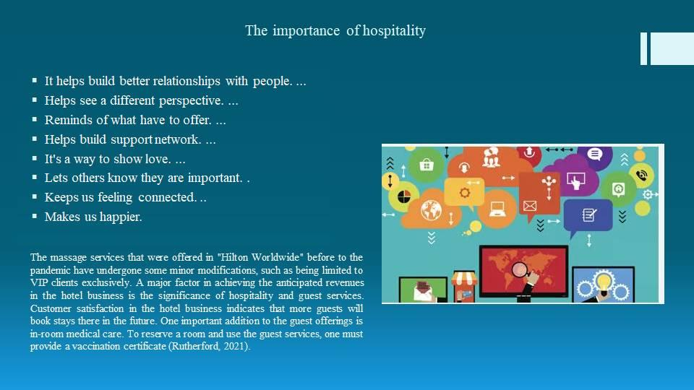

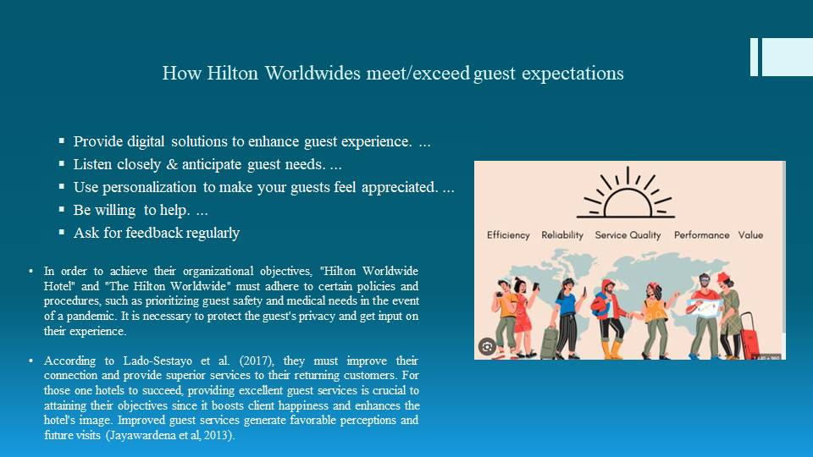

6. Slide: Have all of their pre-pandemic services been completely implemented, or have they undergone modifications as a result?
The massage services that were offered in "Hilton Worldwide" before to the pandemic have undergone some minor modifications, such as being limited to VIP clients exclusively. A major factor in achieving the anticipated revenues in the hotel business is the significance of hospitality and guest services. Customer satisfaction in the hotel business indicates that more guests will book stays there in the future. One important addition to the guest offerings is in-room medical care. To reserve a room and use the guest services, one must provide a vaccination certificate (Rutherford, 2021).
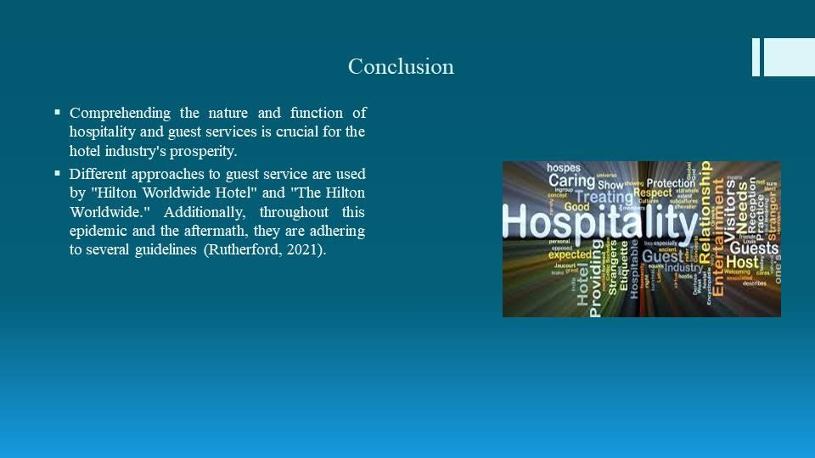
Slide 7: How may the post-pandemic atmosphere be used to regulate guests' expectations?
Security and health care
The visitor's confidentiality
Visitor experience
Linkage with the repeat clientele (Lado-Sestayo et al, 2017)
In order to achieve their organizational objectives, "Hilton Worldwide Hotel" and "The Hilton Worldwide" must adhere to certain policies and procedures, such as prioritizing guest safety and medical needs in the event of a pandemic. It is necessary to protect the guest's privacy and get input on their experience. According to Lado-Sestayo et al. (2017), they must improve their connection and provide superior services to their returning customers. For those one hotels to succeed, providing excellent guest services is crucial to attaining their objectives since it boosts client happiness and enhances the hotel's image. Improved guest services generate favorable perceptions and future visits (Jayawardena et al, 2013).

8. Slide: Remarks
Comprehending the nature and function of hospitality and guest services is crucial for the hotel industry's prosperity. Different approaches to guest service are used by "Hilton Worldwide Hotel" and "The Hilton Worldwide." Additionally, throughout this epidemic and the aftermath, they are adhering to several guidelines (Rutherford, 2021).
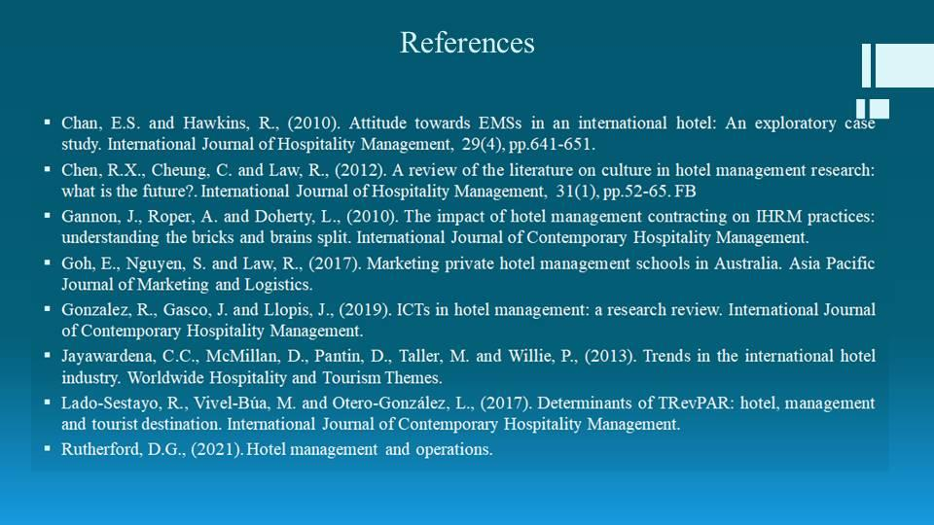

References
Chan, E.S. and Hawkins, R., (2010). Attitude towards EMSs in an international hotel: An exploratory case study. International Journal of Hospitality Management, 29(4), pp.641-651.
Chen, R.X., Cheung, C. and Law, R., (2012). A review of the literature on culture in hotel management research: what is the future?. International Journal of Hospitality Management, 31(1), pp.52-65. FB
Gannon, J., Roper, A. and Doherty, L., (2010). The impact of hotel management contracting on IHRM practices: understanding the bricks and brains split. International Journal of Contemporary Hospitality Management.
Goh, E., Nguyen, S. and Law, R., (2017). Marketing private hotel management schools in Australia. Asia Pacific Journal of Marketing and Logistics.
Gonzalez, R., Gasco, J. and Llopis, J., (2019). ICTs in hotel management: a research review. International Journal of Contemporary Hospitality Management.
Jayawardena, C.C., McMillan, D., Pantin, D., Taller, M. and Willie, P., (2013). Trends in the international hotel industry. Worldwide Hospitality and Tourism Themes.
Lado-Sestayo, R., Vivel-Búa, M. and Otero-González, L., (2017). Determinants of TRevPAR: hotel, management and tourist destination. International Journal of Contemporary Hospitality Management.
Rutherford, D.G., (2021). Hotel management and operations.

