University of Wales Trinity Saint David

Academic and Employability skills
Module code 40001
PRACTICAL PORTFOLIO
Assessment task 2:

REFLECTION

Pawel Marek Maszkowski Lecturer: Joanna Walsh
Student ID: 2030041

Executive Summary

The following study will evaluate specific topics needed for structuring an academic report. The researcher will be selecting four topics onto which the researcher will be underling their importance. Later, the researcher will be comparing the topic with a reflective model and analysing the following with the help of published literature.

Table of Contents

Introduction 4
Time management 4
Academic Writing 5
Paraphrasing 6
Referencing 7
Conclusion 7
Reference list 8
Appendix – class/homework 10
Appendix 1 1Paraphrasing 10
Appendix 1 2 Harvard Referencing 12
Appendix 1 3, Academic writing (class notice) 15

Introduction
The report discusses academics and the various employability skills needed in real life. The report is underling the learnings from the module. In order to do this, the researcher had selected four topics: Time management, Academic writing, Paraphrasing, and Referencing. In each of the sections, the researcher firstly highlighted the topic. Post that, the researcher highlighted how the specific topic helped the researcher implement it in the classroom and beyond that. The following section compares the topic with a reflective model and analyses the topic with the published literature.

Time management
Time Management is considered a process of planning organising how to divide an individual’s time into various activities. Effective time management helps assign special time slots to activities as per their importance. Some people have an easier time managing their time than others, but everyone can create routines to enhance their time management abilities (Adams & Blair, 2019). Time management is vital because it allows individuals to regulate the workday to grow their business without sacrificing the work-life balance. Implementing Time management in the organisation helps improve the performance and helps produce work better. It also helps in delivering work on time and helps in reducing stress.
Implementing time management in my daily routine helped me prioritise my tasks so that I can have enough time available for doing the other activities. Time management helped me improve my work-life balance and increased happiness in me. During my course days when the exam was knocking at the door, the help of Time management helped me complete all my subjects before the exam. In my Time management routine, one of my daily activities includes doing exercise daily that helps me stay fit and reduce stress. Implementing Time management also helped me prioritise my tasks as per their urgency or importance (Xu, Wang & Yang, 2020, March). Time management helped me be more organised than before and focused on my academics.
Time management can be compared with the Gibbs Reflective model as it is considered a self-reflection and management tool that helps people think clearly. Gibbs Reflective Model disorganising organises the various experiences of the specific activity and helps conclude. The following reflective model has five steps in choosing a situation to analyse and work on. The first step is about describing where the problem needs to be addressed, why we need to do the time management, and why. The next step is about feelings, as in this step, one needs to encourage himself about following the time management routine. In this step, one needs to consider the situation before the following position (Adeani, Febriani & Syafryadin, 2020). The next step is about evaluation, as in this stage, one needs to look objectively at the critical approaches to be worked upon. In this stage, one needs to examine the positive and the negative effects of the situation. In this case, one will consider the time management routine’s positive and negative uses. The next stage is about the conclusion, as in this stage, one needs to conclude what had happened in implementing the time management routine. The last and final step is an action plan. In this stage, the possible actions that one can implement looking over the results of the time management routine followed.
According to the studies (Won & Shirley, 2018), it can be said that effective Time management helps a student in completing more in a lesser time interval. Time management helps keep a student focused and not waste time on distractions, such as playing games, surfing the internet, etc. Effective Time management in an organisation can affect students’ performance and help improve their soft skills.

Academic Writing
Academic writing is considered transparent, concise, more focused and backed up by evidence. It helps in aiding the reader’s understanding. It is a formal tone and style and is not complex. Academic writing does not require any long sentences and a complicated vocabulary. The simplest form of Academic wiring is considered to be descriptive, and its primary purpose is to provide information and facts. The various features of Academic writing include complexity, precision, explicitness, formality, accuracy and hedging (Altınmakas & Bayyurt, 2019).
Academic writing is said to be a key player in academics. Academic writing helps develop students’ ability to express themselves by understanding the topic and communicating in different subject fields. Academic writing helped me write the assignments that our institution gave us to write on various topics. Academic writing is considered a skill that almost every individual needs to implement upon them—this kind of forces in thinking analytically. One needs to take the information and write it down to make sense to the reader. It also helped me learn the structure and techniques required in writing an academic piece (Tusting et al., 2019). It is about being more professional and making life easy carrier wise. Doing intensive research on the internet about a topic is more than simple internet research. It is because, in order to do Academic writing, one needs to look after every point minutely about a topic.
Academic writing can be compared with the Gibbs Reflective Model as it helps encourage people to think systematically about the various experiences they had during a specific situation. Using the following reflection on those structures can be structured into phases. It often helps people think about the activity experience more detail-oriented. Implementing the next reflective model in Academic writing helps look at a topic from the positive to the event’s negative impact (Markkanen et al., 2020).
According to the studies of (Huisman et al., 2019), it can be said that Academic writing is a tool of communication that conveys acquired knowledge in a specific field of study. Academic writing helps a student analyse and report the understanding that helps in thinking creatively. It is one of the essential tools that a student needs to learn for the future. Practising Academic writing regularly makes a student more creative in their daily life. Academic writing also helps them understand and give students a chance to develop their unconventional ideas and approaches.

Paraphrasing
Paraphrasing is all about using various kinds of words and phrases in order to present the same idea in a different style. Paraphrasing is generally used with the text’s short sections, such as sentences and phrases. It can be used for note-taking and explaining information in tables, diagrams and charts. It is a way of interpreting another person’s ideas. Paraphrasing in academic writing is an effective way to restate or clarify another author’s ideas into your argument or the analysis (Shi, Fazel & Kowkabi, 2018).
Paraphrasing helped me understand the source from where I have to paraphrase and then write down the same in my own words. Moreover, it helps the reader or the tutor know that the writer had understood the source and then paraphrased the section. It helped me develop creative skills while Paraphrasing, Appendix 1 1Paraphrasing; it helped me create sentences by myself. Paraphrasing helped in improving my communication skill. Besides academics, it also helps in business and office-related tasks (Marr, 2019). If there is unique and attractive content in a company in their advertisement, then more customers will be attracted to the brand.
The following reflective model is a critical part of the learning that cannot take place without reflection. It can be compared with Kolb’s Reflective Cycle as it has four stages of learning: concrete experience, abstract conceptualisation, reflective observation, and active experimentation. It is about watching others and developing comments on your own similar to that of Paraphrasing (Din, Idris & Tajuddin, 2020).
According to the studies of (Prentice & Kinden, 2018), it can be said that Paraphrasing is one of the critical factors in the student. Reading a novel, article, or book is sometimes about reading a complex structural sentence and takes more time to grasp the source’s gist. Thus, Paraphrasing is essential so that complex sentences can be modified into simpler ones. At first, Paraphrasing may be a problematic talent for a pupil to master. Regular practice, on the other hand, can correct this. Because one may review the information several times and try to picture the topic using alternative words and sentence patterns.

Referencing
Referencing is all about providing credit to the source of information used in one’s work. It is all about research that is a buildup on other people’s previously done work. In the body of the study, acknowledging the source is said to be considered the proper way to do Referencing and link the citations to the lists of the cited works. It is seen that there are four widely used referencing styles such as MLA, APA, Harvard System and the MHRA (Pears & Shields, 2019).
Referencing is one of the essential parts of the academic work, and it puts to work in the context and helps demonstrate the depth and breadth of the research and the. The citations or the referencing are not used to avoid plagiarism, but it also respects the intellectual property rights of the original researcher (Gravett & Kinchin, 2020). Doing proper referencing helped me get more marks in my academics, Appendix 1 2 Harvard Referencing.
Comparing Referencing with Driscoll’s model of reflection, the following model is based on the three questions that must be answered to complete the reflective cycle. By answering the questions, one can answer and analyse the experiences. The same goes for referencing. Also, it gives credit to the one whose idea is taken in order to do the referencing (Mulryan-Kyne, 2021).
According to the studies of (Pandey et al., 2020), it can be said that referencing is very much crucial in Academic writing as it helps in enabling the readers in locating the source that is being referred to. According to the study, the referencing style follows in understanding two systems, including the documentary note and subordinate systems. The most common referencing styles to be used in referencing is the Harvard and the APA.

Conclusion
The above academic report underlined the skills that are needed in a workplace. In order to complete the study, the researcher had selected topics such as time management, also known as organising the analysis, Academic writing, Paraphrasing, and Referencing. The researcher had highlighted each of the issues and analysed their importance. Furthermore, the researcher also compared the topics with one of the reflective models and studied with published literature.

Reference list
Adams, R.V. & Blair, E., 2019. Impact of time management behaviours on undergraduate engineering students’ performance. SAGE Open, 9(1), p.2158244018824506. https://journals.sagepub.com/doi/pdf/10.1177/2158244018824506
Adeani, I.S., Febriani, R.B. & Syafryadin, S., 2020. USING GIBBS’REFLECTIVE CYCLE IN MAKING REFLECTIONS OF LITERARY ANALYSIS. Indonesian EFL Journal, 6(2), pp.139-148. http://journal.uniku.ac.id/index.php/IEFLJ/article/download/3382/2034
Altınmakas, D. & Bayyurt, Y., 2019. An exploratory study on factors influencing undergraduate students’ academic writing practices in Turkey. Journal of English for Academic Purposes, 37, pp.88-103. https://www.sciencedirect.com/science/article/pii/S147515851830050X
Din, W.M., Idris, F. & Tajuddin, M., 2020. Adapting Kolb’s Experiential Learning Cycle in Enhancing Attitude and Skills Among Undergraduates through Volunteerism. Asean Journal of Teaching and Learning in Higher Education (AJTLHE), 12(2), pp.122-139. https://ejournal.ukm.my/ajtlhe/article/download/44003/11421
Gravett, K. & Kinchin, I.M., 2020. Referencing and empowerment: exploring barriers to agency in the higher education student experience. Teaching in Higher Education, 25(1), pp.84-97. https://www.tandfonline.com/doi/abs/10.1080/13562517.2018.1541883
Huisman, B., Saab, N., van den Broek, P. & van Driel, J., 2019. The impact of formative peer feedback on higher education students’ academic writing: a Meta-Analysis. Assessment & Evaluation in Higher Education, 44(6), pp.863-880. https://www.tandfonline.com/doi/pdf/10.1080/02602938.2018.1545896
Markkanen, P., Välimäki, M., Anttila, M. & Kuuskorpi, M., 2020. A reflective cycle: Understanding challenging situations in a school setting. Educational Research, 62(1), pp.46-62. https://www.tandfonline.com/doi/abs/10.1080/00131881.2020.1711790
Marr, J.W., 2019. Making the mechanics of Paraphrasing more explicit through Grammatical Metaphor. Journal of English for Academic Purposes, 42, p.100783. https://www.sciencedirect.com/science/article/pii/S1475158518306544
Mulryan-Kyne, C., 2021. Supporting reflection and reflective practice in an initial teacher education programme: an exploratory study. European Journal of Teacher Education, 44(4), pp.502-519. https://www.tandfonline.com/doi/abs/10.1080/02619768.2020.1793946

Pandey, S., Pandey, S., Dwivedi, S., Pandey, D., Mishra, H. & Mahapatra, S., 2020. Methods of various citing and referencing style: fundamentals for early career researchers. Publishing Research Quarterly, 36(2), pp.243-253. https://link.springer.com/article/10.1007/s12109-020-09726-0
Pears, R. & Shields, G.J., 2019. Cite them right: the essential referencing guide. Macmillan International Higher Education. https://books.google.com/books?hl=en&lr=&id=A8SWDwAAQBAJ&oi=fnd&pg=PP1&dq=referencing+in+academic+writing&ots=LCAtw7e5jf&sig=gdLPGLj2pxCEc96uXzthj2Q9mqY
Prentice, F.M. & Kinden, C.E., 2018. Paraphrasing tools, language translation tools and plagiarism: an exploratory study. International Journal for Educational Integrity, 14(1), pp.1-16. https://link.springer.com/article/10.1007/s40979-018-0036-7
Shi, L., Fazel, I. & Kowkabi, N., 2018. Paraphrasing to transform knowledge in advanced graduate student writing. English for specific purposes, 51, pp.31-44. https://www.sciencedirect.com/science/article/pii/S0889490617300480
Tusting, K., McCulloch, S., Bhatt, I., Hamilton, M. & Barton, D., 2019. Academics writing: The dynamics of knowledge creation. Routledge. https://www.taylorfrancis.com/books/mono/10.4324/9780429197994/academics-writing-karin-tusting-sharon-mcculloch-ibrar-bhatt-mary-hamilton-david-barton
Won, S. & Shirley, L.Y., 2018. Relations of perceived parental autonomy support and control with adolescents’ academic time management and procrastination. Learning and Individual Differences, 61, pp.205-215. https://www.sciencedirect.com/science/article/pii/S1041608017302157
Xu, C., Wang, C. & Yang, N., 2020, March. Study on College Students’ Spare Time Management. In 5th International Conference on Financial Innovation and Economic Development (ICFIED 2020) (pp. 20-23). Atlantis Press. https://www.atlantis-press.com/proceedings/icfied-20/125935913

Appendix – class/homework

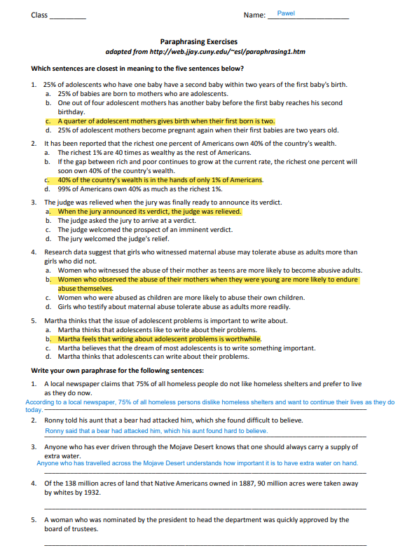
Appendix 1 1Paraphrasing
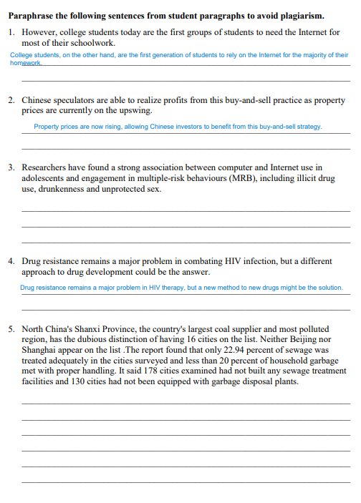

Appendix 1 2 Harvard Referencing
HARVARD REFERENCING WORKSHOP

How would the following references be cited in your text and formatted in your list of references?

Book
The Complete Guide to referencing and avoiding plagiarism by Neville, Colin
Book. English. 2nd ed. Published Maidenhead : Open University Press 2010
In text:
(Neville, 2010)
In reference list:
Neville, C., 2010. The Complete Guide to Referencing and Avoiding Plagiarism. 2nd ed. Maidenhead: Open University Press.

Chapter in an edited book
Cite a chapter by P Baty called Collaborative Learning from page 231 to page 248 contained in the following book: Study skills for Dyslexic students.
Hargreaves, Sandra
Book. English.
Published Los Angeles, Calif. ; London : SAGE 2007
In text:
(Baty, 2007)
In reference list:
Baty, P., 2007. Collaborative Learning. In: Study skills for Dyslexic students. London: Los Angeles, Calif, pp. 231-248.

Journal articles
Putting the Defendant in Their Place: Why Do We Still Use the Dock in Criminal Proceedings? Mulcahy, Linda. British Journal of Criminology volume 53 Issue 6 (2013): 1139-1156.
In text:
(Mulcahy, 2013)
In reference list:
Mulcahy, L., 2013. British Journal of Criminology. Putting the Defendant in Their Place: Why Do We Still Use the Dock in Criminal Proceedings?, 53(6), pp. 1139-1156.

Equity and Efficiency in the Workplace: New Trends in Managing Human Resources. Reid, Douglas; Strudler, Robert; Ryner, Sara; Dyer, Lee. ILR Report 24.2 (Spring 1987): 35.
In text:
(Reid, D., Strudler, R., Ryner, S., Dyer, L., 1987)
In reference list:
Reid, D., Strudler, R., Ryner, S., Dyer, L., 1987. Equity and Efficiency in the Workplace: New Trends in Managing Human Resource. ILReport 24.2, p. 35.

Newspaper articles
Daily Telegraph (London) October 21, 2013 Monday p1
Fears of rising bills as deal is struck for new nuclear plant. Roland Gribben
In text:
(Gribbler, 2013)
In reference list:
Gribben, R., 2013. Fears of rising bills as deal is stuck for new nuclear plant.. Daily Telegraph, 21 October, p. 1.

Web pages
Type the following words into Google: BBC news electronic retinas. Write a reference for the article “Two blind British men have electronic retinas fitted”.
In text:
(Walsh, 2012)
In reference list:
Walsh, F., 2012. Two blind British men have electronic retinas fitted. [Online]
Available at: https://www.bbc.com/news/health-17936302
[Accessed 28 7 2021].

Appendix 1 3, Academic writing (class notice)


