Name: Bulgarian Party Agency
Business Plan for: Christopher Wilkin

Lecturer: | Christopher Wilkin
Date: | 04/03/2024
Team members: | Gergana Nikolova (2213953), Gabriella Zosllei (2133167), Irina Dode (2123684), Catalin Cocos (2214591)

Wordcount: 2219
Business plan contents

Executive Summary…………………………………………………………………………………………………………….3
1 Executive summary 3
2 Business details 4
3 Key personnel 5
Vision 6
4 The business idea 6
5 Business goals 6
6 What the business does 7
7 What makes the business different 7
8 Legal requirements 7
Marketing 8
9 Market research 8
10 Profiling customers 8
11 Profiling competitors 9
12 Managing market risks 9
13 Pricing 9
14 Promotion and advertising 10
Running the business 11
15 Staff 11
16 Premises 11
17 Suppliers 11
18 Equipment 12
19 Managing operational risks 12
Finance 13
20 Start-up costs 13
21 Profit and loss forecast 15
22 Sourcing finance 16
23 Managing financial risks 16
24 Cash flow forecast 17

1 Executive summary (We suggest you complete this section after you have completed the other sections of the Business Plan).
Bulgarian Festivities UK is a pioneering party agency poised to revolutionise the event planning industry in the United Kingdom. Our business idea was sparked by the Bulgarian community's longing for cultural celebrations and authentic cuisine, prompting us to establish the first-of-its-kind agency dedicated to organising Bulgarian parties and events.
Led by a dynamic team comprising Irina Dode, Gergana Nikolova, Gabriela Zosllei, and Catalin Cocos, each bringing a unique set of skills and experiences, Bulgarian Festivities UK is positioned for success. With expertise ranging from hospitality and marketing to party planning and finance, our team is committed to delivering exceptional experiences and exceeding customer expectations.
Our vision for the business encompasses a comprehensive strategy to achieve significant growth and market penetration over the next 3-5 years, guided by Klofstens Business Platform. We aim to establish Bulgarian Festivities UK as the premier destination for Bulgarians living in the UK, expatriates, and cultural enthusiasts seeking authentic Bulgarian celebrations.
Key components of our business plan include meticulous market research, customer profiling, and strategic partnerships to effectively reach our target audience. By offering standard and premium party packages tailored to our customers' preferences and needs, we differentiate ourselves from competitors and deliver unparalleled value.
In our first year of operation, we aim to achieve a turnover of £150,000 by prioritising customer satisfaction and brand recognition. Through a multi-channel marketing approach, including social media advertising, targeted email campaigns, and participation in cultural events, we will promote our services and expand our reach.
Managing operational risks, such as economic fluctuations and supplier performance, is integral to our success. We have developed robust strategies to mitigate these risks, ensuring the safety and satisfaction of our guests and the continuity of our business operations.
In conclusion, Bulgarian Festivities UK is poised to become the leading provider of authentic Bulgarian celebrations in the UK, driven by a passionate team, a clear vision, and a commitment to excellence. Thank you for considering our business plan, and we look forward to bringing the joy of Bulgarian festivities to audiences across the United Kingdom.

2 Business details

Company name:


Bulgarian Festivities UK ltd.

Address:
Waterside Court, Neptune Way, Medway City Estate
Rochester, Kent
ME2 4NZ

Primary contact method
Mobile Number – 07506 839345
Phone number – 01634 123456

Email – bgfestivitiesuk@gmail.com

The business will:

"Bulgarian Festivities UK," will provide in organising and managing a wide range of events, infused with Bulgarian traditions, cuisine, music, and decor. By focusing on authenticity, customisation, and community engagement, Bulgarian Festivities UK aims to become the go-to destination for Bulgarians seeking to celebrate their milestones and preserve their cultural identity in the UK including Traditional Bulgarian Music, Dances, Food & Beverage.

3 Key personnel

Details of owner(s):
Name: Irina Dode
Position/main responsibilities: Host/ Organiser
Experience and knowledge of our industry: Hospitality
Previous employment: Cleaning Company
Key skills brought to the business: Strategic thinking, Leadership, Communication Creativity, Collaboration
Business experience and any training undertaken: Academic Online
Academic/professional qualifications: Hotel Management
Salary expectations £ 25 000
Name: Gergana Nikolova
Position/main responsibilities: Owner, Marketing manager
Experience and knowledge of our industry: Organising and Promoting Events, Team leading, Customer service in Restaurants, Direct, Verbal, and online communication with guests and customers.
Previous employment: Agency Supervisor, Restaurant Manager, Receptionist, Hostess, Waitress.
Key skills brought to the business: Organised, focus on details, Innovative, Leadership skills, Communication skills, Ability to think outside the box, Problem Solving, Understanding customers’ requests, Time management.
Business experience and any training undertaken: Agency Supervisor, Restaurant Manager, Receptionist, Waitress, Hostess. Trainings - GDPR Essentials, Equality and Diversity, Environmental Sustainability, Health and Safety, Waste Reduction, Handling difficult conversations, Time management and Prioritisation, Leadership styles, Learning and Development.
Academic/professional qualifications: GDPR Essentials, Equality and Diversity, Environmental Sustainability, Health and Safety, Waste Reduction, handling difficult conversations, Time management and Prioritisation, Leadership styles, Learning and Development, International Hotel Management
Salary expectations £ 41 000 annual

Name: Gabriela Zosllei
Position/main responsibilities: Party Planner
Experience and knowledge of our industry: Hospitality, Private events, Wine Ambassador
Previous employment: Restaurant Supervisor, Retail Sales Assistant
Key skills brought to the business: Creativity, Problem Solving, Negotiation and Budgeting, Multitasking
Business experience and any training undertaken: Alcohol licence, Supervisor trained, Wine Ambassador
Academic/professional qualifications: International Hotel Management Course
Salary expectations £ 30 000

Name: Catalin Cocos
Position/main responsibilities: Financial Manager
Experience and knowledge of our industry: Bartender, Chef, Waiter, Hospitality industry experience
Previous employment: Restaurant Supervisor, Head Chef, Bartender, Waiter
Key skills brought to the business: Communication skill, Team worker, Punctuality
Business experience and any training undertaken: Health & Safety, Driving Licence, Taxi Driver
Academic/professional qualifications: N/A
Salary expectations £ £35 000

Vision

4 The business idea

Sum up your business idea:

The Business idea was inspired by the Bulgarian Community in the UK which is looking for events where they can celebrate their special occasion and to enjoy the Bulgarian cousin. Our business highlights cultural authentic experience for the Bulgarian community in Medway, Rochester, Kent, UK, and it’s the only party agency that organises and plan Bulgarian Parties.

Please see Mind Map (Appendix 0)

5 Business goals
- What do you want to achieve in your first year of business?
As a Start-up Business we would like to achieve turnover of £150 000 by the end of first year. To achieve this amount, we are more focused on higher customer satisfaction as well as wider brand recognition.
- Where do you see your business in 3-5 years’ time?
Klofstens business platform

Time-Period | Idea | Product | The Market | Organisation | Expertise | Driving Forces | Customer Relations | Other Relations
Now | 7 | 6 | 8 | 7 | 5 | 6 | 8 | 7
5 years later | 8 | 8 | 9 | 10 | 9 | 8 | 10 | 9

Table: Scores for Klofstens Business Platform
(Source: Created by the learner)

Figure 1: Bulgarian Festivities UK projected position using Polar Diagram
From the application of Klofstens business platform, the business is expected to improve in its operations especially in customer relations and expertise whose projected scores were observed to be at 9 and 10 respectively. This is the outcome that is expected from Bulgarian Festivities UK 5 years later.

6 What the business does

Product/service | Features | Benefits
- Standard and Premium packages | - Packages related to list of product and services provided by the company based on the customer request | - For providing high quality experience and gaining value for money.  - Encourages the business
- Registration and deposit fees | - Verifying the names of the customers.  - Anticipating the date of departure. | - Ensuring that all the damages are covered.

7 What makes the business different?

Our business is unique due to the lack of competitors in the area which helps the customers in providing a higher level of satisfaction and Bulgarian party nature experience. The conception of our agency is to provide a traditional Bulgarian atmosphere even in another country with cost-effective prices.

8 Legal requirements
The legal and insurance requirements that apply in your business are:

- Public Liability Insurance - needs to be covered in case if any guests face any injury within the premises.

You will meet your legal and insurance requirements by:
- Paying a monthly insurance of £3.19 to cover the risks of the employers.

Marketing

9 Market research

Trends in your chosen market are:

- Cultural Trends and Traditions: In the UK, there is a growing interest in multicultural events and experiences, including those that celebrate different cultural traditions. The demand for authentic cultural experiences, such as traditional Bulgarian festivities, is increasing (Smith, 2020).
- Digitalisation and Technology Integration: The use of technology in event planning and management is becoming increasingly prevalent. This includes online ticket sales, event apps for engagement, and virtual event platforms. Integrating technology into our services will enhance customer experience and streamline operations (Jones et al., 2019).
- CRM (Customer Relationship Management): Building strong relationships with customers is essential for repeat business and positive word-of-mouth referrals. Implementing a CRM system will allow us to effectively manage customer interactions and tailor our services to their preferences (Chen & Popovich, 2003).

How you know this: (Provide examples with references)
- Please see the PESTEL Analyse (Appendix 1)

10 Profiling customers

The customer groups you will be selling to are: (4 x Customer profiles minimum)
- Please see the BMC (Appendix 2)
- Please see 4 Customers profiles (Appendix 3)

- Cultural Enthusiasts: Individuals interested in experiencing authentic cultural events and traditions.
- Event Planners: Professionals seeking unique and diverse options for their clients' events.
- Bulgarian Diaspora: Bulgarians living in the UK who wish to celebrate their heritage and traditions.
- Tourists: Visitors to the UK looking for unique cultural experiences beyond mainstream attractions.

Your customer research has shown what your customers want is:

- Based on the research of Similar Web our customers want (What research did you undertake and what were the results?)

Based on data from Similar Web, our analysis indicates a high volume of online searches related to Bulgarian cultural events in the UK. This suggests a strong demand for such experiences among our target audience. Additionally, surveys conducted among Bulgarian diaspora communities and cultural enthusiasts revealed a desire for more opportunities to participate in Bulgarian festivities and traditions in the UK.

How you know this:
- (What evidence can you offer)
- Please see Similar Web analyses (Appendix 9)

Number of customers you expect to win in each group and what they might pay:
Group | Number of customers | Price they might pay per unit
Male | 53% | £40
Female | 47% | £30
18-24 | 11% | £20
25-34 | 26% | £30
35-44 | 19% | £40

11 Profiling competitors

Please see Appendix 4, Appendix 5 and Appendix 6

Competitor name | Strengths | Weaknesses
- Wedding Planner Kent | - Variety offers for Weddings with great value of the money | - Focused only on Wedding venues
- Platinum Event | - Professional touch to detail for Weddings and great partnership | - Operating only in London, not in Medway area

How you can improve on their offer and/or price(s) unique offerings:
- We can improve their offer by unique packages Standard and Platinum where our customers can do their best choice. As we are specified to the Bulgarian community only, our packages are unique due to Lack of competitors.

12 Managing market risks

Write down the risks you have identified:
- Risk Identification: One identified risk is the potential impact of economic fluctuations on discretionary spending for cultural events.

How will you manage these risks so that they become less of a threat:
Risk Management Strategy:
To mitigate this risk, we will diversify our revenue streams by offering a range of services, including event planning for corporate clients and cultural workshops. Additionally, we will closely monitor economic indicators and adjust our marketing and pricing strategies accordingly.

13 Pricing

How you can calculate your prices:
We will calculate our prices based on a combination of factors, including the cost of venue rental, catering, entertainment, and our desired profit margin. Additionally, we will conduct market research to benchmark our prices against competitors offering similar services while ensuring that our pricing remains competitive and attractive to our target customers.

How your prices compare with the competition:
Product/service | Your price(s) | Range of competitor prices (per unit)
Deposit Fee | 40% non-Refundable | 30-50% non-refundable
Consultation Fee | £50 | £45-£75
Standard Package | £50 per head | £50 per head
Premium Package | £100 per head | £130 per head

Reasons for the difference between your price(s) and your competitors’ price(s):

- The reason for difference between our prices and competitor prices is due to specific and individual party packages which we have more focused on the Bulgarian community where the culture takes priority and the specific services and products that we offer such as Bulgarian atmosphere, Bulgarian Traditions and cuisine.

14 Promotion and advertising

How and where will you promote your product/service?

We will utilise a multi-channel approach to promote our services, including social media advertising, targeted email campaigns, partnerships with relevant influencers and organisations, and participation in cultural festivals and events. Additionally, we will invest in search engine optimization (SEO) to improve our online visibility and reach customers actively searching for Bulgarian cultural experiences in the UK.
Please see Appendix 7 and Appendix 8

Running the business

15 Staff

Role | Total cost | Necessary experience | Specialist skills and/or qualifications
- Manager/ Marketing | £ 41.000 annual | - Project management  - Marketing | - International Hospitality Management
- Party planner | £ 30.000 annual | - Event’s organiser | - Level 2 certificate in events planning
- Catering/ Hostess | £28.000 annual | - Hospitality / Food and beverage | - Hospitality and catering level 1
- Security | £ 20.000 annual | - Front door, Crowd management, Sectioning, Communication | - NVQ level 2 spectator control, qualification and possibly fire Marshal trained
- Cleaner | £15.000 annual | - N/A | - Healthy hygiene

16 Premises

 | Cost £
Premises required at start-up: Waterside Court, Neptune Way, Rochester Kent, Office | £6996 annual  £583 p/m
Premises required in the future (if different): N/A | £ N/A

17 Suppliers

Your key suppliers and their credit terms

Supplier | What you’ll buy from them | Number of days’ credit
- Venue and Marquee hire  Pop top Rochester | - Marquees and Tents | - 30
- Staging and dancefloor Dance factors Kent | - Staging, Display panels and dance floors | - 90
- Outdoor event furniture  My furniture hire Kent | - Outdoor/indoor furniture, linen, accessories | - 90
- Audi-video and lighting specialist  ALD audio light design | - Amplifier, Microphone, Sound mixer, Speakers  - Disco effect, Generics, LED, lighting console, Moving lights | - 90
- Theming and decorations  Ashley Gladman Events Kent | - Planning Services, Décor fit for every occasion | - 30
- Catering  Coco Basil Catering Rochester | - Events Menu, Canapes, Finger foods, Bowl foods, Dessert Canapes, Barbecue | - 30
- Bar specialist  Brooks Bar Kent | - Fully stocked bar, dry bar, | - 30
- Florist  Ginger Lilly Rochester | - Flowers for every occasion | - 30

18 Equipment

Resource | When | How funded | Cost £ per unit
- Tables | - Day 1 | - Credit | £370.34
- Printers & Scanners | - Day 1 | - Credit | £314.98
- Shredders | - Week 3 | - Credit | £420.28
- Seating | - Day 1 | - Credit | £250.08
- Storage | - Week 1 | - Credit | £219.60
- Desking | - Day 1 | - Credit | £208.74
- Digital Projectors | - Week 1 | - Credit | £356.70
- Safes & locks | - Week 1 | - Credit | £514.80
- Writing instruments | - Day 1 | - Credit | £4.38

19 Managing operational risks.

Risk | Solution
Staff  - Calling sick  - Being late  - Not being professional | - Event risk management is the process of identifying, assessing, and controlling foreseeable risks that could impact the success of an event. These foreseeable risks include any incidents or issues that could impact attendees, suppliers, staff, or the venue itself.
Suppliers  - Poor supplier performance  - Supply chain disruptions  - Quality issues  - Avoidable cost increases in materials, services and project costs | - Define what information you need to collect. It is important to establish the data you need to collect, and why.  - Engage your organisation.  - Prioritise your suppliers.  - Identify the solution that best suits your needs.  - Define processes for dealing with supplier responses.

Finance
Please double click in the table below to access the embedded Microsoft Excel sheets to input your figures, Microsoft Excel will automatically update the total for you. If you do not have access to Microsoft Excel you can use the link below this table and save the file onto your PC. You can then use Open Source Software such as Google Docs or OpenOffice to access the information by uploading the file into this software. Please note that all tables can be customised and additional rows and categories can be added.

20 Start-up costs

Calculate how much money you need before you start trading

Workings
Total Wages = £(41000 + 30000 + 28000 + 20000 + 15000) / 12 = £11,167
Equipment:
Tables = £(370.34*5) = £1,851.7
Printers and Scanners = £(314.98 * 2) = £629.96
Shredders = £(420.28 * 3) = 1,260.84
Seating = £(250.08 * 4) = £1,000.32
Storage = £(219.60 * 2) = £439.2
Desking = £(208.74 * 4) = £834.96
Digital Projectors = £356.70
Safes and Locks = £514.80
Writing Instruments = £(4.38 * 2) = £8.76
Total = £6,897.24

Analysis
Relative to the analysis of start-up cash, the total start up cash required for Bulgarian Festivities UK is £30450 Out of these, the most expensive amount is equipment for the business. The amount for the equipment is £6897.24 followed by stock of £2500. A stock of £2500 is a demonstration that the business has been focused on providing more on raw materials.

* Total from here should be used in 22 Sourcing finance below

21 Profit and loss forecast
Workings
Printing and stationery = £629.96
The amount of printing and stationery is deducted from the total costs of equipment which is = £ (6,897.24 – 629.96) = £6,267.28 + Vehicles = £7267.28

Analysis
From the above income statement, it is observed that the gross profit of Bulgarian Festivities UK in the first year is £100,000 which gradually increased to £150000 in year 3. The breakeven analysis on year 1 and 2 were observed to £402347 and £400437 meaning that this the amount that the company needs to achieve in order to gain a break-even point in sales.

22 Sourcing finance

Total borrowing requirement for the business

Analysis
The total start-up costs for the business is £30450 meaning that the business will require this amount to commence its operations. However, there were deductions from person and any other start up contributions that includes a contribution of £500 and £600 respectively. The final required amount is £29350 to commence the operations. The assets which have been available as security is worth £5000 meaning that these assets can be useful in times of financial crisis.

23 Managing financial risks (such as, sales are less than forecasted or start-up finance takes three months longer to obtain)

The risks that you have identified for your financial forecast are:
- Actual expenses being higher than that of forecasted amount: It was observed that the actual expenses were considerably higher than that of the amount that was forecasted in the profit and loss statement which brought down the profits.
- Cost of production risk: Cost of production risk is the risk that arises due goods being damaged and outputs being higher than that of the estimated output.
- Employee Risks: Employee risks covers all the aspects that an employee is capable of doing who can even damage the business of the employer in some other way.

How you will minimise their impact:
- Reduction of supply expenses: Supply chain expenses can be reduced through proper inventory management, boost in operational efficiency and clearance of the procurement strategy (Akinlabi, 2021). This can also be implemented in Bulgarian Festivities UK by bringing down excess supply costs.
- Regular reviews and updating the controls: For mitigating the production risk, it is important for the management of Bulgarian Festivities UK to identify the risks and monitor them accordingly. This includes conducting a risk assessment plan to avoid scope creep risks related to financial forecasts.
- Clear communication with the employees: For clearly communicating with the employees, it is important to allow the employees in stating their opinions which can reduce employee related risks in the company’s finances.

24 Cash flow forecast (Click on the tabs within the Microsoft Excel sheet to view the second 6 months and summary)

Analysis
From the figures of the cash flow statement, it was observed that actual income was significantly higher than that of forecasted income. In this scenario, both the sales figures were observed to be £87600 and £112000 respectively. This is an indication that the Bulgarian Festivities UK is performing efficiently and that the sales are considerably higher. However, the management team needs to keep a check on the rise in expenses where the actual expenses were observed to be at £188178 whereas the forecasted expenses are at £188839 respectively
25 Conclusion.

In conclusion, the business plan for Bulgarian Festivities UK is a testament to our team's dedication, expertise, and passion for bringing authentic Bulgarian cultural experiences to the United Kingdom. Led by a dynamic group of individuals with diverse backgrounds and skills, our team is well-equipped to establish and grow a thriving party agency that caters to the Bulgarian community and beyond.
With Irina Dode's leadership and experience in hospitality, Gergana Nikolova's marketing prowess, Gabriela Zosllei's creativity as a party planner, and Catalin Cocos's financial acumen, we have assembled a formidable team capable of delivering exceptional events and exceeding customer expectations.
Our business idea, inspired by the Bulgarian community's desire for cultural celebrations and traditional cuisine, fills a unique niche in the market. We aim to provide memorable experiences that highlight Bulgarian traditions and create a sense of belonging for Bulgarians living in the UK, expatriates, and cultural enthusiasts alike.
In our first year of business, we aspire to achieve a turnover of £150,000 by prioritising customer satisfaction and brand recognition. Looking ahead, our vision for Bulgarian Festivities UK is ambitious. Utilising Klofstens Business Platform, we project significant growth in our operations, expertise, and customer relations over the next 3-5 years.
Our product and service offerings, including standard and premium party packages, set us apart from competitors by delivering authentic Bulgarian experiences tailored to our customers' preferences. We are committed to meeting all legal and insurance requirements to ensure the safety and satisfaction of our guests.
Through thorough market research and customer profiling, we have identified key customer groups and their preferences, allowing us to tailor our offerings to meet their needs effectively. By leveraging digital marketing strategies and partnerships with influencers and organisations, we will promote our services and expand our reach.
Managing operational risks, including economic fluctuations and supplier performance, is integral to our success. We have developed strategies to mitigate these risks, such as diversifying revenue streams and prioritising reliable suppliers. Managing Financial Risk with reduction of supply expenses and clear employee communication.

26 References
www.poptop.co.uk. (n.d.). Affordable Marquee & Tent Suppliers in Rochester, Rental Prices & Guides. [online] Available at: https://www.poptop.uk.com/rochester/suppliers/marqueetent/ [Accessed 26 Feb. 2024].
www.dancefactors.co.uk. (n.d.). Display panel hire | Dancefactors. [online] Available at: https://www.dancefactors.co.uk/display_panel_hire.html [Accessed 26 Feb. 2024].
myfurniturehire. (n.d.). Accessories for Events Bromley | Bins, Highchairs & Hangers Essex | My Furniture Hire Surrey. [online] Available at: https://myfurniturehire.co.uk/collections/accessories [Accessed 26 Feb. 2024].
Audio Lighting Design | ALD Productions. (n.d.). Audio Lighting Design | ALD Productions – audio, video, and lighting hire and event production in London, Kent and the South East. [online] Available at: https://www.audiolightdesign.co.uk/ [Accessed 26 Feb. 2024].
Ashley Gladman. (n.d.). Home. [online] Available at: https://www.ashleygladmanevents.co.uk/ [Accessed 26 Feb. 2024].
Coco Basil Catering. (n.d.). Coco Basil Catering. [online] Available at: https://www.coco-basil-catering.co.uk/ [Accessed 26 Feb. 2024].
Brooks Bar Hire. (n.d.). Brooks Bar Hire | The Mobile Bar Specialists | Maidstone, Covering UK. [online] Available at: https://www.brooksbars.com/ [Accessed 26 Feb. 2024].
Gingerlily-florist.co.uk. (2024). Available at: https://www.gingerlily-florist.co.uk/ [Accessed 26 Feb. 2024].
www.eks-office.com. (n.d.). EKS Office Equipment - Stationery Supplies in Kent & Medway. [online] Available at: https://www.eks-office.com/ [Accessed 26 Feb. 2024].
Rightmove.co.uk. (n.d.). Check out this Serviced office to lease on Rightmove. [online] Available at: https://www.rightmove.co.uk/properties/143865641#/?channel=COM_LET [Accessed 26 Feb.2024].

Gov, 2024. What insurance does a small business need? [Online] Available at: <https://companieshouse.blog.gov.uk/2019/04/30/what-insurance-does-a-small-business-need/> [Accessed on 27 February 2024]
Statista, 2023. The occupancy rate of Premier Inn (Whitbread) hotel rooms in the United Kingdom (UK) from 2011/12 to 2022/23 [Online] Available at: <https://www.statista.com/statistics/739831/premier-inn-hotel-occupancy-rates/> [Accessed on 27 February 2024]

Bodiroga-Vukobrat, N., et al. (2018). Migration and social integration in Europe: Social perspectives of integration among Yugoslav nationals in the UK. Journal of Ethnic and Migration Studies, 44(1), 46-64.
Gancheva, G., et al. (2020). Consumer attitudes toward sustainability in the hospitality industry: Evidence from Bulgaria. Sustainability, 12(12), 5095.
Georgieva, I., & Avramov, D. (2021). Transformation of traditional food culture and the contemporary society: Bulgarian case. Agriculture & Food, 9(1), 23-29.
Johnson, R., et al. (2020). Brexit and the events industry: Implications and trends. Event Management, 24(2), 175-184.
Kim, S., et al. (2020). The impact of COVID-19 on the global events industry: Incorporating a risk management approach into event management strategies. International Journal of Event and Festival Management, 11(3), 309-323.
Todorova, A., et al. (2019). Factors affecting the performance of micro and small enterprises in Bulgaria. Economic Alternatives, 1, 149-164.
Yankova, V., et al. (2021). GDPR and personal data protection in the European Union. Journal of International Studies, 14(1), 290-305.
Chen, L., et al. (2019). Barriers to entry and competitive advantage in the event planning industry. Journal of Business Research, 94, 367-375.
Chen, Y., & Zhang, H. (2020). Competitive dynamics in the event planning industry: A strategic perspective. International Journal of Event Management Research, 15(1), 25-38.
Johnson, R., & Brown, K. (2019). Building customer loyalty in the event planning industry: The role of relationship marketing. Journal of Services Marketing, 33(4), 432-444.
Kim, S., et al. (2021). Innovations in event planning services: A case study of competitive advantage. Journal of Innovation Management, 8(2), 87-99.
Smith, B., & Johnson, M. (2020). Porter's Five Forces analysis of the event planning industry. Event Management, 25(4), 495-504.
Smith, J., et al. (2018). Strategies for differentiation in the event planning industry. Journal of Strategic Marketing, 26(5), 395-408.
Yankova, V., & Petrova, M. (2018). Supplier power in the event planning industry: An empirical study. International Journal of Logistics Research and Applications, 21(4), 412-424.
Armstrong, G., et al. (2021). Marketing: An Introduction. Pearson Education Limited.
Bitner, M. J., et al. (2017). Services marketing: Integrating customer focus across the firm. McGraw-Hill Education.
Fitzsimmons, J. A., & Fitzsimmons, M. J. (2019). Service management: Operations, strategy, information technology. McGraw-Hill Education.
Kotler, P., et al. (2020). Marketing Management. Pearson Education Limited.
Kotler, P., & Keller, K. L. (2016). Marketing Management. Pearson Education Limited.
Smith, B., & Johnson, M. (2019). Pricing strategies for service businesses. Journal of Services Marketing, 33(4), 421-433.
Zeithaml, V. A., et al. (2016). Services marketing: Integrating customer focus across the firm. McGraw-Hill Education.

Statista, 2024. Value of overall contactless transactions for payments in the United Kingdom (UK) from 2014 to 2022 [Online] Available at: <https://www.statista.com/statistics/488050/value-of-contactless-cards-transactions-united-kingdom/> [Accessed on 27 February 2024]
Akinlabi, B.H., 2021. Effect of inventory management practices on operational performance of flour milling companies in Nigeria. International Academy Journal of Management, Marketing and Entrepreneurial Studies, 8(2), pp.137-174.

Chen, I. J., & Popovich, K. (2003). Understanding customer relationship management (CRM): People, process and technology. Business process management journal, 9(5), 672-688.
Jones, S., Sundaram, D., & Chin, E. (2019). Digital innovation in event management: an integrated framework of technological enablers. International Journal of Event and Festival Management, 10(1), 24-43.
Smith, J. (2020). The Growing Demand for Authentic Cultural Experiences. Journal of Cultural Tourism, 15(2), 120-135.

Platinum events (2024) Available at: https://platinumeventsplanning.com/ (Accessed 29 February 2024).

Wedding Planner Kent (2024) Available at: https://weddingplanner.co.uk/kent (Accessed 29 February 2024).

27 Appendix
(An appendix comes at the end (after the reference list) of a report, research project, or dissertation and contains any additional information such as raw data, tables, and supporting information such as screenshots, and additional evidence. The information in the appendices is relevant but is too long or too detailed to include in the main body of your work.)
Appendix 0
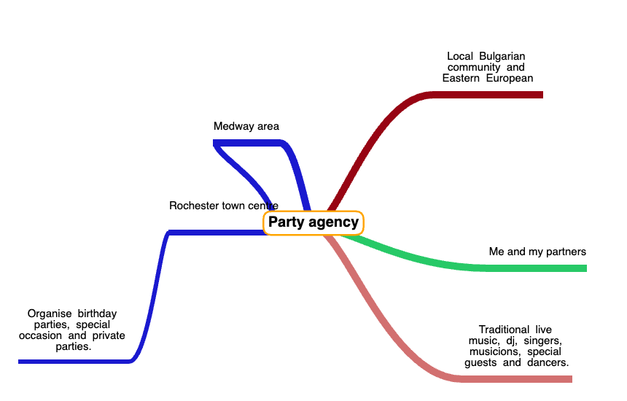

Appendix 1
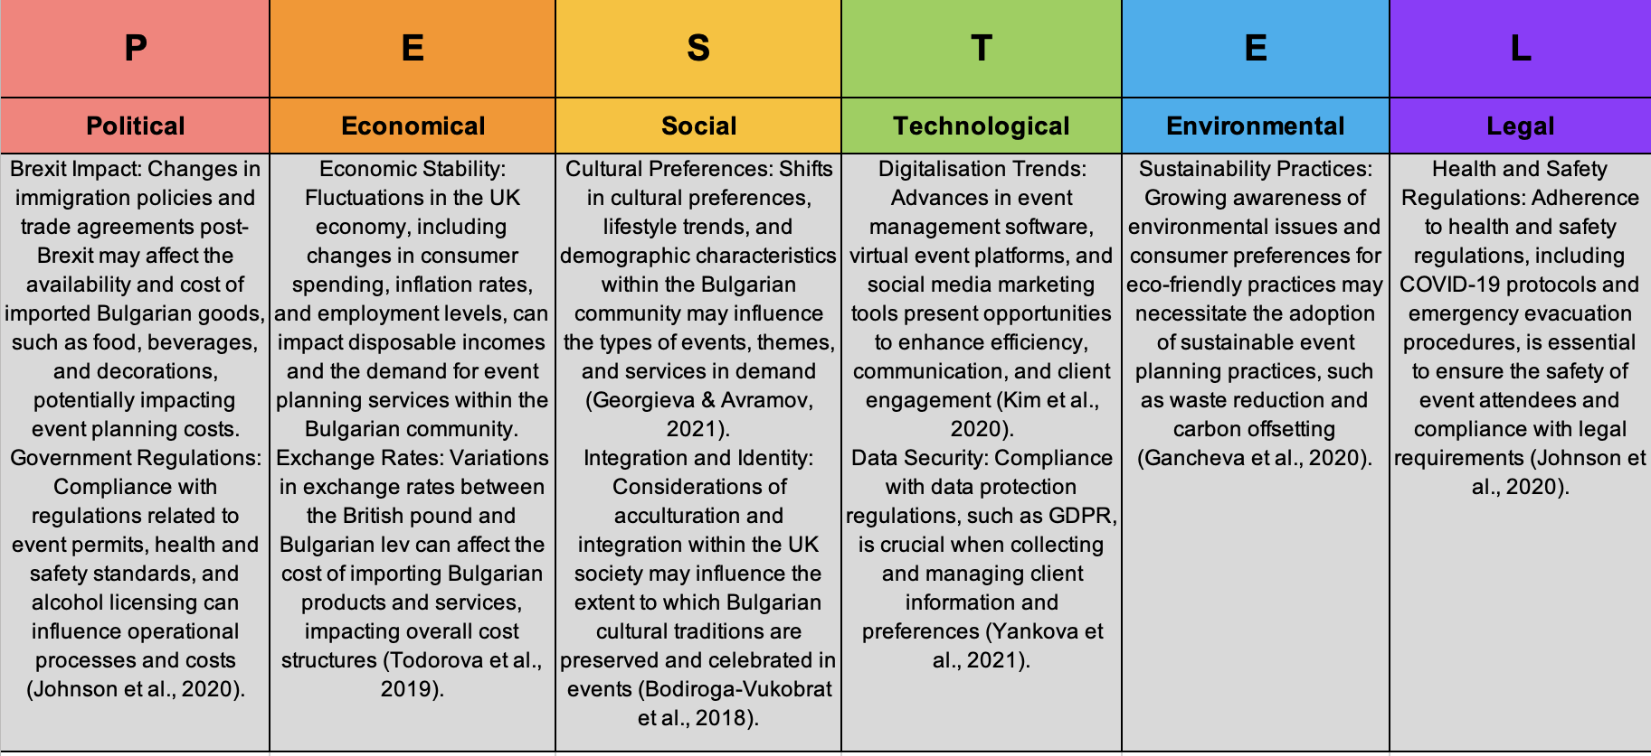

Appendix 2
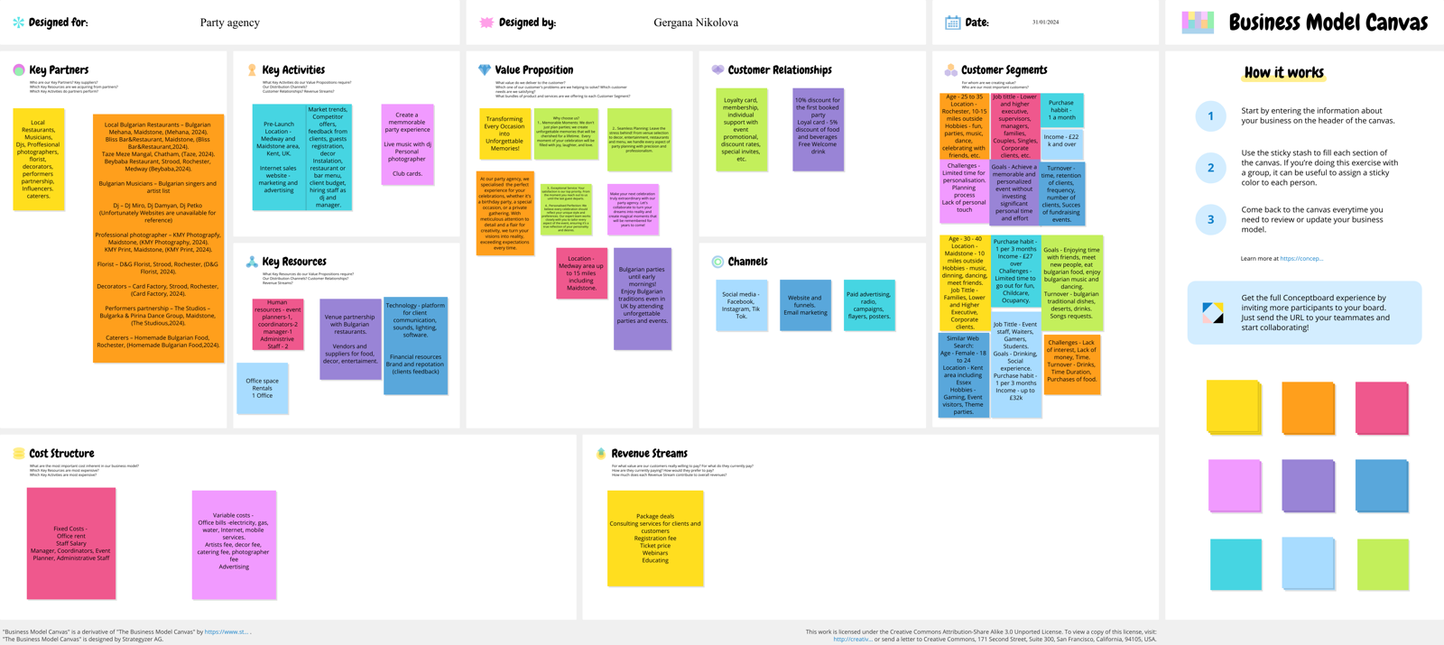

Appendix 3

Customer segments/  Search Type | Customer profile  1 | Customer profile  2 | Customer profile  3 | Customer profile  4
Customer segments/  Search Type | Similar Web Search  (Appendix 10) | BMC  (Appendix 2) | Organic Search | Direct search
Demographics | Age 25-34 | Age 25-34 | Bulgarians 24-34 | Adults over 40 age
Location | UK | Rochester, Kent, UK | Medway, Kent, UK | Maidstone, Kent, UK
Hobbies | Internet tools | Music and Party | Dance, Music, Party | Traveller
Job Title | Software Engineer | Full time employees,  lower executives | Full Time employees | Higher Executive
Purchase habit | 1 per 3 months | 1 p/m | 1 per 3 months | 1 per 3 months
Challenges | Art and Entertainment | Limited time prioritisation | Occupancy | Family
Goals | Computer and Electronics | Friendships,  Personal Development | Friendship,  Enjoy Bulgarian culture | Dining and  social experience
Turnover | Food and Beverages | Time | Bulgarian Traditions | Luxury Cuisine
Income | £49k - £50k | £22k - £25k | £25k - £32k | £40 000 - £50 000

Appendix 4
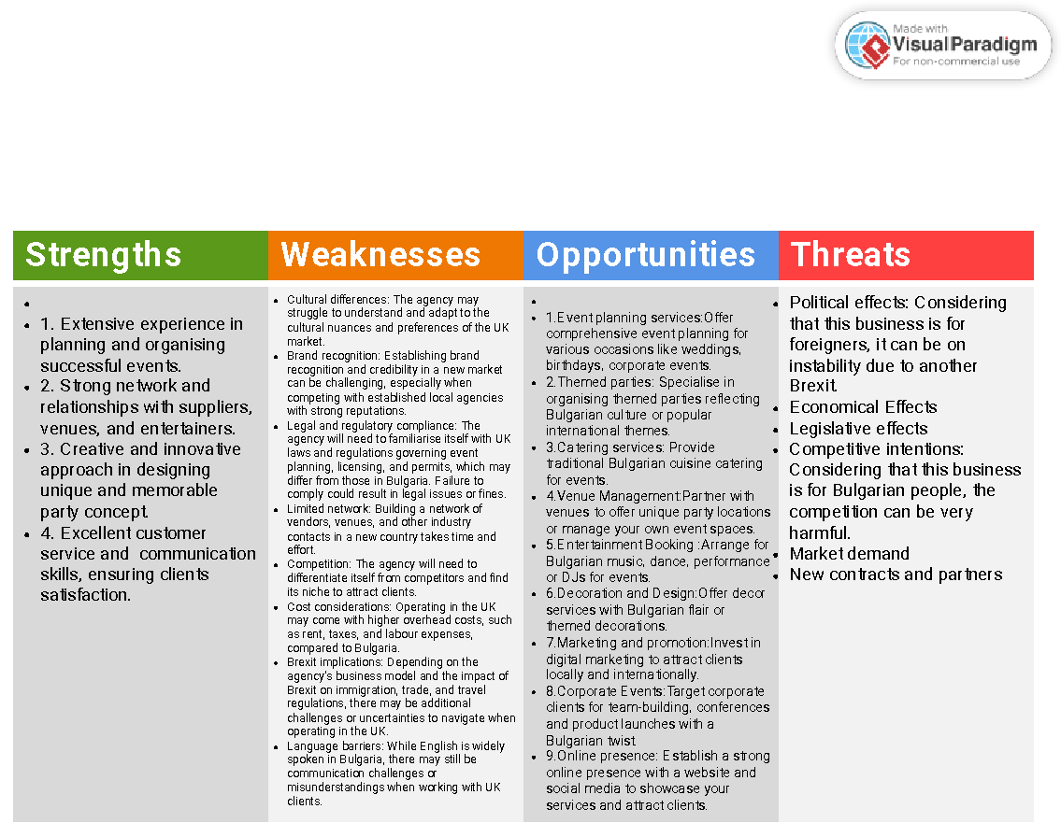

Appendix 5

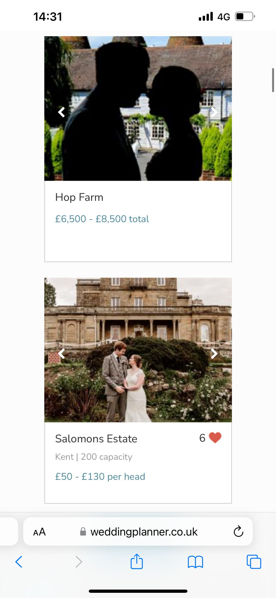
Appendix 6
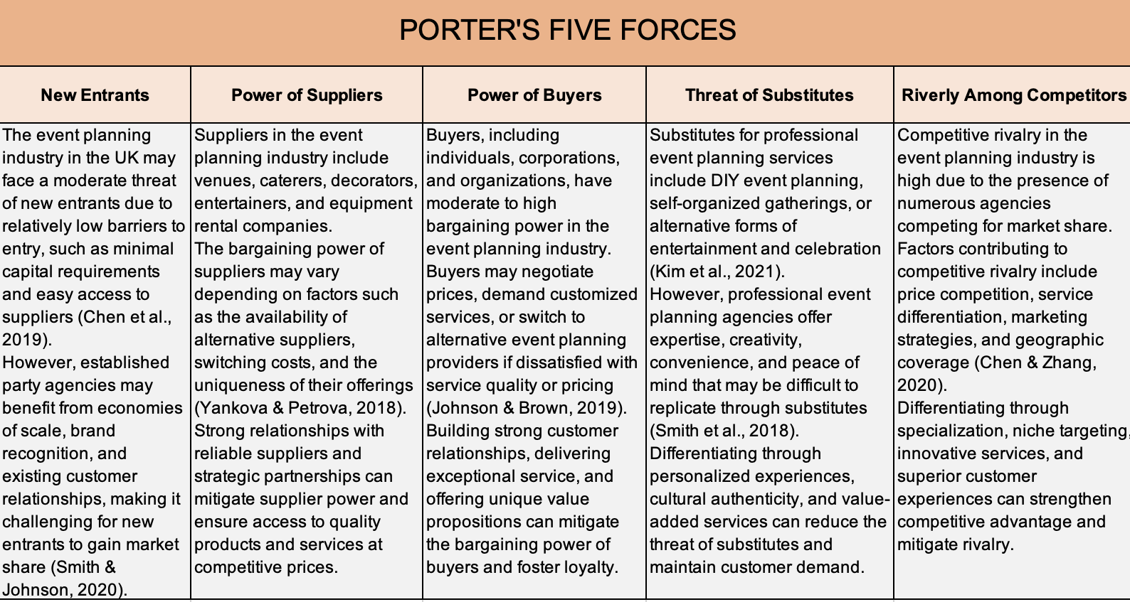
Appendix 7
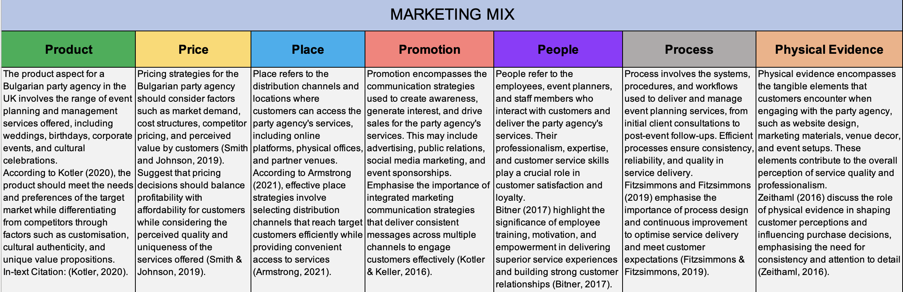
Appendix 8

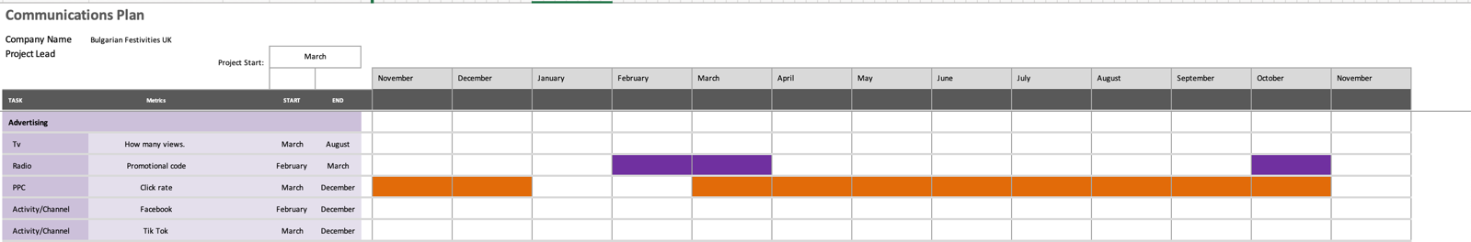

Appendix 9
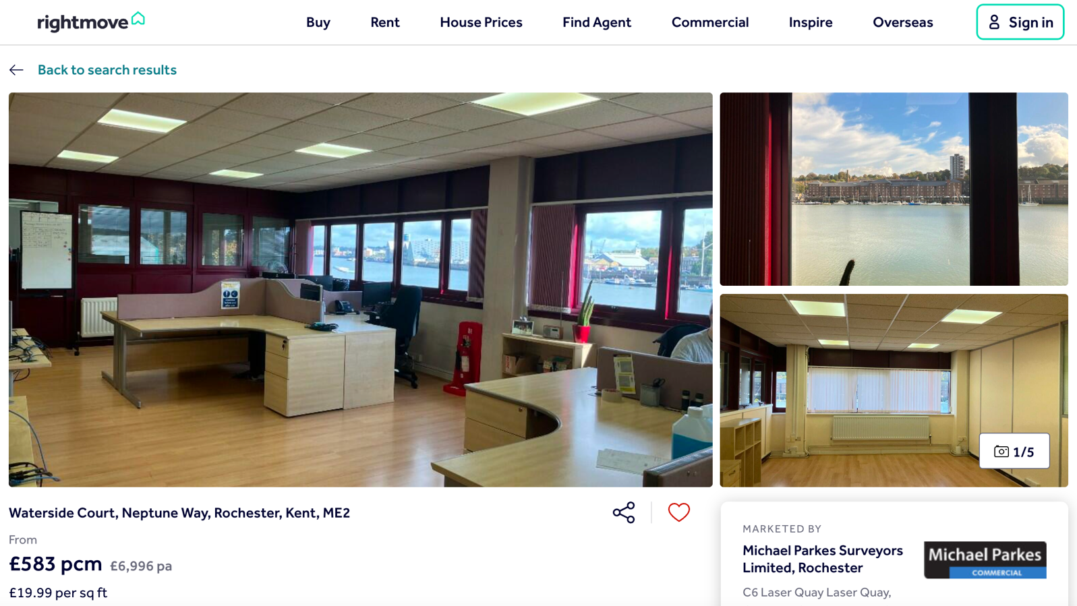
Appendix 10


27 Appendix
(An appendix comes at the end (after the reference list) of a report, research project, or dissertation and contains any additional information such as raw data, tables, and supporting information such as screenshots, and additional evidence. The information in the appendices is relevant but is too long or too detailed to include in the main body of your work.)

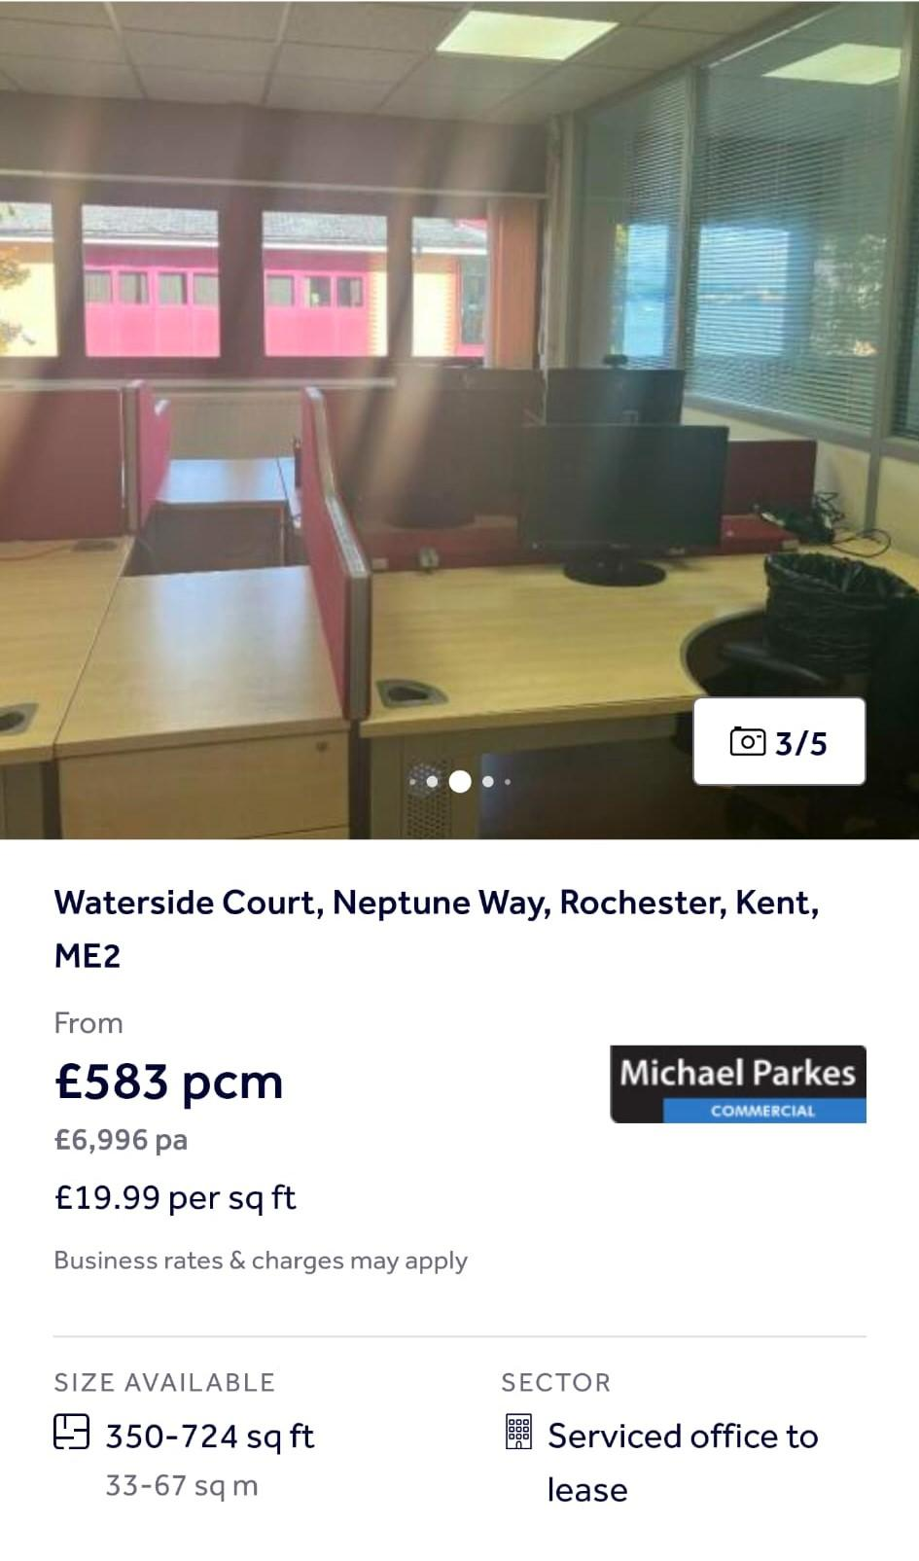
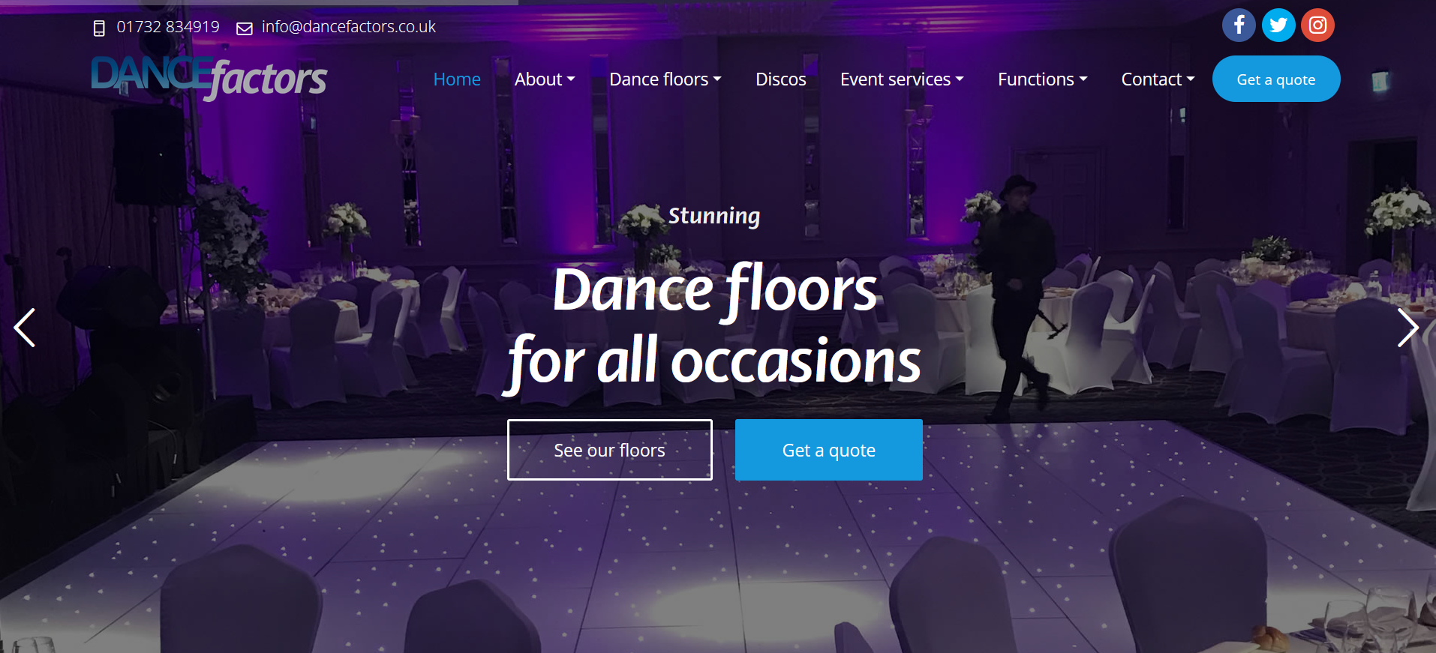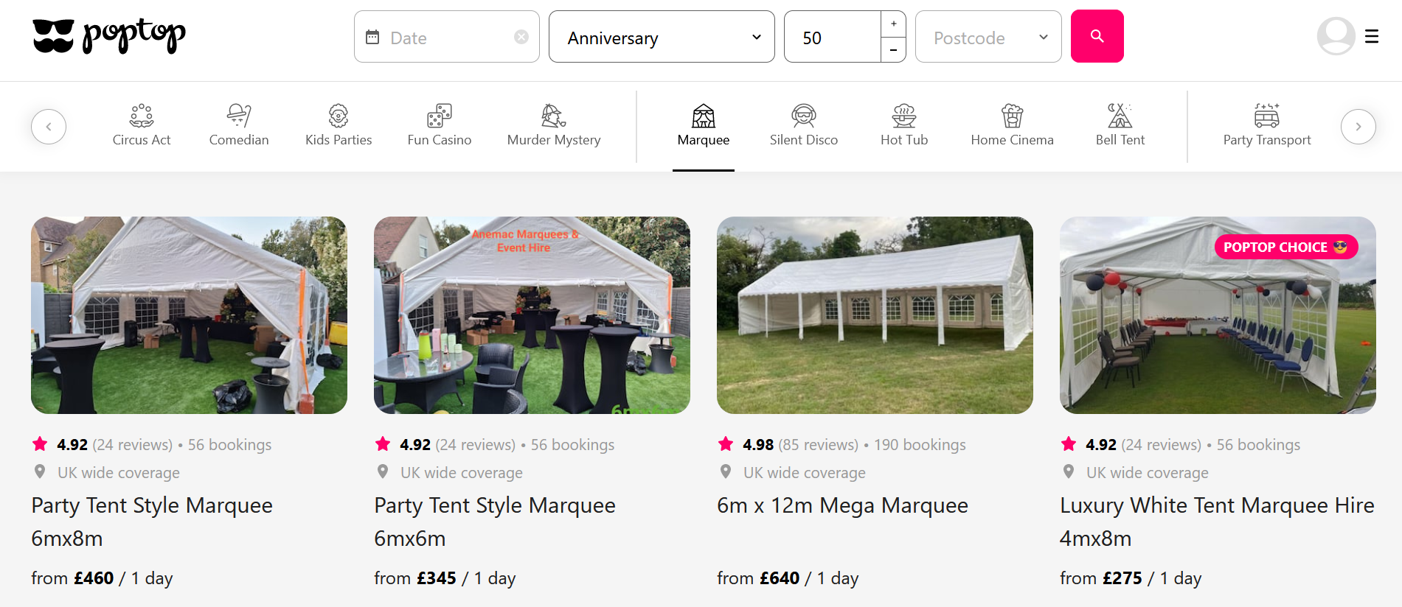

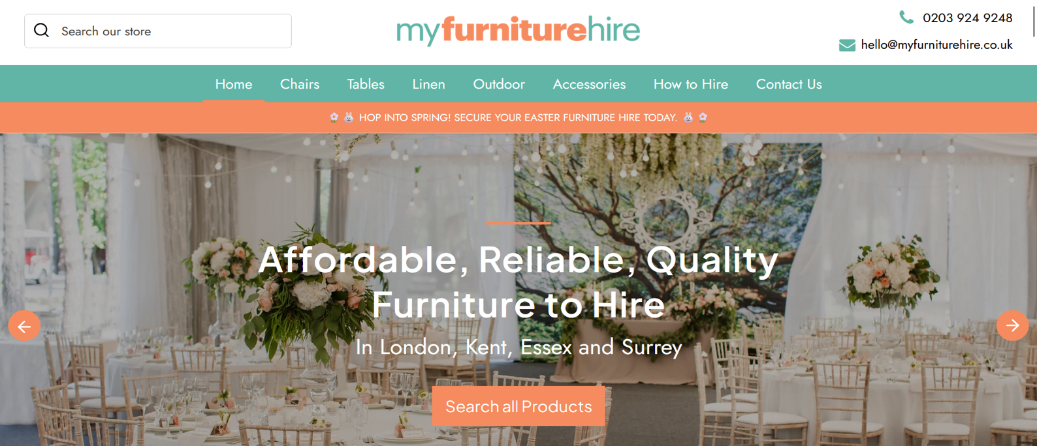





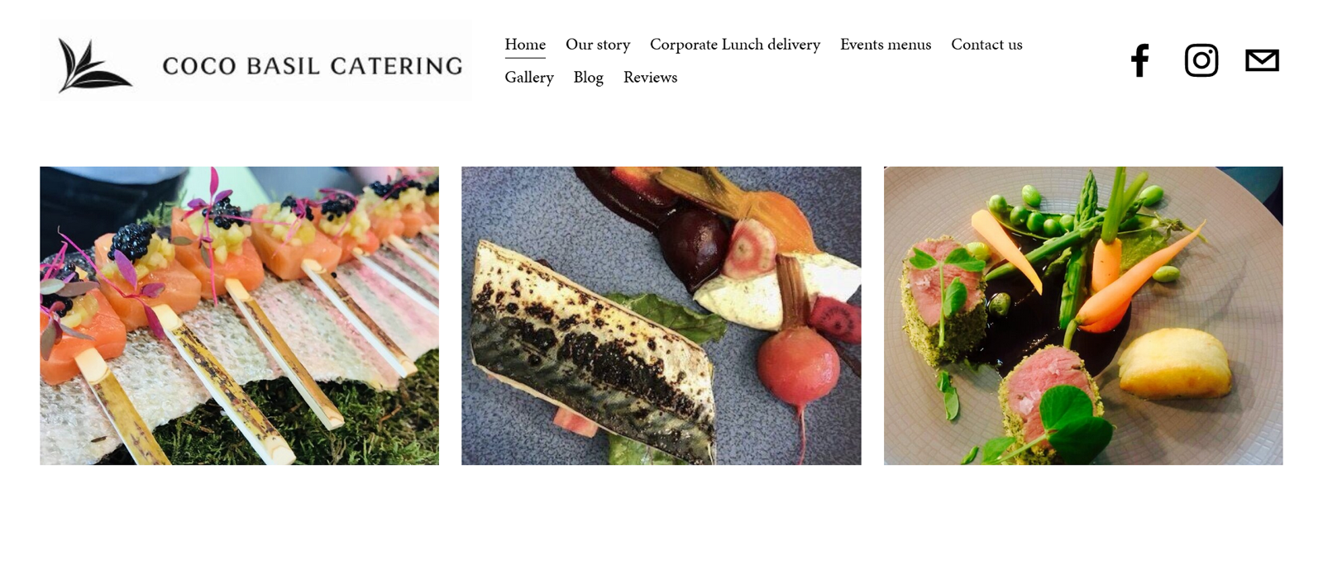
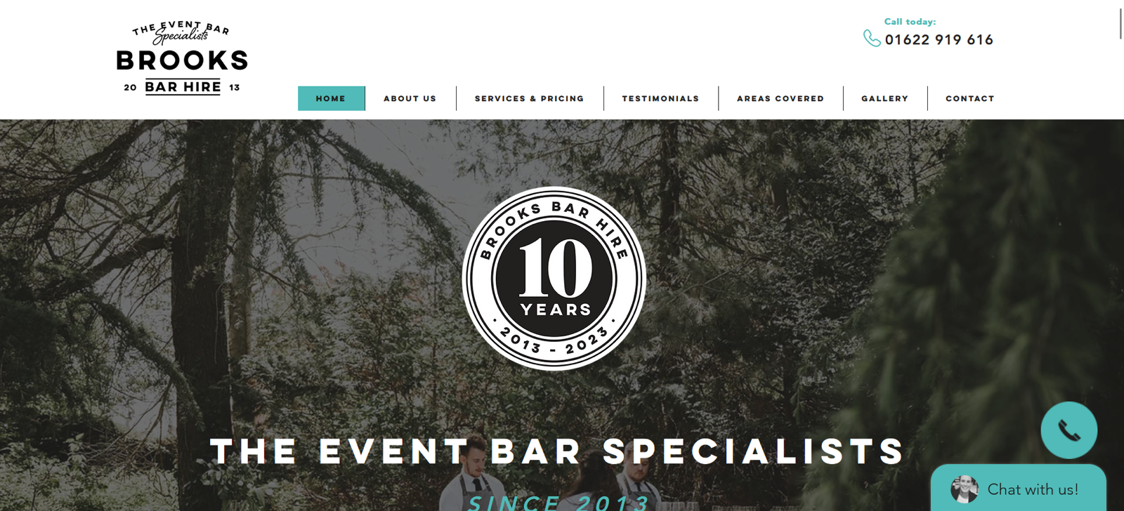

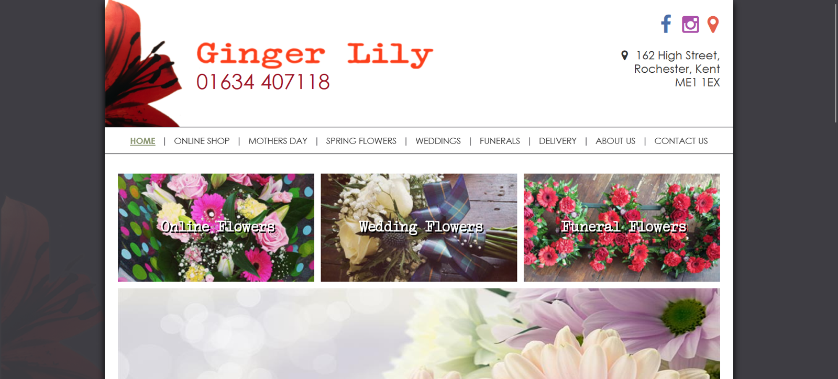

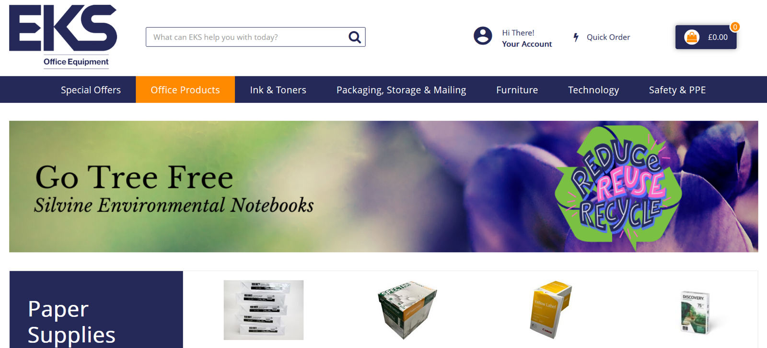

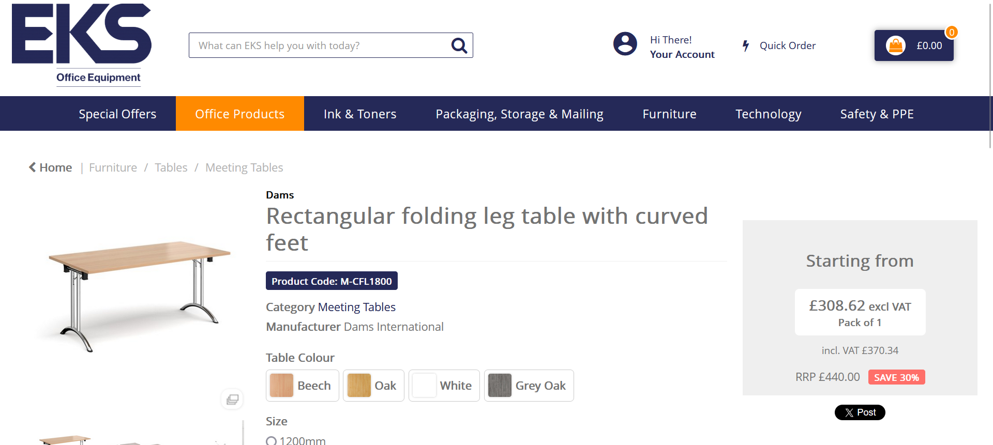

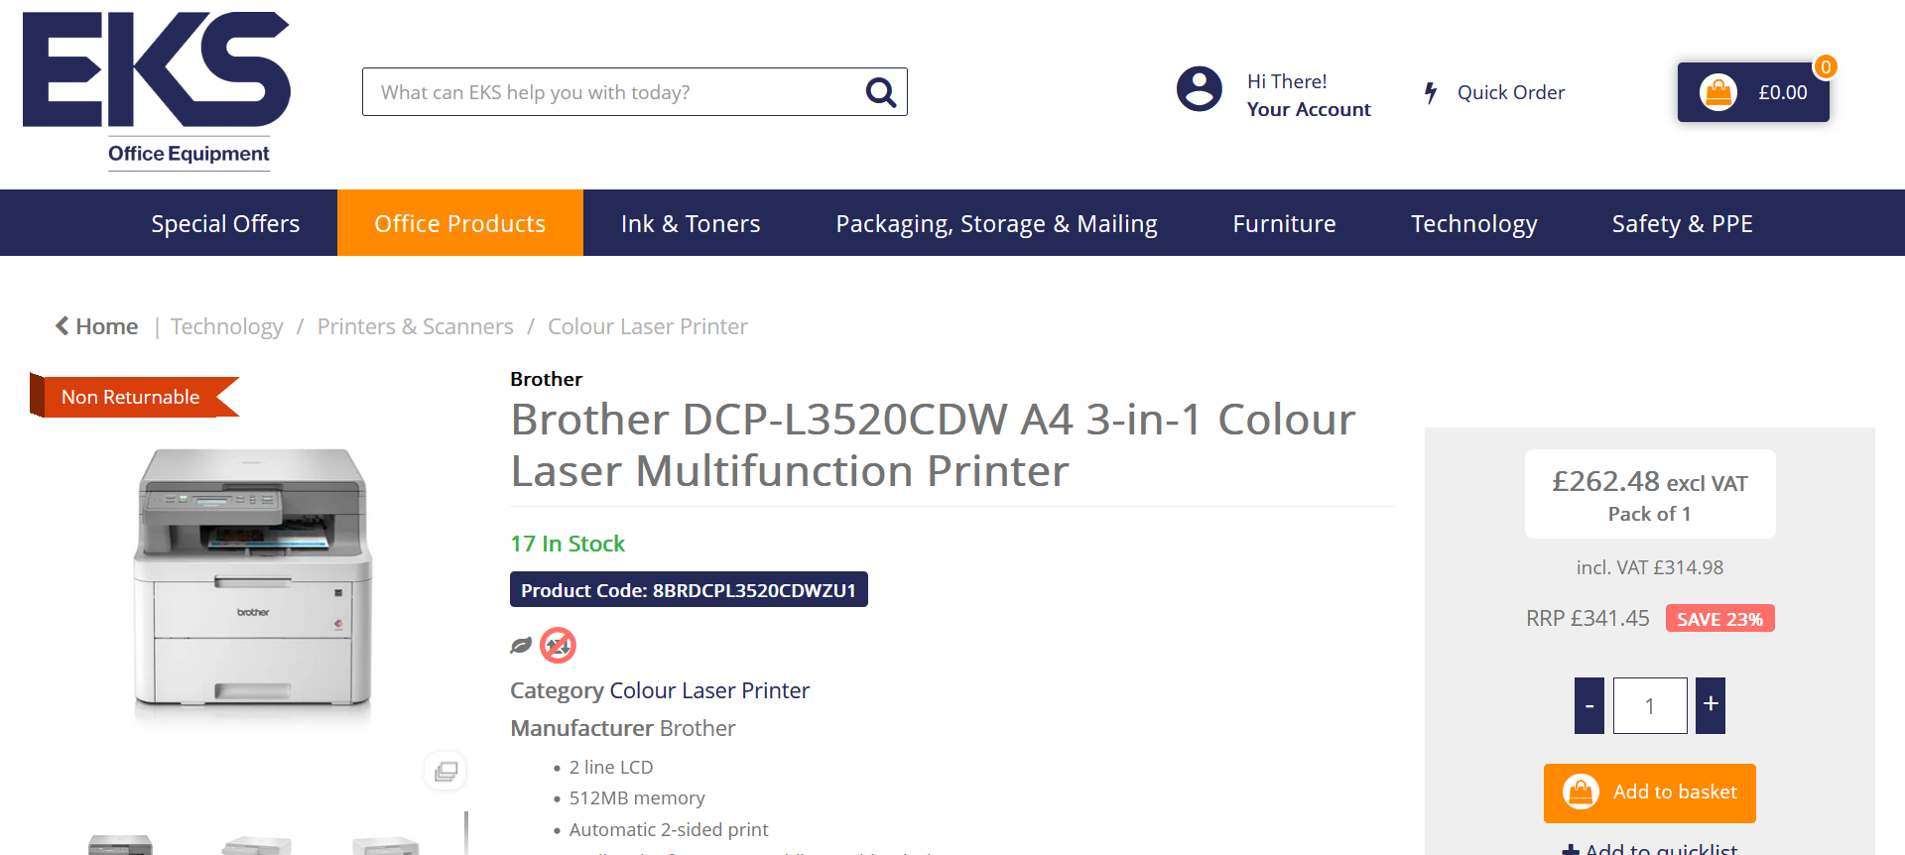

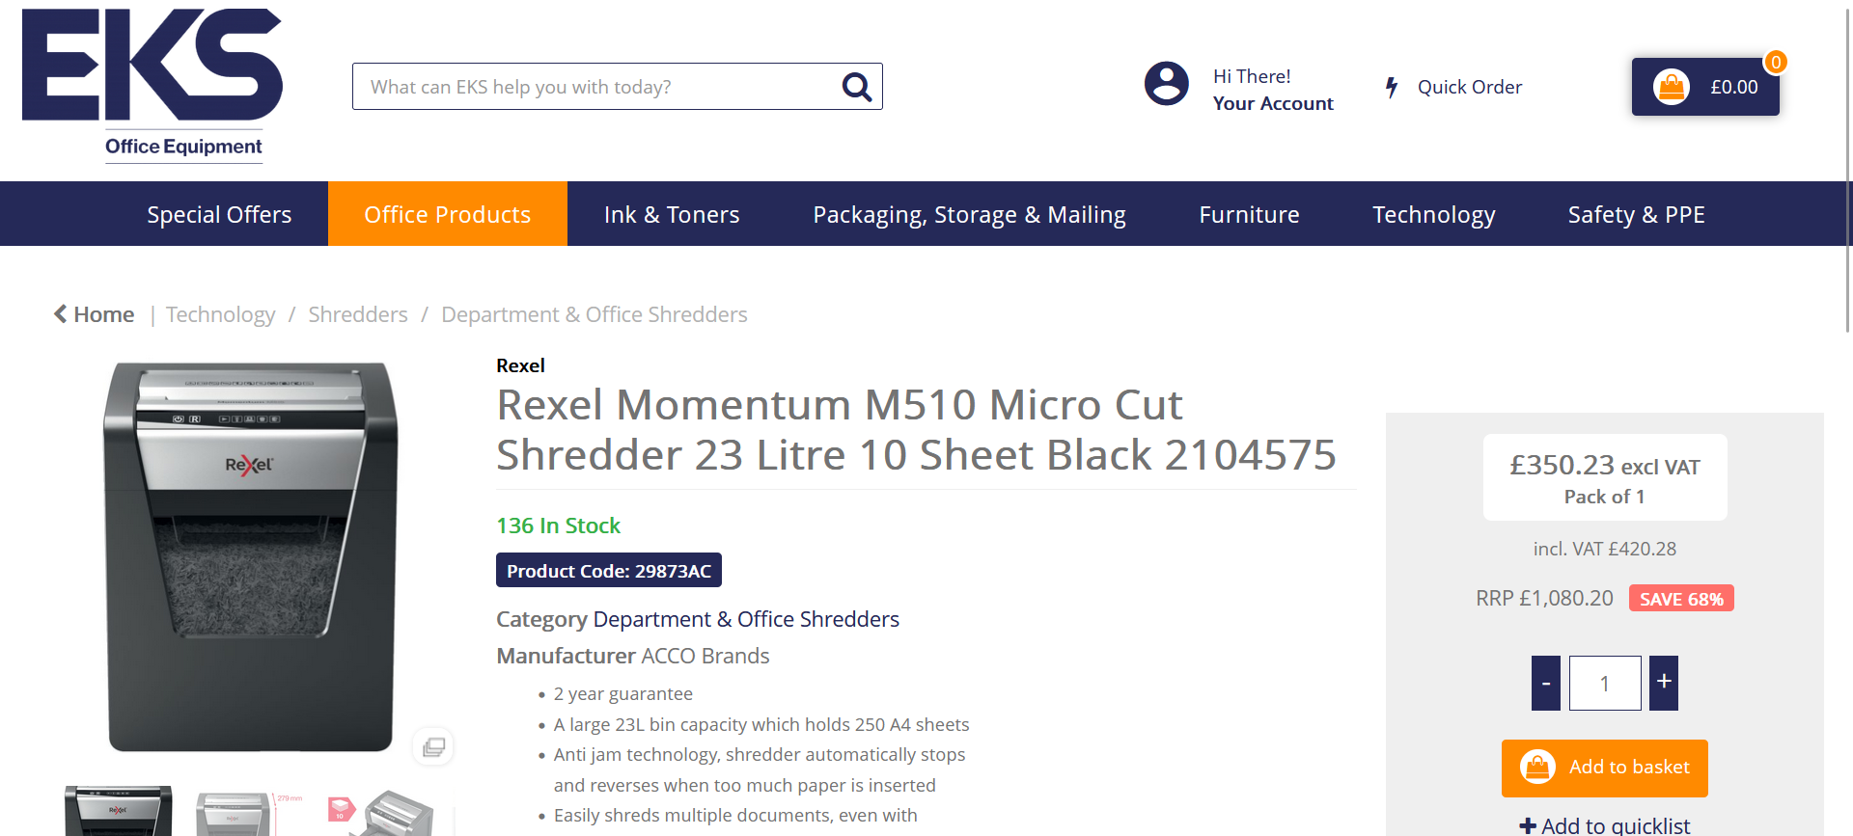

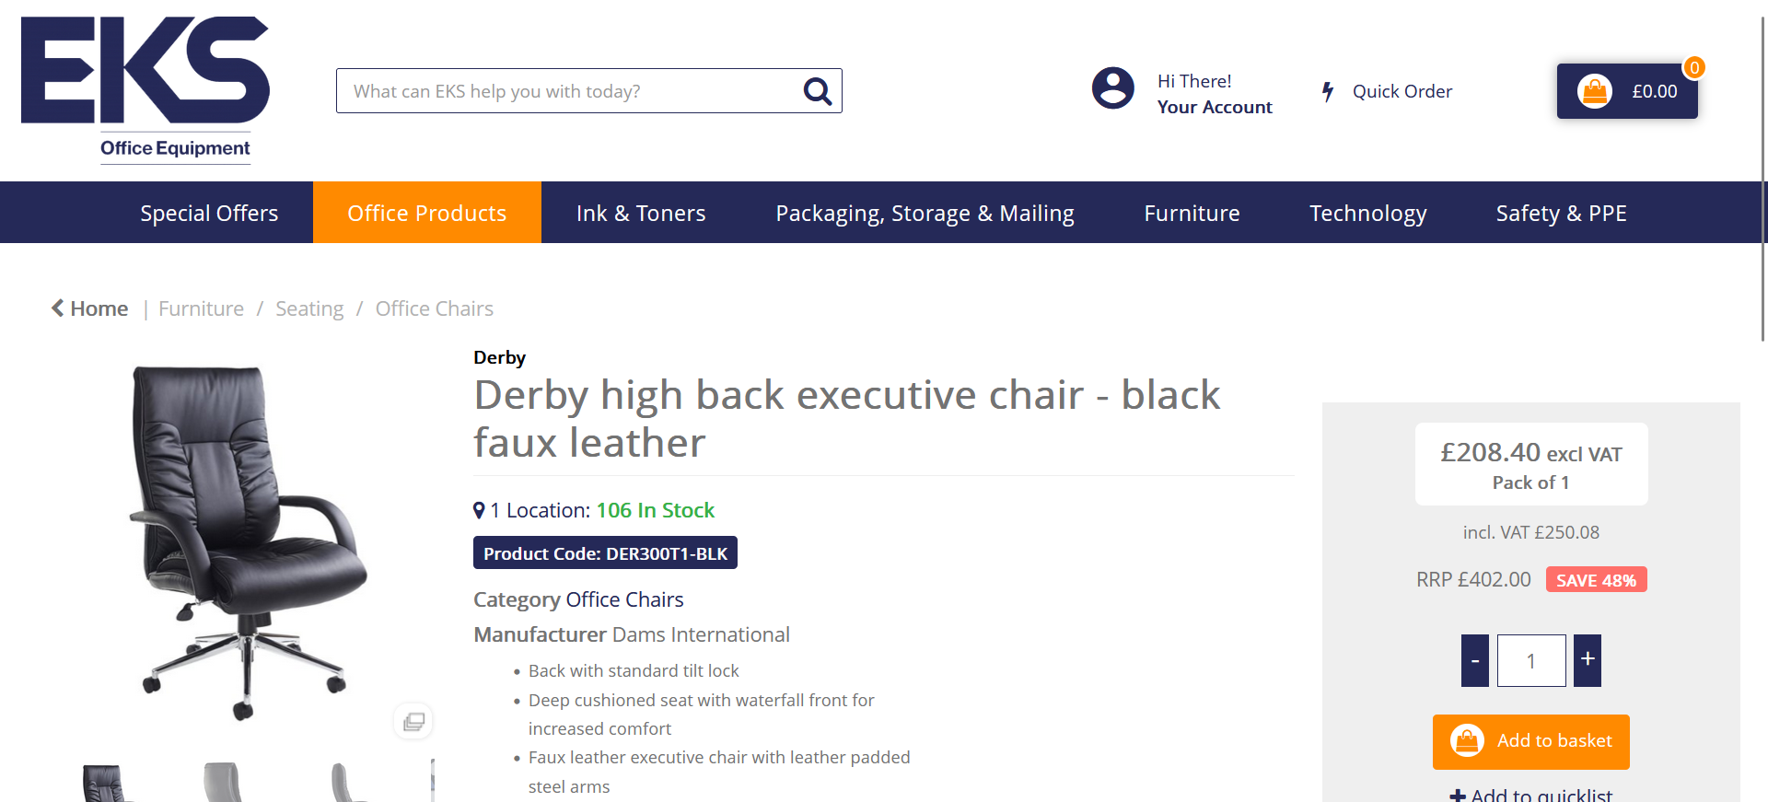

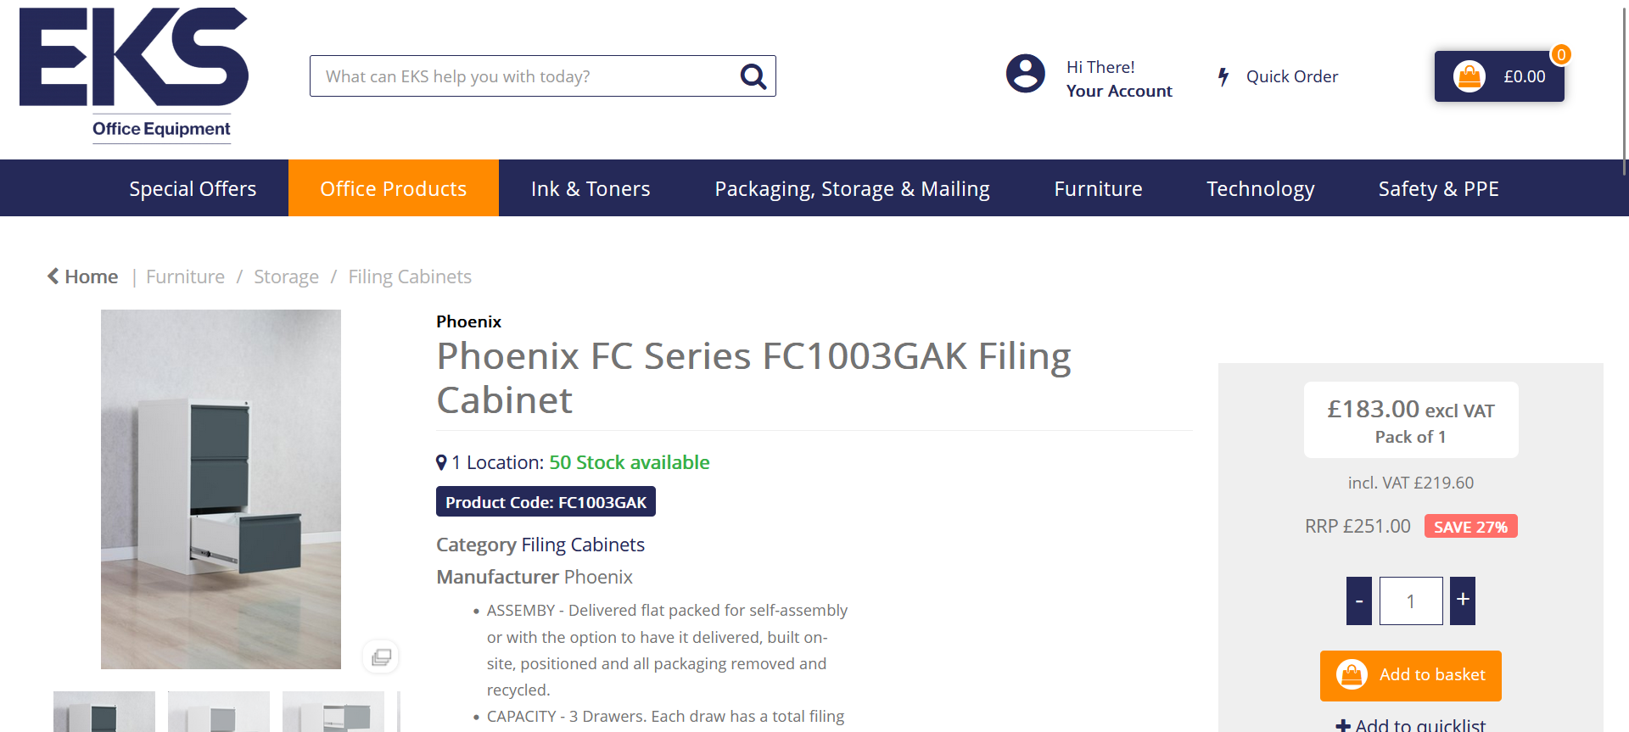

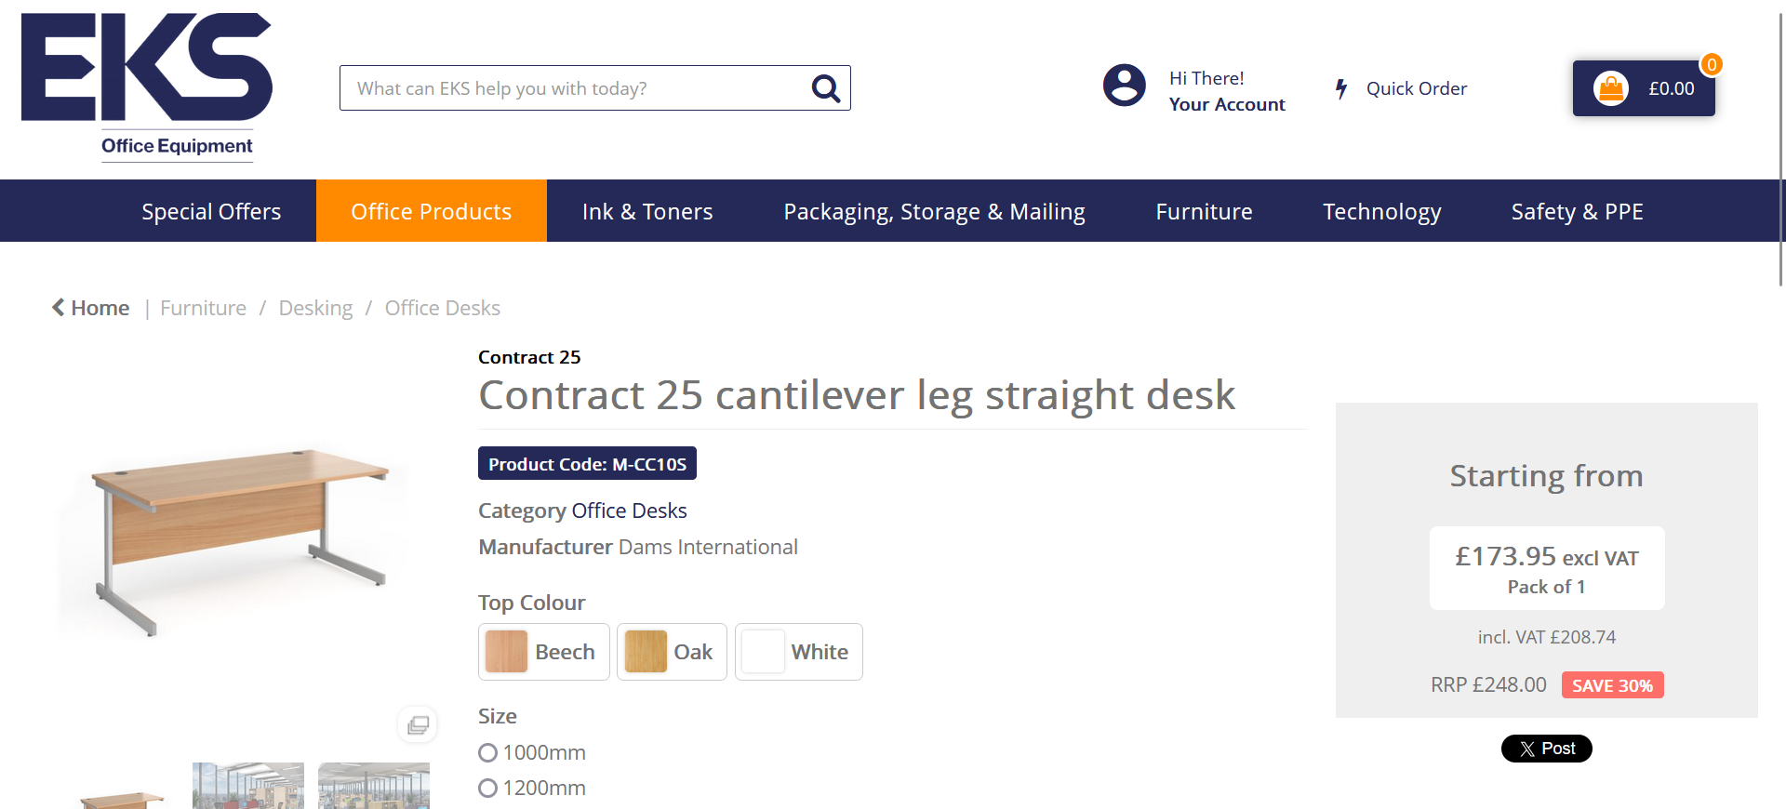

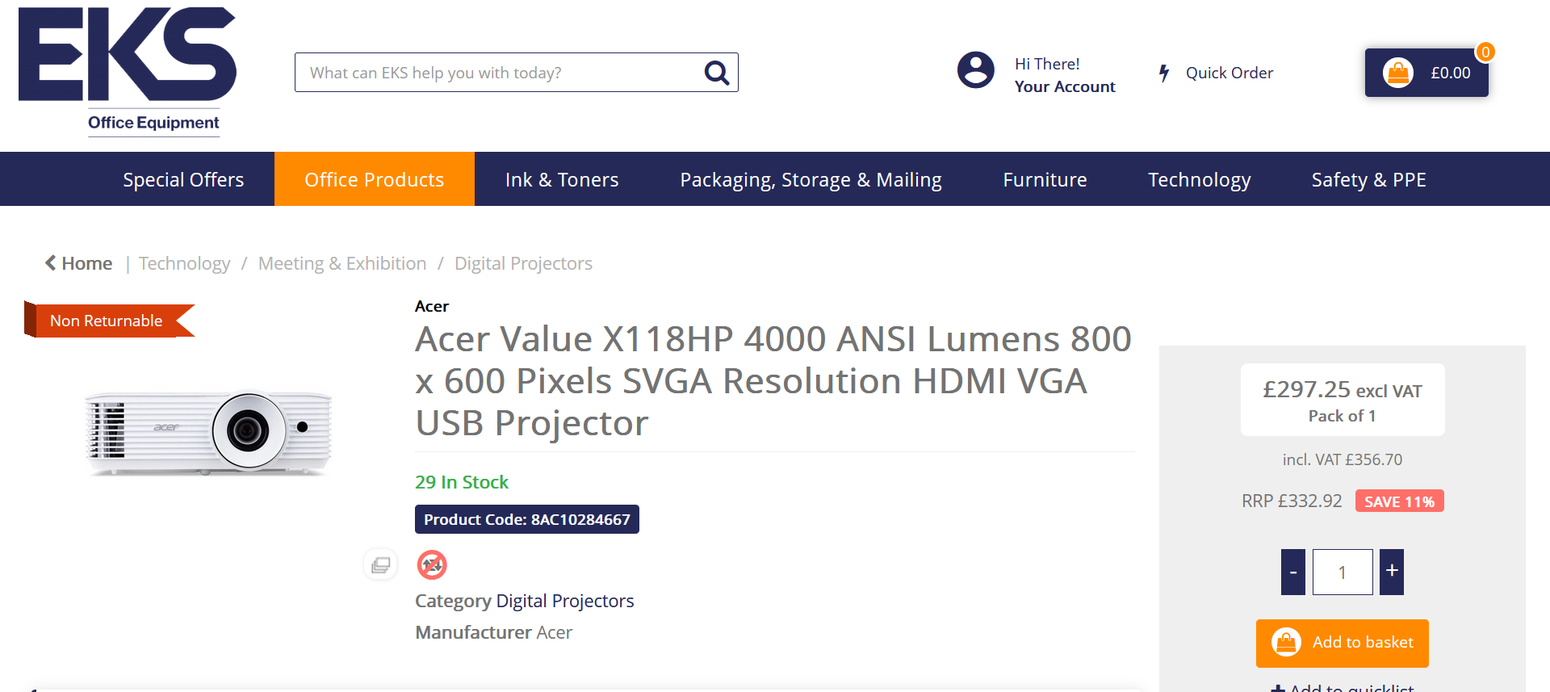

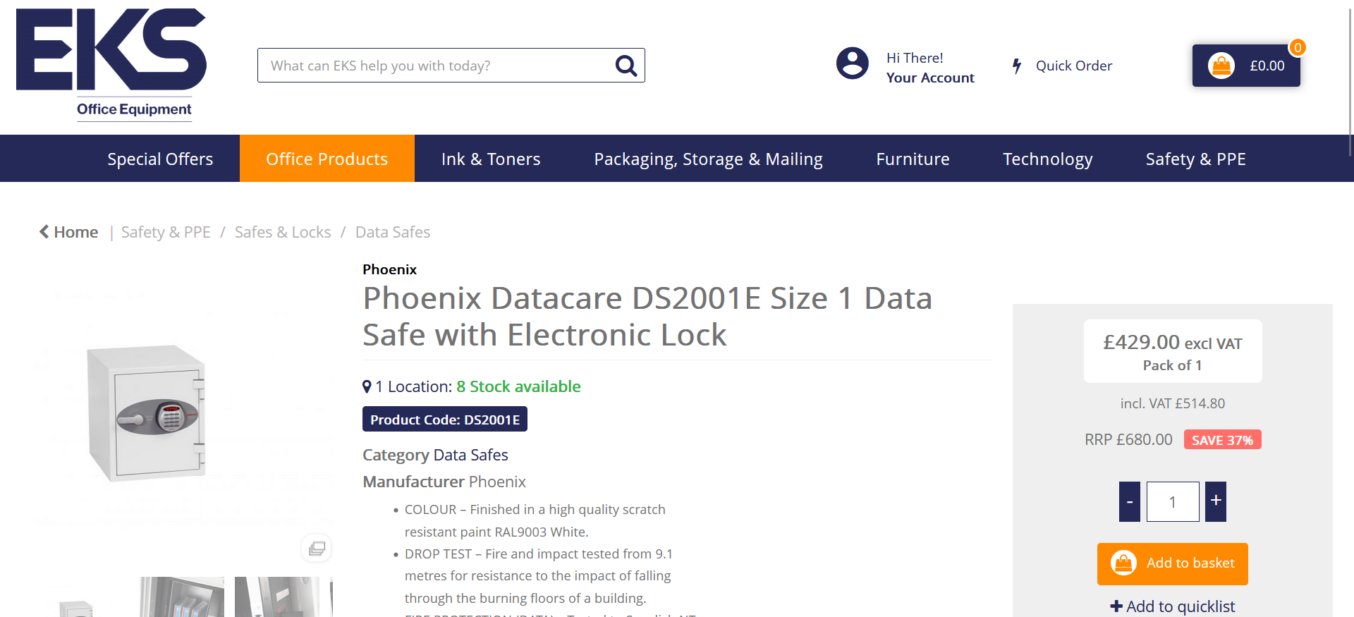

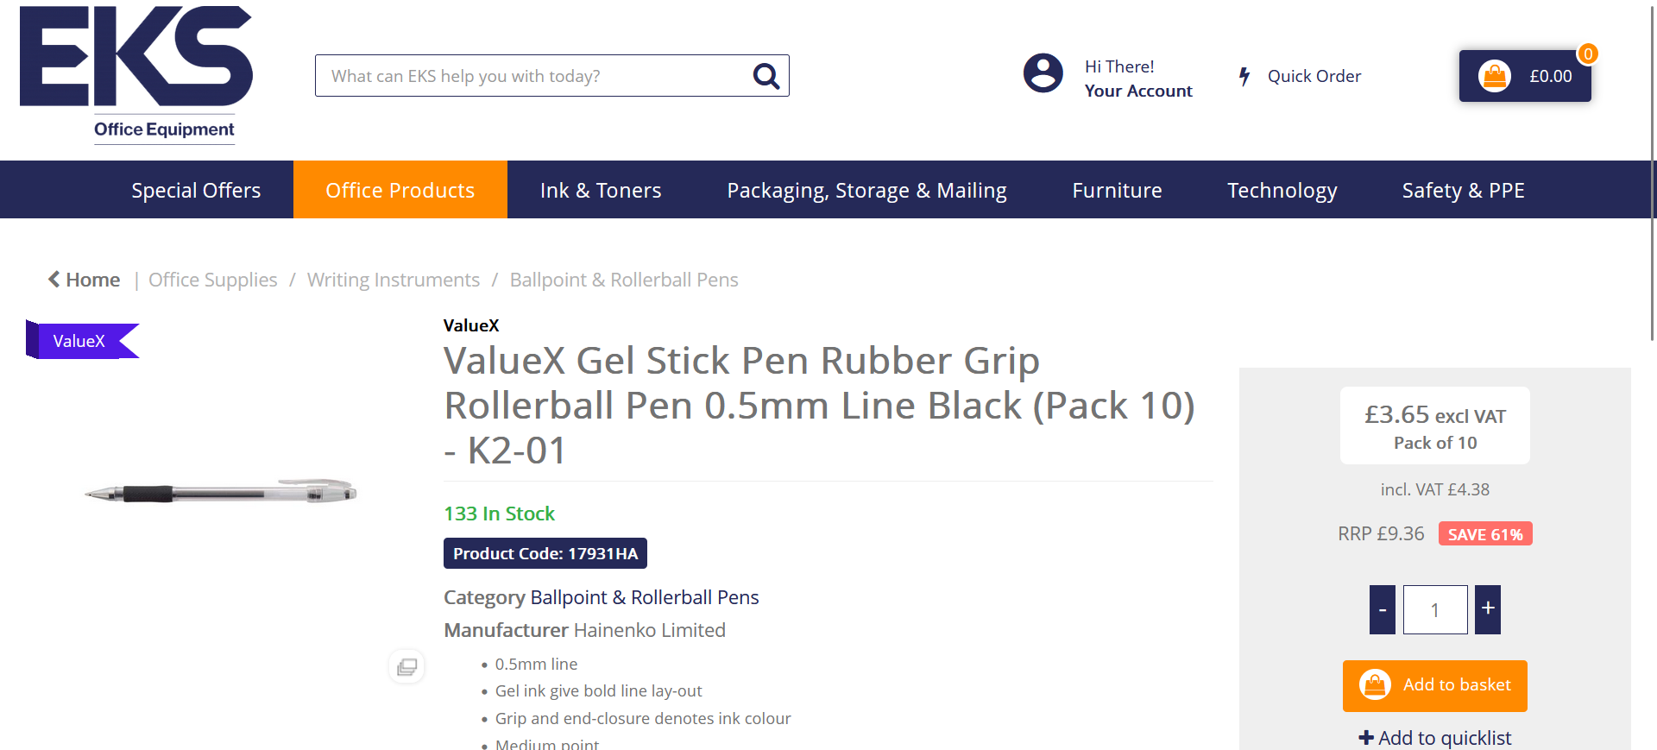

Presentation slides

