

Service Improvement Report: Governance and Escalation Failure in
Neonatal Care at the Countess of Chester Hospital
Student Name and ID: Utsav Patel (2431966)
Programme: MSc Public Health and Social Care in Practice
Module Title: Quality Assurance and Service Improvements (LCHS7006)
Assignment Title: Component 2 – Service Improvement Report
Lecturer: Shepherd Ziko

Contents
Introduction 2
Main Part 3
1. Root Cause Analysis and Governance Failure 3
2. Swiss Cheese Model: Interacting Safety Barrier Failures 5
Governance Layer 5
Escalation and Communication Layer 6
Clinical Supervision Layer 6
Cultural Layer 6
Regulatory Oversight Layer 7
3. Donabedian SPO Model and Fishbone Diagram 7
4. SWOT and Impact on Quality, Equity, and Efficiency 9
Impact on Quality 10
Impact on Equity 10
Impact on Efficiency 10
Recommendations 11
1. Establish Mandatory Escalation Protocols Using PDSA 11
2. Reinforce RCA and Incident Learning Through PDCA 12
3. Improve Operational Flow and Error Detection Using Lean 13
4. Reduce Escalation Variation Using Six Sigma 14
5. Build Psychological Safety and Leadership Transparency 15
Conclusion 15

Introduction

The Countess of Chester Hospital neonatal unit gained national attention after a series of unexplained deteriorations and deaths between 2015 and 2016, raising serious concerns about leadership, escalation, and governance (BBC, 2024). The conviction of nurse Lucy Letby for murdering seven infants and attempting to murder others showed that severe clinical harm occurred without timely organisational intervention (Thirlwall Inquiry, 2023).
(The Guardian, 2024)
These events exposed weaknesses in clinical supervision, incident learning, and safety monitoring, highlighting the need for structured governance, multidisciplinary review, real-time surveillance, and rapid escalation to prevent avoidable harm (Health Foundation, 2021). Continuous quality oversight is essential in neonatal units because patient fragility and rapid deterioration require constant vigilance and ongoing safety feedback (NHS England, 2023).
Component 1 analysed the Letby case and identified systemic leadership failures, weak escalation, delayed risk recognition, and organisational silencing of clinical concerns. It showed that repeated neonatal collapses, mortality deviations, and warning patterns were not escalated for multidisciplinary review or reported externally, despite consultant concerns (CQC, 2024). The presentation demonstrated that governance issues were structural and cultural, influencing escalation confidence, vigilance, and clinical supervision within neonatal care (The King’s Fund, 2023). Component 2 now extends this work through deeper analytical evaluation using formal safety frameworks, organisational theory, and quality improvement approaches. This shift reflects academic expectations to move from descriptive evidence toward critical, theory-driven analysis to understand how governance weaknesses shaped neonatal safety and patient outcomes (Health Foundation, 2021).
The central quality issue for Component 2 is governance and leadership failure, including weak escalation processes, delayed RCA, inadequate reporting, poor policy compliance, and suppression of clinical information (CQC, 2024). Governance is critical because it provides the structure for accountability, escalation, risk assessment, organisational learning, and transparency to protect patients (NHS England, 2023). When governance breaks down, warning signs are missed, supervision weakens, and regulatory action occurs too late, increasing preventable harm in neonatal settings (The King’s Fund, 2023). Focusing on governance failure also highlights how safety culture, communication, duty of candour, and organisational trust shape staff confidence in escalating concerns (Health Foundation, 2021).
The report applies structured analytical tools, including the Swiss Cheese Model to show how multiple safety barriers failed, Root Cause Analysis to identify systemic causes, the Ishikawa Diagram to map contributory factors, and the Donabedian model to link organisational structures with neonatal safety outcomes (Reason, 2000; Donabedian, 1988). A SWOT analysis further assesses strengths, risks, resource constraints, and governance challenges affecting escalation reliability (WHO, 2022). These frameworks support critical synthesis rather than description, highlighting organisational failure, transparency gaps, quality risks, and public-trust implications for NHS neonatal services. The section concludes with evidence-based improvement recommendations using PDSA, PDCA, Lean, and Six Sigma to strengthen leadership accountability, safety culture, escalation, and continuous learning (IHI, 2023).

Main Part

1. Root Cause Analysis and Governance Failure
Repeated neonatal collapses at the Countess of Chester Hospital required immediate incident investigation, yet RCA was not activated to assess emerging safety patterns or escalation gaps (Thirlwall Inquiry, 2023). RCA is designed to analyse system weaknesses rather than assign individual blame, examining risks across organisational, communication, supervision, and environmental levels (NHS England, 2022). Without early RCA, incidents were treated as isolated rather than pattern-based, reducing capacity to detect anomalies (Health Foundation, 2021). National policy requires sentinel neonatal events to undergo structured RCA, multidisciplinary review, and corrective planning, but leadership failed to implement these standards early in the crisis (CQC, 2024).
The absence of RCA prolonged uncertainty, weakened accountability, and prevented systematic review of escalation pathways, data trends, and reporting processes (King’s Fund, 2023). Poor RCA also limited learning cycles, meaning repeated deterioration did not trigger governance escalation, policy revision, or resource reassessment despite ongoing clinical concern (Nuffield Trust, 2024).
Delayed RCA created major risk because neonatal deterioration is highly time-sensitive, and early analysis is needed to identify whether harm relates to monitoring gaps, escalation failure, environmental deficits, or human interference (WHO, 2022). Without RCA, consultant concerns were undocumented and unsupported by structured safety mapping, increasing misinterpretation and internal conflict (NHS Improvement, 2023). RCA absence also reduced regulatory visibility, as external bodies require documented analysis of repeated harm before statutory intervention (CQC, 2024).
Governance failure was therefore a core driver because the organisation lacked investigative rigour and learning structures when mortality deviation emerged in a specialist neonatal setting (Health Foundation, 2021). RCA neglect intensified distrust between clinicians and senior managers, weakening communication, emotional stability, and collaborative problem-solving (King’s Fund, 2023). The Letby case shows RCA is not only a post-incident tool but a continuous responsibility for early risk recognition, timely intervention, transparent escalation, and shared situational awareness (NHS England, 2022).

2. Swiss Cheese Model: Interacting Safety Barrier Failures
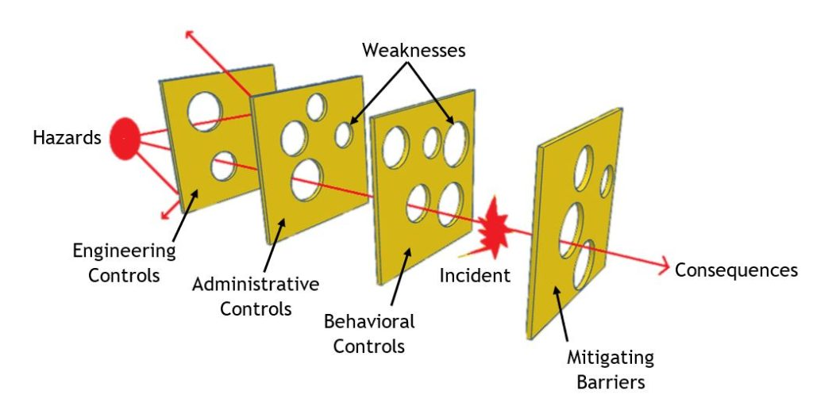
University of Michigan SAFEChE (2025) explains that the Swiss Cheese Model provides a robust lens to understand how multiple protective layers failed simultaneously across leadership, governance, escalation pathways, and regulatory oversight at the Countess of Chester Hospital (Reason, 2000). Neonatal units require multilayered defences, including risk-reporting procedures, escalation triggers, multidisciplinary supervision, communication channels, and external oversight, to ensure early recognition of abnormal clinical patterns (BMJ Quality and Safety, 2020). In this case, each layer contained latent weaknesses: governance was unresponsive, escalation lacked authority, internal culture discouraged questioning, mortality review mechanisms were inconsistent, and regulatory thresholds were not activated until substantial harm had occurred (Thirlwall Inquiry, 2023).

Governance Layer
Executive leaders failed to interpret mortality deviation as a serious incident requiring structured escalation, undermining the protective function of board-level safety assurance (Nuffield Trust, 2024). Consultant clinicians raised written concerns, but leadership interpreted these reports as disruptive rather than as valid risk indicators, diminishing escalation legitimacy and organisational trust (King’s Fund, 2023). Governance in neonatal settings must embed proactive safety intelligence systems capable of triangulating clinical data, concern patterns, and professional judgement, yet no such systems were used in early monitoring (NHS England, 2023).

Escalation and Communication Layer
Escalation pathways are designed to enable immediate multidisciplinary review when repeated clinical deterioration occurs, but escalation authority was weakened because senior managers continually discouraged further reporting (CQC, 2024). Early escalation failures prevented real-time situational awareness and eliminated opportunities for shared risk evaluation among clinicians, data analysts, governance officers, and external advisors (Health Foundation, 2021).

Clinical Supervision Layer
Clinical supervision lacked independence and authority because managerial priorities superseded clinician judgement, allowing deteriorations to accumulate without transparent investigation or real-time data auditing (NHS Improvement, 2023). Neonatal supervision requires systematic review cycles to evaluate observation, medication, staffing conditions, escalation triggers, and unit-level alarm indicators, yet these processes were not consistently applied (WHO, 2022).

Cultural Layer
Cultural silencing emerged when clinicians felt intimidated or discouraged from escalating concerns, increasing the likelihood that multiple risk signals remained hidden within the organisation rather than shared for early intervention (King’s Fund, 2023). Effective safety culture encourages transparent escalation and psychological safety; however, the internal environment was characterised by defensiveness and conflict, undermining patient protection (Health Foundation, 2021).

Regulatory Oversight Layer
External regulators were unaware of neonatal mortality trends because internal escalation did not reach statutory reporting levels, thereby weakening regulatory buffers and delaying independent scrutiny (CQC, 2024). The Swiss Cheese Model illustrates that catastrophic harm emerged not solely due to criminal behaviour but due to simultaneous breakdowns in organisational defences (Reason, 2000).

3. Donabedian SPO Model and Fishbone Diagram
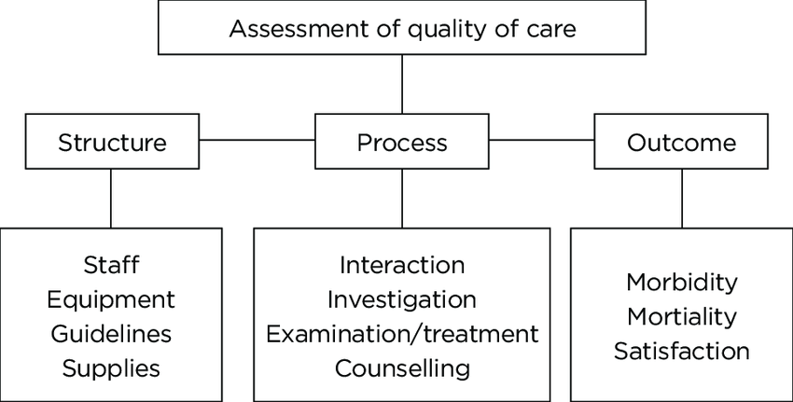

According to Donabedian (1988), The Donabedian Structure–Process–Outcome (SPO) model demonstrates that poor organisational structures and weak clinical processes directly contributed to harmful neonatal outcomes (Donabedian, 1988). Structural deficiencies included lack of governance transparency, insufficient incident data auditing, inadequate escalation procedures, and inconsistent clinical supervision standards across neonatal care (NHS England, 2023). When structure is compromised, clinical processes-such as escalation, mortality review, RCA activation, and multidisciplinary assessment-become unreliable, increasing the likelihood of repeated harm (Health Foundation, 2021). Neonatal processes must incorporate rigorous observation, safe staffing patterns, clinical documentation, medication review, and multidisciplinary decision-making; however, systemic breakdown diminished operational reliability (WHO, 2022).
Outcome consequences were severe, including repeated avoidable harm, loss of public trust, downgrading of neonatal care capacity, reputational damage, and legal intervention due to prolonged governance inaction (BBC, 2024). The SPO model confirms that neonatal outcomes were not random but the predictable consequences of weak structures and flawed safety processes (King’s Fund, 2023). Leadership accountability, incident transparency, RCA learning cycles, and regulatory escalation were missing structural elements that would normally prevent repeated unsafe events in neonatal settings (NHS Improvement, 2023). 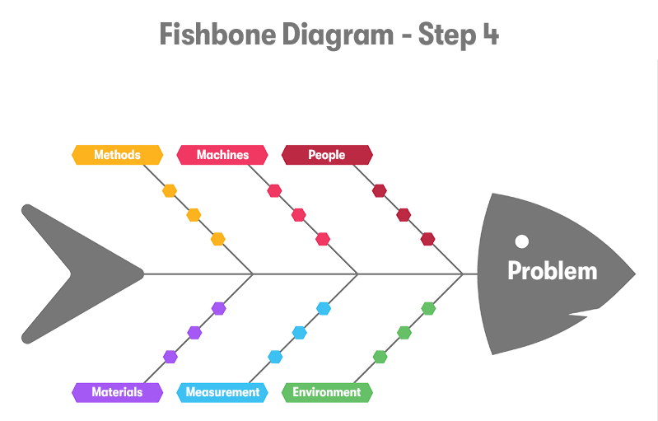
Purple Griffon (2024) describes the fishbone diagram enables multidimensional analysis of contributory factors: People, Policies, Processes, Environment, Technology, and Culture (Purple Griffon, 2024). Under People, leadership response lacked authority, clinical escalation was dismissed, and whistle-blowers experienced marginalisation, weakening trust and organisational cohesion (Nuffield Trust, 2024). Under Policies, Duty of Candour and Freedom to Speak Up standards were not embedded, creating policy non-compliance that enabled delayed risk disclosure (CQC, 2024). Under Processes, absence of RCA, inconsistent mortality review cycles, weak incident auditing, and fragmented escalation made it impossible to detect abnormal patterns early (Health Foundation, 2021).
Under Environment, neonatal units experienced workload pressure, high dependency demand, and limited interprofessional communication structures, increasing complexity without commensurate monitoring (WHO, 2022). Under Technology, lack of digital surveillance and electronic anomaly detection removed opportunities for automated early-warning analysis and escalation (NHS England, 2023). Finally, under Culture, psychological safety was weak, clinicians feared managerial repercussions, and leadership mistrust generated unsafe silence rather than rapid escalation (King’s Fund, 2023). The Fishbone Diagram demonstrates that neonatal harm was systemic, multifactorial, and reinforced across interdependent organisational elements.

4. SWOT and Impact on Quality, Equity, and Efficiency
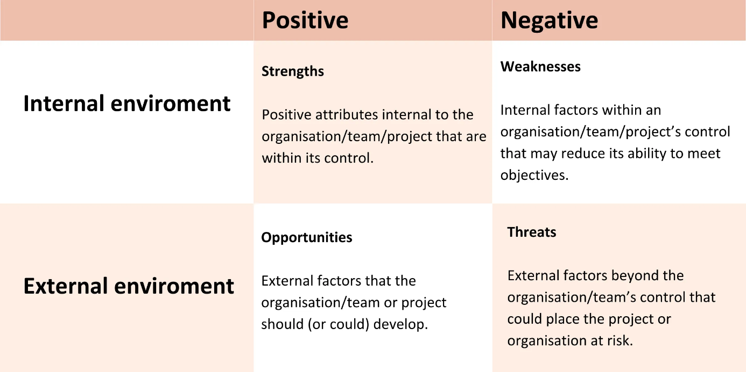

Whāraurau (2024) explains that a SWOT analysis highlights strengths, weaknesses, opportunities, and threats affecting neonatal governance. Strengths included highly trained neonatal clinicians capable of early pattern recognition, indicating professional vigilance and clinical expertise (WHO, 2022). Weaknesses included delayed RCA, fragmented escalation, defensive leadership, inconsistent mortality review, limited digital surveillance, and cultural silencing (NHS England, 2023). Opportunities included embedding structured RCA frameworks, integrating digital incident dashboards, improving clinical supervision governance, strengthening regulator collaboration, and establishing transparent escalation algorithms (Health Foundation, 2021). Threats included reputational harm, legal accountability, organisational instability, loss of neonatal commissioning confidence, and long-term erosion of public trust (BBC, 2024).

Impact on Quality
Quality deteriorated because unsafe supervision, poor escalation, and lack of learning cycles allowed repeated harm without effective identification or resolution (CQC, 2024). Neonatal quality requires structured monitoring, comprehensive RCA, transparent communication, and clinical vigilance; absence of these interventions compromised patient safety (NHS Improvement, 2023).

Impact on Equity
Equity was compromised because neonatal families were denied urgent transparency under the Duty of Candour, and clinicians lacked support to express escalation concerns openly (The King’s Fund, 2023). Psychological inequity also emerged because whistle-blowers felt marginalised rather than protected (Nuffield Trust, 2024). Neonatal equity requires consistent safety protections independent of managerial preference, yet governance gaps created unequal protection and delayed justice (Health Foundation, 2021).

Impact on Efficiency
Efficiency declined because prolonged investigations, delayed regulatory intervention, ward disruption, staffing anxiety, and escalating operational uncertainty increased legal costs and organisational instability (BBC, 2024). Efficient neonatal services depend on timely escalation, rapid data analysis, shared clinical learning cycles, and transparent accountability structures, all of which were absent (NHS England, 2023). Organisational inefficiency became compounded when internal mistrust increased turnover, degraded collaboration, and disrupted service continuity (King’s Fund, 2023).

Recommendations
Strengthening patient safety within neonatal care environments requires a comprehensive governance strategy supported by structured escalation pathways, transparent leadership accountability, and ongoing incident-learning systems to reduce the likelihood of repeated preventable harm (CQC, 2024). The Countess of Chester case indicates that clinical supervision, incident learning, and escalation must be operationalised using continuous improvement methodologies to protect high-risk neonatal patients (Health Foundation, 2021). Quality improvement frameworks such as PDSA, PDCA, Lean, and Six Sigma provide robust implementation pathways to restore escalation reliability, improve organisational learning, enhance transparency, and rebuild regulatory confidence in neonatal service delivery (NHS Improvement, 2023).

1. Establish Mandatory Escalation Protocols Using PDSA
A first recommendation is to implement a structured escalation algorithm supported by the PDSA (Plan–Do–Study–Act) cycle, ensuring that any repeated neonatal deterioration automatically triggers multidisciplinary review, safety mapping, and early regulatory liaison (IHI, 2023). Under the Plan phase, neonatal escalation criteria should be defined, including clinical triggers such as repeated collapses, unexpected mortality deviation, unresolved clinical anomalies, and expressed clinician concerns (NHS England, 2023). The Do phase should pilot escalation pathways in one neonatal ward to evaluate timeliness of reporting, leadership responsiveness, digital auditing, and multidisciplinary decision-making (Health Foundation, 2021).

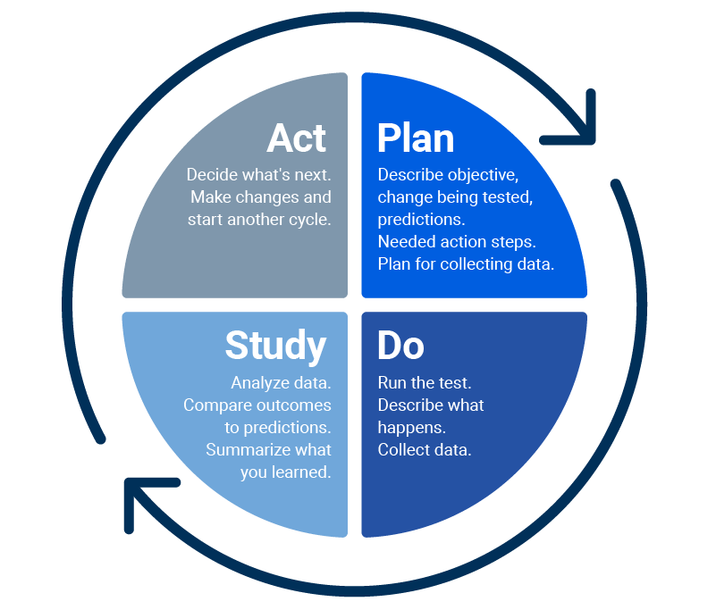
PDSA cycle helps test and refine changes in a process (Smartsheet, 2019).
The Study phase must evaluate escalation speed, communication clarity, early RCA activation rates, stakeholder participation, and documentation quality to identify process gaps (CQC, 2024). The Act phase should refine escalation rules, communication steps, and reporting triggers before full organisational rollout and regulator sharing (NHS Improvement, 2023). This recommendation ensures that escalation becomes automatic rather than dependent on hierarchical interpretation, enabling early surveillance, rapid risk recognition, and transparent safety intelligence (The King’s Fund, 2023).

2. Reinforce RCA and Incident Learning Through PDCA
A second recommendation is the adoption of PDCA (Plan–Do–Check–Act) cycles to standardise incident-learning structures, ensuring that all neonatal anomalies undergo timely, evidence-based RCA and mortality review (Health Foundation, 2021). During the Plan phase, a formal incident review committee should be established with medical, governance, data, nursing, digital, and regulatory representation (CQC, 2024). The Do phase should implement mandatory RCA activation rules for escalation events, incident documentation protocols, family communication standards, and external liaison processes (NHS England, 2023).
The Check phase should compare incident outcomes with escalation timelines, RCA completeness, mortality trends, and whistleblowing quality to assess system reliability (Nuffield Trust, 2024). The Act phase must refine RCA documentation tools, improve feedback loops, enhance role clarity, and develop escalation scorecards for leadership monitoring (The King’s Fund, 2023). PDCA strengthens strategic learning, ensures transparent accountability, and embeds continuous oversight into neonatal services (NHS Improvement, 2023).

3. Improve Operational Flow and Error Detection Using Lean
Lean methodology can streamline neonatal workflows, reduce duplication, improve communication, and ensure rapid escalation between clinicians, governance teams, and managers (WHO, 2022). This is essential because neonatal care requires continuous supervision, fast decision-making, and seamless communication to prevent deterioration (Health Foundation, 2021). Lean mapping should identify bottlenecks in incident recording, mortality review scheduling, escalation approval chains, and response timeliness (CQC, 2024).
Redesigning workflows can remove unnecessary approval layers, speed escalation, and increase transparency by standardising formats, communication templates, and digital information sharing (NHS England, 2023). Lean improves efficiency, reduces cognitive burden, and strengthens incident learning by ensuring concerns are reported without repeated negotiation or hierarchical barriers (The King’s Fund, 2023). Evidence shows Lean increases multidisciplinary reliability and creates safer environments by reducing variation and improving process clarity (NHS Improvement, 2023).

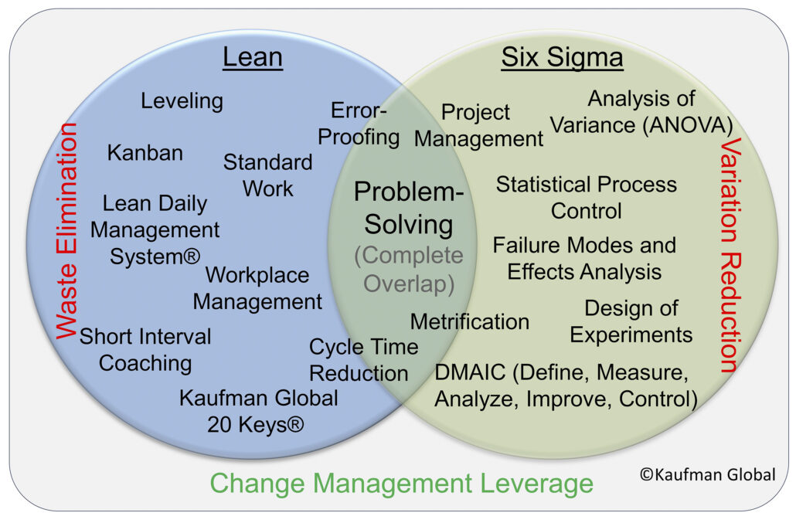
(Kaufman Global, 2017)

4. Reduce Escalation Variation Using Six Sigma
Six Sigma can minimise escalation variation, ensuring organisational responses to neonatal harm are consistent and not influenced by hierarchy or leadership preference (Purple Griffon, 2024). The DMAIC framework supports reliable escalation by defining abnormal neonatal events, measuring escalation speed, analysing bottlenecks, improving automation, and controlling quality through real-time audits and compliance dashboards (NHS England, 2023). Standardisation strengthens neonatal safety by reducing discretionary interpretation, enabling early pattern recognition, accurate documentation, and transparent escalation (Health Foundation, 2021).
Reducing variance is essential in high-risk neonatal environments where escalation must be immediate and regulatory liaison consistent rather than subjective (Nuffield Trust, 2024). Six Sigma also facilitates training, communication scripts, competency standards, and reporting expectations that reinforce a just-culture learning model (The King’s Fund, 2023).

5. Build Psychological Safety and Leadership Transparency
Sustained neonatal safety depends on psychological safety, ensuring clinicians can raise concerns without fear of retaliation or dismissal (CQC, 2024). A transparent culture requires regular multidisciplinary debriefs, open RCA learning forums, escalation dashboards, and mandated external reporting when repeated anomalies occur (Health Foundation, 2021). Leadership accountability should link escalation compliance to executive performance and external reporting duties (NHS Improvement, 2023). Psychological safety must be supported through independent whistleblowing guardians, confidential reporting systems, and training to strengthen escalation confidence (The King’s Fund, 2023). Safe neonatal services rely on organisational cultures that prioritise transparency, learning, and accountability over defensiveness (WHO, 2022), increasing public trust, regulatory partnership, family confidence, and multidisciplinary safety learning (Nuffield Trust, 2024).

Conclusion
This report demonstrated that repeated neonatal harm at the Countess of Chester Hospital resulted primarily from leadership and governance weaknesses that allowed delayed escalation, inconsistent RCA, inadequate mortality review, and limited regulatory reporting (Thirlwall Inquiry, 2023). The analysis showed that neonatal deterioration requires rapid incident investigation because high-risk environments are vulnerable to clinical anomalies and require ongoing surveillance to detect emerging patterns before they escalate (WHO, 2022).
Weak governance structures meant that escalation decisions were influenced by organisational defensiveness rather than transparent risk evaluation, reducing staff confidence and preventing timely multidisciplinary learning (King’s Fund, 2023). Poor safety culture further contributed to suppressed whistleblowing, emotional distress, and fractured communication between clinical teams and senior leaders, increasing vulnerability to repeated preventable harm (Nuffield Trust, 2024).
The Swiss Cheese Model revealed that interacting system failures across governance, escalation, communication, and regulatory oversight created conditions in which organisational defence lawyers were ineffective (Reason, 2000). The Donabedian Structure–Process–Outcome model illustrated how inadequate safety structures generated unreliable processes and contributed to severe neonatal outcomes, public distrust, and reputational decline (NHS England, 2023).
Fishbone analysis confirmed that risk was influenced by multiple contributory categories, including policy non-compliance, supervision gaps, technology limitations, and cultural fear among clinicians (Health Foundation, 2021). SWOT analysis showed that quality improvement opportunities exist to enhance escalation reliability, promote transparency, integrate digital monitoring, and strengthen leadership collaboration with regulators (CQC, 2024).
The recommendations proposed a programme of governance reform using PDSA, PDCA, Lean, and Six Sigma to ensure automatic escalation triggers, consistent RCA learning cycles, reduced variation, and improved cultural transparency (NHS Improvement, 2023). Strengthening psychological safety, leadership accountability, and digital surveillance will reinforce neonatal risk protection and ensure that clinical patterns receive rapid investigation rather than delayed recognition (IHI, 2023). Sustained quality improvement is essential for rebuilding family trust, regulatory confidence, and safe neonatal service continuity in future practice (BBC, 2024).

Reference:
- BBC (2024) Lucy Letby case: NHS neonatal deaths investigation. BBC News. Available at: https://www.bbc.co.uk/news (Accessed: 12 December 2025).
- Care Quality Commission (2024) Inspection summary – Countess of Chester Hospital NHS Foundation Trust. Care Quality Commission. Available at: https://www.cqc.org.uk/provider/RJR/inspection-summary (Accessed: 12 December 2025).
- IHI – Institute for Healthcare Improvement (2023) Science of Improvement and Model for PDSA cycles. IHI. Available at: https://www.ihi.org/resources/Pages/Tools/PlanDoStudyActWorksheet.aspx (Accessed: 12 December 2025).
- King’s Fund (2023) Leadership, culture, and quality in the NHS. The King’s Fund. Available at: https://www.kingsfund.org.uk/topics/leadership (Accessed: 12 December 2025).
- Kaufman Global (2017) Variation. Available at: https://www.kaufmanglobal.com/glossary/variation/
- NHS England (2023) Neonatal critical care services and escalation standards. NHS England. Available at: https://www.england.nhs.uk (Accessed: 12 December 2025).
- NHS Improvement (2023) Patient safety incident response frameworks (PSIRF). NHS Improvement. Available at: https://www.england.nhs.uk/patient-safety (Accessed: 12 December 2025).
- Reason, J. (2000) ‘Human error: Models and management’, BMJ, 320(7237), pp. 768–770. Available at: https://www.bmj.com/content/320/7237/768 (Accessed: 12 December 2025).
- Thirlwall Inquiry (2023) Independent Inquiry into the events at the Countess of Chester Hospital neonatal unit. Department of Health and Social Care. Available at: https://www.gov.uk/government/organisations/department-of-health-and-social-care (Accessed: 12 December 2025).
- World Health Organization (2022) Standards for neonatal intensive care safety. WHO. Available at: https://www.who.int/health-topics/newborn-health (Accessed: 12 December 2025).
- BBC (2024) Lucy Letby case: NHS neonatal deaths investigation. BBC News. Available at: https://www.bbc.co.uk/news (Accessed: 12 December 2025).
- BMJ Quality and Safety (2020) Safety culture and incident learning in acute care. BMJ Quality and Safety. Available at: https://qualitysafety.bmj.com (Accessed: 12 December 2025).
- Care Quality Commission (2024) Inspection summary – Countess of Chester Hospital NHS Foundation Trust. CQC. Available at: https://www.cqc.org.uk/provider/RJR/inspection-summary (Accessed: 12 December 2025).
- King’s Fund (2023) Leadership, organisational culture, and NHS quality. The King’s Fund. Available at: https://www.kingsfund.org.uk/topics/leadership (Accessed: 12 December 2025).
- NHS England (2022) Serious Incident Framework and RCA guidance. NHS England. Available at: https://www.england.nhs.uk/patient-safety (Accessed: 12 December 2025).
- Nuffield Trust (2024) Safety escalation and clinical governance in neonatal services. Nuffield Trust. Available at: https://www.nuffieldtrust.org.uk (Accessed: 12 December 2025).
- Purple Griffon (2024) Fishbone diagram: analysis and application. Purple Griffon. Available at: https://purplegriffon.com/blog (Accessed: 12 December 2025).
- Thirlwall Inquiry (2023) Independent Inquiry into the Countess of Chester neonatal incidents. Department of Health and Social Care. Available at: https://www.gov.uk (Accessed: 12 December 2025).
- World Health Organization (2022) Newborn health and neonatal safety standards. WHO. Available at: https://www.who.int/health-topics/newborn-health (Accessed: 12 December 2025).
- Care Quality Commission (2024) Inspection summary – Countess of Chester Hospital NHS Foundation Trust. CQC. Available at: https://www.cqc.org.uk/provider/RJR/inspection-summary (Accessed: 12 December 2025).
- King’s Fund (2023) Leadership, culture, and incident escalation in NHS quality assurance. The King’s Fund. Available at: https://www.kingsfund.org.uk/topics/leadership (Accessed: 12 December 2025).
- NHS England (2023) Neonatal safety and escalation standards. NHS England. Available at: https://www.england.nhs.uk (Accessed: 12 December 2025).
- NHS Improvement (2023) Patient Safety Incident Response Framework (PSIRF). NHS Improvement. Available at: https://www.england.nhs.uk/patient-safety (Accessed: 12 December 2025).
- Nuffield Trust (2024) Clinical escalation and neonatal governance lessons. Nuffield Trust. Available at: https://www.nuffieldtrust.org.uk (Accessed: 12 December 2025).
- Purple Griffon (2024) Six Sigma and DMAIC in healthcare. Purple Griffon. Available at: https://purplegriffon.com/blog (Accessed: 12 December 2025).
- World Health Organization (2022) Neonatal risk and escalation standards. WHO. Available at: https://www.who.int/health-topics/newborn-health (Accessed: 12 December 2025).
- BBC (2024) Lucy Letby case: NHS neonatal deaths investigation. BBC News. Available at: https://www.bbc.co.uk/news (Accessed: 12 December 2025).
- Care Quality Commission (2024) Inspection summary – Countess of Chester Hospital NHS Foundation Trust. CQC. Available at: https://www.cqc.org.uk/provider/RJR/inspection-summary (Accessed: 12 December 2025).
- Health Foundation (2021) Quality Improvement Made Simple. Health Foundation. Available at: https://reader.health.org.uk/qi-made-simple-2021 (Accessed: 12 December 2025).
- King’s Fund (2023) Leadership, culture, and quality in NHS risk escalation. The King’s Fund. Available at: https://www.kingsfund.org.uk/topics/leadership (Accessed: 12 December 2025).
- NHS England (2023) Neonatal escalation and safety standards. NHS England. Available at: https://www.england.nhs.uk (Accessed: 12 December 2025).
- Nuffield Trust (2024) Clinical governance lessons from neonatal escalation failure. Nuffield Trust. Available at: https://www.nuffieldtrust.org.uk (Accessed: 12 December 2025).
- Thirlwall Inquiry (2023) Independent Inquiry into the Countess of Chester Hospital neonatal incidents. Department of Health and Social Care. Available at: https://www.gov.uk (Accessed: 12 December 2025).
- World Health Organization (2022) Newborn health and neonatal risk standards. WHO. Available at: https://www.who.int/health-topics/newborn-health (Accessed: 12 December 2025).

