RINA SALIQUE
1806203
BMSW5106
DR KALAM

KNOWLEDGE AND INFORMATION MANAGEMENT SKILLS FOR THE WORKPLACE

Table of Contents

Introduction 3
1. Evaluating the concept of knowledge and management 3
a. Identifying the relationship between “data, information, and knowledge” 3
b. Explain the relationship between individual knowledge and organisational knowledge 5
c. Applying the knowledge assets model 6
d. Actual and potential knowledge asset 7
2. Understanding the management process of organizational development 10
a. Explain what is required to create, store, apply, and integrate knowledge 10
b. Consider the importance of Intellectual Property rights 10
3. Managing knowledge management culture 10
a. “Explain the contribution knowledge assets have on an organization” 10
b. Evaluate the knowledge requirements of the organisation. 12
c. Evaluate the Framework of Iceland for enabling knowledge sharing 13
d. Recommend improvements to the current framework of Knowledge Sharing and Management 14
Conclusion 15
Reference List 16

Introduction
Recording of data and evaluating it in meaningful information is essential for developing knowledge of an individual that is used successfully for business management. The role of individual knowledge and organisational knowledge evaluation is essential for identifying its requirement in proper management of an organisation. This report is identifying the concept of knowledge Assets and knowledge management either it is explicit or Tacit knowledge.Information Technology has been identified to play an efficient role in knowledge management in current Business Development strategy.

1. Evaluating the concept of knowledge and management

a. Identifying the relationship between “data, information, and knowledge”
DIKW model could be applied in determining the relationship of data, information and knowledge
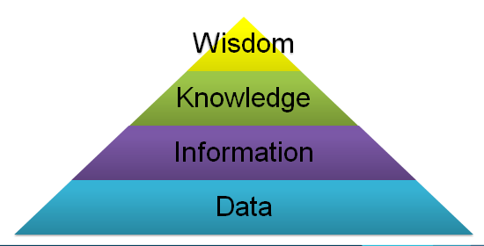
Figure 1: DIKW
(Source: Mutongi, 2016)
Data are concerning facts that are identified, observed and collected from relevant sources. Data is having no value unless it is transformed effectively into meaningful information. Data is recorded in the means of symbols signals in an understanding manner. Symbols related to data do consider, graph, diagrams, or images.
Information is a meaningful message, a transformed part of data that implies specific facts with details that are used generally for assumption or making a decision. Information is generated from historical sources, such as pictures or stories, or by the process of communication either it is formal or informal. The collection of information aims at making a decision by analysing the collected facts and figures and realising its related opportunity.
Sources of information
It has been previously discussed that information could be collected from two different sources such as formal communication or informal communication.
Formal Communication: the formal communication enables in collecting information in a structured manner with reliable and consistent data such as annual reports of an organisation.
Informal Communication: Information form these sources is collected by the means of unstructured interviews and face to face conversation in either verbal or audio communication processes.
“Capturing Valuable Information”
Valuable information could be collected from online sources. For example, the journals and articles provided online related to an organisation with specific data could be used as relevant information in a usable manner. For example, the financial statement data provided in the annual report of Iceland, available in online sources is having valuable information that could be identified in the following manner
Timely – The information is available easily in this journal which could be communicated easily on the basis of details properly
Concise – presenting information with the help of graphs and data evaluated in a common practicing way has presented the information concisely.
Accuracy – The circumstance created in this article is useful enough for the reader to determine the situation and current position of an organisation with accurate data and information provided by a financial statement in the annual report (Nurulin and Skvortsova, 2018).
Reliable – the information presented in the report is reliable as it has been audited by the auditors presenting the confidentiality of data and information shared with stakeholders.
Frequency - frequency of information is of two types that are continued or periodic. The annual report is providing period frequency of information on a yearly basis.
Order - The order of information is signified by its process of collecting data from internal sources of an organization and going through a database of business for conveying it into usable information for the stakeholders.
Information flow and information overload
The flow of information and information overload is a referred situation where information are collected for making a decision, however, excess of information beyond the cognitive capacity creates an issue of decision making.
Knowledge is a state of cognitive and recognition where experiences of an individual are enhanced by the help of data collected and going through information or considering a situation of decision making. Knowledge focuses on developing recognition, the capacity of the act, and understanding of an individual within a mind that is purposefully used in making a business successful by employing effective knowledge. It could be said that the ultimate purpose of enhancing knowledge is the creation of value (Sallehet al. 2018).
Wisdom: Knowledge does not make an individual wise. After defining the role of Data, Information and Knowledge, its relationship could be identified effectively. These three variables are usually used in a business purpose in an interchangeable manner as a process relevant. Its intended application could help a business in collecting appropriate data and information as per the knowledge and applies the cognitive power of an individual in making a decision. Sources of data and information are two-fold: that is, situations and activities for collecting relevant data and generating understanding meaningful information.

b. Explain the relationship between individual knowledge and organisational knowledge
Knowledge is built by an individual on the basis of the environment where they are involved in for enhancing their experience on the basis of knowledge they possess.
Knowledge is generally described into two different forms that are individual knowledge as tacit knowledge and organisational knowledge also known as explicit knowledge (Lin et al. 2018).
Explicit knowledge could be stored and shared with others with the help of technological documentation or other communication media channels. This knowledge is identified in detail form and in a systematic way that is stored either manually in document procedure or in data files.
Tacit knowledge on the other side is characterized by the factors of individuals’ beliefs, intuition, perception, and values gained by involving in a different environment. Individual knowledge is held unconsciously which is difficult to record, describe, and elicit.
Relationship between Organisational and individual knowledge
Tacit Knowledge (Individual Knowledge) | Explicit Knowledge (Organisational knowledge)
The practical knowledge gained from external sources activities involvement provides an individual with new ideas and opportunity with an exceptional situation that helps in enhancing the capacity of adapting into a new situation and deal with the uncertain situation successfully (Qiu and Wang, 2018) | Enhances the ability to disseminate, reapply, and reproduce by accessing the knowledge in organisational strategy responsible for achieving the goal of the business.
Involvement in a practical working and experimental environment enable in determining the uncertain situation transparently and increases the ability of collaboration by sharing a common vision and cultural transmission | Enable in organizing, translating the vision and systematic the mission statement of an organisation successfully into operational guidelines
The mentoring and coaching process enhances experimental knowledge that could be transferred by face to face communication basis. | Organisational knowledge to others members working and sharing a common workplace could be shared with the help of documentation and other technological services.
Table 1: Relationship between Individual and organisational knowledge
(Source: Created by Researcher)

c. Applying the knowledge assets model
Knowledge assets are generally applied in organisational context that drives the success of an organisation. It can be unorganized with tactical knowledge. For example, the presence of deep expertise in business is key personnel are the unstructured knowledge asset. Structured knowledge assets are concerned with explicit knowledge in a codified manner. For example, the copyrights, intellectual proprietary rights, and patents are in a codified form consenting explicit knowledge assets (Anderson and Gallini, 2019). The interesting fact regarding this knowledge asset is that better-structured knowledge assets in a codified manner enable business in sharing the knowledge efficiently to internal and external business.
“Nonaka and Tekeuchi: Theory of knowledge assets”, would beneficially identify the four different category in PAEI factors related to knowledge assets
P - "Routine Knowledge Assets": the individual knowledge process is utilised according to this is structure where organisational action, daily practices and cultures are embedded.
"A - Systemic Knowledge Assets": systematic explicit and codified knowledge are stored in the process of manuals, documents, database and patents.
"E – Conceptual Knowledge Assets": the structure signifies that explicit knowledge are in the form of a symbol that includes brand equity, concept of the product languages and designing style.
"I – Experiential Knowledge Assets": tacit knowledge is related to individual knowledge that is on the basis of collective experience that additionally includes the judgement situation of an individual with growing skills and prosocial feelings that helps in developing trust and care.
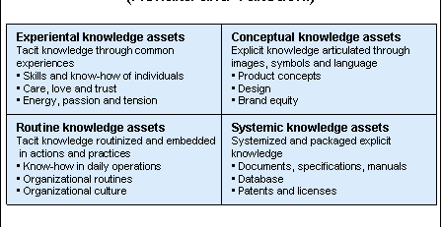
With the help of these models experimental knowledge assets were developed for the experience of an individual and enhance trust that is needed for managing knowledge. Conceptual knowledge on the other side focuses on explicit knowledge that helps in articulating the concept of product and brand equity of an individual in an organisation (Schmitt, 2018). Routinised assets of knowledge do focus on daily operation and embedded actions related to organisational culture.

d. Actual and potential knowledge asset
Knowledge management involves Collection of data and information that helps in enhancing knowledge explicitly by converting or codifying it in the form that could be shared over the organisation. An essential part of knowledge management is gathering tacit knowledge effectively and converting it into explicit organisational knowledge.
Knowledge management requires capturing of knowledge from appropriate sources that could be identified by the help of model of “Nonaka and Takeuchi: Theory of knowledge Creation”
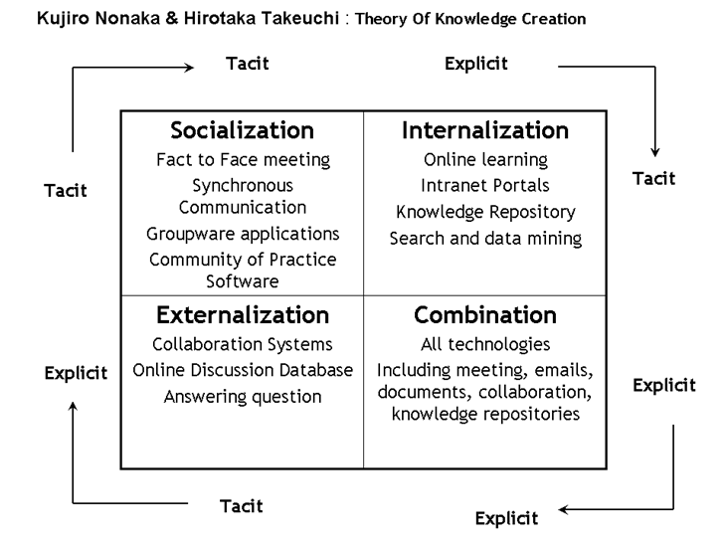
Figure 1: Knowledge creation model
(Source: Magnier-Watanabe and Benton, 2017)
Actual and potential knowledge is related to the relationship between tacit and explicit knowledge. Individual knowledge used in a qualified form for utilising it into the purpose of organisational success. With an application of the theory of knowledge creation potentiality of knowledge could be identified in a following way
- Socialization: in the case of tacit knowledge assets with observation, guidance, observation and imitation focuses on tacit to tacit knowledge.
- Externalization: This knowledge management is related to tacit and explicit where it is deemed particularly focused on difficult mechanisms of conversation. Tacit knowledge in this case is used in the form of manual or documents form for sharing it easily. It is for the identified that a tacit knowledge could not be modified and the conversation mechanism is acceptable at debate (Maravilhas and Martins, 2019). In the case of tacit knowledge metaphor is easily used essentially as an external mechanism.
- Combination: this part of the knowledge is related to explicit to explicit form which is the simplest form applied as a codified source of knowledge that is applied for creating new knowledge.
- Internalization: the Spectre of the theory focuses on explicit to take a relationship where exercises versus are applied for enhancing knowledge on the basis of learning by modifying the existing tacit knowledge of the users (RIBEIRO et al. 2018).
According to the applicable theory with great effort has been put for investigating its applicability in a practical knowledge development in order to manage its link with organisational culture.
Effective process of knowledge management
Knowledge Management is concerned as a systematic process that is developed on the basis of Data Collection and organising it with clarification that could be disseminated for reusing it in a meaningful information throughout the company. A knowledge management effective leader with tacit knowledge as well as explicit knowledge that possesses maturity attributes and dynamic attributes (RobayoMacías and Rubiano Ortiz, 2017). Different process that could be applied by an organisation for managing and developing knowledge in both aspects are as follows
- Cross-training programs – it is a process that includes shadowing training and mentoring programs that are applied in an organisation and allows every employee to develop their knowledge by observing and learning by others' working strategy.
- Document management systems – the systems of document management box cloud and Google drives are allowed by an organisation for storing the documents and share them to vast requirements on the basis of a controlled management system at it's a granular level (Arbabi, 2016). Digital Certificate used for adding metadata and taking that enables in finding the files easily on the basis of information.
- Content management systems (CMSs) – the system of content management is used as a bloom fire and SharePoint where the organisational teams and individuals are able to update or access the information related to the company over Intranet.
- Social networking tools - social networking in current days is privately used by most of the organisation as a tool within the workplace such as Twitter and Facebook that allows the entire organisational team to communicate in a shared space and collaborate with other teams that further helps in developing their knowledge. This system of knowledge management provides benefits of conversation related to historical events within employees that allows them to search over the discussed information (Addis, 2016).
- Chabot’s– chatbots is considered as a natural evaluation of organisation that helps in developing knowledge management processes. Chatbots in an organisation that is widely used is Spoke that applies artificial intelligence as well as machine learning processes that respond to the Employees request and provide appropriate information.
Role of Information knowledge in Knowledge management
The current business position information technology has been considered as a common force that is generally used for processing the information transferring and protecting information related to organisation. Additional information technology is used in an organisation for achieving the objectives (Serna et al. 2017). Data warehouse data mining Browsers and internet could be used as a useful program for improving knowledge management of an organisation in an organised manner that further helps in improving the performance of an organisation by gaining competitive advantage. In the search of proper management of knowledge Information Technology plays a vital role as it helps in storing the knowledge in a documentary form and transferring it essentially throughout the organisation. An inclusive organisation is able to improve the communication knowledge by transferring and sharing your existing knowledge to other members of an organisation efficiently.

2. Understanding the management process of organizational development

a. Explain what is required to create, store, apply, and integrate knowledge
Application of Nonaka and Takeuchi model and its four factors could be applied for determining the situation where, the value of knowledge is created effectively and stored for purposeful usages in future; the stored knowledge could be applied in business purpose in an integrated manner.
Creating knowledge typically considers a situation where workflows are documented in a systematic manner and decision making processes are recorded for identifying the knowledge of workers (Menonet al. 2016). Knowledge is created in an innovative manner when a continuous situation occurs
It is a concerned factor where knowledge is stored with a purpose of dissemination with a plan in the form of presentation, conferences and publication. Knowledge is stored in both structured and unstructured manner either in a documentation form or in a patent of intellectual property rights form.
Application of knowledge in a tacit and explicit process is beneficial for utilising the information in a problem solving and making decisions for improving the core value of a concerned organization (Thornleyet al. 2016).
Restructuring of information in an integrated, present and indexing format, enable in disseminating the information to larger group so that it could be used later. Using of knowledge into business regardless of its success or risk of failure enable in developing new knowledge. To improve the knowledge and evade from repetition of such failure foster integration of knowledge is applied.

b. Consider the importance of Intellectual Property rights
The knowledge based assets in unstructured manner such as copyrights, patents and intellectual property are utilised in an organisation for protecting their innovative ideas. With a growing technology needs and competitive environment of business, intellectual property plays an effective role in its innovative growth. It helps in strengthening the competitive advantage of an organisation in a market. IPMs are developed within organisation for managing documentation, data analysis and searching tools (Yakovlevet al. 2017). It supports tactical decision and strategic decision making process by the help of information acquired. IPRs utilises data form both internal and external sources and provide redundancy of information instead of retention of knowledge that helps in disseminating the process of problem solving.

3. Managing knowledge management culture

a. “Explain the contribution knowledge assets have on an organization”
Knowledge assets are the stored intellectual resources in an organisation. With respect to an organisation patents, software, procedures, policies, guides, documents, databases, and workforce are the knowledge assets of an organisation. With respect to the case of Iceland, it can be stated that knowledge assets are of great use for it (Oyemomiet al., 2016). However, it is necessary for the organisation to identify its assets pertaining to knowledge so that it can enjoy its benefits. Knowledge assets are a part of knowledge management that is based on the procedure of gathering knowledge and codifying the same into a form so that information can be shared in the organisation across various platforms.
Visual thinking is made tangible for Iceland and burden on experts is mitigated. Iceland is aided in terms of protecting its intellectual capital on account of its knowledge assets and its administration. Iceland is enabled to have its focus on the assets that are of most importance for it like its employees (Gunjal, 2019). It can be stated that the organisation is aided in terms of managing its staff in a better way because of adequate administration of its knowledge assets. The organisation is also aided in terms of linking its people by using collaborative methods. The organisation is also aided in terms of re-orienting its culture by making use of a proper strategy of sharing optimal knowledge. Iceland is also aided in terms of increasing its efficiency. A strategy of knowledge management enables Iceland to enhance its business decisions on account of its leading practices as well as expertise. Knowledge management strategy also facilitates innovation in the company. Productivity of the organisation can be increased on account of on-board trainings along with proper access of knowledge on time if it is successful in managing knowledge effectively.

b. Evaluate the knowledge requirements of the organisation.
For effective operation of an organisation, knowledge is required in several aspects so that it can operate effectively. Knowledge conversion takes place in four procedures namely socialising in which knowledge is shared, capture in which knowledge gained is converted into written report. Dissemination is yet another procedure in which the report formed is copied as well as distributed (Deloitte.com, 2020). The fourth process is internalisation in which experience knowledge is gained from explicit sources. It is important to be noted that knowledge assets and its management will enable Iceland to measure the progress it makes as well as its staff will be enabled to administer data in large volume so that it can serve its customers in a better way.
Knowledge requirements of Iceland can be in various forms as shown in the figure below:
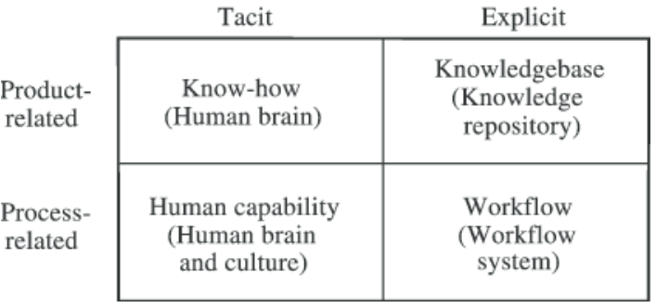
Figure 2: Kinds of knowledge required in Iceland
(Source: Created by the learner)
With respect to the aspect of product, in Iceland knowledge pertaining to human brain is required that questions about every aspect that takes place in an organisation. Employees of Iceland need to know about its products with respect to the aspect of human brain. Another aspect that is related to product is knowledge base on which the organisation can operate effectively. Another aspect is process-related in which trainings are organised in Iceland so that a healthy work culture can be created in it. The other aspect of knowledge requirement is workflow system so that the organisation can operate efficiently. Workflow system and human capability in relation with work culture is an aspect of process of Iceland. Knowledge requirements as well as its management aid the organisation Iceland to operate effectively.

c. Evaluate the Framework of Iceland for enabling knowledge sharing
As per the opinion of Marjan and Hamideh(2017), knowledge management within the organization requires a suitable organizational framework as it determines the process channelizing the shared knowledge. Apart from that the organizational framework helps in the identification of shared knowledge based on the defined roles, responsibilities and power distribution of the hierarchy of an organization. In fact, the business automation and autonomy is totally developed based on the decision making process of the organizational framework and management structure.
From the context of Iceland Supermarket it can be stated that the overall business is dependent on its Hierarchical Organizational Framework and the overall knowledge management of the company is dependent on the framework. Considering this it can be stated that the overall knowledge management and sharing framework is critical as well as complex in its implementation. Since its initiation in the year 1970 the organizational growth is visible and right now the business is being conducted over 950 locations with the help of more than 23000 employees across its outlets (iceland.co.uk, 2020). Based on this it can be stated that the knowledge sharing network of the organization is well linked by which the business objectives are being attained in an effective way by which business expansion of the organization has become possible in the last 50 years.
The knowledge sharing process of the organization starts with identification of the needs for providing knowledge to knowledge creation, sharing, and development, implication of knowledge and saving it following an effective evaluation. Hierarchical Organizational Structure is suitable for the business process when it is at the initial stage but the knowledge sharing process seems difficult when the organization is large in size in terms of location and number of employees. Based on the opinion of the North and Kumta(2018), in hierarchical organizational structure the value and beliefs of managers might differ based on their perception by which requirement of knowledge and learning might not get understood in a proper way. This aspect might hamper the knowledge sharing of the organization. This type of issue is there in the business process of the Iceland Supermarket by which the overall knowledge sharing is getting hampered.
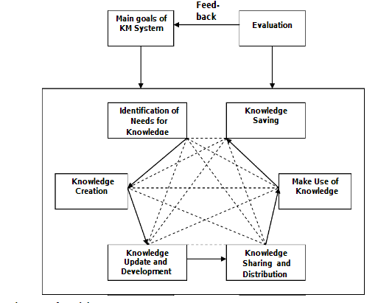
Figure 3: Knowledge Sharing Process of Iceland Supermarket
(Source: Influenced by Marjan and Hamideh, 2017, p.3232)

d. Recommend improvements to the current framework of Knowledge Sharing and Management
Based on the evaluation of the knowledge sharing framework some recommendations can be made.
- The organization should adopt and apply an effective Knowledge Sharing System where all the outlets, employees and the management can be connected by which the proper identification of the requirement for knowledge creation can be possible by which the employee performance can be enhanced by 28% within the next 2 years.
- The management should develop a “Uniform Civil Code” and policy for all the managers so that their personal as well as professional values never get any conflict in terms of sharing the knowledge with their followers by which the shared knowledge of the employees can be equal by which work process of the employees can become equal by within the next year.

Conclusion
Knowledge management model is a pictography that defines knowledge management framework in an integrated manner developing relationship between different elements of knowledge, data and information in a lucid manner. It helps in capturing and creating knowledge in different process of an individual that could be applied in organizational development. Possessing knowledge differently within organisation enables in facilitating the system for acquiring and storing of knowledge’s that could be effectively applied in continuous learning process and bringing improvement in organizational function.

Reference List
Addis, M., 2016. Tacit and explicit knowledge in construction management. Construction management and economics, 34(7-8), pp.439-445.
Anderson, R.D. and Gallini, N., 2019. Competition Policy and Intellectual Property Rights in a Knowledge-Based Economy. Routledge.
Arbabi, A., 2016. Study the relation between Nonaka and Takeuchi knowledge management model and organizational strategic performance from the perspective of the balanced scorecard. Journal of Administrative Management, Education and Training, 12(5), pp.294-301.
Deloitte.com 2020. Benefits of knowledge management. [online] Available at: https://www2.deloitte.com/lu/en/pages/strategy/articles/benefits-knowledge-management.html [Accessed 2 May 2020].
Gunjal, B., 2019. Knowledge management: why do we need it for corporates.Malaysian Journal of Library & Information Science (ISSN: 1394-6234).
iceland.co.uk, 2020. The Iceland Story. Available at: https://about.iceland.co.uk/our-story/ [accessed on: 02/05/2020]
Lin, C., Li, B. and Wu, Y.J., 2018. Existing knowledge assets and disruptive innovation: The role of knowledge embeddedness and specificity. Sustainability, 10(2), p.342.
Magnier-Watanabe, R. and Benton, C., 2017. Management innovation and firm performance: The mediating effects of tacit and explicit knowledge. Knowledge Management Research & Practice, 15(3), pp.325-335.
Maravilhas, S. and Martins, J., 2019. Strategic knowledge management in a digital environment: Tacit and explicit knowledge in Fab Labs. Journal of business research, 94, pp.353-359.
Marjan, A.F. and Hamideh, R., 2017. A Framework for Evaluating the Impact of Organizational Structure on Knowledge Management (Case study: ICT Organization of Tehran Municipality). International Journal of Advanced Networking and Applications, 8(6), p.3232.
Menon, K., Kärkkäinen, H. and Gupta, J.P., 2016, July. Role of Industrial Internet platforms in the management of product lifecycle related information and knowledge. In IFIP International Conference on Product Lifecycle Management (pp. 549-558). Springer, Cham.
Mutongi, C., 2016. Revisiting Data, Information, Knowledge and Wisdom (DIKW) Model and Introducing the Green Leaf Model. IOSR Journal of Business and Management (IOSR-JBM), 18, pp.66-71.
North, K. and Kumta, G., 2018. Knowledge management: Value creation through organizational learning. Springer.
Nurulin, Y. and Skvortsova, I., 2018. Conceptual model of information support for taking decisions. In SHS Web of Conferences (Vol. 44, p. 00064). EDP Sciences.
Oyemomi, O., Liu, S., Neaga, I. and Alkhuraiji, A., 2016. How knowledge sharing and business process contribute to organizational performance: Using the fsQCA approach. Journal of Business Research, 69(11), pp.5222-5227.
Qiu, B. and Wang, T., 2018. Does knowledge protection benefit shareholders? evidence from stock market reaction and firm investment in knowledge assets. Journal of Financial and Quantitative Analysis, 53(3), pp.1341-1370.
RIBEIRO, R.L., RENAULT, T.B. and da Silva, A.J.D.O., 2018. CONTROLES DE TRANSPORTES INTERNOS DE MATÉRIAS PRIMAS DE UMA INDÚSTRIA CIMENTEIRA À LUZ DA TEORIA DO CONHECIMENTO DE NONAKA E TAKEUCHI. RevistaUniabeu, 11(29), pp.190-213.
RobayoMacías, M.D.C. and Rubiano Ortiz, A., 2017. Estrategias de mejoramiento a partir del modelo de Gestión del conocimiento de Nonaka y Takeuchi para el fortalecimiento de la culturainvestigativa en la fundaciónCidcasede Bogotá.
Salleh, M.F.M., Yusoff, W.S., Basnan, N. and Yaacob, T.S.T., 2018. Knowledge Assets and Bilateral-Trade Flows in ASEAN-5 Countries: An Extension of Gravity Panel Data Model. JurnalEkonomi Malaysia, 52(2), pp.19-26.
Schmitt, U., 2018, November. Effectuating tacit and explicit knowledge via personal knowledge management frameworks and devices. In ICICKM 2018 15th International Conference on Intellectual Capital Knowledge Management & Organisational Learning (p. 301). Academic Conferences and publishing limited.
Serna, E., Bachiller, O. and Serna, A., 2017. Knowledge meaning and management in requirements engineering. International Journal of Information Management, 37(3), pp.155-161.
Thornley, C., Carcary, M., Connolly, N., O'Duffy, M. and Pierce, J., 2016. Developing a maturity model for knowledge management (KM) in the digital age.
Yakovlev, D., Ageev, A., Yushkov, E. and Bogatyreova, M., 2017, January. Improvement of the course “Management of intellectual property” based on the mixed state contract in the field of scientific R&D. In Journal of Physics: Conference Series (Vol. 781, No. 1, p. 012062). IOP Publishing.

