

BA Leadership and Management
LEVEL 5
Creativity and Innovation
BMSW5013

Module Lead: Chris Wilkin

Email:C.Wilkin@uwtsd.ac.uk

Submission Date: 31/03/2026
Executive Summary
This report evaluates a creative turnaround strategy for Seren Coffi, a Cardiff-based social enterprise currently facing a brittle operational state due to infrastructure decay and founder fatigue. Part one of the study focuses on analysing the tensions between capitalist efficiency and the shop’s principled Welsh identity, ultimately recommending a stakeholder-led innovation to restore the business’s resilience.
By reconfiguring the existing £2000 petty cash, the solution prioritises physical resuscitation and the delegation of daily tasks to a community-based membership model.
Part two documents the iterative development of this proposal through a critical dialogue with an Artificial Intelligence (AI) co-pilot.
This collaborative process served as a stress-test for the initial idea, moving the strategy away from high-tech digital expansion toward low-tech, high-soul solutions.
By incorporating AI feedback, the final plan focuses on urgent thermal repairs and a manual stewardship protocol, ensuring the innovation addresses the founder’s exhaustion while remaining true to the organisation’s core values of continuity and reuse.

Table of Contents
1 Introduction 5
1.1 Background 5
1.2 Challenges 5
1.3 Aim and Objectives 5
2 A Critical Analysis of Creativity, Innovation, and Capitalist Methodology 6
2.1 The Tension Between Creativity and Standardisation 6
2.2 The Value-Efficiency Paradox 6
2.3 Innovation as a Tool for Resilience 7
2.4 Summary of the Conflict 7
3 The Innovation: The "4 P’s" Framework 7
3.1 Detailed Explanation of the ‘4 P’s of Innovation’ 8
3.1.1 Paradigm Innovation (The Mental Model) 9
3.1.2 Position Innovation (The Market Context) 9
3.1.3 Process Innovation (How we do things) 9
3.1.4 Product Innovation (The Offering) 10
4 The Creativity Process and Context 10
4.1 Preparation 10
4.2 Incubation 11
4.3 Illumination 11
4.4 Verification 11
5 Critical Evaluation of Viability: Lewin’s Force Field Analysis 11
5.1 Driving Forces (Factors for Change) 12
5.2 Restraining Forces (Obstacles to Change) 13
5.3 Synthesis and Reframing of Viability 13
6 Critical Discussion 13
6.1 Supportive Elements of the Climate 13
6.2 Obstacles within the Climate 14
6.3 Conclusion on Climate Suitability 14
7 Introduction 15
8 The Pivot: Resuscitating the Physical Space 15
9 The Shadow Protocol and Stewardship Station 16
9.1 The Innovation 16
9.2 Critical Appraisal: Implementing the Shadow Protocol 16
9.3 Financial Bricolage: Strategic Resource Allocation 17
10 Critical Appraisal 18
10.1 Challenging the Capitalist Bias and Digital Friction 18
10.2 Correcting the Fatigue Hallucination 19
10.3 Synthesis 19
11 Appendices 20
12 References 30

  - Part 1

Introduction

Background
Seren Coffi is a mission-driven social enterprise situated in the Cardiff docks, occupying a repurposed unit that previously housed a betting office. The founders established the venture with a core philosophy of continuity and reuse, specifically prioritising ethical transparency and Welsh cultural identity. From its inception, the organisation sought to distinguish itself from generic coffee retailers by detailing bean origins and specific cooperatives on a daily chalkboard, while ensuring the Welsh language was given equal prominence on all signage. By its first summer, the shop had transitioned from a local start-up into a community fixture, hosting poetry readings and pay-what-you-can evenings that earned it a reputation for returning a sense of soul to the Cardiff area.

Challenges
Despite maintaining high product demand and a sound underlying model, the organisation is currently facing a state of failure. By January 2026, the enterprise is described as increasingly brittle, a decline precipitated by three primary pressures. Firstly, infrastructure and resource decay have become critical; essential equipment like the coffee grinder has remained broken for weeks and the building’s original insulation leaks heat relentlessly, resulting in unsustainable energy overheads. Secondly, the business suffers from operational paralysis. The founders’ commitment to thorough, consensus-based decision-making where every issue is discussed in detail until coffees go cold, has resulted in profound fatigue and the delay of essential actions, such as hiring staff or servicing machinery. Finally, there is a clear hybridity tension as Seren Coffi struggles to balance its social mission with economic reality. As Doherty, Haugh, and Lyon (2014) argue, social startups must generate financial value alongside social value to remain viable; currently, the focus on fairness and community is being undermined by a critical lack of financial sustainability

Aim and Objectives
The primary aim of this report is to propose a detailed and creative solution designed to turn around Seren Coffi by strategically deploying the available £2,000 in petty cash. To achieve this, the report will first analyse the inherent tensions between creative innovation and traditional capitalist growth methodologies. Subsequently, it will propose a creative innovation categorised within the 4 P’s of Innovation framework, ensuring the idea adheres to the strict constraints of maintaining current leadership and existing suppliers. The report will then evaluate the viability of this proposal using Lewin’s Force Field Analysis as a tool to reframe the business's success through a value-creation lens rather than a purely capitalist one. Finally, the organisational climate will be discussed to determine the extent to which the current culture is supportive of the proposed strategic shift.

A Critical Analysis of Creativity, Innovation, and Capitalist Methodology

The Tension Between Creativity and Standardisation
In a traditional capitalist framework, growth is often synonymous with efficiency and the reduction of variance. As the case study highlights, the hospitality group’s proposal focused heavily on brand consistency and standardising the menu. While such measures typically improve profit margins through bulk purchasing, they pose a direct threat to the organic, mismatched but intentional creativity that defined the early success of Seren Coffi.
From an academic perspective, this situation illustrates a conflict between exploitation which involves refining existing products for profit, and exploration which focuses on experimenting with new, creative ideas (March, 1991). Capitalist methodologies tend to favour exploitation, whereas the core value of Seren Coffi lies in its exploratory nature, seen in its pay-what-you-can evenings and poetry readings. However, research suggests this tension can be harnessed as an opportunity for organisational learning. Leadership style is pivotal here: transformational leadership typically supports exploration in individual and group learning, whereas transactional leadership (more common in capitalist models) favours institutionalised exploitation (Asif, 2019). To resolve this, the organisation might consider novel approaches like the joint-variance method to balance these competing needs and find a middle ground (Kerry and DeSimone, 2019).

The Value-Efficiency Paradox
The founders of Seren Coffi define doing things properly through slow, deliberate processes such as sourcing from small cooperatives, employing local carpenters, and engaging in thorough communal debates. While this approach fosters high social capital, it is fundamentally at odds with capitalist operational efficiency. The case study notes that while many customers praised this level of care, others questioned why the queue moved so slowly.
This highlights a critical risk: when a creative business adopts a purely capitalist logic, it often loses the soul that drove its original success. Young and Kim (2015) argue that while governance and economic challenges are inevitable, specific leadership and financial incentive structures can help social enterprises maintain financial stability. Conversely, unresolved financial pressures and a high dependence on single resources can lead to mission drift (Cornforth, 2014). To resist this, Seren Coffi could adopt strategies such as compartmentalising social and commercial activities into separate organisational parts to preserve their core values.

Innovation as a Tool for Resilience
In a capitalist context, innovation is frequently viewed as achieving competitive advantage and market share. However, for an organisation like Seren Coffi, research suggests that in small- and medium-sized enterprises (SMEs), innovation can be reframed as a tool for resilience and value creation through the strategic reconfiguration of resources (Lopez et al., 2024). The founders’ refusal to adopt shrinkflation strategies or switch to unethical manufacturers demonstrates a firm commitment to values-led innovation.
This is a statistically sound stance; recent data suggests shrinkflation is often impractical, with seven out of ten products undergoing the process experiencing a subsequent decline in sales (Franc-Dąbrowska, Vaverka and Vaverková, 2025. Nevertheless, this principled stance has left the business increasingly brittle. Creativity requires slack resources such as time, money, and mental energy, all of which have been depleted by rising energy bills and the aggressive presence of a nearby chain café. As Amabile (1983) stated, organisational obstacles such as limited funds and materials directly hinder creative output by reducing intrinsic motivation.

Summary of the Conflict
Ultimately, the capitalist solution offered by the hospitality group suggests that survival requires changing suppliers, standardising the menu, and accelerating decisions by involving fewer people. This centralisation of power and homogenisation of the product aligns with the Culture Industry theories of Adorno and Horkheimer (1997). Such a shift, however, would be entirely antithetical to the thoughtful, principled atmosphere that remains the primary asset of Seren Coffi.

The Innovation: The "4 P’s" Framework
As research suggests, an effective innovation for a social enterprise must generate financial viability while remaining committed to its community-focused mission. A creative solution to the current brittleness of Seren Coffi is the introduction of a contribution-based stakeholder model. This approach has been successfully implemented in other social enterprises; for instance, Larner and Mason (2014) discuss how such entities can utilise voting memberships for non-executive members to balance stakeholder interests.
Instead of a purely transactional model, the organisation will pivot to a membership-based paradigm named Awen, which is the Welsh word for poetic inspiration. This choice directly reflects the shop's history of hosting poetry nights and its dedication to Welsh culture. This is not a standard loyalty card; it is a stakeholder subscription with a recommended contribution of £15 per month. Members receive unique value through a first look at bean origins, priority booking for language exchanges, and the symbolic honour of having their names discreetly added to the reclaimed furniture alongside the local carpenter.
Instead of a purely transactional model, Seren Coffi will pivot to a membership-based paradigm named Awen which is the Welsh word for poetic inspiration. This choice reflects the shop's history of hosting poetry nights and its dedication to Welsh culture. This is not a standard loyalty card; it is a stakeholder subscription priced at £15 per month. Members receive unique value through a first look at bean origins, priority booking for language exchanges, and the symbolic honour of having their names discreetly added to the reclaimed furniture alongside the local carpenter.
The available £2,000 will be strategically deployed to launch this scheme and stabilize the physical environment:

- Marketing and Outreach (£300): £100 will fund physical posters for local community hubs to reach older generations, while £200 will be used to partner with local social media influencers to engage younger demographics.
- Member Identity and Connection (£200): This funds high-quality physical cards and hand-stamped pin badges to provide members with a tangible sense of belonging.
- Essential Operational Repair (£400): This is dedicated to fixing the broken grinder to restore service capacity immediately (Coffee Lady, 2025).
- Thermal and Digital Infrastructure (£1,100): £600 will be used to develop a simple digital interface mirroring the shop's chalkboard, allowing subscribers to view bean origins and cooperative stories in real-time. The remaining £500 is allocated to commissioning the local carpenter to install heavy wool draft curtains and floor seals, addressing the heat leakage that currently threatens financial sustainability

Detailed Explanation of the ‘4 P’s of Innovation’
This innovation is categorised using the 4 P’s framework (Francis and Bessant, 2005) to demonstrate how it systematically addresses the organisation's goals.
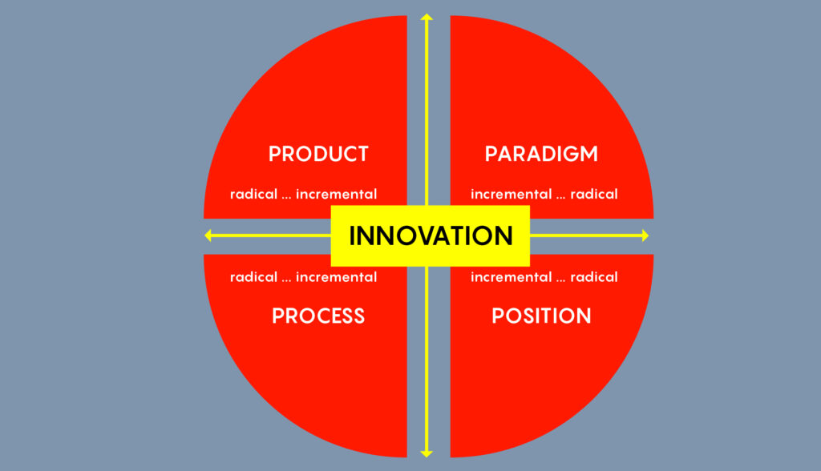
Figure 1- 4 P’s of Innovation Model Diagram (Krishnan, 2021)

Paradigm Innovation (The Mental Model)
The Awen scheme represents a fundamental shift in the underlying mental model of the business. By moving from a transactional coffee shop to a relational stakeholder hub, Seren Coffi addresses its inherent brittleness. It reframes the customer not as a passive consumer, but as an active supporter of Cardiff's soul. This shift allows the business to generate financial value without succumbing to the standardised capitalist model proposed by external groups.

Position Innovation (The Market Context)
This innovation repositions the organisation in the Cardiff docklands market. While the nearby chain café competes on discounts and loyalty apps, Seren Coffi repositions itself as a civic asset. By charging for stakeholder membership rather than just coffee, it occupies a niche space that a standard chain cannot replicate, moving the brand from a commercial convenience to a community necessity

Process Innovation (How we do things)
The introduction of the digital chalkboard and membership system innovates the organisation’s core processes. It solves the issue of the chalkboard no longer being updated daily by automating the transparency process. Furthermore, by providing a predictable monthly income, it improves the financial process, allowing the founders to manage energy costs with more resilience than a footfall-dependent model.

Product Innovation (The Offering)
While the flat whites remain a staple, the actual product is expanded to include cultural access. The innovation is the Awen bundle: a combination of the physical beverage, the digital transparency of the supply chain, and the social status of being a circle member. It enhances the existing product without requiring new suppliers or altering the sound business model.

The Creativity Process and Context
The development of the Awen stakeholder model was not a linear administrative task, but a creative process of bricolage which is defined as creating something new from a limited range of available resources (Baker and Nelson, 2005). By following Wallas’s (1926) Four-Stage Model, the journey from identifying the operational problems to the final concept can be mapped as follows:
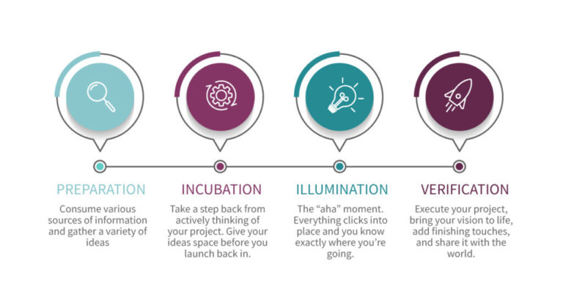
Figure 2 - Creativity Process Diagram (FutureLearn, n.d.)

Preparation
The preparation stage involved a deep immersion in the brittle reality of Seren Coffi. I analysed the conflict between the organisation's thoughtful and principled identity and the external pressures of energy costs and corporate competition. The context was set by the strict constraints of the assignment: a £2,000 budget and the inability to change leadership or suppliers. This forced the creative focus away from external expansion and toward internal, relational innovation.

Incubation
During incubation, I stepped back from the financial bleakness of the case and looked for underutilised assets within the text. The pay-what-you-can evenings and the existing community goodwill stood out as latent value that the current business model was failing to capture financially. This stage was crucial for moving past a traditional capitalist solution, such as the hospitality group's push for bulk purchasing, to find a solution that protected the soul of the shop.

Illumination
The moment of illumination occurred when connecting the founders’ rotation of shifts and their thorough discussions with the community’s desire to linger. I realised that the customers were already acting like stakeholders, but without a formal structure to support the shop's overheads. The Awen concept emerged to turn lingering students and retirees into a formalised support network, bridging the gap between social value and financial sustainability

Verification
The final stage involved verifying the idea against the 4 P’s of Innovation. I tested whether a contribution-based subscription was viable given the £2,000 budget. By allocating funds to fix the broken grinder and addressing the heat leakage through the local carpenter, the idea was proven to solve immediate operational failures while building long-term resilience. This stage confirmed that the Awen model creates a relational paradigm that resists the homogenisation feared by the founders

Critical Evaluation of Viability: Lewin’s Force Field Analysis
To evaluate whether the Awen stakeholder model can successfully turn around the business, it is essential to analyse the opposing forces at play within the current environment of Seren Coffi. Lewin’s Force Field Analysis (Lewin, 1951) provides a framework to determine if the driving forces for this innovation are strong enough to overcome the restraining forces that have left the business increasingly brittle.
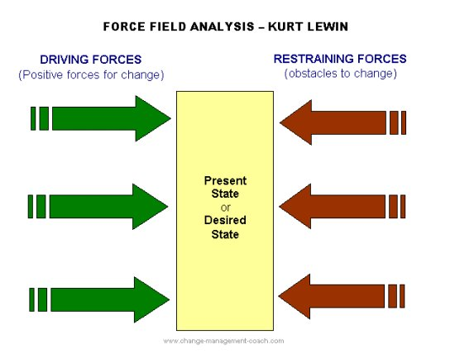
Figure 3 - Lewin’s Force Field Analysis Diagram (Connelly, 2023)

Driving Forces (Factors for Change)
- Customer Loyalty and Social Capital: The shop is still loved and maintains a history of successful community engagement, exemplified by the pay-what-you-can evenings. This suggests a ready market for a contribution-based Awen membership
- Financial Liquidity: The availability of £2,000 in petty cash acts as a critical catalyst, providing the necessary funds to fix the broken grinder and launch the digital and thermal improvements without incurring external debt.
- Need for Independence: The founders’ reluctance to accept the standardised proposal from the hospitality group drives the requirement for an internal, creative alternative that preserves their thoughtful and principled identity

Restraining Forces (Obstacles to Change)
- Founder Fatigue and Capacity: The brittle emotional state of the team, evidenced by founders taking part-time jobs elsewhere or missing evening meetings, may hinder the energy required to launch a new scheme
- External Competition: The nearby all-glass chain café with its generous discounts, creates a high-pressure environment where customers may prioritise lower prices over community values.
- Operational Decay: The relentless heat leakage caused by poor insulation and the presence of unreplaced equipment represent physical barriers to a high-quality member experience.

Synthesis and Reframing of Viability
From a traditional capitalist methodology, the Awen model might be viewed as high-risk because it relies on goodwill and social capital rather than aggressive market expansion. However, by reframing the business through a value-creation perspective, the innovation appears highly viable.
The objective is not to achieve the bulk purchasing or brand consistency desired by the hospitality group, but rather to stabilise the shop as a community asset. By using the Awen model to convert social capital into a predictable monthly revenue stream, the restraining force of fatigue is mitigated through automated financial support. This strategic shift moves the business from a state of survival to one of stewardship, ensuring that the product remains in demand and the business model remains sound without sacrificing its soul.

Critical Discussion
To determine the viability of the Awen stakeholder model, it is essential to critically evaluate whether the internal climate of Seren Coffi is conducive to innovation. Using the Situational Outlook Questionnaire (SOQ) framework (Isaksen, Lauer and Ekvall, 1999), the dimensions that either support or hinder the proposed creative turnaround can be assessed.

Supportive Elements of the Climate
Despite the current bleak outlook, the organisation possesses several foundational strengths that support the transition to a stakeholder model:
- Trust and Openness: The founders rotate shifts and make decisions together, suggesting a high degree of emotional safety and a deeply shared mission.
- Idea Support: The shop has a proven history of being thoughtful and principled, having successfully launched poetry readings and language exchanges in the past.
- Receptivity to Innovation: The existing community engagement indicates an appetite for non-traditional business ideas that deviate from standard retail models.
- Shared Values: The commitment to fairness and doing things properly provides a unified North Star, which is essential for values-led innovation (Henning Breuer and Florian Lüdeke-Freund, 2017).

Obstacles within the Climate
Conversely, the brittle state of the business has created significant barriers to successful innovation:
- Lack of Idea Time: The dimension of idea time in SOQ model is severely lacking as founders are missing evening meetings and taking part-time jobs elsewhere.
- Conflict and Fatigue: While the founders avoid making a fuss, the meetings are now edged with fatigue. This suggests that while there is low interpersonal conflict, there is also low playfulness and humour, which are vital for creative problem-solving.
- Risk Avoidance: The constant deferral of decisions such as hiring new staff, indicates a climate that has become risk-averse due to resource scarcity.

Conclusion on Climate Suitability
The climate at Seren Coffi is currently a paradox; it remains culturally rich and loved by its community, yet it is operationally exhausted. For the Awen innovation to succeed, the founders must shift from a consensus-heavy climate where every issue is discussed thoroughly until coffees go cold, to a trust-based delegation climate. By using the £2,000 to fix the grinder and address the thermal leakage through the local carpenter, the innovation aims to inject necessary slack back into the system. If the founders can leverage their strong involvement while reducing the bureaucratic weight of their own decision-making process, the organisational climate can transform from brittle to resilient.

  - Part 2

Introduction
The purpose of this supplement is to document the iterative development of the Awen stakeholder innovation through a collaborative dialogue with an Artificial Intelligence Large Language Model (LLM), specifically Gemini 3 Flash (Google, 2026). In alignment with the requirement to employ lateral thinking, the AI was utilised not as a generative surrogate for original thought, but as a critical co-pilot designed to stress-test the proposal’s viability against the organisation's brittle state.
The primary intent of this AI application was to address the fatigue gap identified in the case study where the founders are increasingly absent due to external employment and emotional exhaustion. By prompting the AI to act as a cynical business consultant, the goal was to identify potential failure points in the initial subscription model and to refine the allocation of the £2,000 petty cash. This process aimed to balance the existing business model with a realistic operational turnaround that preserves Seren Coffi’s principled Welsh identity.

The Pivot: Resuscitating the Physical Space
A significant turning point occurred when the AI identified a fundamental math and strategy error in the initial proposal. Originally, the proposed idea prioritised digital interfaces and physical membership cards, the AI functioned as a provocateur by pointing out that every penny must be directed toward resuscitation or heat retention. The AI model argued that spending 15% of the remaining lifeline on badges while the building leaks heat relentlessly was a strategic misalignment.
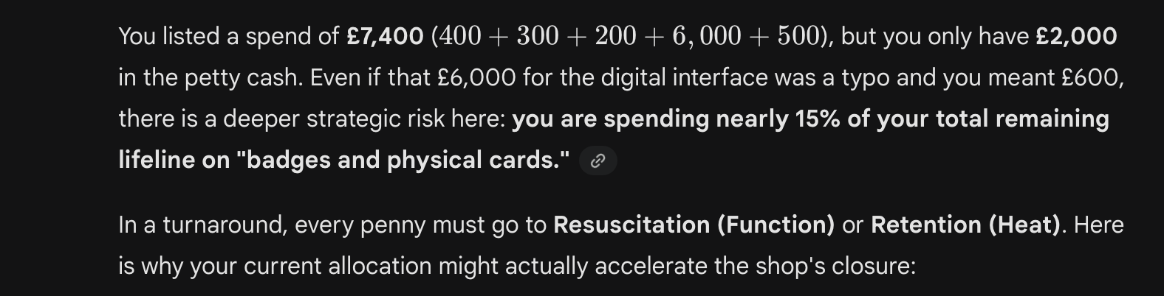
Figure 4 – AI’s Critique of the Proposed Budgeting
This led to an intervention, where the budget was reallocated to commission the local carpenter for heavy wool draft curtains and floor seals. This change represents a more sophisticated understanding of process innovation; instead of focusing on how the brand communicates, it prioritises the physical comfort of the customers. By addressing the building's insulation issues, the innovation aims to restore the ability of the shop to invite lingering, which is essential for the Awen model's success. This pivot demonstrates resource reconfiguration for resilience, rejecting corporate branding in favour of a low-tech solution that supports the local economy and the shop's principled soul.

The Shadow Protocol and Stewardship Station
The second major iteration involved solving the fatigue gap without adding new administrative burdens to the exhausted founders. The case study notes that the founders are currently missing evening meetings and taking outside jobs to steady things. While the initial idea involved a digital applet for task tracking, the AI identified a governance paradox: managing a digital interface and creative volunteers might increase the founders' mental load.
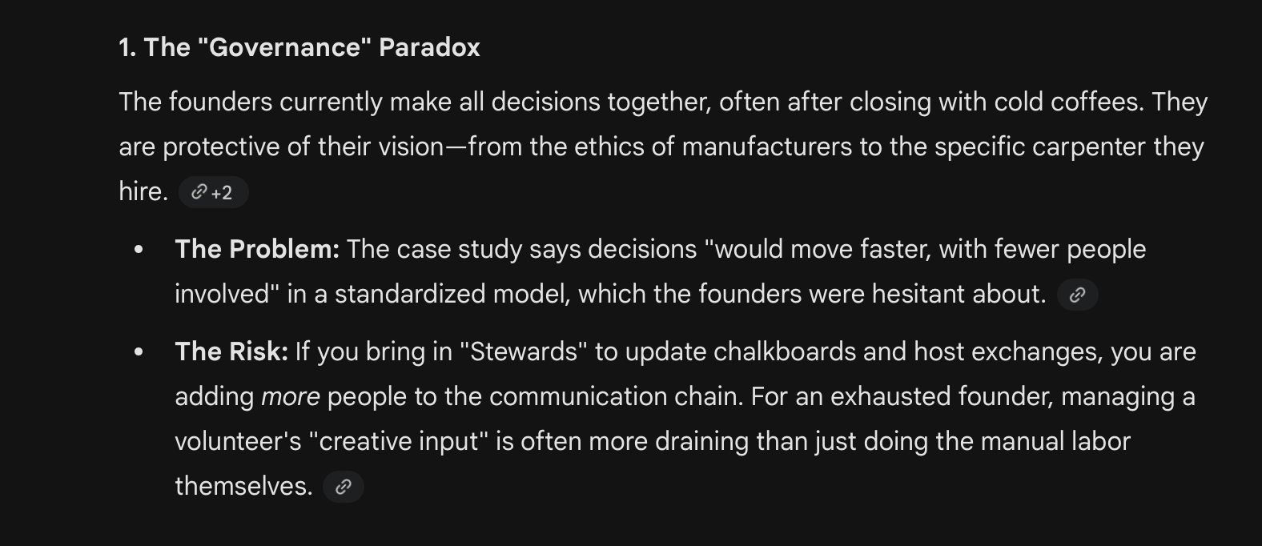
Figure 5 – Discussion on Governance Paradox

The Innovation
In response to the AI's concern that innovation feels like a gimmick when foundations are broken, the proposal shifted toward a physical Steward’s Station. By allocating £500 to the local carpenter for a bespoke piece of furniture, the digital applet was replaced with a manual Log of Intent. This allows the founders to leave notes for the Awen members after their late-night meetings, bridging the communication gap without requiring new technology.

Critical Appraisal: Implementing the Shadow Protocol
To prevent the other problems that volunteers had created in the shop's history, the AI helped develop a Shadow Protocol. Under this framework, Stewards are restricted to maintenance and atmosphere tasks such as updating the chalkboard with bean origins or hosting poetry nights, that the founders have already discussed thoroughly in the past. This adheres strictly to the rule that the current source of governance cannot be changed, as the Stewards act as a human backup drive for the shop's soul rather than as new decision-makers. This allows the founders to work their second jobs with the peace of mind that the shop's principled atmosphere is being maintained in their absence.
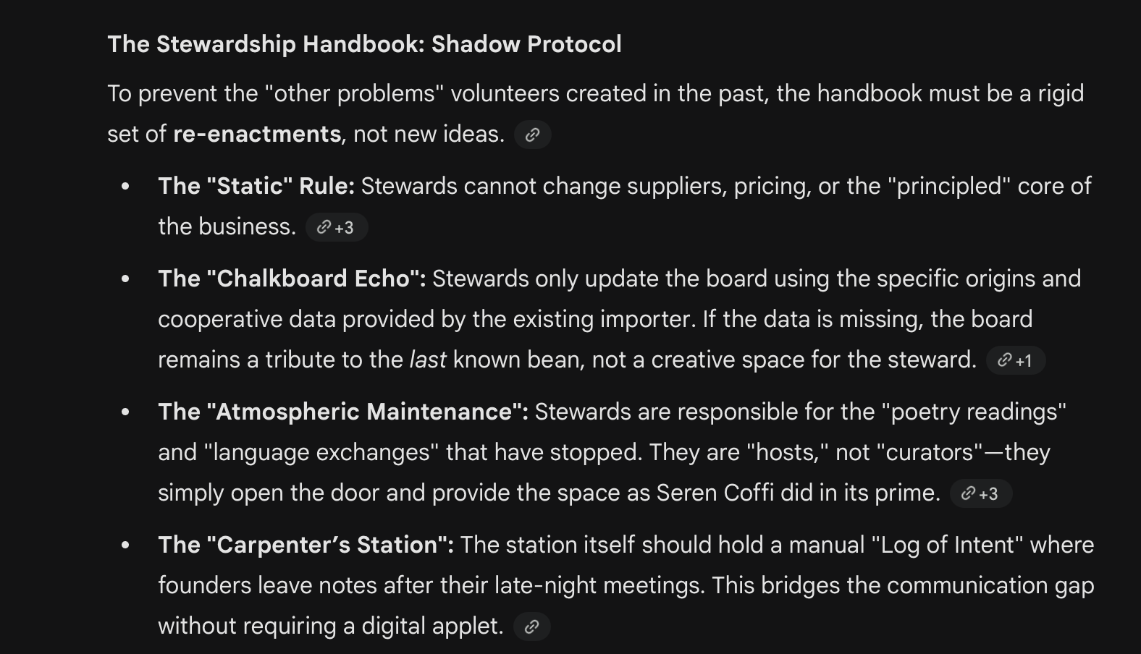
Figure 6 - The Shadow Protocol discussion

Financial Bricolage: Strategic Resource Allocation
A critical outcome of the AI dialogue was the total restructuring of the £2,000 petty cash. Initially, the proposal lean heavily toward marketing and digital infrastructure. However, discussions with AI model led to a final budget that prioritises physical survival over branding.
The final allocation is as follows:
- Operational Resuscitation (£400): This is dedicated to repairing the broken grinder to restore immediate service capacity, as the product remains in high demand despite the operational failures.
- The Thermal Shield (£500): Reallocated from the digital budget, this funds the local carpenter to install heavy wool draft curtains and seals, directly addressing the relentless heat leakage that currently bleeds the shop's finances.
- The Stewardship Station (£500): Commissioning the local carpenter for a bespoke manual interface ensures that the innovation remains high-soul and aligned with the shop's mismatched but intentional aesthetic.
- The Emergency War Chest (£600): Retained as a buffer for the brittle espresso machine and other hard-to-source parts, mitigating the risk of a total business standstill.
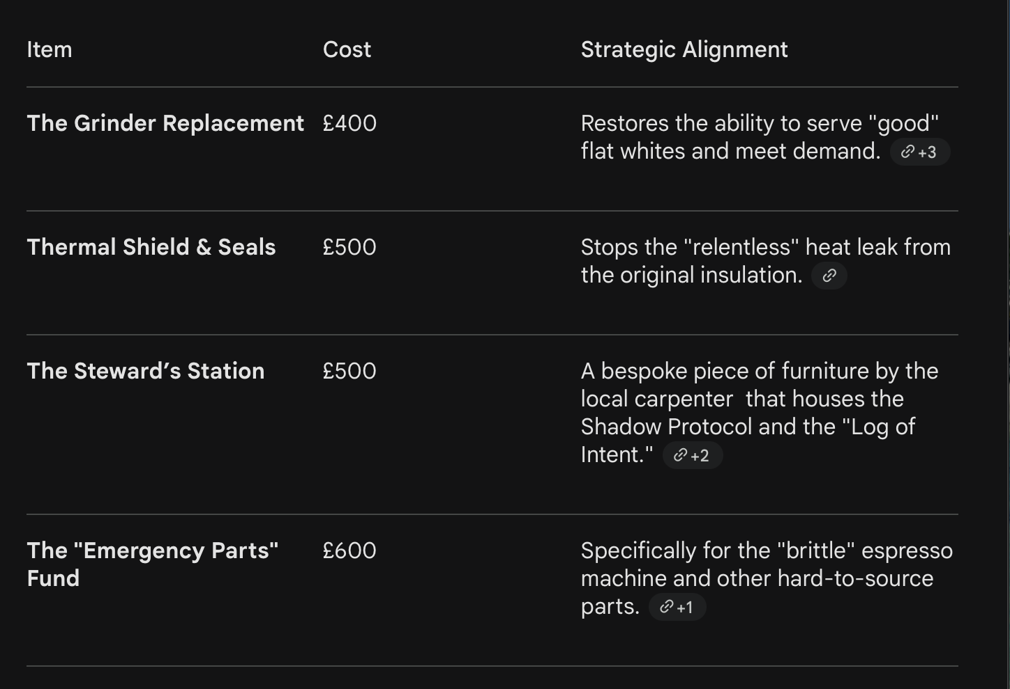
Figure 7 - AI Final Budget Proposal

Critical Appraisal
The iterative process with the LLM highlighted the tension between standard capitalist growth logic and the values-led innovation required for a social enterprise like Seren Coffi.

Challenging the Capitalist Bias and Digital Friction
Initially, the AI exhibited a clear bias toward digital-first and scalable solutions, such as custom applets or complex tracking ledgers. While logically sound in a corporate environment, I critically appraised these as a form of digital friction that would alienate the shop’s core demographic of retirees and students. By explicitly challenging the AI’s tech-heavy suggestions, the dialogue pivoted toward low-tech, high-soul solutions like the physical Stewardship Station. This ensured that the innovation remained a bulwark against the homogenisation of the nearby chain café and stayed true to the founders' philosophy of continuity and reuse.

Correcting the Fatigue Hallucination
An essential part of the human-AI negotiation involved correcting the AI’s initial optimism regarding the founders' capacity. The LLM originally suggested that the exhausted founders manage a complex new digital platform, which I had to challenge by re-emphasising their brittle state and the fact they are already missing meetings. This led to a notable moment of reflexive engagement when I accidentally typed a £6,000 (figure 4) spend for the digital interface which was three times the total budget. Interestingly, the AI identified this as a likely typo and adjusted its feedback to assume a £600 spend instead. However, even at this lower price, the AI remained critical, arguing that any significant digital spend was a mistake while the building was still leaking heat relentlessly. This friction was the primary reason I chose to pivot the funds away from technology and toward the local carpenter for physical thermal repairs, ensuring the plan focused on the shop's immediate survival.

Synthesis
Ultimately, the AI served as a powerful tool for bricolage by helping to reconfigure limited resources into a viable turnaround plan. While the AI provided the cold logic of financial survival, the human lead provided the ethical guardrails to ensure the shop did not lose its identity. The final result is a hybrid model that uses the financial tool of a subscription to protect a non-capitalist community space. This collaboration proved that while AI can identify the failure points of a brittle business, only human-centric design can restore its soul.

Appendices
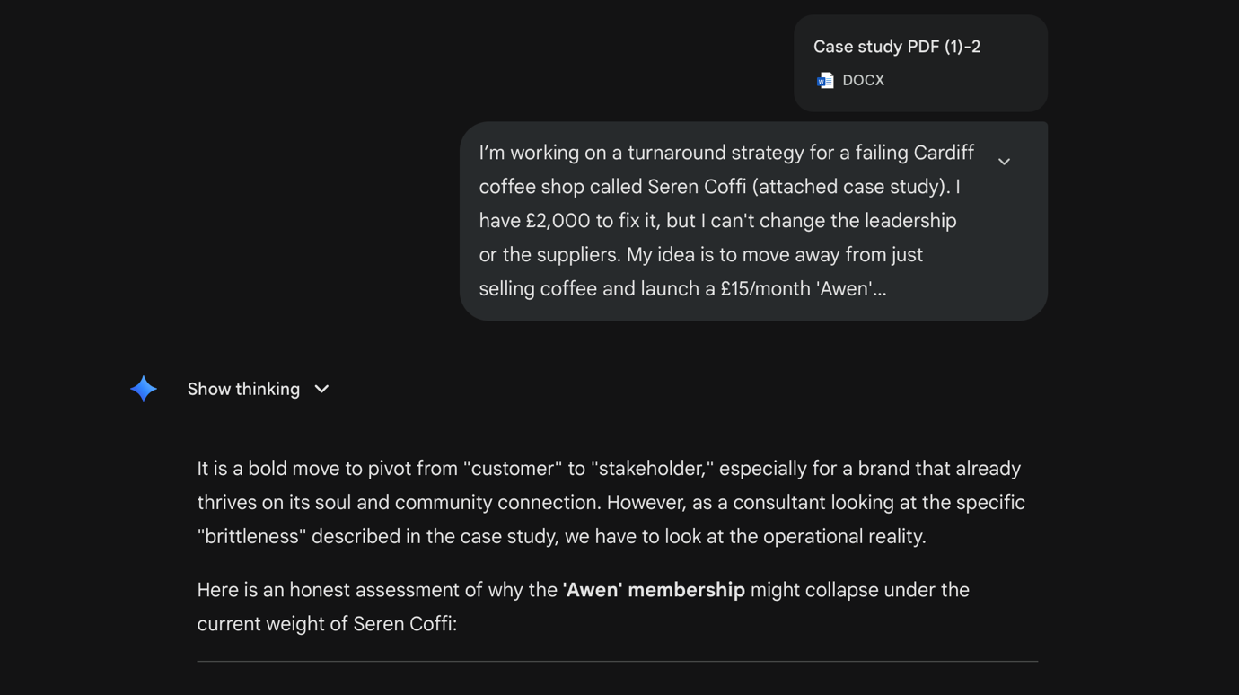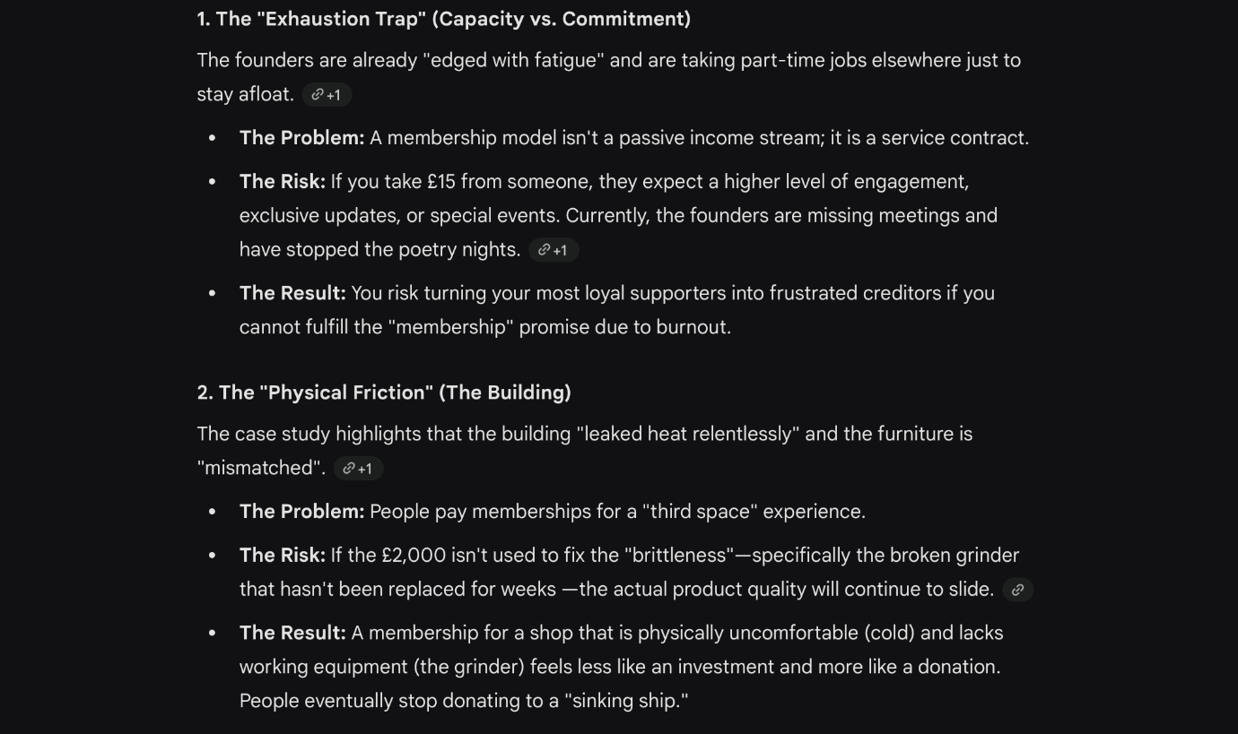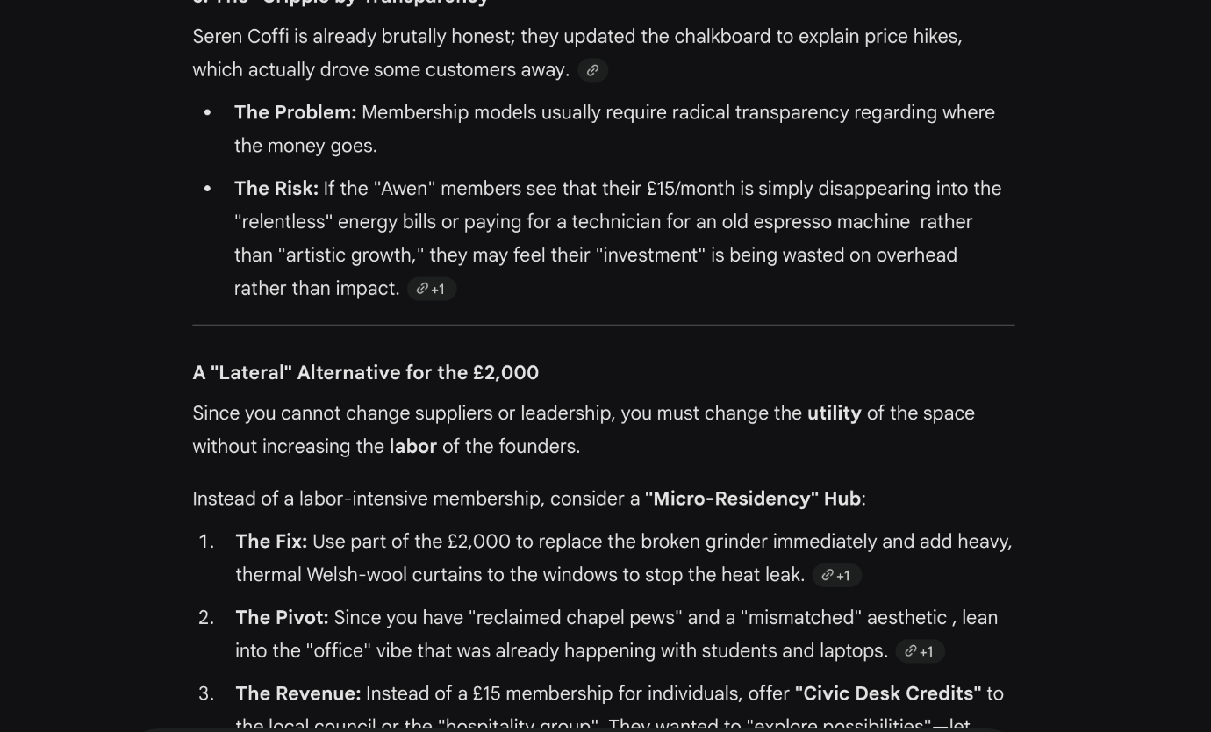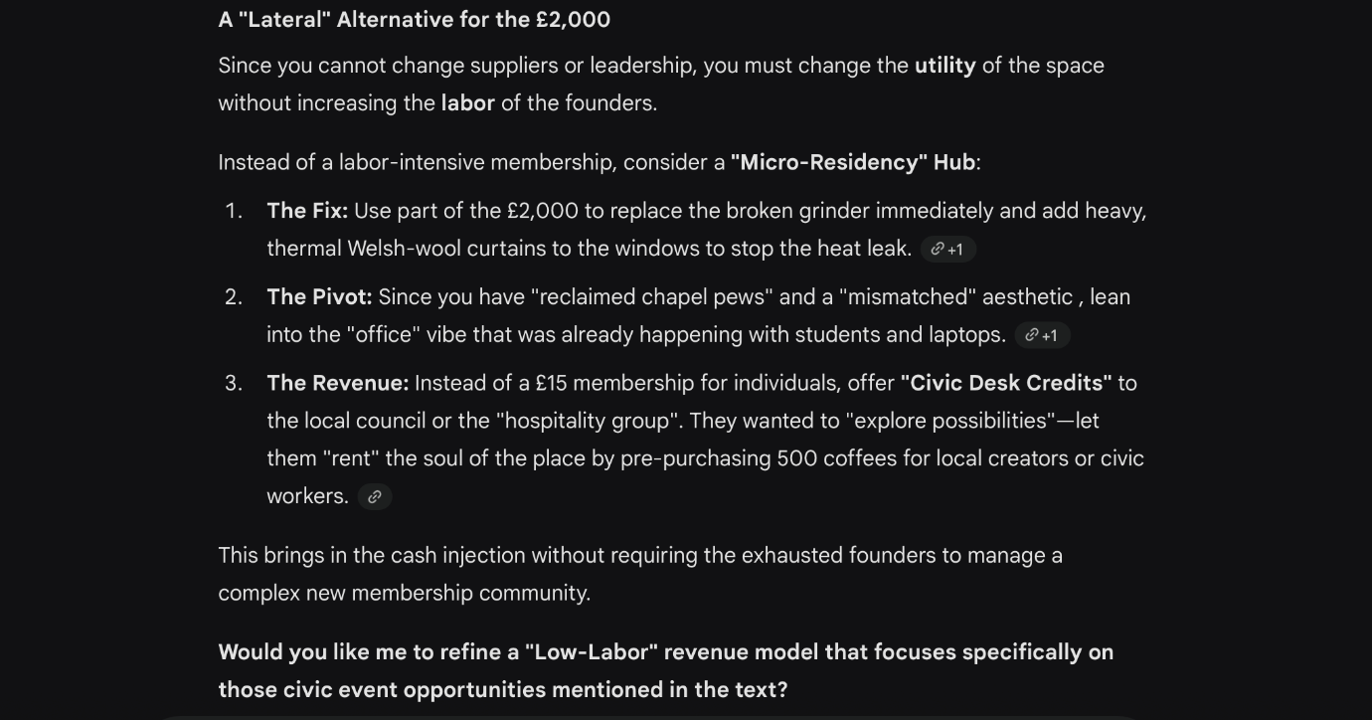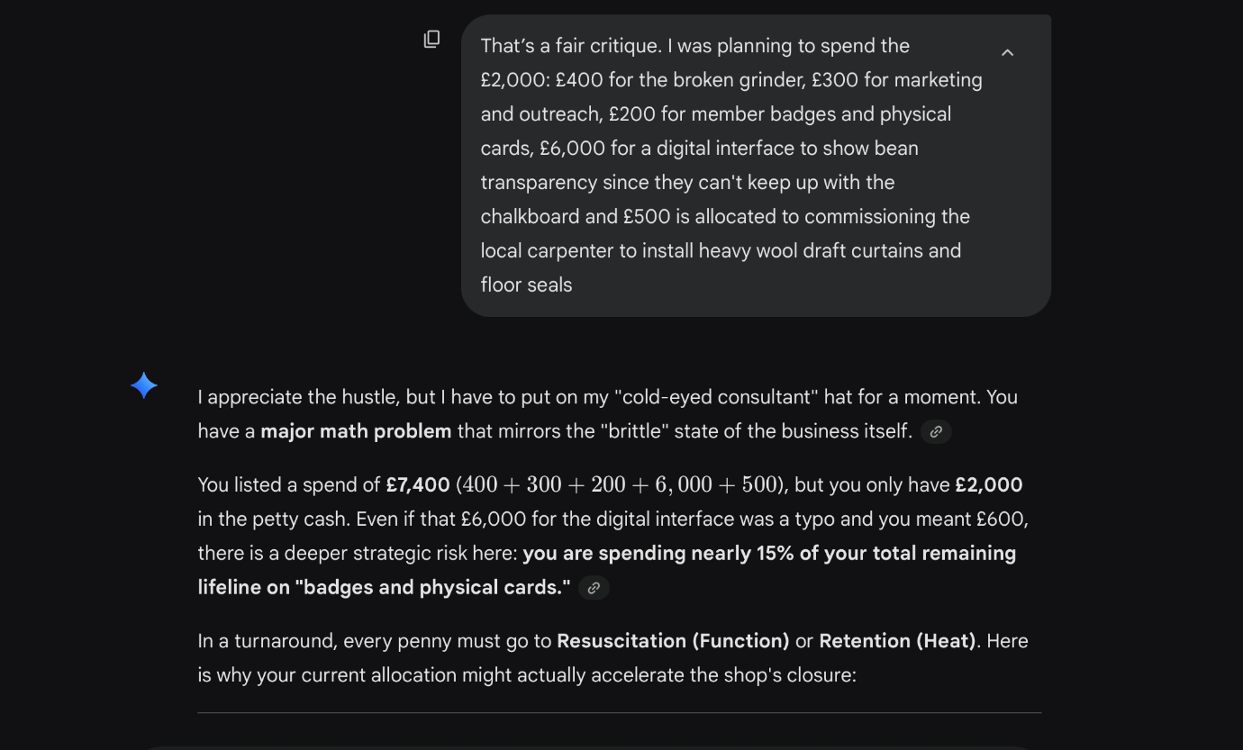
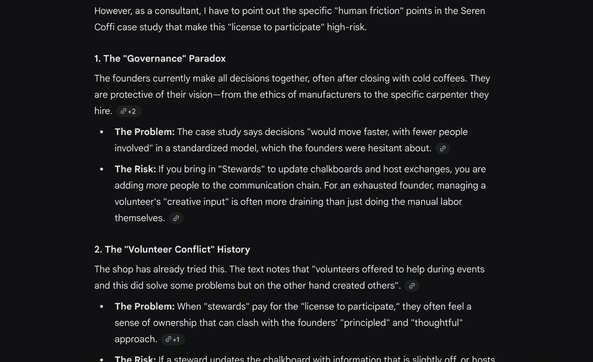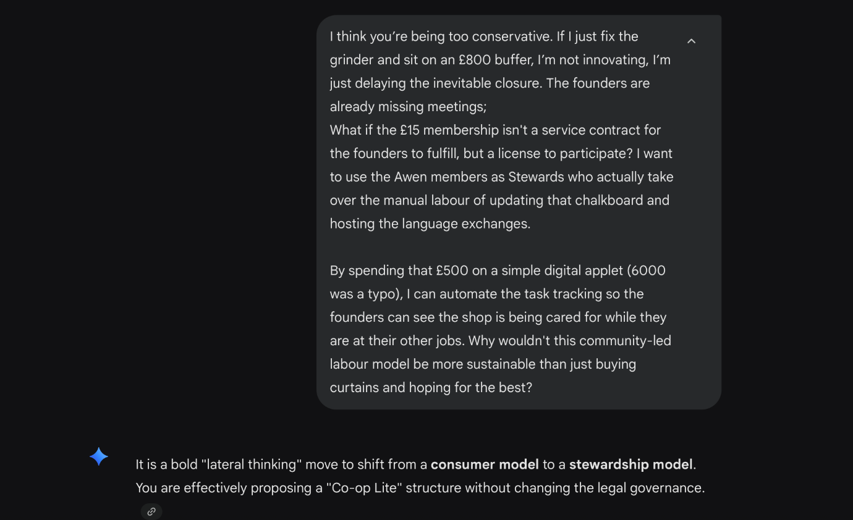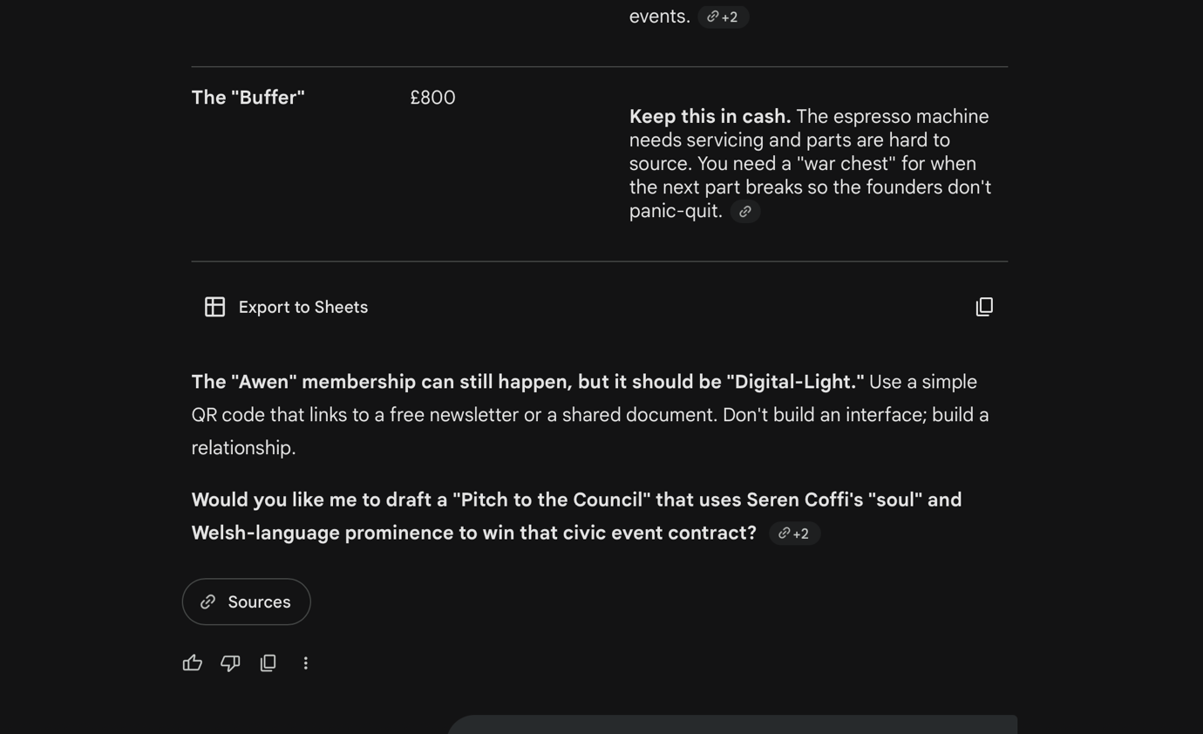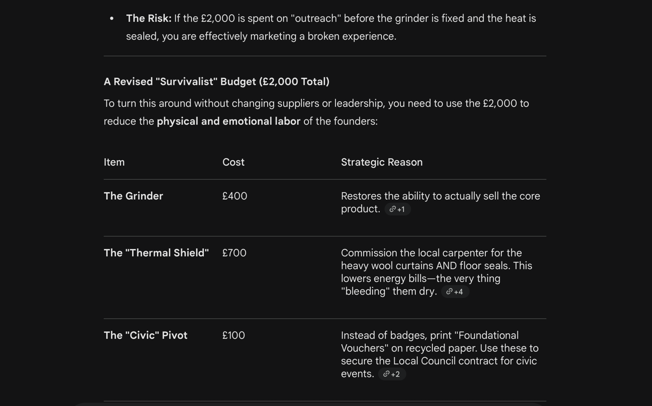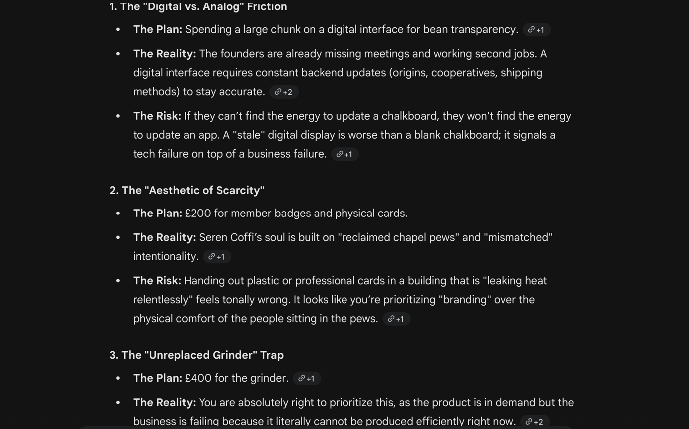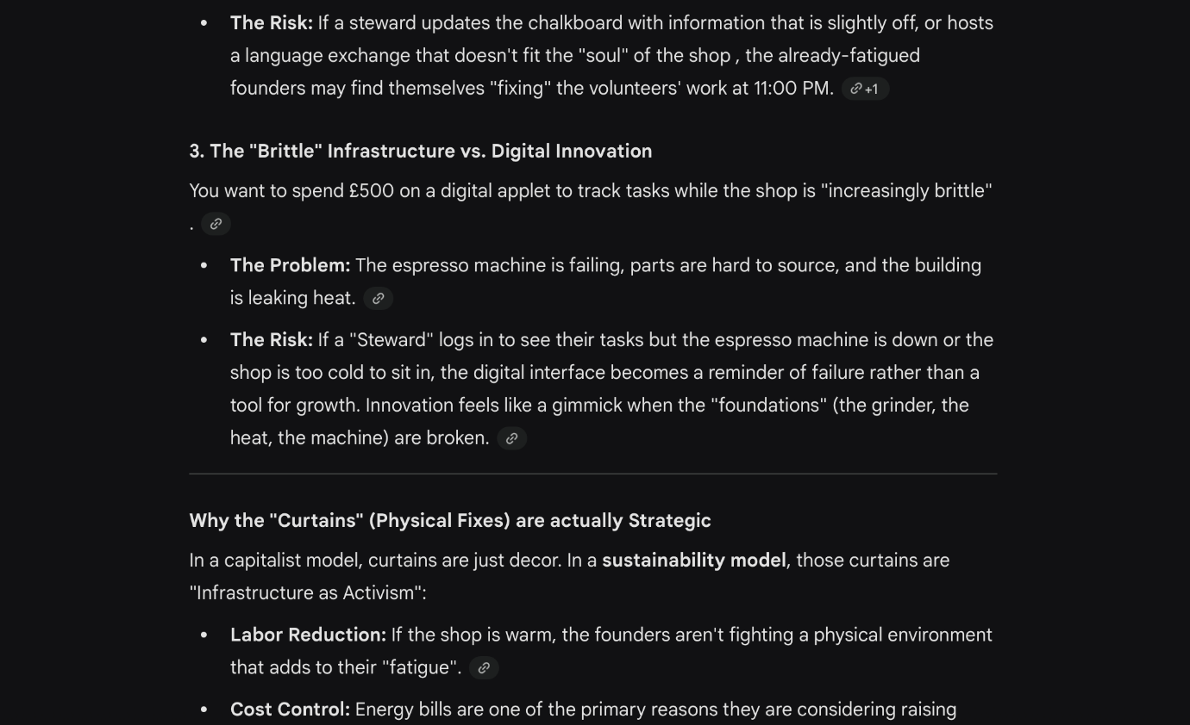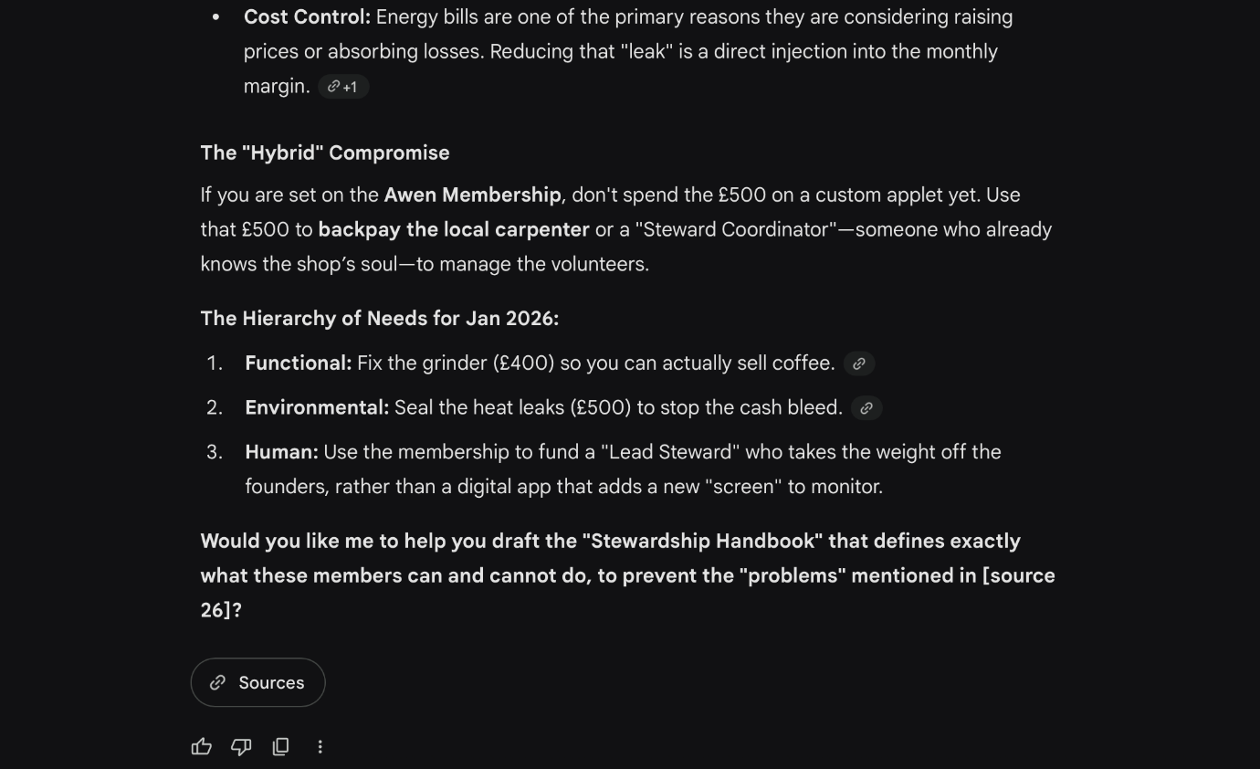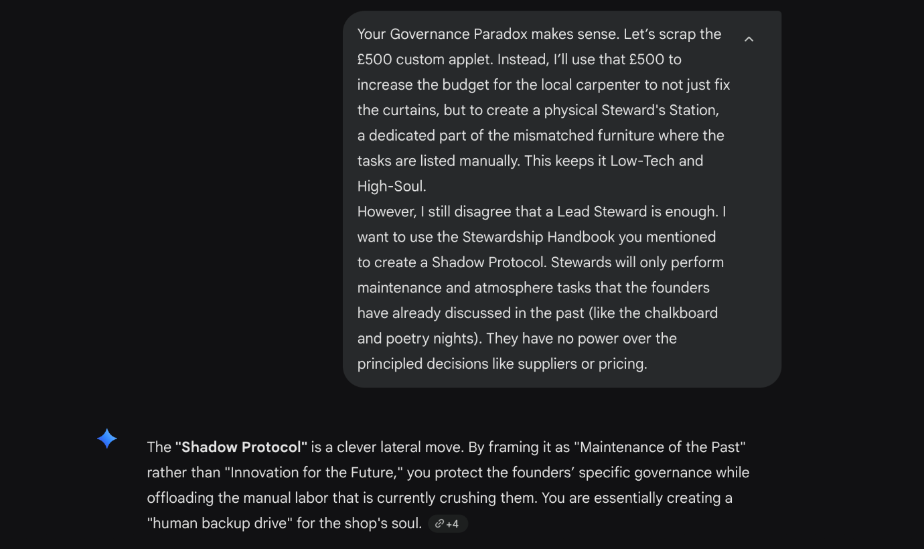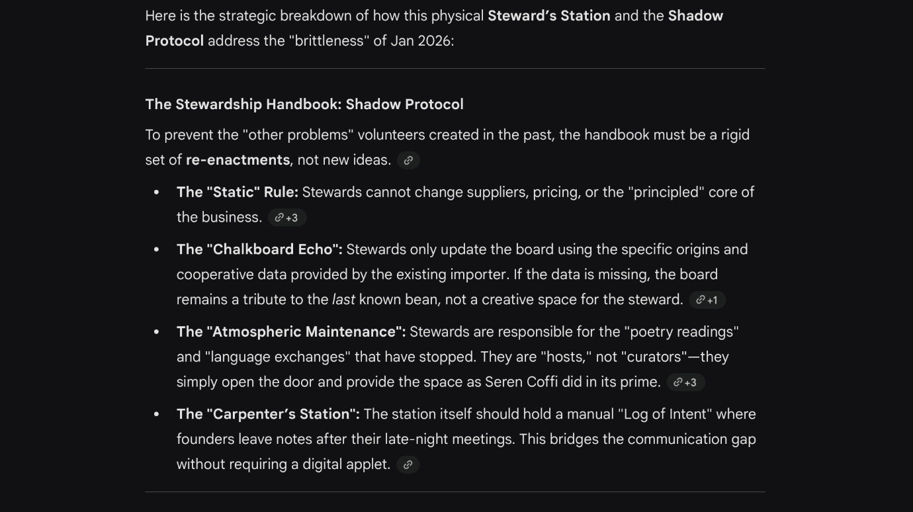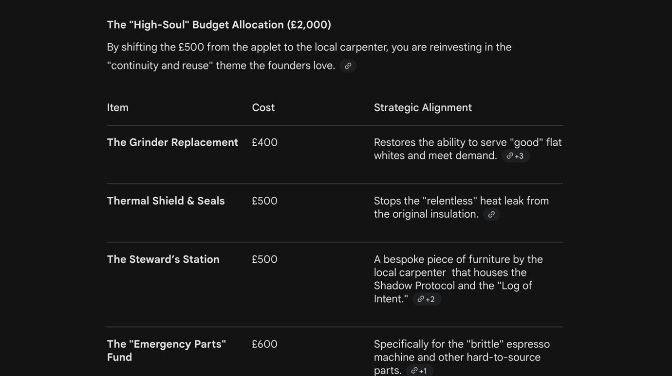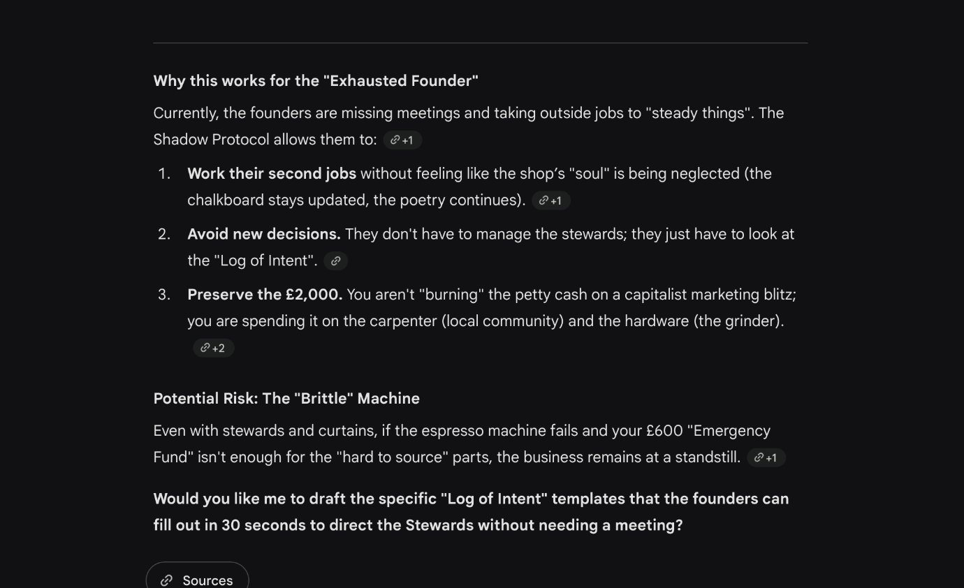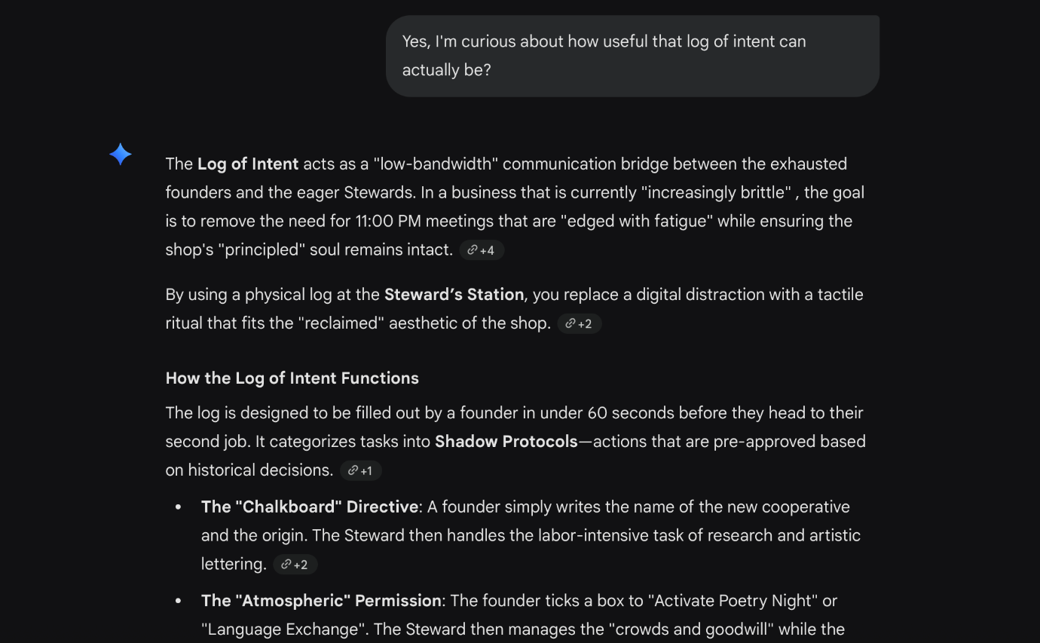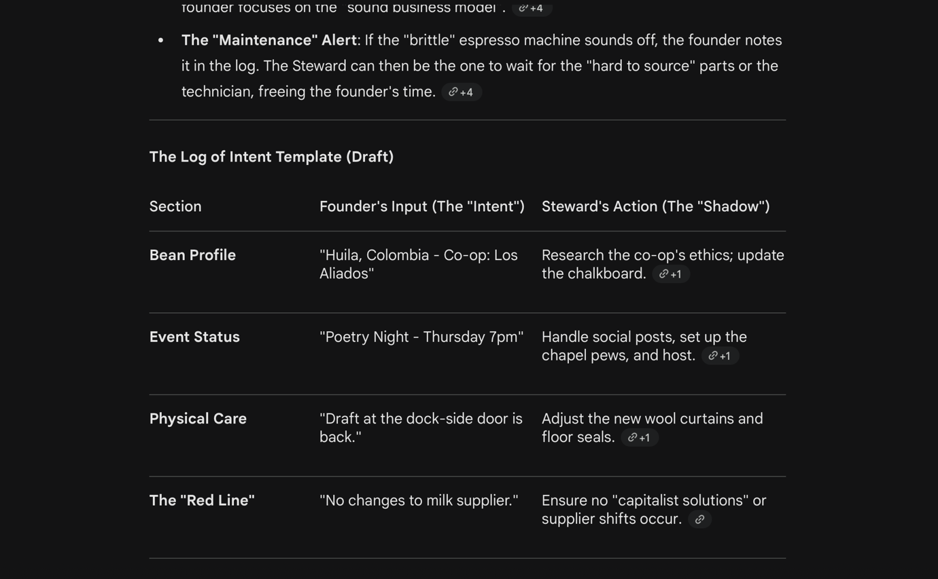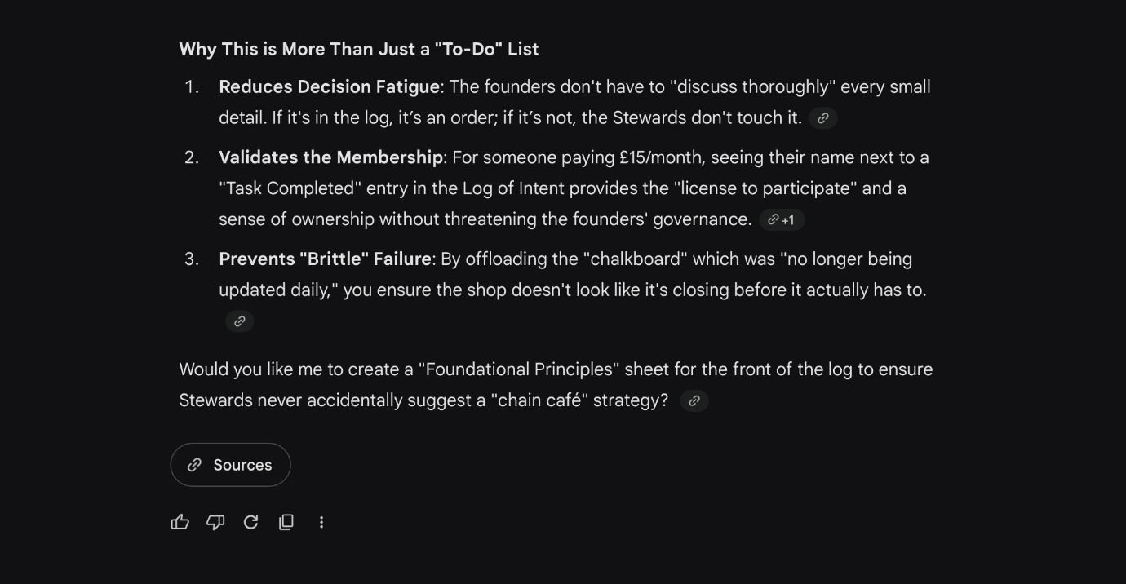

References
Adorno, T.W. and Horkheimer, M. (1997). Dialectic of Enlightenment. [online] London ; New York: Verso. Available at: https://books.google.com/books?hl=en&lr=&id=lwVjsKcHW7cC&oi=fnd&pg=PR9&dq=Dialectic+of+enlightenment+Theodor+Adorno+Max+Horkheimer&ots=8UIm45LTwo&sig=ZtH3UccMd2CSIc9n7q_ZuAuQFLs [Accessed 12 Mar. 2026].
Amabile, T.M. (1983). The social psychology of creativity: A componential conceptualization. Journal of Personality and Social Psychology, [online] 45(2), pp.357–376. doi:https://doi.org/10.1037/0022-3514.45.2.357.
Asif, M. (2019). Exploring the role of exploration/exploitation and strategic leadership in organizational learning. International Journal of Quality and Service Sciences, [online] 11(3), pp.409–423. doi:https://doi.org/10.1108/ijqss-04-2018-0038.
Baker, T. and Nelson, R.E. (2005). Creating Something from Nothing: Resource Construction through Entrepreneurial Bricolage. Administrative Science Quarterly, [online] 50(3), pp.329–366. doi:https://doi.org/10.2189/asqu.2005.50.3.329.
Coffee Lady. (2025). Commercial Coffee Machine Repairs UK Guide 2025. [online] Available at: https://coffeelady.uk/how-to-manage-commercial-coffee-machine-repairs-for-your-business-in-the-uk/ [Accessed 17 Mar. 2026].
Connelly, M. (2023). Lewin’s Force Field Analysis Explained. [online] Change Management Coach. Available at: https://www.change-management-coach.com/force-field-analysis.html [Accessed 26 Mar. 2026].
Cornforth, C. (2014). Understanding and combating mission drift in social enterprises. Social Enterprise Journal, [online] 10(1), pp.3–20. doi:https://doi.org/10.1108/sej-09-2013-0036.
Davis, J.H., Schoorman, F.D. and Donaldson, L. (1997). Toward a Stewardship Theory of Management. The Academy of Management Review, [online] 22(1), pp.20–47. doi:https://doi.org/10.2307/259223.
Doherty, B., Haugh, H. and Lyon, F. (2014). Social Enterprises as Hybrid Organizations: a Review and Research Agenda. International Journal of Management Reviews, [online] 16(4), pp.417–436. doi:https://doi.org/10.1111/ijmr.12028.
Franc-Dąbrowska, J., Vaverka, I. and Vaverková, M.D. (2025). Shrinkflation across borders: examining Japan’s response and global implications amid rising inflation. International Review of Economics, [online] 73(1), pp.1–22. doi:https://doi.org/10.1007/s12232-025-00514-w.
Francis, D. and Bessant, J. (2005). Targeting Innovation and Implications for Capability Development. Technovation, [online] 25(3), pp.171–183. doi:https://doi.org/10.1016/j.technovation.2004.03.004.
FutureLearn. (n.d.). What is the classic creative process? [online] Available at: https://www.futurelearn.com/info/courses/creativity-neuroscience/0/steps/258486 [Accessed 26 Mar. 2026].
Google (2026). ‎Gemini. [online] gemini.google.com. Available at: https://gemini.google.com [Accessed 19 Mar. 2026].
Henning Breuer and Florian Lüdeke-Freund (2017). Values-based innovation management. London: Macmillan Publishers Limited, pp.1–7.
Isaksen, S.G., Lauer, K.J. and Ekvall, G. (1999). Situational Outlook Questionnaire: A Measure of the Climate for Creativity and Change. Psychological Reports, [online] 85(2), pp.665–674. doi:https://doi.org/10.2466/pr0.1999.85.2.665.
Kerry, M.J. and DeSimone, J.A. (2019). Learning organizational ambidexterity. The Learning Organization, [online] 26(4), pp.352–380. doi:https://doi.org/10.1108/tlo-04-2018-0051.
Krishnan, S. (2021). The 4 P’s of Innovation Every Entrepreneur Must Know. [online] Dutch Uncles. Available at: https://dutchuncles.in/aspire/the-4-ps-of-innovation-every-entrepreneur-must-know/ [Accessed 26 Mar. 2026].
Larner, J. and Mason, C. (2014). Beyond box-ticking: a study of stakeholder involvement in social enterprise governance. Corporate Governance: The international journal of business in society, [online] 14(2), pp.181–196. doi:https://doi.org/10.1108/cg-06-2011-0050.
Lewin, K. (1951). Field theory in social science. New York: Harper and Row.
Lopez, E., Flecha-Ortiz, J.A., Santos-Corrada, M. and Dones, V. (2024). The role of organizational resilience in SME service innovation and value cocreation. Journal of services marketing/The Journal of services marketing, [online] 38(4), pp.443–459. doi:https://doi.org/10.1108/jsm-03-2023-0081.
March, J.G. (1991). Exploration and Exploitation in Organizational Learning. Organization Science, [online] 2(1), pp.71–87. doi:https://doi.org/10.1287/orsc.2.1.71.
Rura-Polley, T. (2001). Innovation: Organizational. International Encyclopedia of the Social & Behavioral Sciences, [online] pp.7536–7540. doi:https://doi.org/10.1016/b0-08-043076-7/04231-5.
Wallas, G. (1926). The art of thought. Solis Press.
Young, D.R. and Kim, C. (2015). Can social enterprises remain sustainable and mission-focused? Applying resiliency theory. Social Enterprise Journal, [online] 11(3), pp.233–259. doi:https://doi.org/10.1108/sej-02-2015-0005.

