Sophie Evans (2108843)

Economics of Sustainability (BMSP6007)
Global Risks

Contents
Introduction 2
Main Body 3
Biodiversity loss and ecosystem collapse 3
Pollution 5
Impact of biodiversity loss and eco system collapse 9
Impact of Pollution 10
Sustainable Development Goals 13
Conclusion 14
Recommendations 15

Introduction
The report will identify global risks and discuss how the identified risks may impact global efforts on sustainable development. The risks that will be discussed are biodiversity loss and ecosystem collapse as well as pollution.
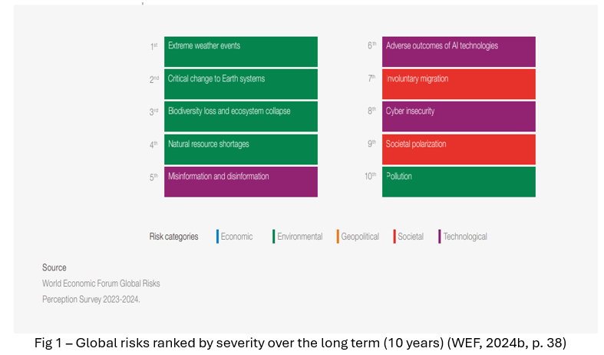
Every year the World Economic Forum (WEF) releases an annual report of the “Global Risks.” According to World Economic Forum (2024a) the report assesses some of the most significant risks humankind may encounter in the next ten years, amongst a context of swift technical advancements, economic instability, global warming, and conflicts. According to the World Economic Forum (2024b, p. 5) the term "global risk" refers to the probability of an occurrence of an event or situation that, if it materialises, will have a detrimental effect on a sizable section of the world's GDP, population, natural resources. The World Economic Forum (2024b, p. 38) has identified the most significant risks for the decade to come in the Global Risks Report. The diagram below (see Fig 1) highlights these risks. Therefore, this report will explore the risks of biodiversity loss and ecosystem collapse as well as pollution.

Main Body

Biodiversity loss and ecosystem collapse
According to Client Earth (2021) biodiversity refers to the assortment of species found in the natural world, encompassing plants, animals, insects, and microbes that inhabit our globe. Each of these organisms coexist and collaborate within ecosystems to sustain and facilitate life on earth, existing in a fragile equilibrium. According to National Geographic (2024) scientists have approximated that the total number of plant and animal species now in existence is around 8.7 million, with insects representing the majority of these species.
Iberdrola (2024) states that biodiversity loss pertains to the reduction or extinction of biological diversity, which encompasses the assortment of living organisms inhabiting the globe, their various degrees of biological organisation, and their corresponding genetic variability, as well as the inherent patterns seen in ecosystems. According to World Economic Forum (2020) when ecosystems collapse, they undergo a rapid deterioration in their organisation and operation, resulting in significant alterations to their size or scope, as well as the composition of the species that inhabit them.

According to the Royal Society (2024) the biodiversity of the earth is impacted by humanity in a variety of intentional and unintentional ways. Up until now, the largest danger to biodiversity has come from human habitat modification, which has been done to create room for farms or harvest natural resources. The Royal Society (2024) also states that 30% of the worldwide reduction in biodiversity is thought to be caused by changes in land use, mostly for large-scale food production. Around 20% of the problem is overexploitation, which includes overfishing, overhunting, and overharvesting for goods like food, medicine, and timber. Climate change is an influential factor directly causing the loss of biodiversity. When combined with pollution, these two factors account for 14% of biodiversity loss. Invasive alien species also contribute to the loss of biodiversity, comprising of 11%.

According to WWF (2022) since 1970, the number of animal species worldwide has decreased by an average of 69%, freshwater populations have declined by an average of 83%. The startling rate of decrease serves as a dire alert that the rich biodiversity that supports all life on Earth is in danger of collapsing, endangering all species, including humanity.

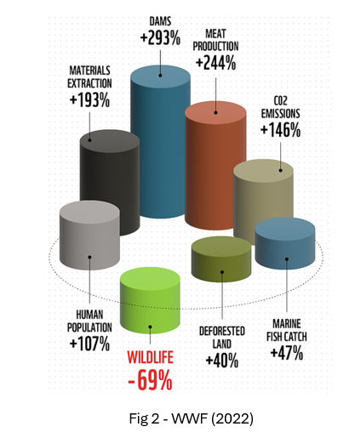

The WWF (2022) findings also assess biodiversity loss by region, highlighting regions that are severely at risk of ecosystem collapse. Fig 3 below illustrates that Latin America and the Caribbean have had a 94% reduction since 1970.

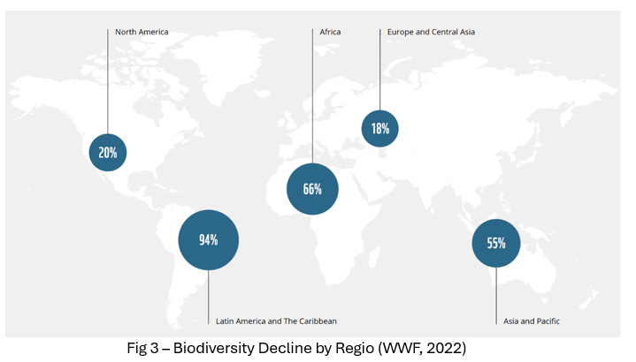

Pollution
According to Nathanson (2024) pollution refers to the introduction of any substance whether it is in solid, liquid, or gas form or any type of energy into the environment. The primary forms of pollution, often categorised by their respective environments, are air pollution, water pollution, and land pollution.
According to the World Health Organization (2024) Air pollution is the term used to describe any chemical, physical, or biological factor that tampers with the natural properties of the atmosphere to contaminate the interior or outdoor environment. Common causes of air pollution include motor vehicles, industrial operations, household combustion appliances, and forest fires. The World Health Organization (2024) also states that the majority of people on the planet (99%) breathe air that is high in pollutants and exceeds WHO guideline limits; the biggest exposures occur in low- and middle-income nations. According to EPA (2023) the United States released over 66 million tonnes of pollutants into the atmosphere in 2022. Visual Capitalist (2024) reports that the South Asian countries lead the world in PM2.5 Pollution (see Fig 4 below). Fine particulate matter (PM2.5) is defined as particles with a diameter of 2.5 micrometres or smaller, which can enter your lungs deeply and result in health issues. In addition to having high levels of air pollution, these nations also surpass the World Health Organization's set limits for air quality.

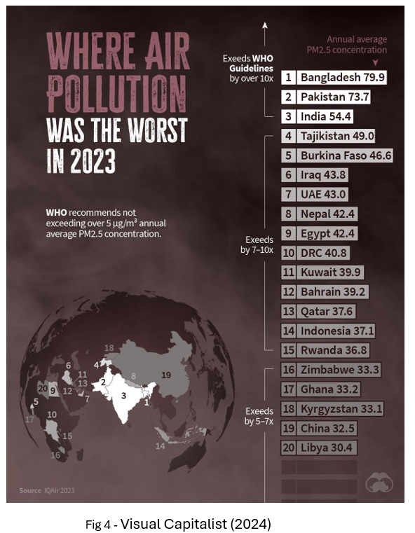
According to Denchak (2023) water pollution is the result of undesirable elements typically chemicals or microorganisms entering a stream, river, lake, ocean, aquifer, or other body of water, compromising its quality and making it hazardous for people and the environment. Iberdrola (2024) mentions that water pollution is mostly caused by bacteria, viruses, parasites, pharmaceutical products, fertilisers, pesticides, phosphates, nitrates, plastics, faeces, and even radioactive materials. Since these chemicals don't necessarily alter the water's colour, they are frequently imperceptible contaminants. Human activity is the primary source of water pollution. According to East Central University (2019) water pollution is impacted by agriculture as farmers frequently employ chemicals and pesticides to protect their crops from bacteria and insects. These compounds have the potential to affect people, plants, and animals when they leak into groundwater. Further water contamination results from the chemicals mixing with precipitation when it rains, flowing into rivers and streams that then filter into the ocean.
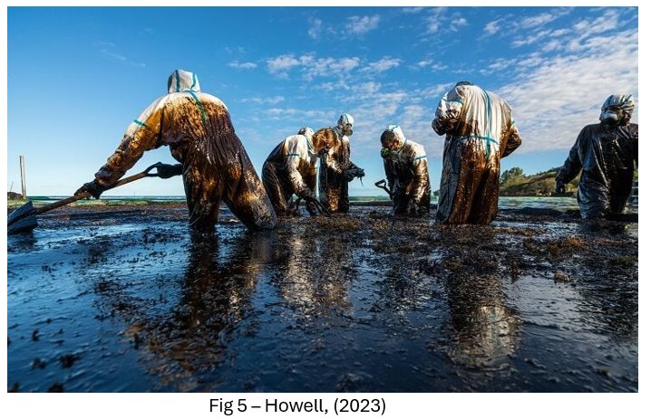
Howell (2023) mentions approximately 1,000 tonnes of oil leaked into the Indian Ocean as a result of an oil spill that occurred in Mauritius in 2020, resulting in a natural disaster. Oil left thousands of species drowning, with disastrous effects for Mauritius's health, food security, and economy.
According to Nathanson (2024) land pollution is the accumulation of solid or liquid waste products underground or on land in a form that can contaminate groundwater and soil, endanger public health, and result in unattractive settings and annoyances. Texas disposal systems (2024) the primary causes of land pollution include agriculture, mining, extraction, urbanisation, waste, and litter. According to Cladco (2023) 2021 saw 14 million tonnes of general waste dumped in landfills in the UK. Of this, 6.8 million tonnes were biodegradable waste that produced greenhouse gases. Tiseo (2024) mentions that land pollution has adverse effects on both animal and human health, and it also leads to the destruction of land. It is apparent that global land degradation is progressing at a pace that exceeds the capacity for restoration, hence impacting the security of food and water for millions of individuals. Between 2015 and 2019, the share of degraded land in Sub-Saharan Africa increased by over eight percent, indicating a rapid degradation in the region.
According to Obebe & Adamu (2020) one of the largest environmental problems today is plastic pollution. Only nine percent (9%) of the nine billion tonnes of plastic that have ever been created worldwide have been recycled, the majority ends up in dumps, landfills, or the environment—particularly the seas, which according to Alves (2024) can harm wildlife, particularly marine species, affect human health and devastate ecosystems. According to Mckay (2024) oceans throughout the world are also inhabited by plastic waste. Fig 6 below illustrates that there is 1.3 trillion pieces of plastic in the Indian Ocean and 930 billion in the North Atlantic.
Alves (2024) also states that the amount of plastics produced worldwide has increased twofold since the turn of the century, reaching about 400 million metric tonnes annually in 2021. Although plastic items have an average lifespan of ten years, the decomposition of plastics can take up to 500 years, depending on their composition and method of disposal. The increase of plastic consumption will have a negative overall affect and will continue to pollute the environment.

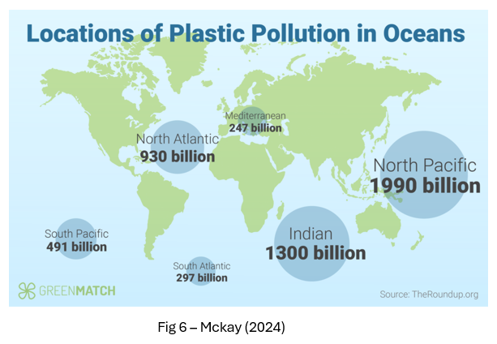

Impact of biodiversity loss and eco system collapse
According to Rafferty (2024) food security worldwide and the creation of novel medications to treat illnesses in the future are both threatened by biodiversity loss. A declining biodiversity impacts the productivity of an ecosystem—the quantity of food energy that is transformed into biomass—as well as the quality of the ecosystem's services, which typically include feeding the population, preserving the soil, and cleaning the water that flows through it. According to WEF (2020) the loss of biodiversity can have an impact on industries like agriculture as these sectors depend on natural resources such as soil, water, and land. The WEF (2020) also mention that half of global gross-domestic-product (GDP) are reliant on natural ecosystems and an ecological collapse would drastically lower global GDP and have serious economic repercussions.
Food security is defined as “physical, social, and economic access to sufficient, safe, and nutritious food that meets food preferences and dietary needs for an active and healthy life.” (Technoserve, 2022). According to the United Nations (n.d.) the 2023 State of food security & nutrition in the world reported that 122 million more individuals experienced hunger in 2022 compared to 2019—between 691 and 783 million people. A nutritious diet was unaffordable for more than 3.1 billion people. Malnutrition affects many children under the age of five. In addition to hunger, 900 million people had severe food insecurity and 2.4 billion people experience moderate or severe food insecurity. This can then be supported by the Malthusian theory of population which according to Kagan (2024) the theory states that populations continuously develops until they outgrow their food supply, at which point a disease, famine, war, or other disaster reverses the trend of population expansion. Economics Online (2021) states that the theory known as the "Malthusian Population Trap" holds that as a result of improved farming practices leading to greater food supply, population numbers rise. Due to the fact that the growing population must reside on land that was formerly utilised for crops, these increasing population levels subsequently cause food shortages.

Impact of Pollution
According to Kolkowska (2023) increased population causes more waste and pollution which contribute to air pollution, water pollution, and other environmental problems. Both human health and the planet's ecosystems are negatively impacted by this. It is estimated that pollution causes 7 million premature deaths annually. According to European Environment Agency (2023) the greatest threat to environmental health in Europe is air pollution, which also contributes significantly to illness and fatalities. Numerous conditions can be brought on by short- and long-term exposure to air pollution, such as lower respiratory infections, worsened asthma, trachea, bronchus, and lung cancers, stroke, and chronic obstructive pulmonary disease. Fig 7 below illustrates the health impacts of air pollution.

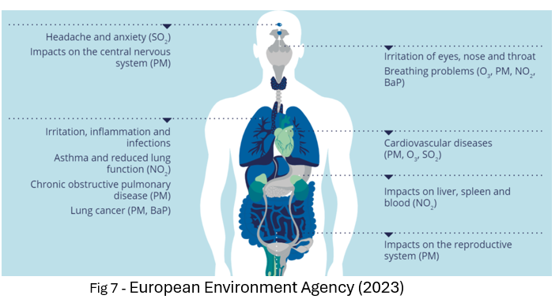

According to National Geographic (2024) air pollution can produce acid rain, which harms crops, deteriorates the quality of water in rivers, lakes, and streams, and alters the composition of soil around plants, which can result in impacting food production.

Atlas Scientific (2023) the repercussions of water pollution for ecosystems, animals, and human health are extensive, making it a crucial environmental concern. Water quality that people depend on for drinking, farming, and enjoyment can be negatively impacted by contaminants in water sources, which can also damage aquatic life and upset the delicate balance of aquatic ecosystems. According to WHO (2023) more than 2 billion people live in water-stressed nations in 2021, and it is anticipated that in some areas, the effects of climate change and population expansion will make the situation worse. In 2022 ,1.7 billion people on the planet used faeces-contaminated drinking water, which poses a threat to drinking water safety.

Overall several forms of pollution have an impact on human health, biodiversity, ecosystems, as well as disrupting food production and clean water supplies, all of which have an impact global effort on sustainable development.

Economist Simon Kuznets developed the Environmental Kuznets Curve (EKG) which according to Prasad (2024) economic development is considered to be the primary source of environmental degradation. Dinda (2004) states that early stages of industrialization are associated with rising levels of pollution. In the later stages of industrialisation, more advanced development is accompanied with the increased concern for environmental quality and as a result strengthening of environmental regulations and pollution levels decline.
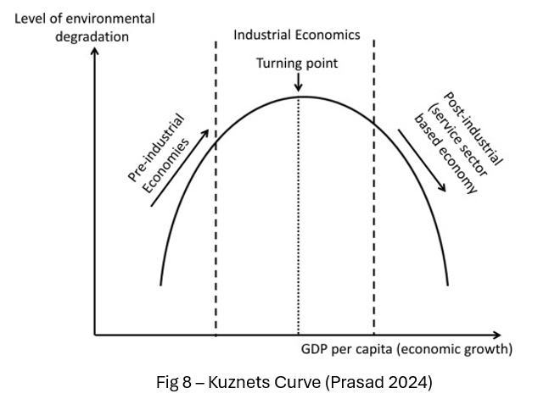

The Office for National Statistics supports the Environmental Kuznets Curve theory as according to Syed (2019) between 1985 and 2016, the UK demonstrated an absolute decoupling, with GDP per capita growing by 70.7% while CO2 emissions decreased by 34.2%. A major contributing factor to this decoupling connection is the evolution of technology, changes in economic structure, and the application of environmental laws like the Climate Change Act of 2008.

Sustainable Development Goals
WHO (2024) mention that the 2030 Agenda for Sustainable Development was endorsed by every nation in the UN in 2015, which contains 17 goals. The goal of the Sustainable Development Goals (SDGs) is to change the world. They are an appeal for people to take action in order to save the environment, eradicate poverty and injustice, and guarantee that everyone lives in prosperity, fairness, and health.
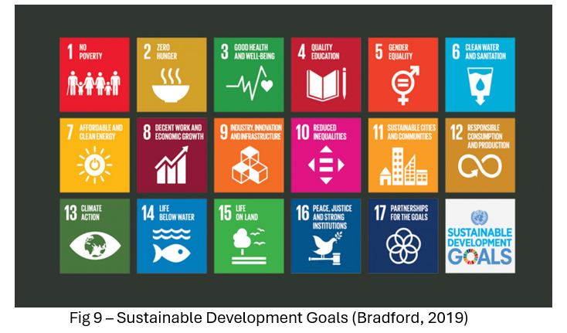

Several of the SGD`s focus on preventing biodiversity loss, ecosystem collapse and pollution. Goal 15 “Life on Land” is aimed at according to The Global Goals (n.d.) is to preserve, repair, and encourage the sustainable use of terrestrial ecosystems; manage forests sustainably; oppose desertification; stop and reverse land degradation; and prevent the loss of biodiversity. Goal 14 “Life Below Water” focuses on eliminating pollution, overfishing and to sustainably manage and safeguard marine and coastal ecosystems. WHO (2024) states that the objectives of goal 7, "Affordable Clean Energy," and goal 11, "Sustainable Cities and Communities," include enhancing air quality. By achieving this, both goals may contribute to goal 3, "Good Health and Well-being," by preventing illnesses caused by air pollution. Global Goals (n.d) mention that Goal 6 “Clean water and sanitation” focuses on access to safe and clean drinking water for humanity, and to reach universal access to fair and sufficient sanitation and hygiene by 2030 and put a stop to open defecation. According to the United Nations (n.d.) Goal 12 “Responsible consumption and production” aims to considerably decrease the amount of waste produced by prevention, reduction, recycling, and reuse which also promotes the principles of the circular economy.

Therefore, in order to mitigate risks associated with biodiversity loss, ecosystem collapse, and pollution, it is imperative for governments and corporate executives to adopt policies that are in line with the Sustainable Development Goals (SDGs) for the purpose of achieving a prosperous and sustainable global environment.

Conclusion
To conclude, the report has discussed the global risk of biodiversity loss, ecosystem collapse and pollution. The report emphasises that human activity has significantly impacted global diversity, ecosystems, and pollution due to excessive exploitation of resources. This aligns with the Malthusian theory, which posits that population growth leads to resource scarcity and land degradation. Anthropogenic air pollutants contribute to adverse health effects in humans, while plastic pollution poses a threat to marine ecosystems and can taint water sources.
The study also addressed the necessity for governments and businesses to adopt sustainable practices in order to support the 17 goals and mitigate environmental impacts, such as protecting biodiversity, ecosystems and preventing pollution.

Recommendations
The following recommendations have been proposed to reduce the risk of biodiversity loss, ecosystem collapse, and pollution.

- Government must enact laws protecting portions of land necessary for biodiversity and its ecosystem to flourish in order to mitigate the impacts of biodiversity loss and ecosystem collapse. This legislation will additionally mitigate the environmental damage brought on by excessive resource exploitation by human activities.

- The government must take action and collaborate with businesses to implement a deposit return scheme to incentivize consumers to return used plastic products to retailers. This could be beneficial reduce the massive quantity of plastic waste in the ocean and on land.

- In order to mitigate the effects of air pollution, governments should keep establishing additional clean air zones. This might deter people from driving older, polluting vehicles and instead encourage them to carpool, walk, or cycle to places. Reducing air pollution has the potential to minimise the harmful effects on people's health.

The 3 recommendations have the potential to support the SDG`s.

