DS 1 Template
Patrick Nwansi
Student ID: 2617292
Module ID: LCLM4002_Lon
Lecturer Name: Anees Baqir
Assessment title: DS1 My Digital Life

My Screenshots/Photos

Screenshot/Photo 1
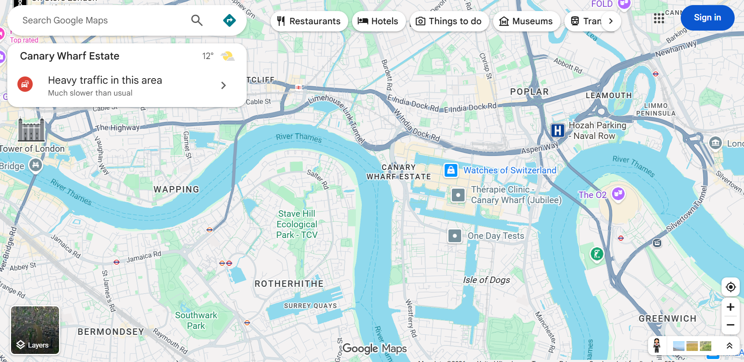
This is a map of the General area of where my university is based, Marking out all of the local train stations & bus routes which helps me navigate my way directly to the university in a timely fashion

Screenshot/Photo 2
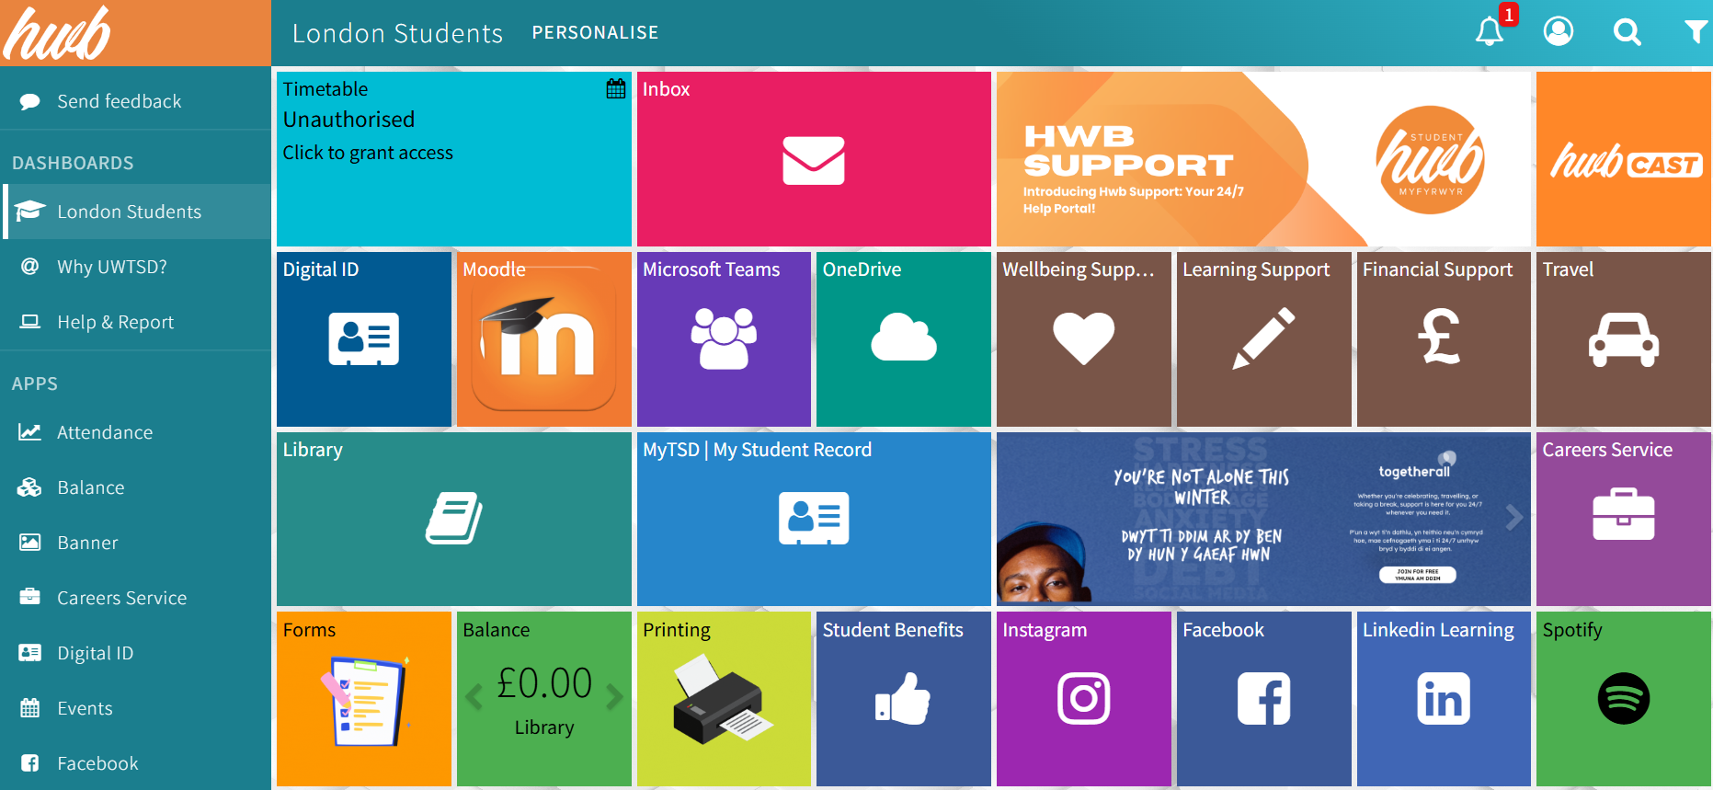
This is a screen shot of the dashboard of UWTSD Hwb which helps me organise my assignments & regulate my timetable. This support hub makes life easier when it comes accessing your Modules while keeping you punctual & on time

Screenshot/Photo 3

This app called is Called “Bus times” & this is a real special app Because it helps me with the bus timetables, which allows me to mauver through London on my Journey in the Morning on time. It also lets you know what busses are coming & how long they will be helping you to stay on time

Screenshot/Photo 4
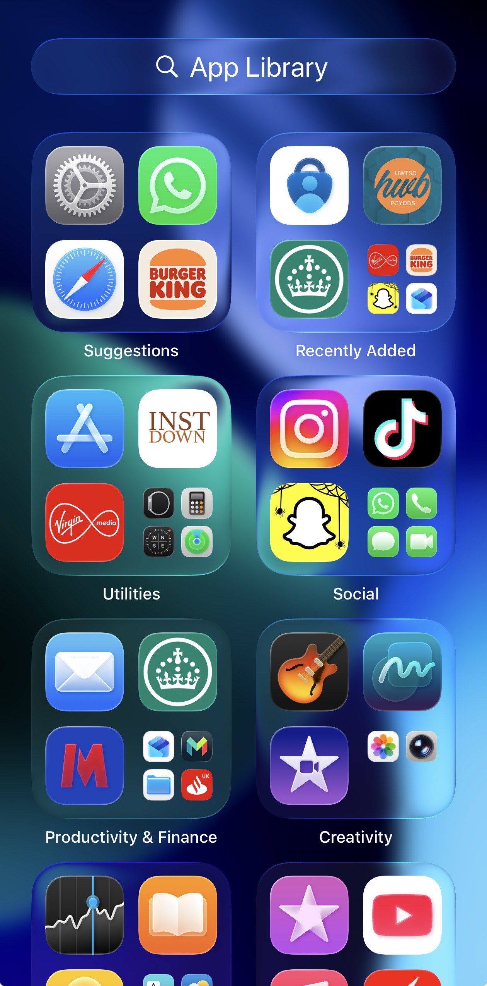This image shows the apps that I use to navigate online in my digital life, they vary from banking apps to social media to government sites to the app stores

Screenshot/Photo 5
This app is call “Just Eat” I use this app to order take away Meals Whenever I'm feeling hungry it's also used to order My weekly shopping which saves me from having to psychically doing the task myself

Screenshot/Photo 6
This is My Selfridges app, I use this app for Clothes shopping, this app also provides a delivery service so it really makes my life easier & help me to save time because shopping can be so time consuming when you've got other things to do.

My Short Reflection
I used digital tools like “Google maps” “App store” “Just eat app” “Selfridges app” “Bus times app” to navigate the internet, these tool enrich my life immensely because I would literally be lost without them. These Apps enhance my digital life so much when it comes to time saving & efficiency
Digital skills are so important to me because in a ever changing world where artificial intelligence is becoming the norm I really don’t want to be left behind when it comes to tech would like to be at the helm of technological advancements

Sentence starters
- I use digital tools to …
- I feel confident when I …
- I want to improve …
- I often use these tools: …
- I sometimes feel nervous about …
- I hope this module will help me …
- Digital skills are important for me because …
You can write more if you want.

Submission Checklist
Before you submit, please check:
​​​ ☒ I added 4–6 screenshots
☒ I wrote short sentences for each screenshot
☒ I wrote my short reflection
☒ My work is my own
☒ My file opens correctly
​​☒ My file opens correctly

