
Reflective Learning Log – Mr Chaudhry Muhammad Asim
Module title: Hotel placement – Managing Guest Service Operations

Module: BMIH6003
Module Lead: Jessica Newport
Student ID: 2246597

AI Acknowledgement:

I conﬁrm that I have not used any AI tools in the research and creation of this assignment. I confirm that I only used ‘’Grammarly’’ on 17.02.2026 for word and sentence suggestions, spell checks and grammar. I have not presented any AI-generated materials as my own work. I confirm that I have copies of my drafts, notes, and other resources I used, which I may be asked to provide as evidence.

Table of Contents

BMIH6003 – Managing Guest Service Operations 1
Reflective Learning Log – Mr Chaudhry Muhammad Asim 2
Introduction 2
Reflection on Experience 2
Application of Theory 3
Improvement Plan 4
Conclusion 5
References 6
Appendix: Learning objectives…………………………………………………………………………………………………………7

BMIH6003 – Managing Guest Service Operations

Reflective Learning Log – Mr Chaudhry Muhammad Asim

Introduction
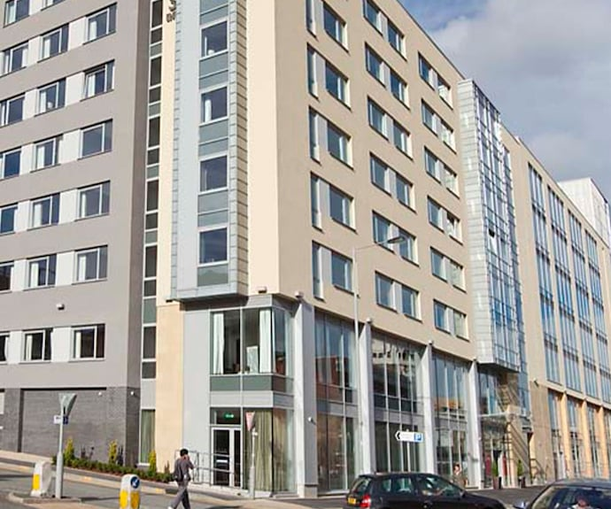

Leonardo Hotel Bradford is located at Hall Ings, Bradford BD1 5SH, operating as a modern mid-scale property serving business and leisure markets. The official website (Leonardo Hotels, 2026) emphasises cleanliness, comfort and professionalism.
During my placement in Housekeeping, supervised by Emilia Bugno, the 23-member team worked from 9 am (weekdays) and 10 am (weekends), finishing between 2 pm and 5 pm depending on occupancy; managers started earlier for administrative preparation.
The department significantly shapes guest experience through room standards and public area maintenance. However, delays occurred when staff required managerial approval to resolve minor complaints, generating guest dissatisfaction and employee frustration. This reflection analyses the issue using Management, Organisational Behaviour and Personnel Resourcing theories, supported by industry evidence.

Reflection on Experience
During an evening shift, a guest complained that bathroom surfaces had not been cleaned thoroughly. Jane, one of the staff, identified the issue and requested Emilia’s (The manager) approval to use additional materials and arrange an immediate re-service. Authorisation took nearly fifteen to twenty minutes, during which the guest remained dissatisfied, and Jane appeared visibly uncomfortable, despite feeling capable of resolving the matter promptly.
This incident highlighted how administrative controls can undermine service recovery. Emilia later explained that staff often understood appropriate corrective actions but hesitated without approval, fearing policy breaches. This reluctance affected service speed, team motivation and emotional well-being.
The issue appeared rooted not in technical competence but in limited empowerment. In my view, staff require clearer training on only applying policy in situational contexts to prevent avoidable delays. The experience prompted critical reflection on how leadership style and organisational structure shape responsiveness, autonomy and overall performance within hospitality operations.

Application of Theory
Lewin’s Leadership Styles Model, as explored in the Management and Organisational Behaviour module, helps to explain the operational approach adopted within the Housekeeping department. During most observed shifts, management leaned towards an autocratic style, where decisions were centralised, and staff were expected to follow instructions. Although this ensures consistency and control, it also risks reducing flexibility. The situation described earlier reflects this, as Jane lacked the autonomy to act independently. If a more democratic element were introduced, staff might offer improved service through quicker responses.
Blake and Mouton’s Managerial Grid further explains the balance between concern for operational performance and concern for staff morale. Jane showed strength in managing tasks, but sometimes missed the motivational aspect. A greater emphasis on people management, as exemplified in the “Team Management” style (high task and high people focus), could increase staff confidence and improve responsiveness.
Another valuable perspective can be gained from Adair’s Action-Centred Leadership model, which emphasises the importance of balancing task, team, and individual needs. In this context, I observed that operations tended to focus heavily on the task aspect. However, if leaders prioritised team support and personal needs, staff would feel appreciated and be more emotionally equipped to address guest concerns.
Motivation and empowerment are further emphasised within the Personnel Resourcing module. Hinkin and Tracey (2000) argue that staff who feel trusted and involved in operational improvements are more likely to demonstrate ownership and accountability. Pfeffer (1994) also links autonomy to increased staff engagement. Jane confirmed that her job satisfaction rose when she was directly involved in developing solutions. Providing limited decision-making authority at the operational level would therefore minimise service delays.
From a service delivery perspective, Jones (2008) emphasises that Housekeeping personnel are the frontline of guest perception, and delays in addressing issues can have a lasting negative impact. Walker (2021) highlights that modern guests expect immediate responses in hospitality settings. Wood (2013) adds that service departments must operate sensitively and proactively to create positive impressions. These sources support the importance of response speed in guest interaction.
Industry research from Hotel Owner (2024) confirms that hotels implementing frontline empowerment strategies observe higher guest satisfaction ratings. Moreover, it is recommended that immediate service recovery, particularly in housekeeping, notably decreases complaints. (Kennedy, 2024). Scholarly literature review confirms that staff receiving leadership support to act swiftly experience lower stress levels, which enhances both productivity and emotional resilience. (Saito, Brozović and Baum, 2025)

Improvement Plan
Drawing on reflection and theory application, I proposed the following three improvements for the Housekeeping department at Leonardo Hotel Bradford.
- Introduce a limited-level empowerment policy for housekeeping staff.
Housekeeping staff should be authorised to handle minor complaints or issues up to a certain limit without needing managerial approval, such as performing a re-service or replacing small items. This follows guidance from the Personnel Resourcing module and is consistent with Jones (2008).
- Implement a brief daily coordination meeting before each shift.
Meetings guided by Emilia, promoting staff suggestions and discussing potential challenges, can foster a more democratic environment. This aligns with Adair’s team-oriented approach and enhances engagement.
- Provide short emotional awareness and empathy training.
Drawing from transformational leadership principles, managers could promote empathy-focused communication. This aligns with Wood (2013)’s guidance on customer interaction and enhances the emotional aspect of service recovery.

Conclusion
Working in Housekeeping at Leonardo Hotel Bradford emphasised how important quick decision-making is in managing guest expectations. Through reflection, I realised that competence alone is not enough without confidence and autonomy. Observing Jane’s hesitance due to policy restrictions helped me understand how leadership style impacts operational responsiveness.
Applying theories from the Management, Organisational Behaviour, and Personnel Resourcing modules enhanced my understanding of how leadership balance, empowerment, and service recovery contribute to guest satisfaction. Implementing structured empowerment, improved communication, and increased emotional awareness could considerably boost Housekeeping performance.
The experience also aided my personal growth. I became more confident in recognising operational limitations and proposing improvements. I learned that reflecting on practice can support leadership development and help connect theory to real challenges.

References
Adair, J. (1973) Action-centred leadership. London: McGraw-Hill.
Blake, R.R. and Mouton, J.S. (1964) The managerial grid. Houston, TX: Gulf Publishing Company.
Hinkin, T.R. and Tracey, J.B. (2000) ‘The cost of turnover: putting a price on the learning curve’, Cornell Hotel and Restaurant Administration Quarterly, 41(3), pp. 14–21.
Kennedy, D. (2024) Proactive Hospitality Is Like Overdraft Protection, HospitalityNet, 17 December. Available at: https://www.hospitalitynet.org/opinion/4125117.html (Accessed: 26 February 2026).
Hotel Owner (2024) ‘Why empowering housekeeping teams improves guest satisfaction’. Available at: https://www.hotelowner.co.uk (Accessed: 12 February 2026).
Jones, T.J.A. (2008) Professional management of housekeeping operations. 5th edn. Hoboken, NJ: John Wiley & Sons.
Leonardo Hotels (2026) Leonardo Hotel Bradford. Available at: https://www.leonardohotels.co.uk/bradford/leonardo-hotel-bradford (Accessed: 17 February 2026).
Lewin, K., Lippitt, R. and White, R.K. (1939) ‘Patterns of aggressive behavior in experimentally created social climates’, Journal of Social Psychology, 10(2), pp. 271–299.
Pfeffer, J. (1994) Competitive advantage through people: unleashing the power of the workforce. Boston, MA: Harvard Business School Press.
Saito, H., Brozović, D. and Baum, T. (2025) Well-being of hospitality employees: A systematic literature review, International Journal of Hospitality Management, 124, article 103955. Available at: https://www.sciencedirect.com/science/article/pii/S0278431924002676 (Accessed: 26 February 2026).
Walker, J.R. (2021) Introduction to hospitality. 8th edn. Harlow: Pearson.
Wood, R.C. (2013) Key concepts in hospitality management. London: SAGE Publications Ltd.



