Developing Innovation and Creativity for Business Advantage
(BMSW6105_SWAN)


Lecturer, Davina Wyn Evans

By Badsa Miah ID:1815821 Date:17/03/2023

Executive summary

This report highlights what creativity and innovation is and how the innovation opportunity can be implemented which will be demonstrated through the use of innovation models which are the open and closed innovation, the innovation process and the 4p s to innovation. These models have been applied to the opportunity for Samsung to understand how innovation is applied and outcome that are created from the use of these model. However with each model being discussed this report has highlighted areas of advantages and disadvantages of using these models.
The models open and close innovation was included to this report to discuss and apply to the opportunity, the models’ pros and cons was also discussed with the addition of how this would best suit the opportunity to allow the innovation to be implemented.
The innovation process model by Tidd & Bessant has been used for this report. This model has shown clarity in how to implement the innovation opportunity through its stages but however there were areas where the model didn’t highlight that was also crucial for innovation process which was discussed. As well as the 4ps of innovation that shows how the opportunity is taken to the market.
In this report an assessment of the effectiveness has been done by using Kurt Lewins force field Analysis which highlighted areas where there are risks and barrier as well as forces for the change of the innovation opportunity identified. benefits and drawbacks have also been identified and discussed. The barrier and risks for Samsung in the force field analysis shows the forces against innovation opportunity and how it can affect the innovation.
Furthermore, the type of leadership style was also discussed for the purpose of helping to achieve the innovation’s success.
Samsung is always leading the way when it comes to creativity and innovation that is also demonstrated buy its global market share and showing how their creativity thinking process was leading to its success Samsung shows this through its NCD process which can be found in the main body of the report. This report provides details of how innovation is created, implemented, and delivered.

Contents
Executive summary 2
1.0 Introduction 4
2.0 Main findings 5
2.1-What is innovation? 5
2.1.1-non-innovation risks 5
2.1.2-What is creativity? 5
2.1.3 The difference between innovation and creativity 5
2.2-Overview of innovation opportunity 6
2.2.1-Innovation Matrix 6
2.2.2 The creativity thinking process. 7
2.2.3 Definition of Samsung's innovation process 7
2.4 Models of innovation 8
2.4.1 Opened and closed innovation 8
2.4.2 The innovation process 10
( 10
2.4.3- 4Ps to Innovation Mix 11
2.5 Assessment of the effectiveness 12
2.5.1 Barriers & Risks 13
2.6 Leadership & Management 14
3.0 Conclusion 14
Reference List 15

Introduction
This report will be discussing what innovation is and creativity and how they differ.
As well as looking at models that could be used for the chosen organisation and its strategy and implementation. The research will be looking at innovation matrix, open and closed innovation, model of innovation and the 4p`s to innovation as well as force field analysis.
The report will be using wide range of textbooks, websites, journals, to conduct this report. The chosen Organisation is Samsung how they come up with innovation and creating and improving its technology.
Samsung launched the Black and white tv in 1970 later launched the third quick start tv named Econo Tv in 1975.
Samsung started its production of refrigerators and washing machines in 1974 as well as in 1979 within the Korean market Samsung developed VHS VCRs, started mass production microwaves as well as took over Korea Electronics information company also acquiring 50% share in the semiconductor company becoming one of the largest manufacturers. Samsung ref
Samsung developed the mobile phone handset in 1991. In 2009 launched its smart phone. This highlights that Samsung is constantly creating new ideas and bringing new innovative ways to improve its technology. Investing in research and development (R&D). Market share of Samsung in 2021.
Figure 1- Market share
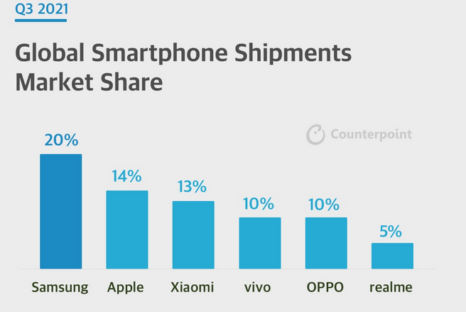
(Sean, 2021)
Figure 1 demonstrates the outcome of Samsungs innovative ways as it has shown that Samsung has placed 1 in the global market this meaning that Samsung has proven to bring success in the use of innovation because it has increased its global market share which has increased the value of their company. This figure highlights the global share of Samsung in the markets for its smartphone. Figure also shows Apple being the second largest competitor.
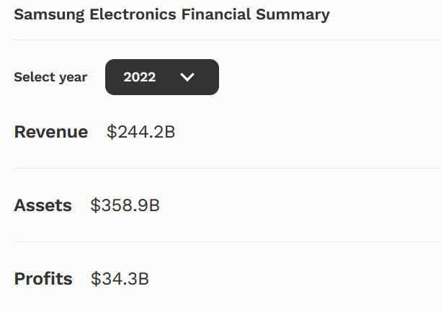 (Forbes, 2023)

2.0 Main findings

2.1-What is innovation?
Invention and innovation are usually differentiated. Innovation is the first attempt to implement an invention. Invention and innovation are often intertwined (biotechnology for instance). However, there is often a long delay. Indeed, decades-long delays are common (Fagerberg, Et Al 2006)
When an idea can be put to work for example when a new phone enters the market with its few changes it can be seen as innovation to improves the users interface. to name a few recent advances. Where would the ages be without, the wheel, the alphabet, agriculture, or printing? (Fagerberg, Et All 2006).

2.1.1-non-innovation risks
It's hazardous to try something new. Modern businesses risk most by not innovating.
Reluctance or incapacity to upgrade products or services may prevent your business from competing, diversifying, or operating. Non-innovative companies’ risk.
losing market share to competition, loosing critical workers lower margins and profit company failure (Geissdoerfer, Savaget, & Evans, 2017).

2.1.2-What is creativity?
Creativity is the ability to develop or recognise ideas, alternatives, or possibilities to solve issues, communicate with others as well as entertain others and us (Franken, R.E.1998).
Bringing an idea in to reality You can't construct something fresh with old ways. Flexible, fast-thinking, and adaptable organisations thrive in the fast-paced economy. Old processes prevent this. Every business wants to grow and beat the competition. If you want to succeed, you must offer clients something fresh, different, and useful.
Copying other companies won't make you the best. Innovate, create great solutions, and push boundaries to be the greatest (Franken, R.E.1998).

2.1.3 The difference between innovation and creativity
Creativity is coming up with new and effective ideas while innovation is the successful implementation of those ideas which have been thought up (Goleman, D. 2015).

2.2-Overview of innovation opportunity

The opportunity that has been identified for Samsung is the improvements to their smartphones which has identified through research and development as well as the gathering of quantitative data from its mobile devices along with consumer feedback. This opportunity was found through innovation process model on Samsung by this being a key innovation that is currently in use by the company (Samsung2023).

2.2.1-Innovation Matrix

Figure 2-Innovation Matrix
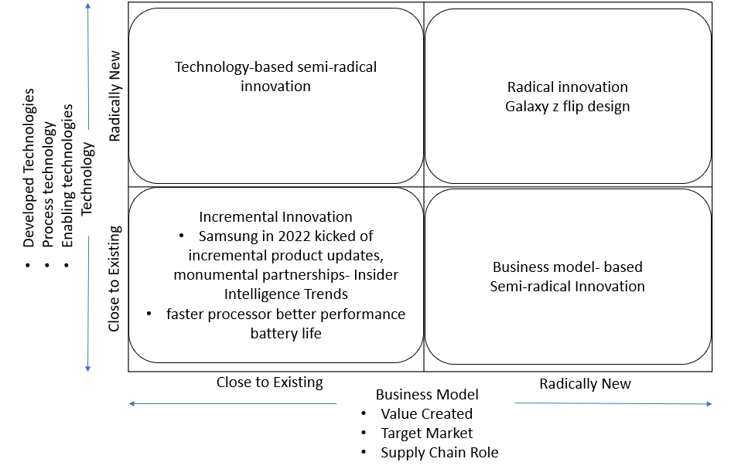

The innovation matrix is tool that can be used for a company to identify types of innovations and what they entail and allow a deeper insight of the type of innovations (Davila et al, 2012).
Samsungs opportunity can be identified using the innovation matrix when analysis.
Types of innovation in Samsung
Samsung continually improving their nanometre chips to improve the reduce power consumption hence better battery life and performance however this type of innovation is more incremental innovation since the smartphone does not need to be a radical transformation to its design but however, they did launch a galaxy flip phone that had a greater screen size. They increased its sales by 105% (Samsung 2023).
Through the innovation Matrix, it has been shown that incremental innovation and technology based semi radical innovation has been identified for this innovation in Samsung. This innovation is an incremental innovation as this innovation includes small improvement to their existing smartphones and is a dominant form of innovation within company because they are the creators of their smartphones (Borad, 2022).

2.2.2 The creativity thinking process.
Set creative goals for your team. Set goals with deadlines to boost creativity.
Build an open, risk-taking workplace. This will inspire creative thinking. To be receptive to new ideas, businesses must practise what they preach! The workplace typically reflects the owner.
Give workers chances to learn and try new things. This will inspire fresh thoughts and solutions. Teaching your personnel skills increases their creativity. It's an expense most companies don't need, but it may pay off.
Recognize and praise innovative employees. This encourages innovative thinking. Any business should value creativity. Give staff time off, gift cards, or public appreciation. A creativity contest where staff submit their best ideas for a weekend getaway is another fun method to inspire innovation (Creativity 2023).
Create! Let staff to brainstorm daily or weekly. This can happen in a meeting, lunch, or after work. This fosters creativity. You can also directly ask your employees "what are you excited about working on."
Diversify! Diversity encourages creativity. Employee perspectives, backgrounds, and abilities bring great ideas to life! Opposites attract. To encourage this type of workforce in your organisation, hire people with unique abilities or form teams with people whose life experiences can help solve challenges creatively and give innovative ideas.
Promote flexible work! Flexible work arrangements can boost productivity and comfort. They may also have the freedom to walk about, which helps them focus when they're most energetic or motivated (which could discourage productivity). Empowering people to set their hours motivates them to succeed and take breaks to avoid mental burnout (Peek, S. 2023).

2.2.3 Definition of Samsung's innovation process
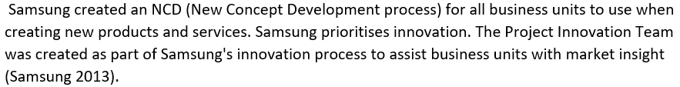

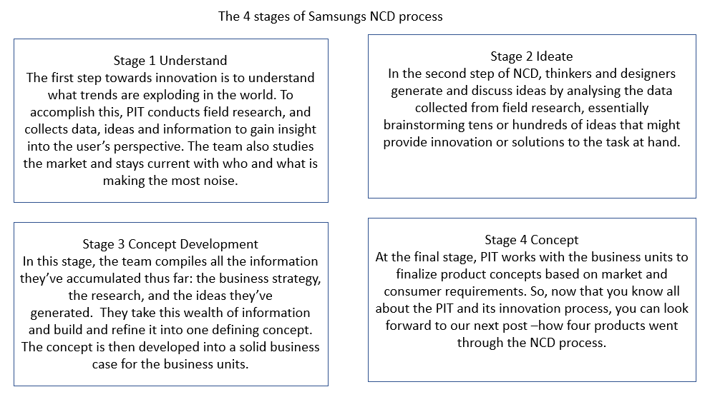(Samsung 2013)

2.4 Models of innovation

2.4.1 Opened and closed innovation
Figure 3 open Innovation model
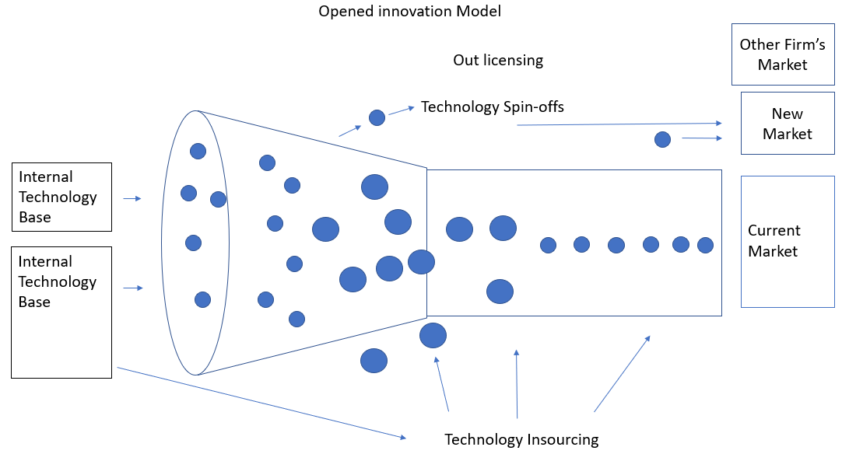
Figure 4 closed Innovation model
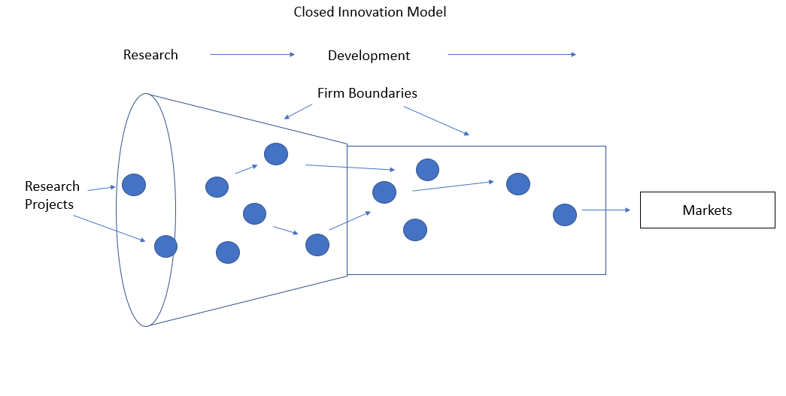
Open innovation is the use of ideas from an external source including internal ones, this meaning the sharing of information and knowledge about problems as well as looking outside the organisation for suggestions and solutions (Herzog, P. and Leker, J. 2011).
Open innovation is used with the chosen opportunity for Samsung as the opportunity requires the hub for its improvements which collaborates with 14 foreign R&D centres in 12 countries and 7 global AI centres to obtain breakthrough technologies and boost global R&D capacity. Active open innovation with world-class universities, research institutes, and partner companies maximises technical cooperation. This demonstrating that Samsung use open innovation to make improvements on their smartphone (Samsung 2021).
Closed Innovation is innovation which within clearly specified company boundaries takes place exclusively within an organisation through the entire innovation process. Closed innovation is innovation which is developed by internal team of the company (Herzog, P. and Leker, J. 2011).
Closed innovation process can be applied for the chosen opportunity by Samsung Smartphone’s chip being produced and improved by Samsung, therefore having innovation which is part of Samsung internal team (Vanhaverbeke, W., Chesbrough, H.W. and West, J. 2017).
Evaluation of open and closed innovation
Closed-innovation drawbacks:
This corporate innovation paradigm develops new technology with low resources. No matter how talented, department staff cannot constantly come up with new ideas. See figure 4.
Without external knowledge, the firm cannot enhance the idea and product before launching it. Without such expertise, failure is likely. but however certain instances require the organisation to be closed when part of innovation requires secrecy for the purpose of gaining advantage in the market.
Modern open innovation uses outsourcing, specialists, innovators, and technology. This model solves internal innovation issues faster and better. The open innovation strategy is the only way for companies without an innovation department to produce effective breakthroughs. There for it is better to use hybrid innovation as Samsung demonstrates (GoTech Innovation 2021). see figure 3.
Through analysis on this model there has shown to be a clear advantage of using open innovation in comparison to close innovation as open innovation allows issues to be solved easier and quicker when facing issues during innovation, however a hybrid of both can be utilised in certain areas of the innovation to make most use of both paradigms.

2.4.2 The innovation process
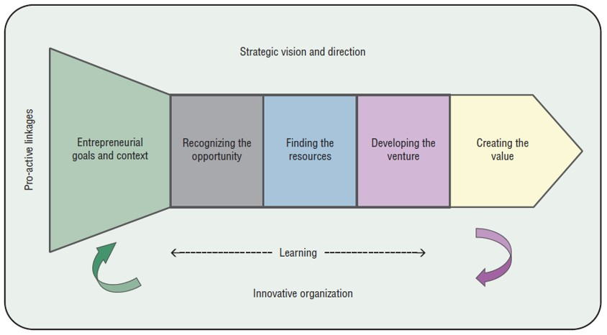
(Tidd, J. 2014)

Figure 5 Samsung’s Innovation Process

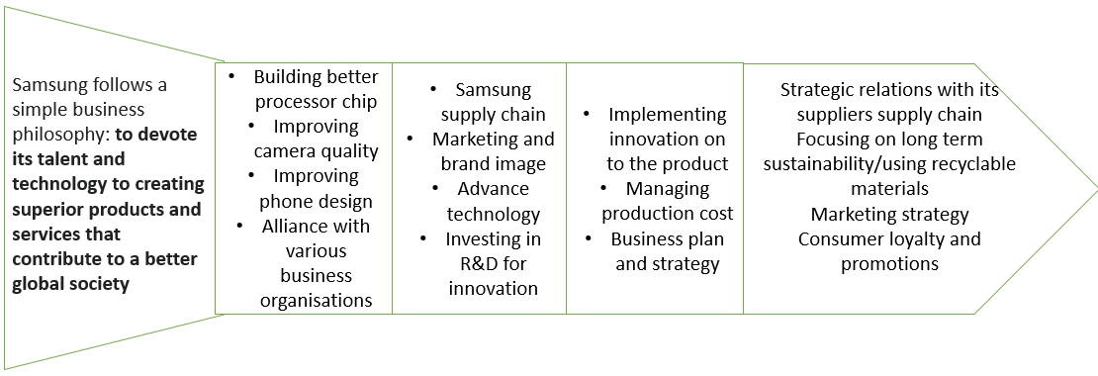

This model has highlight areas of how Samsung can use the innovation process in a leaner way however this model does not show the time scale of a product to launch. This does highlight the processes that need to be undertaken to reach its goals.
The Advantages are that Businesses can achieve greater results in less time with the help of process innovation methods, which can enhance a company's efficiency, effectiveness, and processes. Since it sets stages for innovation it allows businesses to have better management and understanding during their innovation with the addition of making innovation work (Tidd, J. 2014).
Disadvantages it can be time consuming and very costly this model does not show the cost it can incur for the innovation could end up wasting resources and a product that might not sell. The reputation of the company can be jeopardised if the product is poor in quality, a example being when Samsung had to recall their Galaxy Note 7 which had batteries that would overheat and explode due to one of their suppliers having a fault (BBC, 2017).
This lean process may seem simple but however but in reality, it is more complicated to follow it gives us an idea to how these stages should be managed it does not define or show the time scale this it might require this could be costly, see Figure 5
Figure 5 demonstrates how Samsung can utilise the Innovation process model for its innovation opportunity, but this will contain the full extent of the information required for the innovation such time scaling, expenditure, risks, and timeline to completion which creates barrier form the use of the model.

2.4.3- 4Ps to Innovation Mix
There are 4P’s to innovation Product Innovation, Process Innovation, Position Innovation, Paradigm innovation (Tidd, J., & Bessant, J. R. 2020).
Advantages and limitations of the 4p’s innovation model
Advantages
The four-dimensional innovation space model displays the four categories and demonstrates how innovation and change interact. The range from incremental to radical is a simple tool to assess one's position and a suitable beginning point for thinking about possible modifications to the current business model and their potential effects.
Limitation
The model's biggest strength is its drawback. The model is simply a starting point because of its simplicity.
According to Agola & Hunter's latest book, the strategy fails in developing markets without infrastructure. Their research suggests adding a fifth aspect, payment innovation. This 5th P addresses ways to expedite product/service payment to address funding issues (Agola, N. O., & Hunter, A. 2016). see Figure 6 below.

Figure 6-The 4 Ps of Innovation
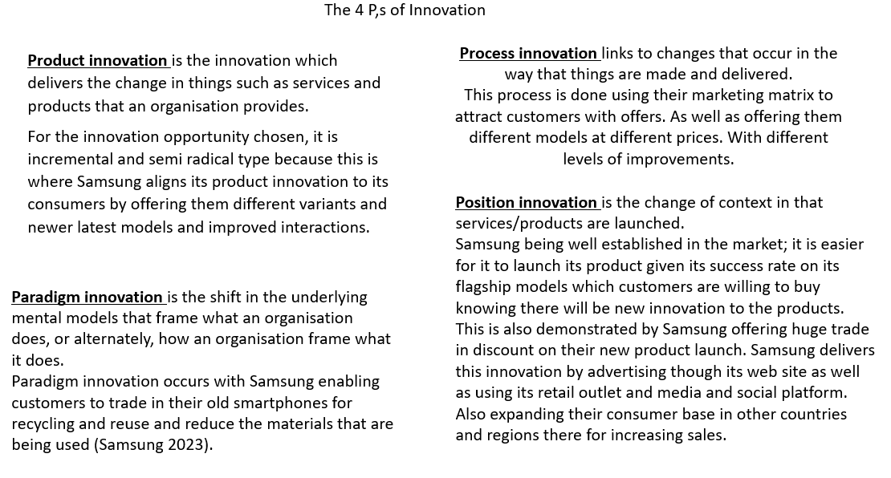

2.5 Assessment of the effectiveness
Lewins force field model can aid the effectiveness of the chosen model by highlighting the for and against change of the opportunity. The method assumes that forces for and against the current state are in balance.
Force Field Analysis benefits
There are several benefits of force field analysis such as It can be used by a group or individual, it provides a decision-making analysis and It highlights negative forces that should be eradicated to ensure transformation success. This impartial examination lets everyone list their strengths and cons.
Force field analysis's drawback
Subjective scoring system. Develops slowly. Not ideal in complex situations with many variables.
Force field analysis relies on the group's competence and knowledge. Force field analysis is usually based on assumptions, not facts. Even if the assumptions are based on accumulated data, the interpretation of the data shouldn't be considered objective in the whole process of analysing driving and restraining forces (Bhasin, 2019).
Using Kurt Lewins Forcefield analysis to gather information on the opportunities (Swanson, D. J., & Creed, A. S. 2014). See figure 7 below.

Figure 7 Force field Analysis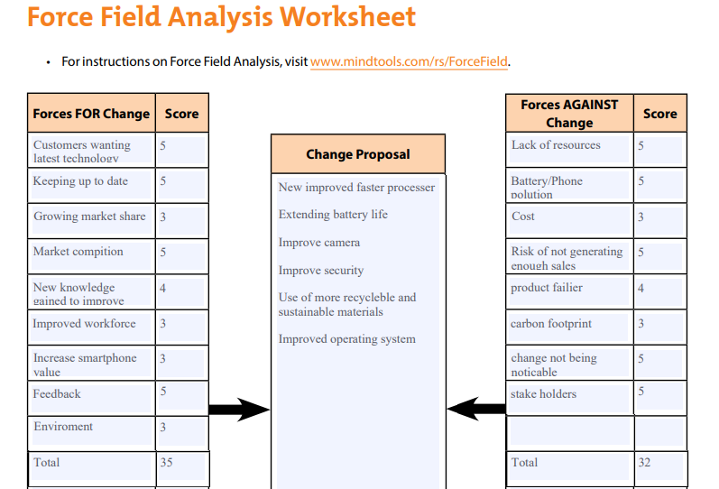
Result is in favour on change.

2.5.1 Barriers & Risks
The barriers that Samsung may face when implementing the innovation opportunity are the stakeholders, carbon footprint and a lack of resources as highlighted in the force field analysis. The stakeholders are barrier because they can stop the innovation from occurring. Carbon footprint is also a barrier as this will be heavily looked at as new products have to become more environmentally friendly. A lack of resources was also found as a barrier because it can stop production of the innovation that is being made. The risks that Samsung may face when implementing the innovation opportunity are the Product failing, high cost as shown in figure 7.

2.6 Leadership & Management
A democratic as well as visionary leadership style suits this innovation because Samsung is a large company that share internal information they are hugely invested in its research and development to come up with new ideas working with its employees and collaborating. The democratic leadership style is considered for the innovation identified by the leadership style being collaboration, communication and team leadership which will be required for gathering knowledge and ideas for creating the innovation in the organisation. The visionary leadership style will also be considered as this suit best when a clear direction is needed which will allow the identified innovation to be complete as well as prioritised (Kippenberger, T. 2002).

3.0 Conclusion
From the main finding it has been concluded that the innovation process has identified the innovation opportunity which has been discussed for Samsungs through its 4 steps. It was able to highlight the areas which the innovation will require for its development However there are elements that were missing which are crucial such as timeframe as well as risks and costs that would impact on its success.
In addition, other models of innovation were also discussed for the chosen innovation for the purpose of making the opportunity a success, these models have shown there are other factors that are required when implementing the innovation such as the type of innovation it is which can be opened or closed this defining the innovation. In this report the innovation matrix model has been used to identify the type of innovation that had been identified which was found to be incremental therefore meaning the innovation was minor improvements with huge performance difference in comparison to existing product. It was also concluded from the 4ps of innovation how to implement the innovation to the audience.
The force field analysis also helped to identify the risk and barriers that may pose on the innovation and its application. It illustrated the forces for and against the innovation which concluded that there was more pros towards the innovation. This innovation also requires leadership style and management to manage the innovation identified this was concluded to be democratic and visionary. This report helps to understand the tools needed to create, implement, and make the innovation work.

Reference List
Agola, N. O., & Hunter, A. (2016). Inclusive Innovation for Sustainable Development: Theory and Practice. Springer.
BBC (2017) Samsung confirms battery faults as cause of note 7 fires, BBC News. BBC. Available at: https://www.bbc.co.uk/news/business-38714461 (Accessed: March 6, 2023).
Bhasin, H. (2019) Force Field Analysis, Marketing91. Available at: https://www.marketing91.com/force-field-analysis (Accessed: February 27, 2023).
Borad, S.B. (2022) Innovation matrix – meaning, types and its explanation, Finance Management. Available at: https://efinancemanagement.com/financial-management/innovation-matrix#Innovation_Matrix_4_Types_of_Innovation (Accessed: February 21, 2023).
Creativity (2023) Psychology Today. Sussex Publishers. Available at: https://www.psychologytoday.com/gb/basics/creativity (Accessed: February 27, 2023).
Davila et al (2012) Making innovation work: How to manage it, measure it, and profit from ... Available at: https://www.researchgate.net/publication/234799741_Making_Innovation_Work_How_to_Manage_It_Measure_It_and_Profit_from_It (Accessed: February 21, 2023).
Fagerberg, Mowery, D. C., & Nelson, R. R. (2006). The Oxford handbook of innovation. Oxford University Press.
Forbes (2023) Samsung Electronics | Company Overview &amp; News, Forbes. Forbes Magazine. Available at: https://www.forbes.com/companies/samsung-electronics/ (Accessed: February 7, 2023).
Geissdoerfer, M., Savaget, P., & Evans, S. (2017). The Cambridge business model innovation process. Procedia Manufacturing, 8, 262-269.
Goleman, D. (2015) What's the difference between creativity and innovation?, World Economic Forum. Available at: https://www.weforum.org/agenda/2015/01/whats-the-difference-between-creativity-and-innovation/ (Accessed: February 8, 2023).
GoTech Innovation (2021) Closed innovations vs open innovations, GoTech Innovation. Available at: https://gotechinnovation.com/closed-innovations-vs-open-innovations/ (Accessed: February 23, 2023).
Herzog, P. and Leker, J. (2011) Open and closed innovation: Different cultures for different strategies. Wiesbaden: Gabler Verlag.
Kippenberger, T. (2002) Leadership styles. Oxford: Capstone Pub.
Peek, S. (2023) Creativity vs. innovation: What's the difference? Business News Daily. Available at: https://www.businessnewsdaily.com/6848-creativity-vs-innovation.html (Accessed: February 27, 2023).
Samsung (2013) Samsung's product innovation team: How ideas becomes streamlined, – Samsung Global Newsroom. Available at: https://news.samsung.com/global/samsungs-product-innovation-team-how-ideas-becomes-streamlined (Accessed: February 22, 2023).
Samsung (2021) R& amp; D centre: Business area: About Us, Samsung UK. Available at: https://www.samsung.com/uk/about-us/business-area/r-and-d-center/ (Accessed: February 22, 2023).
Samsung (2023) [user guide] galaxy S23 ultra: Smartphone game changer, – Samsung Global Newsroom. Available at: https://news.samsung.com/global/user-guide-galaxy-s23-ultra-smartphone-game-change (Accessed: February 21, 2023).
Samsung (2023) Customer service: Support, Samsung Semiconductor Global. Available at: https://semiconductor.samsung.com/support/quality-support/customer-service/ (Accessed: March 5, 2023).
Samsung (2023) Samsung Mobile Phone & Device Trade in, Samsung UK. Available at: https://www.samsung.com/uk/trade-in/#faq (Accessed: March 5, 2023).
Sean (2021) Samsung leads global smartphone market in Q3 2021: Report, Gizmo China. Available at: https://www.gizmochina.com/2021/12/13/samsung-lead-smartphone-market-in-q3-2021/ (Accessed: February 7, 2023).
Swanson, D. J., & Creed, A. S. (2014). Sharpening the focus of force field analysis. Journal of change management, 14(1), 28-47.
Tidd, J. (2006). A review of innovation models. Imperial College London, 16.
Tidd, J. (2014) Strategic Innovation Management, Google Books. Wiley Global Education. Available at:https://books.google.com/books/about/Strategic_Innovation_Management.html?id=Ii1EDwAAQBAJ (Accessed: February 27, 2023).
Tidd, J., & Bessant, J. R. (2020). Managing innovation: integrating technological, market and organizational change. John Wiley & Sons.
Vanhaverbeke, W., Chesbrough, H.W. and West, J. (2017) New frontiers in open innovation. Oxford: Oxford University Press.

