Student Name: Ana-Maria Moise  Student ID: 2233131  Module Title: Foreign languages and cultural awareness  Module Code: BMIH5003  Lecturer: Heidi Prosser  Date:02/02/2024 | 
ASSIGNMENT 1: PORTFOLIO
(4 Components)

Component 1: Professional Reflection (500 words +/- 10%)

Weighting: 25%
Cultural awareness is crucial in the hotel industry from both staff and guest perspective. It is important to acknowledge that the hotel can have different visitors, with different religions, nationalities, and cultures and it is also likely that the staff will be from diverse backgrounds too. Inevitably, conflicts can occur and to overcome this situation, effective communication is needed.
I have in my team several employees who have different cultures and languages, and I am trying to train them so they can reach their maximum potential to deliver exceptional services to our hotel guests. But the inevitability happened and one evening in the hotel’s restaurant, a guest was very upset that the waitress didn’t understand his order too well. It was a very busy evening, and everyone was trying their best to ensure every client was served on time and to keep the guests happy. I went to the guest and apologized for my employee as she is new, and she is trying her best to deliver excellent services, but her English language isn’t the best and she is trying to improve it. ‘’ You can learn to deal with conflict in a positive and constructive manner that enhances decision-making and contributes to effective working relationships. These skills are called conflict resolution skills.’’(https://opentextbc.ca/workinginfoodserviceindustry/chapter/conflict-resolution/). I talked with the gentleman, and I offered to serve him that evening, ensuring him that I will deliver excellent services and he will be satisfied and also offering him a 10% discount on his order. The client accepted and the evening went smoothly, and the client was happy in the end.
After that, I talked with my employee and arranged a meeting at a convenient time and place so we can discuss what happened and how we can prevent this. I never manage conflicts in front of the guests. Always I talk calmly, and I adopt an understanding attitude. I am very focused on my language, tone, and body language. I know she is working hard to improve her language skills and we set up a plan with realistic and achievable goals and offered my help with everything she needs. Also, I arranged a meeting with all my employees to see their needs and level, to see what needs to be improved, and based on that, I have set up a plan to suit everybody's needs and where improvements are needed. During the meeting, I had a positive attitude, I paid attention to everyone’s issues and needs. In the end, all were happy with how the meeting went and I saw the determination to improve their weak points.

References:
https://www.siteminder.com/r/trends-advice/hotel-guest-experience/cultural-sensitivity-hotel-cater-guests/
https://opentextbc.ca/workinginfoodserviceindustry/chapter/conflict-resolution/
https://www.linkedin.com/pulse/challenges-cultural-differences-hospitality-teams-gon%C3%A7alves-mendes/

Component 2: Training Plan (500 words +/- 10%)

Weighting: 25%

Identified cultural misunderstanding (in a few words):
Lack of knowledge of two or more foreign languages.
Speaking same language but understand different things.
Little knowledge in knowing other cultures.

Training plan (Why/What//Who/Where/When):
A training plan is needed to avoid cultural misunderstandings, to help the staff to improve their abilities. In this way, they will be able to offer to the guest, an unforgettable experience. Also, studies show that a trained staff is more likely to retain customers and stay competitive.
A good, structured training plan is based on cultural awareness training. I will provide an overview of different cultures, customs, habits, and traditions to avoid conflicts with guests from different countries.
Communication skills and being multilingual is something that I want to implement for my employees. This will help them communicate more effectively with guests who don’t have English as a first language.
Discuss with the staff real-case scenarios that can occur and find the best possible solution to resolve the problem respectfully and effectively.
Another step is to ask for guest feedback and upon the feedback, I will see what needs to be improved at each one of my employees.
All workers must be trained constantly and monitored to be updated on global cultural trends.
I encourage open dialogue between me and my staff when an issue takes place or any other problem that is concerning so we can solve it the best way possible.
Following the latest guidelines in the hospitality industry.
Upskilling the actual staff and asking the experienced staff to be trainers.
Training in customer service that covers communication, problem-solving, empathy, and conflict resolution.
Knowing two or more foreign languages will improve the sense of performance, helping my staff to understand and recognize the message that I am sending them.
Having staff that can communicate in various languages with the guests, can lead to becoming a brand in the hospitality domain.
Seeking online resources and apps to help employees with the learning foreign languages.
Setting manageable milestones so they can stay motivated throughout their learning time.
Keeping the staff motivated, encouraging them, and praising their achievements keeps them positive.
Constantly, I will do assessments to keep a record of their progress and work where it’s needed.
The staff need to be able to speak, write, and read foreign languages.
The employees must learn how to do a personal summary, of what they have learned in a month and if they feel any progress.
Being in a food and beverage service, I would also insist on menu knowledge, serving etiquette, handling special requests, and having the ability to explain the menu regarding allergies.
Implementing updated and professional development programs will help ensure continuous improvements.
I will provide a list of movies and books to watch and read about other cultures, habits, and how to address and interact with other nationalities.

References:
https://preply.com/en/blog/b2b-intercultural-misunderstandings/
https://www.linkedin.com/advice/3/how-can-you-quickly-resolve-conflicts-related-diversity#:~:text=To%20quickly%20resolve%20conflicts%20related,party%20to%20mediate%20the%20discussion
https://cht.edu.au/news/how-to-create-an-effective-training-plan-for-your-hospitality-business#:~:text=Create%20a%20Training%20Plan,employee%20in%20the%20necessary%20skills
https://www.canarytechnologies.com/post/hotel-staff-training-strategies
https://www.workplacelanguages.com/7-benefits-of-language-training/
https://www.goabroad.com/articles/language-study-abroad/10-best-ways-to-learn-a-new-language

Component 3: Student Self-Reflection (500 words +/- 10%)

Weighting: 25%
During my placement at Marriott Hotel in Twickenham, I had the chance to work at front desk as a receptionist. The experience was amazing, and I had the chance to see how it feels in that position and how to interact with people from different countries, with different customs, habits and language. There was a particular positive event that occurred during my shift. A group of people from different countries like Spain, Italy and Portugal were attending a conference and there needed to do the rooms check-in. Me and my colleague were doing this. But just a few people knew English, the rest hardly anything. But they needed guidance, information how to get to the conference, how to pay for public transport. I was the only one who knew to speak a bit of Italian and Spanish so the only one who can help them at that point. I tried to remain calm and trying to remember the bit of knowledge of those two foreign languages. I learned this from movies, friends so it wasn’t fluent, but I managed it very good. The guests were over the moon that I was there to explain and to guide them using their language. The manager called me into his office and complimented my way of dealing with the guests.
I felt like in seventh heaven, I used my knowledge of two foreign languages in a prestigious hotel and I could show what I knew and how I could manage a situation like this. Being the only one who speaks Spanish or Italian, I felt so proud of myself. Besides that, I was surprised that none of my colleagues didn’t know any of those two languages. It made me feel like I wanted to learn more of these two languages as I felt it could help me in my day-to-day life. After this event, my self-confidence was bursting, and I felt I could manage any situation regarding Spanish or Italian guests excepting the natives’ English speakers.
At that time, I felt like I was useful, I could help, and I was so proud of myself, I felt it like a big achievement. The fact that I received compliments for managing the situation so good, for me was like I received a promotion.
The situation could have been better if I studied more, maybe I could have helped more. Dealing with this kind of situation, made me think fast, work under pressure and I had to confront my fear of speaking another language and with important people.
This experience has highlighted the importance of continuous learning and adaptation. I recognized that cultural awareness is essential in the hospitality industry for providing exceptional customer experience.

References:
https://www.salford.ac.uk/sites/default/files/2021-02/Reflective-writing.pdf
https://www.peoplemanagement.co.uk/article/1814062/five-ways-leaders-practise-self-reflection-why-its-important-business-growth
https://www.tsw.co.uk/blog/leadership-and-management/gibbs-reflective-cycle/

Component 4: Training Presentation (6 Slides)

Weighting: 25%
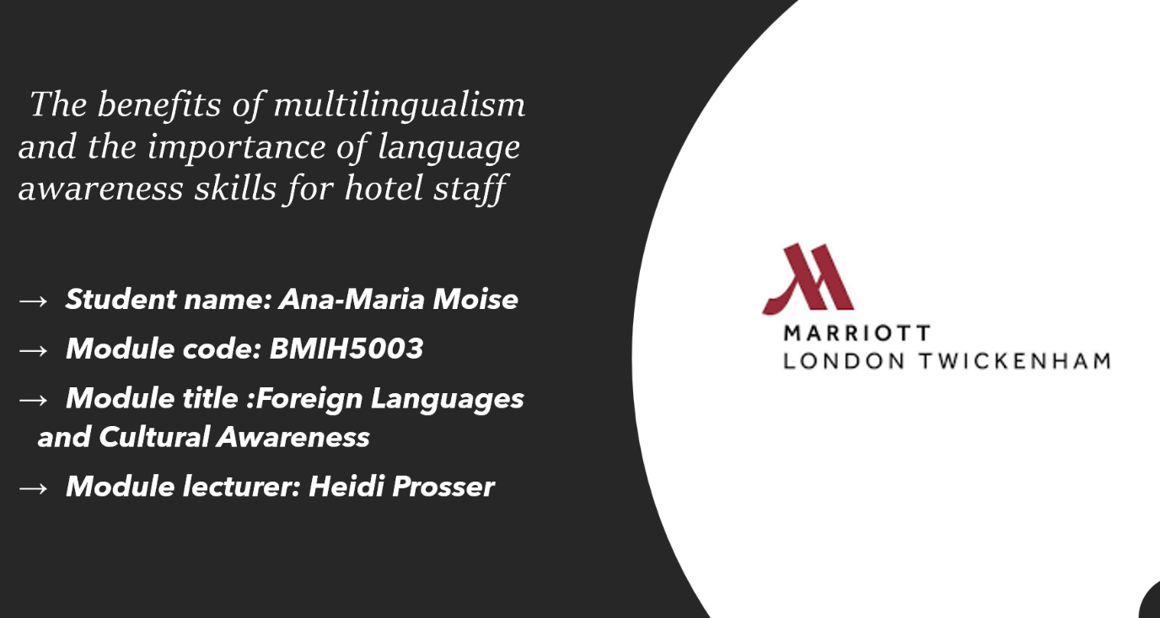
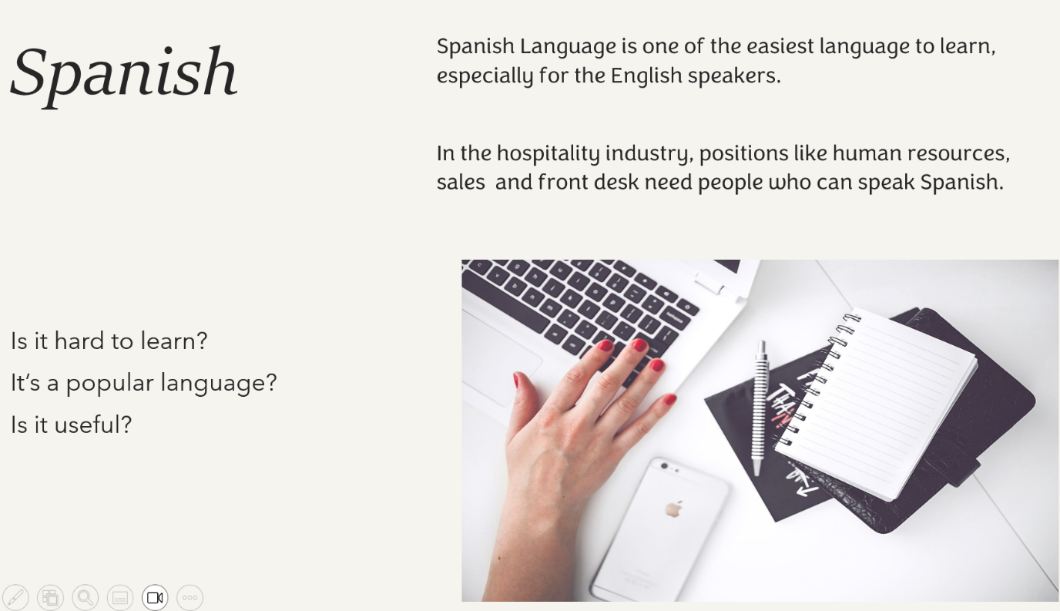

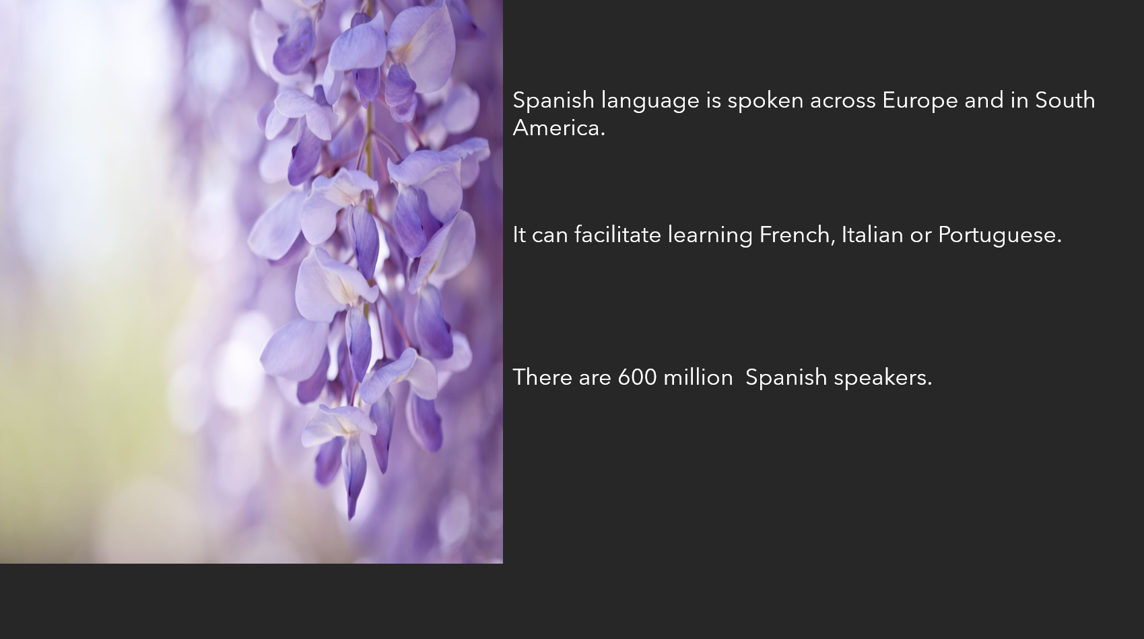

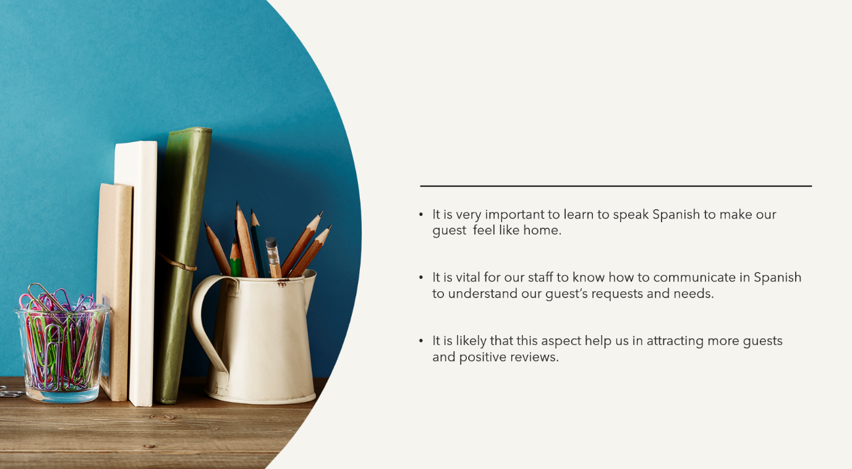

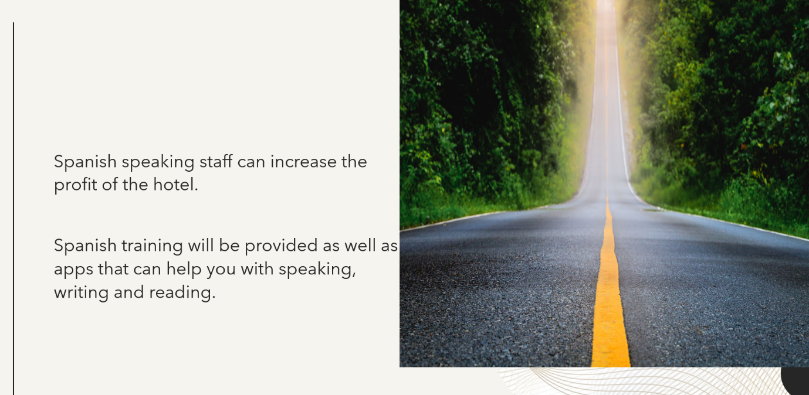

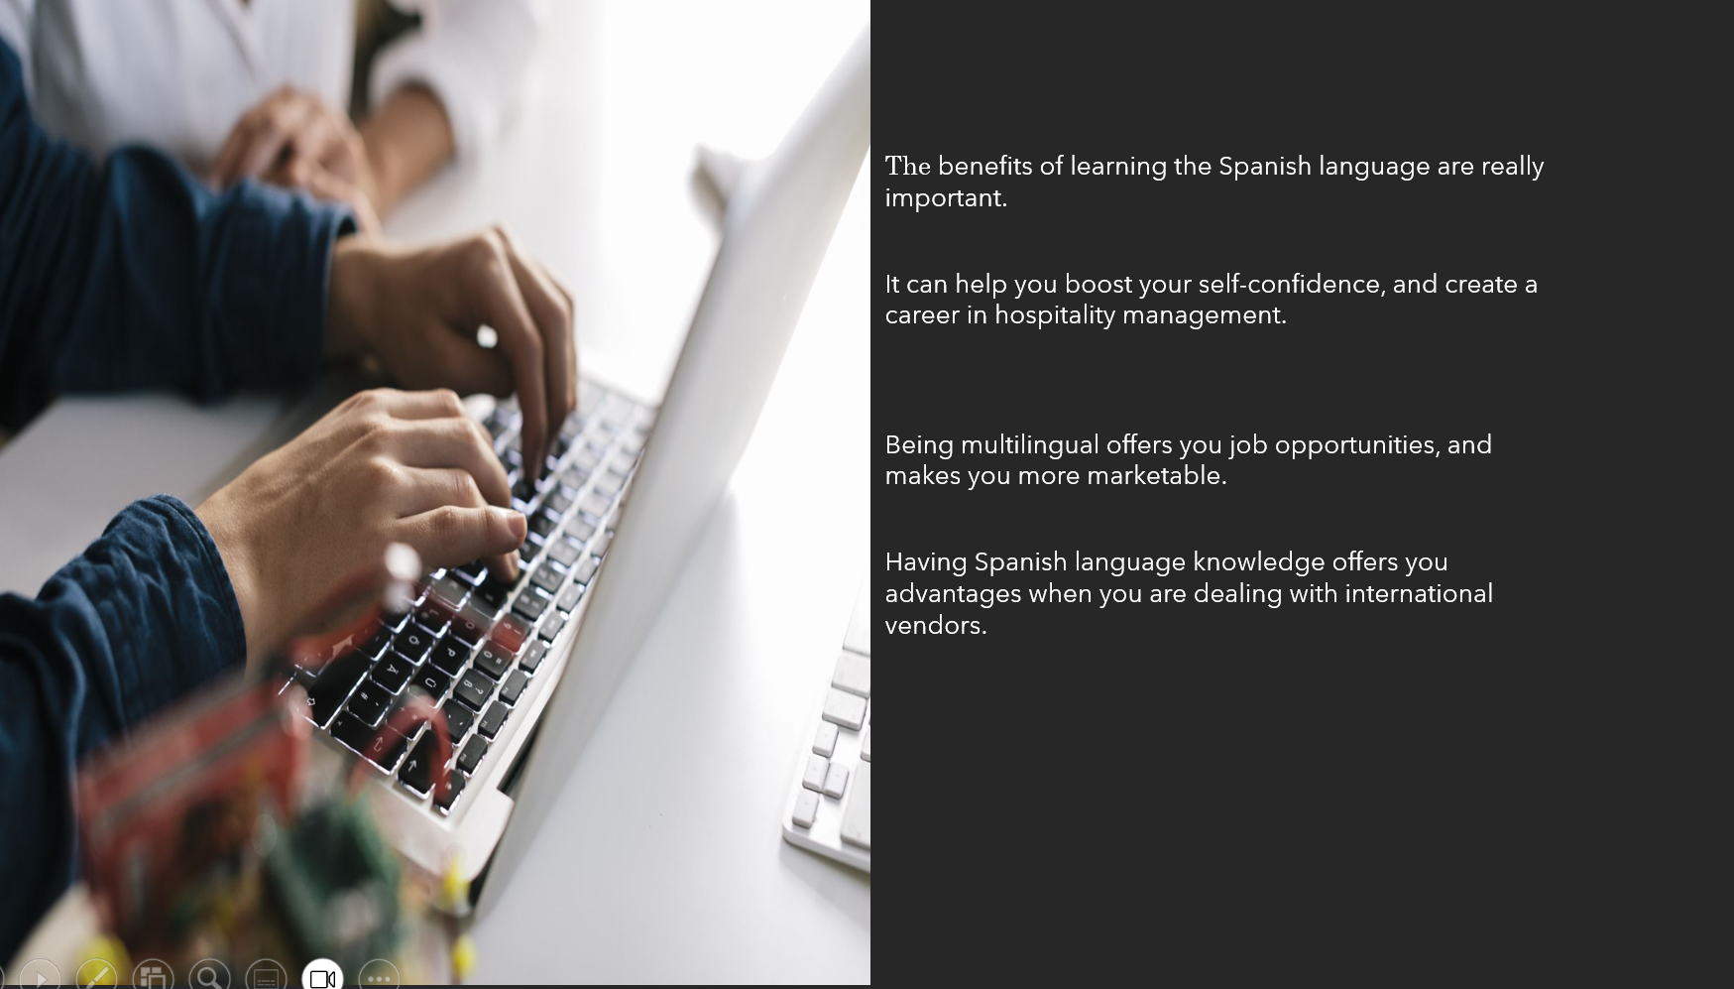
References (no screenshots):
https://cclshouston.com/blog/the-importance-of-spanish-to-the-hospitality-industry
https://repository.acmt.hr/islandora/object/acmt%3A77/datastream/PDF/view
https://www.hospitalitynet.org/opinion/4116096.html
https://www.successcenter.com/article/learn-spanish-language-to-make-career-in-travel-tourism-and-hospitality-industry
https://www.spanish.academy/blog/is-spanish-hard-to-learn/

