Final Report

- Introduction
In this project production, I served as the main worker of indoor scene prop modeling and mapping, the main worker of indoor scene modeling, the main worker of indoor scene layout, the auxiliary work of making character bones, the main worker of making post effects, and participated in the production of two-stage animation, post rendering auxiliary workers, post color matching and other work.

- Production process
In this project production, besides being familiar with the software, I also tried many unused software such as ue5 and Houdini.

2.1 Indoor scene prop modeling and mapping
The modeling and mapping of props in the indoor scene is my primary task. First, the team leader specifies the style and indoor scene requirements. According to the instructions of the team leader, the most important goal of the indoor props I need to make is TV modeling, followed by tableware, sofa, gas stove, tea table, lamp, glass bottle and other props. First of all, TV modeling. Because the TV style required by our project is relatively retro and old TV sets, I first collected the TV sets used by people in the last century on the Internet for reference.
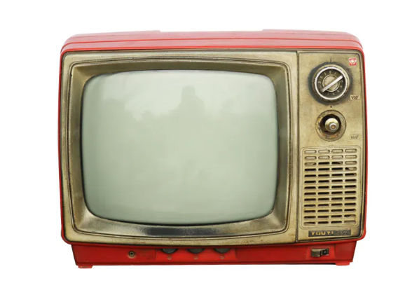
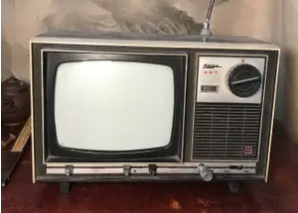

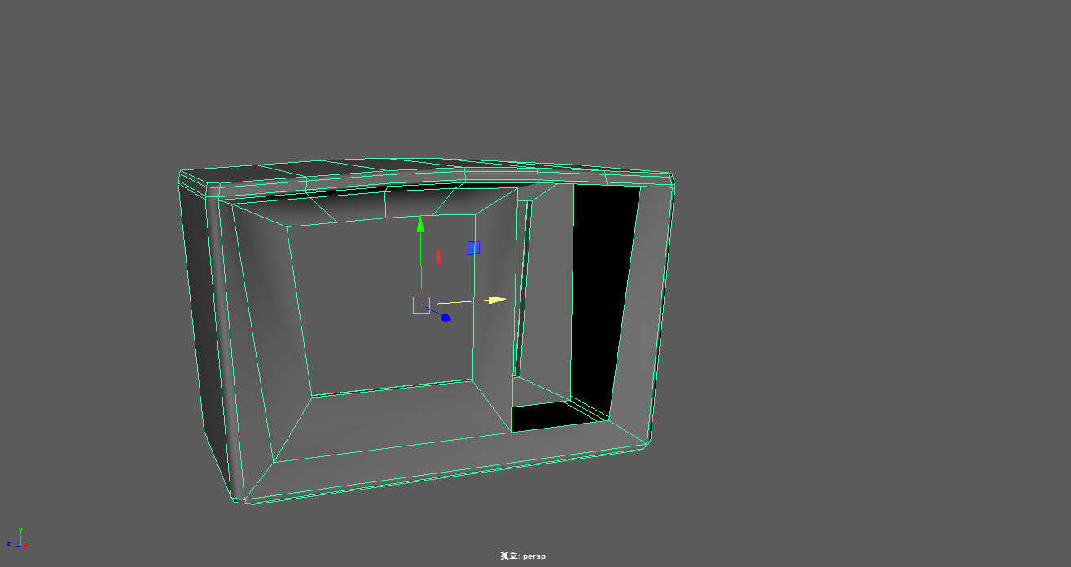
The old TV in the last century generally has a prominent screen , and a rotating button for rotating and adjusting the sound channel. According to these characteristics, I built the model, first made a cuboid, and then reserved the control plate, screen plate and the box behind the TV according to the characteristics of the TV.

Subsequently, the control panel is made, mainly including two switch buttons, two slide modules and two rotation modules. The modeling method is to use Maya's most basic polygon modeling function to add lines and adjust the position of points for modeling.
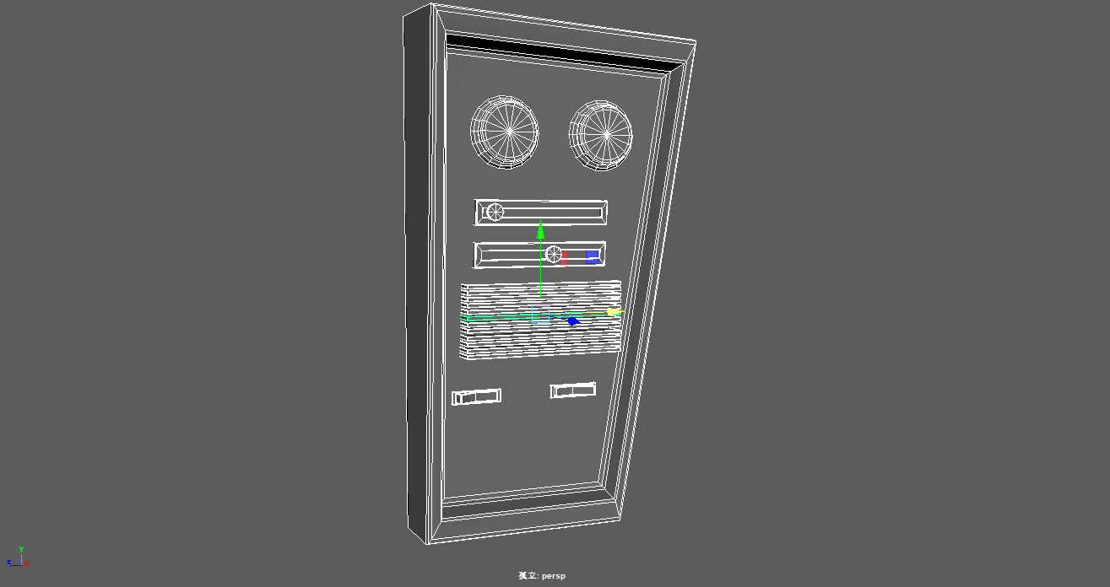
From the information I searched, I found that many old TVs used antennas to receive signals, so I added antennas to receive signals when I made TVs.
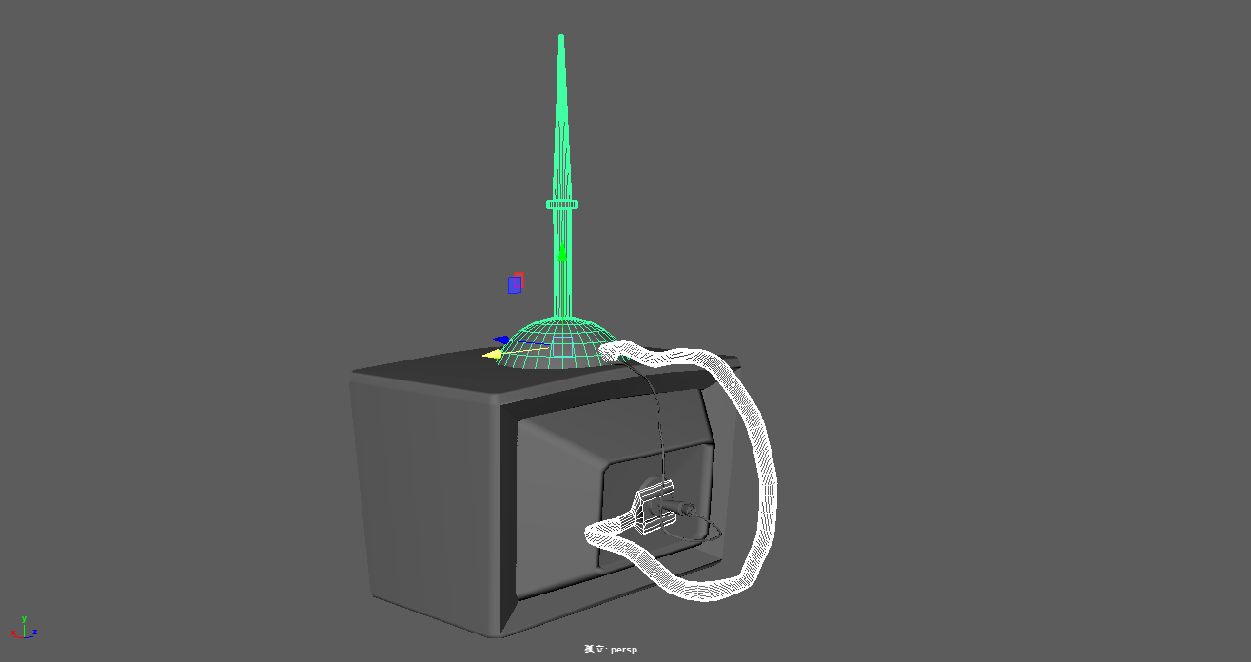
Polygon modeling is still used in the modeling of the sofa. However, in order to simulate the soft material of the sofa back and cushion, the edges and corners are adjusted after the prototype is made. The tools used are generally lattice tools, soft selection tools, chamfering tools, etc.
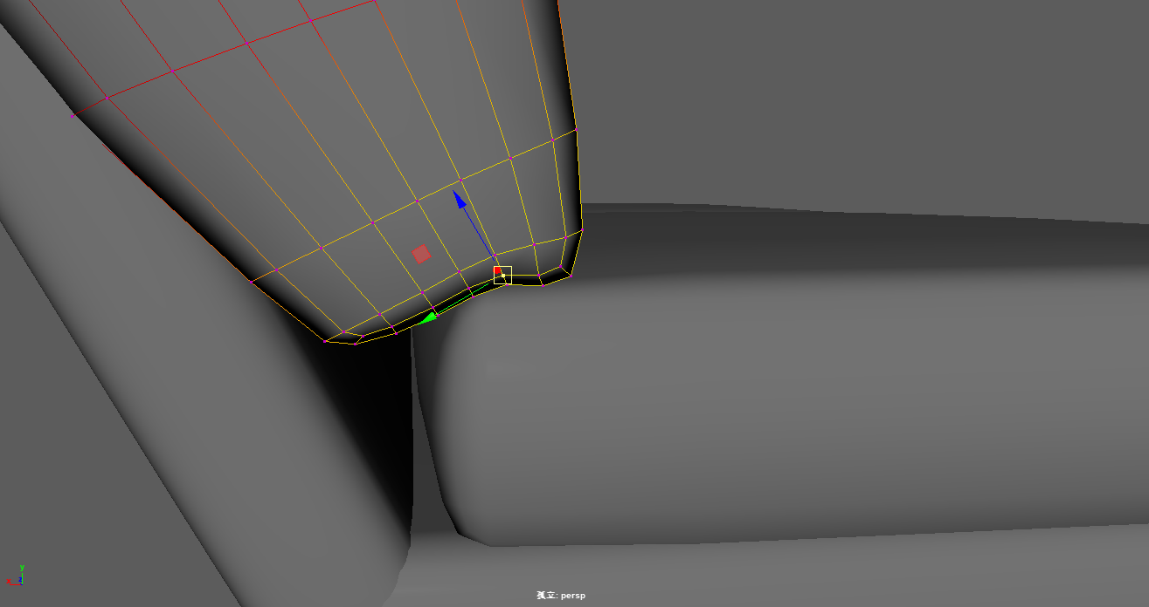
And two different specifications were produced so that they can be used in later scenes.
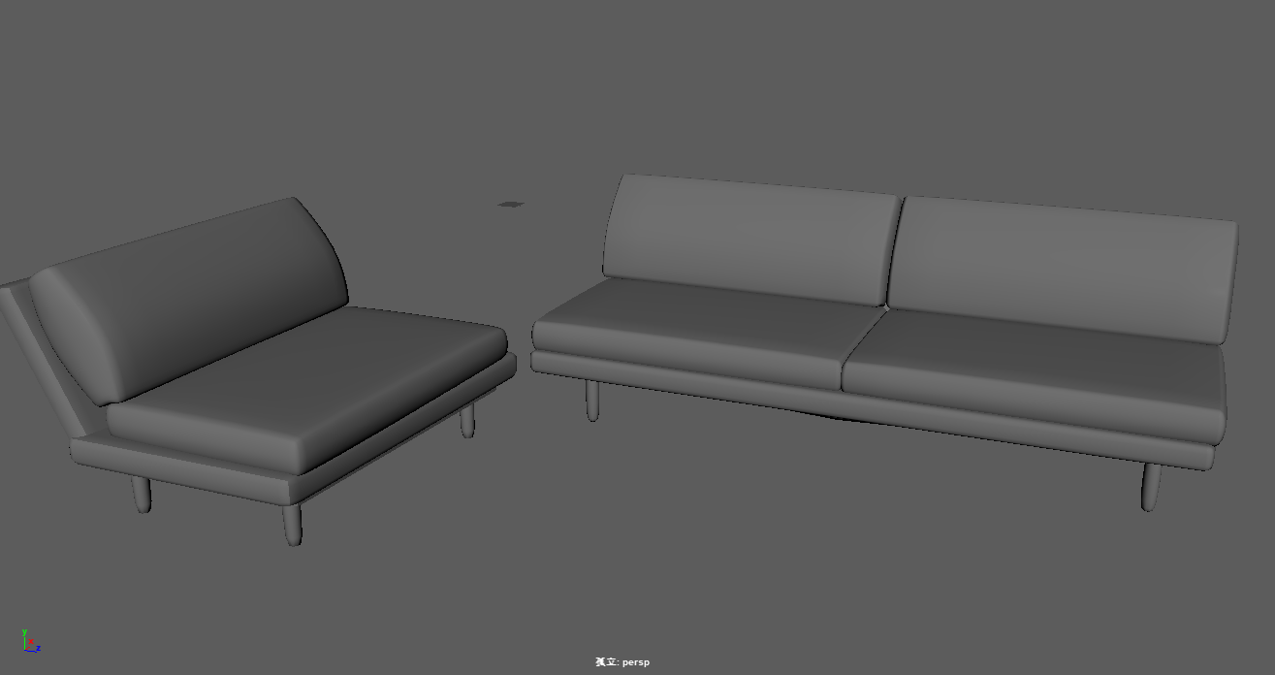
When modeling the gas stove, first use the cuboid to make the corresponding main part, and use extrusion, chamfering and other tools to make the groove and the position of gas combustion.

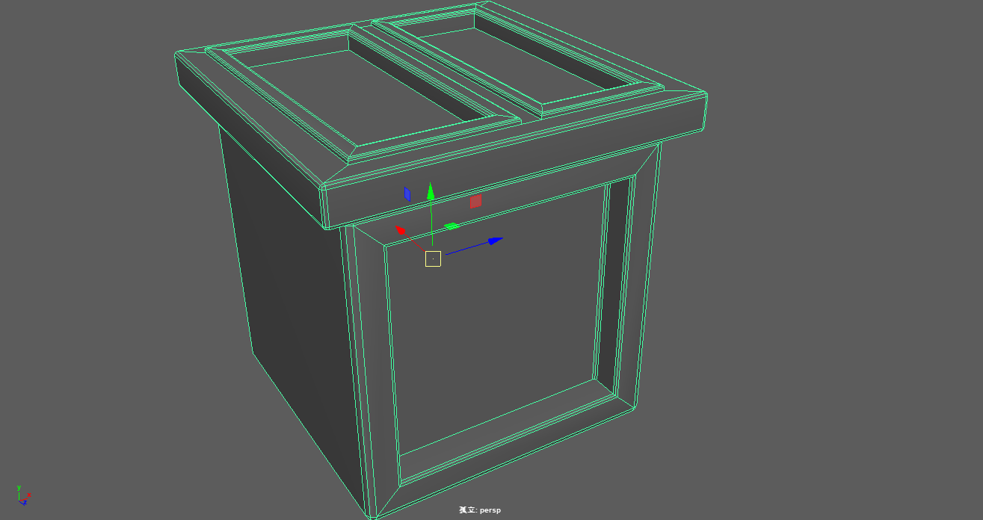
When making the main part, use the cylinder and adjust the number of segments to 6. It is agreed that the lines and points of the model should be kept as simple as possible in the early stage of modeling. Because too many lines and points are not conducive to the later adjustment, adjust the cylinder to only six sides, and then use the extrusion and chamfering tools to make the model.
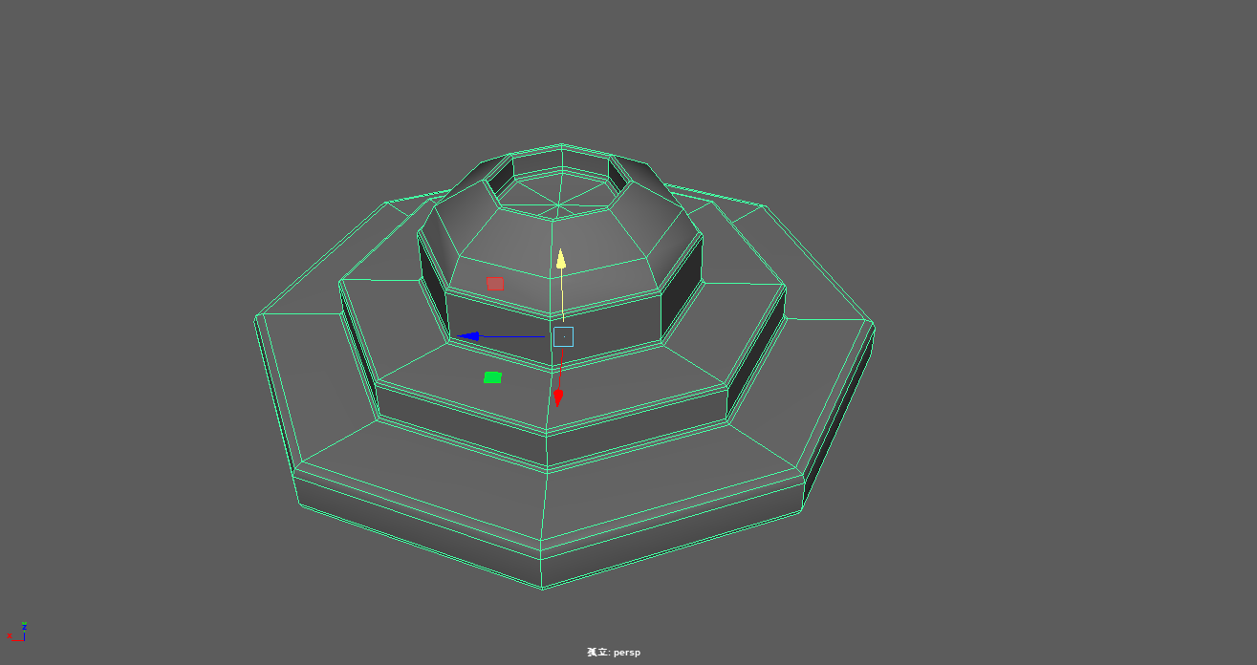
The iron frame in the gas stove is made by the same method.
Finally, after copying some of the same parts, the model of the gas stove is completed.
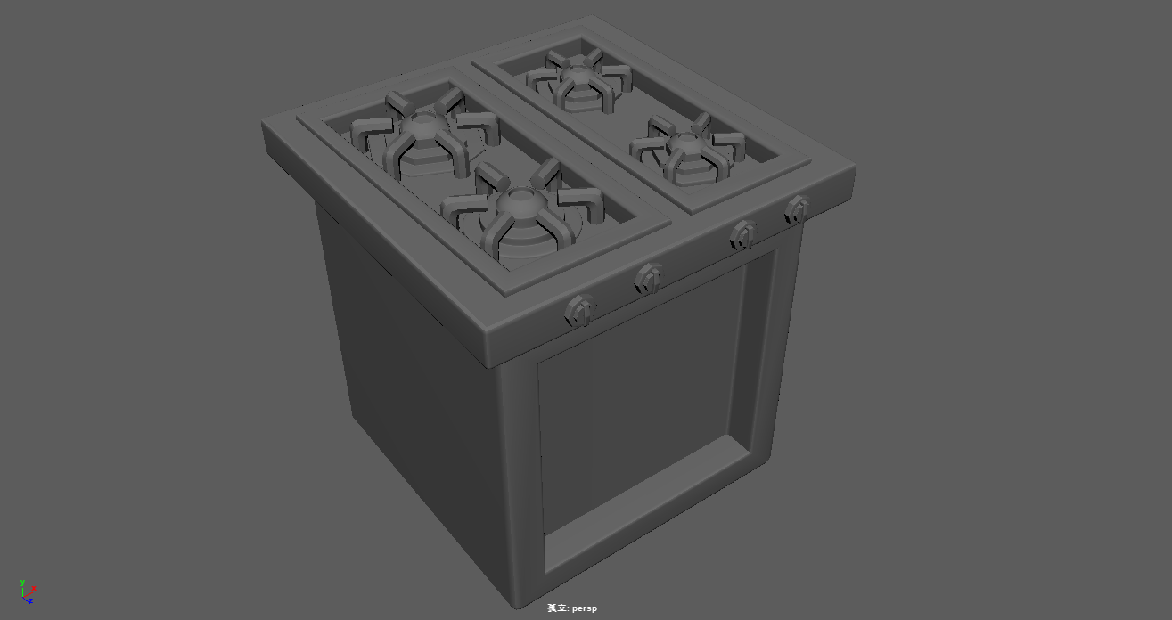
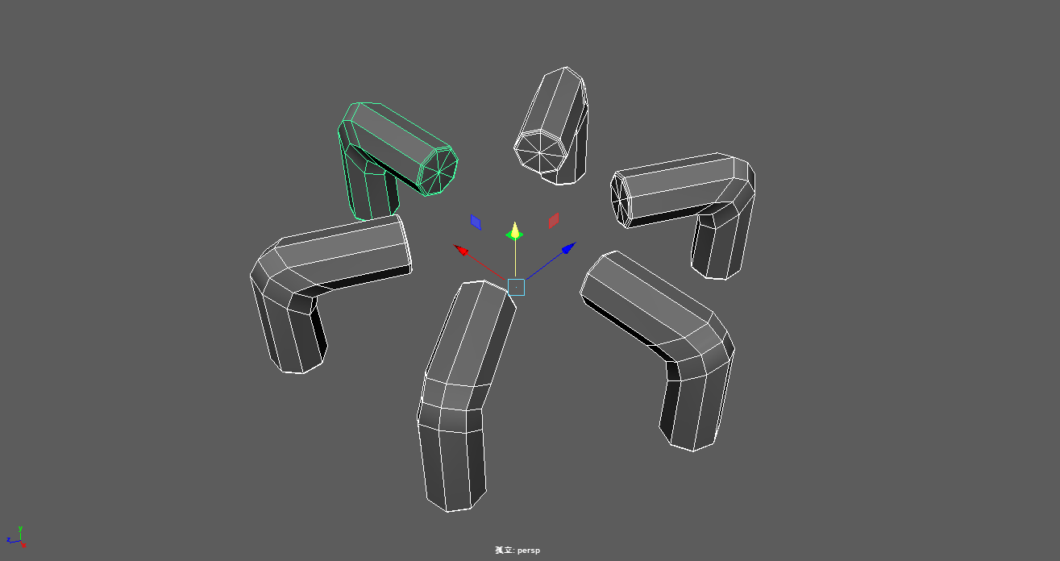
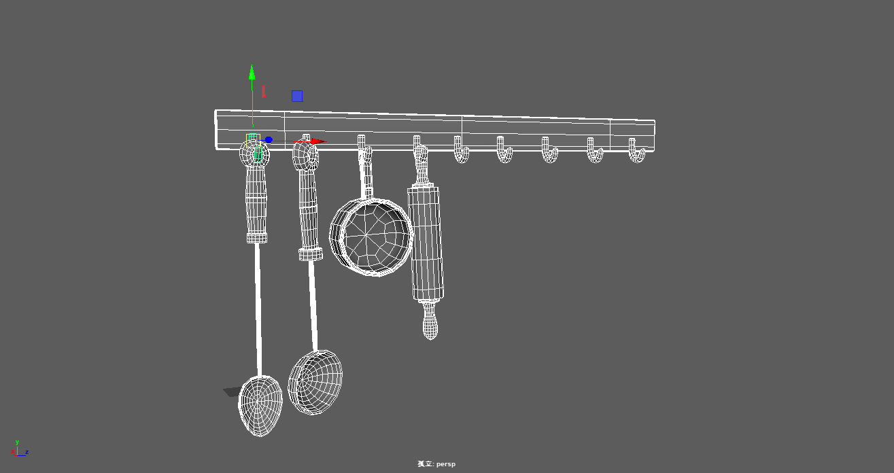
Some modeling methods of kitchen utensils are similar to the previous methods of making gas stoves, but it is worth noting that a kitchen utensil may have more than one material, so it needs to be separately modeled according to the material requirements and then combined together.

Similar manufacturing methods include beer bottle, refrigerator, tea table, lamp and other model modeling.
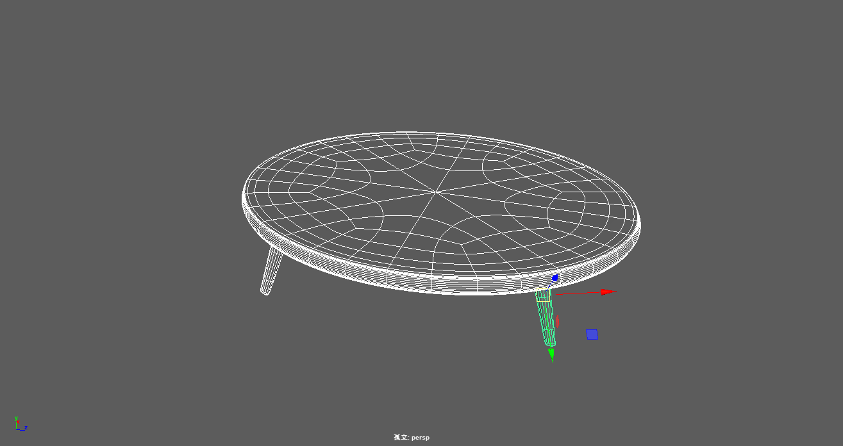
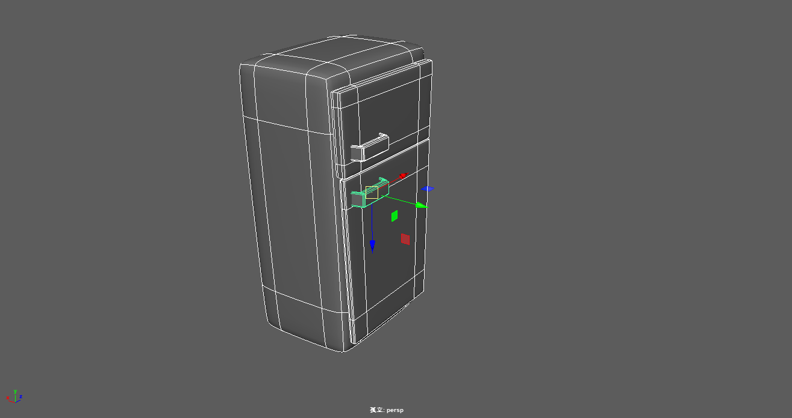
After the indoor model is made, the second step is to draw the model map

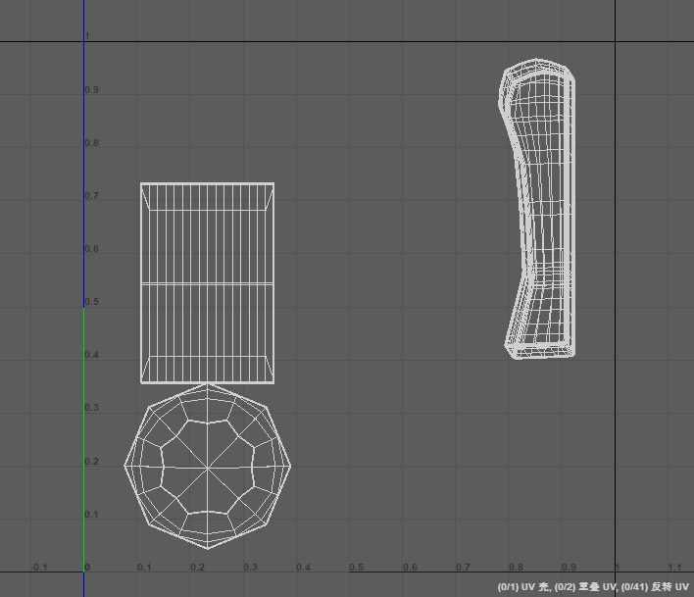
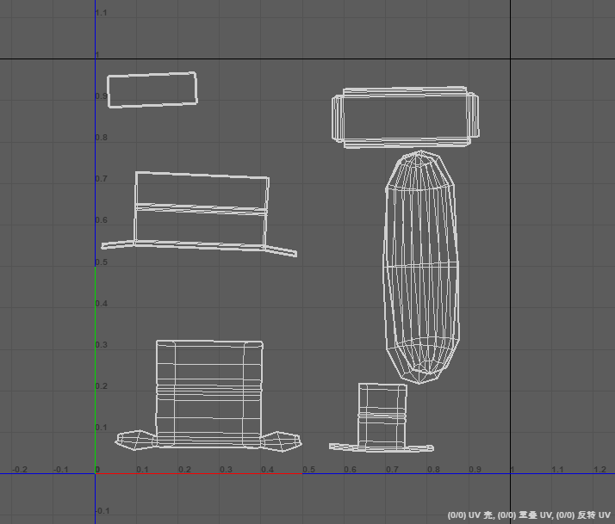
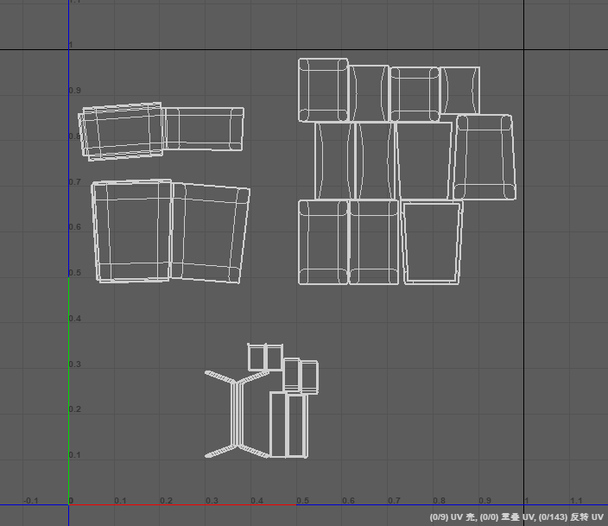
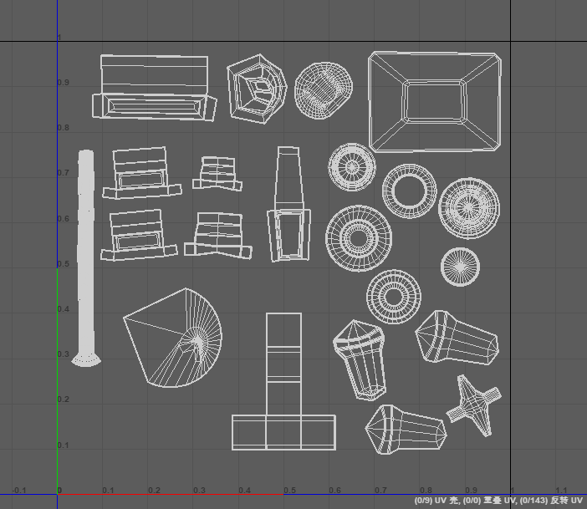
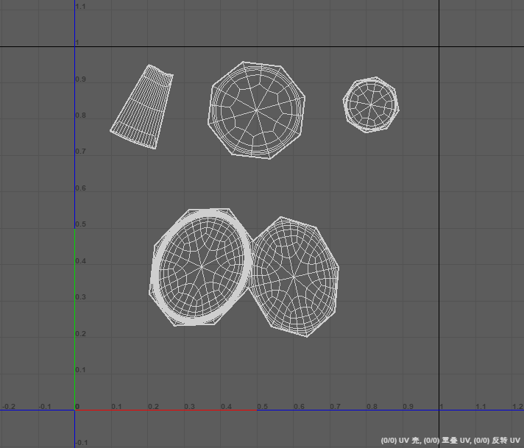
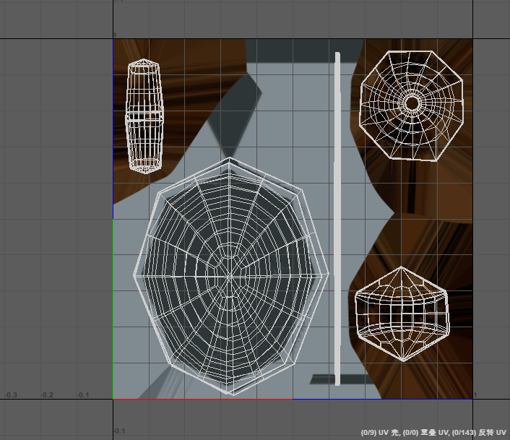
Before drawing the model map, adjust the UV of the model. After combining each model, adjust the UV map according to their shape characteristics.

After adjusting the UV maps respectively, export the materials to obj format files, and use substance painter to draw maps for the model. The main channels for painting are: base color, height, roughness, metallic and normal maps.
First, import the model into substance painter and bake the map. Then paint the map.
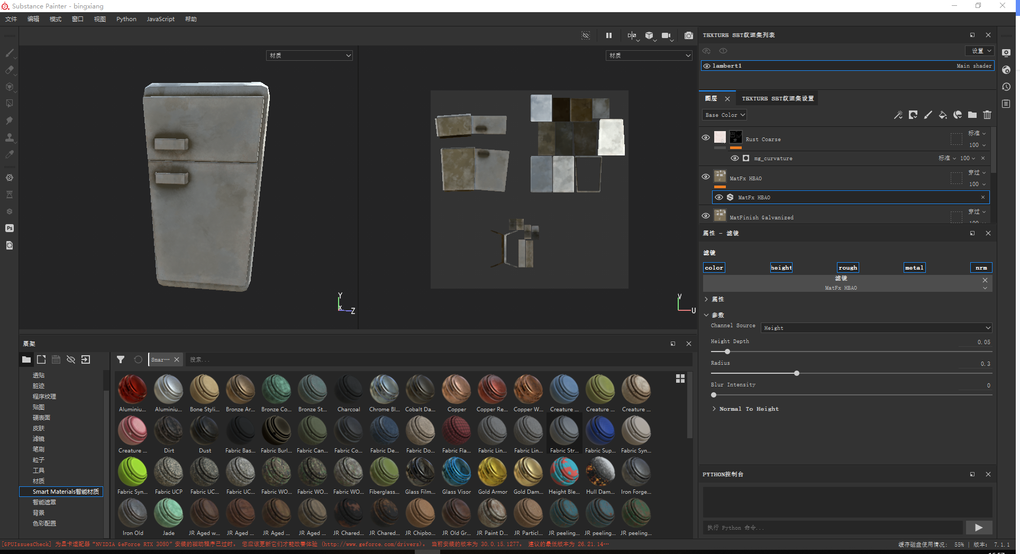

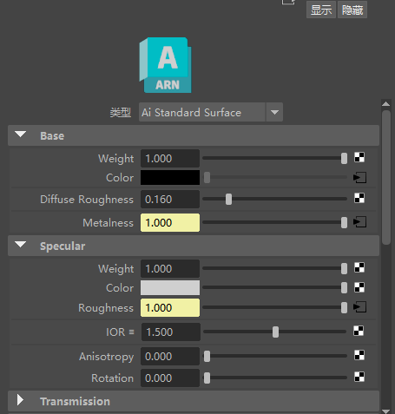
After the mapping is completed, return to Maya to test the mapping, add AI standard surface material to the model, and replace the mapping files with color, metalness, roughness and bump mapping.
After the replacement, check the rendering and modify the details.
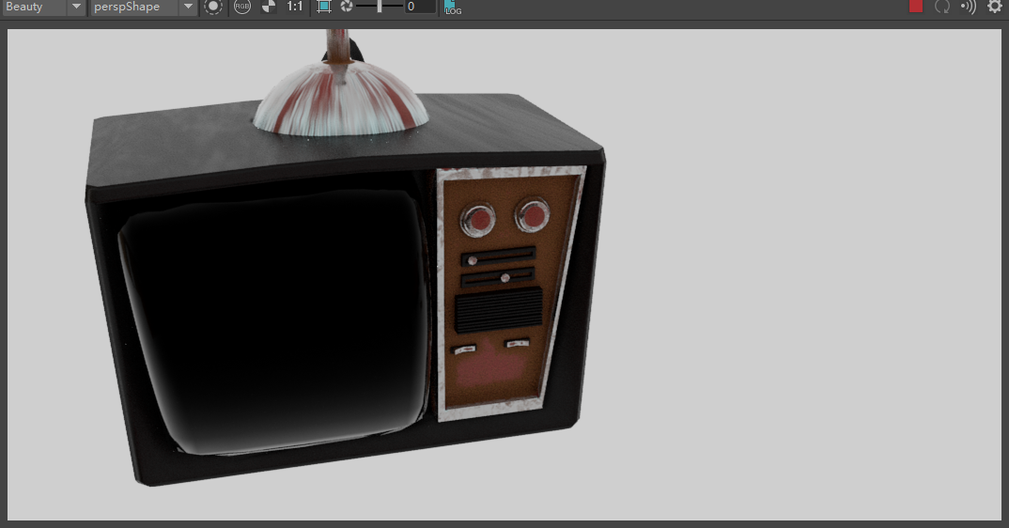

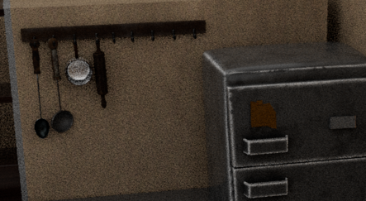

2.2 Indoor scene modeling and mapping
The indoor scene is built according to the lens in the dynamic mirror. The main modeling models include walls, windows, floors and so on.
After the discussion of the group members, it was decided that in the indoor scene, the camera moved from the kitchen window to the living room area, so the kitchen part made the window part, and modeled the kitchen cabinet and other props to enrich the scene.
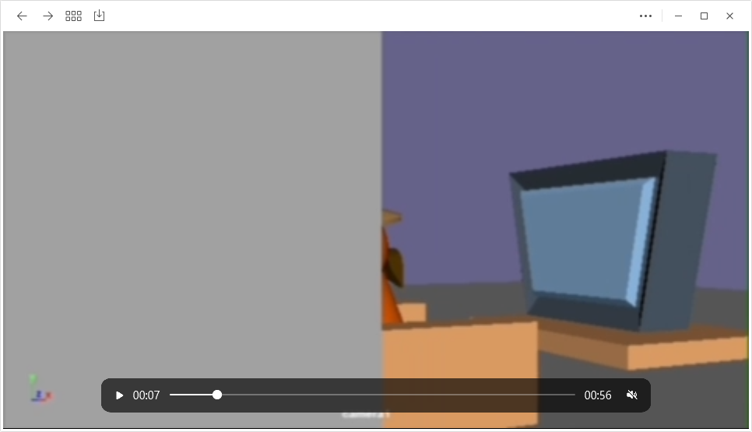
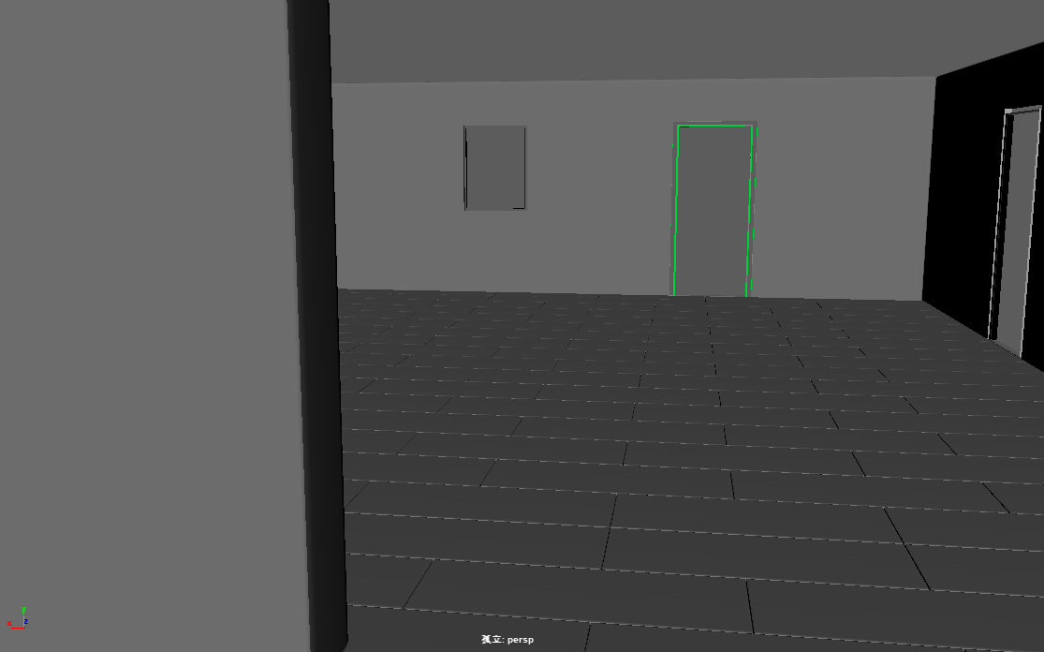
After completing the modeling of the indoor scene, similar to the previous steps, import the model into substance painter to draw maps and test it in Maya.
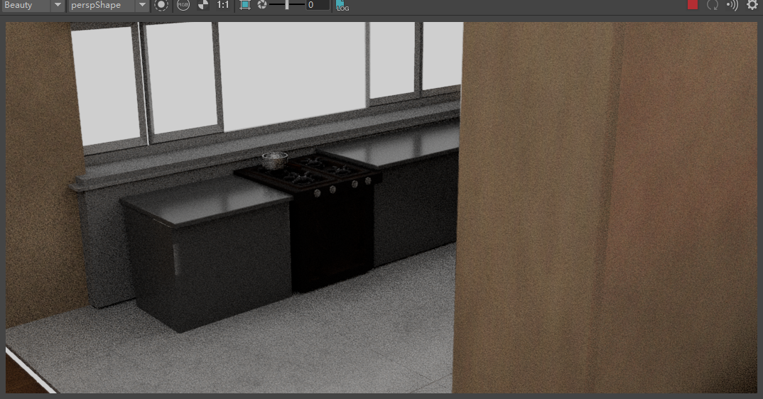
2.3 indoor scene layout
This work only needs to summarize the models of all the students who make the indoor scene props, and after finishing the maps they draw, import all the props into the indoor scene and put them in the appropriate position. The following pictures are all the props folders, and there are a lot of them.
After completing the layout in Maya software, you need to check some details, such as missing props, model defects, etc. for example, the TV cabinet model in the following figure is missing and needs to be supplemented.
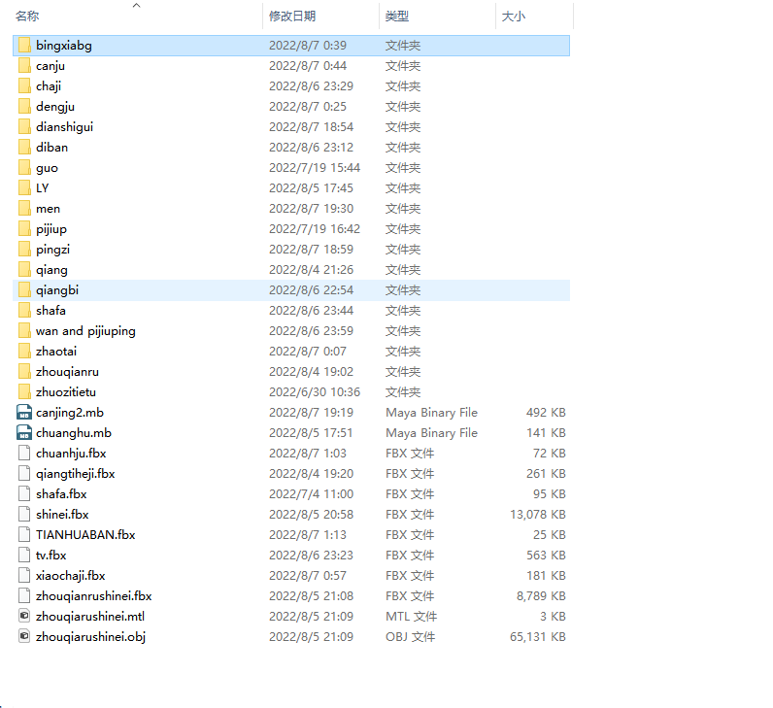
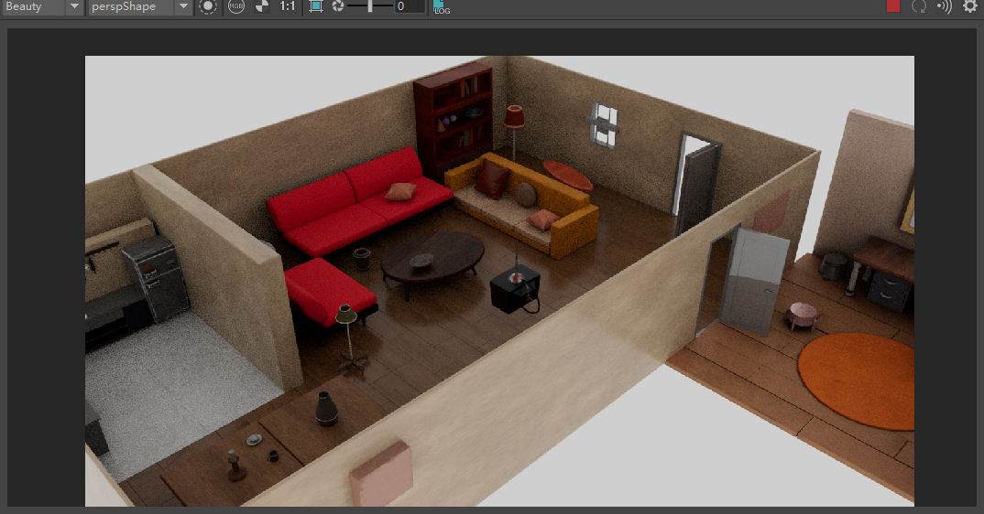
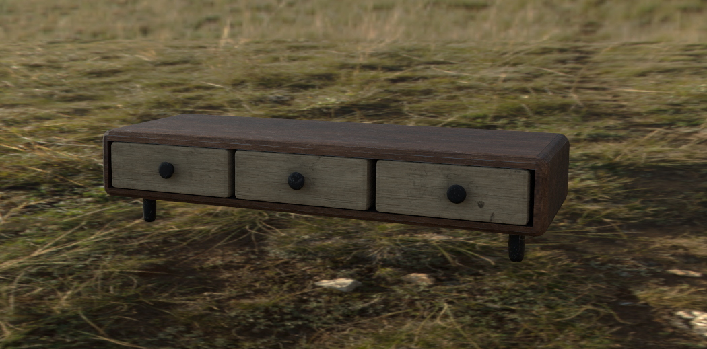
After completing the layout of the indoor scene model in Maya, it is necessary to import the scene into ue5 for construction and production.
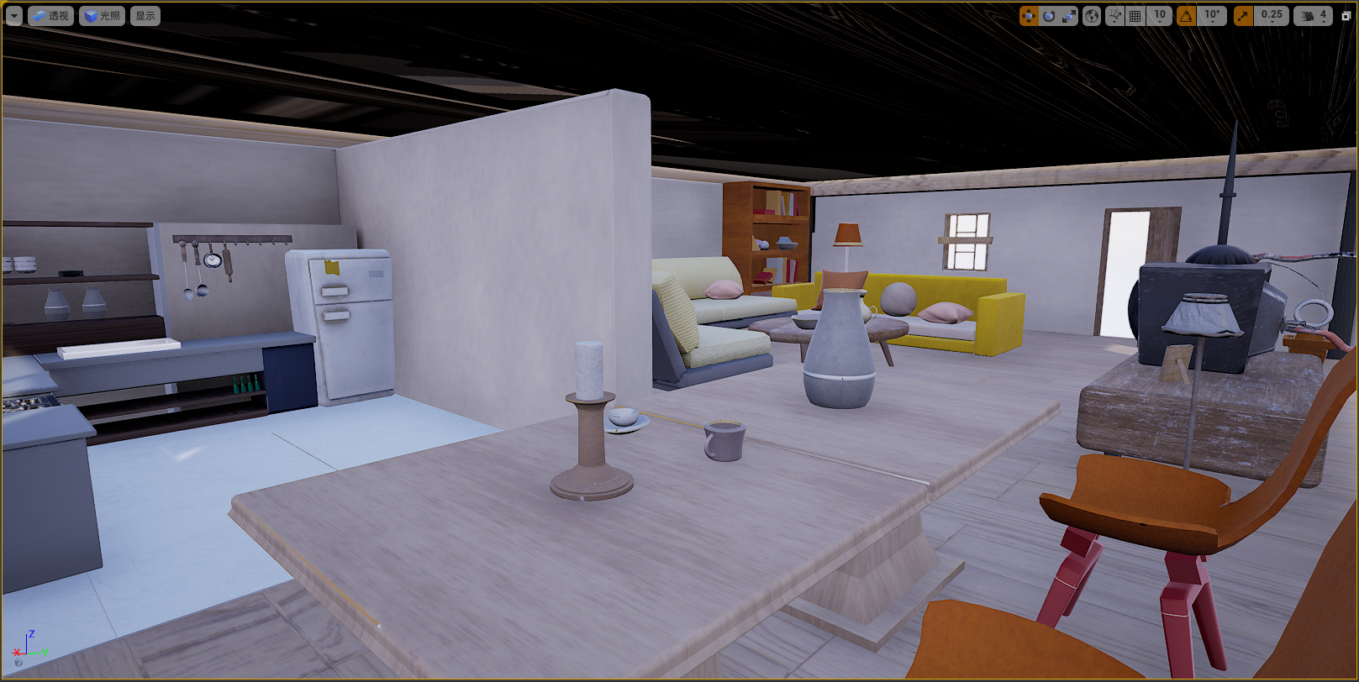
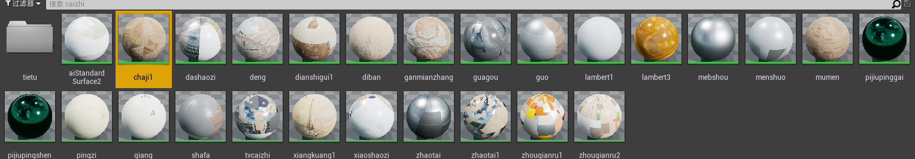
The combination of material surplus models in ue5 requires the combination of maps in the material blueprint of ue5.
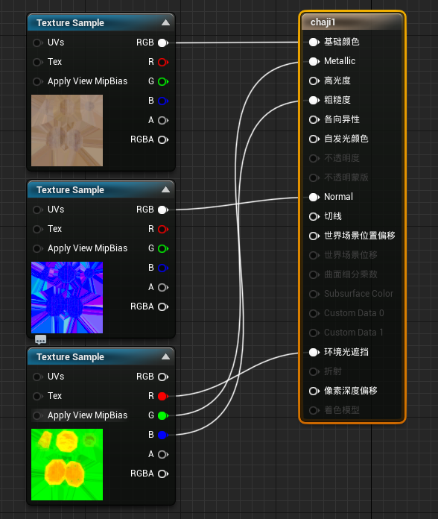
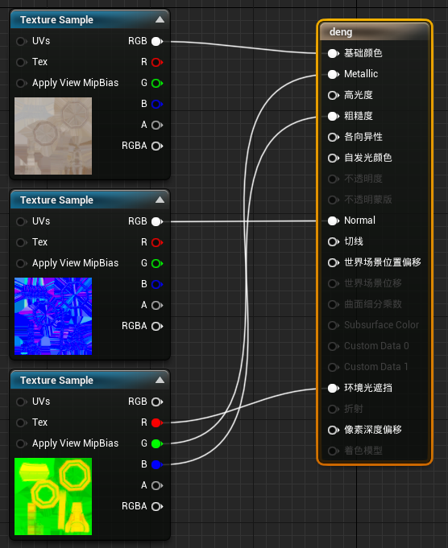
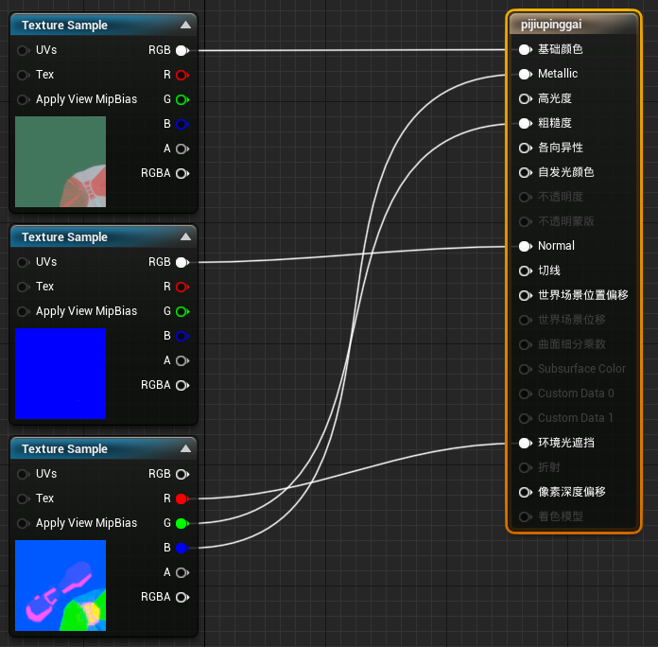
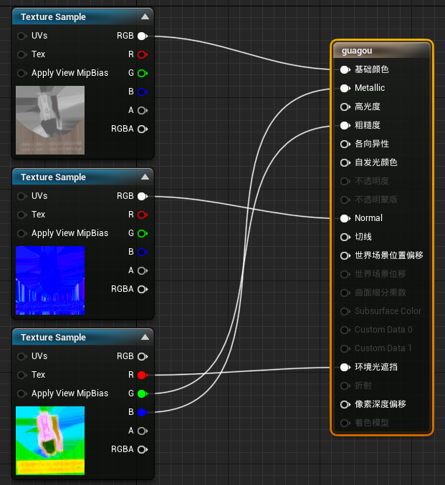
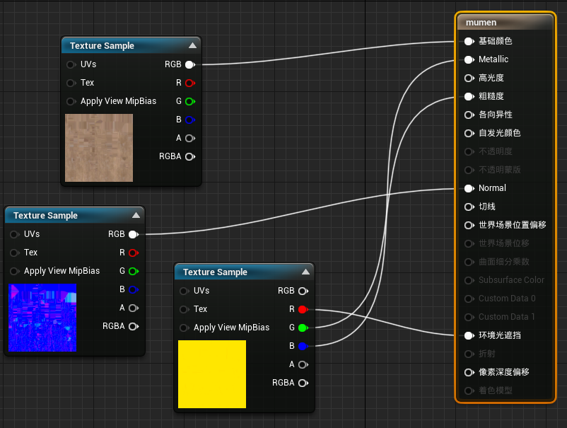
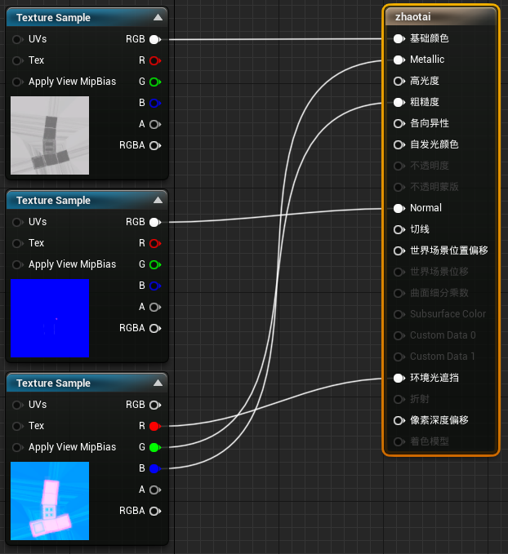
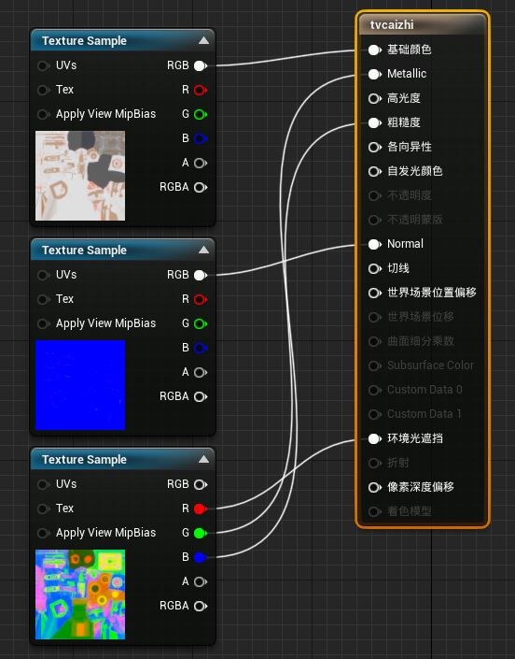
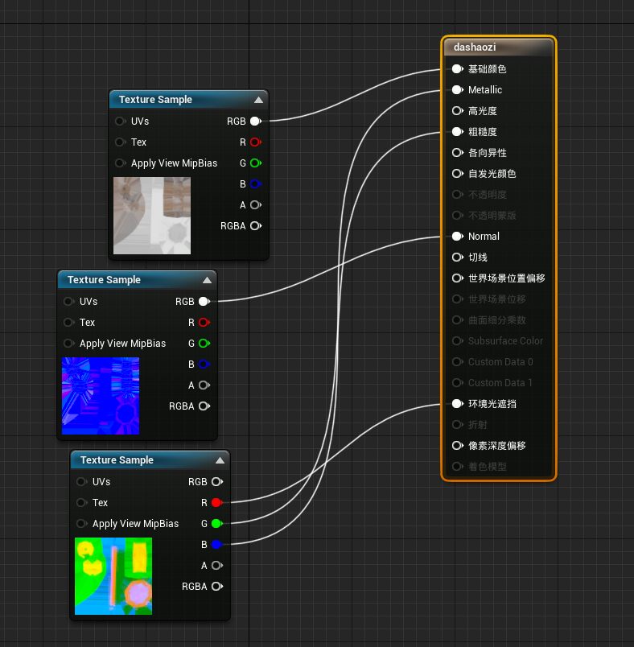

During the production process, the normal of the model made by someone has problems, which will cause problems such as map confusion. Therefore, it is necessary to manually adjust the direction of the normal in Maya.
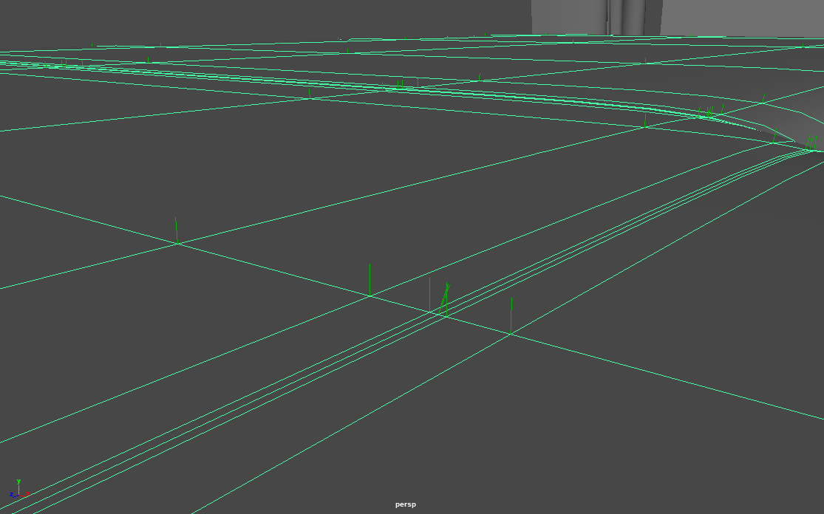
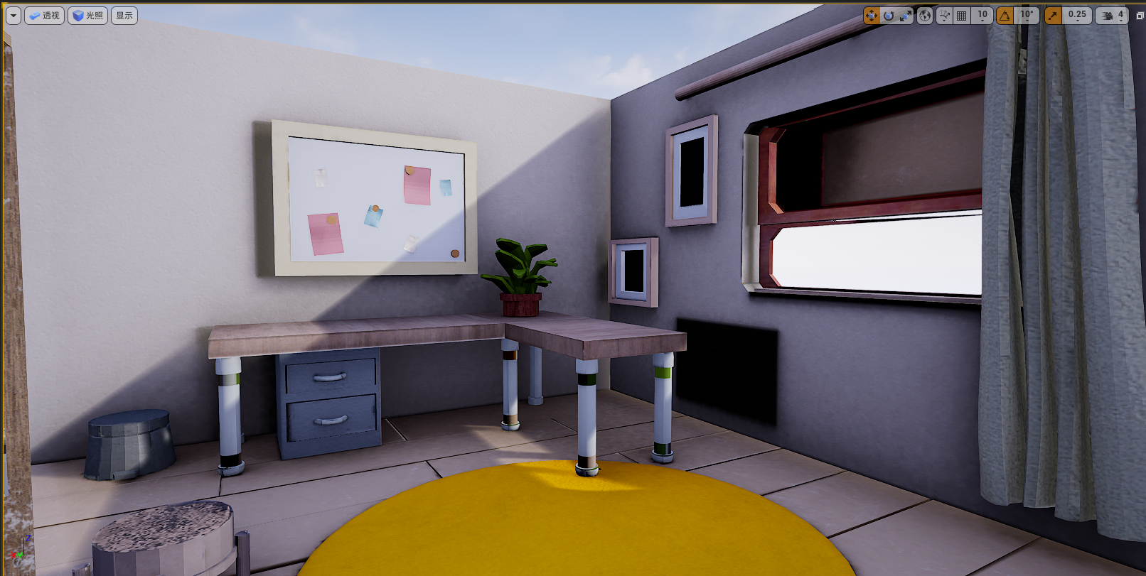
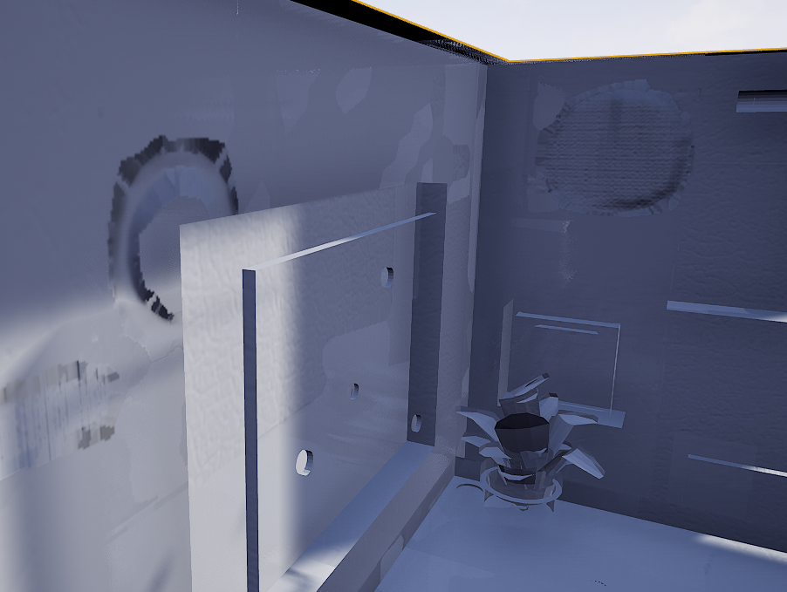

2.4 Facial bone binding of pig character model
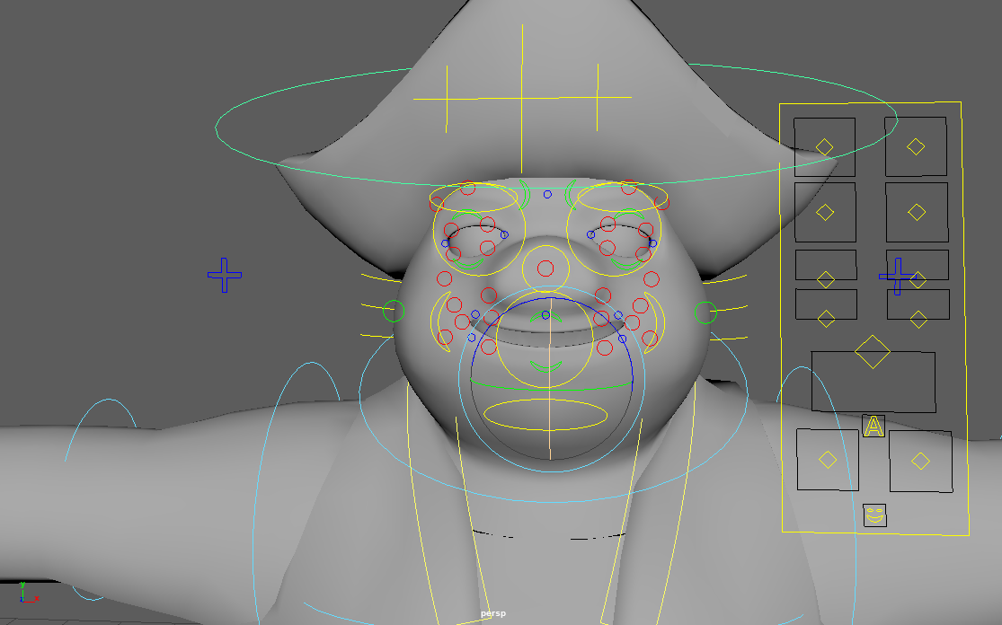
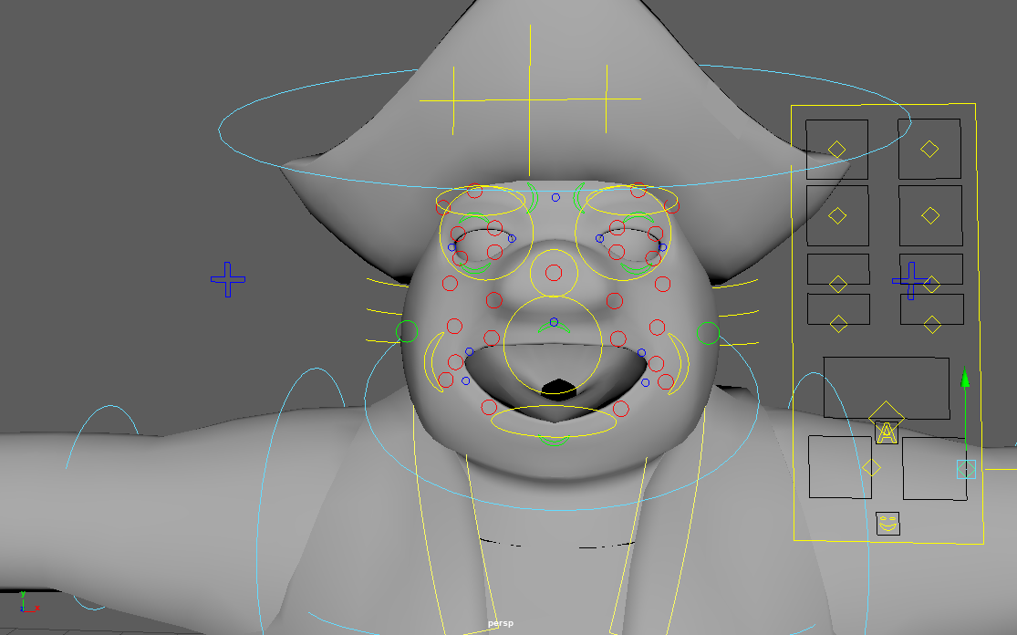
This task is not to bind the bones of the whole body, because the model is expected to be used in ue5, so it needs to use specific bones supported by ue5 for binding, so I am only responsible for binding the bones of the face.

2.5 Making bullet explosion effects
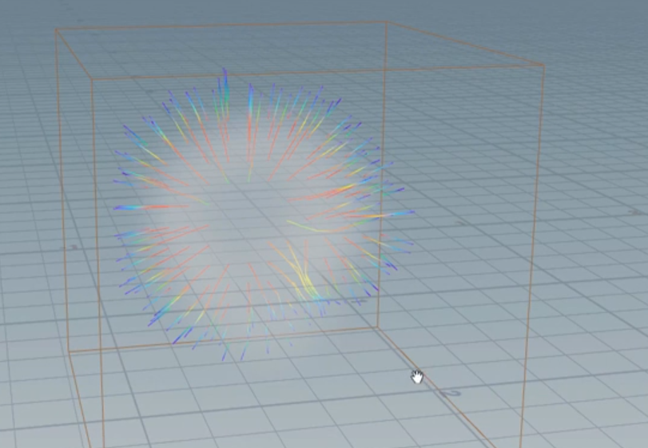
The software used in this process is Houdini and ue5. First, create a sphere in Houdini, change the routing method to polygon, increase the frequency value, and then modify the value of uniform scaled to 0.5. Then, add a mountain effect to the sphere, modify the value, and then continue to add a null node, named source. Add a normal node under source, and change the value under the add normals to option to points. Continue to add a fluidsource effect adjustment value and then continue to add a null node named vel.
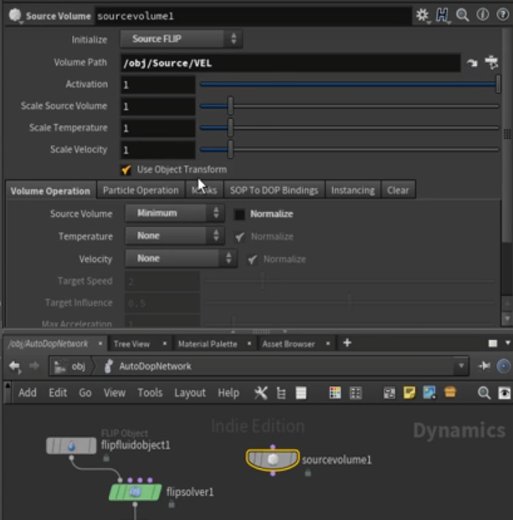
Enter the flipluidobject node blueprint page, adjust the SOP path file to specify as the source node. After adjusting a series of values, add the sourcevolume node, and change the volume path file to specify as the vel node.

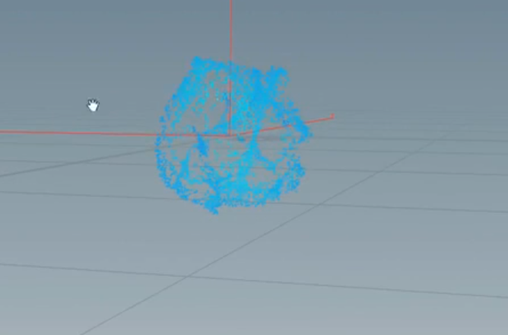
After deleting the gravity node, link the source volume node to the flipsolver node.
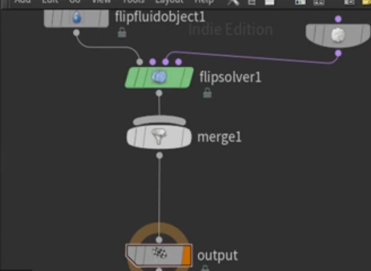

Enter source_fluid In the node interface, import_source is linked to the particlefluidsurface node, and the node under import source is deleted.

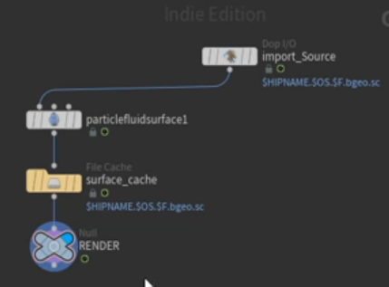
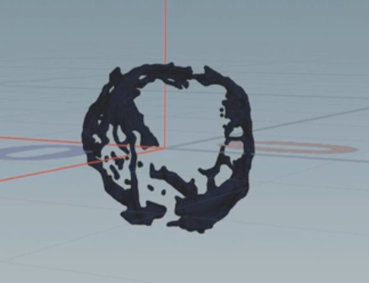

Continue to delete the node under particlefluidsurface
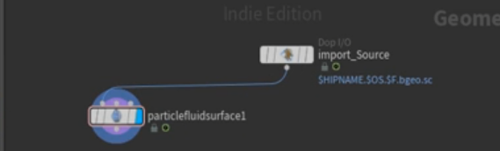

Adjust the erode value to make the effect meet the target requirements.
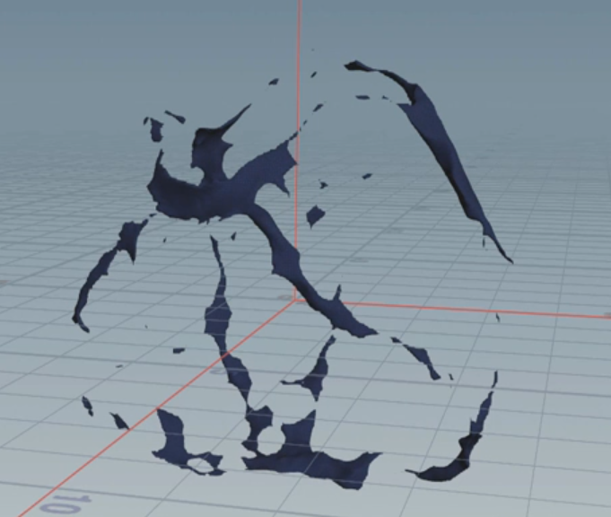

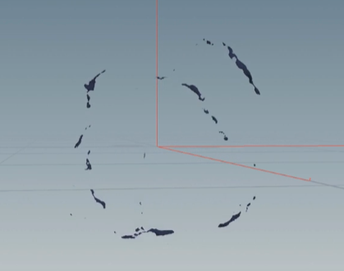
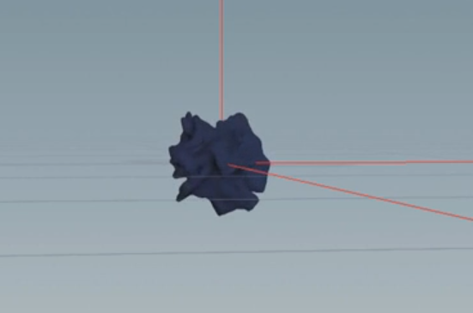
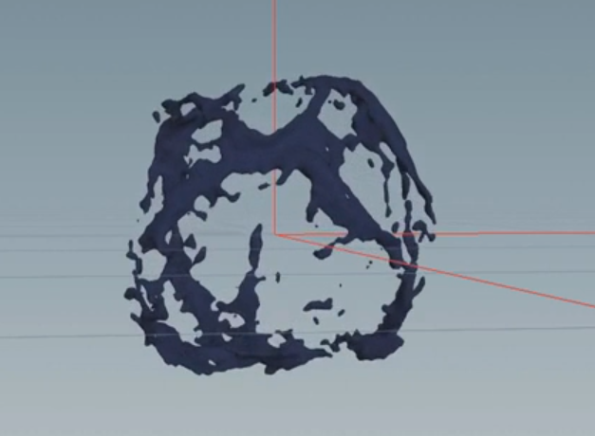
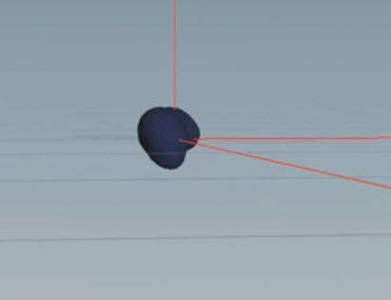

After making the explosion effect, set the explosion duration to 40 frames and export it.
Open ue5 and import the made Painsplat_ POS material, create a new shader, and copy blueprint data in Houdini.
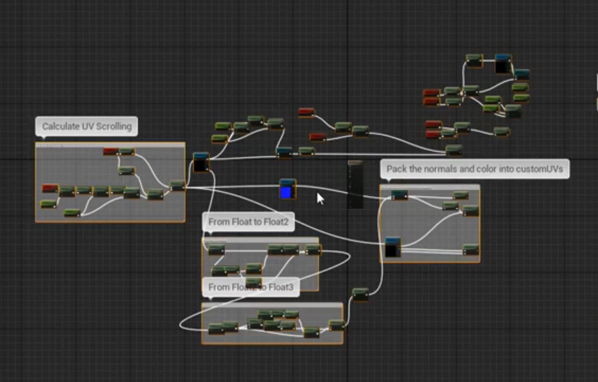
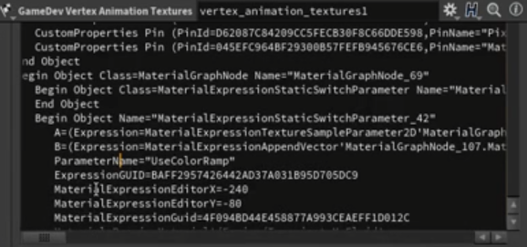

And link the UsecolorRamp output to the shader's bace color. In the menu bar, select Create material instance
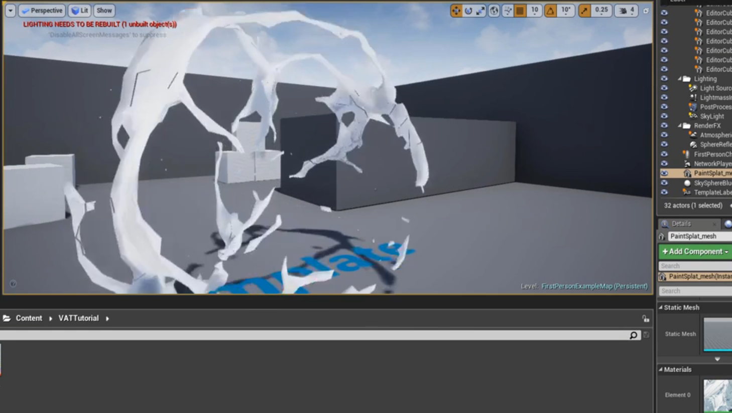
Then add to materials

Then add a particle system and add new mesh data after entering the edit page
Add the Duplicate attribute to add a Particle Position node in the blueprint and link it to node B of the multiply and add nodes.

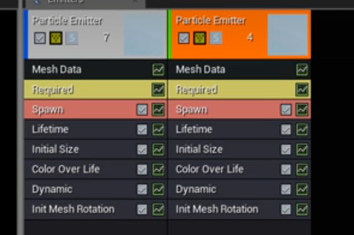
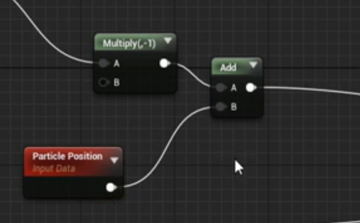
Add a particle color node to link to the base color node of the material. After adjusting the node parameters and colors, add a duplicate emitter on the emitter.

Then enter the firstperson project blueprint and add a span emitter at location node. After the material is linked to the explosion material, the output is linked to the stop movement immediately node.

Then make the liquid left on the ground or on the wall after the bullet explodes.
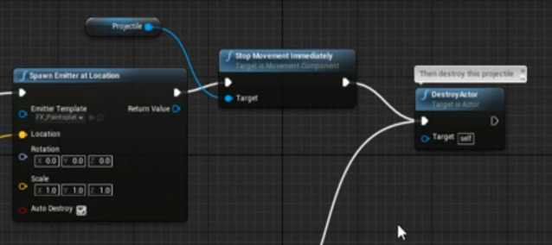
Go back to Houdini, create a sphere, add a mountain node, and then add a particle fluid function.

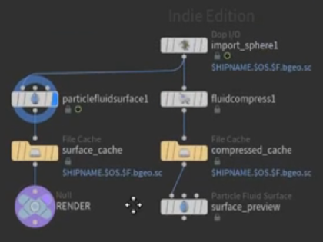
Delete some unnecessary nodes and export them.
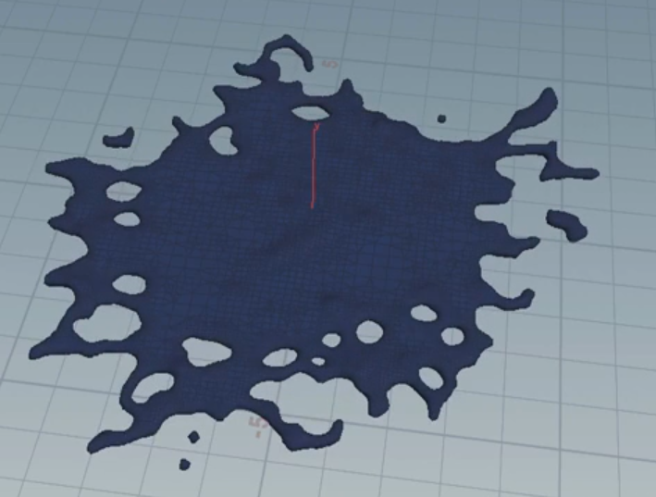

Add a grid and SOP_ simple_ Baker node.

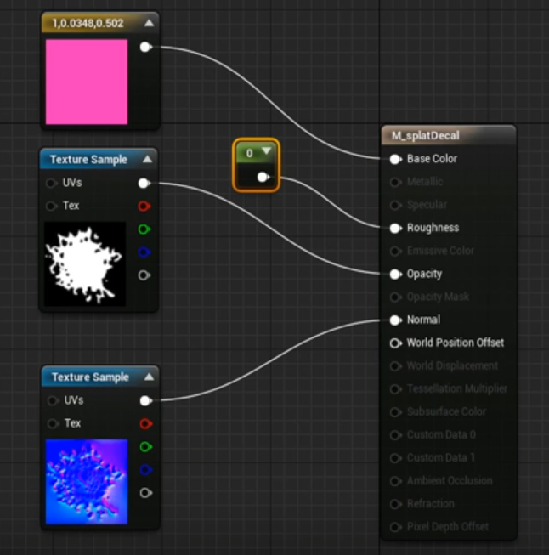
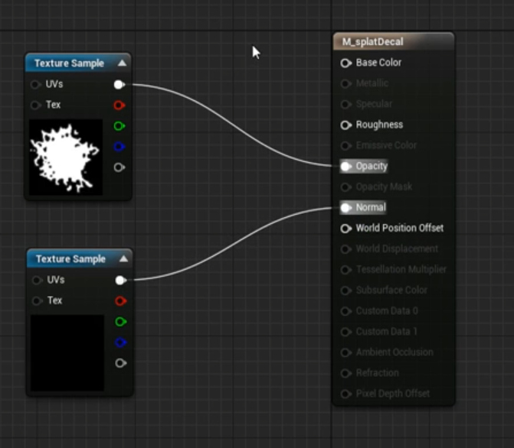
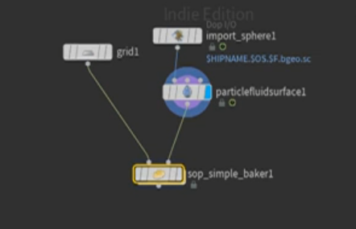
After exporting alpha and normal maps, add them to ue5. After creating a material and entering the blueprint, link the two maps into the blueprint.

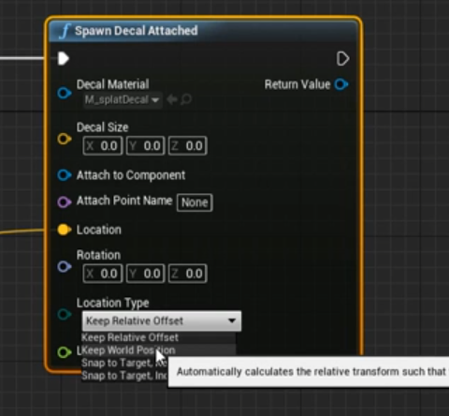
Enter the bullet blueprint again and add a spawn Decal attached node.

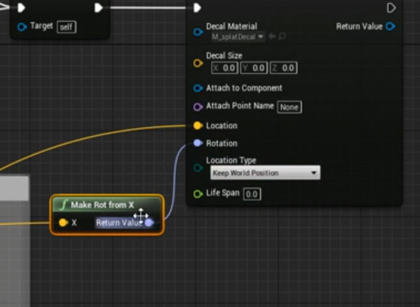
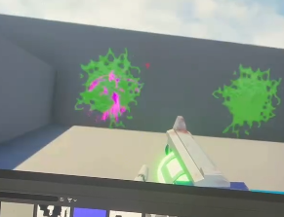
Add a make rot from X link to the rotation

Complete the explosion of bullets and the residual effect of liquid on the wall.
2.6 animation production
I made action animation for two shots. One is the scene of two characters fighting, and the other is the scene of a huge carrot hitting a pig.
For the first shot, I first referred to my own video. Because the leaves on the head of the carrot will swing due to inertia when turning around, I shot a video of turning the head to simulate the swing of the leaves. However, I finally found that the hair was too light, and I had to shake my head hard to drive the swing of the hair. Finally, I used my own potted plant to simulate, and then set the key frame of the head leaves.
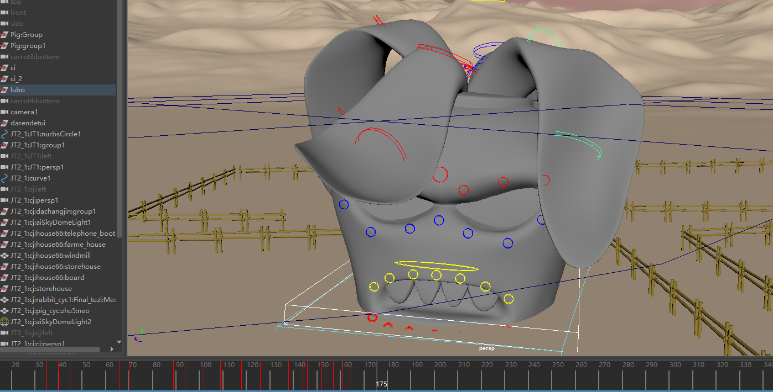

In the animation production, we need to consider various effects caused by inertia or gravity. In addition, we need to grasp the smoothness of animation.
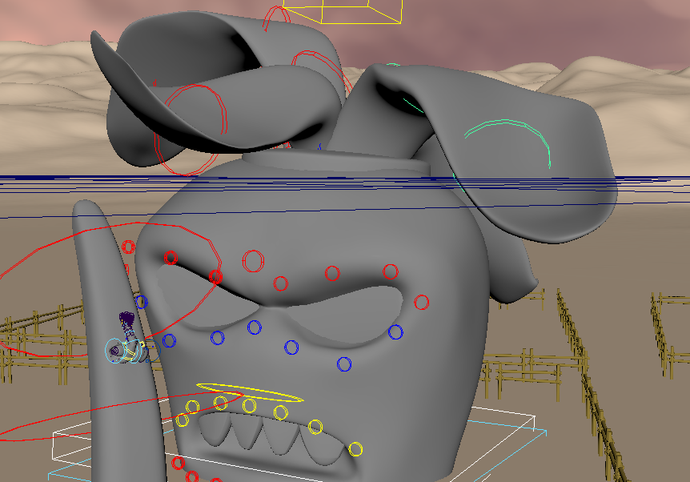

The animation of the ground spike is to remove unnecessary parts such as the head after turning the radish upside down, and set the key frame of the ground spike after leaving only the legs. The movement of the ground spike is also relatively simple, only the up and down movement of the Y axis.
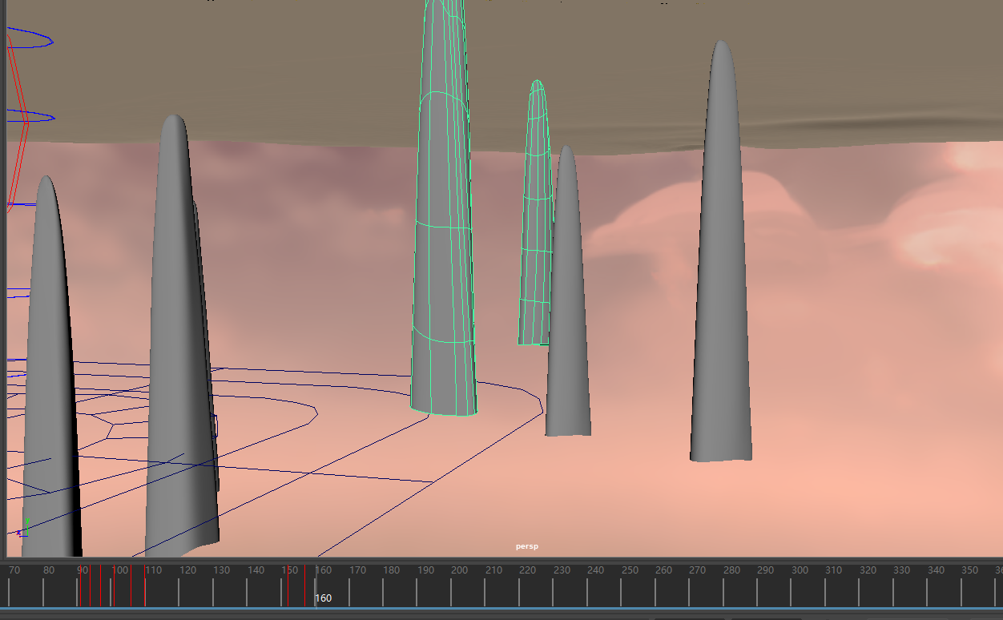

The way to make the character of radish beating flying pig is to copy a radish model and invert the model, leaving only one leg on the surface and the rest hidden underground.
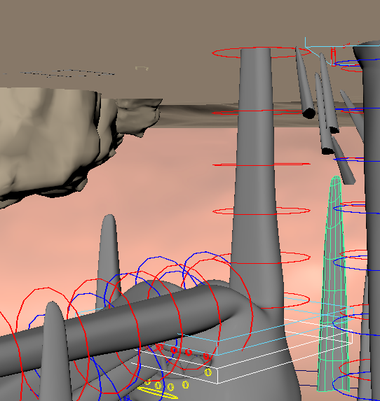

Finally, I made the animation of the pig character being hit by the radish. I divided the animation of the pig into three stages. The first stage is to shoot the pig into the air after the ground spike rises, the second stage is the stage of the pig falling, and the third stage is the stage of the pig character being hit by the leg.
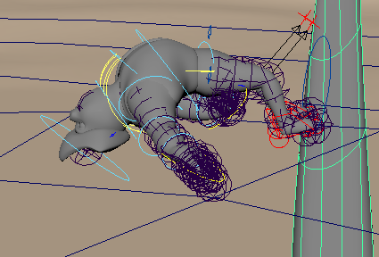
Because it is quickly hit into the air, according to the inertia of inertia, the legs, hands and other parts will be lower than the trunk, and the whole will appear in a C shape.

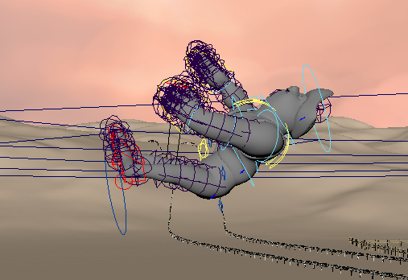
Then, due to gravity, the character falls in the opposite direction to the rising posture.

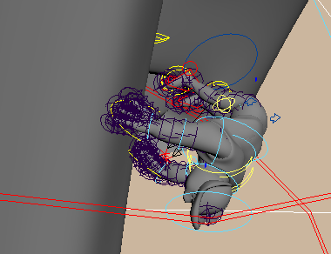
The third stage is to be hit by the radish in the air. During the production of this stage, it is noted that the character is not only affected by the falling gravity, but also by the force of the radish hitting it. Because the radish is a lateral force, but because of the influence of the human body structure, the direction of the body will be changed.

The animation of the second shot is because we found that the interaction between the two characters was less after we finished all the shots, so we added the scene of the body conflict between the two characters.
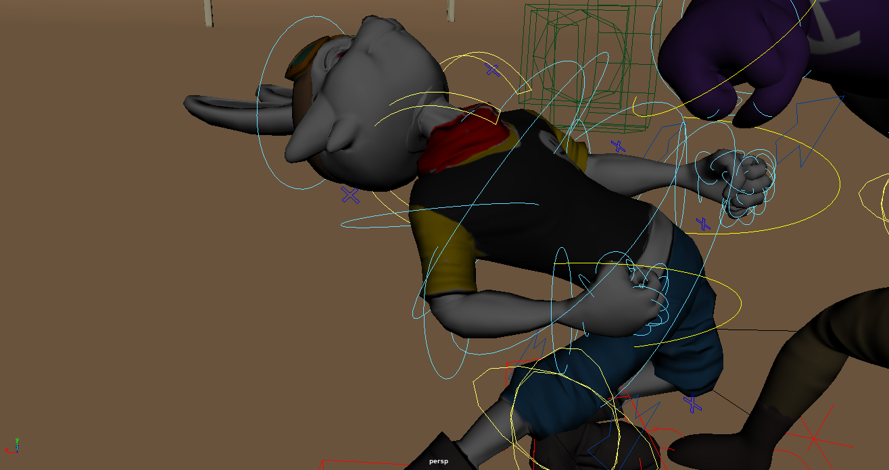
First of all, I looked for some fighting animations similar to our two characters on the Internet. Because the pig character is taller than the rabbit, the two characters should fully reflect their physical characteristics. The pig character represents the strength type, while the rabbit is the agile type. When fighting, I want to reflect their physical characteristics, For example, the rabbit uses inertia to counterattack after dodging the pig's fist, which is more close to the character.
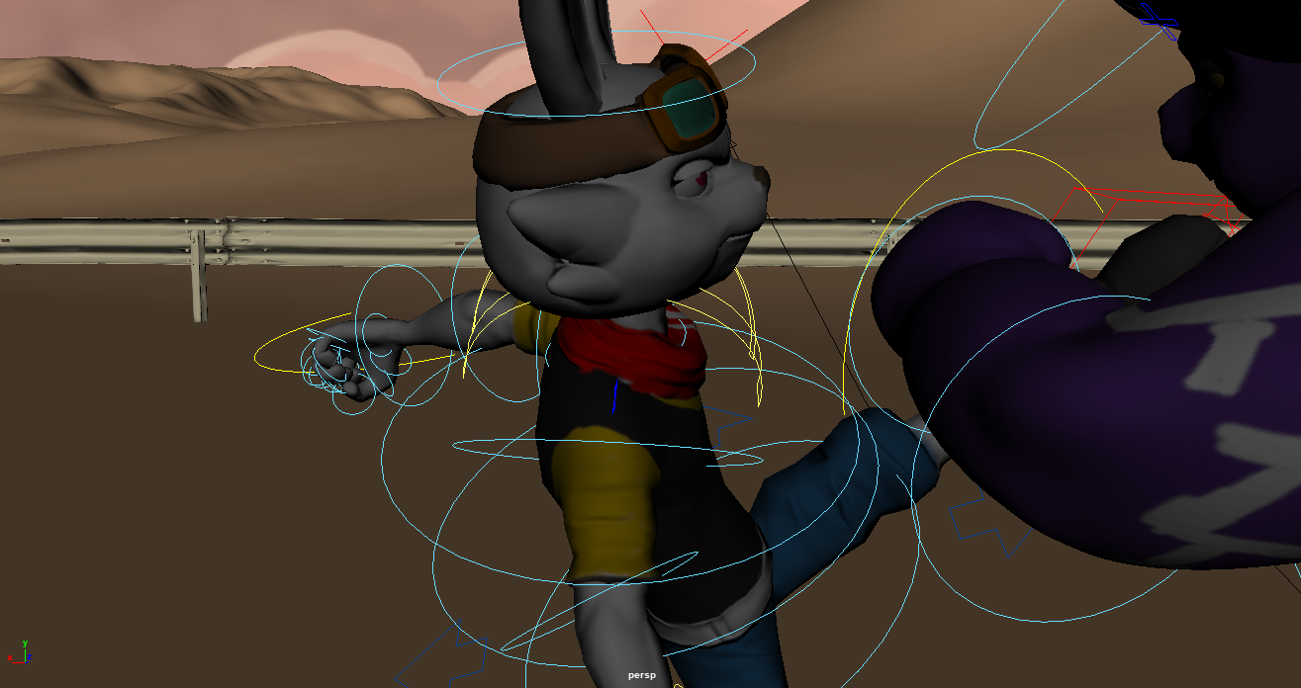

2.7 rendering
What needs to be done in this part is very time-consuming. For various reasons in the middle, we gave up the production of the middle segment in ue5 and rendered it in Maya.
First of all, after group discussion, we unified the lighting intensity and the color of the scene. Because the animation files we obtained are only character animations without scenes and maps, we need to adjust the intensity data of the lighting before rendering each shot, and attach the maps of the characters and scenes. This process was completed by four people working all night.
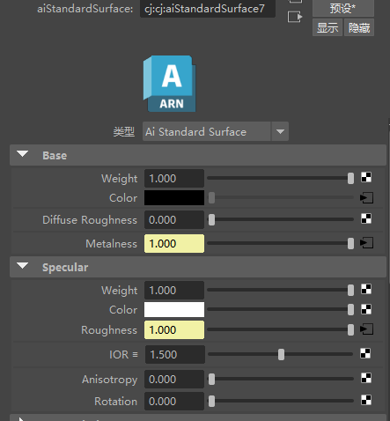

Finally, I rendered the animation of 7 shots.

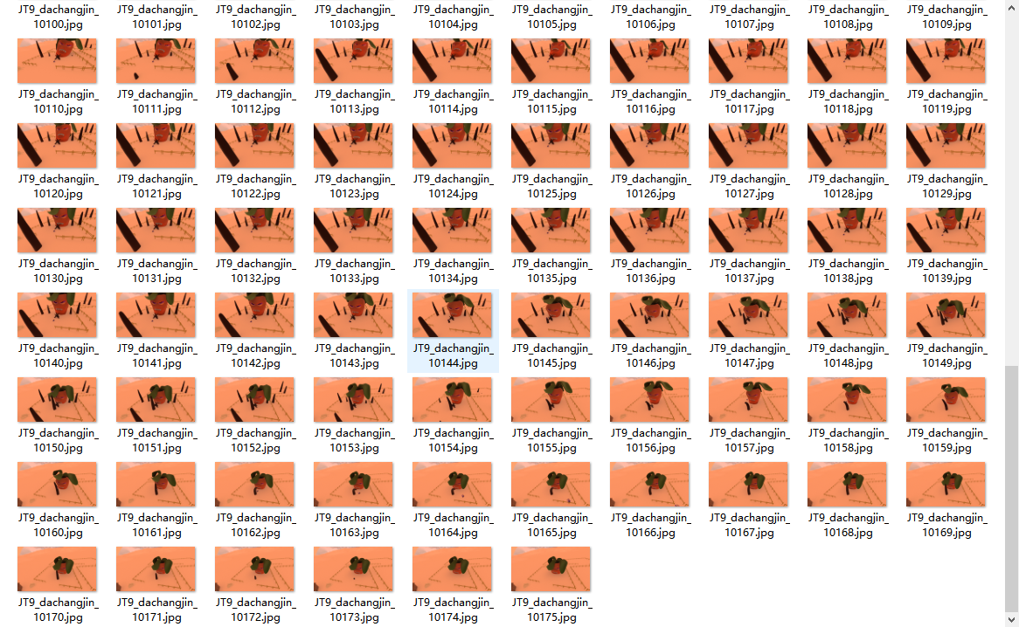

2.8 late color matching and production of 2D special effects
Because the animations made by Maya and ue5 are very different, and because the pictures rendered by different people are also very different, it is important to adjust the color and stylize in the later stage.
First of all, I need to deal with the problem of different brightness of different lens pictures. First, I got the edited animation film from Jirui Hu, and then I cut the lens in after effect according to different lenses.
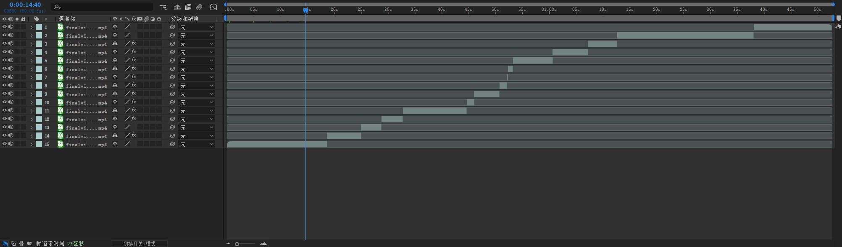

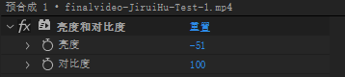
Then, after unifying the overall brightness through the after effect brightness adjustment function, the RGB curve function is used to adjust the color of each segment to achieve the unification of color and brightness.

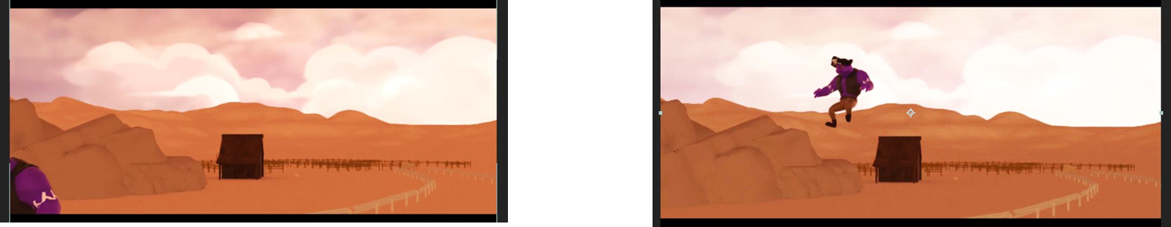
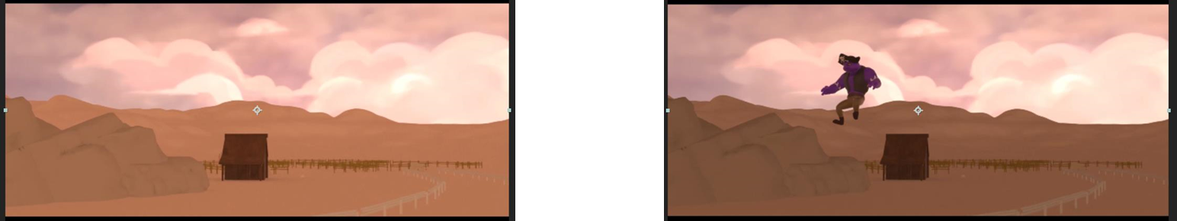

Then style adjustment. Because we made two clips in ue5, the rendering styles and images in Maya are very different from those in ue5, so I give two solutions.
The first scenario is to use 3D rendering to 2D in Maya. First, change the type in "filter" to "Outline" in the rendering settings, and then use Aiton material for all materials to basically achieve outline display. However, there are many problems in the testing of team members. The first problem is that the rendering speed is greatly reduced. The second problem is that the software versions of the team members participating in rendering are different. Only users of Maya 2020 and later have the Aiton material option. This is a fatal problem because the rendering time of only two people cannot catch up with the final report.In the second scheme, I propose to use after effect for stylization. There is a stylization function called animation in after effect. After testing, although it is not as good as Maya 3D rendering 2D, it can be used and can be completed by myself.
Therefore, after effect is used for post stylization.
First, after I adjust the brightness in after effect, I add a stylized effect to each clip.
Because the color difference is different, the contour cannot be recognized automatically, so some shots need to be manually keyed for adjustment.
Finally, the stylization processing is completed.
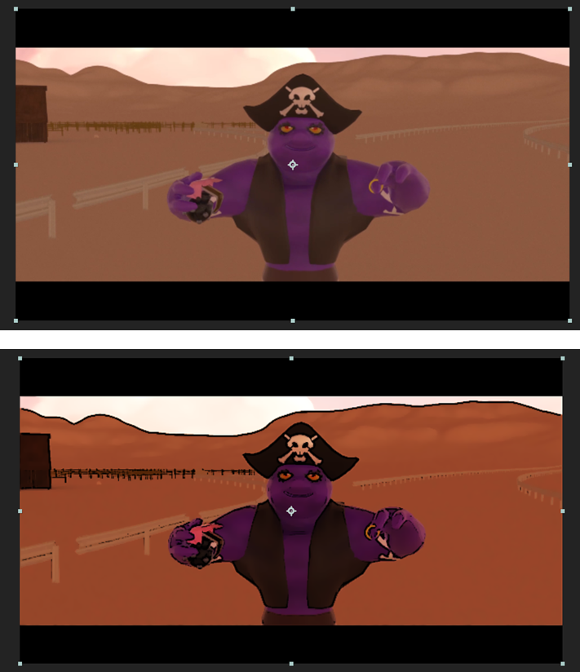
2.9 2D effect drawing production
First, collect sequence diagram materials on the network, draw them frame by frame on procreat, and then use after effect for synthesis.
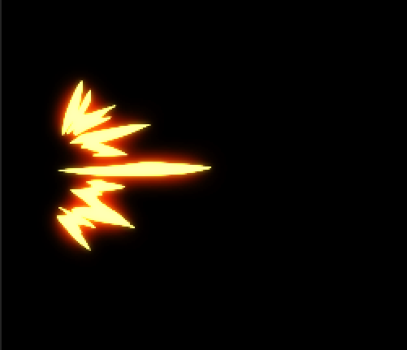
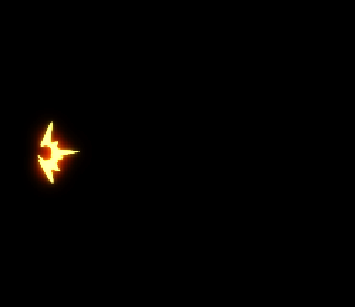
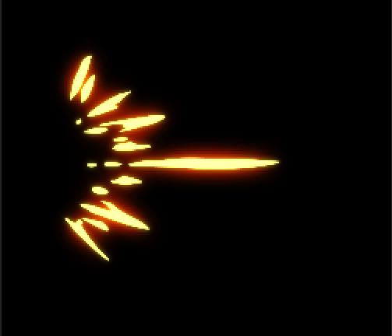

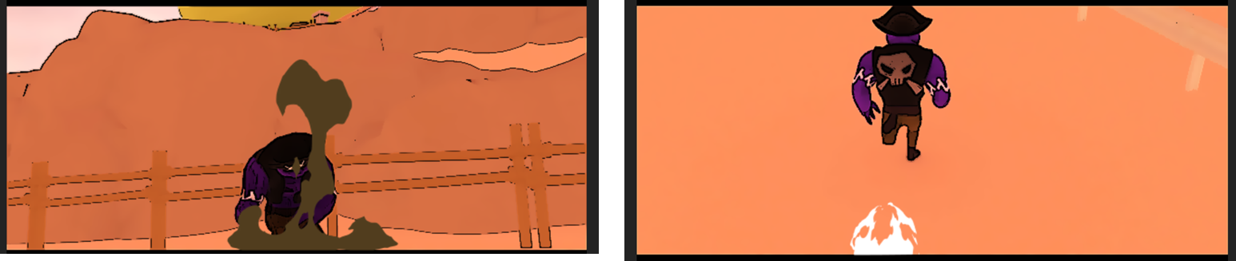

3. Conclusion and analysis
I have encountered many difficulties in the production of this project and also given me many opportunities to learn. I understand that the software of animation is constantly updated with the development of the times. If you want to learn animation well and do it well, you need to keep learning. The process of pre production is relatively easy. The students in the early stage are full of energy, so everyone will complete their work well. Our work in the early stage is to make indoor asset models. The team leader gave me the items and reference drawings needed in the room, so we only need to model according to the reference pictures and our own ideas, On the one hand, after the appearance of the finished video, I also feel that there are some shortcomings. For example, some details are not paid enough attention to when modeling, and most of them are polygon modeling. Compared with digital engraving modeling, the details are not enough. If I have the opportunity, I think I will try digital engraving technology more in the future production.
The second is the mapping process. Basically all the mapping work is done in substance painter. During the use process, I still feel that my painting skills are very inadequate. I need to practice more in the follow-up study and work.
Making special effects is something I'm not good at, because making special effects is a very complicated job, and you can't learn special effects through one or two individual cases. In terms of the use of software, you can't finish using a software skillfully in one day. In the process of making group projects, the use of Houdini is only limited to making special effects by referring to the tutorial, and the production is not perfect, Because it is found in ue5 that the liquid effect left after the bullet explosion is only limited to the plane and can not perform well on the curved surface, these shortcomings will be solved as much as possible in the future work.
For a student majoring in animation, it is very important to make action and understand the movement rules. In the process of making two animation sections, I think the level of making animation is improved compared with that before, but it is still far from enough. Before making animation, reference is needed, and the difference between animation and reality should be considered. Therefore, more attention should be paid to the details of animation in the subsequent process.
Finally, I think I have done a good job in the later part of the color palette. It is not easy to adjust the video rendered by Maya to make the difference as small as possible from that produced in ue5. It is very difficult to find a way to solve the problem of different painting styles in an emergency. In the future, we should learn more about different software and knowledge, It is possible to try to solve the problems caused by the unknown.

