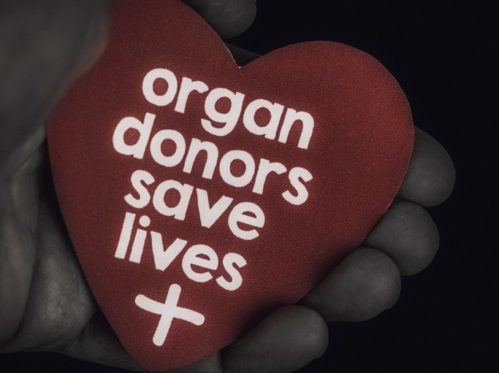
THE IMPORTANCE
OF
ORGAN DONATION

(Schmerling, 2021)

Hi, my name is Leah. I am an advocate for Organ Donors. I became an advocate for this campaign many years ago after reading a story that touched my heart about a young girl called Kiera, who passed away due to a road traffic accident in the summer of 2017. Kiera donated 4 of her organs in total, her heart, liver, and her kidneys. These organs were then donated and helped to save the lives of two adults, a young child, and a baby. Since then, I have become actively involved in trying to convince you - the older generation to sign up and become organ donors, as we are faced with a current shortage of elderly donors.
There are thousands of people waiting for an organ donation as we speak, with the average waiting time being between 1 to 5 years (NHS, 2015). Unfortunately, many people die without ever receiving an organ donation. This could be for many reasons such as Covid-19 or due to a shortage in a particular organ.
Therefore, it is important for you to support this campaign and to opt-in by signing up to donate your organs today and giving someone else a second chance at this beautiful gift called life (Phelps Health, 2022).
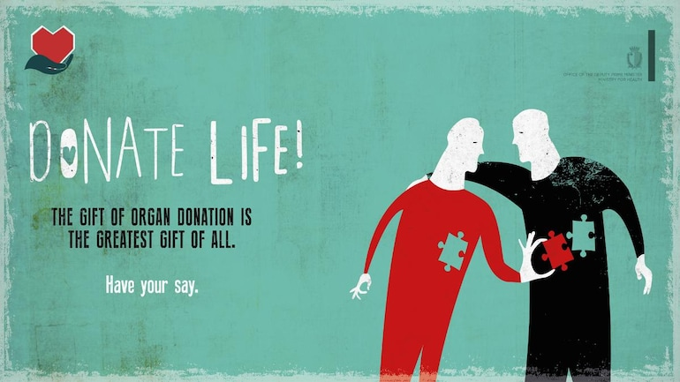
NHS Blood and Transplant
Organ Donation and Transplantation Directorate
Fox Den Road
Stoke Gifford
BRISTOL
BS34 8RR
(Image:Organdonation.gov)

Website: https://www.organdonation.nhs.uk/
Contact us on - 0300 123 23 23

REFERENCES

National Kidney Foundation. Available at:
https://www.kidney.org/ (Accessed: 17th March 2022)

NHS Blood and Transplant, (2015). Available at:
https://www.organdonation.nhs.uk/get-involved/news/nearly-49-000-people-in-uk-have-had-to-wait-for-a-transplant-in-the-last-decade/ (Accessed: 17th March 2022)

Organ Donation.gov. [Image] Available at:
https://www.indiatoday.in/education-today/gk-current-affairs/story/organ-donation-body-parts-you-can-donate-donor-laws-1576069-2019-08-01 (Accessed: 17th March 2022)

Phelps Health, (2022) [online] No greater Gift. One Donor Can Save up to 8 Lives. Available at:
https://phelpshealth.org/news/featured-stories/no-greater-gift-1-organ-donor-can-save-8-lives (Accessed: 17th March 2022)

Schmerling, R. (2021) [Image] Available at:
https://www.health.harvard.edu/blog/flowers-chocolates-organ-donation-are-you-in-2021021121928 (Accessed: 17th March 2022)

Elevated Speech

Hi, my name is Leah. I am a student at the University of Wales Trinity Saint David, and I am also an advocate for Organ Donors. Today I am going to talk about the importance of Organ Donors and why it is important to become an active donor. I became an advocate for this campaign many years ago after reading a story that touched my heart about a young girl called Kiera who passed away due to a road traffic accident in the summer of 2017. Kiera donated 4 of her organs in total, her heart, liver, and her kidneys. These organs were then donated and helped to save the lives of two adults, a young child, and a baby. Since then, I have become actively involved in trying to convince you - the older generation to sign up and become organ donors, as we are faced with a current shortage of elderly donors. As it stands Organ donation is the highest amongst 18 to 49-year-olds (Stuart, 2021) and there are thousands of people currently still waiting for an organ donation as we speak, with the average waiting time being between 1 and 5 years. Unfortunately, many people die without ever receiving an organ donation. This could be for reasons such as Covid-19 or due to a shortage in a particular organ, Such as Kidneys, which has the longest waiting list.
This is due to the different types of blood groups such as blood types O and B which are less common. People with blood group O can donate to all other blood groups but can only receive an organ from the same blood group. This has led to a global shortage over time.
This information can be found at (www.kidney.org). Fortunately, technology has also advanced over the years, and we can now transfer organs almost immediately, with fewer complications ensuring a higher successful transplant rate.

Therefore, it is important that you support this campaign and opt-in to donate your organs to continue to help save the lives of people from all over the world. It is said that one donor can save 8 lives or more, with each donation going on to play a major part in someone else’s life (Phelps Health, 2022). According to the annual organ donation transplantation activity report (NHS, 2020), the overall consent and authorization of organ donors has increased over the last year with 68% to 69% of the population having opted-in to become organ donors. It would be amazing if this figure continues to rise annually.

We need you to help save people’s lives and become an active member in this campaign by signing up today NHS Organ Donor Register to donate your organs and give someone else a second chance at this beautiful gift called life.

Thank you for your time.

REFERENCES

National Kidney Foundation. Available at:
https://www.kidney.org/ (Accessed: 17th March 2022)

NHS Blood and Transplant, (2015). Available at:
https://www.organdonation.nhs.uk/get-involved/news/nearly-49-000-people-in-uk-have-had-to-wait-for-a-transplant-in-the-last-decade/ (Accessed: 17th March 2022)

Phelps Health, (2022) [online] No greater Gift. One Donor Can Save up to 8 Lives. Available at:
https://phelpshealth.org/news/featured-stories/no-greater-gift-1-organ-donor-can-save-8-lives (Accessed: 17th March 2022)

Stuart, (2020) Statista, (2021). Available at:
https://www.statista.com/statistics/519936/organ-donation-population-by-age-united-kingdom-uk/ (Accessed: 17th March 2022)

