BA International Hotel Management
Management & Organisational Behaviour
BMIH5004

THE IMPACT OF LEADERSHIP STYLES ON EMPLOYEE ENGAGEMENT IN THE TECH INDUSTRY

LECTURER: JESSICA NEWPORT

STUDENT: ALINA PANDREA
STUDENT ID: 2226713

Table of Contents

1. Introduction 2
2. Organisation Structure, Corporate Culture, and Organisational Goals 2
2.1 Organisation Structure 2
2.2 Corporate Culture 3
2.3 Organisational Goals 4
3. Analysis of Recent Organisational Change Initiatives 4
3.1 Identification of Initiatives 4
3.2 Impact on Organisation 4
3.3 Management of Changes 5
4. Strategic Direction of Hyatt Hotels Corporation 5
4.1 Analysis of Strategic Direction 5
4.2 Long-term Strategies 6
5. Recommendations for Organisational Improvement 6
5.1 Enhancing Customer-Centric Practices 6
5.2 Sustainability Initiatives 7
5.3 Digital and Technological Upgrades 7
6. Conclusion 7
7. References 9

1. Introduction
The name Hyatt Hotels Corporation is practically synonymous with five-star luxury hotels when most people think of the company. Starting with the first hotel in one nation in 1957, Hyatt's global network now comprises more than 1,150 locations in 70 countries. In a short amount of time, Hyatt became a global icon in the hotel sector. This venue has a lot of regulars because of its welcoming atmosphere, contemporary amenities, and fun events. Hyatt aims to solidify its position in the UK market by introducing premium brands that appeal to business travellers as well as leisure tourists. The company's customer-centric culture and rapid response to market needs set it apart in the highly competitive hotel industry (Jones, 2024).
An analysis of Hyatt's management style, corporate culture, transformation programs, and strategic objectives is presented in this report. In order to determine how effectively Hyatt can enhance operational effectiveness, this report will examine the company's organisational structure. Also covered is the impact of culture on customer and employee satisfaction. One way to understand Hyatt's plan for the UK market is to examine their transformation projects and long-term objectives. The results will highlight Hyatt's strong points as well as areas where it may grow.

2. Organisation Structure, Corporate Culture, and Organisational Goals

2.1 Organisation Structure
The global success of all Hyatt Hotels Corporation properties, including those in the UK, is guaranteed by the hierarchical structure of the company. At the corporate level, there is a centralised management team that watches over Hyatt's every move, from strategy development to execution. This is how corporate checks that all of the company's sites are up to par and represent the brand properly. Due to Hyatt's divisional strategy, each resort can meet the unique needs of its guests. While maintaining the high standards of the brand, Hyatt hotels in the UK can tailor their marketing, operational, and customer service strategies to cater to the specific needs of its clientele (Ergashev and Berdiev, 2020).

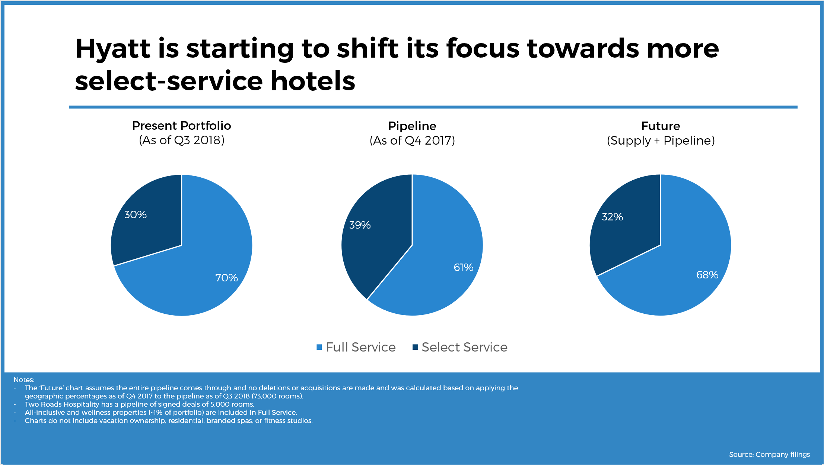

Figure 1: Hyatt's focus on wellness and hospitality
Source: Skift Research (2019)

2.2 Corporate Culture
Ensuring that every employee feels valued and respected is a core value of Hyatt's corporate culture. Great for business since it raises morale everywhere and delights consumers. Mental, emotional, and physical health are highly valued by Hyatt. The safety of the people is always considered important. People are the top priority, in keeping with the "care" approach. Hyatt has remained dominant in the UK industry despite the emergence of new competitors because of its system that rewards and acknowledges exceptional service from every employee (Sebayang, Sutama and Wendri, 2023). Staff members whose work is consistently outstanding are financially, socially, and professionally rewarded in a variety of ways. Having workers that love their work and are prepared to go above and beyond for customers is a huge boon to any company. Due to its dedication to its staff and its attempts to provide an inclusive environment, Hyatt has been able to successfully retain its loyal client base. Attracting and keeping clients requires both of these (Rockett, 2023).

2.3 Organisational Goals
As part of its objective to better the lives of its staff and clients, Hyatt places a premium on offering genuine hospitality. Building loyal customers and providing exceptional service is the company's top priority, regardless of the location. This objective has potential and help it grow internationally. Among Hyatt's many goals is to become the most prominent player in the environmentally conscious hotel sector while simultaneously expanding its customer base and improving guest service. To reach its efficiency goals, a hotel must first understand its customers' needs. Among the many rules that British hotels must follow are those that encourage environmental responsibility and civic participation (Sharma et al., 2021). Through steadfast commitment to its customers and ongoing innovation, Hyatt strives to become the most recognisable brand in the hospitality industry. These objectives supplement the previously set regional and corporate targets (Gomes, 2023).

3. Analysis of Recent Organisational Change Initiatives

3.1 Identification of Initiatives
Digital creativity, environmental responsibility, and customer satisfaction have emerged as new priorities at Hyatt Hotels Corporation in recent years. Hyatt is committed to doing its share to address the increasing demand for environmental protection (Ruiz Molina et al., 2022). Many of the company's properties in the UK and around the world have undergone renovations with an eye towards sustainability. More efficient machinery reduces both water use and trash output. Technological developments in the last several years have caused the hotel industry to undergo radical transformation. Possibilities include digital interaction, arrival procedures driven by smartphones, and touchless alternatives, among others. In order to meet the needs of the guests more effectively, the company has expanded the range of health-related facilities and customisation options (Wang, Yang and Deng, 2024).

3.2 Impact on Organisation
Among many other benefits, these innovations have made processes easier, made visitors happier, and improved operations. To make a positive impact while simultaneously savouring life's pleasures is a common motivation for many to get involved with environmental causes. One is more likely to succeed in reaching their objectives if they are both concrete and based on reality. Customer loyalty and main results tend to rise for businesses that prioritise environmental responsibility. Among the numerous advantages provided by contemporary systems are quicker service delivery, simpler registration, and reduced wait times (Breznik, Law and Gorenak, 2021). The majority of the time, the guests really enjoy themselves with this. Team members can spend less time on administrative tasks and more time creating memories thanks to automation. Thanks to the update, travelling is even more thrilling than before (Demianenko, 2022).

3.3 Management of Changes
The transformation process exemplifies how a company may evolve through strategic planning. A comprehensive framework centred on key personnel has been established by the organisation to guarantee a smooth transition for employees. Training and ongoing support are crucial components of this system. Environmental programs teach people to be more efficient with machinery and set new standards in an attempt to lessen the human influence on the earth. The squad is clearly well-prepared because of their unwavering commitment to the plan. Careful preparation is required for the introduction of new technology, which entails a slow rollout and comprehensive training of personnel. In an effort to identify problems, managers sought feedback from staff and consumers. By prioritising collaborative, standard-based development, organisations can effectively adapt to changing conditions (Sakovska et al., 2021).

4. Strategic Direction of Hyatt Hotels Corporation

4.1 Analysis of Strategic Direction
The company's strategic goals include strengthening internal operations and penetrating untapped global markets. To succeed, one needs fresh concepts, expanding markets, and superior technology. It is my deepest wish that the firm can maintain its dominant position in the hotel sector. The company is increasing its presence in developed as well as developing nations in an effort to appeal to a broader spectrum of consumers. Included in this category are both established and developing markets, such as those in the United Kingdom and Europe. Hyatt has been able to expand its customer base and make the most of its most profitable locations by concentrating on a small number of services. There is no less crucial field than digital transformation. Simplifying booking processes, increasing customer happiness, and expanding the company all necessitate modern digital solutions (Hultman et al., 2021). With a heavy investment in an AI-driven app and associated technologies, Hyatt aims to improve their customer service. Hyatt has shown its inventive side by releasing an abundance of new programs to suit the evolving needs of its consumers. Sustainable buildings and cashless payment systems are a couple instances of this design philosophy in action (Zhang, 2023).

4.2 Long-term Strategies
Hyatt plans and executes long-term initiatives with an eye on operational effectiveness and customer needs to reach their goals. For the company, the most important thing is to establish goodwill with local builders and landowners. Entering new markets will be very easy when one uses this strategy. By tailoring this strategy to meet the specific needs of each market, one can cut the expansion time in half. Creating and refining its digital platforms is a top priority for Hyatt. The ideal customers are traveller experts in the field of technology. Hyatt can improve its customer service by analysing data. Hyatt should have no trouble adapting to shifting customer preferences and market conditions if its plans pan out. Increasing their online presence, penetrating new markets, and developing innovative solutions are all parts of Hyatt's strategy to boost brand value and remain competitive (Kozhukhіvska et al., 2022).

5. Recommendations for Organisational Improvement

5.1 Enhancing Customer-Centric Practices
In order to better serve its varied clientele and stay ahead of the competition, Hyatt Hotels Corporation should change to concentrate to its customers and use cutting-edge personalisation tools. Every hotel is implementing data-driven personalisation strategies to guarantee that each guest has an unforgettable experience. Hyatt was able to gain a deeper understanding of its customers' desires and needs, and perhaps even predict their needs he while it utilised customer data analytics. It was not feasible to use digital tools due to insufficient training for front-line employees. This training must be completed within the next six months by all UK properties. Managers at the regional level are required to look after all the operations properly for complete growth (Mullins and McLean, 2019).

5.2 Sustainability Initiatives
Following the industry's trend towards environmentally friendly operations, another important suggestion is to use more sustainable methods. By cutting down on waste and switching to renewable energy, Hyatt might improve its reputation in the distance. A small number of British households will be part of an experimental program for the upcoming twelve months. They must report to an officer whose job it is to encourage people to reduce their energy and garbage consumption. Since this initiative has the potential to result in cost savings for hotels that are concerned about the environment, the hotel sector stands to gain financially (Mullins and Dossor, 2013).

5.3 Digital and Technological Upgrades
Hyatt can completely revamp their operations and service to customers by utilising new technology. Potentially time-saving options for guests include the hotel chain's automated services and mobile check-ins. The formation of a digital transformation task force is necessary to guarantee the seamless rollout of these technologies throughout the UK next year. One can ensure a smooth transition by providing his employees with all the necessary resources. If these changes are put into action, Hyatt stands to gain from increased output, decreased customer dissatisfaction, and reduced wait times (Bharwani and Mathews, 2021).
Hyatt could increase its position in the UK market and adapt to industry changes by becoming more environmentally conscious, improving personalisation, and upgrading technology (Erdem and Barakazı, 2023).

6. Conclusion
The organisational framework, culture, and strategy of Hyatt Hotels Corporation are its three pillars. The ability to swiftly adjust to local tastes and break into new markets is a testament to Hyatt's operational flexibility and strategic alliances. A result of the firm's unwavering commitment to its clients is its adaptability. Helping guests relax is also in keeping with Hyatt's brand principles. That way of life is highly valued in the hospitality industry since it leads to satisfied and returning customers.
Hyatt has demonstrated its comprehension of consumer preferences through its dedication to digitisation, growth into new markets, and emphasis on sustainability. It is clear that Hyatt takes preservation of the environment and modernisation very seriously because they support environmental efforts and use cutting-edge technology (Stringam and Gerdes, 2021). This means it will probably sell to a wider audience. The operational success of Hyatt hinges on its unified structure, culture, and strategy, especially in the fiercely competitive UK market. These and other reasons have contributed to Hyatt's rise to prominence in the hospitality sector and its reputation as an inventive, customer-centric business.

7. References
Bharwani, S. and Mathews, D., 2021. Techno-business strategies for enhancing guest experience in luxury hotels: a managerial perspective. Worldwide Hospitality and Tourism Themes, 13(2), pp.168-185.
Breznik, K., Law, K. and Gorenak, M., 2021. Hotel branding exposed: a content analysis of related organisational values. Organizacija, 54(3), pp.180-191.
Demianenko, A., 2022. Improvement of Corporative Sustainability Development Strategy (on the basis of Internship Report at Hyatt Regency Kyiv) (Doctoral dissertation).
Erdem, A. and Barakazı, M., 2023. Innovative technology applications in hotel businesses. In Digital Transformation of the Hotel Industry: Theories, Practices, and Global Challenges (pp. 17-36). Cham: Springer International Publishing.
Ergashev, T.K. and Berdiev, J.Q., 2020. THEORETICAL AND PRACTICAL ASPECTS OF USING MODERN MANAGEMENT METHODS IN THE HOTEL INDUSTRY. Theoretical & Applied Science, (4), pp.849-859.
Gomes, M.V.M., 2023. Hyatt Hotels Corporation Equity Research-Implications of the New Industry Outlook (Master's thesis, Universidade NOVA de Lisboa (Portugal)).
Hultman, M., Papadopoulou, C., Oghazi, P. and Opoku, R., 2021. Branding the hotel industry: The effect of step-up versus step-down brand extensions. Journal of business research, 124, pp.560-570.
Jones, P., 2024. Wellness in the Global Hospitality and Tourism Industry. Athens Journal of Tourism, 11(3), pp.225-238.
Kozhukhіvska, R., Sakovska, О., Maslovata, S., Dluhoborskа, L. and Chuchmii, I., 2022, June. Managing innovation in tourism and hospitality industry: International experience. In AIP Conference Proceedings (Vol. 2413, No. 1). AIP Publishing.
Mullins, L.J. and Dossor, P., 2013. Hospitality management and organisational behaviour. 5th ed. Harlow: Pearson. Available at:
http://www.dawsonera.com/depp/reader/protected/external/AbstractView/S9780273758419 [Accessed 4 Nov. 2024].
Mullins, L.J. and McLean, J.E., 2019. Organisational behaviour in the workplace. 12th ed. Harlow: Pearson Education.
Rockett, G., 2023. History/overview of Hilton. The Routledge Handbook of Diversity, Equity, and Inclusion Management in the Hospitality Industry.
Ruiz Molina, M.E., Belda-Miquel, S., Hytti, A. and Gil-Saura, I., 2022. Addressing sustainable food management in hotels: proposing a framework and examining hotel groups. British Food Journal, 124(2), pp.462-492.
Sakovska, O., Kozhukhivska, R., Kustrich, L., Gomeniuk, M. and Podzihun, S., 2021, November. Improvement of the marketing management system of tourism and hospitality industry enterprises on the basis of innovations. In International Conference on Business and Technology (pp. 881-895). Cham: Springer International Publishing.
Sebayang, G.A., Sutama, I.K. and Wendri, I., 2023. The Implementation of Green Training to Improve Employees’ Pro Environmental Behavior at Hyatt Regency Bali (Doctoral dissertation, Politeknik Negeri Bali).
Sharma, A., Shin, H., Santa-María, M.J. and Nicolau, J.L., 2021. Hotels' COVID-19 innovation and performance. Annals of Tourism Research, 88, p.103180.
Skift Research (2019) A deep dive into Hyatt 2019: Making waves in wellness and hospitality. Available at: https://research.skift.com/report/a-deep-dive-into-hyatt-2019-making-waves-in-wellness-and-hospitality/ (Accessed: 4 November 2024).
Stringam, B.B. and Gerdes, J.H., 2021. Hotel and guest room technology. University of South Florida (USF) M3 Publishing, 17(9781732127593), p.6.
Wang, D., Yang, M. and Deng, Z., 2024. Pathway to Environment Management in Hotel Industry: A Stakeholder Engagement Framework. Journal of China Tourism Research, pp.1-21.
Zhang, J., 2023. Analysis of Strategic Human Resource Management Practices: A Case Study of Hilton Worldwide. Frontiers in Business, Economics and Management, 8(3), pp.204-211.

