HND IT: Academic and Employability Skills - Reflection on Academic and Employability Skills
07 / 02 / 2019
Kewin Baranowski 1810551
Contents
Section 1 1
Brief Overview 1
Presentation Screenshots: 2
Key Points learnt 3
Improvements 4
Section 2: Research into Skills Evaluation 4
Key Skills Required for Successful learning in HE 4
Key Skills Employers Generally Look for 4
Self-Evaluation Exercise 5
Strengths 5
Weaknesses 5
Personality Type 6
Section 3: Action Plans 6
Short Term Goals 6
Long Term Goals 7
Section 4: Application 7
a) Looking after your data 7
“3 Different Places” Backup Strategy 7
Possible Disaster Scenarios 8
Ransomware – Serious Data Threat 8
b) Time management and self-organisation 9
Enhancing Productivity, Improving Organisation, and Reducing Stress levels 9
e-Portfolio 9
Section 5: Conclusion & Evaluation 11
Conclusion 11
Bibliography - Further Reading 11
Section 6: Appendices 12
Additional Screenshots: 12
References 13

Section 1

Brief Overview
Kewin Baranowski is 18 years old, he was born in Wałcz, Poland. He has one sister who is 26 years old. His entire family is Polish and most of them still live in Poland to this day. Kewin moved to the UK when he was 7 years old as his parents were moving there, he has lived in the UK for 11 years now. Every summer Kewin and his parents travel to Poland and stay there for about a month.
One of Kewin’s biggest strength is definitely his creativity, he used to do Art in school and has always enjoyed the creative side of things. His computer skills are also very impressive since he has been around a computer his whole life, teamwork skills are also good as he enjoys working with others and helping them. But, one of his biggest weaknesses is time management, if he doesn’t enjoy a particular subject or simply does not have much interest in it, he will struggle to get started working on it despite making plans and organising it. Self-motivation can also be an issue due to this, simply not having much of an interest in the topic/task he is working on will completely demotivate him from being able to do it. His personality type is more of an introverted person, who prefers to look at things in a logical way and takes priority in facts instead of emotions. And also prefers to stay inside and do his own thing rather than go out and party.
Kewin is an avid gamer, he has had a passion for gaming since a very young age, some of his favourite game genres include MOBAs, FPS’, Action Role-Playing Games, and MMORPGs. Some of his favourite games he is playing right now include League of Legends, Rainbow Six Siege, Dead by Daylight, and Diablo 3. He enjoys playing on his custom gaming computer, he prefers the computer to any other platform as it is the most powerful one and can be customized and modified to his liking. Another one of his hobbies is music, he listens to music pretty much all the time, whether that would be while doing assignments, playing games, relaxing, walking, etc. His favourite type of music is hip hop/rap and the main platforms he uses to listen to music are SoundCloud and YouTube. He does not have any exact plans for the future, but he knows he would like either a career within the gaming industry or within the music industry. He would also like to move abroad somewhere sometime in the future, whether that would be to North America or Asia (more specifically Japan).

Presentation Screenshots:
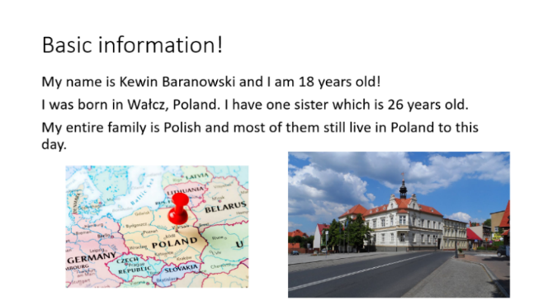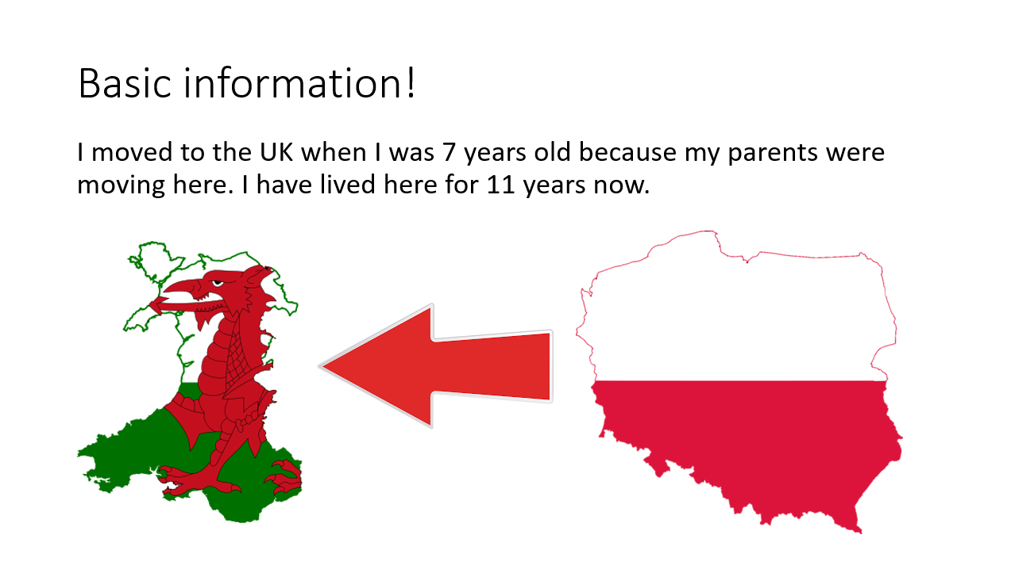
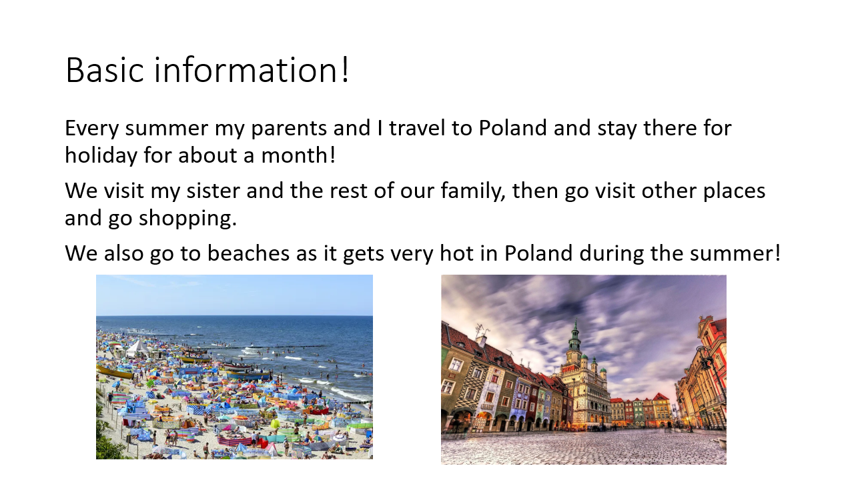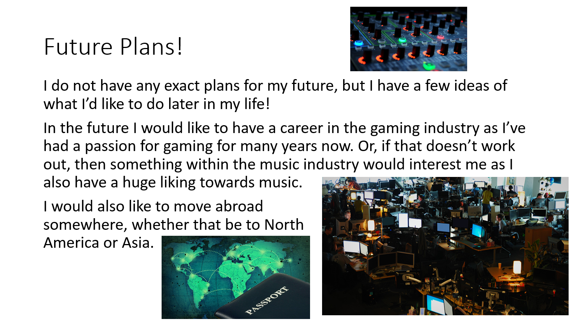

Key Points learnt
Key points learnt when producing and delivering the PowerPoint presentation;
Kewin developed his skills in making eye-contact while delivering the presentation in front of an audience. He learnt that this is a very important skill to have as it allows you to make sure that the audience stays interested in your presentation as by making eye-contact, it shows that you are engaging with the audience and you are truly passionate about what you’re presenting.
He also learnt how to manage his time a bit better, the presentation was to last around 5 minutes and he feels like he met this criteria. He made sure that his presentation would not be too brief and end really quick, but also so that it would be too much for the audience and would just drag on. He did this by making quite brief points on the slides so that he could then expand on them and talk about in further detail if need be.

Improvements
Improvements that could be made to enhance future presentations would be;
In the future, he could try to make his presentations more engaging and interactive, he could do this by improving his body language by maybe moving around a little bit or using various hand gestures when explaining points. And he could make the presentation more interactive by adding animations and transitions between slides, this would make the overall presentation look a lot smoother and cleaner.

Section 2: Research into Skills Evaluation

Key Skills Required for Successful learning in HE
The most important key skill required for successful learning in Higher Education would be time management, this is because as a HE student you never want to end up doing a piece of work on the last day it is due in, as this will mean you won’t put much effort into it and most likely won’t get the marks you would’ve otherwise. Doing assignments, revision for exams or any other pieces of works ahead of time and planning and organising them well will allow you to make sure you were fully prepared and went over everything you wanted to without having to stress about lack of time. Time management can also be related to turning up to lessons, this is important as your tutors will quite often give you very good advice about your assignments, it allows you to stay up to date on what you should be focusing on and you also have the chance to ask the tutors about anything you may need help with.
Organisational skills are also quite important, this is because when working on HE assignments, you need to always make sure your work is presented in an organised manner while also including all the important information. Good organisational skills will help you prepare and layout your work so that anyone viewing it can easily navigate it by having things such as a table of contents, as well as clear headings, and even a references section so that any article or book you have used can be referenced there.
Problem-solving skills are quite important within HE for specific tasks/subjects, your problem-solving skills will come in very handy for when unexpected situations occur, problem-solving skills help you determine the source of a problem and find an effective solution[1]. Doing something such as testing tables requires you to go through many tasks seeing what the outcome will be, and if the outcome does not match what the result should’ve actually been then you need to figure out why and explain how you would/will solve it.

Key Skills Employers Generally Look for
Depending on the type of job a person might be applying for, the skills the employers will be looking for may vary, but most jobs will require you to have good time management skills. This will be to ensure the employers know that the hired staff will show up on time as they should, and so that they may even be able to rely on those employees to cover other people if they were not able to come in.
Communication skills are also very important, especially if the field of work the employee will be around is retail. This is crucial as you want your employees to be able to freely speak with, and go out of their way to, always help customers even if they are currently doing another task. You don’t want to employ someone who may not be able to speak with customers with ease or who may not be able to go out of their way to help customers.
Teamwork skills are important within a workplace as you will be working with and or around other employees, good teamwork skills will allow you to efficiently work with others by being able to take on tasks you are given as well as help others to achieve your overall set goal. This could include things such as helping a group of people work on one set task or it could be a situation where everyone has their own separate tasks, but you must make sure all of them are complete so that you can reach your end goal.

Self-Evaluation Exercise

Strengths
Creativity – Kewin has a pretty good imagination, he used to do art and was quite good at it, he would always come up with creative designs and techniques and always tried to make his artworks as unique as possible. This has helped him within the IT area as well, as he now really enjoy creating logos and banners for various projects. Apart from art, he feels he is quite creative when it comes to different things too, such as choosing the way he figures things out or maybe the way he might design page layouts.
Teamwork – Kewin thinks his teamwork skills are quite good as he enjoys working within a group, he always tries to help his teammates if they need it to make sure their overall goal is reached. He is not afraid of taking constructive criticism and will gladly learn and improve from it if a group member was to ever tell him something he did was wrong. He is also not afraid of asking his group members for help if he ever needs it, because he would rather make sure that their task is successfully complete than worry about asking someone for help.
Communication – Communicating with others is important for many different situations, Kewin thinks his communication skills are pretty decent. When working within groups he is always willing to speak a lot especially if other groupmates aren’t communicating as much so he can sort of guide everyone and direct them so that they all know exactly what they’re doing as a group. Listening is also important, people’s voices should always be heard and so making sure you listen to people’s opinions and decisions is always good.
Ability to Work Under Pressure – Exams usually cause many people a lot of stress, but they have never been too big of issues to Kewin, even without huge amounts of last-day revision he is able to get his predicted grades/marks. The same thing goes for controlled assignments, in an environment where people are put under a lot of pressure with a likeliness of them getting something wrong because of it, he tends to do quite well under these conditions despite the fact the pressure might be high.
Computer Skills – After being an IT student for quite a decent amount of time and spending a lot of his life around a computer, Kewin’s computer skills have reached quite a decent level. He is very familiar with almost any type of computer software, and quite experienced with the Microsoft Office 365 products such as Word, PowerPoint, Excel, etc. after using them for such a long time. He especially enjoys using Adobe Photoshop and thinks his skills with it are quite good too, he enjoys creating banners, logos, or photo edits.

Weaknesses
Self-Motivation – One of Kewin’s weaknesses would be lack of self-motivation, in some situations he can find it hard to just start doing something, especially if he is not that interested in the subject. Unless the subject is something within his area of interest, he sometimes may find it hard to get on with the task and may struggle to even get started with it. Or, whenever he gets stuck on any part of a task, it really demotivates him and sometimes he finds it kind of hard to get back into the task.
Time Management – Kewin’s time management skills could definitely do with some improving, usually, he makes decent plans for when to start or do things, but then most of the time fails to meet those plans. The main reason for this is procrastination and distractions, but mainly lack of motivation leads to him putting those plans off to the side.
Decision Making – Most of the times Kewin can figure out a problem or the cause of an issue, but then finding a solution to that issue or picking a solution out of some he may have come up with is tough for him. A lot of the times he sees too many strengths and weaknesses in decisions and picking one becomes quite the task for him. Weighing out the strengths and the weaknesses in the choices doesn’t fix the issue as some strengths may be more important than others, he values quality over quantity.

Personality Type
After completing some JUNG Personality tests, the results all ended up being an “INTP” personality type. The first test[2] gave a result of INTP, and the second test[3] gave a result of INTP-T, this shows that the person “Seeks to develop logical explanations for everything that interests them.”[4] Which makes a lot of sense as this is a person who will like to deep dive into a subject which they have a lot of interest in and find the meanings behind things and find out how they work. The test also shows that they are introverted, which matches what was said in the PowerPoint presentation with them preferring to stay inside and develop ideas instead of socialising.
The full description of INTP from Myers Briggs website:
“Seek to develop logical explanations for everything that interests them. Theoretical and abstract, interested more in ideas than in social interaction. Quiet, contained, flexible, and adaptable. Have unusual ability to focus in depth to solve problems in their area of interest. Sceptical, sometimes critical, always analytical.”[3]

Section 3: Action Plans

Short Term Goals
Part-time Job – Finding a part-time job can be done by searching and applying for jobs within the desired area via the internet, for this to be done a CV must be made and uploaded. Once this is done the person must wait for a reply from the employer to see if they have given them an interview date if so, the person can go in for the interview and see if they can get the job. If they get the job this will provide them money and work experience. If the person has already applied for jobs, all they need to do it wait for a response, and once they get a good response they can start preparing for their interview by making sure they look smart, are there on time, and know what to say.
Japan trip – An upcoming Japan trip in the month of June, this trip will require a lot of planning and organising. 5 people will be doing on this trip so things such as hotels have to be booked, transport must be organised, valid travel documents must be owned, Japanese Yen must be obtained by exchanging currency at a location which provides currency exchange. All of these things must be planned between the 5 people making sure everything is planned well and everyone can make it. This goal being completed successfully will result in the 5 best friends having a well spent time together. They should start doing these as fast as possible to make sure that they don’t have any problems acquiring tickets or exchanging currencies.
Upcoming due assignments – Upcoming due college assignments must be completed to at least a Passing grade, this must be done so that the course the person is studying can be passed as the lowest required grades to complete the course are a Pass. This can be done by making sure assignments are complete at least a few days before the due date so that the person can go over them and make sure everything is good.
Exercise more – Exercising more as a goal is very important for everyone, the person must not work themselves over too much as they could hurt their health instead of improving it. With exercising it is very crucial to stay consistent otherwise, all the progress will go to waste and routine will have to be restarted. It’s good to start with exercising every other day, but then at some point getting into the habit of doing exercises every day to stay as active as possible. Doing this will allow the person to stay healthy, which is good in itself, but it’ll also make the person feel better physically and mentally.

Long Term Goals
Finish course – Finishing the college HND course can be done by doing well in assignments, the person should aim for at least Passes in every unit so that they can get an overall Pass and successfully complete the course. They need to stay on top of assignments and make sure they don’t fall behind or are ever not turning up to lessons as it means they could miss out on valuable information from their tutors. Completing this course will result in the person getting a very good level 5 degree, this then allows them to get a really good job in the IT field in the future.
Get fulltime job in IT – After getting the qualifications from completing the college course the person can then apply for a good paying fulltime IT job. This will allow them to have a stable income and be able to have a lot of money to spend on whatever their needs may be. This can be done by applying for appropriate jobs within their desired area and waiting for a response, similar to a part-time job, except this job will be more serious as this will be a real more serious career that the person has been striving to achieve. What the person can do in the meantime is do further research to see what job they may want to delve into in the future once they have all their qualifications.
Move abroad (Japan or Poland) – After achieving the qualifications and getting a good job, the person can start looking into moving abroad into their location of preference, in this case being either Poland or Japan. While the person is still not fully sure where they would like to move to exactly, they can still do research and find out what living costs there are like, what exact areas they would be better off living in, what the food or cultures there are like as some countries’ cultures may not be appealing to everyone.

Section 4: Application

a) Looking after your data

“3 Different Places” Backup Strategy
Describe the backup strategy you created that obeys the “in 3 different places” rule discussed in class. Explain how it provides a robust level of data protection for any work you are likely to produce during your time in University, as well as any other important data you would not wish to lose.
The “in 3 different places” or “The rule of three” strategy is based on backing up data in a way so that if a disaster were to occur the data would still be restorable and safe. “When considering backups, a good rule of thumb for any data that you do not want to lose is the Rule of Three; back up your data in three different places. The three places can be different for each firm, but there should be three.”[5]. One of the three places used in this case is a simple USB backup, any coursework data will be backed up onto the USB drive. This USB drive can be carried around anywhere thanks to its impressive small size, having this device on a person at all times means that the data on it can be used at all times even without using the internet. The second place used is a cloud backup, in this case, OneDrive was used. Though internet access is required for this one, as long as you have internet connection working you can access your data and files from anywhere you are, all you have you do is log into your account and all your data will be there, from there you can view, upload, and download files. You can even access OneDrive from your Android and iOS devices if you download the application. The third and last place used is the student’s home PC, this will allow the student to access and backup their data whenever they make any progress of it at home, or after they get back from college.

Possible Disaster Scenarios
Flood – When the chosen rule of three strategies is faced with a natural disaster such as a flood, and desktop computers were destroyed along with all data stored on them, the person would still have the USB stick with their backup if they kept it safe, but if they didn’t then the backup which was made onto OneDrive will still be safe and the person can still access this one any other device they want to just by logging onto their account. So, to restore the data from OneDrive they could redownload all the files which were lost during the disaster.
Hacker Attack – When a system is hacked into, the attackers can sometimes even take over the entire network, gaining all the data during the process. So, if the person’s network was hacked, and the hackers managed to gain access to the user’s OneDrive account, the user still has a backup of their files as they have the USB drive with them. The USB drive can then be plugged into the computer once the attack has been taken care of, and the data from the USB can be transferred to the PC if the attackers altered/stole the original data.
Human Error – The person themselves could cause data loss in many ways, one of these could be by “accidentally managing to format a hard drive”[6]. If the person managed to lose data on their USB drive while working in college, then they still have backups on OneDrive and on their home PCs, and if they lose the data on their home PC, they still have the OneDrive and USB Drive. Data can be easily restored as no major disaster occurred so there is nothing to worry about.
Liquid Damage – Liquid damage is when any sort of liquid makes contact with a device and causes a short circuit, recovering data from this is usually very hard unless you have a recent backup. If some sort of liquid such as water was to be spilled onto a USB stick while it is in the computer, it would most likely lose most of its data, having the backup back at the home PC and OneDrive will allow the user to easily restore this data by loading up the last backed up files.
Viruses – A lot of times computer viruses will not only steal your data, but also there’s a chance that they’ll randomly destroy it too, if this were to happen at the person’s home PC, then they still have their USB drive as a backup and the OneDrive. But if this were to happen to them in college while they were working off of the USB, then they’d still have the OneDrive and home PC backups. After getting rid of and making sure there are no viruses on the system, the data can be safely transferred back over to the device that had a virus on it.

Ransomware – Serious Data Threat
If ransomware were to take over the user’s home PC and block them from accessing their data, the user still has two of the backup strategies that they can use to continue using their data. For example, they could use their USB drive on another computer to access their data easily on there, or they could log onto their OneDrive account and retrieve their data through there as well.

b) Time management and self-organisation

Enhancing Productivity, Improving Organisation, and Reducing Stress levels
A way a person can enhance their productivity is by getting rid of any distractions, this could include things like the “phone, email notifications and having multiple web browsers open on the desktop”[7], these may not seem like obvious distractions at first but they distract them more than they’d like. Finding out what productive hours someone has can help greatly, some people just tend to do better at certain times during the day, finding out what those hours are for you will help as it will mean you can then plan ahead to always try to get as much work done during those hours.
Someone can improve their organisational skills by creating a list of things they want to do, keeping a list allows you to see exactly where you’re at and crossing out the tasks you complete is also a good idea since “it motivates you to keep doing it because it gives you such a sense of satisfaction and accomplishing crossing each item on your list”[8]. Setting yourself a schedule for when to complete each task or even set yourself a time limit to complete them may be good as it will get you used to do things on time.
A way someone can reduce their stress levels could be by doing some exercises or some sort of physical activity, as doing so “stimulates the release of endorphins which make you feel better and more relaxed.”[9] therefore lowering your stress levels. Sometimes even just talking with “someone about how you feel can be helpful.”[10] getting things off your chest is a good way to make you feel better and distract your mind from whatever is causing you stress.

e-Portfolio
This is the main e-Portfolio folder.

Inside the e-Portfolio folder are two sub-folders, the Personal Development folder and the Academic Development folder.
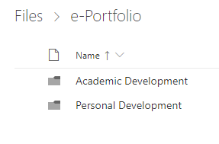
Inside the Personal Development sub-folder can be found two more sub-folders, a few files. The About Me.pptx file is the class presentation. The Goals.docx file has both Short-Term and Long-Term goals. The JobSites.docx file has a list of links to various sites where you can search for jobs. And the Reflective Journal.docx is a document which acts almost like a diary.
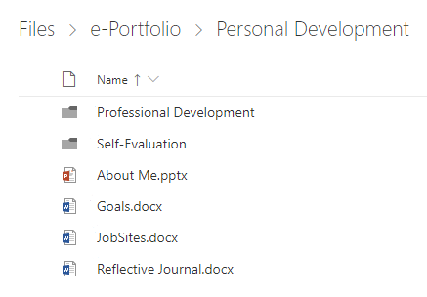
Inside the Professional Development sub-folder can be found the CV.docx file which is just a CV, and a Personal Statement.docx file which includes achievements and interests.
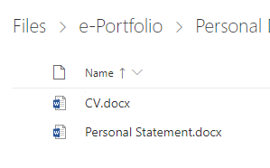
Inside the Self-Evaluation sub-folder can be found a Positive Qualities, Strengths, Virtues, and Areas to enhance.docx file, this file includes various strengths, qualities, and areas to be improved on.
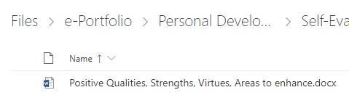
Inside the other main sub-folder Academic Development can be found two more sub-folders and a file. The Assignments sub-folder has more sub-folders for each module with the assignment files inside of them. And the Skills Evaluation sub-folder has files in it which identify and describe the person’s skills.
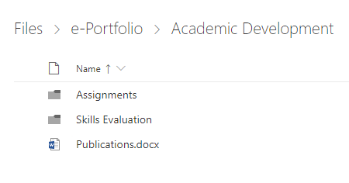

Section 5: Conclusion & Evaluation

Conclusion
Section 1 was a brief overview of the person, going over their basic information, hobbies, strengths, weaknesses, personality, etc. A part of the section included a bit of an inside on what the person feels like they learnt, what they could’ve improved on from their class Presentation. Section 2 discussed what key skills are required for successful learning in HE, this included things skills like time management, organisation, as well as problem-solving. Another part of the section was about key skills employers generally look for, the skills listed here included time management, communication, and teamwork. Then there was a self-evaluation exercise which made the person go over their strengths, weaknesses and their type of personality, and then compared their findings with their initial statements. Section 3 Goes over the person’s Short-term goals, why they are aiming for those goals, and how they can achieve them, and then it goes over to their Long-term goals and why they want to achieve them and how they can achieve them. Section 4 is split up into two parts, part A discusses a backup strategy called “The rule of three” and what it is, and then talks about how that strategy could go up against various data loss disasters and be able to restore data after the disaster is over. And part B discusses how a person can enhance their productivity, improve their organisation and reduce their stress levels. It then goes over to show an e-Portfolio and explains what each file and sub-folder within it is used for alongside screenshots.

Bibliography - Further Reading
“The Importance of Eye Contact during a Presentation” https://virtualspeech.com/blog/importance-of-eye-contact-during-a-presentation
“What are the top 10 skills that'll get you a job when you graduate?” https://targetjobs.co.uk/careers-advice/career-planning/273051-the-top-10-skills-thatll-get-you-a-job-when-you-graduate
“What are my skills?” https://www.myworldofwork.co.uk/what-are-my-skills-0
“List of Strengths for Resumes, Cover Letters, and Interviews” https://www.thebalancecareers.com/resume-strengths-list-2063804
“List of Weaknesses With Examples” https://www.thebalancecareers.com/list-of-weaknesses-2063805
“99 Key Skills for a Resume (Best List of Examples for All Types of Jobs)” https://zety.com/blog/what-skills-to-put-on-a-resume
“16 Personality Types” https://www.personalityperfect.com/16-personality-types/
“Long-Term and Short-Term Goals” https://careerwise.minnstate.edu/mymncareers/finish-school/long-short-goals.html
“10 Common Causes of Data Loss” https://consoltech.com/blog/10-common-causes-of-data-loss/
“What is ransomware? How these attacks work and how to recover from them” https://www.csoonline.com/article/3236183/what-is-ransomware-how-it-works-and-how-to-remove-it.html

Section 6: Appendices

Additional Screenshots:
Test results from the “Open Source Psychometrics Project” website.
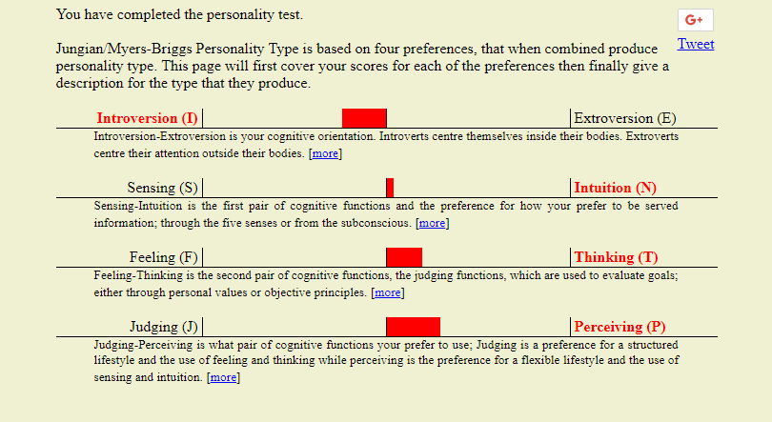
Test results from the “16Personalities” website.
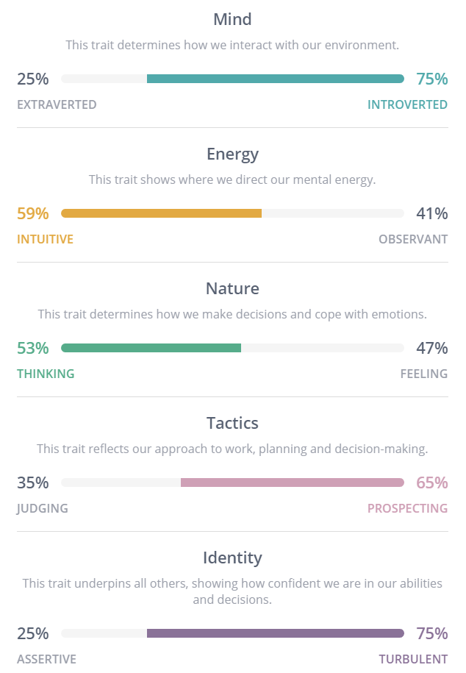
Description of INTP from personality perfect website.
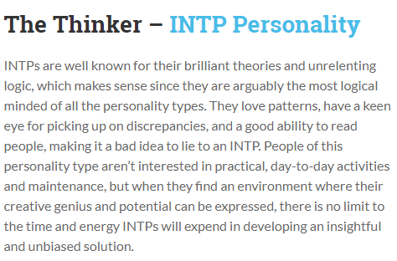

References
[1] “Problem-Solving Skills: Definitions and Examples” [Online Source] [https://www.indeed.com/career-advice/resumes-cover-letters/problem-solving-skills]
[2] “Myers-Briggs/Jung Test” [Online Source] [https://openpsychometrics.org/tests/OEJTS/]
[3] “16Personalities - Personality Test” [Online Source] [https://www.16personalities.com/]
[4] “The 16 MBTI® Types” [Online Source] [Author: Isabel Briggs Myers] [https://www.myersbriggs.org/my-mbti-personality-type/mbti-basics/the-16-mbti-types.htm?bhcp=1]
[5] “Backups—The Rule of Three” [Online Source] [Author: Pegeen Turner] [https://www.lawtechnologytoday.org/2014/12/backups-rule-three/]
[6] “4 Data Loss Scenarios that can Happen to You!” [Online Source] [https://www.pacetechnical.com/4-data-loss-scenarios-that-can-happen-to-you/]
[7] “50 Ways to Increase Productivity and Achieve More in Less Time” [Online Source] [Author: Kim Roach] [Updated: June 27, 2018 ] [https://www.lifehack.org/articles/featured/50-ways-to-increase-your-productivity.html]
[8] “9 Ways to Improve Your Organization Skills” [Online Source] [May 4, 2018] [https://officedynamics.com/9-ways-to-improve-your-organization-skills/]
[9] “The Importance of Exercise” [Online Source] [https://www.skillsyouneed.com/ps/exercise.html]
[10] “Dealing with Stress - Ten Tips” [Online Source] [https://www.skillsyouneed.com/ps/stress-tips.html]

