Wireless Networks and Simulation Assignment Student number: P147535
Module Code: ACCA5004
Module Tutor: Dr Carlene Campbell

Nabil Ouzahra 2nd year student at UWTSD Computer Networks & Cybersecurity (BSc)

Abstract—Wireless communication has played major role in changing the way we are living today, the field of digital data transmission has seen lots of research and improvement, all aiming to improve the quality of results. This paper focus on two elements; first one is analysing the performance of different techniques of modulation used by different designs and applications such as BPSK, QPSK and QAM. Running different simulations using NetSim to study the effect of Noise interference (SNR) on the Bit Error Rate (BER), second element is designing Smart Factory utilizing Wireless Sensor Network (WSN) to control and manage different elements such as access, fire alarm, light control and security, and testing and analysing the results to check if the modulation technique chosen proven to be the appropriate one.

Keywords:

BPSK: Binary phase-shift keying
QPSK: Quadrature phase-shift keying
QAM: Quadrature amplitude modulation
BER: Bit Error Rate
SNR: Signal to Noise Ratio
CNR: Carrier Noise Ratio
WSN: Wireless Sensor Network
NetSim: Network simulation software
AWGN: Additive white Gaussian noise
Rayleigh: statistical model of noise effect over wireless communication.

Introduction
The world we are living in today is evolving fast, thanks to all technological inventions, almost everything humans use in daily basis become smart and wireless. With this evolution communication has become key to allow all these devices to be connected in an efficient way, with all this change, wireless communication also has evolved fast in past two decades, most analogue methods been replaced by digital systems (examples; TV, Satellite and GSM).
Wireless digital communication uses different modulation techniques like Binary phase-shift keying (BPSK), Quadrature phase-shift keying QPSK and Quadrature amplitude modulation QAM to transmit digital signals throughout channel and recreate the same signal using the process of demodulation, however as the signal degraded and sometimes distorted because of noises effect, the transmission is not always 100 percent accurate, therefore certain modulation techniques may suit certain applications and designs and there is no one solution for every application.
The aim of an efficient and reliable transmission is always transmitting the maximum amount of data measured by bit/second in limited frequency available (Hz) with minimum error possible also known as Bit Error Rate (BER) [1].

research and evaluation of modulation schemes

BPSK modulation research
Binary phase-shift keying (BPSK) is one of the most reliable and widely used modulation techniques thanks to its low Bit Error Rate (BER) and simplicity in implementing it to a design or application comparing to other more complex modulation techniques such as 8QAM, 16QAM or 64QAM [2].
Before going into the details of how this modulation technique works, it is important to explain what is modulation in the wireless communication; the primary function of any modulation technique is impressing the digital data so it can be transmitted signal carrier [3]. The concept of how it function is very simple, it shifts the sine wave of the carrier 180° every time the digital signal change state from 0 to 1 and vise verse as shown on figure -1.

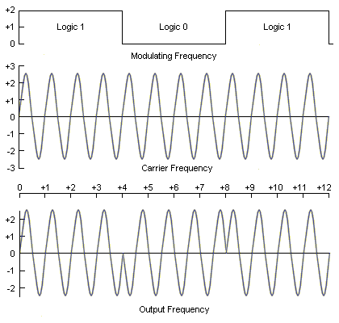
Figure -1: BPSK phase shift key modulation [4]

In terms of efficiency BPSK is considered as one of the robust modulation techniques thanks to its low BER, the simple functionality of its phase shifting helps in transmitting the data accurately even when with presence of some level of noise interference.
In real life scenarios, noises factor and the complexity of some modulations such as QPSK and QAM, they both play major role in increasing the Bit Error Rate even if they allow high rate of data transmission [5], some studies shows that some modulation techniques are more susceptible to noise comparing to others,
figure 2 shows good example of what been mentioned, BPSK modulation is less effect by noise comparing to QPSK and QAM, this comparison was done using the Carrier Noise Ratio (CNR) [6].

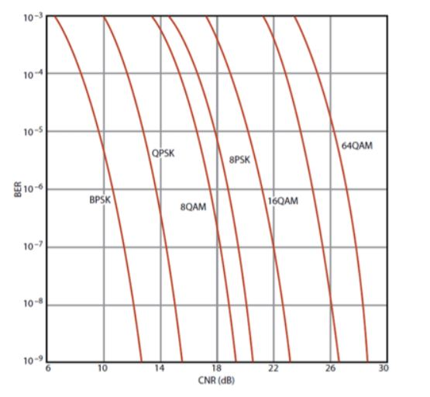
Figure -2: Modulation techniques comparison using BER versus CNR [3]

It is also important to check the spectral efficiency [7]of BPSK and its comparison to other modulation techniques, this element can be considered as key when choosing the modulation, this efficiency shows the how quickly data can be transmitted in the given bandwidth, always measured by bit/second/hertz (b/s/Hz), figure -3 shows the spectral efficiency of different modulation techniques.

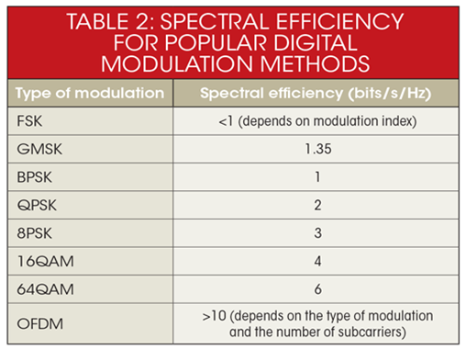
Figure -3: Spectral Efficiency of different modulation techniques [3]

From the previous points discussed earlier regarding the efficiency of BPSK modulation when it comes to Bit Error Rate, the noise resistance and low amount of data needed to be transmitted in WSN [3][6], it become clear that this modulation technique would suit in theory the design of Smart Factory WSN.
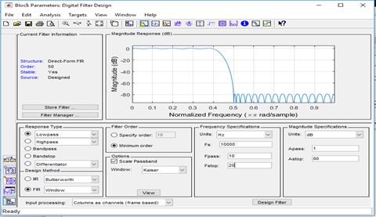
It may appear as best solution but in modern communication modulation the only way to find good answer would be running simulation test, some useful software such as NetSim, OMnet and MATLAB allow the engineer to test their designs to an extreme level and find some good results after analysis. This can have some major effect when it comes to quality of service, cost and time management when running the project. The second benefit of simulation would be allowing the system designer to study any problems from different levels and helps understand all issues before starting building any real system [8].
Testbed approach use to be very popular in the past with wireless communication compering to simulation, however due to the hardware constraint and the cost involve with producing testbeds environment, simulation techniques start to take over and become major player in developing protocols, system performance and start to offer accurate analysis of the wireless networks.
Simulation may have many advantages over testbed approach such as the ability of modeling large scale scenarios without any costs involve, the ability of modifying data and collecting real-time results in very short time, however when it comes to modeling the physical layer the results are not always adequate, this is where the limitation of this technique shows [9].
In terms of mathematical modeling, this is may be considered as second pillar of engineering and science research, at the back of every new technology or scientific discovery there is mathematical support and backing, however experience shows that mathematical modeling can be very rigid and highly iterative process [9].
To summaries we can say that BPSK can be used in any design that require low speed data transmission, high power efficiency optimum and good noise resistance [10]. All this can only prove that this should suit well our Smart Factory WNS design.

Experimental study of BPSK modulation technique
Using MATLAB Simulink, BPSK modulation system was designed to perform some experiments to show the effect of different level of noise interference on the wireless communication, the analysis of the performance was focused on two elements; Bit error rate (BER) and Signal to noise ratio (SNR). The Author also performed good comparison of the behavior of the three models BPSK, QPSK and QAM simultaneously using the same level of noise to prove previous finding from the research section [3].
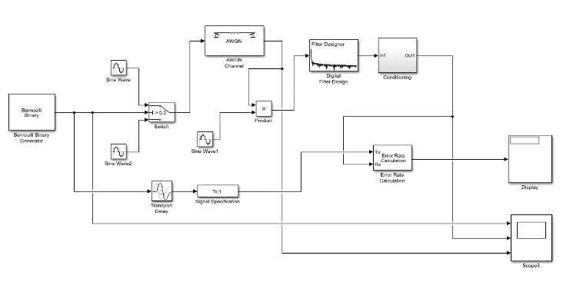

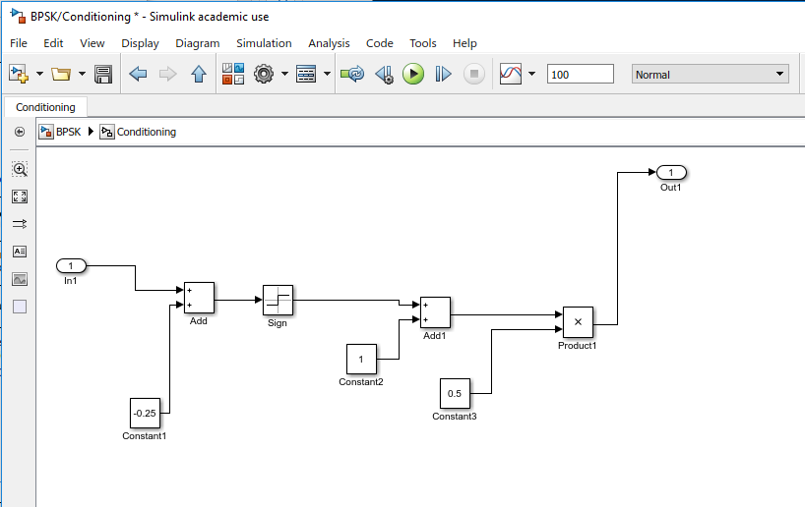
Figure -4: BPSK modulation design including noise factor and output display for BER.
Figure -5: BPSK Conditioning block and filter
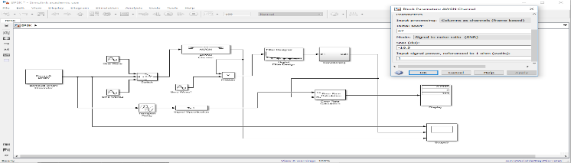
After building the BPSK modulation system that allow the transmission of digital binary signal randomly generated by the Bernoulli block, the modulator and demodulator sections guaranty the accuracy of our signal transmitted via the signal carrier.
To complete this system, white Gaussian noise [11] (AWGN), noise generator was added to help with the experiment of noise effect over bit error rate (BER), This experiment could be taken to another level by studying the performance of the WSN with presence of different noise type such as Rayleigh fading statistical model [5].
The test was run on the transmission of 100 bits at different levels of signal to noise ratio to see when the system accrues maximum BER, the lowest BER and no effect level over BPSK data transmission. Figures 6,7,8,9 and 10 will show the clear difference of results when noise level (SNR) was changed from (-5 dB) to (-16.5dB) to (-25 dB).

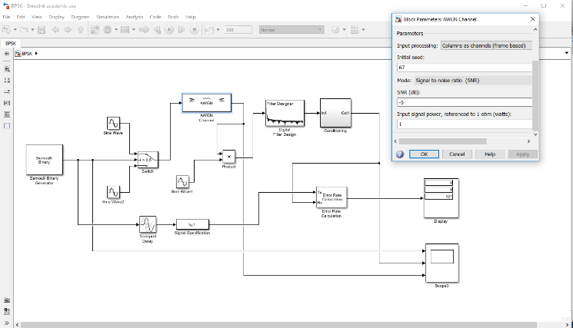
Both figures 6 and 7 shows that when the SNR was (-5 dB) the input signal and output one is the same, the transmission is unaffected by this level of noise, the BER is 0 percent.
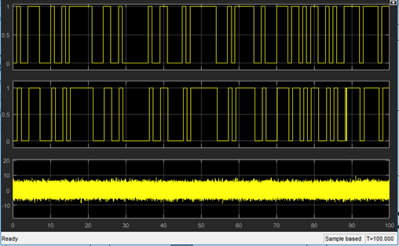
Figure -6: BPSK under (AWGN) noise with SNR of (-5 dB)
Figure -7: BPSK under (AWGN) noise with SNR (-5 dB),
(1st graph input signal, 2nd graph output signal, 3rd graph is the noise)

From figures 8 and 9, the results show that when (AWGN) level of noise was (-16.5 dB) the BER is 3 percent, and the output signal start to show some errors comparing to the input signal.
This is the point where the signal start getting affected by noise but still at transmitting fine.

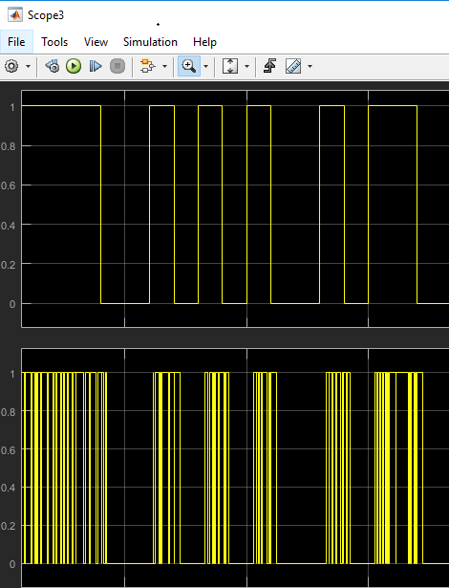
Figure -8: BPSK under (AWGN) noise with SNR of (-16.5 dB)
Figure -9: BPSK under (AWGN) noise with SNR of (-16.5 dB)
(signals input/output)

Figures 10 and 11 shows clearly that output signal have great deformation and the binary data transmitted suffer great distortion, the results show that at this high level of noise the BER was almost 25 percent, and this can be considered in wireless data transmission as major failure.
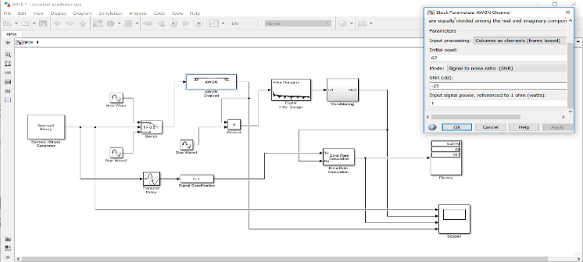
Figure -10: BPSK under (AWGN) noise with SNR of (-25 dB)
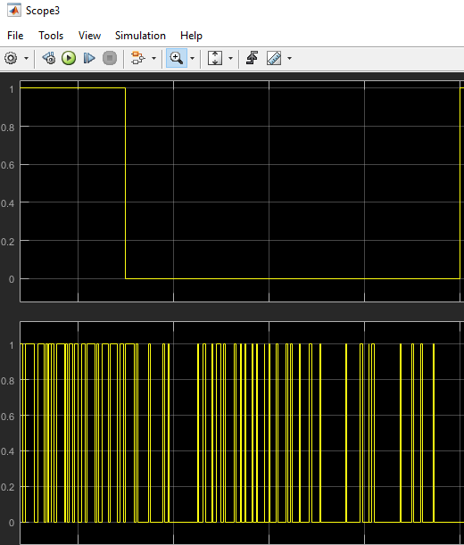
Figure -11: BPSK under (AWGN) noise with SNR of (-25 dB) (signals input/output)
This three experiments carried demonstrates that BPSK modulation used to transmit digital data clearly that the quality of this transmission suffers when operating at high level of noise, however if we would like to see how robust is comparing to other well-known modulation schemes such as QPSK and QAM, the three modulations need to be built and tested at this level of noises (SNR -2dB, -5dB and -10dB).

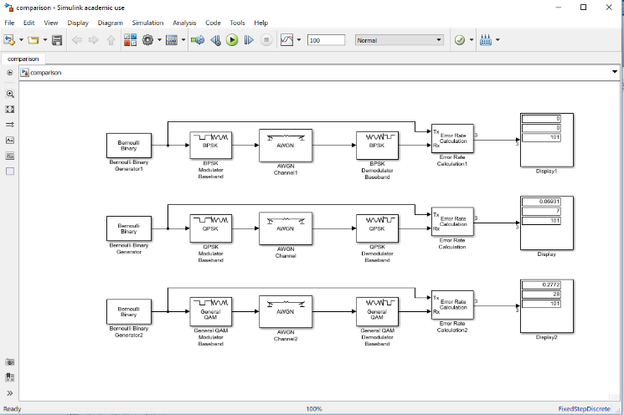
After building simulation scenario with the three modulations BPSK, QPSK and QAM using the prebuilt modulators and demodulators as seen on figure -11, by changing the level of (AWGN) each time and after plotting the results in graph, we could clearly see that our results seen on figure -12 confirm the findings of our research, BPSK proves again that it is more rebuts than QPSK and QAM when under substantial level of noise.

Figure -12: Test comparison design between BPSK/QPSK/QAM

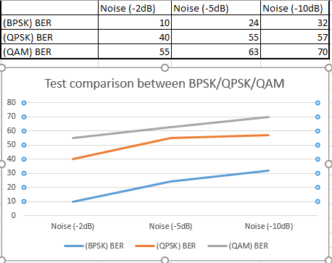

Figure -13: Test comparison results of BER when BPSK/QPSK/QAM affected by (AWGN) noise.

Data Analysis

From the graph result, we could clearly see the increase of BER every time we increase the noise level throughout the three modulation techniques BPSK, QPSK and QAM, and also this results show clear evidence that BPSK is the most resilient to the noises effect and stay efficient enough when high noise level such as (-10dB).

Designing the smart factory based on wireless sensor network.

Simulation and evaluation of performance
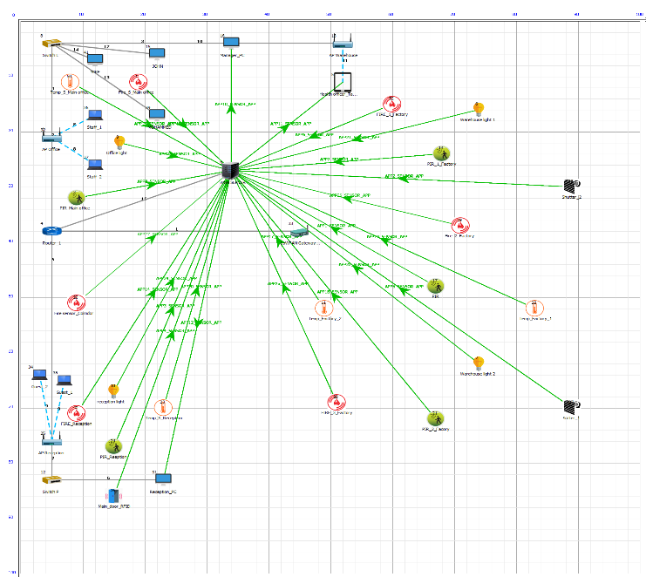
The full design of this Smart Factory presented bellow on Figure – 14.
Figure -14: Full design of the Smart Factory using WSN

This design was created using NetSim, one of the leading products used in simulation by academics and experts. In this scenario it is assumed that the factory is composed of three major areas;
- Reception area (in blue).
- Main office and Corridor (in Orange).
- Factory area, (in red) as per figure -15 bellow.
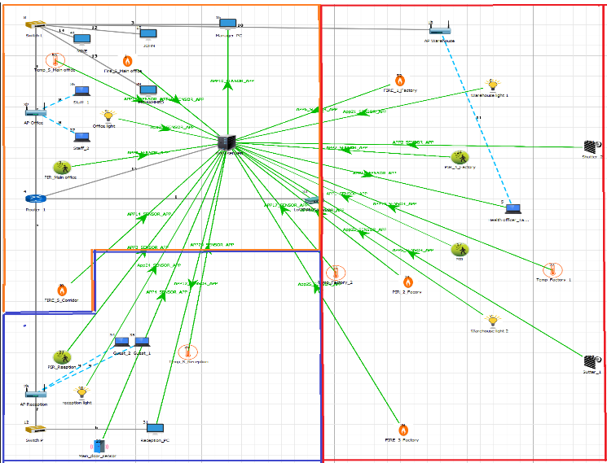
Figure -15: The three major parts of the Smart Factory

In each area the channel and noise factor will be different, this will have great effect on the quality of the data transmitted, as per the quantity we could say that in general the amount of data transmitted in this types of networks (WSN) is small.
Some sensors would be set on idle and only will transmit data when there is change of status, some would be set to transmit periodically, and this should have great effect in terms of energy efficiency.
All types of sensors such as Door RFID, shutter contact, PIR, Light switches, temperature and Fire sensor been carefully placed in their appropriate places so that data collision is minimum and data transmission to the LoWPAN is effective.
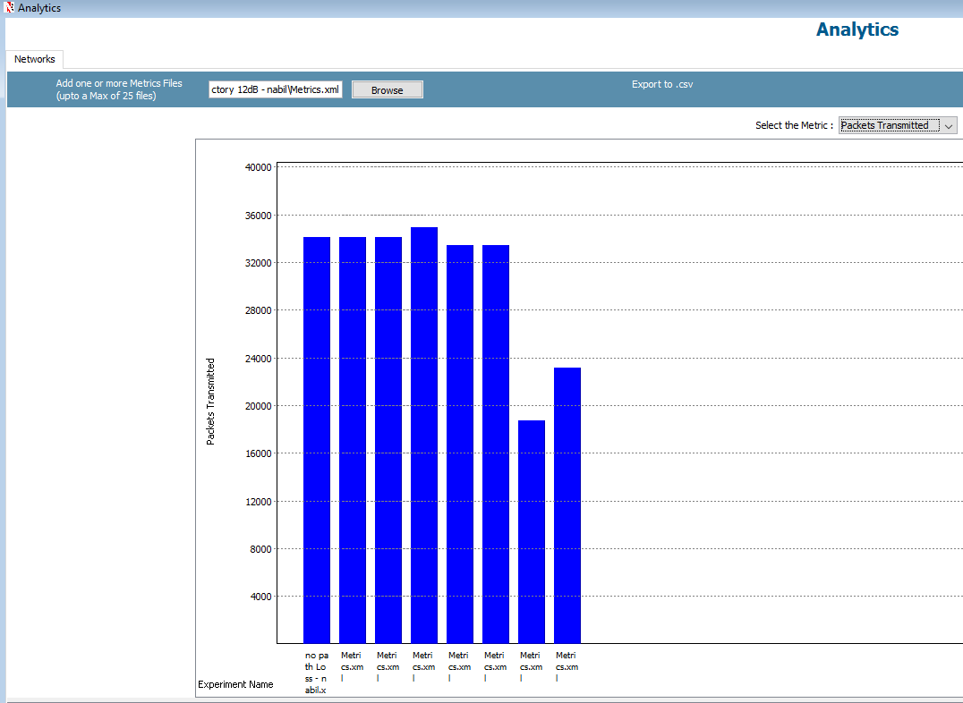
Local Server for this WSN is directly connected to the backbone router linked to the ISP, this should allow only secure encrypted remote access for the contractors “Warehouse Secure”.
The LoWPAN [12] was placed in an intersection between the three areas to provide better connection for all the sensors.
Most of the local PCs including the manager and security are wired to keep interference signals and data collision at minimum between WiFi system and data send and received by the sensors.
Three access points for WiFi been placed in factory section for the maintenance and management team, the main office section for the staff use and the reception are for all guests and visitors.

Performance comparison based on Noise interference
This simulation was done based on three different areas in terms of noise effect and channel quality;

Reception Area: In this area we assume that the maximum noise level could affect the transmission would be equivalent to (Office Indoor) Rayleigh -5dB with no path loss due to the open space and, lack of windows and mirrors.

Main offices area and corridor: In this area we assume that the walls separating them from the factory part will have some effect on the transmission, the maximum noise level would be equivalent to (Office Indoor) Rayleigh -5dB with shadowing, fading and path loss due to thickness of this walls and existing of other objects that could cause reflections and refraction of signals.

Factory Area: In this area we assumed that the maximum effect of the noise factor would vary between the equivalent of (Factory Indoor) Rayleigh -5dB, -10 dB and -12 dB as top extreme level with shadowing, fading and path loss.

the results show great difference between the 3 areas specially in terms of Packets Error, we run three comparison tests between the Metrics produced by simulation of;

- No path loss.
- Path Loss only – Office indoor.
- Path Loss only – Factory indoor.
- Path loss, fading and shadowing – Office indoor.
- Path loss, fading and shadowing – Factory indoor
- Noise equivalent to Rayleigh -5dB factory indoor with path loss, fading and shadowing.
- Noise equivalent to Rayleigh -10dB factory indoor with path loss, fading and shadowing.
- Noise equivalent to Rayleigh -12dB factory indoor with path loss, fading and shadowing.

The results of the four simulation carried using the above different noise levels shows that there is major difference on terms of packets errors, but not much difference in terms of data transmitted, overhead transmitted and packet collided with exception of when the level of noise is raise to high level of -10dB and -12dB. The results shown on figures 16 ,17 and 18 demonstrate the impact of level of noise interference on the entire performance of the WSN, the amount of packet error shown when the noise level was set at 10dB and 12dB factory indoor was extremely high, indicating big failure in data transmission.

Figure 16: Packet transmitted - comparison of all simulations

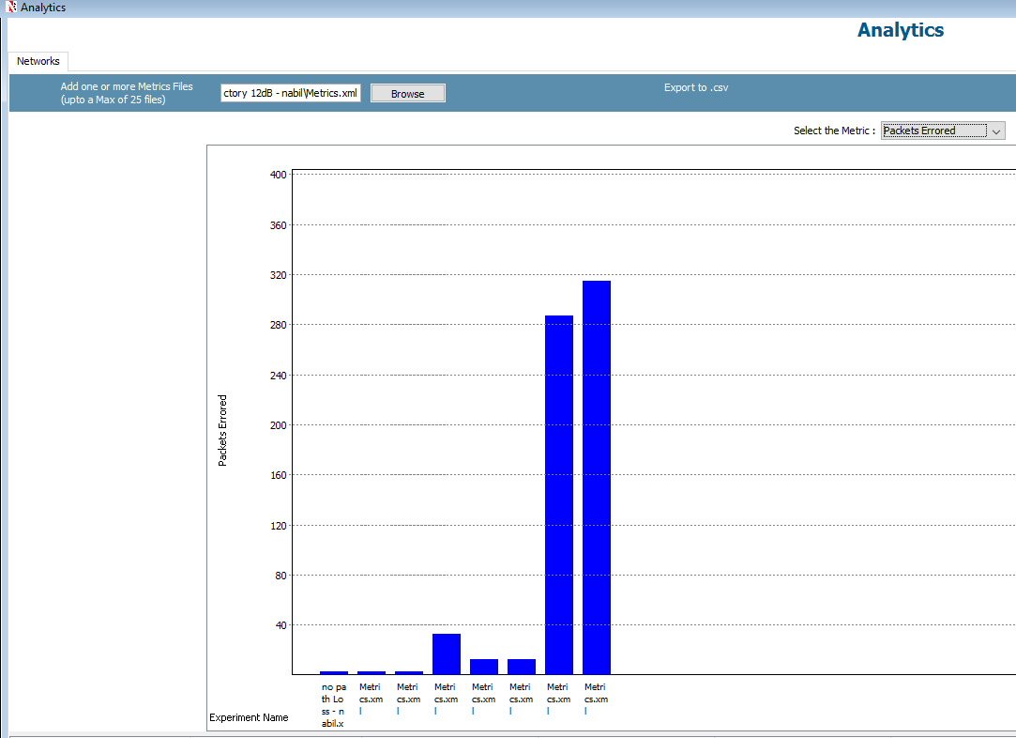

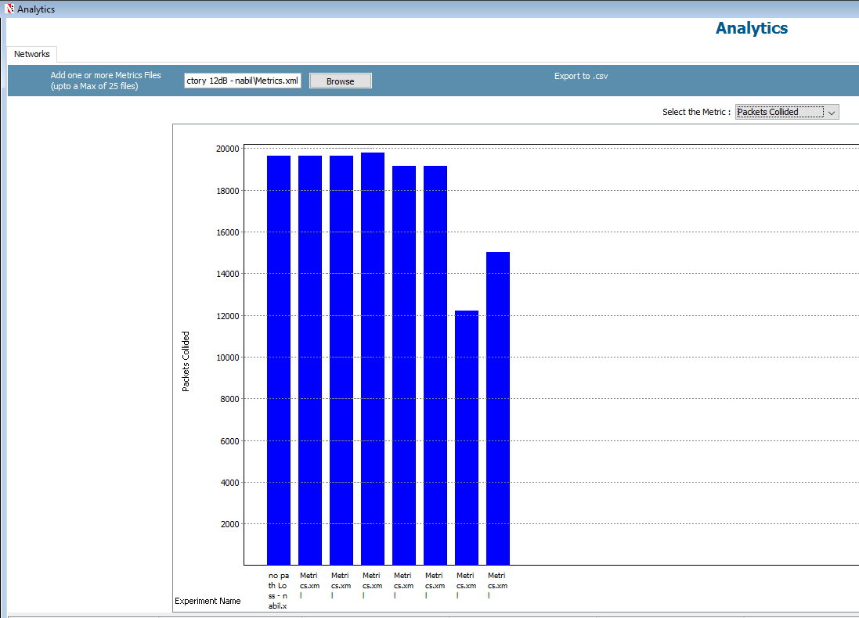
Figure 17: Packets Error - comparison of all simulations

Figure 18: Packet collided - comparison of all simulations

When analysing the data transmitted, the results shows significant part of overhead data, this type of data doesn’t represent the message transmitted, but the all the data synchronizing the transmission and protocols exchange. We could say that this significant amount of overhead data represents fundamental limitation to the network performance and heavy cost.
Networks performance should always be measured by the quality and quantity of data transmission, experiments in this field proven that there is no perfect protocol and modulation technique in the wireless communication, this is why the author believe that there is always room for more research and improvement to the current used systems [13]. As per the throughputs graphs (please see the Appendix), they all show an increase of data at the start of the simulation and after few microseconds the graphs appear to slow down and stabilise, all this can be explained by the amount of overhead data exchanged between the devices before the actual data start to be transmitted.

Performance comparison based on modulation techniques

Due to lack of Software limitation, it was not possible to run different simulation using different modulation techniques, the software only allow QPSK modulation set as default on the LoWPAN [12].

Justification of the best modulation technique chosen for WSN.
In terms of difference between the two modulations techniques BPSK and QPSK. We are confident, and research and simulation also proven if the amount of data transmitted is low (as per our WSN design), the noise effect not raising to an extreme level and all sensors if correctly configured to be energy efficient, BPSK modulation would be perfect for this design.
In general, BPSK is good with power consumption, its simplicity to transmit data made it very efficient in low data rate designs [14].

Conclusion

This paper has highlighted the importance of modulation techniques and their effect on the wireless communication, it become clear that some modulations would only suit certain type of data transmission, certain designs and applications it only depends on the environment where it will be used the amount of data intended to transmit and type of networks used. This research allowed us to see the links between all these elements, as per the WSN best modulation technique, the results of simulations and research shows that BPPSK would be the ideal one however we could not exclude QPSK from this, because it could bring some great results also. Finally, it is important to highlight also that there is no perfect data transmission protocol that is hundred percent efficient, and more research and innovation could be done to overcome data errors and delays.

Appendix

Results of the simulation 1 (No path loss, no fading signal).

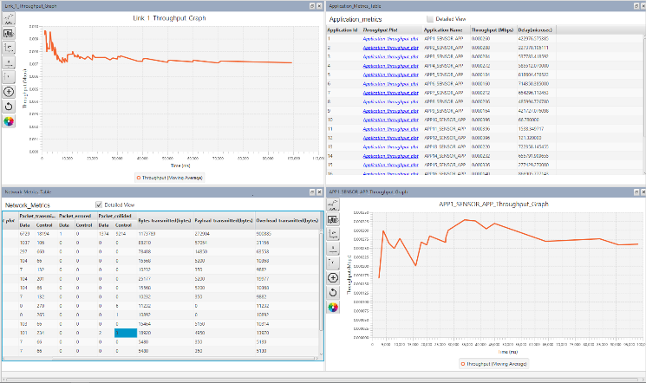
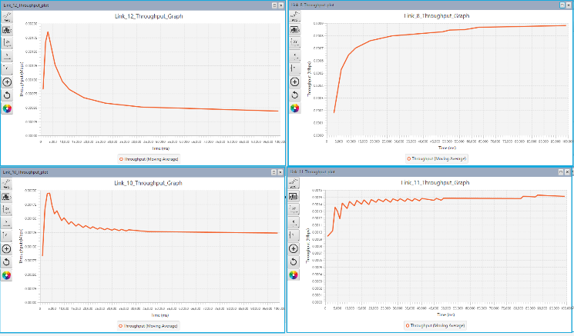

Results of simulation 2 (Rayleigh noise 5dB, path loss, fading and shadowing effects).

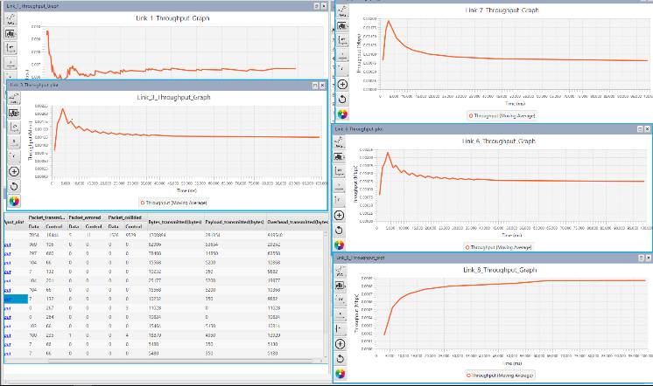

Results of simulation 4 (Rayleigh noise 5dB, Factory Indoor, path loss, fading and shadowing effects).

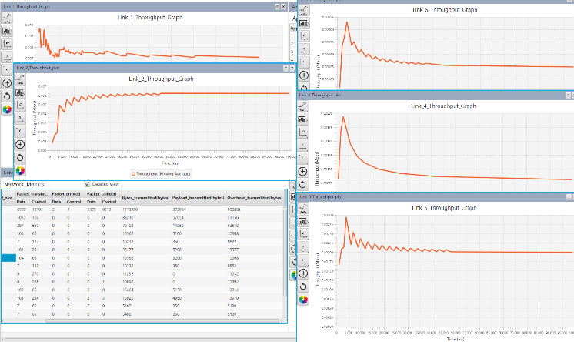

Results of simulation 4 (Rayleigh noise, 10dB Factory Indoor, path loss, fading and shadowing effects).

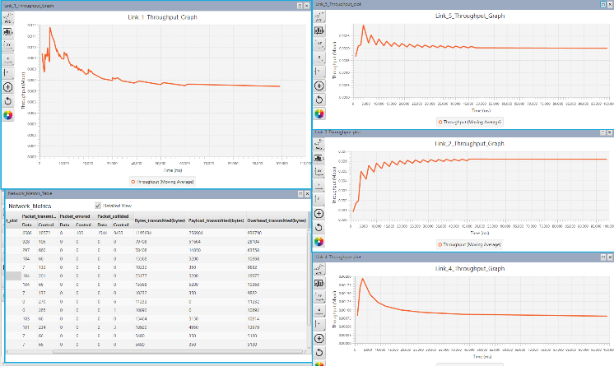

List of figures and tables:

Figure 1: BPSK phase shift key modulation
Figure 2: Modulation techniques comparison using BER versus CNR
Figure 3: Spectral Efficiency of different modulation techniques
Figure 4: BPSK modulation design including noise factor and output display for BER.
Figure 5: BPSK Conditioning block and filter
Figure 6: BPSK under (AWGN) noise with SNR of (-5 dB)
Figure 7: BPSK under (AWGN) noise with SNR (-5 dB),
Figure 8: BPSK under (AWGN) noise with SNR of (-16.5 dB)
Figure 9: Signals input/output - BPSK under (AWGN) noise with SNR of (-16.5 dB)
Figure 10: BPSK under (AWGN) noise with SNR of (-25 dB)
Figure 11: Signals input/output - BPSK under (AWGN) noise with SNR of (-25 dB)
Figure 12: Test comparison design between BPSK/QPSK/QAM
Figure 13: Test comparison results of BER when BPSK/QPSK/QAM affected by (AWGN) noise.
Figure 14: Full design of the Smart Factory using WSN Figure 15:
Figure 15: The three major parts of the Smart Factory
Figure 16: Packet transmitted - comparison of all simulations
Figure 17: Packets Error - comparison of all simulations
Figure 18: Packet collided - comparison of all simulations

References

[1] M. Masud, M. Samsuzzaman, and M. Rahman, “Bit Error Rate Performance Analysis on Modulation Techniques of Wideband Code Division Multiple Access,” arXiv Prepr. arXiv …, vol. 1, no. 2, pp. 22–29, 2010.
[2] G. Tharakanatha, S. Mahaboob Kamal Basha, V. Bhaskar Chanda, and I. Hemalatha, “Implementation and Bit Error Rate analysis of BPSK Modulation and Demodulation Technique using MATLAB,” Int. J. Eng. Trends Technol., vol. 4, no. 9, 2013.
[3] L. E. Frenzel, “Understanding Modern Digital Modulation Techniques Electronic Design,” Electron. Des., 2012.
[4] technologyUK.net, “Phase Shift Keying (PSK),” 2018. [Online]. Available: https://www.technologyuk.net/telecommunications/telecom-principles/phase-shift-keying.shtml. [Accessed: 08-Apr-2018].
[5] M. A. Khan, S. Pal, and A. Jose, “BER Performance of BPSK , QPSK & 16 QAM with and without using OFDM over AWGN , Rayleigh and Rician Fading Channel,” vol. 4, no. 7, pp. 64–69, 2015.
[6] J. A. Desai and S. N. Kulkarni, “Effect of Noise on BER of BPSK , QPSK , DPSK , and QAM Modulation Techniques,” vol. III, no. Vii, pp. 71–74, 2016.
[7] M. M. Madankar and P. S. Ashtankar, “Performance analysis of BPSK modulation scheme for different channel conditions,” 2016 IEEE Students’ Conf. Electr. Electron. Comput. Sci. SCEECS 2016, no. 2002, 2016.
[8] Donald Craig, “Advantages of Simulation,” 1996. [Online]. Available: http://www.cs.mun.ca/~donald/msc/node6.html. [Accessed: 09-Apr-2018].
[9] K. Tan, D. Wu, A. Chan, and P. Mohapatra, “Comparing Simulation Tools and Experimental Testbeds for Wireless Mesh Networks.”
[10] A. Khan, A. K. Singh, D. K. Gupta, and D. K. Vimal, “Communication System Using BPSK Modulation,” Int. J. Sci. Eng. Res., vol. 4, no. 5, 2013.
[11] M. Hussain, R. Chowdhury, M. Hossain, S. Jahan, and M. H. Rahman, “Performance Analysis of Various Modulation Schemes for Achieving Energy Efficient Communication over Fading Channel for Wireless Sensor Network,” vol. 11, no. 1, pp. 97–100, 2016.
[12] Y. Mazzer and B. Tourancheau, “Comparisons of 6LoWPAN Implementations on Wireless Sensor Networks.”
[13] B. P. Dunn and J. N. Laneman, “OVERHEAD IN COMMUNICATION SYSTEMS AS THE COST OF CONSTRAINTS,” 2010.
[14] A. Khan, A. K. Singh, D. K. Gupta, and D. K. Vimal, “Communication System Using BPSK Modulation,” Int. J. Sci. Eng. Res., vol. 4, no. 5, 2013.

