

BSc (Hons) Professional Police Practice

LEVEL 4 - 40 Credits

Workbook title: Competency Based Workbook 1 (PCDA)

(SOUTH WALES POLICE, GWENT POLICE AND UWTSD)

Learner name: Jordan Warmeant

Learner’s University Registration Number:
2319966

FACULTY OF BUSINESS AND MANAGEMENT
PUBLIC SERVICE PROGRAMME

Module title: Professional Police Practice 1 (PCDA)

Workbook Guidance

Please read these notes carefully; they provide essential information.

What is the workbook for?

The purpose of this workbook is to enable learners to demonstrate and provide evidence of how they meet the learning outcomes set by the College of Policing, for the BSc programme. Essentially, you are being asked to outline your experiential learning based upon your theoretical understanding in a range of operational situations.

Area of Professional Practice covered, (called elements in your module descriptor):

- Wellbeing and Resilience
- Communication Skills
- Managing Conflict
- Valuing Difference and Inclusion
- Criminal Justice
- Decision making, discretion
- Conducting Investigations
- Criminal Justice (Managing offenders)

You may wish to use the same incidents as you’ve outlined in the Occupational Competence Portfolio.

How should the workbook be presented?

Blank electronic copies can be found on Moodle of this workbook. You must submit this document electronically therefore it is important that you save your work regularly and upload the final typed version through Turnitin on Moodle.

Word count policy can be found in chapter 7 of the Academic Quality under section 7.7 (this applies to presenting work above and under the specified word count).
(https://www.uwtsd.ac.uk/media/uwtsd-website/content-assets/documents/academic-office/aqh-chapters/chapters---en/Chapter_07_Assessment_Taught_Programmes_Pages_72-79-UPDATED-05-11-2019.pdf)

Reflective practice is a core aspect for your workbooks and although there is a variety of useful resources on Moodle, there is one particular book, that is specifically based on reflective practice in policing, here is a link to one chapter from Selina Copley’s Reflective Practice for Policing Students:
https://moodle.uwtsd.ac.uk/pluginfile.php/298870/mod_resource/content/1/Reflective%20Practice%20for%20Policing%20Students%20-%20Selina%20Copley%20Chapter5.pdf

How is the workbook assessed?

Advice and support about the completion of this workbook will be provided by university staff as part of your initial training day. Your tutor constable and in-force training staff will not be involved in assessing or marking your workbook after it has been submitted.

Dates of workbook submission will be made available during the initial training day and posted on Moodle.

Once submitted your workbook will be assessed and marked independently.

Confidentiality

It is important that no individual can be identified either directly or indirectly from the information in the workbook. Therefore, you must:

- adhere to guidance in the Student Handbook about unfair practice and plagiarism;
- not identify individuals including witnesses, victims or offenders by name;
- not write information that enables any individual to be identified indirectly through the description you provide. This includes references to names, colleagues, places (including hospitals, schools, town, villages, streets) specific incidents which were high profile and could be identified due to past publicity, other professionals or any other personal information including medical or other conditions;
- take personal responsibility for adhering to confidentiality rules.
- not include any dates of any incidents or anything that specifically identifies an actual incident.

Please be aware that any content that is deemed to be inappropriate, disrespectful, or abusive will not be tolerated. Following review of any content of this nature the information will be shared with the employer of the student responsible.

The content of this workbook should be your own work. Do not allow anyone else to see your work or use your work for their own submissions.

Should any health and wellbeing concerns be raised because of disclosures made by the student within this workbook, the employer of the student will be informed.

NOTE

Your workbook will be submitted electronically via Turnitin on Moodle. Guidance on this is in the Student Handbook.

Remember that the workbook is YOUR responsibility you must not rely on the assessor or anyone else to pick up any confidentiality breaches as this is your work and you must accept full responsibility for confidentiality. Meeting all the confidentiality requirements is very important.

Dyslexia and other special circumstances

If you have any condition that you feel may affect your ability to deal with any part of the programme, please see the Student Handbook for further guidance. The University has a Student Services Unit that may be able to help but it is the learner’s individual responsibility to contact them.

Guidance:

- Your workbook must contain the items specified in the table below (clearly identified and in the order given);
- You should use this particular document to insert your text / answer within each section of this workbook;
- You should upload your completed document as a saved pdf of this workbook; if this is not possible then a Worddoc file is acceptable. Do not send a scanned file from a photocopier, an apple.dot file, or a Microsoft publisher file as Turnitin will not be able to assess them despite you being able to upload them.

Contents:

Workbook | Area of Professional Practice | Word count
Task 1 | Wellbeing and Resilience | 1000
Task 2 | Communication Skills, Managing Conflict, Valuing Difference and Inclusion | 1500
Task 3 | Criminal Justice, Valuing difference and inclusion | 1500
Task 4 | Decision making and discretion, Conducting Investigations and Criminal Justice (Managing offenders) | 1500
 | Bibliography
Task 5 | Development Plan | 500
 | Total | 6000
Confirmation of Confidentiality and Plagiarism
This is confirmed by submitting through Turnitin

Task 1

Relevant areas of the National Policing Curriculum:
Wellbeing and Resilience

Guidance:

Focussing on your initial 6 months of learning and since being attested as a Police Constable, outline the coping strategies you have applied to develop resilience and minimise stress.

1000 words (+/- 10%: include your actual word count at the end of each section)

ANSWER:
This essay will outline the coping strategies in regard to stress and resilience that I have used throughout the first 6 months. The NHS defines stress as “Stress is the body’s reaction to feeling threatened or under pressure.” (NHS, 2021). Resilience is defined as “Resilience is the ability to cope with and recover from setbacks” (Cherry, 2023). I will use the Borton’s reflective model to give this writing a systematic format. The Borton’s reflective model is a model that has three parts, the first part is “what?” this means what has happened in the task. Then it is ‘so what?” Which is an analysis of the reflective event. Then it is “what now?” This is used to do a conclusion of the event to see what can be done better in the future and to talk about what has gone right. (Borton, 1970). In this reflective tool I will explain the coping strategies I have used which have worked and which have not worked, and I will also think of new strategies I could use to help in the future.

The first strategy I used is exercise I used this for physical health and mental health benefits. I go to the gym and do boxing twice a week and then do 2 cardiovascular training sessions which has helped my physical health massively by feeling fitter in doing my daily role in the job. I decided to start exercising quite regularly due to the overwhelming stress I endured in terms of the exams. It helped me take my mind of the exams and this helped me in terms of revision as I used a revision tool which was recorded voice notes of the legislation which I would play whilst using the treadmill. Doing research, I found that exercise boosts memory and helps improve concentration I found five tips on how to help with revision one of the tips was to use exercise into the revision to help taking breaks which helps boost energy levels. (BBC, 2024)

This made me feel more prepared for my exam and helped me feel like I knew more of the legislations. Using this also helped me build resilience as most other techniques of revision would not work and didn’t stick in my brain as well as the voice notes. This has also benefited my mental health as it helped me accomplish a sense of pride as the more, I exercised the more fit I felt and the longer I could endure cardiovascular activity. Whilst researching the benefits of exercises I found a research article which outlined the benefits (NHS, 2021). In this article it outlines benefits such as reducing stress which I experienced throughout the 6 months.

The second coping strategy I used was playing 5 a side football. I used this for trying to reduce my stress levels. I would play a game every Wednesday with friends to maintain my fitness and to have some people to talk to about outside of work life. Doing this helped me massively as it helped me learn to leave the stress of work at work and to maintain a social life with my friends. This reduced my stress a lot and it taught me how to accept a loss and to think about how I could have done better for the next game which helped me prepare which taught me a lot of preparation tools which I could use in work as well as outside of work. It also helped me understand the level of cardiovascular fitness I was at and helped me set goals in which I can achieve.

During research (University of South Wales 2020) I found that football can help improve social confidence and mental health since playing football I feel like I am a more confident individual which helped relieve stress that I built up from the practicals. Playing football releases endorphins (Fit People, 2019) which make you feel happier.

The third strategy I used was maintaining a work and family life balance I developed this strategy towards the second exam. I did this because for the first exam I was so stressed about passing the exam that I was so focused on revision and work and was struggling to fit in time with the family. To challenge this, I started to make sure that weekends was time for the family and weekdays was for work time. I started to plan days out with the family on the weekends which helped me feel less isolated and less stressed and I also found the right work balance to make sure I was balancing both in a fair manner. When I was struggling, I was looking for stress coping strategies and I found ten stress busters on the NHS website. (NHS, 2021). One of the ten stress busters I found was spending time with family which helps with work stress and having time to connect with family helps relieve stress. This helped me massively as I felt that I had events to look forward to outside of work and helped me prepare for my exams.

The above coping strategies have worked exceptionally well for me. The exercise helped me massively in terms of maintaining fitness for my role and to learn the legislation that I needed to do my role. Boxing helped me learn discipline and helped me build my physical build to help me deal with everyday occurrences. Boxing taught me how to know my own strength which has helped me learn about the different use of force that I can use to achieve the best outcome after considering all the alternatives. Maintaining a family and social life helped me feel less isolated from my life outside of work and helped me relieve stress and build resilience by having people to talk to outside of work and to have events to look forward to at the end of the week. Going forward I will focus more on boxing and family life and do less football as I had many injuries that occurred whilst I was playing football which could prevent me from doing my role due to over-exercising.

Word count: 1023

Task 2

Relevant areas of the National Policing Curriculum:
Communication Skills, Managing Conflict, Valuing Difference and Inclusion

You must choose a policing incident involving conflict in which you played a significant role with an offender/service user/victim and reflect on what happened.

Give a brief description of the incident including social and legislative contexts and any relevant cultural, ethnicity and language issues.

Review the fundamental elements of effective communication used (verbal, non-verbal, active listening skills, open and closed questions, building rapport and negotiation skills).

Describe the process for determining whether the use of force was necessary in a conflict situation (including any theories or models underpinning the causes of conflict within policing interventions – e.g. Betari’s Box, The Drama triangle, Emotional versus rational brain) and provide a reflection on the outcome of the incident.

Your reflection must illustrate your understanding and application of core principles of ethics, equality, diversity and human rights, as well as any relevant Code of Practice considerations, culturally sensitive practice and language preference.

1500 words (+/- 10%: include your actual word count at the end of each section)

ANSWER:

Through every call communication is used as the best tool to do the job efficiently. Using verbal communication and non-verbal communication can help with understanding the reasons why people commit crimes and help us to effectively support the victims in the best way possible. Using skills like listening skills can help us assess the threat and risk on every call and to get a good understanding of the circumstances of the call to help us chose the best outcome and support that we can offer. Building rapport with the people at a call is a big factor that we can use to help support the victims as it is the worst day of their life, and they might have had negative encounters previously with the police.

Betari’s box is a theory that describes “how people can get locked into a vicious or virtuous circle of communication, based on how their attitudes and behaviour respond to each other.” College of policing (2020).
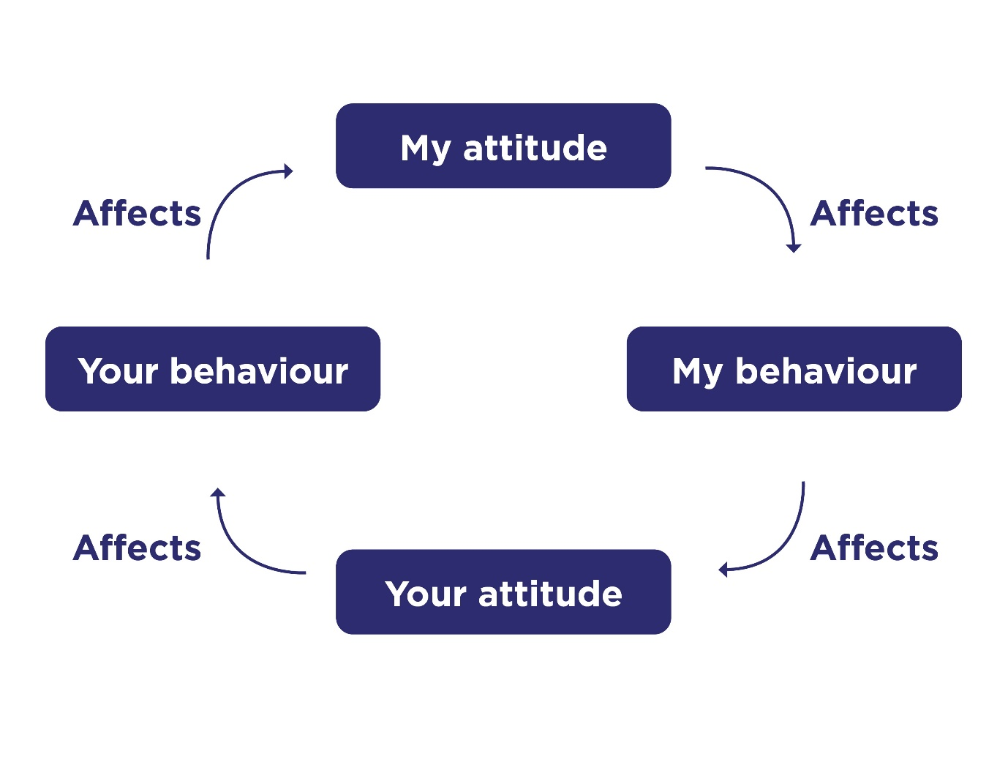
(Farmer, 2019)

I received a call of a male that was walking through the streets with their friends and the friends was holding him up to help him walk through the streets. The male was highly intoxicated, and his friends were struggling to help him walk back through the street.

When officers attended the call, I took into account betari’s box, and I knew that if I went in there with a good respectful attitude that would be the best way to gather information when we arrived, we asked the friends if they needed any help with the male. I also checked on the male’s welfare I used various communication skills such as using body language to show the male that I was talking and using verbal communication skills to ask questions. When I asked the male, he was slurring on his words and started to get annoyed by officers’ presence. I asked the male if he would like a lift home via the safety bus, but he refused and walked off.

After this my colleagues and I left the male with his friends but when walking away the male started to approach officers and started shouting towards them, I then noticed that his behaviour and attitude had changed from before I then had to consider my behaviour and attitude referring back to Betari’s box his attitude and his behaviour affects mine. Due to the aggression shown by the male I started to use body gestures and I changed my posture from an open posture to a closed posture to help defend myself in case of his aggression rises. During research I have found that this is an important way to engage someone in a conversation (Martin, 2020).

At this point one of the male’s female friends had told the officers that the male had autism and had drunk more than usual. After this officers had tried to talk the male into getting a lift home, but the male refused and would not maintain eye contact with officers to show engagement with officers when being spoken to. A study from the mayo clinic stated that people with autism do not contain eye contact. (Mayo Clinic, 2018).

After this had happened, an officer had attempted to put the male in handcuffs to stop him fighting out. When officers touched the male, this had caused an overload of heightened sensory overload which is a common anger trigger for autistic people (Sara, 2023). When officers managed to restrain the individual in handcuffs, the male was asked if he was going to calm down and enter the van compliantly when the male had heard this, he started trying to bite the officers around him and started to drop to the floor. When the male had fallen to the floor he started kicking out and trying to bite the officers whilst on the ground.

After seeing the male trying to bite the officers, I considered arresting for assault an emergency worker which is defined in section 1 of the act (Assaults on emergency workers offences Act 2018) as “An Act to make provision about offences when perpetrated against emergency workers, and persons assisting such workers; to make certain offences aggravated when perpetrated against such workers in the exercise of their duty; and for connected purposes”.

From finding out he has autism I decided to use discretion and think of ways to return the male home in order to safeguard him. I understood that with his autism, that being out in the nightlife it might be making him uncomfortable as autistic people suffer with sensory overload due to being overstimulated by all the noise around them (Rudy, 2019). I knew that because it was a weekend night the city centre would be extremely busy and could cause his senses to feel overstimulated and make him more anxious research has found that Friday nights and Saturday are the busiest. (COUNCIL, 2020)

After trying to use our verbal communication we realised that this was not working with the male and realised that this wasn’t efficient. I took into consideration the alcohol consumption of the male and realised this influenced his behaviour. I knew that alcohol consumption is one of the substances that increases violence. (American Addiction Centers, 2022)

Officers restrained the male on the floor securely and maintained his head to a position where he was facing away from officers. When the male was kicking out myself and other officers restrained his legs and put on the leg restraints, we put the leg restraints under his knee and above his ankle and tightened them to a position that was comfortable for him and made sure it wasn’t too tight and that we could fit two fingers between the restraints. After officers knew that the male was restrained and couldn’t attempt to injure officers, they used a five man carry to lift the male into the van. When officers had placed the male into the van, I took into consideration that the male was vulnerable and asked his friends for his house keys.

In the back of the van, I sat in front of the male and allowed him his personal space, I tried to talk to the male and explain what was happening. The male started using listening skills to acknowledge what I was saying and told me he was sorry for behaving the way he did and told me he just had drunk to much that evening. After having a talk with the male during the ride to his mother’s I used communication skills and listening skills, the skills I used was verbally speaking to the male and using body language to express that I understood what he had communicated back. I did this to understand what he thought had happened and tried to build a rapport with the male, but the male did not seem capable of having a rapport building conversation due to alcohol consumption.

I then told the male that we were taking him back to his mother’s and asked if he knew where that is he replied with the address of his mothers. When I arrived at his mother’s I opened the van and told the male we had arrived. I knew that this would help his attitude and behaviour calm down to a compliant way as he was returned back to his routine and through research, I knew this was important for people who have autism and also found out “I use routine as a coping strategy to enable my daily functioning. The world can be chaotic, unpredictable, overwhelming, loud, bright and exhausting; every aspect of daily living is seemingly designed against someone with autism” (Hawkins, 2023). This helped me understand why the male was behaving the way he was. I then explained if he did not hit the officers the handcuffs will be taken off, he replied and told me he would not hit any more officers. After this the male acted compliantly and walked with the help of two officers inside the garden. I then noticed his behaviour and attitude had changed to a calm compliant attitude.

When I walked up to the door, a female answered. I asked her if I could come in and help her put him in his room to which she allowed. After this I spoke to the female and explained to her what had happened on this night. I told her that we had talked to the male multiple times on the night to check on his welfare and to see that he was safe and was able to get home. I briefly explained that he attacked the officers and was restrained and taken home. After speaking to the female, she completely understood the police actions and thanked us for returning him safely. I offered the female help and support in caring for her son to which she accepted gratefully and told her about different charities that can help her son and told her if she needed any assistance to give the police a call.

On reflection of this incident, I feel like we worked well and made sure a vulnerable adult returned safely home. Throughout this call I used many theories on dealing with conflict to resolve the incident with the best outcome. I used many ways of communicating with the male for example, verbal, non-verbal, listening skills throughout the incident I considered the core principles of ethics I was completely honest with the male throughout the call and tried empathising with the male throughout the whole interaction but due to his intoxication he was not able to understand. In the future I would consider allowing someone who suffers with autism a bit more space and allow them time to help in understanding their actions. Betari’s box was not useful during this call because of the alcohol consumption the male could not respond to changing attitudes and did not understand his behaviour.

Word count: 1650

Task 3

Relevant areas of the National Policing Curriculum:
Criminal Justice, Valuing difference and inclusion

You must choose a policing incident in which you played a significant role with an offender/service user/victim and reflect on what happened.

Give a brief description of a relevant incident including social and legislative contexts and any relevant cultural, ethnicity and language issues.

Explain and reflect on your responsibilities and procedures in line with the relevant Codes of Practice to support victims and witnesses through the criminal justice system.

Illustrate how policing values were engaged, as well as any other considerations including culturally sensitive practice and language preference.

1500 words (+/- 10%: include your actual word count at the end of each section)

ANSWER:

Throughout all incidents policing values are engaged and the victims’ codes of practice is used in every incident. In this incident I had encountered victims that felt intimidated and vulnerable due to an assault that had happened. Throughout this essay I will reflect upon how I used responsibilities and procedures to help support victims and witnesses.

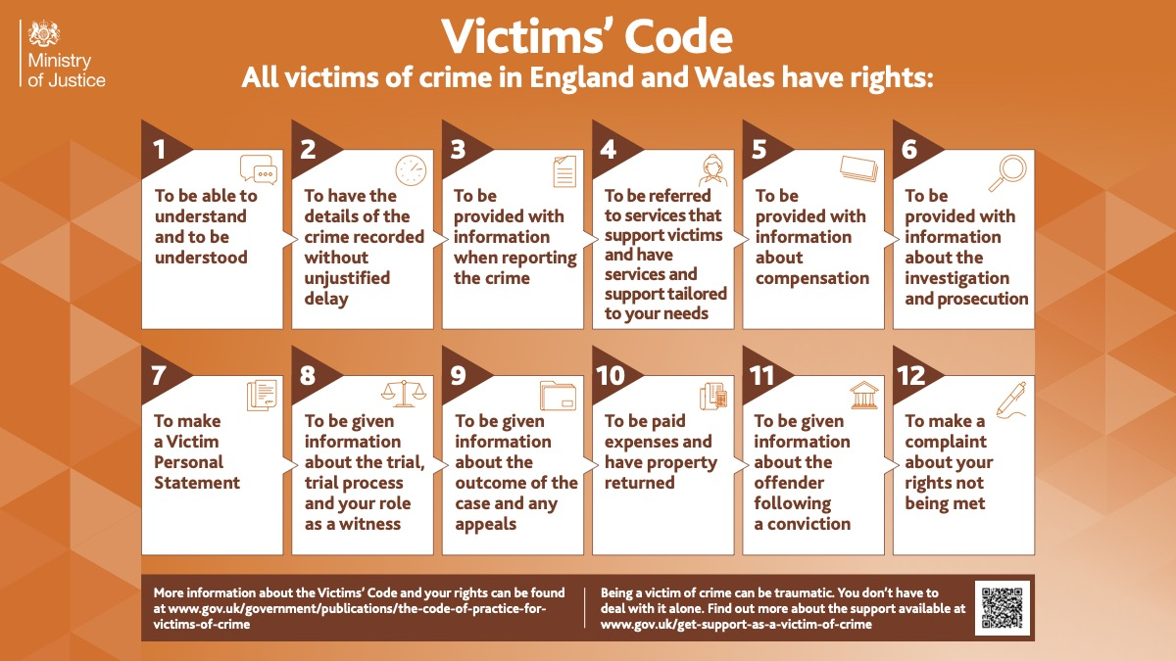
The below diagram explains the 12 victim codes of practice. (Witness care unit, n.d. 2019)

An incident that I had attended was an assault that took place when a family attended a concert. When the family had attended a concert, they were dancing and listening to the songs which they had said made them feel very vulnerable as they didn’t know their surroundings and then the mother-in-law was getting barged from a female and a male that was standing behind them and had a group of males standing behind the couple. When the daughter in law had noticed this, they had asked the couple if they could please stop barging into them. When they had asked this the couple acknowledged them and carried on.

The daughter had asked them to stop once more and on this occasion the male that was with the female had punched her in the face. Upon seeing this the husband had stood up and went to talk to the male to de-escalate the situation. After this the husband was trying to defend himself and a fight had broken out. The suspect’s friend had tried to pull the husband’s top over his head to stop him defending himself. The suspect had gotten the male and female on the ground and carried on attacking them. One of the males had bitten the husband’s ear. After witnessing this, the mother-in-law and the other sister had tried to protect the daughter and husband and tried to pull the subjects off but because of this sustained many injuries.

When I had arrived, I was directed to the medical tent where the victims had been getting treated. I used victim code 1 by making sure that the victims were understanding the process I did this by explaining how the case will proceed and asked them if they understood what I was saying. I asked them what happened, and I made sure that they knew I was understanding what they were saying by using body language and gestures. I told the victims that the crime is going to be recorded and progressed to the national case progression standards and I told the victims that I will be in regular contact throughout the case to let them know about any updates I also had gave them the case number in case they wanted to phone up to ask about the case progression and had also told them to contact me via mobile number if they needed anything. A study had shown that in 2022/2023 the biggest complaints made against police was delivery of duties and services this means that lack of victim contact was a big issue in police contact. (for police complaints, 2023)

On contacting the family , I was made aware that the family had sustained some serious injuries and trauma from the incident. I spoke to the victims and asked them if I could refer them to victim focus which is an organisation that supports victims and helps them recover from traumatic events. Upon speaking to the victims, I had asked them if they could attend the station that was covering the arena that the concert had taken place in to take a statement. After asking them this I had found out that they weren’t from this area and due to the trauma from the incident they were suffering with anxiety, and they had also told me that they couldn’t leave the house as they were so afraid from the incident according to research (Williams, n.d.) I found out that a factor that victims struggle with after a report is readjustment this is where they struggle to deal with everyday life after an incident and they grow fear of leaving their safe space. After hearing this I had told them that I will be in contact with an officer that can cover the area that they live in, and they could take a statement from them.

One of the victim’s had said they had dropped their phone because of the assault and the friend had located the phone to be showing in a repair shop. The female had also told me that in one of the family pictures they had taken the suspects faces can be seen. After hearing this I told the victim that in relation to code 5 of the victim’s code of practice that she could request compensation if the phone is not recovered and that I would report it to the crown prosecution service. I had told the victim that the process of the compensation would be that if the offender must pay compensation that it will be an amount that the offender can afford to pay back which is stated in (Victim Support, n.d.).

I had attended the repair shop that the phone was located at and had recovered the stolen mobile phone and had asked the victim for the password of the phone and had asked for the victim to tell me the time of the assault so I could ask the digital media investigator who will Collect data for example the data we was looking from this mobile phone was pictures of potential data, analyse the data and they then will make reports on digital evidence which can be used as evidence in court. (Oliver, 2019) the digital media investigator looked at the mobile device and then they sent the photos through to facial recognition as a potential suspect. On doing this I had come back with a match of one of the suspects from the event and matched the face to CCTV evidence of the assault.

I had done CCTV enquiries from the arena of the concert and had tried to identify the suspect’s by having descriptions that were provided by the victims. After checking the CCTV I had no luck in identifying the suspects but had sent some photos of faces to be identified by facial recognition. I had informed the victims of this and regularly updated the victims of everything that was happening in the investigation. I had taken the seat numbers of the tickets that the victims were sat in to narrow down the CCTV and had recorded a time that the assault had taken.

Due to this the victims had suffered life changing events as they had told me that they could not leave the house due to fear of the event. One of the victims had told me that they suffer with agoraphobia after this incident which is defined as “Agoraphobia is an anxiety disorder that causes an intense fear of becoming overwhelmed or unable to escape or get help. Because of fear and anxiety, people with agoraphobia often avoid new places and unfamiliar situations, like:
Large, open areas or enclosed spaces.
Crowds.
Places outside of their home.” Cleveland Clinic (2023)

After hearing this I had asked the victims if there were any support, they would like us to provide. I had referred them to multiple charities which they could talk about what happened and seek support from people who have suffered from similar events to see different mechanisms of recovering. Throughout this case I regularly maintained contact with the victims to check on their wellbeing and had been informed that they had attended some support meetings which allowed them to talk about the trauma with other victims which they could help each other with different recovering mechanisms. They had also told me that they had attended the doctors to speak to a therapist that could help with their anxiety about leaving the address.

After hearing all of the trauma the victims had suffered, I asked them if they were willing to do a victim personal statement which gives victims a chance to explain the affect the crime has had on them. (Ministry of Justice, 2013). I had told the victims that they would need to attend court and had explained to them the process of court and that if they did not feel comfortable seeing the suspects that they could attend court via an online meeting.
At the end of the case I had told the victims that two people had been changed for the assault on the night and due to evidential failures, the other potential suspects had not been identified. I had told the victims all about the charge process and had told them that the remaining suspects will still be investigated and if they are found the victims would be contacted. I had told the victims that if they wanted to make a complaint about this case that they were entitled to do so and explained to them the complaint process, but they had told me they were satisfied with the outcome of the investigation.

Reflecting on this incident I think I used the victims’ codes of practice really well and in the future what I would do differently is explain the codes of practice a little bit more to the victims as I was told they understood the processes in relation to the codes, but I think I could have explained them a bit more in detail.

Word count:1571

Task 4

Relevant areas of the National Policing Curriculum:
Decision making and discretion, Conducting Investigations and Criminal Justice (Managing offenders)

You must choose a policing incident in which you played a significant role with an offender/service user/victim and reflect on what happened.

Give a brief description of the situation including social and legislative contexts and any relevant cultural, ethnicity and language issues. Reflect on how you applied the National Decision Model (NDM) to assist in resolving this incident. Consider the role of discretion in the decision-making process.

Explain your responsibilities with regards to the provision of the CPIA when conducting this investigation including when managing the offender and suspects and recording and retaining significant information.

Illustrate how policing values were engaged particularly through an analysis of the potential impact of bias on the decision-making process.

1500 words (+/- 10%: include your actual word count at the end of each section)

ANSWER:

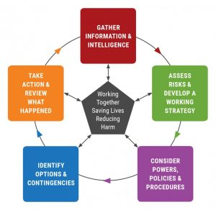
(Coxhead, 2017)
The diagram above explains the national decision model (NDM).
The NDM is the national decision model which is split into 6 parts: code of ethics, gather information and intelligence, assess threat, risk and develop a working strategy, consider powers and policy, identify options and contingencies and take action and review what happened. (College Of Policing, 2013). Throughout this essay I will describe an incident that I attended in the early weeks of my career in the police. I will refer to the NDM and explain how I used each part to decide my course of action. I will explain how I used discretion and decision making to choose the best outcome for the incident.

I received a call that a domestic disturbance was ongoing at a property between two females and that one of the females was breaching her bail, the female was on bail due to the fact she had smashed the window of the door to gain entry into the property. Which she had been arrested for criminal damage section 1 1971 which is defined as “A person who without lawful excuse destroys or damages any property belonging to another intending to destroy or damage any such property or being reckless as to whether any such property would be destroyed or damaged shall be guilty of an offence.” (Legislation.gov.uk, 2011)

My first step I done was to gather as much information and intelligence in regard to the call. I was told by the operator that the female had been arrested and placed on bail and had bail conditions to not to return to the property on any occasion. Through gathering information I found out that my colleague had reminded this female that she was not allowed back at the address and that was her second warning. I used the information that these two females are relatives, and I knew that this is a domestic incident. I was informed that this female is an alcoholic and that she could get aggressive towards police.

I took all the information by my colleagues, and I created an unbiased viewpoint, unconscious bias is defined as “Unconscious bias refers to the automatic associations and reactions that arise when we encounter a person or group. Instead of maintaining neutrality, we tend to associate positive or negative stereotypes with certain groups and let these biases influence our behaviour towards them.” (Nikolopoulou, 2023). I processed all the information that I had gathered, and I used the code of ethics to treat the females with respect and I made sure that I did not allow the experience that colleagues have had with the female to affect my judgement and decisions.

The next stage in the NDM is assess threat and risk. I used all the information I had gathered and started to analyse it for risks. I knew that as this is a domestic related call there could be signs of aggression towards the victim. A study from the Women’s Aid states that 24.9% of women have endured a violent relationship for over ten years. (Aid, 2024). In reference to this I knew that the female had been living at the property for 25 years. I took this into consideration when assessing the risk towards the victim and assessed whether it would be best to safeguard the victim by making sure that they are not present in the same room. I took into account that both the victim and the suspect are females and a study has shown that women are more likely to experience domestic abuse than men the study states that 93% of victims are female. (Lives, n.d.) Another risk I had analysed is if the female was intoxicated as the NHS states that alcohol has major impact on your decision making and causes you to be more reckless. (NHS, 2022)

From assessing all the risks from this call, we had come up with working strategy that included a plan where we would enter the premise locate the victim and safeguard them by making sure they were in a different room than the suspect and then we would locate the female and decide if she was intoxicated .

When knocking the door a female had opened and was emotionally upset and told us that the other female who was the subject was located in the upstairs bedroom the victim was acting scared and she had told me that she didn’t want the female in the property anymore as the mother who lived there had dementia and was a vulnerable adult the victim told me that the female regularly drinks and can become violent with her. According to the national statistics it states that a higher level of adults who have a disability suffered from domestic abuse than adults who do not have any disabilities. (Office for National Statistics, 2022) The victim had told me that the female upstairs had entered the property as she has nowhere else to live and that the mother of the house allowed her entry, after gathering more information from the victim the mother had dementia and the victim was acting on behalf of her care and said that the other female was not allowed to be in the property.

The next stage in the NDM is consider powers and policies. After speaking to the victim and hearing that the female had ignored police warnings not to enter the property again or she will be arrested I started to think about the different powers and policies I could have used to achieve a different outcome.
I considered using my discretion and professional judgement, I thought about getting the female to leave and to not arrest the female. However due to the nature of the call and it being a domestic call and using all the information of violence that the female had made the victim endure I knew that the option of getting her to disperse would not be beneficial. I took into account that the female understood that the bail conditions was not to enter the premises and took into account that the female had been warned by police to not attend, this helped me come up with arresting the female for breach of police bail. I had used my policing principles for example in this instance I used objectivity which is when you make a choice based on evidence and best professional judgement. I used this by assessing the warning the female had in the past not to return and used my professional judgement that if the female were warned by police in the past that warning her again would not stop the female from returning.

After gathering this information, I went to speak to the other female. When going upstairs I seen the female packing her bag and she stated that she was allowed in the property at this stage I was taking into consideration the body language and the gestures the female was making.

I then used all the information that I gathered and following the guidance of the NDM I took action by assessing if the female was intoxicated by engaging in a conversation with the female, I determined that she was sober which allowed me to choose the option of no handcuffs as she was being compliant and opposed no threat. I placed the female under arrest for breach of her bail and told her that she had been made aware that she wasn’t allowed to go to the property. As she has been told multiple times that she isn’t allowed to enter the property I used my discretion and decision making to arrest the female as this was the only option available to protect the vulnerable adult as the female was going back to the property two times previously.

Throughout this case I was the officer in charge and stated in the criminal procedure and investigations act 1996 an officer in charge can delegate a task to another colleague. (Ministry of Justice, 2015) taking this into account I had asked a colleague to go back to the address to get a witness statement whilst I dealt with the suspect.

I also updated the victim to let her know that the female will be charged, be put on court bail, and told her that if she tries to gain entry again to lock her doors and phone the police. The victim had told me that she works certain days and that she did not want the female returning whilst her mother was home in the property and the victim had expressed to me that she was struggling with the care of the mother due to a family balance with work. I had told the victim that if she were struggling with providing support and help to the mother that she could talk about it to her family to agree on an outcome which would allow them to have a good family work life balance. The victim told me that she was concerned about putting her mother in a care home as they didn’t want to lose the family house and couldn’t afford to maintain the property and pay for a care home. I had told the victim a few care homes where they send carers to the house of the patients to help them in their own home and comfort.

After returning back to the police station my responsibilities under the CPIA were to make sure that all evidence had been obtained and to start working on the case file to prepare for an interview, I had written an interview planning booklet and delegated the interview to a colleague to do as I needed to complete the file work ready for the charge.

Looking back at this call what I would do differently in this scenario is to keep an open-eyed account and to not assume the female to be intoxicated.

Word count: 1648

Task 5

Personal Development Plan (PDP) / Learning Plan.

As part of your reflective process, please use this table to aid you in identifying the next steps for development. This is equivalent to 500 words. Please note that this not the actual number of words you need to use, the wordcount reflects the thought and research you put into it.

Identified area for development. | How it will be achieved | Who can provide support? | Timeline
Achieve a work life balance between family life, university work and response work. | This can be achieved by effectively organising my time between family life and workload balance from university to stop myself from feeling stressed due to trying to complete the university work whilst tired from response work. | Family can provide support by understanding the level of work I have to understand why I can’t plan time with them.  Talking to my Sargeant about feeling the pressure of the response workload on top of the university work.  Talking to colleagues who have done the university work to see how they coped and compare methods. | May 2025.  I can see if I have developed better in May 2025 on my next university workload in the second year to see if I have managed to deal with the pressure.
The next area of development I have identified is to target my lowest knowledge in legislation which is traffic laws. | This can be achieved by asking traffic if I could do two days of work with them to see how traffic laws work and to gain knowledge of the traffic law by seeing it in action. | Talk to my Sargeant ask them if it is possible for me to go to traffic for a day to help improve my knowledge.  Speak to traffic officers to ask them questions on certain acts of legislation which I get confused on. | May 2025.  In 2025 I can see if my knowledge of traffic has improved and see if my confidence has gradually increased due to understanding the legislations more.
The third area of development I have identified is case files. | This can be achieved by doing my Hub attachment to help me focus on areas of NICHE that I struggle with by being tutored by officers in the HUB. | Speak to experienced officers and ask for help when creating case files and asking them for any tips on how to do them efficiently. | September 2024.  I can see if I have improved in my case work after my HUB attachment.

Bibliography
The bibliography should only include sources referenced within the workbook using the Harvard referencing system. Information about referencing in written assignments and how to avoid plagiarism can be found on Moodle. It is important that you are aware of the importance of ensuring that the work submitted is your original work.
Ahmed, Bilal (2022). 7 Common CCTV System Issues & How to Fix Them. Available at:
https://www.techmaish.com/7-common-cctv-system-issues-how-to-fix-them/
Aid, W. (2024). The impact of domestic abuse. Women’s Aid. Available at:https://www.womensaid.org.uk/information-support/what-is-domestic-abuse/the-impact-of-domestic-abuse.
American Addiction Centers (2022). Relationship Between Drug Addiction, Alcoholism, and Violence. American Addiction Centers. Available at: https://americanaddictioncenters.org/rehab-guide/addiction-and-violence.
[Accessed 27 May 2024].
Borton, T. (1970). Reach, touch, and teach. New York McGraw-Hill.

BBC (2024). Does exercise help with revision? BBC Bitesize. Available at: https://www.bbc.co.uk/bitesize/articles/zvdvbqt [Accessed 17 Jun. 2024].

COUNCIL, C. (2020). Cardiff Council Cumulative Impact Assessment Cardiff City Centre.:
https://www.cardiff.gov.uk/ENG/Business/Licences-and-permits/Entertainment-and-alcohol-licences/Premises-licence/Documents/Cardiff%20Council%20-%20Cumulative%20Impact%20Assessment%202020%20-%202023.pdf.

Cherry, K. (2023). How Resilience Helps You Cope with Life’s Challenges.
https://www.verywellmind.com/what-is-resilience-2795059

Cleveland Clinic (2023). Agoraphobia Symptoms & Treatments | Cleveland Clinic.:
https://my.clevelandclinic.org/health/diseases/15769-agoraphobia.
College of Policing (2020). Conflict management skills. https://www.college.police.uk/guidance/conflict-management/conflict-management-skills.
College Of Policing (2013). National Decision Model. at: https://www.college.police.uk/app/national-decision-model/national-decision-model
Coxhead, J. (2017). Interoperability of the National Decision-Making Model. EMPAC home page. Available at: https://empac.org.uk/interoperability-national-decision-making-model/.
Farmer, C. (2019). What is the Betari/Betaris Box? Corporate Coach Group. : https://corporatecoachgroup.com/blog/what-is-the-betari-box.
for police complaints, independent office (2023). Police complaints Statistics for England and Wales (plain text format) - 2022/23 | Independent Office for Police Conduct (IOPC). [online] www.policeconduct.gov.uk. Available at: https://www.policeconduct.gov.uk/publications/police-complaints-statistics-england-and-wales-202223-plain-text.
Fit People. (2019). Doing Sports Helps us to Produce Endorphins. [online] Available at: https://fitpeople.com/health/doing-sports-helps-us-to-produce-endorphins/
Hawkins, S. (2023). Why Routine Is So Important to Many Autistic People. The Mighty. Available at: https://themighty.com/topic/autism-spectrum-disorder/routine-autism-spectrum/ [Accessed 17 Jun. 2024].
Legislation.gov.uk (2011). Criminal Damage Act 1971. https://www.legislation.gov.uk/ukpga/1971/48.

Legislaton.gov.uk(2018)
https://www.legislation.gov.uk/ukpga/2018/23/pdfs/ukpga_20180023_en.pdf

Lives, save (2004). Facts and figures. [online] SafeLives. Available at: https://safelives.org.uk/about-domestic-abuse/what-is-domestic-abuse/facts-and-figures/

Mayo Clinic (2018).
Autism Spectrum Disorder
https://www.mayoclinic.org/diseases-conditions/autism-spectrum-disorder/symptoms-causes/syc-20352928

Ministry of Justice (2013). Victim Personal Statement. GOV.UK. Available at: https://www.gov.uk/government/publications/victim-personal-statement.

Ministry of Justice (2015). Criminal Procedure and Investigations Act 1996 (section 23(1)) Code of Practice Revised in accordance with section 25(4) of the Criminal Procedure and Investigations Act 1996. [online] Available at: https://assets.publishing.service.gov.uk/media/5a80d491e5274a2e8ab5267c/code-of-practice-approved.pdf.

National Health Service (2022). Risks - Alcohol misuse https://www.nhs.uk/conditions/alcohol-misuse/risks/.

NHS (2021). Benefits of Exercise. [online] NHS. Available at: https://www.nhs.uk/live-well/exercise/exercise-health-benefits/

NHS (2021). 10 Stress Busters. [online] nhs.uk. Available at:
https://www.nhs.uk/mental-health/self-help/guides-tools-and-activities/tips-to-reduce-stress/

National Health Service (2022). Risks - Alcohol misuse https://www.nhs.uk/conditions/alcohol-misuse/risks/.
NHS (2021). Stress - Every Mind Matters.
https://www.nhs.uk/every-mind-matters/mental-health-issues/stress/.
Nikolopoulou, K. (2023). What Is Unconscious Bias? | Definition & Examples. [online] Scribbr. Available at:
https://www.scribbr.com/research-bias/unconscious-bias/.

Office for National Statistics (2022). Domestic abuse victim characteristics, England and Wales - Office for National Statistics. www.ons.gov.uk. Available at: https://www.ons.gov.uk/peoplepopulationandcommunity/crimeandjustice/articles/domesticabusevictimcharacteristicsenglandandwales/yearendingmarch2022
Oliver, B. (2019). What is the Role of a Digital Media Investigator. Available at: https://www.adfsolutions.com/news/digital-media-investigator
Rudy, L.J. (2019). Your Autistic Child’s Melt Down May Be From Sensory Overload. Verywell Health. https://www.verywellhealth.com/autism-and-sensory-overload-259892.
Sara (2023). Autism Anger Triggers: Identifying and Managing Key Causes. Learning For A Purpose. Available at:
https://learningforapurpose.com/autism-anger-triggers/#:~:text=One%20of%20the%20primary%20triggers%20for%20anger%20in
University of Wales (2020) - Playing football can improve mental health.
Playing football can improve mental health — new research | University of South Wales

Victim Support (n.d.). Compensation. [online] Victim Support. Available at: https://www.victimsupport.org.uk/help-and-support/what-you-can-do/compensation/.

Williams, E. (n.d.). The impact of crime. [online] Victim Support. Available at: https://www.victimsupport.org.uk/you-co/coping-crime/how-can-crime-affect-me/impact-crime/.
Witness care unit, V. and (n.d.). Victim & Witness Care Unit | Victims’ Code. [online] victimandwitnesscare.org.uk. Available at: https://victimandwitnesscare.org.uk/victimscode.php

CONFIDENTIALITY and PLAGIARISM – Will be confirmed through Turnitin.

Recognition and Confirmation of the progress on the Occupational Competency Portfolio (OCP).

By signing the section below you are acknowledging your progress on O.C.P. This is recognised by the university as work that is fully supporting this module and is equivalent to 500 words towards the overall wordcount.

I confirm that I am progressing with the Occupational Competency Portfolio (OCP) in accordance to the regulations.

Signed: JORDAN WARMEANT (Learner - Electronic signature or type name)

Date: 27/05/2024_ _ _ _ _ _ _ _ _ _

