Business report - Comparison of Shangri-La Hotels and Travelodge Hotels

Module title: Financial Management for the Hotel Industry
Module code: BMIH5007
Lecturer’s name: Tristan Hawkins
Student name: Sarda-Anu-Stefania Kumar
Student code: 2230813
Words: 2188

The financial comparison report aims to assess the performance and financial well-being of the selected industry giants, Shangri-La Hotels and Travelodge Hotels. The report investigates some of the financial dimensions represented by revenue, profitability, market position, growth potential, financial commitment to sustainability and others, in order to draw conclusions on the priority and current state of two companies’ financial objectives.
Shangri-La Hotels, renowned for its high-priced luxury and international exposure, appears to have strong finances, robust and rising revenue, and profit margin figure. This macroeconomic analysis confirms that the firm has positioned itself as a solid market player due to its focus on high-quality services and affluent client segmentation.
In turn, Travelodge Hotels, a budget acquisition enterprise known for its extensive chain expansion opportunities, have managed to generate stable revenue and achieve profitability goals because of the low average pricing ratios.
This company’s cost-effective approach and pricing and other strategies have contributed to its financial viability. This report provides a comparison of the major financial ratios and performance indicators of Shangri-La Hotels and Travelodge Hotels. It identifies the strengths and areas for improvement of the performance of both companies. The factors analysed include liquidity, leverage, and profitability, which give a good indication of the company’s operation’s health and sustainability. This financial comparison report has been prepared to offer a clear synopsis of the financial positions of Shangri-La Hotels and Travelodge Hotels. Therefore, the report is important for making investment decisions and general assessments for potential or current investors, as well as for analysing industry professionals.

Contents
Introduction 4
Financial metrics 4
Revenue 5
Cost control 7
Market position 8
Growth potential 9
Financial commitment to CSR 9
Conclusion 11
Recommendations 11
References 13

Introduction
The purpose of this comparison financial report between Shangri-La Hotels and Travelodge Hotels is to analyse and evaluate the financial performance of these two hotel chains. By examining key financial metrics such as total revenue, profitability, asset utilization, and liquidity, this report aims to provide insights into the financial health and operational efficiency of Shangri-La Hotels and Travelodge Hotels.
The study utilizes a net present value model approach to analyse the financial data of both companies. Results from the analysis suggest that Shangri-La hotels have consistently outperformed Travelodge hotels in terms of financial performance. Using a time series method, the study compares the financial ratios of Shangri-La Hotels and Travelodge Hotels over multiple periods (Oktavianie, R. and Novianti, M., 2022).
Based in Hong Kong SAR, the Shangri-La Group has evolved from a single hotel venture to a varied and comprehensive global portfolio. The properties are situated in prestigious locations and exotic destinations around the globe, offering unique environments where people can gather to live, work, relax, dine, and socialise. (Shangri-La Group, 2023)
Travelodge Hotels, established in 1985, proudly stand as the pioneer budget hotel chain in the United Kingdom. Presently, Travelodge stands as a prominent figure in the budget hotel industry, with a vast and modernised collection of six hundred hotels spread across Spain, Ireland, and the UK. (Travelodge, 2024)

Financial metrics
Financial metrics are quantifiable measures used to judge and evaluate the economic performance and health of an enterprise. These metrics deliver perceptions into different attributes of a firm's economic situation, such as revenue generation, profitability, efficiency, liquidity, leverage, and overall operational effectiveness. By analysing and interpreting financial metrics, stakeholders, investors, and analysts can make educated choices regarding financing, strategic planning, and performance assessment. Financial metrics enact a crucial part in evaluating the financial stability, growth potential, and overall success of a business. (Hernandez, N., 2017)

Revenue
When it comes to the revenue, it is fair to say that Shangri-La Hotels has consistently higher revenue compared to Travelodge Hotels and this can be attributed to Shangri-La's premium pricing strategy, while Travelodge Hotels, on the other hand, caters to budget-conscious travellers.
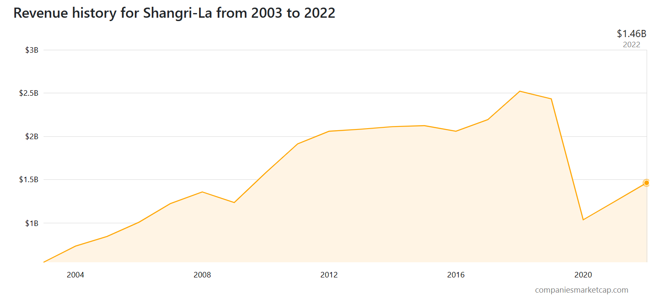
Figure 1 Revenue History for Shangri-La Source: www.companiesmarketcap.com
As per the most recent financial reports from Shangri-La, the company's recent income for the last year stands at $1.46 billion. In the year 2022, the company accomplished a profit of $1.46 billion, showing an increase contrasted to the prior year's revenue of $1.24 billion. Revenue characterizes the total earnings produced by a corporation over the sale of goods and services, without deducting any expenses. (“MINISO Success Story - How Variety Store is Building a Global Empire”) (Companiesmarketcap, 2023)
On the other hand, In 2022, Travelodge achieved by the end of the year on December 31, 2022, the total underlying revenue reached an impressive $1,136 million, a significant increase from $909 million in 2019. (Statista Research Department, 2023) The EBITDA profit also saw a notable rise, reaching $265.79 million compared to the $161 million profit in 2019. Furthermore, Travelodge maintained its outstanding performance streak, surpassing competitors for the 8th consecutive year in 2022. (Travelodge, 2023)
For the Shangri-La Group the main factors that are contributing to the revenue are the easing of Covid-19 restrictions has been observed since the beginning of 2022 as well as large scale events being held in different countries, for example in Singapore was the Grand Prix from October 2022, in Malaysia was the surge in domestic staycation bookings gained traction following the return of inter-state travel in mid-October 2021 and the reopening of borders on 1 April 2022, and when it comes to the UK the hotel experienced a positive upswing in business due to the return of post-Covid travel, however, it faced challenges towards the end of the year due to strikes in different industries. (Travelodge.co.uk, 2023)
The main factors contributing to the total revenue of Travelodge in the last years are Commonwealth games and events, half term timing and weather, London protests and other events.
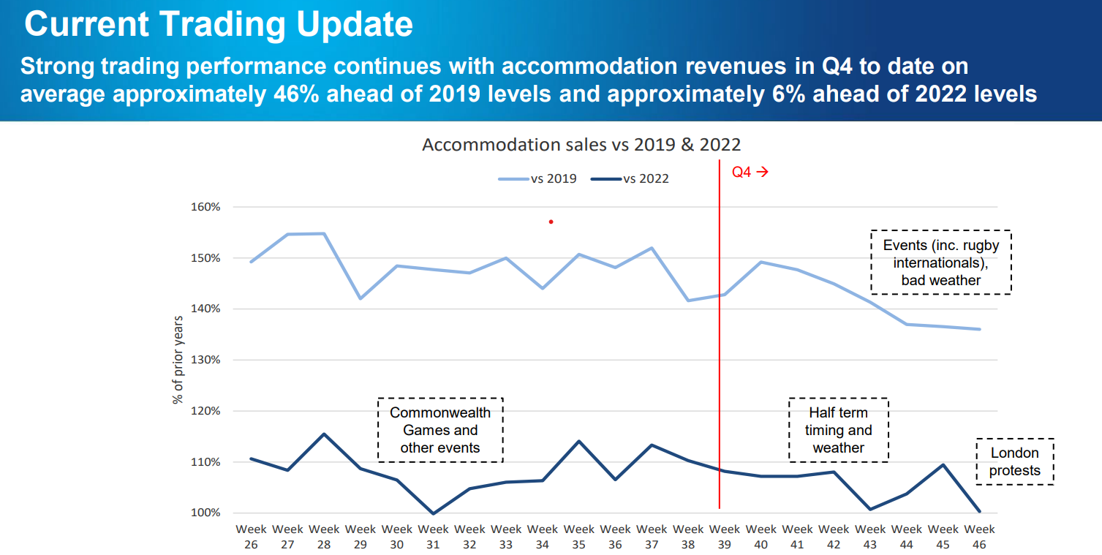
Figure 2 Trading Update Source: www.travelodge.co.uk
The trading performance remained strong throughout quarter four, despite facing challenges in the early weeks such as severe weather and protests. There was a consistent demand for both leisure and business services across the country. Both London and regional areas performed better than in 2022. The demand for events also remained high, with bookings being made further in advance. Although there are positive forward bookings, visibility for the future remains limited. (Travelodge, 2024)
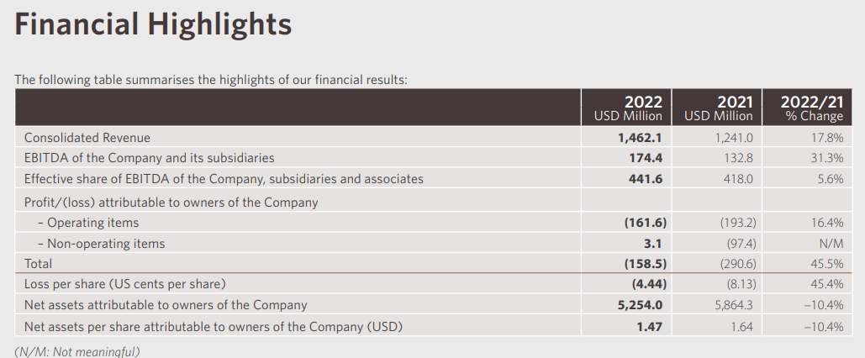
Figure 3 Financial Highlights Source: sitecore-cd.shangri-la.com
For Shangri-La Hotels it can be seen an increase in the consolidated revenue in 2022 comparing to last year, as well as in the EBITDA. (Shangri-La Asia Limited, 2023)
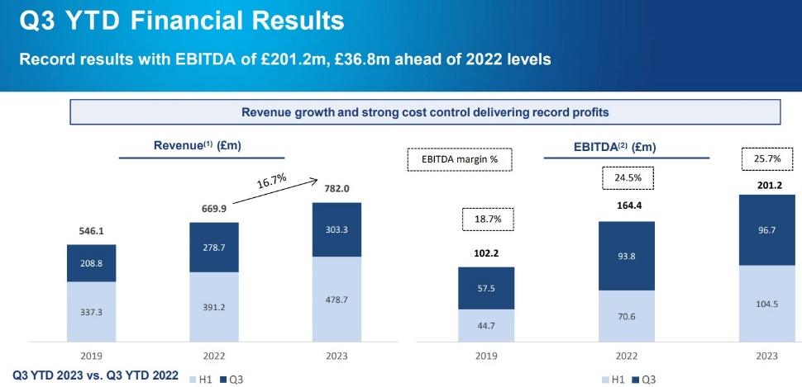
Figure 4 Financial Results Source: www.travelodge.co.uk
The same can be said for the Travelodge Hotels when it comes to the EBITDA factor.
EBITDA, which stands for earnings before interest, taxes, depreciation, and amortisation, works as an unconventional metric for measuring profitability compared to net revenue.
By factoring in depreciation, amortisation, taxes, and debt payment expenses, EBITDA aims to reflect the actual cash profit produced by a company's activities. (Hayes, 2024)
Shangri-La Hotel Group's revenue management strategy is more sophisticated and data-driven compared to Travelodge Hotels' cost-based approach. Shangri-La's focus on personalized pricing and loyalty programs generates higher room rates and occupancy levels.

Cost control
Shangri-La Hotel Group has implemented stringent cost control measures to maintain profitability. The group focuses on optimizing operational efficiency through standardized processes, energy conservation, and employee training. Shangri-La also leverages its scale to negotiate favourable terms with suppliers and contractors (Shangri-La Hotel Group, 2021).
Travelodge Hotels' cost control measures emphasize lean operations and franchise partnerships. The company minimizes operating costs through efficient housekeeping practices, standardized amenities, and a focus on essential guest services. Travelodge's franchise model allows franchisees to bear operating costs while the company retains a royalty fee (Wyndham Hotels & Resorts, 2021).
Travelodge Hotels has a clear advantage in cost control due to its lean operating model and franchise partnerships. The company's standardized processes and focus on essential services reduce operating costs significantly.

Market position
When it comes to the market position Shangri-La Hotels holds a strong position in the luxury hotel segment as their brand is synonymous with opulence and top-notch service; Travelodge Hotels, on the contrary, targets the mid-range market. (Shangri-La Group, 2024)
Shangri-La Hotels has shown itself as a dominant competitor in the luxury hotel industry with a significant 15% market share. This success is a testament to the brand's formidable reputation and the loyalty of its customers (Financial Times, 2024).
In contrast, Travelodge Hotels, known for their budget accommodations, have only captured a 5% share of the market (Kunst, 2023). This discrepancy underscores the importance of implementing targeted marketing strategies to enhance market presence and increase penetration. (Startups, 2024)
The renowned hotel chain Travelodge is well-known among the majority of UK consumers, with an impressive 92% brand awareness rate. In the first quarter of 2023, a significant 28.6% of UK consumers expressed interest in choosing Travelodge for their next stay. (Nguyen, 2023)
Shangri-La Hotels shows promising growth potential in emerging markets, expanding into new regions, and diversifying offerings can further drive growth. (Alhemeiri et al., 2020)
The company's strong brand reputation positions it well for future expansion opportunities and with continued investment in innovation and customer experience they are contributing to sustained growth. (Market Research, 2024)
Both Shangri-La Hotels and Travelodge Hotels have significant growth potential. Shangri-La can expand by entering new markets and enhancing their loyalty program, and Travelodge can focus on improving their amenities and customer service to attract more guests.

Growth potential
Both Shangri-La Hotel Group and Travelodge Hotels have significant growth potential. Shangri-La Hotel Group plans to expand its portfolio of luxury and upscale hotels in Asia and the Middle East. Travelodge Hotels plans to expand its portfolio of budget-friendly hotels in the United States and Europe.
They envision significant growth opportunities for expanding the Travelodge Hotels network in the UK, with plans to open an additional 300 sites. With a dedicated workforce of over 13,000 employees, they are committed to providing opportunities for personal and professional growth for all team members. (Boydell, 2023)
Travelodge Hotels has also significant growth potential in both domestic and international markets and expanding into new regions will further drive revenue growth, as well as investing in technology and customer experience will enhance growth opportunities. (Rutakirwa, 2018)
In 2022, the group has opened its first construct top class appearance and feel price range-luxe layout Travelodge lodges in London Docklands, Hexham (Northeast) and Wimbledon. Interestingly, three of the motels opening, London Docklands, Braintree, and Wimbledon, are in collaboration with local authorities, with Wimbledon and Docklands being introduced underneath lease-wrapper systems. (Taiwo, 2023).
Travelodge’s current development agenda additionally consists of four lodges that have started creation and are predicted to open in 2023. Two of these resorts are placed in London, at Bermondsey and Beckenham, and the opposite are in Ipswich and Colchester. (Bennett, 2022)

Financial commitment to CSR
Corporate Social Responsibility has appeared as a necessary main concern for commercial company leaders around the globe. CSR is a mode that a company is requiring collectively responsible practices into its business and is accountable for its moves correlated with society, built totally on a multiple backside-line technique: people, environment, and ethics. The core of CSR consists of ecological worries, admire of nearby groups, era exploitation and energy consumption.(Gentinetta, 2020)
Both Shangri-La Hotel Group and Travelodge Hotels are committed to CSR. Shangri-La Hotel Group has a long history of supporting environmental and social initiatives, and Travelodge Hotels has a strong focus on sustainability.
Shangri-La Hotels and Resorts stays devoted to working in a socially, economically, and environmentally accountable behaviour at the same time as balancing the hobbies of various stakeholders. In striving to be a frontrunner in commercial residency and sustainable growth, a company-level CSR Committee drives the employer’s creativities within the tactical areas of shareholder members of the family, the environment, the supply chain, personnel, and health and safety. (Roblek et al., 2016)
As Shangri-La Hotels faces the challenges related to the changing world, updating the institution sustainability method facilitates them to honestly talk about the recognition areas and cope with innovative and destiny dangers and opportunities. (Halmi, 2020)
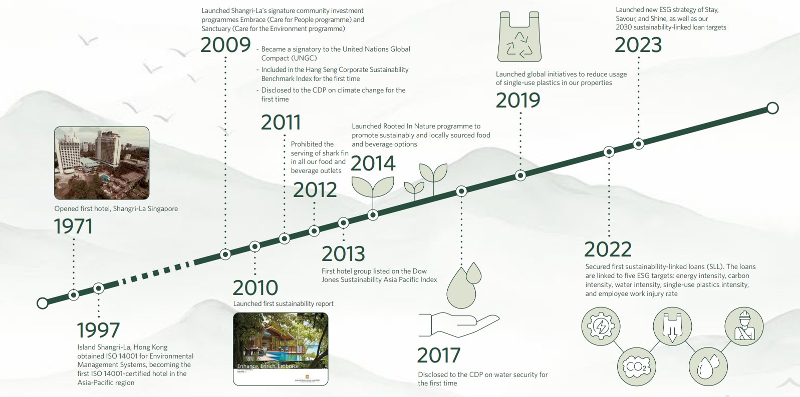
Figure 7 Source: https://sitecore-cd.shangri-la.com/-/media/Project/Shangri-La-Group/Sustainability/Images/Sustainability-Report/2023_SustainabilityReport.pdf
Their new Triple S approach in 2023 covers the primary agencies and priority topics in order that we do not forget ESG problems all through the entire Shangri-La enjoy and invite their guests to Stay, Savour, and Shine with Shangri-La. (Kuok, 2023)
The sustainability strategy for Travelodge Hotels is to follow the key factors of being inclusive, caring and conscious; for example to have 50/50 shortlists of males and females for senior degree roles with the goal of having 50/50 in function via the end of 2025; to encourage a in addition 1,000 humans to educate in Cardiopulmonary Resuscitation (“CPR”) throughout 2022; to recognise the climate-related dangers and possibilities the business faces and begin training for our Task Force for Climate Related Disclosure requirements for 2023. (Boydell, 2023)

Conclusion
Shangri-La Hotel Group and Travelodge Hotels represent two distinct business models in the hospitality industry. Shangri-La's emphasis on luxury, personalized experiences, and data-driven revenue management has led to strong financial performance in the luxury hotel segment. Travelodge's focus on cost control, franchise partnerships, and essential services has enabled the company to achieve financial stability in the budget and midscale segment. Both organizations have developed effective economic management strategies that align with their respective business models and market positioning. While Shangri-La Hotel Group has a stronger presence in the luxury segment and a geographically diverse portfolio, Travelodge Hotels' cost-effective operations and focus on value driven.
In conclusion, while Shangri-La Hotels lead in revenue and market position, Travelodge Hotels have room for growth. Both brands have shown dedication to CSR, with Shangri-La taking a more proactive approach. The key for both companies is to capitalise on their strengths and address areas of improvement to stay competitive in the ever-evolving hospitality industry, so even though Shangri-La Hotels outperforms Travelodge Hotels, both chains can benefit from continuous financial analysis and strategic decision-making to maintain their competitive edge in the hospitality industry.

Recommendations
Based on the recommendations provided in the report, it is suggested that Shangri-La Hotel Group should prioritize revenue management and cost control strategies to optimize financial performance. By effectively managing revenue streams and controlling costs, the company can enhance profitability and operational efficiency. Additionally, expanding into new markets can present opportunities for growth and market diversification, potentially increasing the company's market share and revenue streams. It is important for Shangri-La Hotel Group to carefully assess market conditions, conduct thorough market research, and develop a strategic expansion plan to ensure successful entry into new markets.
Travelodge Hotels should prioritize cost control measures and efforts to enhance profitability. By effectively managing costs and optimizing operational efficiency, the company can improve its financial performance and overall sustainability. Additionally, investing in revenue management strategies can help increase ADRs and maximize revenue generation. By implementing dynamic pricing strategies, demand forecasting, and distribution channel optimization, Travelodge Hotels can strategically adjust pricing and availability to capture higher ADRs and drive revenue growth.

References

- “Shangri-La Hotels and Resorts has tapped longtime hospitality executive Oliver Bonke as its president and COO”, 2017, Travel weekly, 76(25), pp. 4-. Available online at Shangri-La Hotels and Resorts has tapped longtime hospitality executive Oliver Bonke as its president and COO - University of Wales Trinity Saint David (uwtsd.ac.uk) accessed on 28th of April 2024
- “Travelodge Hotels. (At-a-glance)”, 2001, Franchising world, 33(7), pp. 64. Available online at https://librarysearch.uwtsd.ac.uk/permalink/44WHELF_UWTSD/1ir6fgh/cdi_gale_infotracgeneralonefile_A80056975 accessed on 28th of April 2024
- “Travelodge Hotels”, 2001, Hotel & motel management, 216(15), pp. 60- Available online at https://librarysearch.uwtsd.ac.uk/permalink/44WHELF_UWTSD/1ir6fgh/cdi_gale_businessinsightsgauss_A78932327 accessed on 28th of April 2024
- Adam Hayes, 2024, EBITDA: Definition, Calculation Formulas, History, and Criticisms- Available online at EBITDA: Definition, Calculation Formulas, History, and Criticisms (investopedia.com) accessed on 28th of April 2024
- Alexander Kunst, 2023, Travelodge brand awareness- Available online at https://www.statista.com/forecasts/1335657/travelodge-hotels-brand-profile-in-the-uk accessed on 29th of April 2024
- Boydell Jo, 2023, Better future report 2023- Available online at https://travelodgecorp.wpenginepowered.com/wp-content/uploads/Better-Future-Report-2023.pdf accessed on 29th of April 2024
- Companiesmarketcap, 2023, Revenue for Shangri-La- Available online at Shangri-La (0069.HK) - Revenue (companiesmarketcap.com) accessed on 28th of April 2024
- Deloitte, 2021, Hotel financial performance 2021. Available online at https://www2.deloitte.com/us/en/pages/hospitality-and-leisure/articles/hotel-financial-performance-report.html accessed on 4th of May 2024
- Ellis, D., 2012, “Shangri-La Hotels and Resorts,” Business traveller Middle East, pp. 16- Available online at retrieve (ebscohost.com) accessed on 28th of April 2024
- Financial Times, 2024, Shangri-La Hotel PCL- Available online at https://markets.ft.com/data/equities/tearsheet/summary?s=SHANG:SET accessed on 29th of April 2024
- Halmi, L., Peršić, M. and Poldrugovac, K., 2020, “Harmonization of sustainability reporting system in the hotel industry,” Tourism and hospitality management, 26(2), pp. 463–467.- Available online at uWzuH (proquest.com) accessed on 28th of April 2024
- Justine Gentinetta, 2020, 11 Examples of CSR practices in the hospitality industry- Available online at https://hospitalityinsights.ehl.edu/csr-practices-hospitality-industry accessed on 29th of April 2024
- Kuok, H., 2023, Sustainability report 2023- Available online at https://sitecore-cd.shangri-la.com/-/media/Project/Shangri-La-Group/Sustainability/Images/Sustainability-Report/2023_SustainabilityReport.pdf accessed on 28th of April 2024
- Management Association, Information Resources, editor., 2019, Corporate Social Responsibility: Concepts, Methodologies, Tools, and Applications. IGI Global available online at https://doi.org/10.4018/978-1-5225-6192-7 accessed on 5th of May 2024
- Market Research, 2024, The Winning Formula: Decoding Shangri Las Market Analysis- Available online at https://blog.osum.com/shangri-la-market-analysis/ accessed on 28th of April 2024
- Nahyan Alhemeiri et al., 2020, Financial analysis of Shangri-La Hotel- Available online at Financial-analysis-of-Shangri-La-Hotel.pdf (researchgate.net) accessed on 28th of April 2024
- Nguyen, H., 2023, UK Evaluating 3 budget hotel brands “Journey through the purchase funnel”- Available online at UK - Evaluating 3 budget hotel brands’ journey through the purchase funnel (yougov.com) accessed on 29th of April 2024
- Nick Hernandez, M. B. A., 2017, Essential financial metrics. The Journal of Medical Practice Management: MPM, 32(6), 387. Available online at 3_Metrics_for_mktg_mix_1-libre.pdf (d1wqtxts1xzle7.cloudfront.net) accessed on 5th of May 2024
- PwC., 2021, Hotel industry trends, 2021 available online at https://www.pwc.com/gx/en/hospitality-leisure/pdf/hotel-industry-trends-2021.pdf accessed on 4th of May 2024
- Shangri-La Asia Limited, 2023, Annual report 2022- Available online at e0069_230418_AR.pdf (shangri-la.com) accessed on 29th of April 2024
- Shangri-La Group, 2024, Trusted Partner in Asia’s Economic Growth Welcome: Shangri-La Group- Available online at https://www.shangri-la.com/group/our-story/about-shangri-la accessed on 28th of April 2024
- Shangri-La Hotel Group, 2020, Annual Report 2020. Available online at https://www.shangri-la.com/corporate/en/investor-relations/financial-information/annual-reports/ accessed on 4th of May 2024
- Startups, 2024, Building A Brand Empire: Unraveling Travelodge Marketing Strategy – Available online at Building a Brand Empire: Unravelling Travelodge Marketing Strategy - Osum accessed on 28th of April 2024
- Statista Research Department, 2023, Annual revenue of Travelodge UK from 2013 to 2021- Available online at Travelodge UK revenue 2021 | Statista accessed on 28th of April 2024
- Steve Bennett, 2022, Travelodge details its plans for new openings in 2022 and 2023- Available online at https://hospitality-on.com/en/hospitality/travelodge-details-its-plans-new-openings-2022-and-2023 accessed on 29th of April 2024
- Taiwo, I., 2023, Travelodge seeks partnerships with local authorities to open 300 hotels- Available online at https://www.hospitalityinvestor.com/development/travelodge-seeks-partnerships-local-authorities-open-300-hotels accessed on 29th of April 2024
- Tamtama, Noviadry & Riantisari, Rahmawati., 2023, Analisis Rasio Keuangan Dalam Menilai Kinerja Keuangan Pada Industri Kosmetik Terdaftar BEI Periode 2022. eCo-Buss. 6. 797-809. 10.32877/eb.v6i2.1008. available at https://www.researchgate.net/publication/376491326_Analisis_Rasio_Keuangan_Dalam_Menilai_Kinerja_Keuangan_Pada_Industri_Kosmetik_Terdaftar_BEI_Periode_2022 accessed on 5th of May 2024
- Thompson, S., 2017, "Value opportunities", Investors Chronicle,- Available online at https://www.proquest.com/trade-journals/value-opportunities/docview/1866362586/se-2?accountid=130472 accessed on 28th of April 2024
- Tonny Rutakirwa, 2018, Marketing and Communications Report,- Available online at (PDF) Marketing and Communications Report (researchgate.net) accessed on 28th of April 2024
- Travelodge Hotels., 2020, Annual Report 2020. Available online at https://www.travelodge.com/corporate/en/investor-relations/financial-information/annual-reports/ accessed on 4th of May 2024
- Travelodge, 2023, Travelodge reports record results for 2022 and encouraging early 2023 trading | Travelodge- Available online at https://www.travelodge.co.uk/blog/news/travelodge-trading-record-results-2022-2023/ accessed on 28th of April 2024
- Travelodge, 2023, Travelodge reveals its current hotel development schedule for 2022 and 2023- Available online at Travelodge reveals its current hotel development schedule for 2022 and 2023 | Travelodge accessed on 28th of April 2024
- Travelodge.co.uk, 2023, Trading Update Presentation- Available online at 2022 Q4 Financial Results Presentation FINAL DRAFT (travelodge.co.uk) accessed on 28th of April 2024
- Violeta Roblek et al., 2016, The impact of corporate sustainability in achieving business goals in hotel industry- Available online at (PDF) The impact of corporate sustainability in achieving business goals in hotel industry (researchgate.net) accessed on 29th of April 2024

