

current environmental forces and their impact

Benjamin Williams

MBA

University of Wales Trinity Saint DaviD

GLOBAL BUSINESS CHALLENGES

December 2022

private and confidential

Executive summary

The report has focused on the current environmental forces and their impacts. The document has highlighted key areas that are essential for future organisational health and success, ensuring continued growth whilst valuing and protecting the environmental conditions surrounding the various operating regions.

Key findings

Fujifilm operates in many marketplaces, with a varied approach to its operations and how it conducts business in the areas.

There are many areas where the business must consider the sustainability of the local organisation's operations, from changes in governmental policy, local interest rates and changing tax levels and rules.

Having alternating market focuses with varying product ranges from other business units also provides flexibility and versatility in each market.

Approaches, however, have yet to consider the competitive landscape of the market and the increased emergence of Chinese organisations providing cheaper derivatives.

Fujifilm can utilise the marketing department to take all the learnings from the pestle analysis and apply them to the real-world economic conditions of each local market by addressing the individual social factors.

Changing government policies can also harm overall business performance by increasing environmental uncertainty. Therefore, Fujifilm will need to study the varying trends in individual countries' political areas, as any policy changes alter the priorities toward different industry options.

Government policies also must be considered to help protect the intellectual rights of the organisation to reduce the risks of stolen ideas and concepts.

Spending patterns can be influenced by social conditions, with some markets having a strong status symbol approach to others having a more functional approach, this ability to learn lessons from the respective areas and implement a marketing strategy based on the social aspects.

Two different strategy options for Fujifilm, the first being to differentiate itself from the competition through innovation and development and the second being to focus on how it can provide an overriding cost advantage

Adoption of local, regional operators focusing on promoting the Fujifilm direction in a manner that suits the social demographic of the consumer groups whilst presenting the environmental messaging and focus required by any local government and law.

Table of Contents

Introduction:

Scope

Research Methods

Main findings

Present Data

Discussion

Conclusion

Recommendations

References

Introduction

Fujifilm has, over the years, provided an essential guide to how a business can anticipate the marketplace and diversify its product portfolio. This can ensure the organisation's longevity and present a company that continues to grow in high revenue and profit markets whilst maintaining its core beliefs and providing added value to all areas of the industry it is involved in. Established in 1984 as a subsidiary of Dailcel, it focused on photographic films, enabling the organisation to produce motion pictures and manufacture and supply x-ray films. In the early 1990s, the organisation was enjoying a buoyant market; however, by 2001; the organisation went through a rapid reduction in sales. The organisation implemented a plan named vision 75, which focused on saving it from reduced profitability and reinstating increased profit levels. As a result, by 2010, the business was only making a 16% profit from its original imaging business. Fujifilm has successfully survived the declining markets and is now involved in over 300 entities to ensure the continued growth of the organisation, Pfeffer J. 2021.

1.1 Scope

The paper will consider documented information from various sources to ensure an unbiased viewpoint and provide as much substantiated data as possible. Reference points being taken from direct organisations focusing on or pertaining to how Fujifilm has used market experience in the international sector focusing upon a critical assessment of the conditions of the business environment in which the organisation operates.

It will utilise tools such as a pestle. Bush T. 2019 states, “PESTLE analysis is a prevalent business analysis tool. Not only is it straightforward to use, but it is also very effective; the basic premise of PESTLE analysis is that you analyse a chosen organisation from six different perspectives: Political, Economic, Sociocultural, Technological, Legal, and Environmental, by doing so, you unlock a powerful understanding of how a given business is performing from every angle”.

Further analysis will take place in several national and international macroeconomic performance indicators that are relevant to the organisation. The corporate financial institution 2022 states, "Macroeconomics refers to the study of the overall state of the economy. While microeconomics studies how individuals make decisions, macroeconomics deals with the overall aggregate effect of microeconomics. Macroeconomics is crucial for the government to understand and predict the long-term consequences of their decisions”.

1.2 Research Methods

To understand how these models can support the assessment of the competitive environment and conditions of the business environmental conditions, IG Group Holdings Plc 2022 states: Macroeconomic indicators are a key part of fundamental analysis for traders, as they provide insight into the state of a country’s economy, with the top indicators being split between a) Top leading indicators: The stock market, House prices, Bond yields, Production and manufacturing statistics, Retail sales, Interest rates, and b) Top lagging indicators: GDP growth rates, The Consumer Price Index (CPI) and inflation, Currency strength and stability, Labour market statistics, Commodity prices. The BBC 2021 states, “The second E in PESTLE stands for environmental influences. Environmental influences refer to our surroundings. This can include the air we breathe, the water that covers most of the Earth’s surface, and the plants and animals around us. In recent years, scientists have examined how people affect the environment. Concerns include air pollution, deforestation, and acid rain. However, society is more aware of the damage that individuals and businesses can inflict on the environment as well as looking for ways to protect it”. Currence J. 2018 states, “An option that can help you pay more attention to the external environment is a PESTLE analysis, in which you scan the Political, Economic, Social, Technological, Legal and Environmental trends shaping the world in which we operate”.

We will also consider the advantages and disadvantages of business environment analysis, considering areas such as lack of forewarning of unseen events, organisational effectiveness, and absence of strategic approaches, by looking at ways to identify the threats and understand what is happening in the marketplace and forecasting the future. Accounting learning.com 2022 states: “When a company neglects to adjust its strategy to the business environment or does not react to the demands of the environment by changing its strategy, the company cannot achieve success in attaining its objectives. However, environmental analysis enables the business enterprises to study the environment and formulate the strategies accordingly, which will result in successful attainment of objectives”.

To enable the report stage, a complete understanding and critical analysis will need to occur, extending to further research and sourcing relevant data for the evaluation. Finally, it will show a clear conclusion based on the findings and offer recommendations for increased business alterations to ensure the organisation's longevity, environmental factors and presence in the relevant marketplaces, Bloomfield J. Fisher M. 2019.

Main findings

Fujifilm has operations in many marketplaces, with a varied approach to its operations and how it conducts business in the areas, focusing on ensuring local law and adherence is strong with high levels of understanding of environmental conditions that factor into the growth and development opportunities.

There are many areas where the business must consider the sustainability of the local organisation's operations, from changes in governmental policy, local interest rates and changing tax levels and rules. Consistent monitoring and strategising to ensure the continued presence of a low-cost, high-quality organisation is needed to ensure sustainability.

Interest rate and market conditions, Frank M. Goyal V. 2004 are set to cause increased challenges when presenting strategic direction. The growth and decline of market conditions set around government spending powers and consumer spending may lead to increased pressures; however, with the maintenance of a low-cost resource centre, these costs can be mitigated against potential volumes and price markers of products.

Directional change and agility need to be considered as part of a large organisation, and the ability to have local business hubs making local decisions based on the economic factors in the market represents a strong basis for success. The ability to have an alternating market focus with varying product range from other business units also provide flexibility and versatility in each market, providing many levels of agility and leverage available to ensure market growth presence and impact in the overall consumer and governmental demographics and environmental factors

3 Present Data

Various tools can be used to consider the business environment, with pestle analysis contributor 2015 stating that “Business Analysis is a set of tasks and techniques used as a connection between stakeholders. These help them to understand the firm’s structure and policies. The process can also recommend solutions which help to attain business goals. To apply Business Analysis effectively, analysts employ different analytical tools”. More modern methods have also been developed, such as Microsoft’s Power BI model allows for self-service data ingestion, processing, analysis, and visualisation to enable non-tech users to transform raw data into immersive reports and interactive dashboards. Microsoft BI 2022 power states: “take your visualisations to the next level and empower everyone to make data-driven decisions quickly. Easily work together, collaborate on reports, and share insights across popular applications. Bismark O. et al. 2018 stated: 'Mckinsey 7s model and other tools such as PESTLE, BSC and SWOT analysis having been the tools that most professional institutions use to evaluate the overall performance of the organisation'.

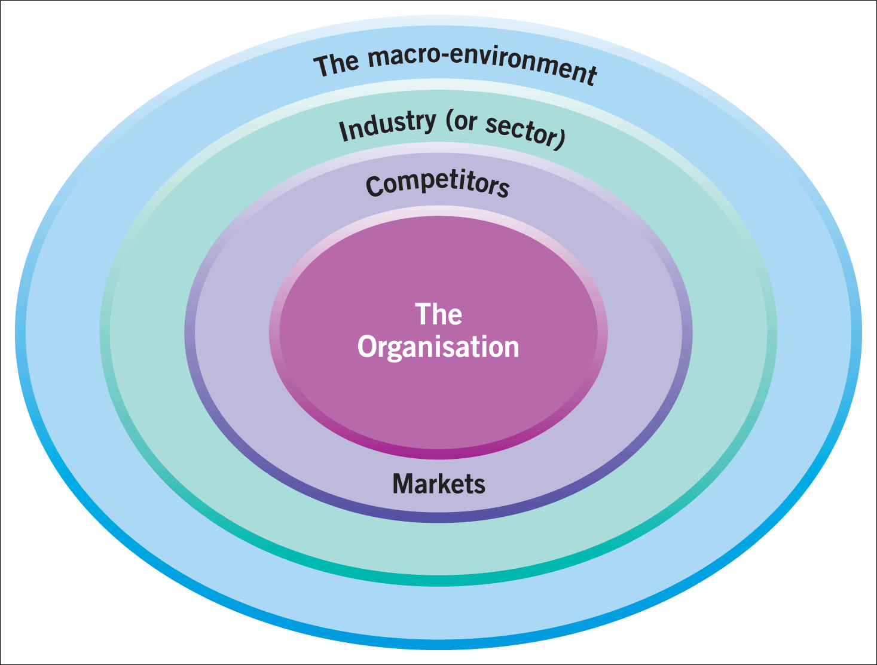
When considering the layers of the business environment: The macro environment, as defined by Tamplin T. 2022, is "the overall operating conditions for an industry or country.

Macroeconomists use different statistics and measures to evaluate factors that might affect the performance of an economy or company, Syverson C. 2019, including all relevant economic, political, and technological factors. Macro-environment is different from the micro-environment, which refers to the supply and demand fundamentals of a single industry, product, or region.

We therefore need to consider the various sectors to enable a clear environmental picture, the demographic environment for Fujifilm has a broad impact as the organisation covers several different continents with various forces affecting the demographics, this therefore can be seen as challenging to merge all the factors into one, however with any large organisation there will be regional headquarters that can take a view point and focus on the current demographics in the relevant operating location enabling a more transparent view towards the effects of increasing population corresponding goods and trends in the regions, successfully managed by the organisation to ensure manufacturing is taken place at source with product lines being introduced or recalled dependant on the current market activities, this is demonstrated by the different types of medical products available in different country regions based on the need of the demographics and the results the products con offer in line with the need of the client base. The organisation's industry sector is split between many areas of manufacturing and product categories; to substantiate the direction for the varying product lines, Klemeš J. et al. 2018, direct business heads allow the transition of the sub-organisational direction to take place. This ensures a strong focus on the single product group taking place and ensures the overriding business unit does not take a single-dimensional approach toward economic factors such as interest rates and inflation. The measure used for success for the organisation has always been the Japanese Yen, with the various business units reporting profit and loss through the overriding local currencies. This area is essential in ensuring that the correct performance measurement can be undertaken in local currencies without international exchange rates having a plus or minus effect on the operating performance. With ever-changing political and social factors based in ever-changing locations, the need to substantiate by allowing and supporting individual business units to develop and manage the changing environment by securing individual directions and decisions based upon the product categories and markets they are engaged in, Tamplin T., 2022.

The industry environment provides a vital element toward the business to which valuation is conducted toward customers, Sony M. Nail B. 2019. Together with competitors and collaborators, identify areas that can affect the business's future success. Focus has been given to market engagement in many sectors by creating and supplying product categories to meet market conditions and demand. This has been identified by the focus on engagement through industry evaluation and direction through direct customer working groups and ensuring all environmental factors are considered and undertaken. However, this approach has yet to consider the market's competitive landscape and the increased emergence of Chinese organisations providing cheaper derivatives in the marketplaces through a reduction in one-source manufacturing processes. This is in direct opposition to the Fujifilm focus on manufacturing in the region of the business units founding locations.

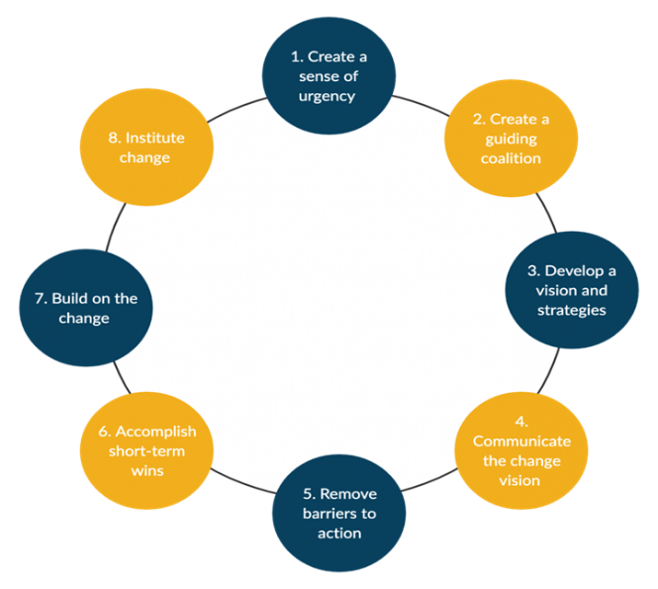
Kotter's model can Describe a method in which the approach is taken, Kotter. J 1966. Fujifilm has adopted an approach to focus on the elements of Kotter’s model. This direction can be shown in the various business units and the direction taken to ensure operational success against the business environment. This approach, used in line with other methods, also helps support the overriding direction of the organisation being “Value from innovation" only by adopting this method as a localised practice has helped ensure the factors considered have the suitable environmental condition to ensure a higher level of success, as opposed to adoption on a global scale which may promote inconsistencies in relevant market conditions.

When we consider the PESTLE application, Matovic I. 2020, this can be a valuable tool to enable the development of effective strategies and achieving the long-term growth ambitions of the organisation,

Political Factors:

The political factors in consideration of a global organisation, Tallberg J. 2019, suggest that it is sensitive to the political changes in the environment of different countries' policies; in the context of the political environment, it is essential to the success to ensure Fujifilm can diversify the systemic risks to the organisation and will need to factor these risks into the strategic planning processes.

Influencing Political factors: A stable environment provides a business environment with predictable solid growth trends; where there are areas of chaos, this will cause concern for investors and stakeholders, as Fujifilm is present in many different countries with each having its political pressures, increased tensions and potential instabilities can affect the industry growth and limit future opportunities to the organisation. In conjunction with changing government policies, this can also harm overall business performance by increasing environmental uncertainty. Fujifilm will need to study the varying trends in individual countries' political areas, as any policy changes may alter the priorities toward different industry options. The effects of potential pressure from organised groups and protesters need to be analysed to ensure collaboration can take place with such groups to help support and collaborate with communities to support long-term goal progression. This, with a developed governance tool supported within a democratic environment, will help support and more comfortable international Fujifilm business. When Fujifilm enters world areas with high levels of tax, this will directly impact its profitability, Hinton J. 2018, which can affect international trade and would force reductions of exports from those markets due to the nature of the organisation. Fujifilm can enter low-taxation markets and enhance its operations by utilising the increased profit to invest in development and research. This must be taken into consideration toward the business environment and potential additional issues surrounding exports and trading routes from these low-tax nations; the government policies also have to be considered in order to help protect the intellectual rights of the organisation to reduce the risks of ideas and concepts being stolen. If not managed effectively, this may also impact the external investment Fujifilm receives, and stock levels should the market decide it is a risk from these elements. The potential for bureaucracy and corruption may also negatively affect the organisation, as operations in countries with high-level corruption associated with low support laws enforcement make the operations in these areas unpredictable for Fujifilm. With corruption potentially influencing business operations, Fujifilm does engage and regularly provide increased levels of training for all employees to try to mitigate the risks from this; however, deciding to operate in these markets could threaten the development of the organisation by harming the law systems and de-stabilising the established the general society.

Economic Factors

By understanding the economic factors, Kavosa Z. Et al. 2018, Fujifilm can help estimate the overall trajectory of the organisation. To be considered, areas such as inflation, savings rate, foreign exchange and interest rates, and the labour market will need to be considered.

It is essential to recognise the lifecycle of the industry and environment entered, Kalvani S. et al. 2021, as an area that is reaching saturation inside a mature market will present a more challenging environment, with the overall performance also impacted by governmental control and investment toward infrastructure. A well-developed governmental infrastructure program can help support and grow the overall industry that may be embarked. The labour market also needs to be evaluated to understand and set competitive rates for compensation, Koval V. 2018, together with the general supply of skilled workers. Fujifilm looks at predicting the labour market and considering methods to attract talent to be aligned with the availability of skilled labour, as any restrictions will impact operational efficiency and growth development. Growth Domestic output (GDP) will affect long-term growth, with a higher level signifying a high level of consumer spending. Should high employment be present, this will lower consumer spending, reduce tax intake from governments, and affect market segments' profitability potential through reduced income availability. The health of markets will also affect the ability of the organisation to raise any needed capital from the financial markets; the need to raise these investments at fair rates will be vital to driving the organisation's expansion. All business activities are influenced by the economic structure of local and international markets providing altered economic and regulatory requirements to be navigated alongside the current competitive landscape.

Social Factors:

Fujifilm can utilise the marketing department to take all the learnings from the pestle analysis and apply them to the real-world economic conditions of each local market. Established by addressing the individual social factors, it can help its understanding of the spending patterns, trends and culture towards groups of consumers and potential buyers, Brocken B. et al. 2019.

Spending patterns can be influenced by social conditions, with some markets having a strong status symbol approach to others having a more functional approach. This ability to learn lessons from the respective areas and implement a marketing strategy based on the social aspects to ensure messaging and approach hit the correct functional parameters to ensure success. Fujifilm should understand the consumer in the country to determine these local social factors. This can also take place toward the overall gender roles and how it aligns the marketing to strategies, approaches and content. Certain societies have different patriarchal focuses, which affect messaging and content. This has an impact on the increased emergence in the specific market of online shopping and the generational differences and attitudes toward purchasing through visualisation only. The correct adoption of these areas would allow for potential high yields as the presence and cost of physical locations could be minimised. The culture of each demographic also plays a vital role Simon J. 2019, and the development of local teams and partnerships will help drive the understanding and implementation strategies for the market areas. Fujifilm should focus on and understand the leisure interests of each market and produce ways to enhance the customer experience further and if specific markets are more open to products in the experimental stages as opposed to established elements.

Technologies

The rapid increase in technological advances over the last few decades has seen a vast increase in the application and complexity of products available in the market. The thorough understanding and trajectory of technology is a crucial part of ensuring the strategies and life cycles are appropriately managed and designed, ensuring a consistent, timely flow of information and products to ensure the company is and remains at the forefront of technology and delivering to the market products that are at a minimum in line with the current technological trends, André Cavalcante, S. (2013)

This includes social media marketing, product development, innovations, and life cycles. The use and data that now surrounds media marketing have been constantly developed to support the way Fujifilm can market and present itself on individual social networks. By utilising natural resources and implementing data-driven concepts, the organisation has the opportunity to directly market with meaningful messaging in a focused and data-driven manner and driving further the direct content and providing any return on investment strategies that are set in place for this sector. The speed at which markets develop through technology highlights the increased need for consistent, relevant innovation and development. Using market research, working groups and feedback forums, relevant new adoptions can take place and drive future product acceptance and success. This also affects the life cycle production and the option to include optional upgrades to current products to provide customers with innovation that offers consistently upgradeable items, helping meet some strict environmental recycling conditions and ensuring the customer base's loyalty through the encouragement of brand loyalty through innovation adoption. The international growth and presence of Fujifilm offer a unique platform in many markets to adjust where products are offered, offering an increased life cycle transference from market to market depending on the economic and social development of the current location.

Environmental Factors

Due to the organisation's size and the increased awareness level, the responsibility lies with Fujifilm. This shows in the organisational environmental focus, by abiding by local laws and practices, and by introducing new, improved methods into less established economic regions, supporting innovation in these markets and driving new environmental standards where it can, Christodoulou A. 2019.

The increased population of urban dwellers has increased levels of recycling, and environmental considerations taking place, with increasingly strict rules toward the direction organisations must take. This can be utilised by Fujifilm by engaging with and participating in green schemes to focus on the utilisation of renewable sources and clean energy. This can also be adopted towards a cultural shift and grow the organisational brand image on a world stage. The potential to secure subsidies for investment in technologies may also support the reduction in taxation in high-tax economies. Supporting increased investment through reducing taxation delivers the environmental changes the economies need to secure the long-term well-being and health of the population. The general changing attitude to consumers through the purchasing decisions also factors in the approach and messaging aligned with the environmental focus, delivering high levels of customer satisfaction and supporting the development and loyalty toward the brand. This approach can also detract from any negative media attention and help avoid any excess depletion of local resources and help understand how local discrepancies can affect the way the organisation utilises even the most essential resources, such as water.

Legal Factors

The final Pestel is legal, Abdoh H. et al. 2020, Fujifilm at no stage can enter any market without knowing and understanding the legal factors surrounding any potential operation in the relevant area. This requires a careful evaluation of the legalities to avoid fines and negative press. Any misunderstanding or ignorance can harm the overall organisation and hurt its competitive advantage. Furthermore, it may have more significant impacts on intellectual property or violation of working conditions and environmental standards.

Employee law and protection must be followed in each country operating in, with varying levels of employee protection and rights being offered. Fujifilm must meet all local guidelines and rules to ensure the workforce is appropriately looked after and protected. This may present a challenge or opportunity for Fujifilm. Due to the international nature of the organisation, it has the opportunity to improve work conditions in less established regions by adopting those of other advanced economies and legal stature, Ashlstrom D.et al. 2020. There is also a requirement to ensure consumer rules are followed and legally adhered to, ensuring data protection, marketing guidelines and product minimum quality and acceptance regulations are met. This may involve many regulatory changes and must be wayed up against that region's potential investment and profit possibilities. The intellectual laws can also differ regarding where Fujifilm can protect intellectual property in the best manner, which may impose different strategies and areas of the business operating in different world locations to best protect its wealthy asset interests.

The Pestel tool represents an impartial model to provide a detailed analysis of the micro environmental factors, Vardopoulos I. et al. 2021. These range from a variety of factors, each having an impact on the strategic decision-making processes and helping shape the business's environmental factors the organisation operates in.

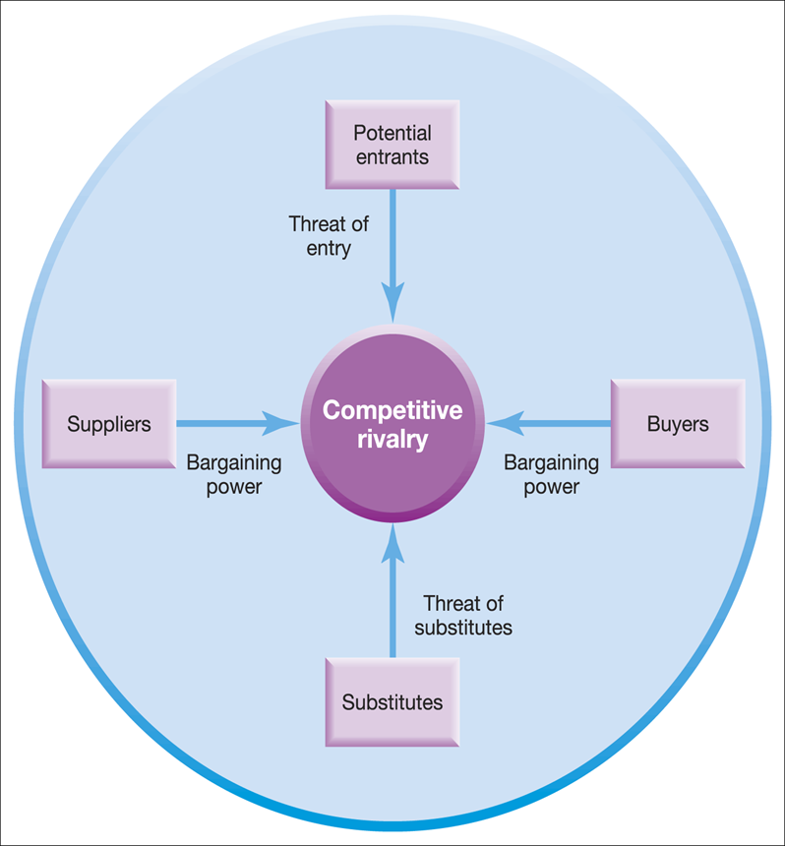
The five forces framework:

This tool will help support any strategy direction, Bruijl D. 2018, in the Fujifilm group. Furthermore, it can provide in the mapping of various forces in the healthcare landscape, not just in the local business environment but also in international marketplaces.

As stated by Fujifilm Holdings Corp. 2018. The Porter Five Forces determining the industry structure in Medical Equipment & Supplies are 1. Bargaining power of suppliers in Medical Equipment & Supplies – If suppliers have strong bargaining power, they will extract higher prices from the Fujifilm Holdings Corp. It will impact the potential of Fujifilm Holdings Corp. to maintain above average profits in Medical Equipment & Supplies industry, Gereffi G. 2020. 2. The threat of substitute products and services in the Medical Equipment & Supplies sector – If the threat of substitute is high, then Fujifilm Holdings Corp. has to either continuously invest into R&D, or it risks losing out to disruptors in the industry. 3. Rivalry among existing players in Medical Equipment & Supplies industry – If competition is intense, then it becomes difficult for existing players such as Fujifilm Holdings Corp. to earn sustainable profits.

4. Bargaining power of buyers of Fujifilm Holdings Corp. and Healthcare sector – If the buyers have strong bargaining power, then they usually tend to drive the price down, thus limiting the potential of Fujifilm Holdings Corp. to earn sustainable profits

5. Threat of new entrants in the Medical Equipment & Supplies industry – if there is a substantial threat of new entrants in the Medical Equipment & Supplies industry, then-current players will be willing to earn lower profits to reduce the threats from new players.

To create increased profit levels, the organisation will need to have a sustainable competitive advantage, Distanont A. 2020. This will need to include areas Fujifilm can develop and identify to map the five forces and ensure correct positioning. This can lead to the development of a strategy toward cost leadership due to its international purchasing and resource scale proposals, an option to become a low-cost equipment producer with opportunities to drive further investment into innovation and discovery. This can then lean toward the creation and suitability of supplying highly valued products charged at a premium rate due to innovations included in the product categories and the perceived values these bring. This presents the strategic direction to focus on quality and development instead of cost elements where consumers benchmark against what an identical product costs. Buy driving the value, innovation and development supports the higher premium product and gives consumers forward-thinking, cutting-edge devices.

This provides two different strategy options for Fujifilm, the first being to differentiate itself from the competition through innovation and development, and the second being to focus on how it can provide an overriding cost advantage and grow its business through low-cost product offerings. The challenge with option two is that when you enter a market based on the price of an organisation, the price of the product always goes down as the competition is forced to alter its pricing to gain or retain market share. Option one presents an opportunity to grow the organisation on value and innovations, which could be considered a more sustainable growth strategy than focusing on low-cost products alone.

Discussion

Further discussion and investigation are needed to establish the parameters around the entire group and overedging directions to take, Van Zantem J. Van Tulder R. 2018. With such a large entity operating in so many different environmental markets, multiple approaches would need to occur. However, consideration would need to be made between the focal points of a cost model and quality models' focal points and the economic considerations used for market adoption. This may help the organisation focus across the two areas and give flexibility in all markets to quickly adapt the model to help retain and build market share whilst also having the presence and capability of transforming into a premium innovation-based organisation. Further discussions on the environmental impacts, Singh K. et al. 2019, to the models adopted together with the need to show sustainability and environmental responsibilities in the regions and countries adopted. The challenge for the organisation is not to be made a pariah in specific markets due to its environmental policies, as by not adopting a universal approach could render the organisation open to criticism on the world stage.

Conclusion

In conclusion, Fujifilm has established its organisation as a well-known brand and holds a reputation for quality derived from in inception in the photographic business, the organisation has developed and diversified strongly in the marketplace creating many avenues of business practices and driving its branded message through the world. As the organisation considers the changing environment, more focus should be taken toward a universal approach, by still ensuring the legalities of each global area are adhered to but by ensuring as many areas of the business are universally conducting their environmental responsibilities. This will drive the adoption of new technologies in less established regions and also support brand awareness through community projects, in turn developing the organisation's reputation and putting it in a stronger position to deliver increased operational effectiveness and results.

Recommendations

It is recommended that the universal adoption of environmental policies is adhered to, Robinson O. et al. 2018, ensuring and increasing a well-respected organisation shown to be fully adopting its global responsibilities and supporting community development. Considerations of multiple strategies depend on the adoption cycle in different country regions to promote tailored growth plans and strategies that ensure local knowledge is utilised and adhered to. The development and creation of social sectors through multimedia and platforms, Cinelli M. Morales G. 2021, with the introduction of targeted deployment marketing strategies that can be managed through the return-on-investment purpose but also creating the messaging and content for the future. Key to the organisation's ongoing success will be its continued ability to engage and fully understand local markets, ensuring focus is given to those environmental conditions and that a global focus does not consume or override the needs of individual locations. This model would show the adoption of local and regional operators focusing on promoting the Fujifilm direction in a manner that suits the social demographic of the consumer groups whilst presenting the environmental messaging and focus required by any local government and law. The organisation also has an opportunity to increase its worldwide presence by utilising and developing an implementation of a worldwide environmental strategy, Miller C. Wyborn C. 2020. Focusing on resource reduction through the management and recyclability of products, further increasing the organisation's overall image but also ensuring each of their businesses have a focus on the community macro level by supporting the needs of local business units and governmental directions.

Document brief 5000 words: Word Count 4892
(Excluding: Header Page, Contents, Executive summary and references)
- Reference : (43)

Abdoh H.et al., 2020
effect of PESTLE factors on E-government adoption in Jordan: A conceptual model
Accessed: 4th December 2022
Available at: https://www.researchgate.net/publication/344725635_The_Effect_of_PESTLE_Factors_on_E-Government_Adoption_in_Jordan_A_Conceptual_Model

Account learning .com 2022
Advantages and Disadvantages of Business Environment Analysis
Accessed: 15th December 2022
Available at: https://accountlearning.com/advantages-disadvantages-business-environment-analysis/#:~:text=Advantages%20of%20Environmental%20Analysis%201%201.%20Helps%20in,Future%20...%206%206.%20Threats%20and%20Opportunities%20

Ahlstrom d. et al. 2020
Managing technological, socio-political, and institutional change in the new normal
Accessed: 11th December 2022
Available at: https://onlinelibrary.wiley.com/doi/abs/10.1111/joms.12569

Aithal, P. S. 2017
A critical study on Various Frameworks used to analyse International Business and its Environment.
Accessed: 3rd December 2022
Available at: https://www.researchgate.net/publication/321133985_A_critical_study_on_Various_Frameworks_used_to_analyse_International_Business_and_its_Environment

BBC 2022
PESTLE - Environmental
Accessed: 2nd December 2022
Available at: https://www.bbc.co.uk/bitesize/guides/zcjhfcw/revision/8

Bloomfield J. 2019
Quantitative research design
Accessed: 11th December 2022
Available at: https://search.informit.org/doi/abs/10.3316/INFORMIT.738299924514584

Bismark O. et al. 2018
Utilising Mckinsey 7s Model, SWOT Analysis, PESTLE and Balance
Scorecard to Foster Efficient Implementation of Organizational Strategy.
Accessed: 11th December 2022
Available at: https://www.ijrbem.com/doc/60.pdf#

Bocken N. et al. 2019
Sustainable business model experimentation by understanding ecologies of business models
Accessed: 2nd December 2022
Available at: https://www.sciencedirect.com/science/article/abs/pii/S0959652618331767

Bruijl D. 2018
The relevance of Porter's five forces in today's innovative and changing business environment
Accessed: 3rd December 2022
Available at: https://papers.ssrn.com/sol3/papers.cfm?abstract_id=3192207

BUSH T. 2019
PESTLE Analysis Explained
Accessed: 4th December 2022
Available at: https://pestleanalysis.com/pestle-analysis-explained-with-examples/

Cavalcante A. 2013
Understanding the impact of technology on firms’ business models.
Accessed: 6th December 2022
Available at: https://scirp.org/reference/referencespapers.aspx?referenceid=3117083

CFI Team 2022
Macroeconomics, The study of the aggregate economy
Accessed: 13th December 2022
Available at: https://corporatefinanceinstitute.com/resources/economics/macroeconomics/

Christodoulou A. 2019
Identifying the main opportunities and challenges from the implementation of a port energy management system:
Accessed: 11th December 2022
Available at: https://www.mdpi.com/2071-1050/11/21/6046

Cinelli M. Morales G. 2021
The echo chamber effect on social media
Accessed: 12th December 2022
Available at: https://www.pnas.org/doi/abs/10.1073/pnas.2023301118

Currency J. 2018
Cultivate Critical Evaluation with a PESTLE Analysis
Accessed: 7th December 2022
Available at: https://www.shrm.org/hr-today/news/hr-magazine/0618/pages/cultivate-critical-evaluation-with-a-pestle-analysis.aspx
Distanont A. et al. 2020
The role of innovation in creating a competitive advantage
Accessed: 4th December 2022
Available at: https://so04.tci-thaijo.org/index.php/kjss/article/view/234863

Gereffi G. 2020
What does the COVID-19 pandemic teach us about global value chains? The case of medical supplies
Accessed: 7th December 2022
Available at: https://link.springer.com/article/10.1057/s42214-020-00062-w

Grünig, R. 2017
Developing international strategies. Springer Berlin Heidelberg.
Accessed: 1st December 2022
Available at: https://link.springer.com/book/10.1007/978-3-642-24725-5

Hinton J. 2020
Fit for purpose? Clarifying the critical role of profit for sustainability
Accessed: 13th December 2022
Available at: https://doi.org/10.2458/v27i1.23502

IG Group Holdings Plc. 2022
What are the key macroeconomic indicators to watch?
Accessed: 12th December 2022
Available at: https://www.ig.com/en/trading-strategies/what-are-the-key-macroeconomic-indicators-to-watch--191014#top11

Kalvani S. et al 2021
Social consideration in product life cycle for product social sustainability
Accessed: 13th December 2022
Available at: https://www.mdpi.com/2071-1050/13/20/11292

Kavosi Z. et al. 2018
Factors influencing decision making for healthcare services outsourcing: A review and Delphi study
Accessed: 9th December 2022
Available at: https://www.ncbi.nlm.nih.gov/pmc/articles/PMC6113583/

Kotter, J. 1996
Leading Change
Accessed: 12th December 2022
Available at: https://www.scribd.com/document/537869501/Kotter-J-1996-Leading-Change

Koval V. Polyezhayev Y. 2018
Communicative competencies in enhancing regional competitiveness in the labour market
Accessed: 12th December 2022
Available at: http://www.baltijapublishing.lv/index.php/issue/article/view/544

Leyva-Vázquez M. et al 2018
A framework for PEST analysis based on fuzzy decision maps
Accessed: 7th December 2022
Available at: https://www.researchgate.net/publication/324680636_A_framework_for_PEST_analysis_based_on_fuzzy_decision_maps

Matovic I. 2019
PESTEL Analysis of External Environment as a Success Factor of Startup Business
Accessed: 12th December 2022
Available at: https://society.education/wp-content/uploads/2022/06/ConScienS-Proceedings.pdf#page=101

Microsoft Power BI 2022
Share insights. Show results. Be the hero.
Accessed: 11th December 2022
Available at: https://powerbi.microsoft.com/en-gb/landing/free-account/?ef_id=9c2f73e4c0bf11ee2196106fee2bc376:G:s&OCID=AIDcmmmhj6wa7w_SEM_9c2f73e4c0bf11ee2196106fee2bc376:G:s&msclkid=9c2f73e4c0bf11ee2196106fee2bc376

Miller C. Wyborn C. 2020
Co-production in global sustainability: Histories and theories
Accessed: 3rd December 2022
Available at: https://www.sciencedirect.com/science/article/pii/S1462901117306366

Murray Z. et al. 2004
The effect of market conditions on capital structure adjustment
Accessed: 2nd December 2022
Available at: https://www.sciencedirect.com/science/article/abs/pii/S1544612303000059

PESTLE ANALYSIS CONTRIBUTOR 2015
PESTLE ANALYSIS
Accessed: 1st December 2022
Available at: https://pestleanalysis.com/best-analytical-tools-for-business-analysis/

Pfeffer J. 2021
History of Fujifilm: How Fujifilm Transformed and Survived
Accessed: 11th December 2022
Available at: https://techinspection.net/history-of-fujifilm/

Porter M 1980
Competitive Strategy
Accessed: 6th December 2022
Available at: https://embapro.com/frontpage/porterfiveanalysis/13929-fujifilm-holdings-corp-#:~:text=Strategists%20at%20Fujifilm%20Holdings%20Corp.%20%28Japan%29%20can%20use,industry%20in%20both%20local%20markets%20and%20international%20markets.

Fujifilm Holdings Corp. (2018), Annual Statement of Fujifilm Holdings Corp.
Accessed: 6th December 2022
Available at: https://holdings.fujifilm.com/en/sustainability/report/2018

Robinson O. et al 2018
Towards a universal carbon footprint standard: A case study of carbon management at universities
Accessed: 7th December 2022
Available at: https://www.sciencedirect.com/science/article/pii/S0959652617303736

Singh K. et al., 2019
Environmental ethics, environmental performance, and competitive advantage: Role of environmental training
Accessed: 5th December 2022
Available at: https://www.sciencedirect.com/science/article/abs/pii/S0040162518307352

Sony M. 2019
Key ingredients for evaluating Industry 4.0 readiness for organisations: a literature review
Accessed: 5th December 2022
Available at: https://www.emerald.com/insight/content/doi/10.1108/BIJ-09-2018-0284/full/html

Simon J. 2019
The economics of population growth
Accessed: 7th December 2022
Available at: https://books.google.com.my/books?hl=en&lr=&id=E1mYDwAAQBAJ&oi=fnd&pg=PR1&dq=The+effects+of+demographics+toward+growth&ots=Dn5Vy0klil&sig=E5LjuinD8wRM9QLDwt2gE3N1uC8#v=onepage&q=The%20effects%20of%20demographics%20toward%20growth&f=false

Syverson C. 2004
Macroeconomics and Market Power: Context, Implications, and Open Questions
Accessed: 7th December 2022
Available at: https://www.aeaweb.org/articles?id=10.1257/jep.33.3.23

Tallberg J. 2019
The legitimacy and legitimation of international organisations: introduction and framework
Accessed: 7th December 2022
Available at: https://link.springer.com/article/10.1007/s11558-018-9330-7

Tamplin T. 2022
What Is Macro Environment?
Accessed: 1st December 2022
Available at: https://learn.financestrategists.com/finance-terms/macro-environment/

Timothy G. 2019
New directions in the implementation of Pinch Methodology (PM)
Accessed: 7th December 2022
Available at: https://www.sciencedirect.com/science/article/pii/S1364032118306798#

Van Zanten J. Van Tulder R. 2018
Multinational enterprises and the Sustainable Development Goals:
Accessed: 10th December 2022
Available at: https://link.springer.com/article/10.1057/s42214-018-0008-x

Vardopoulos I. et al. 2021
An integrated swot-pestle-ahp model assessing sustainability in adaptive reuse projects
Accessed: 11th December 2022
Available at: https://www.mdpi.com/2076-3417/11/15/7134#

