

Module Name: International Marketing Principles & Practices
Module Code: 7026
Lecturer Name: Tushara Balendran

Student Name: Syed Tahbib Baksh
Student ID: 2431869

Table of Contents
Introduction 4
Background Information about the company 4
The Macro Environment (PESTLE) 5
STP (Segmentation, Targeting, and Positioning) Strategies in the UK and USA 11
Segmentation Strategies 12
Targeting Strategies 13
Positioning Strategies 14
Marketing Mix (7Ps) Strategies in the UK and USA 16
Product Strategy 16
Price Strategy 17
Place (Distribution Strategy) 17
Promotion Strategy 18
People Strategy 18
Process Strategy 18
Physical Evidence Strategy 19
Evaluation of Marketing Strategy Success in the UK and USA 20
Market Share and Store Presence 20
Sales Figures and Revenue Growth 21
Customer Engagement and Brand Loyalty 22
Effectiveness of Promotional Campaigns 23
Ethical Issues in Marketing Strategies 23
Sourcing and Fair-Trade Practices 23
Environmental Sustainability and Greenwashing Concerns 24
Social Responsibility and Labour Practices 24
Recommendations for International Marketing Strategies 24
Conclusion 25
Reference List 27

Introduction
Effective marketing strategies enable brands to stand out and attract more customers. Starbucks, a well-known coffee brand, also ensures effective marketing for influencing customers. This report analyses the marketing practices of Starbucks in the UK (United Kingdom) and the USA (United States of America). This report discussed the international marketing of Starbucks in the United Kingdom and the United States. It gives a detailed explanation of several ways in which the company has customised its marketing activities to serve the various consumer environments within the two countries. The report also goes into the macro environment analysis using the PESTEL framework, analysing the political, economic, social, technological, legal and environmental forces that affect the marketing choices of Starbucks in the two areas. Also, the report talks about segmentation, targeting and positioning (STP) strategies of Starbucks with emphasis on how the company identifies and selects particular consumer groups in the UK and the USA. It also analyses the marketing mix (7Ps) of the company that consists of strategies of product, price, place, promotion, people, process, and physical evidence.

Background Information about the company
Starbucks is a global coffeehouse brand whose North America segment produces about 75% of total revenues with International at 20% and Channel Development at 5%, which frames how the firm prioritises propositions across markets (Starbucks, 2025). At the close of fiscal 2024 the company operated 40,199 stores worldwide split between 21,018 company-operated and 19,181 licensed sites, which signals a mixed ownership strategy that influences pricing, loyalty, and assortment decisions (Starbucks, 2025).
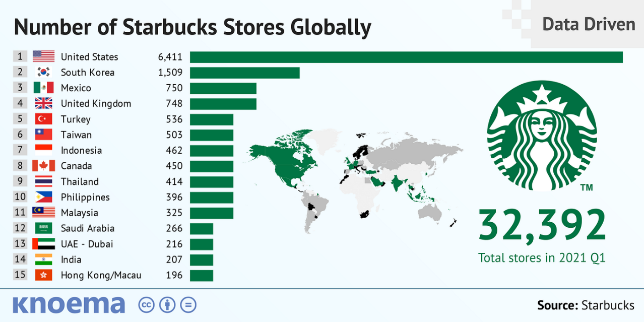
Figure 1: Number of Starbucks Stores Globally (2021)
Source: (Truong, 2022)
The US remains the scale anchor with 10,158 company-operated and 6,777 licensed stores, while the UK contributes 378 company-operated and 976 licensed stores, which underlines the UK’s heavier reliance on licensing partners (Sec.gov, 2025). Active US Starbucks Rewards membership reached 33.8 million in Q4 FY2024, so value communication and mobile ordering are core to demand stimulation in the US (Starbucks, 2024). In January 2024 Starbucks enabled personal reusable cups for mobile and drive-thru orders across the US and Canada, a platform change that ties sustainability cues directly to the digital journey (Starbucks, 2025).

The Macro Environment (PESTLE)
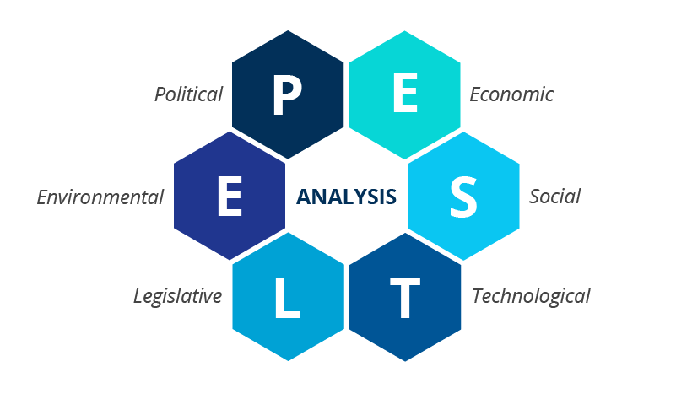
Figure 2: PESTLE Framework
Source: (Ormston, 2025)
Political
UK
The Soft Drinks Industry Levy applies when sugar content is at least 5 g per 100 ml, so Starbucks must engineer and market low-sugar cold beverages carefully, which places mild pressure on recipe design and promotional mix (HM Revenue & Customs, 2019). National Living Wage uplifts from April 2025 raise hourly floors for over-21s to £12.21, which tightens store-level labour margins and can push menu price revisions or loyalty mechanics (GOV.UK, 2024).
USA
Unionisation activity and related labour disputes create operational and reputational risk, which complicates staff scheduling and may shape service promises during campaigns (Durbin, 2024). Data-privacy compliance is fragmented, with CCPA setting robust rights in California that digital programmes must respect when personalising offers (CCPA, 2018).
From the analysis of political factors, it can be stated that political conditions are somewhat less favourable in the UK on wage cost and in the US on labour relations, so the marketing plan must absorb cost signals while protecting speed and hospitality.
Economic
UK
Branded coffee chains operate in a competitive £6.1bn market where price sensitivity is high and loyalty schemes are being tuned to perceived value, which requires disciplined price-pack architecture and rewards calibration (Pearce, 2025). Costa continues to hold the largest branded share, so Starbucks must use distinctiveness in format and digital engagement rather than pure network effects (Young and Facenda, 2024).
The UK has a favourable GDP and GNP, which is optimal for Starbucks, considering the good coffee culture and competitive market. However, there is high market competition by brands such as Costa Coffee and political and economic pressures, which may be challenges.
USA
The federal minimum wage remains $7.25 while states vary upwards, which gives Starbucks more room to align wage bills with local revenue density relative to the UK’s single national floor (DOL, 2025). Large-scale Rewards membership provides a built-in lever for frequency recovery during traffic softness, which stabilises unit economics (Sec.gov, 2025).
The USA has a favourable GDP and GNP, which is favourable to Starbucks, as the market is vast and diversified with a high level of customer loyalty. The brand enjoys the advantages of a wide range of customers, such as millennials and urban workers.
The analysis shows that economic forces look tighter in the UK due to wage floors and strong domestic rivals, while US scale and loyalty depth are favourable for promotional efficiency if service speed is maintained.
Social
Starbucks in the UK is also taking advantage of the tendency towards a high level of digital payments adoption, where more than half of adults use mobile wallets, which facilitates convenience in making orders. The British coffee culture is placed much on out-of-home consumption, and consumers are extremely sensitive in terms of value, and clear claims on savings are needed (Steel and Cruz, 2023).
Starbucks also engages the spirit of individualism through the high degree of customisation of the drinks they serve, and the importance they place on sustainability when it comes to their products. The brand also has outreach to younger audiences, using social media to reach out to lifestyle-oriented customers and increase its interaction.
The chart shows lower power distance in the United Kingdom at 35 than the United States at 40, which supports flatter in-store interaction scripts and approachable barista tone in the UK.
Personal autonomy is stronger in the UK with individualism at 76 compared with 60 in the US, so highly granular drink customisation, one-to-one offers and name-based recognition can be pushed harder in UK messaging.
Achievement orientation is high in both contexts with the UK at 66 and the US at 62, which makes gamified Rewards challenges and status tiers credible motivators across markets. Uncertainty avoidance is lower in the UK at 35 than the US at 46, which permits bolder seasonal experiments and limited runs in Britain while the US mix benefits from clearer labelling, dependable favourites and explicit service guarantees.
UK
Mobile wallets are now used by over half of UK adults, which supports Starbucks’ emphasis on app-centred ordering and rapid check-out in dense commuter nodes (UK Finance, 2025). British coffee culture features heavy out-of-home consumption in branded chains, yet value cues are scrutinised, so limited-time offers and bundled pricing need clear savings claims (Pearce, 2025).
USA
Starbucks Rewards acts as a social habit loop that nudges morning routines and treat-based visits, which the brand amplifies with challenges and star boosts (Sec.gov, 2025). Reusable-cup acceptance in drive-thru and mobile orders adds a visible social signal for sustainability without slowing the lane, which is salient in suburban US trade areas (Starbucks, 2024).
The reliasation from the analysis is that social adoption of digital payments is strong in both countries, which is favourable for personalised offers and order-ahead marketing, although UK value sensitivity demands sharper perceived fairness in pricing.
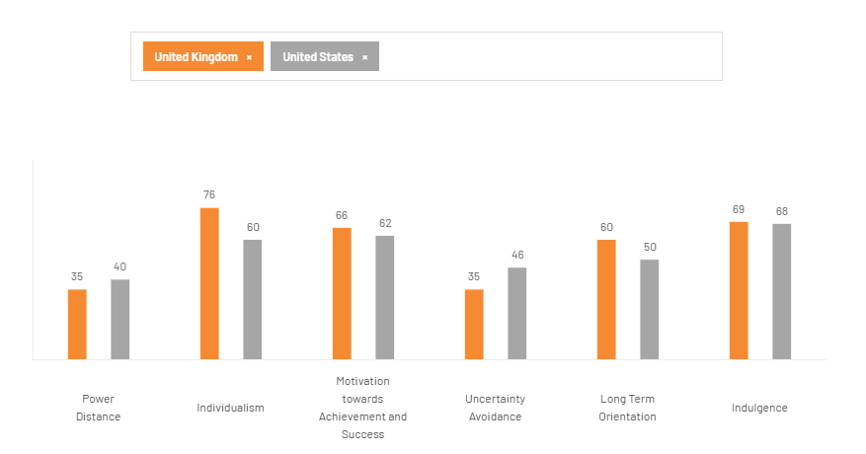
Figure 3: Cultural Insights Country Comparison
Source: (Theculturefactor.com, 2025)
Technological
UK
High contactless and mobile use means frictionless payment and pick-up windows can be marketed as time-saving benefits during peak commuting, which suits drive-thru expansion (Quinio, 2024).
USA
Mobile Order & Pay and the app ecosystem remain central to throughput management at peak, which underpins queue-busting communication in advertising and store signage (Starbucks, 2025).
It is acknowledged that technology is favourable in both markets, which supports data-driven targeting and capacity smoothing through digital pre-orders.
Legal
UK
The UK GDPR applies to profiling and direct marketing, so Starbucks must present lawful bases and robust consent flows in its app journeys (ICO, 2024).
USA
CCPA imposes disclosure and opt-out requirements for California residents, which obliges loyalty data governance that can be messaged as privacy by design (CCPA, 2018).
The analysis shows legal privacy regimes are stricter in practice in the UK due to GDPR lineage while the US presents a patchwork risk, which drives careful consent UX and regional controls in marketing automation and it means the legal factors are favorable for both countries.
Environmental
UK
Sugar-levy thresholds continue to incentivise low-sugar cold platforms and clear nutritional labelling, which supports positioning of Refreshers and zero-added-sugar options (Sasse and Metcalfe, 2022).
USA
In the USA, environmental factors play a significant role in shaping Starbucks' marketing strategies. The growing consumer demand for sustainability drives Starbucks to promote eco-friendly initiatives, such as reusable cups and plant-based options (Dhar and Ray, 2024).
For both countries, environmental forces are moderately favourable where product reformulation and reusable workflows are leveraged as marketing proof points.
Advantages: The American market offers an advantageous opportunity for Starbucks to advance sustainability processes, including reusable cups and plant-based solutions, in accordance with the increased consumer desire to abandon brands that are less environmentally friendly (Starbucks, 2025).
Disadvantages: In addition to the beneficial environmental actions, Starbucks has to deal with such drawbacks as varied environmental policies on the state level and the perception of greenwashing among consumers, which can weaken its sustainability measures. Moreover, the environmental undertakings carried out through operational costs might affect profitability if they are not managed.
Factor | UK | USA | Similarities | Differences
Political | National Living Wage and sugar tax pressures; unionisation and labour disputes risk (Pearce, 2025). | Unionisation and state privacy rules create risks; lower federal minimum wage with state variances (DOL, 2025). | Both face political pressures regarding labour costs and compliance, especially around taxes. | UK emphasises wage and sugar tax, while US focuses on unionisation and state privacy laws.
Economic | Competes in a £6.1bn market; high price sensitivity and competition (Pearce, 2025). | Low federal minimum wage; higher state wages align with revenue density (DOL, 2025). | Both economies support premium coffee demand and loyalty-based propositions. | UK faces tighter economics with strong rivals; US benefits from larger scale and loyalty depth.
Social | Lower power distance, high individualism; informal barista tone; high digital payment adoption (Theculturefactor.com, 2025). | Higher power distance, lower individualism; routines and loyalty cycles matter. | Both markets have strong digital payment adoption. | UK values autonomy; US relies on routines.
Technological | High contactless use and commuter-focused pick-up windows (Quinio, 2024). | App ecosystem central to peak time management (Starbucks, 2025). | Both countries support data-driven targeting and digital pre-orders. | UK focuses on commuter flows, while US emphasises app-based queue management at scale.
Legal | GDPR governs data collection; requires lawful consent for marketing (ICO, 2024). | CCPA shapes loyalty data governance; opt-out rights for California residents (CCPA, 2018). | Both demand robust privacy governance around marketing data. | UK has a unified regime, whereas US rules are state-specific.
Environmental | High sustainability expectations; reusable cups and low sugar products (Dhar & Ray, 2024). | Rising demand for sustainability; plant-based options promoted. | Both markets support reusable practices and sustainability. | UK pressures from fiscal policies; US shaped by activism and state-level laws.

Table 1: PESTLE Comparison of Similarities and Dissimilarities in Both Countries
Source: (Author-developed)

STP (Segmentation, Targeting, and Positioning) Strategies in the UK and USA
Starbucks has managed to customise its marketing plans in the UK and the USA through a strategic approach to segmentation, targeting, and positioning (STP). This will enable the company to attract a wide variety of consumers and also enhance its brand name in these two different markets.

Segmentation Strategies
Demographic Segmentation
The age, income and occupation are the demographic variables that are applied to divide the market by Starbucks in both the UK and the USA.
- Age: Starbucks mainly focuses on millennials (25-40 years old) as they are the consumers who appreciate high-quality coffee and are inclined to the experience of a lifestyle brand (Pereira, 2024). Starbucks marketing campaigns in the UK as well as the USA tend to resonate with the youth culture and depend on social media such as Instagram and Twitter to reach younger consumers.
- Income: Starbucks aims at higher-income people, particularly in urban regions that are ready to pay a premium price in order to receive high-quality coffee and a better in-store experience. The average Starbucks coffee price in the USA is $3.50, and the UK one is the equivalent of 3.00, which proves the concept that Starbucks positions itself as a high-value coffee seller (Bermudez et al., 2022).
- Profession: Starbucks is also aimed at professionals and students in the two countries. Starbucks outlets are a common alternative where office workers and students can have quick coffee breaks, meetings, or even study in an urban setting where the population of the target market is high.
Behavioral Segmentation
Starbucks uses behavioural segmentation, which is applied to customer behaviour in their usage rate, occasion, and loyalty.
- Usage rate: Starbucks distinguishes light, medium, and heavy coffee drinkers, as well as providing a choice of different beverages that are specific to each consumption level. Starbucks, for example, has smaller-sized drinks such as espresso shots that can be used by light users, whereas heavy users can have bigger-sized drinks and customised ones (Starbucks, 2025).
- Occasion: Starbucks has organised its products according to the different occasions, such as a rush in the morning and an afternoon snack. In the USA, the company advertises the iced drinks in summer, whereas in the UK, it sells the seasonal drinks, such as pumpkin spiced lattes, in autumn (Volle, 2022).
- Loyalty Programs: Starbucks Rewards is one of the major loyalty tools in the two countries. By the first quarter of 2024, more than 34.3 million rewards members were active in the USA in Starbucks (Wassel, 2024).
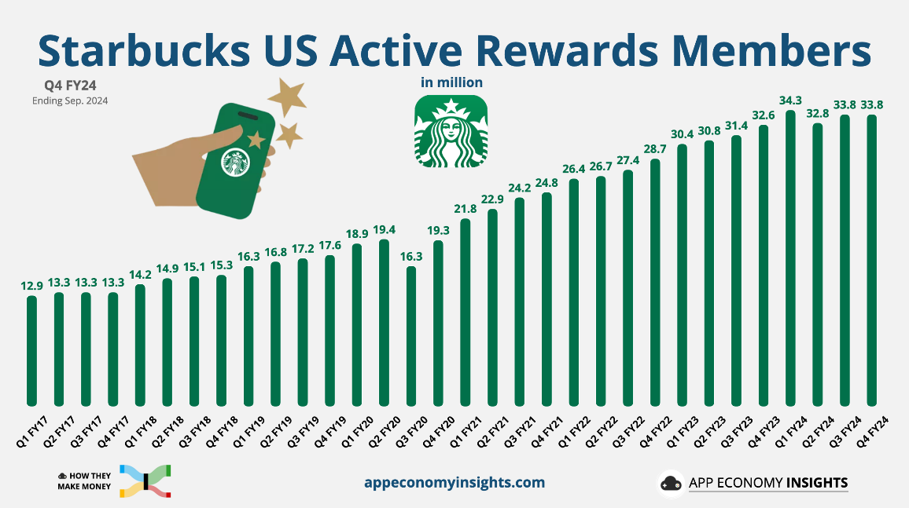
Figure 4: Starbucks US Active Rewards Member
Source: (App Economy Insights, 2025)
Psychographic Segmentation
The segmentation strategy of both countries focuses on the psychographic characteristics of the interests, values and lifestyle of people and Starbucks.
- Lifestyle and Values: Starbucks is a socially responsible brand. As an example, Starbucks is determined to decrease its environmental impact by providing reusable cups and planning to become carbon-neutral in the year 2050 (Starbucks, 2024).
- Coffee Culture: Starbucks also exploits the coffee culture that is developing in the UK and the USA, particularly the positioning of coffee drinking. Starbucks targets people who do not regard coffee drinking only as a routine but as an experience.

Targeting Strategies
Starbucks has a differentiated marketing approach, and its offerings are different according to the segments in both the USA and the UK.
Target Market in the UK
Starbucks focuses mostly on the urban professionals and the younger adults (18-35 years) in the UK. The UK coffee market has very few players, and Costa Coffee has dominated the market, giving Starbucks the challenge of differentiating itself by offering a premium product and excellent customer experience (Aminuddin et al., 2021).
Target Market in the USA
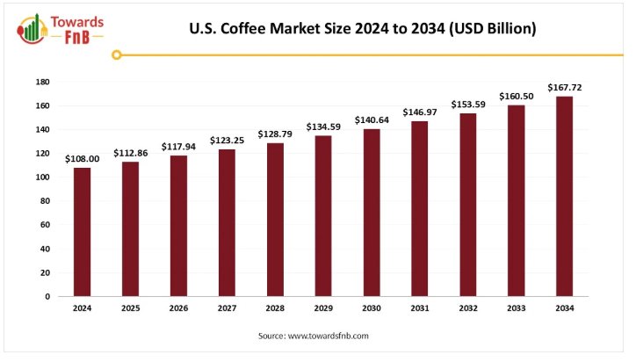
Figure 5: US Coffee Market Size 2024 to 2034
Source: (Towards FnB, 2025)
The USA is still considered to be a home country where Starbucks is located, and the target audience is based on the same group of higher-income millennials and urban residents. Starbucks also adapts its products to the various regional preferences as well. In fact, in healthier regions of the country, such as California, Starbucks has launched plant-based milk and lighter-calorie beverages.

Positioning Strategies
Positioning in the UK
In the UK, Starbucks markets itself as a high-end brand, providing high-quality coffee and a cosy and friendly atmosphere. It is also focused on ethical sourcing and sustainability, which conforms to the trend of consumer interest in responsible businesses. Starbucks has been regarded as a kind of lifestyle, especially in cities where it has become a social place of gathering among young employees and students (Sanchez Herrera et al., 2022).
Positioning in the USA
Starbucks in the USA has a positioning strategy similar to that of the one with increased focus on convenience and customisation. The brand employs the functional positioning strategy, where customers are seeking a fast but quality coffee experience (Gao et al., 2021). Mobile ordering and pay options, through the Starbucks app, have played a significant role in ensuring the positioning of the brand as something convenient to busy people.
Factor | UK | USA | Similarities | Differences
Demographic | Targets millennials, urban professionals, and students (Pereira, 2024). | Focuses on higher-income millennials and urban residents (Bermudez et al., 2022). | Both target younger, higher-income, urban consumers. | UK faces competition from Costa; US has a more diversified demand.
Behavioural | Offers drink size tiers for different usage levels (Starbucks, 2025). | Similar approach but with more customised drinks for heavy users (Starbucks, 2025). | Both segment based on usage intensity and loyalty. | US has a larger Rewards membership for deeper personalisation.
Psychographic | Emphasises socially responsible brands and sustainability (Starbucks, 2024). | Focuses on social responsibility and a “third place” experience (Starbucks, 2024). | Both focus on ethical, lifestyle-oriented consumers. | UK emphasises responsibility; US focuses more on lifestyle experience.
Targeting | Differentiated marketing aimed at premium products (Aminuddin et al., 2021). | Targets higher-income millennials with regional adaptations (Aminuddin et al., 2021). | Both target urban, lifestyle segments with tailored offerings. | UK faces stronger competition, while US has more geographic flexibility.
Positioning | Positioned as a premium, ethical brand (Sanchez Herrera et al., 2022). | Positions similarly but emphasises convenience and mobile ordering (Gao et al., 2021). | Both position Starbucks as a premium lifestyle brand. | UK focuses on ethics; US prioritises convenience and customisation.

Table 2: STP Comparison of Similarities and Dissimilarities of Both Countries
Source: (Author-developed)

Marketing Mix (7Ps) Strategies in the UK and USA
Starbucks has been able to adapt its marketing mix (7Ps) effectively in both the UK and the USA, whereby its product offerings, pricing, place strategy and promotion tactics are effectively aligned to the tastes and demands of the consumers in both the UK and the USA.
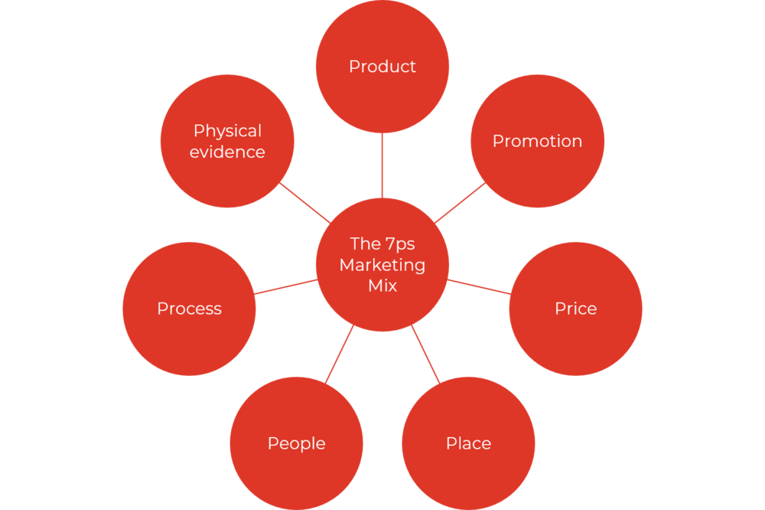
Figure 6: Marketing Mix of 7Ps
Source: (Roberts, 2024)

Product Strategy
The product offering of Starbucks is the major focus of its marketing strategy and is slightly different in the UK and the USA to meet the regional tastes, preferences and cultural impacts.
Product Range
Starbucks has a diverse range of drinks in both markets, such as hot drinks and cold drinks, including coffee, tea, and speciality drinks.
- In the UK, Starbucks focuses on its seasonal menu, which includes such drinks as the Pumpkin Spice Latte and Christmas-themed drinks that have gained immense popularity during the colder seasons (Starbucks, 2025).
- In the USA, Starbucks has been extremely aggressive in marketing its refreshment-based product line, including iced coffee, cold brews, and Frappuccinos, which are consistent with the warm weather and cold beverages that are popular in most localities.

Price Strategy
Starbucks uses a premium pricing strategy in both the UK and the USA, as it is a high-quality coffee brand, and this provides a high-level experience.
Price Range
- Starbucks is selling hot coffee in the UK, and a small one will cost approximately 3 UK pounds, and the price of speciality coffee will be different (Starbucks Menu, 2025). The coffee market in the UK is very competitive, with Costa Coffee and Pret A Manger being the leading competitors within the market.
- In the USA, a typical cup of coffee at Starbucks costs approximately $3.50 (Starbucks Menu, 2025). In the case of Starbucks USA, however, it follows a dynamic pricing model, and its prices differ according to the location. As an example, the cost of living and real estate prices in such metropolitan cities as New York or San Francisco can be higher.

Place (Distribution Strategy)
Starbucks' distribution strategy is aimed at making its products accessible to its target market in both the UK and the USA.
Store Location
- Starbucks is mainly an urban centre business in the UK, and the UK has a high concentration of Starbucks in the major urban centres, especially London. Starbucks UK also aims at high pedestrian areas like train stations, airports and shopping malls (Bodkin, 2023).
- In the USA, Starbucks is even more widespread in its store network, as there are more than 15,000 stores as of 2024 (Cafely, 2024). Starbucks USA is still expanding to suburban and rural locations, and the well-known drive-through model of the brand is especially popular in smaller cities and towns, which provides their customers with maximum convenience.

Promotion Strategy
Starbucks' digital-based promotional efforts in both countries are mostly digital-first, as they emphasise the rising need to use online communication and social media.
Social Media and Advertising.
- Starbucks in the UK pays much attention to seasonal marketing and sustainability messages. Starbucks UK has also utilised social media such as Instagram and Twitter to market limited-edition beverages. Another one is the digital campaign of Starbucks UK that is based on community building and interaction, and is tied to social causes.
- Promotions in the USA, in turn, are based on loyalty in the USA, which Starbucks USA employs through special offers and discounts available to Starbucks Rewards members (Musonera, 2021).

People Strategy
Starbucks places much emphasis on the employees, or rather the partners, as they are called in the UK and the USA.
Customer Service
The quality of the service offered by Starbucks as the brand promise would be impossible without the training, which the employees receive. The workers of Starbucks are also trained in both countries to provide a friendly and personalised customer experience to their guests, to have a pleasant conversation with them, and to make recommendations on the products they wish to buy.
Employee Engagement
Both Starbucks, USA, and the UK market their company culture through providing their employees with innumerable benefits, such as healthcare, flexible working hours, and stock options (Minenko and Mujtaba, 2024). The firm has made a commendable effort to ensure a work environment that is inclusive and diverse, thereby helping the customers experience a better environment.

Process Strategy
Starbucks processes, including ordering and delivery of products, are aimed at being efficient and friendly to the customers.
Order Process
- Starbucks has simplified its ordering system to increase speed, especially during rush periods. The orders that are made in-store are normally done quickly and the mobile ordering option makes sure that the customers do not have to stand in a long queue.
- Starbucks has invested in its drive-thru services in the USA, and in this aspect, the process has been made more efficient in the suburban and rural settings. Speed and convenience are also provided by the ability to place the order in advance using the Starbucks app.

Physical Evidence Strategy
The physical setting of Starbucks is also important in supporting its brand image in the United Kingdom and the USA.
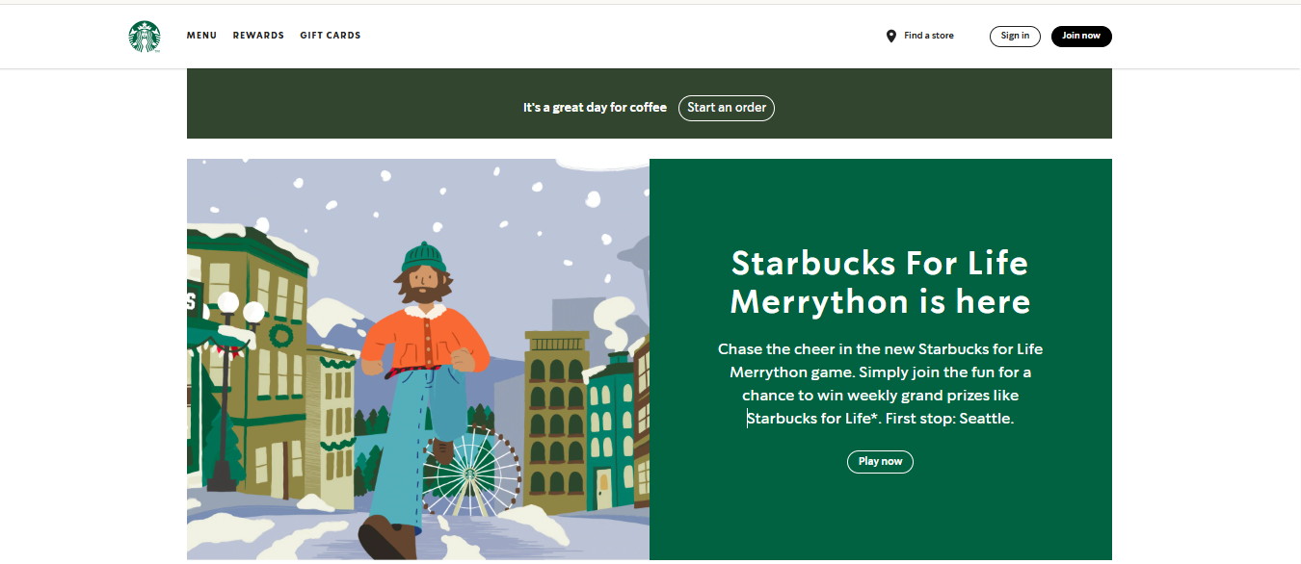
Figure 7: Website of Starbucks USA
Source: (Starbucks, 2025)
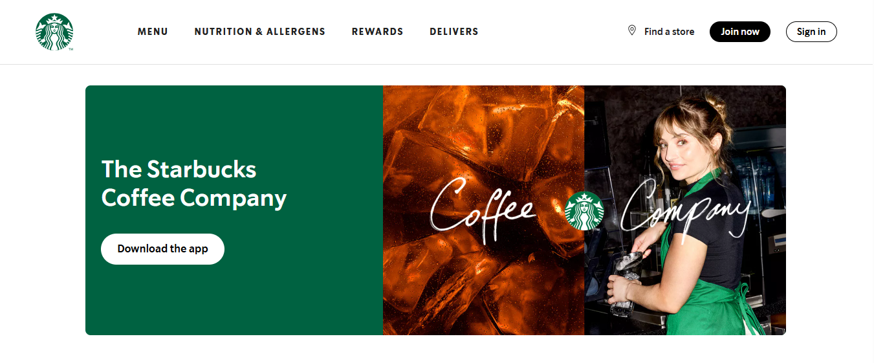
Figure 8: Website of Starbucks UK
Source: (Starbucks, 2025)
Store Design and Ambience
The store designs in Starbucks are uniform in both countries, but respond slightly to the regions. Lots of stores in the UK have warm, and comfortable interiors, which attract coffee and time-wasting lovers who enjoy spending time at the place where they are employed or communicate with others (Zhang and He, 2024). In the USA, the stores are similar in design but are, in most cases, bigger to serve a large number of customers.
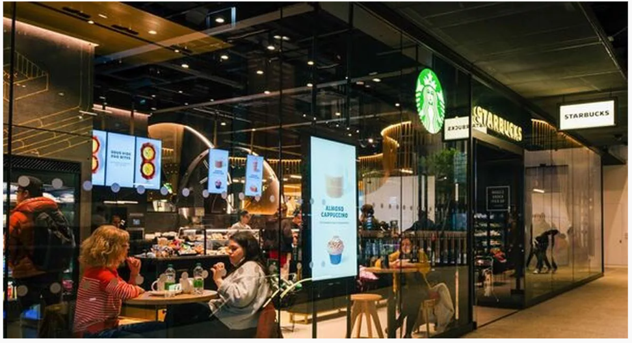
Figure 9: Starbucks Store in the UK
Source: (Cornish, 2024)
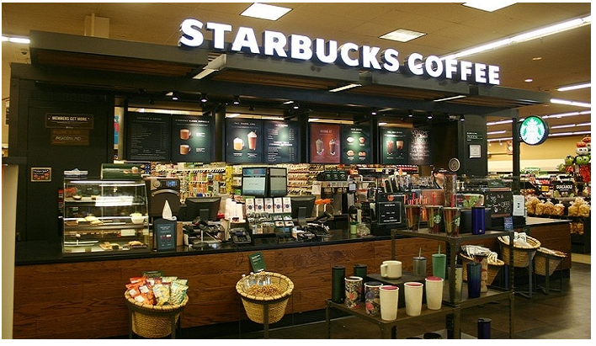
Figure 10: Starbucks Store in the UK
Source: (Global Brands, 2022)

Packaging
Starbucks packages its products with high-quality to match its image. Its products are packaged and served in sleek cups and wrappings, mostly with a theme of the season, which further adds to the customer experience in both the UK and the USA.
Factor | UK | USA | Similarities | Differences
Product | Focus on seasonal drinks like Pumpkin Spice Latte (Starbucks, 2025). | Emphasises cold drinks like iced coffee and Frappuccinos. | Both offer a wide range of hot and cold beverages. | UK focuses on seasonal hot drinks, while US focuses on cold beverages.
Price | Premium pricing with small coffee around £3 (Starbucks Menu, 2025). | Premium pricing with coffee around $3.50 (Starbucks Menu, 2025). | Both use premium pricing. | US pricing varies more by location; UK faces stronger competition.
Place | Focus on major cities and high footfall areas (Bodkin, 2023). | Over 15,000 stores, including suburban locations (Cafely, 2024). | Both focus on convenience in everyday travel routes. | US has a larger, more suburban network; UK is urban-centred.
Promotion | Digital-first, with seasonal and sustainability campaigns. | Rewards and discounts are central to promotions (Musonera, 2021). | Both rely on digital and seasonal campaigns. | UK focuses on sustainability; US focuses on loyalty rewards.
People | Training for friendly, personalised service. | Similar training with a focus on diversity (Minenko and Mujtaba, 2024). | Both focus on well-trained staff. | US has stronger unionisation pressures.
Process | Streamlined in-store and mobile ordering (Starbucks, 2025). | Focus on drive-thru efficiency. | Both emphasise speed and ease of access. | US focuses more on drive-thru operations.

Table 3: Marketing Mix Comparison of Similarities and Dissimilarities of Both Countries
Source: (Author-developed)

Evaluation of Marketing Strategy Success in the UK and USA
Starbucks has established itself as one of the most popular coffee brands in the world by using marketing techniques in the United Kingdom and America.

Market Share and Store Presence
Market Share in the UK
Starbucks is one of the most prominent coffeehouse chains in the UK, but the company has considerable competition with Costa Coffee, Pret A Manger and other local brands. Starbucks controls a market share of 40% of the total branded coffee shop market in the UK, making it the second-largest coffee chain after Costa Coffee, which controls a market share of about 18.7% (Lumina Intelligence, 2025).
Market Share in the USA
Starbucks is still the leader in the coffeehouse market in the USA, with a market share of above 40% of the US coffee shop market (Lipson et al., 2024). Starbucks has over 15,000 outlets in the USA, and its stores are found in almost every state in the country, becoming the most widespread chain of coffee houses in the area.

Sales Figures and Revenue Growth
UK Sales Performance
The adoption of the competitive environment has affected the sales performance of Starbucks in the UK, which has been positive, albeit slightly. Starbucks UK’s Total revenue was £525.6m in 2024 (QSR Media UK, 2025).
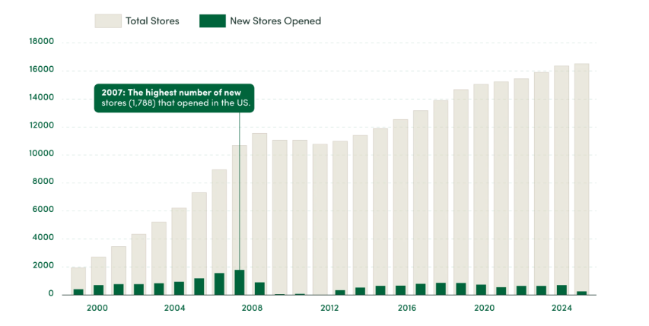
Figure 11: Starbucks Store Growth in the US, 1999 to 2024
Source: (Cafely, 2024)
Although Starbucks faces a high level of competition, especially with Costa Coffee and Pret A Manger, the emphasis of the brand on high-quality products such as speciality coffee and healthy food items has assisted the brand in retaining its market status. Furthermore, reward programs like Starbucks Rewards keep promoting purchasing repeatedly and keeping the customers.
USA Sales Performance
Starbucks continues to have good sales in the USA. Starbucks USA had a revenue of $36.176B in the financial year 2024 (MacroTrends, 2025). This revenue is a big contribution to the store operations of the company, which has both company and licensed stores. The good performance of the company is also related to a number of factors, such as its loyalty program, mobile ordering and the further development of its products.
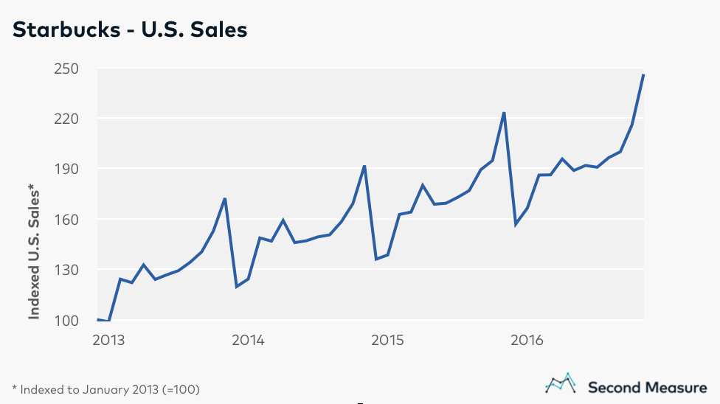
Figure 12: Starbucks USA Sales
Source: (Rieck, 2017)

Customer Engagement and Brand Loyalty
Customer Engagement in the UK
Starbucks has been able to develop customer loyalty in the UK with Starbucks Rewards and frequency on the digital platforms. Among the most significant customer engagement tools in both the UK and the USA, one must mention the app-based loyalty program, where customers can earn stars with every purchase. By 2024, the UK had more than 34.3 million active Starbucks Rewards, which can be considered a critical element to repeat business (Wassel, 2024).
The Customer Engagement in the USA
Starbucks has been very effective in digital interaction, especially in its Starbucks Rewards and mobile application in the USA. The Starbucks app enables customers to make orders in advance, design their beverages, and earn rewards. This high degree of convenience has been very effective in keeping up with the loyal consumers and pushing new consumers largely in the urban areas.
Customer engagement in Starbucks USA is also encouraged using localised marketing campaigns that are in line with local tastes and preferences. An example is in California, where Starbucks has gone on to promote plant-based products and sustainability branding, which attracts the environmentally conscious and health-conscious consumer groups (Susilo and Mendoza, 2023).

Effectiveness of Promotional Campaigns
UK Promotional Campaigns
Starbucks in the UK has effectively implemented the use of seasonal campaigns that have become part of the culture, like the Christmas beverage line and the Pumpkin Spice Latte campaign, which has been operating (Zhou, 2024). The promotion of these campaigns is intensive by using social media, online advertising, and displays available in stores.
USA Promotional Campaigns
Starbucks uses a mix of holiday offers, product launches, and limited deals in the USA to appeal to its customers. Some of the new limited-edition products that Starbucks USA has launched include the Nitro cold-brew and cold foam-based products, which generate buzz and excitement among consumers (Levine, 2019).

Ethical Issues in Marketing Strategies
Starbucks, being a coffeehouse chain company across the globe, has gone a long way to ensuring sustainability and social responsibility. Its marketing practices in the UK have brought several ethical issues and, in this case, aspects of sourcing, environmental responsibility and social responsibility.

Sourcing and Fair-Trade Practices
Among the most crucial ethical concerns of Starbucks, there is the problem associated with sourcing. The company has also dedicated itself to the purchase of Fair Trade-certified coffee, which seeks to make sure farmers in the developing countries receive good remuneration for their harvests (Dierberger et al., 2025). This should be one of the core marketing messages that Starbucks has been promoting, as the company is being presented as a pioneer in terms of ethical sourcing and fair trade.

Environmental Sustainability and Greenwashing Concerns
Another aspect on which Starbucks has been subject to ethical criticism is environmental sustainability. Starbucks' efforts to curb the use of single-use plastic in the UK have received huge acclaim, and the launch of a ban on the use of plastic straws in 2018 was in accordance with the tendency of people to adopt sustainable behaviours (Bujold and Williamson, 2025).

Social Responsibility and Labour Practices
Starbucks have also received commendations in the way they practice social responsibility, which include providing healthcare benefits to its employees or partners, as well as encouraging diversity and inclusion amongst the workforce. Its marketing usually emphasises the way the company pays fair wages, provides a good working environment, and offers career growth opportunities to its employees in the UK.

Recommendations for International Marketing Strategies
The combination of high-quality products, robust branding, and customer-oriented marketing strategies has enabled Starbucks to become one of the leading coffee brands in the world.
Make Localisation and Cultural Relevance Stronger
Although Starbucks has done a lot in making its menu more local, it can further localise its products to improve its popularity in various overseas markets. As an illustration, the trend in Asia and the Middle East is towards flavour profiles including matcha and traditional spices, whereas coffee preferences in Latin America could be more towards sweeter and creamier beverages (Raimondo, 2022).
In such markets as India and China, where tea is the key beverage, Starbucks must also expand and market its tea drinks by using domestic varieties of tea, such as chai or oolong tea, to make unique products.
Take Advantage of Digital and Mobile Technologies
Consumers are getting more convenient and flexible in developed and emerging markets, and Starbucks has been able to leverage mobile ordering and paying through apps in the USA and the UK. Bringing this model to the international markets, especially Asia, where mobile payments are widely used, would contribute immensely to the customer experience and convenience (Pal et al., 2021). Implementation of mobile app-based ordering in additional markets abroad will enable Starbucks to organise its services, enhance the accuracy of orders, and shorten queues, which will also improve the experience of being served in the company. Starbucks should have more personalised rewards depending on customer preferences and purchase history in countries such as South Korea and Japan, where reward programs have gained a lot of popularity (Lee et al., 2022).
Focus on Ethics and Sustainability
The concept of sustainability is an element that is increasingly becoming vital to consumers, especially in the developed markets such as Europe and North America and is also beginning to be considered in the emerging markets (Belz et al., 2025). Sustainable sourcing, reusable packaging and energy-efficient stores should also remain on the agenda of Starbucks, and these should be well-advertised in the marketing of the company. It should focus more on the environmental attributes of its own products, like featuring Fair Trade Certified coffee or plastic-free packaging, to make it more popular among the environmentally aware consumer population.

Conclusion
Such a comparison of Starbucks marketing strategies in the UK and the USA shows that in both markets the company was able to adjust its strategy to satisfy the diverse needs of the customers in these countries, and still retain a strong global brand image. Using the STP (Segmentation, Targeting, and Positioning) approach, Starbucks manages to divide its customer base into segments based on demographics, behaviour and psychographics, and offer something that would attract a large variety of consumer segments. Starbucks focuses on premium products and seasonal beverages and sustainability in the UK and on convenience, personalisation, and an effective loyalty system in the USA. The 7Ps model displays the strategic emphasis of Starbucks on providing a high-end product line that comprises coffee, teas, and seasonal offers.

Reference List
Aminuddin, M. A., Abdullah, N. F., Mazlan, N. A., Mohd Idris, A. A., and Mustafa, A. N. (2021). Starbucks Coffee Company: coffee cafe company.
App Economy Insights (2025). Can Starbucks Be Saved? [online] Appeconomyinsights.com. Available at: https://www.appeconomyinsights.com/p/can-starbucks-be-saved.
Belz, F. M., Peattie, K., and Onel, N. (2025). Sustainability marketing: A global perspective. John Wiley & Sons.
Bermudez, S., Voora, V. and Larrea, C. (2022). Coffee prices and sustainability SUSTAINABLE COMMODITIES MARKETPLACE SERIES. [online] Available at: https://www.iisd.org/system/files/2022-09/2022-global-market-report-coffee.pdf.\
Bodkin, M. A. (2023). Grounds for a" Third Place": The" Starbucks Experience," Sirens, and Space (Doctoral dissertation, The University of Western Ontario (Canada)).
Bujold, P. M., and Williamson, K. (2025). Solutions to plastic pollution with community-based behavior change.
Cafely (2024). Number of Starbucks in the US & Other Statistics [2025]. [online] Available at: https://cafely.com/blogs/research/starbucks-statistics?srsltid=AfmBOooV1EKKOyaLuOakP8iX4qAVHVzVQLWFqwX2GMm_sOXqUTSNAw2R [Accessed 26 Nov. 2025].
CCPA (2018) California consumer privacy act (CCPA), State of California - Department of Justice - Office of the Attorney General. Available at: https://oag.ca.gov/privacy/ccpa (Accessed: November 5, 2025).
Cornish, P. (2024). Starbucks to shut popular UK store in just a few days as locals ‘sad to see it go’. [online] Birmingham Live. Available at: https://www.birminghammail.co.uk/whats-on/food-drink-news/starbucks-shut-popular-store-uk-29699659 [Accessed 12 Dec. 2025].
Dhar, I., and Ray, S. (2024). Global Green Marketing: The Epochal Need.
Dierberger, G., Keita, I., Jang, S., Enger, J., and Erickson, C. (2025). Coffee Industry Inequity: The Challenges for Coffee Farmers and Fair Trade. SAGE Publications: SAGE Business Cases Originals.
DOL (2025) Minimum wage, Quinio. Available at: https://www.dol.gov/general/topic/wages/minimumwage (Accessed: November 5, 2025).
Durbin, D.-A. (2024) Starbucks strike expands, closes nearly 60 US stores, AP News. Available at: https://apnews.com/article/starbucks-strike-baristas-workers-united-7b2f6e5d7b039bc1909d646d84cd426d (Accessed: November 5, 2025).
Gao, J., Zhao, J., and Chen, J. (2021, June). Starbucks’ Customer Brand Strategy. In 2021 International Conference on Enterprise Management and Economic Development (ICEMED 2021) (pp. 231-238). Atlantis Press.
Global Brands (2022). New Starbucks BAYA Energy Launches in Grocery Stores in U.S. [online] Global Brands Magazine. Available at: https://www.globalbrandsmagazine.com/new-starbucks-baya-energy-launches-in-grocery-stores-in-u-s/ [Accessed 12 Dec. 2025].
GOV.UK (2024) National Minimum Wage and National Living Wage rates, Gov.uk. Available at: https://www.gov.uk/national-minimum-wage-rates (Accessed: November 5, 2025).
HM Revenue & Customs (2019) Check if your drink is liable for the Soft Drinks Industry Levy, Gov.uk. Available at: https://www.gov.uk/guidance/check-if-your-drink-is-liable-for-the-soft-drinks-industry-levy (Accessed: November 5, 2025).
ICO (2024) The UK GDPR, ICO. Available at: https://ico.org.uk/for-organisations/data-protection-and-the-eu/data-protection-and-the-eu-in-detail/the-uk-gdpr (Accessed: November 5, 2025).
Lee, W. S., Jung, J., and Moon, J. (2022). Exploring the antecedents and consequences of the coffee quality of Starbucks: a case study. British Food Journal, 124(4), 1066-1080.
Levine, B. (2019). Starbucks taps Bill Nye the Science Guy to explain nitro cold brew. [online] Marketing Dive. Available at: https://www.marketingdive.com/news/starbucks-taps-bill-nye-the-science-guy-to-explain-nitro-cold-brew/559800/ [Accessed 26 Nov. 2025].
Lipson, M., Philbin, M. and Beck, L. (2024). Coffee Wars: Market Share Battles and Investment Opportunities from. [online] Northmarq. Available at: https://www.northmarq.com/insights/research/coffee-wars-market-share-battles-and-investment-opportunities-starbucks-startups.
Lumina Intelligence (2025). Coffee Price Comparison in Sandwich & Bakery Chains (2025). [online] Lumina Intelligence. Available at: https://www.lumina-intelligence.com/blog/foodservice/uk-coffee-market-size-growth-share-statistics-2025/.
MacroTrends (2025). Starbucks revenue 2010-2025 | SBUX. [online] Macrotrends.net. Available at: https://www.macrotrends.net/stocks/charts/SBUX/starbucks/revenue.
Minenko, M., and Mujtaba, B. G. (2024). Diversity Audit at Starbucks: Assessment of Workforce Demography, Inclusion Initiatives, and Corporate Culture. Business Ethics and Leadership, 8(3), 173-183.
Musonera, E. (2021). Strategic marketing case analysis: Starbucks. Journal of Business and Social Science Review, 2(11), 12-22.
Ormston, A. (2025). PESTLE Analysis: A Guide to Understanding Market Influences. [online] B2B International. Available at: https://www.b2binternational.com/2025/04/03/pestle-analysis/.
Pal, A., Herath, T., De’, R., and Rao, H. R. (2021). Is the convenience worth the risk? An investigation of mobile payment usage. Information systems frontiers, 23(4), 941-961.
Pearce, T. (2025) Value in the spotlight as competition heats up in £6.1bn UK branded coffee shop market, World Coffee Portal. Available at: https://www.worldcoffeeportal.com/news/value-in-the-spotlight-as-competition-heats-up-in-6-1bn-uk-branded-coffee-shop-market (Accessed: November 5, 2025).
Pereira, D. (2024). Business Model Analyst. (2024). Starbucks Target Market Analysis (2025). [online] Available at: https://businessmodelanalyst.com/starbucks-target-market/?srsltid=AfmBOoomopX5fEdRSz5dA46_CMPsPJDOyYhtZrcAQrCJLIq-cscCBN7b [Accessed 26 Nov. 2025].
QSR Media UK (2025). Starbucks UK suffers £35.2m pre-tax loss in 2024. [online] QSR Media UK. Available at: https://qsrmedia.co.uk/legal/news/starbucks-uk-suffers-ps352m-pre-tax-loss-in-2024.
Quinio, A. (2024) “Payments using digital wallets surge in Britain,” Financial Times, 23 July. Available at: https://www.ft.com/content/495e8061-2d89-4d18-a846-63092f1a50b0 (Accessed: November 5, 2025).
Raimondo, E. (2022). Coffee industry market strategies in developing countries (Doctoral dissertation, Politecnico di Torino).
Rieck, K.R. (2017). You may like them a latte, but does pumpkin spice drive Starbucks’ sales? [online] Bloomberg Second Measure. Available at: https://secondmeasure.com/datapoints/does-pumpkin-spice-drive-starbucks-sales/.
Roberts, G. (2024). The 7Ps Digital Marketing Mix for Pharma. [online] Available at: https://www.orientation.agency/insights/7ps-digital-marketing-mix-for-pharma.
Sanchez Herrera, J., Pintado Blanco, T., and Lopez Aza, C. (2022). Corporate Activism and Quality of Life: Starbucks Corporation Case Study. In Applied Social Marketing and Quality of Life: Case Studies from an International Perspective (pp. 363-379). Cham: Springer International Publishing.
Sasse, T. and Metcalfe, S. (2022) Sugar tax, Institute for Government. Available at: https://www.instituteforgovernment.org.uk/explainer/sugar-tax (Accessed: November 5, 2025).
Sec.gov (2025) Starbucks Reports Q4 and Full Fiscal Year 2024 Results. Available at: https://www.sec.gov/Archives/edgar/data/829224/000082922424000051/sbux-9292024xexhibit991.htm (Accessed: November 5, 2025).
Starbucks (2024) Starbucks Becomes First National Coffee Retailer to Accept Reusable Cups for Drive-thru and Mobile Orders, Starbucks.com. Available at: https://about.starbucks.com/press/2024/starbucks-becomes-first-national-coffee-retailer-to-accept-reusable-cups-for-drive-thru-and-mobile-orders/ (Accessed: November 5, 2025).
Starbucks (2024). Sustainability - About Starbucks. [online] About Starbucks. Available at: https://about.starbucks.com/stories/category/people-impact/sustainability/.
Starbucks (2025) Starbucks Fiscal 2024 Annual Report, Q4cdn.com. Available at: https://s203.q4cdn.com/326826266/files/doc_financials/2024/ar/Starbucks-Fiscal-2024-Annual-Report.pdf (Accessed: November 5, 2025).
Starbucks (2025). Starbucks – The Best Coffee and Espresso Drinks. [online] Starbucks Coffee Company. Available at: https://www.starbucks.com/.
Starbucks (2025). Starbucks coffee shops - Starbucks.co.uk. [online] Starbucks Coffee Company. Available at: https://www.starbucks.co.uk/.
Starbucks (2025). Starbucks holiday menu returns Nov. 6 with festive drinks, cups and treats. [online] About Starbucks. Available at: https://about.starbucks.com/stories/2025/celebrate-the-season-starbucks-holiday-menu-returns-nov-6-with-festive-drinks-cups-and-treats/.
Starbucks Menu (2025). Starbucks Menu Prices in the UK (updated today). [online] Available at: https://starbucks-menus.com/starbucks-menu-prices-in-the-uk-updated-today/.
Starbucks Menu (2025). Starbucks Menu With Prices | Latest Update April 2025. [online] Available at: https://starbucksmenue.com/.
Susilo, D., and Mendoza, C. M. T. (2023). Marketing Model of Starbucks: A Sustainability Monetization. Jurnal Ekonomi, 12(02), 1182-1190.
Theculturefactor.com (2025) Country comparison tool, Theculturefactor.com. Available at: https://www.theculturefactor.com/country-comparison-tool?countries=united+kingdom%2Cunited+states (Accessed: November 5, 2025).
Towards FnB (2025). U.S. Coffee Market Size to Surpass USD 112.86 Billion in 2025. [online] Towardsfnb.com. Available at: https://www.towardsfnb.com/insights/us-coffee-market.
Truong, P.Q. (2022). Starbucks Recommendation. [online] Medium. Available at: https://medium.com/@truongphung.12947/starbucks-recommendation-99a8865fb9b3.
UK Finance (2025) Over half of UK adults now use mobile wallets, Org.uk. Available at: https://www.ukfinance.org.uk/news-and-insight/press-release/over-half-uk-adults-now-use-mobile-wallets (Accessed: November 5, 2025).
Volle, P. (2022). Rhetorical history and strategic marketing: the example of Starbucks. Journal of Historical Research in Marketing, 14(1), 111-129.
Wassel, B. (2024). Starbucks to Capitalize on Record Loyalty Membership with App Improvements. [online] Marketing Dive. Available at: https://www.marketingdive.com/news/starbucks-rewards-loyalty-q3-personalization/706322/.
Young, J. and Facenda, V. (2024) The UK coffee shop culture endures, Tea & Coffee Trade Journal. Available at: https://www.teaandcoffee.net/blog/33982/the-uk-coffee-shop-culture-endures (Accessed: November 5, 2025).
Zhang, J., and He, Y. (2024, May). The Effectiveness of Starbucks’ Loyalty Program Across Different Culture (UK: Edinburgh; China: Kunming). In 9th International Conference on Financial Innovation and Economic Development (ICFIED 2024) (pp. 601-611). Atlantis Press.
Zhou, Q. (2024). The Impact and Investigation of Starbucks’ Profit Generation Strategies. In SHS Web of Conferences (Vol. 185, p. 03020). EDP Sciences.

