MARKETING PLAN FOR HILTON HOTEL, PARK LANE, LONDON
Marcin Patryk Segrecki
Student ID: 2219780
Lecturer’s Name: Ruth Taylor – Davies
Word Count: 1346
Date of Submission: 08.03.2023

Contents
Introduction_______________________________________________________________3
Situation Analysis__________________________________________________________4
Objectives_________________________________________________________________5
Strategy__________________________________________________________________6
Tactics____________________________________________________________________7
Action____________________________________________________________________8
Control__________________________________________________________________10
Conclusion_______________________________________________________________11
References_______________________________________________________________12
Appendices_______________________________________________________________14

Introduction
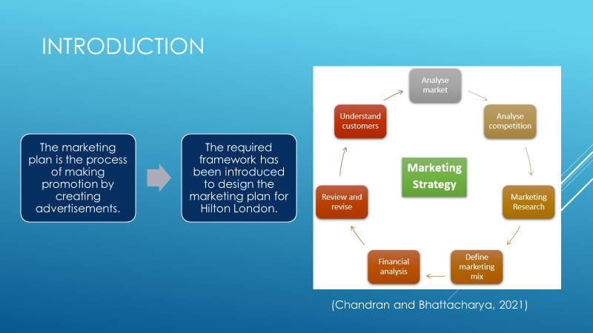
The marketing plan is defined as the process of making an operational approach by creating advertisements to target customers throughout the market. The presentation helps in displaying the required marketing plan of Hilton London. The key frameworks and key areas will be introduced for making a sustainable marketing plan for the business. Hilton London is situated in Park Lane, London. The hotel carries more than 450 rooms along with 56 suits. The various options will be viewed for the possible outcome of the business to find out the required measures.

Situation analysis
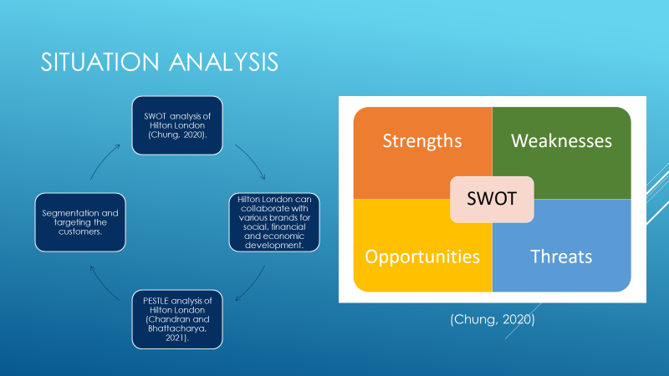
Hilton London is an industry related to the hotel industry. There are various aspects in terms of setting up the marketing plan of Hilton London. There are strengths, weaknesses, opportunities and threats to the business. Hilton London deals with hospitality and resort services. The possible strength will be the strong management system inside the industry. The weakness could be the amount or quality of services provided towards the customers. There will be various opportunities for Hilton London in terms of expansion of their business across the globe. The hotel will help in the segmentation of the people in terms of targeting people having a high pay scale. Hilton London helps in summarising the customers in terms of their profile. There are various competitors of Hilton London. The competitors such as Marriott, Hyatt, Ritz Carlton, Rosewood Hotels, etc. The competitors are there for having a good number of services towards the customers. There are various collaborations of Hilton London such as B2B relationships, partnerships and various franchises. These features help in making more profits and return financially. The collaboration with the brands helps in making posters, and designs for the market. There is various relationship management such as business-to-business relationships that help in maintaining the correlation between the organisational stakeholders. PESTLE analysis of Hilton London can be described with the clarification of all the factors. Political factors help the hotel to restrict them from not violating political laws. Economic factors are the factors that directly affect the hotel for generating economic growth. Social factors can be defined by the social position of the hotel by considering all the demands and needs of the customers. Technological factors can be implemented by introducing new technologies to provide services to the customers for having an advanced experience. Legal factors are the factors that define the rules and regulations of the government. Hilton London may face some issues in terms of non-violating governmental rules. Environmental factors can be defined by making eco-friendly activities by Hilton London.

Objectives
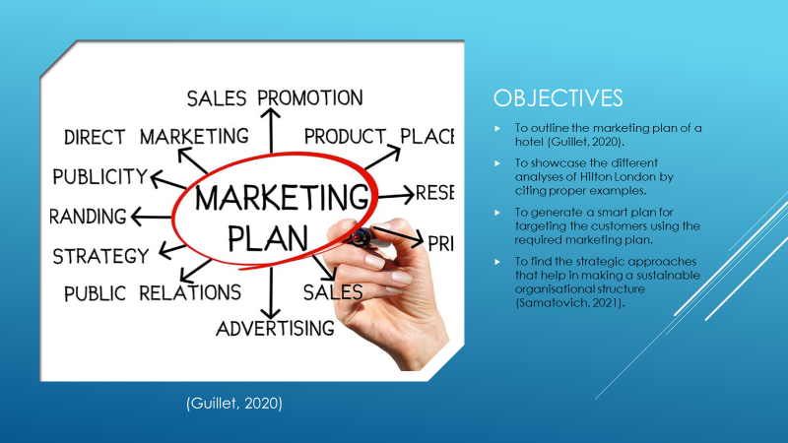
The presentation aims to find the required marketing plan that helps in the development of the Hilton London. The necessary strategic moves will be implemented for making a sustainable organisational structure. The presentation helps in summarising the tactics that need to be adopted by the hotel for making various changes. The main focus is to make a positive impact on the business as well as the customers. The objective is to find a specific marketing plan that will be unique across the market. The marketing mix along with various analyses has to be imposed by the business owner to outline the strategic plans to start off with the business.

Strategy
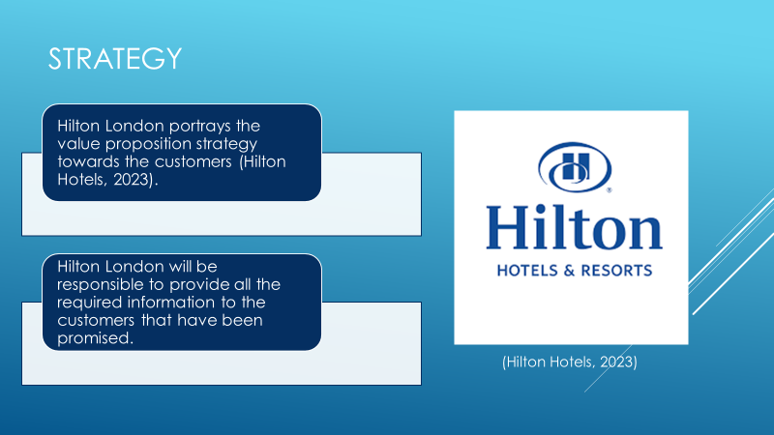
Hilton London helps in making the marketing strategy that defines the value proposition. The value proposition tells the description of the products and services that will be delivered to the customers. The proposition of the services promises the customers and the activities of Hilton London help in qualifying the whole segmentation. The segmentation process helps in classifying the customers according to their profiles and pay scales. Hilton London offers service packages to customers. The customers will get the services that help in getting packages offering the most comfortable and luxurious ways to the customers. The company are responsible to make every detail that will be important for gathering all the required information to summarise the aspects. The value proposition defines the promises that will be kept at the time of providing the services to the customers. The customers are very important for the hospitality industry because the Hilton London will be providing the services that will be effective in terms of gathering the information that helps in improving the services more for providing the most valuable services to the customers.

Tactics
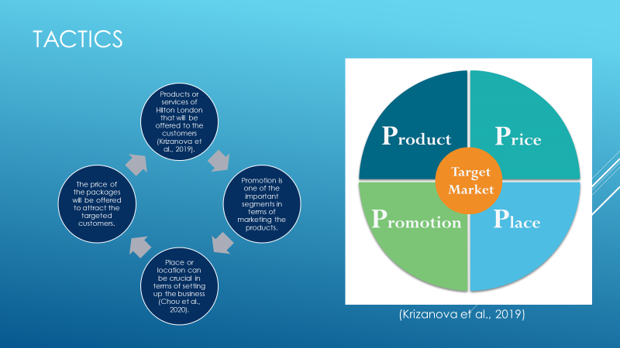
The marketing mix has to be implemented by Hilton London for making a sustainable marketing plan for spreading the services to the targeted audiences. The 4Ps of the marketing mix can be used for the marketing of their business. The product, price, place, and promotion are the four major factors of the marketing mix. The product defines the name of the products and services that will be offered to the customers. The place defines the areas where the hotel industry will be set up. The place or location can be crucial in terms of gathering or approaching customers. The customers will be connected in terms of visualising all the advertisements and promotional activities of the Hilton London. The price segment tells the actual expenses that will be required to experience the offered services. The promotional activity includes the process of promotion in terms of marketing the products by using social media platforms. This includes various promotional activities for making sustainable growth.

Action

Gannt Chart Analysis
(Source: As created by the author)
The required chart has been imposed to make the analysis of the various factors influencing the business.

Control
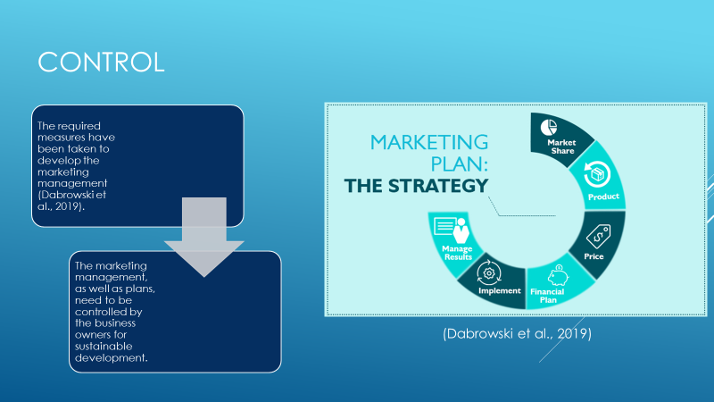
The measure of success can be described by the success major of the organisation by considering all the factors that will be helpful in terms of growth. Hilton London is the industry that helps in connecting new customers by doing effective promotions of the product or services. The services help in summarising the whole issue and upcoming possibilities of the company profile. Hilton London always focuses on the impact of positive attributes towards the organisation. The hotel needs to have certain measures by implementing new ideas that will boost them in gaining profits.

Conclusion
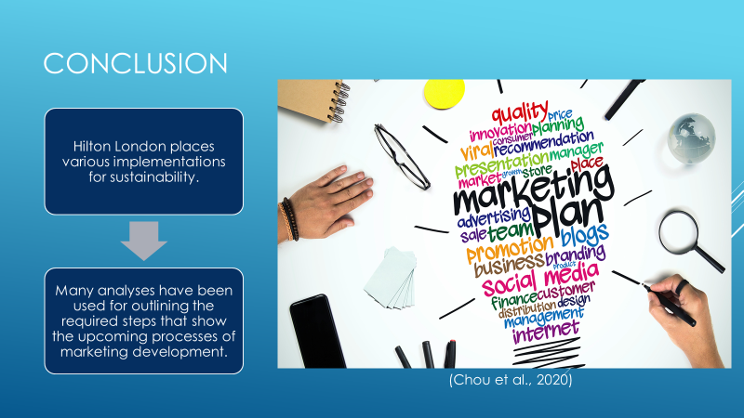
The presentation helps in summarising the whole marketing plan of Hilton London. Various analyses such as SWOT analysis and PESTLE analysis have been discussed to determine the required number of ways to develop the business. The marketing mix has been used for generating the tactics that will be used for making a change in organisational sustainability. The required number of schedules has been provided for implanting the issues and possible outcomes of the Hilton London.

References
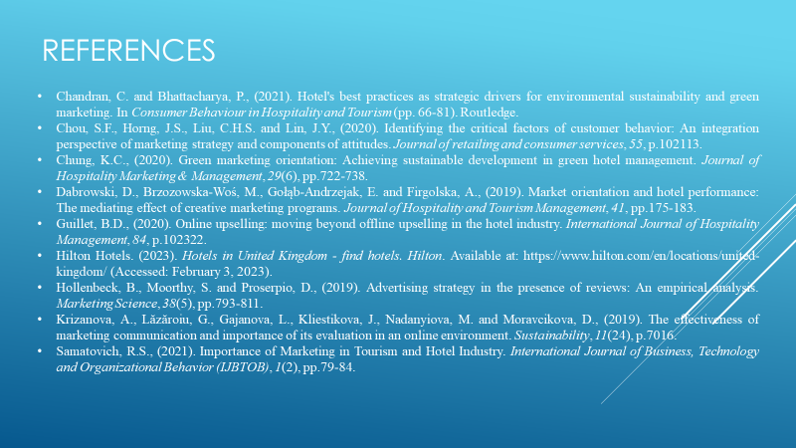
Chandran, C. and Bhattacharya, P., (2021). Hotel's best practices as strategic drivers for environmental sustainability and green marketing. In Consumer Behaviour in Hospitality and Tourism (pp. 66-81). Routledge.
Chou, S.F., Horng, J.S., Liu, C.H.S. and Lin, J.Y., (2020). Identifying the critical factors of customer behavior: An integration perspective of marketing strategy and components of attitudes. Journal of retailing and consumer services, 55, p.102113.
Chung, K.C., (2020). Green marketing orientation: Achieving sustainable development in green hotel management. Journal of Hospitality Marketing & Management, 29(6), pp.722-738.
Dabrowski, D., Brzozowska-Woś, M., Gołąb-Andrzejak, E. and Firgolska, A., (2019). Market orientation and hotel performance: The mediating effect of creative marketing programs. Journal of Hospitality and Tourism Management, 41, pp.175-183.
Guillet, B.D., (2020). Online upselling: moving beyond offline upselling in the hotel industry. International Journal of Hospitality Management, 84, p.102322.
Hilton Hotels. (2023). Hotels in United Kingdom - find hotels. Hilton. Available at: https://www.hilton.com/en/locations/united-kingdom/ (Accessed: February 3, 2023).
Hollenbeck, B., Moorthy, S. and Proserpio, D., (2019). Advertising strategy in the presence of reviews: An empirical analysis. Marketing Science, 38(5), pp.793-811.
Krizanova, A., Lăzăroiu, G., Gajanova, L., Kliestikova, J., Nadanyiova, M. and Moravcikova, D., (2019). The effectiveness of marketing communication and importance of its evaluation in an online environment. Sustainability, 11(24), p.7016.
Samatovich, R.S., (2021). Importance of Marketing in Tourism and Hotel Industry. International Journal of Business, Technology and Organizational Behavior (IJBTOB), 1(2), pp.79-84.

Appendices



