LCLM4002_BIRM Digital Skills Task 3 Website Evaluation
Student Number | 2436275 | Student Name | Zaffar Hussain
Website Chosen | The Highfield Town House Hotel
Insert hyperlink to website | https://www.highfieldedgbaston.co.uk/our-rooms/


Answer: The Highfield Town House Hotel website loads efficiently and quickly, offering a smooth user experience across devices. On both desktop and mobile platforms, the homepage is accessible within a few seconds, with most media and textual content visible almost instantly. The site appears to use compressed images and minimal interactive scripts, helping reduce page weight. Even during periods of high traffic, such as evenings or weekends, there’s no noticeable lag (Fellinger and Fronimaki, 2024). This reliability in speed supports customer engagement and retention, especially when users want quick access to menus or booking details. An intuitive layout further ensures users aren’t stalled while navigating or waiting for content to appear.
Answer: The site is built with a clear and logical structure that includes several sub-pages, such as those for bookings, menus, events, and the gallery. Navigation includes pages like Rooms, Dining, Location, and Contact. Navigation is simple and user-friendly, made possible by a persistent top navigation bar on desktop and a responsive hamburger menu on mobile. Each sub-page is easily accessible through these menus. Additionally, prominent call-to-action buttons like “Book a Room” and “Dining” direct users seamlessly to relevant sections. Customers can explore offerings without needing to scroll excessively or use a search bar, although adding one could enhance usability even more.
Answer: Yes, the customers can make also direct booking via Web-site. The home page and other important pages have a button that reads, Book a Room. It brings the user back to the third-party booking service, Siteminder, where a user can choose a date, time, and a number of visitors. It is simple and fast where very little input is needed. Confirmation messages are delivered upon booking thus helping to reassure the customers. It is a necessity in hospitality business and the incorporation of other tools on the external sites into the main site is a boost to the professional and convenient architecture of the latter..
Answer: Even though it can be considered effective overall, there are some points that could be enhanced to improve the user experience. One is to include a search bar so that users could find a particular content more quickly. The accessibility might be enhanced by the possibility to increase the font size, have a higher contrast between the letters and the background, and adding the alt text to all the images to support the visually impaired individuals. Such a button as the one saying that one can book now could also be a little more attention-seeking by use of colour difference, or animation. Lastly, it would reduce instances of awkward cropping or resizing due to differences when formatting the images on different devices, especially when the mobile device is relatively small.
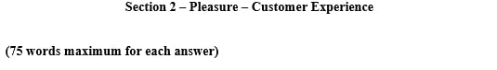
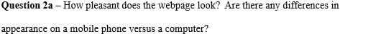
Answer: The Highfield Town House Hotel website is visually attractive, combining elegant modern hotel aesthetics with clean design elements. Soft tones like ivory, sage, and blush reflect a boutique feel, while high-quality images create an inviting impression. On desktop, the layout is well-balanced and clean. On mobile, the site adjusts responsively, though some elements like large images appear slightly cropped (Fellinger and Fronimaki, 2024). Overall, the mobile site retains most of the aesthetic and functional qualities of the desktop version, which is crucial in ensuring a consistent and engaging customer experience regardless of the device used.
Answer: The site relies heavily on strong, high-resolution imagery to create atmosphere and tell the brand’s story. Pictures of rooms, dishes, and architectural details dominate each page, offering users a visual taste of the venue. The colour scheme, consisting of subtle pastels and neutrals, enhances feelings of comfort and hospitality. Videos are not currently used, which is a missed opportunity to engage users more dynamically. Integrating short clips showcasing live events, food preparation, or customer testimonials could enrich user engagement and provide more sensory appeal.
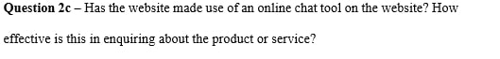
Answer: The website does not currently feature an online chat tool or chatbot. This is a limitation, especially in an era where customers expect real-time responses. If a visitor has a specific question regarding allergens, private hire, or parking, they must resort to calling or emailing, which may not be efficient. Adding a simple chatbot or a live support feature would enhance usability by offering immediate support, reducing customer hesitation and increasing the likelihood of on-the-spot bookings or enquiries. It would also modernise the site and reflect well on customer service responsiveness (Hoang, 2024).
Answer: The social media icons are visible in the footer and link to active Facebook and Instagram pages. These platforms are regularly updated with promotions and event announcements. However, the links could be more prominent and included higher up on the homepage to encourage better user engagement.


Answer: The services, including food, drinks, private hire, and live events, are detailed on dedicated sub-pages. For Highfield, this includes rooms, dining options, and location details. All the services contain the description in textual form, pictures and links of further activities, e.g. booking or inquiries. Special features such as afternoon tea and boutique interiors are also prominently there on the site to the point that the customers know what they are getting.
Answer: Customers do not leave reviews anywhere on the site, but they can be read on such external sites as Google Reviews and Facebook. These are recent reviews and they are mostly positive with most of them commenting on the quality of food, atmosphere and the pleasant service. It would enhance the testimonial results by using them on the site and also retain the user on the same page. Furthermore, using plug-ins to display live reviews would keep the feedback current and authentic. Featuring specific quotes or images from reviewers could also serve as strong social proof for prospective customers.
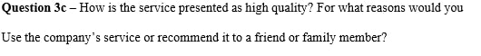
Answer: The website conveys a high level of service quality through both visual and textual cues. Professionally taken photographs, curated menus, and polished typography lend the site a premium feel. Descriptions of locally sourced ingredients and carefully crafted dishes suggest a strong commitment to excellence. I would personally recommend the service based on the transparent presentation of its offerings, the cosy yet upscale ambience shown, and its suitability for both casual dinners and special occasions. The overall impression is of a business that takes pride in delivering a memorable customer experience (Hoang, 2024).
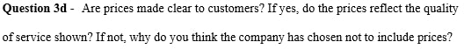
Answer: Yes, the site provides clear pricing for most of its services, especially food and beverages. The menus include detailed descriptions and prices, allowing customers to plan their visit accordingly. This transparency is reassuring and suggests good value. For event or private hire services, prices are not listed, likely due to the customizable nature of those bookings. In such cases, requiring customers to enquire allows the business to offer tailored quotes. Overall, the prices displayed align well with the premium experience presented, indicating a fair balance between cost and value.
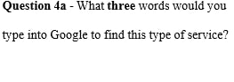 | 1. Boutique hotel Birmingham
 | 2. Luxury stay Edgbaston
 | 3. Afternoon tea Birmingham
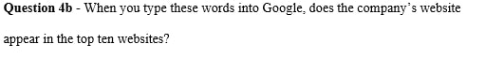
Answer: When these keywords are entered into Google, the Highfield Town House Hotel website typically appears within the top ten results for “Boutique hotel Birmingham” and “Afternoon tea Birmingham.” Its ranking is slightly lower for “Luxury stay Edgbaston,” possibly due to competition or insufficient keyword optimisation. The business has made efforts in SEO by using location-based phrases and tags, but could benefit further from a blog or regularly updated news section that targets long-tail keywords and seasonal search trends (Kamel, 2023).

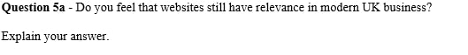
Answer: Websites remain highly relevant in the UK’s modern business landscape. They act as digital shopfronts, offering control over brand presentation, customer engagement, and service accessibility. Despite the rise of social media and mobile apps, websites provide greater depth of information and serve as a central hub for all digital activities. For small businesses, especially, a well-designed website fosters credibility and trust. Customers still turn to websites for bookings, location info, menus, and direct contact. Without one, businesses risk appearing outdated or less professional compared to competitors with polished digital platforms.
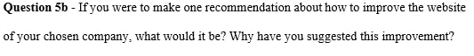
Answer: The one improvement I would recommend to the Highfield Town House Hotel website is to add the chat tool or chatbot to it. This would offer immediate customer care and eliminate the possible obstacles to booking or inquiring of services. Considering that most of the users would favour messaging than phone usage, a chat feature would address this behavioural change. It shows the sensitivity towards the customer concerns as well and would minimize the amount of time required by the staffs to answer the same questions. Having this feature would make the site more contemporary, interactive and eventually more useful in the transformation of interest to action

Reference List
Fellinger, L. and Fronimaki, D. (2024). Enhancing user experience: Unveiling the impact of website speed optimisation on user engagement. Journal of Digital & Social Media Marketing, [online] 11(4), pp.324–338. Available at: https://www.ingentaconnect.com/content/hsp/jdsmm/2024/00000011/00000004/art00003.
Hoang, M. (2024). The Impact of Visual and Interaction Design on User Experience: A Case Study of Wolt’s Application and User Behavior. Theseus.fi. [online] doi:http://www.theseus.fi/handle/10024/877355.
Kamel, L. (2023). The Implementation Plan of Digitalization to Enhance Customer Experience in Stella Gardens Hotel. [online] www.theseus.fi. Available at: https://www.theseus.fi/handle/10024/801740.

