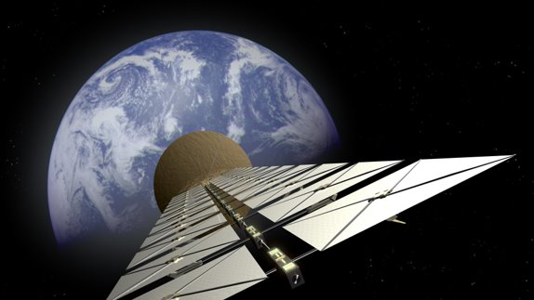  Solar energy from space | Abstract  This is a report on an energy resource from space and how this could improve our future in environmentally  Cameron Finch

Contents Page
- Introduction
What is solar energy from space, how does it work and what are the costs?
- How the media portrays Space Based Solar Energy?
Space Based Solar Energy Vs Solar Energy on Earth.

- Conclusion

Introduction
This report is based around solar energy from space and how it can potentially power our future by taking over our main power source from fossil fuels such as petroleum and coal. I will be covering many aspects by researching how far in development this type of energy source is, how does is this all done, how efficient this method is and how the media portrays this idea. This report is for anyone who takes an interest in this subject and wants a better understanding.

What is solar energy from space, how does it work and what are the costs?
For this aspect of my research I used a website called https://www.spacelegalissues.com and they had an article from April 15th 2019 explaining what space based solar power (SBSP) is and had a lot of useful information on how it worked. SBSP is very similar to how we use solar panels down here on earth but the first main advantage of it being in space is that there is far higher collection period than we would have from down on earth. It could also be possible to position a solar collector in an orbiting location where there is no night period. This energy is then converted to microwaves and sent to a receiving station down to earth via microwave or laser beam.
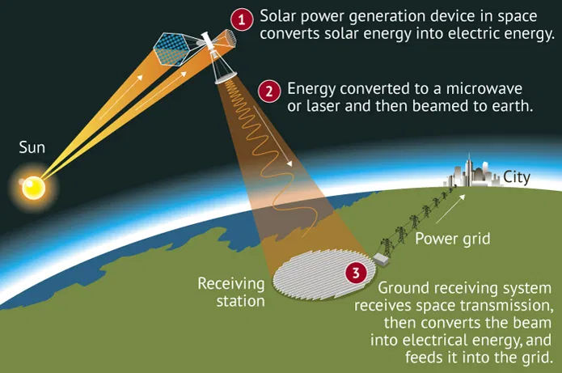

The first con we come across is the cost to make this happen. The cost to get this equipment will be awfully expensive and also getting all that equipment up into space is very expensive. According to Wikipedia the launch of the equipment varies on the weight of the equipment. This will cost you $100-$200 per kilogram of payload from low earth orbit to geosynchronous orbit this is crucial for SPS to be economically viable. That is if everything goes to plan. If there is any damage while being sent into orbit it could affect the generator massively.
How the media portrays Space Based Solar Energy?

On the 26th of November 2020 the BBC done an article on space based solar energy called “The solar discs that could power Earth” in the first part of this article they state that “Space-based power stations are turning from an idle dream into a serious engineering prospect, as scientists hope they can take renewable energy into orbit.” This shows me that even though this project is still in early stages of development they really think that this could be the future of renewable environmentally friendly energy to power earth. They also go on to say that “The aim is that solar power stations in space will become a reality in the coming decades”.
The information I gathered from this bbc news articles shows that even though that this is in early stages of development they really believe that in the future this can really benefit the planet. This also tells me that they have faith in the scientists that are studying and working on making this dream a reality.

Space Based Solar Energy Vs Solar Energy on Earth.
A website called green match wrote an information piece on how more affective Solar Energy up in space is compared to down on earth. This is what they stated. “Space-based solar panels can generate 2,000 gigawatts of power constantly. This is 40 times more energy than a solar panel would generate on Earth annually. This is also several folds higher than the efficiency of solar panels today. “This statement tells me why people are so committed to make this happen even though it is a very long and hard process which will take decades to master. They also explain how this is better by saying “pace-based solar power has several benefits; unlike solar panels on our roofs that can only generate electricity during the day, space-based solar power can generate continuous electricity, 24 hours a day, 99% of the year.

This is because, unlike Earth, the space environment does not have night and day, and the satellites are in the Earth's shadow for only a maximum of 72 minutes per night.”

Conclusion
Before I started my research into space based solar energy I thought it was very interesting as it would be able to drastically help the earth environmentally and also be far more effective than doing it from down here on earth. What I didn’t realise was how hard it actually is to actually do and how early the stages of development were. But even though the task at hand is very complicated a lot of people are committed to making this happen to try and drastically help the environment on earth. I do believe that eventually we can master the process of space based solar energy as technology is advancing more and more every day. But I do think that it is going to take us 20 to 30 years before this starts taking over as our main source of energy down here on Earth.

Bibliography

Author | Louis Matignon
Article title: | The legal status of Chinese space-based solar power stations
Website title: | Space Legal Issues
URL: | https://www.spacelegalissues.com/the-legal-status-of-chinese-space-based-solar-power-stations/
Publication date: April 15th 2019

Author | Amanda Soldini
Article title: | The solar discs that could power Earth
Website title: | Bbc.com
URL: | https://www.bbc.com/future/article/20201126-the-solar-discs-that-could-beam-power-from-space
Publication date: 26th November 2020

Article title: | Is Space-Based Solar Power Our Future? (2022)
Website title: | Greenmatch.co.uk
URL: | https://www.greenmatch.co.uk/blog/2020/02/space-based-solar-power
Publication date: 17 December 2021

