
Howdens Joinery Plc 2024 annual report financial findings & Westward plc captial investment appraisal
Gareth R Francis 1707331

January 12, 2026
University of Wales Trinity Saint David

Executive Summary
The purpose of this report is to analyse the financial performance of Howdens PLC by retrieving their 2024 Annual Financial Report, compiling financial ratio based on the profit and loss, balance sheet. Ratio to be calculated will using several financial ratios such as, Profitability, Liquidity, Gearing, Efficiency and Investor ratios to determine how well the company is performing, by comparing year on year (2024 vs 2023), industry benchmarking and literature review.
Gross Profit margin found to be consistent, measured at 61.6% (2024) and 60.8% (2023) which is a slight growth of 0.8% composed to a benchmark level of 50% in similar industry. Net profit margin health as well, measuring at 14.6% and 14.7% for 2024 and 2023 respectively compared to an industry average of ~10%. Sales turnover and Operating Profits appear to be in control. Return on Capital Employed showed a year-on-year reduction of 2% going from 21.3% in 2023 to 19.3% in 2024 but still appearing in a financially strong position compared to industry data of 20%.
Current Ratio appears consistent and in control as they can pay their current liabilities immediately if needed. Calculations at 2.1 times and 1.9 times for 2024 and 2023 respectively confirms more current assets available than current liabilities, Industry experts stipulate a value above 1 time as good. Quick Ratio also strong measuring at 1.3 times (2024) and 1.1 times (2023), indicating they have the means to quickly convert their products for sale and generate cash to pay any immediate liabilities. Average values are found to be 0.8 times, with 1 time described as very strong!
Gearing and Interest Cover ratio could not be calculated based on the fact Howdens does not appear to have any long-term borrowing. No loans, short or long term and no overdrafts visible. Therefore, this provided a value on both ratios of 0. This appears to be non-standard in business world, as typically borrow is the main method of investment, but appears to be relatively cash flow positive.
Debtor days did see an increase from 31 days in 2023 up to 42 days in 2024 appears to slightly outside of the normal business terms of 30 days. This could be due to suppliers not having the means to pay on time as they’re awaiting payment from their supplier, with a reduction of cash flow to pay on time. Similar increase of 8 days with creditor days from 150 to 158 which appear to be part of payment terms with suppliers.
The summary of Howdens 2024 financial performance appears to stable, consistent and comparable to that of 2023. There are a few negatives and positives but overall, they are well with control of profits, liquidity, efficiencies and have the capital in hand.

Westward PLC proposed to expand the business with 3 different project options. Option A has a proposed initial outlay of 600k, Option B, £1M and Option C based on £1.6M over a 4-year period. As part of the evaluation process the use of investment appraisal technique, namely Net Present Value was used to calculate the cash flow and potential return to support with decision making. Option A measured at £919,00, Option B, £1,158,660 and Option C, at £1,153,750 all provide a positive outcome based on the results, it was decided to pursue with Option B as the largest return.
Internal Rate of Return technique also used to understand the maximum cost of the project when changing the discounting value to almost 0. The value was found to be around the 42% as returned a negative value of £2,649.
Comparison study made on the 4 main investment appraisal techniques, namely, Accounting Rate of Return, Payback Period, Net Present Value and Internal Rate of Return to determine the difference and why the use of net present value is deemed the best method. Net Present Value established as best of investment appraisal technique based on fact assumptions of changing the value of money as today further down the line, as time changes value of the money and provides a definitive quantifiable metric with cash flow providing safe and security investment, Negative value signifies a negative cash flow and should result in the rejection of said project.
Recommendation based on appraisal of combining all 3 options to maximise wealth considered by the introduction of Profitability Index (PI) to aid with further decision making by means of ranking mechanism providing guidance on which projects to fund first and if project is divisible the cut of project is funded in part and they are proportional. Option A measured with a PI of 1.53, Option B, 1.16 and Option C had a PI of 0.72. based on the results it was determined that Option C which provided a negative return and less favourable for investment with combining Option A and B to maximise wealth opportunity. However, partial investment could be covered if all 3 projects were to be granted.
Financing the project can be done in several ways such bank overdraft but deemed not viable based on required spend. Medium term borrowing as in a bank loan realistic, but considerations on the affordability must be taken as there will be interest payable, but also a need for a good credit rating to secure the funds at the lowest rate. Long term borrow option could be selling further ordinary share to either current shareholder or on the marketplace, but caution needs to be taken as this could result in more voices, as part of the business. Other feasible option could be to secure local, nation or private funding.

Table of Contents
Executive Summary 1
1.0 Introduction Overview 5
1.1 Howdens Joinery Group PLC Introduction 5
1.2 Westward PLC Introduction 5
2.0 Main Findings 6
2.1 Task 1 – Howdens Joinery PLC 6
2.1.1 Profitability Ratios 6
2.1.1.1 Return on Capital Employed 6
2.1.1.2 Gross Profit Margin Ratio 6
2.1.1.3 Net Profit Margin Ratio 7
2.1.1.4 Assets Turnover 7
2.1.2 Liquidity Ratios 8
2.1.2.1 Current Ratio 8
2.1.2.2 Quick Ratio 8
2.1.3 Gearing Ratio 8
2.1.3.1 Gearing 8
2.1.4 Efficiency Ratios 9
2.1.4.1 Debtors Days Ratio 9
2.1.4.2 Creditors Days Ratio 9
2.1.4.3 Stock Turnover Days Ratio 9
2.1.5 Investor Ratio 10
2.1.5.1 Dividend Cover 10
2.1.5.2 Interest Cover 10
2.1.6 Limitation of Ratio Analysis 10
2.1.7 Recommendations 10
2.2 Task 2 – Westward PLC 11
2.2.1 Net Present Value Technique 11
2.2.2 Internal Rate of Return Technique 11
2.2.3 Net Present Value and Other Investment Appraisal Methods Uses 12
2.2.4 Other Factors to Consider Prior to Investment 13
2.2.5 Limited Available Funds 13
2.2.6 Method to Fund Capital Investment 13
3.0 Conclusion 14
3.1 Howdens Joinery Conclusion 14
3.2 Westward PLC Conclusion 15
4.0 Bibliography 16
5.0 Appendix 20
5.1 Howdens Joinery Ratio Calculations 20
5.1.12 Howdens Joinery 2024 Annual Report – Income Statement 22
5.1.13 Howdens Joinery 2024 Annual Report – Balance Statement 23
5.1.14 Howdens Joinery 2024 Annual Report - Change in Equity Statement 24
5.2 Westward PLC 25
5.2.1 Net Present Value Calculation 25
5.2.2 Internal Rate of Return Calculation 26
5.2.3 Project Re-Calculation with Profitability Index (PI) 26

1.0 Introduction Overview
The content in this report will be split into two sections. Section 1 will evaluate a company listed on the FSTE 100 Index, trading on the London Stock Exchange. Whereas in Section 2, there will be an in-depth analysis of a company called Westward PLC exploring the idea of expanding their business by considering 3 different options within a four-year period.

1.1 Howdens Joinery Group PLC Introduction
Howdens Joinery Group PLC is a company trading on the London Stock Exchange, part of the FTSE 100 index. The FTSE 100 is designed to track the stocks and performance of the top 100 companies in the United Kingdom (Hargreaves Lansdown, 2025), providing a key performance indicator into the United Kingdom’s markets, whilst also acting as a leading indicator of prosperity for companies and the economy. It’s also used as a benchmark tool the helps investors assess and compare market performance worldwide (Investopedia, 2025).
Howdens is a leading kitchen supplier specialist founded in 1995. The company has gone from 14 depots from its founding, growing up to 953 deports within the United Kingdom and Europe. Their main business model is to provide and sell to trade professionals with high end quality products, aiming to provide satisfactory to their customers with excellent depot management and dedicated supply chain delivering and efficient and effective stock management. This model has allowed the company to amass revenues of £2.3bn and pre-tax profits of £328m in both 2024 and 2023 respectively (Howdens, 2025).
The report will critically evaluate and analyse Howdens Joinery PLC based information from their published 2024 Annual Report and Accounts by comparing years 2024 against 2023. Main aspects of the report will be using financial ratio, calculating Profitability, Liquidity, Gearing, Efficiency and Investor ratios to analyse any potential differences and limitations of the ratio analysis and make any recommendations on how the company could improve their financial management.

1.2 Westward PLC Introduction
Westward PLC is a company that produces high end quality curtains and have identified 3 possible projects which could help grow the business with a 4-year plan. Option A is to expand their successful retail outlet to include all products for sale, requiring an initial capital expenditure of £600k. Option B is to develop into internet sales by investing £1M and Option C is to venture into a new product line and produce wooden and roman blinds with £1.6M needed to do so.
To calculate what project would be more viable, ultimately increasing business wealth and profits, the report will use a capital investment appraisal method to evaluate what is the best option for the business. The use of Net Present Value technique will be used based on the estimated cash flow of the 3 projects over the 4-year period, with further analysis required based on the corporation tax of 25%, capital allowance of 20% based on a straight line and cost of capital (discounted value) of 6%. Thereafter, a proposal for which project Westward PLC should pursue, further cemented by the using an additional investment appraisal technique called Internal Rate of Return. The report will also review the benefits of using these types of analytical tools to issue good decision making, whilst providing arguments / discussion points around why the use of net present value is the perceived best technique. Additional comparison with 3 other investment appraisal methods will be undertaken, with the understanding the popularity of the use of non-discounting methods and other factors prior to proceeding with investments.

2.0 Main Findings

2.1 Task 1 – Howdens Joinery PLC

2.1.1 Profitability Ratios

2.1.1.1 Return on Capital Employed
According to (Law, 2014) Return of Capital Employed ratio is one of the most used ratios used to assess a company’s performance in terms of gauging its profitability. This statement coincides with (Marr, 2012) as he goes into further details as to as when an organisation or shareholder has interest in investing then the main objective is to gain a positive return of the capital invested via profit. The metric is often used by many investors as believed to be the best measure / KPI to assess an over performance of an organisation by providing information around how successfully investment has been employed by owners and creditors on said project. The higher the ratio, the more efficient use of funds and better profit established.
The performance of Howdens found that there is reduction of exactly 2% from 2024 (19.3%) to 2023 (21.3%) based on the calculated Return of Capital Employed. Typically for businesses with a Return of Capital Employed of at least 20% suggest an organisation is in a good financial position (Investopedia, 2025) compared to (Analyst Interview, 2025) which say above 10-15% is of strong positioning. Therefore, it appears this comparative information indicates that Howdens is performing strongly as in and around overall industry average.

2.1.1.2 Gross Profit Margin Ratio
Gross Profit Margin ratio is widely used ratio whereby deducting the cost of sales, which is formed by the direct production output and distribution costs that occurs within an organisation (Welwyn, 2024). This ratio defines the efficiencies of its goods and services by understanding the percentile taken away from each pound of cost of goods sale (Clayman, et al., 2012) from allowing to establish how much money is available to cover the companies’ overheads, other expenses and allowance of retaining earnings and dividends. Therefore, naturally, a high gross profit margin would suggest that an organisation is keeping its cost under control. On the contrary, a low gross profit margin would indicate an organisation not keeping costs under control likely due to high production cost and production / operations efficiencies not being managed appropriately (Marr, 2012).
The analysis and calculation from Howdens 2024 annual report found that Gross Profit Margin for 2024 was 61.6% which was 0.8% up in comparison with 2023 at 60.8%. When comparing the 0.8% delta from ’24 to ’23 there appears to be due to 2 key aspects for the increased Gross Profit Margin based on the numbers inputted to the formula. Increase of Sales by £11.2 million and a reduction of £16.0 million for the Cost of Sale. According to an article on (Forbes, 2022) they report that a 50% gross profit margin to with an retail average apparel is of good performance, however, another article from (Vena Solutions, 2024) suggest that an average gross profit margin in the retail sector for building supplies to be 34.2%. this would indicate that Howdens is performing very strongly within its sector.

2.1.1.3 Net Profit Margin Ratio
Net Profit Margin is a KPI (key performance indicator) used to gain an understanding of how much net profit is, as a ratio over its total sales or revenue, in essence, for each pound of sale, how much profit is generated (Holmes, 2008). The ratio emphasises how well a company is performing in terms of its efficiencies and day-to-day management of controlling costs. Low profit margins can indicate too high operating costs or incorrect pricing structure, resulting in lower safety margin, can cause significant problems to a business if there is downturn in the industry, by declining sales or increase of raw materials reducing profitability and even start heading towards a low making (Marr, 2012)
In the case of Howdens, net profit margin for 2024 and 2023 have been calculated at 14.6% and 14.7% respectively, resulting in a slight reduction of 0.1% for 2024 compared with 2023. This suggest that Howdens is keeping their consistency in terms of costs and overall sales with expected good net profit margin of more than 10% seemingly above average within the United Kingdom (Annette&Co, 2026). The typical benchmark for industry of building supplies retail according to (Vena Solutions, 2024) is 8.4%. However, (The Finance Weekly, 2024) have indicated that a net profit margin of 5-15% as being good with 15% or more as exceptional. Additionally, Retail industry benchmark to be generally between 2-6% due to high cost of goods and competitive pricing strategies. It appears to confirm that Howdens is performing strongly within its industry / sector.

2.1.1.4 Assets Turnover
Return on Assets is a used to calculate the return of investments used to acquire new assets such as new premises, equipment and machinery and how to best optimise their uses to generate an income. The use of this metric could be relevant to a comparable companies and industry as a below average indicates an inefficient use of the business assets (Marr, 2012).
Based on the calculations, the asset turnover of Howdens is 1.3 time for 2024 and 1.4 times for 2023 indicates that the organisation is utilising its asset use consistently and within a controlled manner year on year. Based on an article by (Anon., 2017) an asset turnover ratio of greater than 15% appears to put a company in a good position. The 15% indicates that 0.15p is generated per £1 of asset use.

2.1.2 Liquidity Ratios

2.1.2.1 Current Ratio
The current ratio is a commonly used liquidity ratio to determine if a company can pay their current obligations. It provides information to investors, shareholder and analysts to see if an organisation is maximising their current assets whilst being able to pay their liabilities within the financial year. This measure in essence provides the capability to determine whether an organisation can fulfil their short-term financial obligation if debt is required to be paid in one occurrence.
Howdens appears to be in a position the position to pay their current liabilities should there be an immediate need. Based on the calculations, 2.1 times and 1.9 times for 2024 and 2023 respectively as there is more current assets available than current liabilities. Based on typical benchmark data, it appears anything above 1 time puts an organisation in a good position and not at risk (Walsh, 2012).

2.1.2.2 Quick Ratio
The quick ratio measures enable a company to determine its means to pay short term obligation by using the most liquid form of assets, typically, does it have the cash to pay it current liabilities. The method to calculate the quick ratio is to surmise the total current assets and deduct the inventory and divide by the current liabilities (Walsh, 2012).
Howdens for 2024 and 2023 have a similar return of 1.3 and 1.1 times respectively, indicating they have the means to quickly convert their products for sale and generate cash to pay any immediate liabilities. The main differences between both years appears to be that the stock (2024: £390.7M, 2023: £382.8M) and current assets (2024: £1.05B, 2023: £900M) values have increased in comparison. This could be due to valuation of raw materials subsequently being based on to the cost of goods and inventory. Average values are found to be 0.8 times, but according to (Walsh, 2012) a value of 1 time is very strong.

2.1.3 Gearing Ratio

2.1.3.1 Gearing
Gearing ratio is commonly used by investors to gain an understanding of an organisations financial leverage by determining the debt-to-equity ratio. This defines the means of how funds are acquired through loans, debt or equity capital. This is calculated by compiling the long-term debt, short term debt and bank overdraft and dividing by shareholders equity/funds (Barrow, 2011).
In the case of Howdens, it appears that there are no short- or long-term debts nor bank overdrafts suggesting that the company does not have any debt obligations of concern. This was found for both years 2024 and 2023, which is typical unusual, as businesses tend to have some sort of debts/borrowing.

2.1.4 Efficiency Ratios

2.1.4.1 Debtors Days Ratio
Debtors Days is a metric used to establish how well an organisation is at collecting outstanding debt from its customers. In general, the lower the number of days it takes the better as this means there’s a positive cash flow. Business typically has credit agreement (Cheng & Pike, 2023)with their customers and suppliers based on risk factors, with many businesses using credit rating agencies (Pike & Cheng, 2001) to define what is an acceptable level.
Howdens appear to have increase the number days it takes to receive payment of outstanding debt when comparing the 31 days from 2023 with 42 days, this amassing to an increase of 11 days, albeit relatively in control. The perceived normal payment terms are 30 days within business; however, many businesses are failing to pay within this period, many averaging more than 50 days (Rich, 2011). Therefore, the increase of 11 days may be due to suppliers not having the means to pay on time as they’re awaiting payment from their supplier, with a reduction of cash flow to pay on time.

2.1.4.2 Creditors Days Ratio
Creditors days ratio provides a measure of how long it for an organisation takes to pay its creditors (Law, 2014). Organisations will typically have a credit payment agreement in place which stipulates when to pay a required invoice. These tend to have been in place based on good relations by ensuring paying on time and in full (A & C Black, 2011).
Howdens is found to have creditor days of 158 days for 2024 and 150 days for 2023, resulting in an increase of 8 days year on year. Based on this data, it appears that Howdens have a long-term payables agreement with their creditors due to the consistency of the terms. A report by (Mercer & Rossini, 2012) suggesting that private companies in Italy were taking on average between 60-90 days to pay creditors with public sectors can be long at 180 days to even a year or more.

2.1.4.3 Stock Turnover Days Ratio
Stock Turnover ratio is a method to measure how efficient a company is converting its stock into customer sales. Holding on to stock can be expensive if not converted in a timely manner as can be subjected to degradation (Marsh, 2012) of time dependant on what the product is and the environment stored.
Howdens stock days turnover has been measured at 160 days and 154 days for 2024 and 2023 respectively. According to report by (Boisjoly, et al., 2020) the average stock turn over days is 173 days, but this does include all types of products and industries. However, the information indicates that this is seen within industry and deemed fir for purpose, likely as there are no shelf life on produced materials.

2.1.5 Investor Ratio

2.1.5.1 Dividend Cover
Dividend Cover ratio provides information of how many times a dividend could be paid from earnings (Marsh, 2012) According to Corporate Finance Institute, a dividend cover level of less than 1.5 times could be a reason of concern, on the contrary, a value above 2 times is considered a health ratio (Corporate Finance Institute, 2026). In the case of Howdens, dividend cover is measured at 2.2 times for 2024 and 2023. This provides information that they can pay more than 2.2 times than the provided dividend figure.

2.1.5.2 Interest Cover
Interest Cover Ratio indicates how easy an organisation can pay interest on any outstanding debt by dividing the profit before interest and tax by the interest on any long-term borrowing. Based on information from (Hayes, 2025) when an interest ratio of below 1.5 it can only cover its obligations by 1.5 times and may question the companies’ ability to pay the interest expenses in the long term.
However, as highlighted in the Gearing ratio, Howdens does not appear to have any long-term borrowing and therefore, does not have any interest payment to pay lenders. The measured result has been calculated at 0 times.

2.1.6 Limitation of Ratio Analysis
Financial Ratios is a useful tool to analyse an organisations financial situation. However, during the findings in this report there are several limitations observed. Identifying an industry benchmark is not a clear-cut information to obtain. In the example of Howdens, they’re a renowned kitchen supplier operating in the United Kingdom, Ireland, Belgium and France with a specific business model in that they only provide product to tradespersons with expertise. Therefore, attempting to find a direct comparative benchmark is difficult to compared. Additionally, as predominantly a kitchen consumable supplier also diversifies into other sectors such as joinery and bedrooms (Howdens, 2025), this further skewing comparative methods. It’s worth noting that industry benchmarking may not be as representative of performance as this each organisation have their own internal target that may be acceptable, and even in some cases, differences in operational output such as inventory using just-in-time (JIT) in turn having a lower inventory turnover ratio (Martin, 2014).

2.1.7 Recommendations
Based on the analysis carried out using the financial ratio, there is key aspects which could be improved in the future for Howdens. An increase of 11 days compared to 2023 and 2024 in receiving payment from customers appears to be a significant increase and may affect the cash flow on the inflows and outflows. Based on the data in the 2024 balance sheet, Howdens annual sales for the financial year were £2.3bn and by reducing the debtor day by 11 this would provide another £69m to the bottom line each year, resulting increase of cash flow and higher profit margin. This value was obtained by using a simple model of using the delta days from 2024 and 2023 and dividing by the number of days in the year and then multiplying by the yearly sales (Stewart Account Services, 2026). All this allowing for shareholder to receive more dividends per annum. Additional screening on customer account to determine whether there are the same offenders each month causing delay in payments, this could be done by continued credit searches (Beech, 2008). Further benefit to Howdens could be to determine the feasibility to use system such as ERP (Enterprise Resource Planning) to control the full supply chain management to improve performance operationally and financially (Sen & Karia, 2024).

2.2 Task 2 – Westward PLC

2.2.1 Net Present Value Technique
The purpose of using Net Present Value technique is to provide an estimate of the cash inflows and outflow (Gul, et al., 2018) whilst also ensuring maximisation of shareholder wealth by investing a project that return a positive yield based on using discounting method by attributing an appropriate cost of capital and discounting against the cash flows (Laws, 2018). The basic method of decision making using this appraisal method, is if a positive net present value is found to go ahead with a project and if a negative value is return to reject (Hwa, 2008), helping provide a simple and standardise decision making
All 3 investment proposals have calculated using the Net Present Value appraisal method based on the estimated cash flow values, as found in the appendix, within the 4-year period using an assumed corporation tax of 25%, capital allowance of 20% on a straight-line basis and 6% cost of capital. Option A, whereby Westward PLC proposes to expand its retail outlet to include all products for an initial capital expenditure of £600k is expected to provide a positive net present value of £919,000 over the 4 years period. Option B investment proposal is to develop into internet sales with an initial outlay of £1M is also found to have a positive net present value of £1,158,660. Option C is to introduce a new product to create wooden blinds and roman blinds with expenditure of £1.6M provided a positive net present value of £1,153,750. All 3 options are found to provide a profitable return on investment and increase revenue growth in the overall 4-year period. Based on the calculations of net present value, the proposed option to explore would be option B as this is has the high net present value, providing a greater return.

2.2.2 Internal Rate of Return Technique
The Internal Rate of Return appraisal method is an alternative process to help with capital investment decision making. Based on (Drury, 2021), the main purpose of this technique is to gain an understanding of the interest rate earned on an investment over it lifecycle by changing the discount rate to cause the net present value to have an investment of zero, providing information for the maximum cost of capital to finance projects.
The internal rate of return for Option B has been calculated by increasing the discount rate, also known as cost of capital (Atrill & McLaney, 2021) from 6% to 42%. This has provided a negative net present value of -£2,649 which suggest that to achieve the zero net present value to be just less than 42%.

2.2.3 Net Present Value and Other Investment Appraisal Methods Uses
There are 4 main investment appraisal techniques available and used by business to help with making capital investment decision. These include Accounting Rate of Return (ARR), Payback Period (PP), Net Present Value (NPV) and Internal Rate of Return (IRR), all having their strengths and weaknesses (Atrill & McLaney, 2021).
Accounting Rate of Return is an appraisal method which takes the average accounting operating profit divided by the average investment to earn a profit and multiplied by 100 to provide a percentage average of the investments project lifetime. This method appears to be similar as profitability ratio Return of Capital Employed as assesses the performance of profitability to the cost of goods to generate profits. Based on the expression of percentile and could be compared and be more industry relevant than capital investment decision making with a standardised value of to proceed or not, this can be deemed as negative for factual method to appraise a projects capability (Atrill & McLaney, 2017).
Payback Period is described as the moment simplest appraisal technique and widely used due to this. The fundamental of the calculation is to gain an understanding of how long it will take to payback an investment over the benefit, allowing to be expressed as period. Albeit it being simple to use, the negative of using this technique is the fact the payback period does not take into consideration of the cash flow outside of the payback period (Marsh, 2012) and should not be used as standalone method (Ashford, et al., 1988).
Internal Rate of Return is based on discounted cash flow techniques whereby time cost of capital or time value of money for said project appraisal. For simplicity, it’s the rate of return you will receive when putting money into a project and how much cash inflows exceeds the cash outflows on a yearly basis by taking into account the timing of the cash flow (Arnold, 2013) However, as illustrated by (Arnold, 2013) internal rate of return method has its limitation and causes problem in special circumstances and therefore, theoretically net present value is deemed as the preferred method.
Net Present Value is an appraisal technique by discounting the expected cash flow by the rate of return by using a suitable discount rate to optimise maximum financial performance (Rostami, et al., 2024). According to (Atrill & McLaney, 2021) Net Present Value appears to be the most informative appraisal method based on the considerations of all the cash flow for each investment opportunities and its logical allowance for timings of the cash flows (Le, 2021). The benefit of using Net Present Value as an appraisal method for a project is the fact that it’s not defined by any industry specific, the method provides a quantifiable metric by the means of that if a projects net present value has positive value that the cash flow issues a safe security investment, as opposed to a negative value which signifies a negative cash flow and should result in the rejection of said project (Drury, 2021).
Based on literature review carried out when analysing the differences of each of the 4 appraisal methods, it appears that there is continued popularity with using decision makes to use non-discounting method to critical appraise new investment projects. This is because both Accounting Rate of Return and Payback Period are both categorised as non-discounting methods based on the fact the value of today money is the same tomorrow. These techniques are used based on their simplicity to calculate results (Marsh, 2012), along with the ability to generate when data may not always being available such the necessity of the discounting techniques, Internal Rate of Return and Not Present Value (Perez-Vas, 2021). Payback Period method is also used as first level screening mechanism prior to spending further time delving into the detail as this can act as a basic overview to all levels of management providing a basic overview of whether to proceed with a project and how quickly it can recover its original capital expenditure (Drury & Tayles, 2024)

2.2.4 Other Factors to Consider Prior to Investment
As with any investment, there are always risk associated when proposing new project, in particular, expansion of a business and introducing a new product. Information is collated based on the present time and history providing the basis of issuing an informed decision at the time (Barrow, 2011). Unfortunately, we cannot accurately predict the future and what could occur. This type of information for macro-economics for example a countries gross dometic product (GDP), national living standards, interest rates (Tennent, 2008), monitoring a countries inflation, high levels of unemployment (Monsah University, 2025) are crucial considerations including the environmental and social issue and financial information which needs to be filter and considered accordingly (Alkaraan, 2020).

2.2.5 Limited Available Funds
Westward PLC only has a total available spend on projects of £2.5M and therefore, would prefer to maximise the spend on projects which will enable a good return. There is a possibility that they could undertake a fraction of a said project but have requested the information prior. To determine if this is possible additional calculations have been carried out based on the findings of the net present value of each project, Option A, B & C by using an the Profitability Index (PI) (Clayman, et al., 2012) to allow a ranking method, providing guidance on which projects to fund first and if project are divisible the cut of project is funded in part and they are proportional. If profitability index is less than 1, they are rejected based on the fact no return is expected (Law, 2014). Based on the calculation it has been concluded that Option A has a PI of 1.53, Option B, 1.16 and Option C is 0.72. due to this data, it appears that Option C is not the most least preferred option of investment. The most attractive option is to fully endorse Option A and B as these provide a positive profitability index and 100% capital expenditure cover as amassing at total initial expenditure of £1.6M and providing a net present value of just short of £2.1M. If we were to pursue then only a third of the value on Option C would be covered in total project costs.

2.2.6 Method to Fund Capital Investment
According to (Dyson, 2010) there is typical 3 main characterisation from borrowing by the means of short, medium and long term. However, based on the capital expenditure required, short terms borrowing does not appear to be viable, as these options tend to be aspects such as Trade Credits, Bank Overdraft, Factoring, Bill of Exchange and Commercial Paper. Medium-term finance can include bank loans, however, this is not always feasible based on how good of a credit rating an organisation has and additional cost of interest, increasing the cost of project (Miller & Chepeleva, 2023). Long term option is to sell increased number of ordinary shares within the existing shareholder or potentially look at selling on the open market (Lolagari, et al., 2022). However, this can dilute the ownership stronghold an create further voices during annual general meeting (AGM). Other concept of funding can be provided by grants from local, national or private funding (Snopko, 2014).

3.0 Conclusion

3.1 Howdens Joinery Conclusion
Based on the findings of the analysis carried out using financial ratio analysis of the 2024 Annual Report. The ratios used within the analysis were profitability, liquidity, gearing, efficiency and investor, providing a comprehensive overview of the yearly performance of Howdens Joinery.
it is found that Howdens are very well performing company based on the profitability ratios. Gross Profit margin for both 2024 and 2023 are very consistent, measured at 61.6% (2024) and 60.8% (2023) which is a slight growth of 0.8%. This increase could be attributed to the increase of sales for the period of 2024. Based on similar industry, it also appears that Howdens is performing higher than industry average of 50%, cementing a strong performance. Net profit margin is found to be health as well. The company posted a consistent measure at 14.6% and 14.7% for 2024 and 2023 respectively, based on an industry average of ~10%. Sales turnover and Operating Profits appear to be in control. Return on Capital Employed which is one of the commonly used key performance indicators for profitability showed a year-on-year reduction of 2% going from 21.3% in 2023 to 19.3% in 2024 but still appearing in a financially strong position compared to industry data of 20% is return of capital employed is good with some reports saying above 10-15% is of strong positioning.
As for Liquidity ratios, Howdens current ratio appears to be in a consistent and controlled situation as they can pay their current liabilities immediately should there be a requirement to do so. The calculations at 2.1 times and 1.9 times for 2024 and 2023 respectively confirm more current assets available than current liabilities, with industry experts saying anything above times as doing well. Performing as well when it comes to the quick ratio, with similar consistencies o between both years 1.3 times (2024) and 1.1 times (2023), indicating they have the means to quickly convert their products for sale and generate cash to pay any immediate liabilities. Average values are found to be 0.8 times, with 1 time described as very strong!
An interesting finding, when calculating Gearing and Interest Cover ratio, was the fact there does not appear to be any long-term borrowing within Howden Joinery PLC balance sheet. No loans, short or long term and no overdrafts visible. Therefore, this provided a value on both ratios of 0. This appears to be non-standard in business world, as typically borrow is the main method of investment, but appears to be relatively cash flow positive.
Efficiency ratio focusing on debtor days, did see an increase from 31 days in 2023 up to 42 days in 2024 appears to slightly outside of the normal business terms of 30 days, however there is a potential this increase in payment time could be due to suppliers not having the means to pay on time as they’re awaiting payment from their supplier, with a reduction of cash flow to pay on time. There was also an increase of 8 days in creditor days. Based on this a recommendation of introducing further screening to determine if there are regular offenders that do not pay on time and to provide further credit checks to determine if there is risk to payment long term for payment.
The summary of Howdens 2024 financial performance appears to stable, consistent and comparable to that of 2023. There are a few negatives and positives but overall, they are well with control of profits, liquidity, efficiencies and have the capital in hand.

3.2 Westward PLC Conclusion
Based on the analysis carried out as part of the capital investment appraisal on the 3 options defined by Westward PLC, the critical appraisal using Net Present Value technique had identified to propose that Option B was the most optimised project to pursue. This was based on the returned net present value of £1,158,660 which was the highest when compared to Option A, £919,00 and Option C, at £1,153,750 based on a cost of capital of 6%. Further to this the use of Internal Rate of Return technique to establish the maximum cost of the project when changing the discounting value to almost 0. The value was found to be around the 42% as returned a negative value of £2,649.
Comparison study made on the 4 main investment appraisal techniques, namely, Accounting Rate of Return, Payback Period, Net Present Value and Internal Rate of Return to determine the difference and why the use of net present value is deemed the best method. Based on the research, the reason for net present value being the best to calculations due to the fact assumptions of changing the value of money as today further down the line, as time changes value of the money. Also, it can provide a definitive quantifiable metric by the means of that if projects net present value has positive value that the cash flow issues a safe security investment, as opposed to a negative value which signifies a negative cash flow and should result in the rejection of said project. When choosing to support any investment it’s also important to realise the internal and external factors such as countries gross domestic product (GDP), national living standards, interest rates, monitoring a countries inflation, high levels of unemployment as well as environmental and social issue and financial information which needs to be filter and considered accordingly.
Recommendation based on appraisal of combining all 3 options to maximise wealth considered by the introduction of Profitability Index (PI) to aid with further decision making by means of ranking mechanism providing guidance on which projects to fund first and if project is divisible the cut of project is funded in part and they are proportional. Based on this information it was recommended to that Option A with a PI of 1.53 and Option B, 1.16 to be combined as single capital investment. Option C had a PI of 0.72, resulting in low return and less favourable for investment. However, partial investment would be covered if all 3 projects were to be granted.
Financing the project may be available in several types, this can be carried out for shirt, medium- or long-term borrowing. However, based on the capital expenditure required for the project, it’s deemed that shirt term borrowing such bank overdraft would not be viable. The best option would be medium term borrowing, in essence a bank loan, but considerations on the affordability must be taken as there will be interest payable, but also a need for a good credit rating to secure the funds at the lowest rate. Long term borrow option could be selling further ordinary share to either current shareholder or on the marketplace, but caution needs to be taken as this could result in more voices, as part of the business. Other feasible option could be to secure local, nation or private funding.

4.0 Bibliography
A & C Black, 2011. Good Small Business Guide 2012: How to start and grow your business. 6th ed. London: Bloomsbury Publishing.
Alkaraan, F., 2020. Strategic investment decision-making practices in large manufacturing companies: A role for emergent analysis techniques?. Meditari Accountancy Research, 28(4), pp. 633-653.
Analyst Interview, 2025. Return on Capital Employed (ROCE). [Online]
Available at: https://www.analystinterview.com/article/return-on-capital-employed-roce
[Accessed 10 January 2026].
Annette&Co, 2026. What is a good percentage for profit?. [Online]
Available at: https://www.annetteandco.co.uk/good-percentage-for-profit/
[Accessed 10 January 2026].
Anon., 2017. Key Performance Indicators #11 & 12: Equity to Asset Ratio and Asset Turnover Ratio. The Cattleman, 104(6), p. 64.
Arnold, G., 2013. Corporate Financial Management. 5th ed. Harlow: Pearson.
Arnold, G., 2013. Essentials of Corporate Financial Management. 2nd ed. Harlow: Pearson.
Ashford, R. W., Dyson, R. G. & Hodges, S. D., 1988. The Capital-Investment Appraisal of New Technology: Problems, Misconceptions and Research Directions. The Journal of the Operational Research Society, 39(7), pp. 637-642.
Atrill, P. & McLaney, E., 2017. Accounting and Finance for Non-Specialists. 10th ed. Harlow: Pearson.
Atrill, P. & McLaney, E., 2021. Management Accounting for Decision Makers. 10th ed. Harlow: Pearson.
Barrow, C., 2011. Practical Financial Management. 8th ed. London: Kogan Page.
Beech, J., 2008. Credit Crisis and the Impact on Cash Flow. Credit Control, 29(2-3), pp. 14-16.
Boisjoly, R. P., Conine Jr, T. E. & McDonald IV, M. B., 2020. Working capital management: Financial and valuation impacts. Journal of Business Research, Volume 108, pp. 1-8.
Cheng, N. S. & Pike, R., 2023. The Trade Credit Decision: Evidence of UK Firms. Managerial and Descion Economics, 24(6-7), pp. 419-438.
Clayman, M. R., Fridson, M. S. & Troughton, G. H., 2012. Corporate Finance: A Practical Approach. 2nd ed. New Jersey: John Wiley & Sons.
Corporate Finance Institute, 2026. Dividend Coverage Ratio. [Online]
Available at: https://corporatefinanceinstitute.com/resources/valuation/dividend-coverage-ratio-formula/
[Accessed 11 January 2026].
Drury, C., 2021. Management and Cost Accounting. 11th ed. Andover: Cengage.
Drury, C. & Tayles, M., 2024. Management and Cost Accounting. 12th ed. Andover: Cengage.
Dyson, J. R., 2010. Accounting for non-accounting students. 8th ed. Harlow: Pearson.
Forbes, 2022. What Is A Good Gross Profit Margin?. [Online]
Available at: https://www.forbes.com/councils/theyec/2022/10/10/what-is-a-good-gross-profit-margin/
[Accessed 10 Janurary 2026].
Gul, S., Gul, H. & Haider, M., 2018. The Review and Use of Capital Budgeting Investment Techniques in Evaluating Investment Projects: Evidence from Manufacturing Companies Listed on Pakistan Stock Exchange (PSE). City University Research Journal, Volume 08, pp. 247-260.
Hargreaves Lansdown, 2025. FTSE 100: Market Overview. [Online]
Available at: https://www.hl.co.uk/shares/stock-market-summary/ftse-100
[Accessed 27 December 2025].
Hayes, A., 2025. Interest Coverage Ratio: What It Is, Formula, and What It Means for Investors. [Online]
Available at: https://www.investopedia.com/terms/i/interestcoverageratio.asp
[Accessed 11 January 2026].
Holmes, G., 2008. Interpreting company reports and accounts. 10th ed. London: Pearson.
Howdens, 2025. About Howdens. [Online]
Available at: https://www.howdenjoinerygroupplc.com/about/index.asp
[Accessed 21 December 2025].
Hwa, T. K., 2008. Sources of net present value gains in the acquisitions of corporate real estate. Journal of Corporate Real Estate, 10(2), pp. 121-129.
Investopedia, 2025. Return on Capital Employed (ROCE): Ratio, Interpretation, and Example. [Online]
Available at: https://www.investopedia.com/terms/r/roce.asp#:~:text=A%20ROCE%20of%20at%20least,can%20sometimes%20skew%20this%20metric.
[Accessed 10 January 2026].
Investopedia, 2025. Understanding the FTSE: Key Indices and Their Impact on Global Markets. [Online]
Available at: https://www.investopedia.com/terms/f/ftse.asp
[Accessed 21 December 2025].
Law, J., 2014. A Dictionary of Finance and Banking. 5th ed. Oxford: Oxford University Press.
Laws, J., 2018. Essentials of Financial Management. 1st ed. Liverpool: Liverpool University Press.
Le, S., 2021. The Applications of NPV in Different Types of Markets. Advances in Economics, Business and Management Research,, Volume 202, pp. 1054-1059.
Lolagari, H., Daneshvar, A., Madanchi Zaj, M. & Rahnamay Roodposhti, F., 2022. Sustainable Financing Model considering Project Risk. Discrete Dynamics in Nature and Society, Issue 1, pp. 1-19.
Marr, B., 2012. Key performance indicators: The 75 measures every manager needs to know. 1st ed. Harlow: Pearson.
Marsh, C., 2012. Financial Management for Non-Financial Managers. 1st ed. London: Kogan Page.
Martin, K. T., 2014. Financial Management Principles and Applications. 12th ed. Harlow: Pearson.
Mercer, P. & Rossini, G., 2012. Trade and the payment culture in Italy. Credit Management, pp. 30-31.
Miller, A. & Chepeleva, N., 2023. Application of project financing methods in creating regional information system of road transport. E3S Web of Conferences, Volume 403, pp. 1-4.
Monsah University, 2025. Understanding Microeconomics and Macroeconomics: A Comprehensive Guide. [Online]
Available at: https://www.monash.edu/indonesia/news/understanding-microeconomics-and-macroeconomics-a-comprehensive-guide
[Accessed 11 January 2026].
Perez-Vas, R., 2021. Real Options for the Valuation of Investment Projects: Practical Case. In: J. Enriquez-Diaz, ed. Financial Management and Risk Analysis Stratergies for Business Sustainability:. Vigo: IGI Gloabl Scientific Publishing, pp. 20-33.
Pike, R. & Cheng, N. S., 2001. Credit Management: An Examination of Policy Choices, Practices and Late Payment in UK Companies. Journal of Business Finance & Accounting, 28(7 & 8), pp. 1013-1042.
Rich, M., 2011. Debtors Reduction Tactics. NZ Business, 25(4), pp. 32-33.
Rostami, S., Creemers, S. & Leus, R., 2024. Maximizing the net present value of a project under uncertainty: Activity delays and dynamic policies. European Journal of Operational Research, 317(1), pp. 16-24.
Sen, J. & Karia, N., 2024. The impact of supply chain management strategy, organizational competence on the financial performance of small and medium-sized enterprise (SMEs). Global Business and Management Research, 16(4), pp. 1442-1454.
Snopko, J., 2014. PUBLIC-PRIVATE PARTNERSHIP AND HYBRID PROJECTS AS AN EFFECTIVE METHOD FOR FINANCING LOCAL GOVERNMENT INVESTMENT PROJECTS. Zarzadzanie Puloczne, Volume 27, pp. 263-271.
Stewart Account Services, 2026. Improve your debtor days to boost your cashflow. [Online]
Available at: https://stewartaccounting.co.uk/improve-your-debtor-days-to-boost-your-cashflow/
[Accessed 12 January 2026].
Tennent, J., 2008. Guide to Financial Management. 1st ed. London: Profile Books.
The Finance Weekly, 2024. https://www.thefinanceweekly.com/post/net-profit-margin-and-benchmark-per-industry. [Online]
Available at: https://www.thefinanceweekly.com/post/net-profit-margin-and-benchmark-per-industry
[Accessed 10 January 2026].
Vena Solutions, 2024. Industry Benchmarks of Gross, Net and Operating Profit Margins. [Online]
Available at: https://www.venasolutions.com/blog/average-profit-margin-by-industry
[Accessed 10 January 2026].
Walsh, C., 2012. Key Management Ratios: The 100+ ratios every manager needs to know. 4th ed. Harlow: Pearson.
Welwyn, P., 2024. A Straighforward Guide to Bookkeping and Accounts for Small Business. New Edition ed. Derby: Straightforward.

5.0 Appendix

5.1 Howdens Joinery Ratio Calculations
Ratio | Formula |  | 2024 Calculation (£m) |  | 2024 Result | 2023 Calculation (£m) |  | 2023 Result
Return on Capital Employed | Operating Profit | x100 | £339.2 | x100 | 19.3% | £340.2 | x100 | 21.3%
Return on Capital Employed | Total Assets Less Current Liabilities | x100 | £1,753.1 | x100 | 19.3% | £1,596.5 | x100 | 21.3%
Ratio | Formula |  | 2024 Calculation (£m) |  | 2024 Result | 2023 Calculation (£m) |  | 2023 Result
Gross Profit | (Sales - Cost of Sales) | x100 | (£2,322.1 - £891.0) | x100 | 61.6% | (£2,310.9 - £907.0) | x100 | 60.8%
Gross Profit | Sales | x100 | £2,322.1 | x100 | 61.6% | £2,310.9 | x100 | 60.8%
Ratio | Formula |  | 2024 Calculation (£m) |  | 2024 Result | 2023 Calculation (£m) |  | 2023 Result
Net Profit | Operating Profit | x100 | £339.2 | x100 | 14.6% | £340.2 | x100 | 14.7%
Net Profit | Sales | x100 | £2,322.1 | x100 | 14.6% | £2,310.9 | x100 | 14.7%
Ratio | Formula |  | 2024 Calculation (£m) |  | 2024 Result | 2023 Calculation (£m) |  | 2023 Result
Asset Turnover | Sales |  | £2,322.1 |  | 1.3 times | £2,310.9 |  | 1.4 times
Asset Turnover | Total Assets Less Current Liabilities |  | £1,753.1 |  | 1.3 times | £1,596.5 |  | 1.4 times
Ratio | Formula |  | 2024 Calculation (£m) |  | 2024 Result | 2023 Calculation (£m) |  | 2023 Result
Current Ratio | Current Assets |  | £1,024.60 |  | 2.1 times | £899.80 |  | 1.9 times
Current Ratio | Current Liabilities |  | £484.40 |  | 2.1 times | £468.00 |  | 1.9 times
Ratio | Formula |  | 2024 Calculation (£m) |  | 2024 Result | 2023 Calculation (£m) |  | 2023 Result
Quick Ratio | (Current Assets - Stock) |  | (£1,024.6 - £390.7) |  | 1.3 times | (£899.8 - £382.8) |  | 1.1 times
Quick Ratio | Current Liabilities |  | £484.40 |  | 1.3 times | £468.00 |  | 1.1 times
Ratio | Formula |  | 2024 Calculation (£m) |  | 2024 Result | 2023 Calculation (£m) |  | 2023 Result
Gearing | Long Term Borrowing | x100 | £0.0 | x100 | 0.0% | £0.0 | x100 | 0.0%
Gearing | Net Assets | x100 | £1,128.7 | x100 | 0.0% | £978.4 | x100 | 0.0%
Ratio | Formula |  | 2024 Calculation (£m) |  | 2024 Result | 2023 Calculation (£m) |  | 2023 Result
Debtor Days | Receivables | x365 | £264.6 | x365 | 42 days | £194.5 | x365 | 31 days
Debtor Days | Sales | x365 | £2,322.1 | x365 | 42 days | £2,310.9 | x365 | 31 days
Ratio | Formula |  | 2024 Calculation (£m) |  | 2024 Result | 2023 Calculation (£m) |  | 2023 Result
Creditors Days | Payables | x365 | £386.8 | x365 | 158 days | £373.2 | x365 | 150 days
Creditors Days | Cost of Sales | x365 | £891.0 | x365 | 158 days | £907.0 | x365 | 150 days
Ratio | Formula |  | 2024 Calculation (£m) |  | 2024 Result | 2023 Calculation (£m) |  | 2023 Result
Stock Turnover in Days | Stock | x365 | £390.7 | x365 | 160 days | £382.8 | x365 | 154 days
Stock Turnover in Days | Cost of Sales | x365 | £891.0 | x365 | 160 days | £907.0 | x365 | 154 days
Ratio | Formula |  | 2024 Calculation (£m) |  | 2024 Result | 2023 Calculation (£m) |  | 2023 Result
Dividend Cover | Profit After Interest & Tax |  | £249.3 |  | 2.2 times | £254.6 |  | 2.2 times
Dividend Cover | Dividend Paid |  | £115.9 |  | 2.2 times | £114.1 |  | 2.2 times
Ratio | Formula |  | 2024 Calculation (£m) |  | 2024 Result | 2023 Calculation (£m) |  | 2023 Result
Interest Cover | Profit After Interest & Tax |  | £249.3 |  | 0 times | £254.6 |  | 0 times
Interest Cover | Interest on Long Term Borrowing |  | £0 |  | 0 times | £0 |  | 0 times

5.1.12 Howdens Joinery 2024 Annual Report – Income Statement
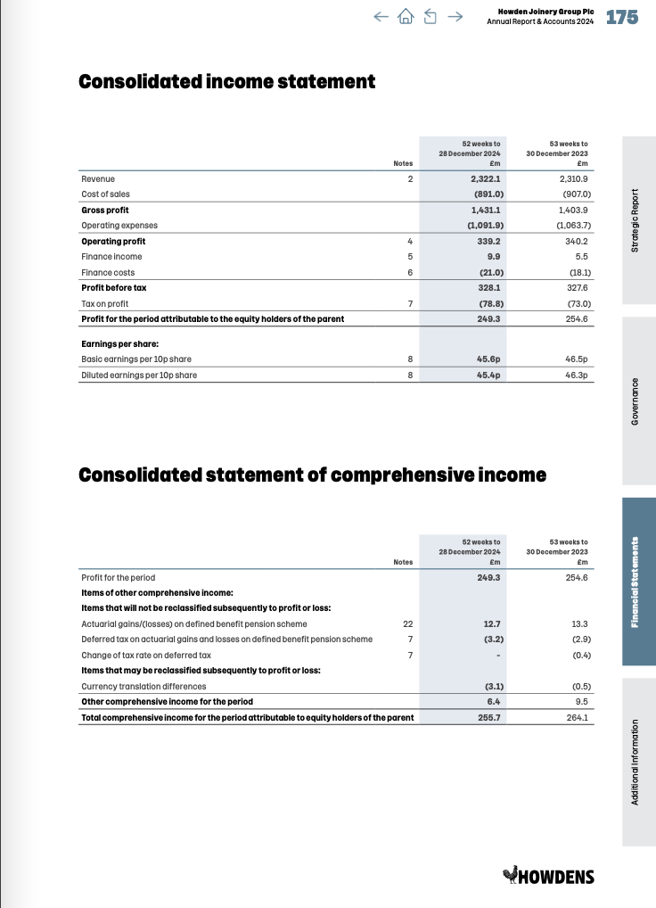

5.1.13 Howdens Joinery 2024 Annual Report – Balance Statement
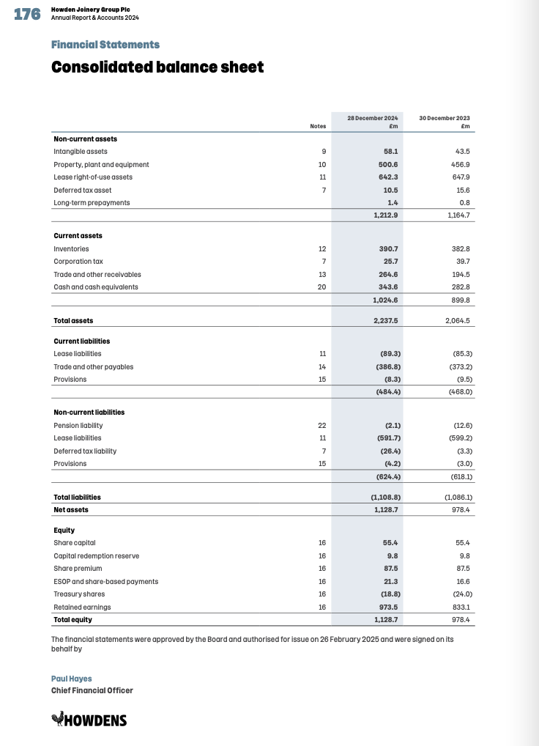

5.1.14 Howdens Joinery 2024 Annual Report - Change in Equity Statement
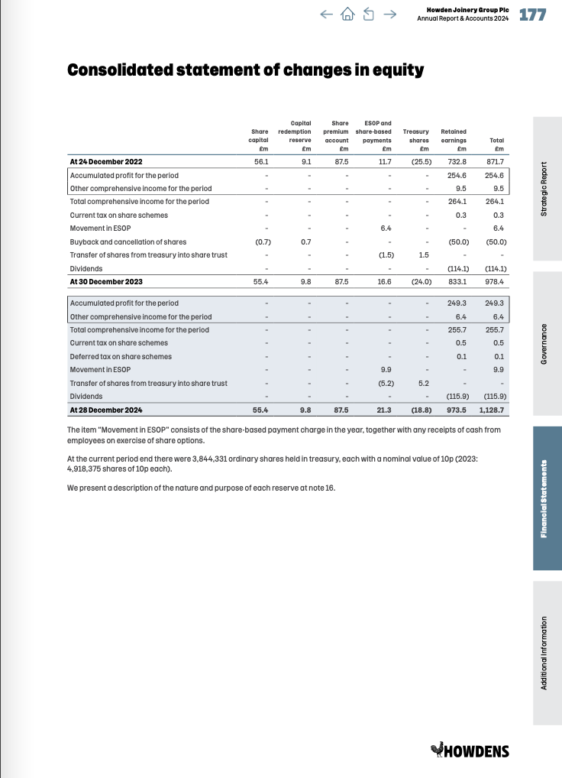

5.2 Westward PLC

5.2.1 Net Present Value Calculation
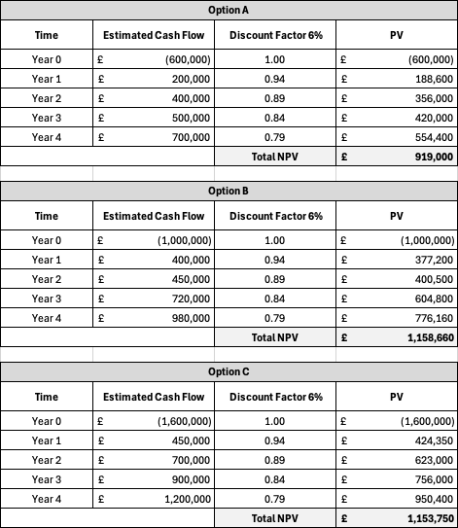

5.2.2 Internal Rate of Return Calculation
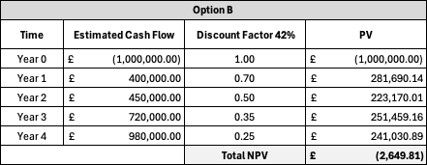

5.2.3 Project Re-Calculation with Profitability Index (PI)


