Essay academic and employability skills a Reflection Account
STUDENT: ABDELLA ABDELLA 1712468
DATE: 03/11/2018
Introduction:

- In December 2014 I joined Tesco in Cardiff city centre Store as a security officer. During the years working in Tesco, I have developed my interpersonal skills, teamwork and self- motivation skills to deliver excellent customer service to the business. The job role of a security officer is Acting as a visual deterrent the customers have bought and Ensuring the safety of customers and colleagues within the working environment and Patrolling in the shop floor and Liaising with police and report writing. Operating cctv camera system. I was Acting as a first line support to employees and visitors to site, providing them a professional and friendly service. and checking Fire, security and building systems monitoring It is also vital for security officer colleagues to be fully trained on the emergency procedures such as; use of the fire extinguisher and dialling with shop lifters. If you working as security officer there’s no room for mistakes so it is important to reflect and improve. According to the UWSTD, (2018) reflection supports to develop abilities instead of carrying on with possible errors. Reflection involves asking questions such as, ‘what is my strength?’ ‘what are my weaknesses?’ ‘what abilities I need have?’ and ‘what have I achieved?

- I think the best way look at David Kolb presented his experimental educational theory in his (1984) by David Kolb, Morgan (2017) Experience is the Source of Learning and Development and presented a model for its practical application. The detailed statement of Kolb's educational approach is based on the need to build learning based on experience, learning process, and that intelligence is the result of interaction between a person and the environment. Kolb has shown that learning methods can be seen as a continuum of material experience, observation, abstract concepts, and practical experimentation in terms of the use of theories in problem solving and decision-making. "The combination of how people recognize and how they handle it is the balanced form of learning - the most comfortable way to learn," Kolb said. Although Kolb thought of these patterns as a continuum that a person goes through with time, but there are people who prefer and rely on one pattern without the rest. this is where the planning takes place on how to do things differently for a good results. The model below.

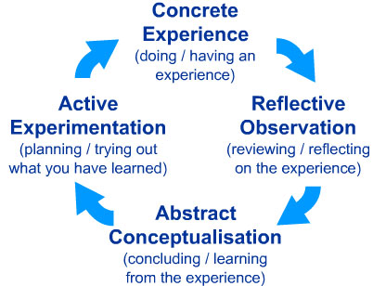

- Professor Graham Gibbs published his Reflective Cycle in his (1988) book "Learning by Doing." It's particularly useful for helping people learn from situations that they experience regularly, especially when these don't go well. Gibbs reflection cycle can be used to also reflect and think systematically. The model below
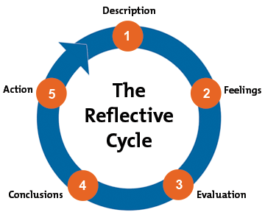
- This kind of cycle it can be helpfully for me to reflect on how to improve on future situations at work. Gibbs developed in (1988) has five stages. Description describe what is beings reflected on. Feeling, any feeling thoughts or feel of the situation. Evaluation, discussing how things went. Analysis, what supported or went against the situation. Conclusion is there anything that could be done different. Action Plan you need to come up with a new plan so that he can make some deferent. Potter (2015) said Reflective Practice provided helpful insights through This pattern or model helps us to understand the source of behaviours and actions resulting from events in a variety of life through a pause and reflection on the value and feelings that resulted from the event.. Below is model. 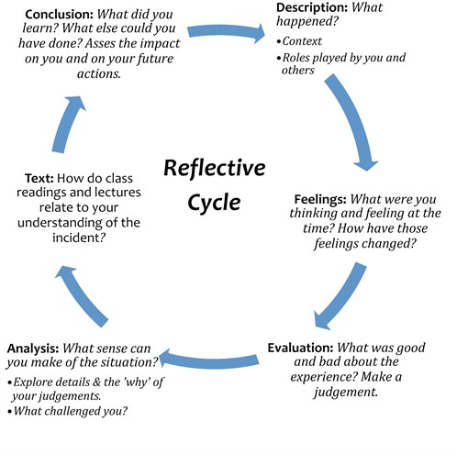
Main Body
- I am really enjoyed this part of this module for me is academic writing in my assignments of this term one. I fill like I got some experience in writing academically as I have a diploma in my country Eritrea in agriculture engineering, but it is deferent from this module of uwstd that I am taken it know. in Eritrea we don’t do lot of research just test in paper. But know I have experience to write my assignment through online research by using Moodle. Helin (2019) said the constitutive view of the discourse was criticized as a descriptive pattern of representation and writing as a tool for retrospective restoration of organizational research. Miller (1966) said Official instructions on the distribution of complementary basic materials. The number of theoretical and practical courses and the energy of restrooms for normal and normal. the most I enjoyed is exploring about different learning styles available. And I learned in this module communication skill I am learn from this skill to be confident and to be effective person, so I need to improve; so, I need Communicate with others, and there is a clear difference between normal communication and effective communication. This difference is manifested by the effectiveness and power of communication with others. Effective communication makes me to understand the others and understanding and accepting others must be my primary purpose of communication. Coffelt and Corey (2016) explain Having oral and written communication skills is one of the essentials of success in the workplace. The communication course in the business world introduces you to effective communication methods, and aims to develop communication skills related to the institution with special emphasis on local and global contexts .sridevi,(2012) said the education process needs to study and prepare the study materials, present the results, criticism and observations on them to develop them, then work on integrating the educational process with the technology and taking advantage of the advanced technical skills that it provides.in order to work with organisation this days you need to have very good communication skill so it is very challenge to me . According to Honey and Mumford questionnaire I study more through reflecting example to learn. I also find it the Harvard referencing very easy to learn and applying method to my academic work.
- Presentations skill I really enjoy in this is term to perform presentation. My confidence is poor when it comes to communicate orally as my English is poor. I fill I am confident to performance was rather disappointing. Helms, and Whitesell, (2017) a full description of active learning strategies, where he teaches all his teaching skills.

Conclusion
- I have manage to include that reflection is an important process of life to be able to develop myself in the future. Using the Kolb Cycle is another way of reflecting which consist of five stages according to Morgan, (2017), this helps look at a situation, reflect and plan on improvement.

Recommendation

- I recommend improving on my presentation skills by doing alotof research in future.
Reference
- Coffelt, T. A., Baker, M. J. and Corey, R. C. (2016) ‘Business Communication Practices From Employers’ Perspectives’, Business & Professional Communication Quarterly, 79(3), pp. 300–316
2.Hawes, L.C. (1975). Pragmatics of analoguing: Theory and model construction in communication[access 20/11/18]
3. Helin, J. (2019) ‘Dialogical writing: Co-inquiring between the written and the spoken word’, Culture & Organization, 25(1), pp. 1–15.

4. Helms, M. M. and Whitesell, M. (2017) ‘Structuring assignments to improve understanding and presentation skills: Experiential learning in the capstone strategic management team presentation’, Journal of Education for Business, 92(7), pp. 332–346.
- 5. Moragan,p.(2012)the business student guideto study employability,London.page 210

6. Miller, H. E. (1966) ‘Textbooks or Research’, Accounting Review, 41(1), pp. 1–7.
7. Osgerby, J., Marriott, P. and Gee, M. (2018) ‘Accounting students perceptions of using visual metaphor as part of personal development planning: an exploratory case study’, Accounting Education, 27(6), pp. 570–589

8. Potter, C. (2015) ‘Leadership development: an applied comparison of Gibbs’ Reflective Cycle and Scharmer’s Theory U’, Industrial & Commercial Training, 47(6), pp. 336–342.
9. ridevi, K. B. (2012) ‘Effectiveness of Case Study in Life Skill Development: An Analysis’, IUP Journal of Soft Skills, 6(3), pp. 48–54
10.https://www.mindtools.com/pages/article/improving-group-dynamics[access 30/11/2018]
11. https://www.kbmanage.com/concept/group-[access30/11/2018]

