

MARKETING MANAGEMENT- ASSESSMENT 2



Student Name: Jaydipkumar Rathod
Student ID: 2239384
Program: MBA- Master of business Administration
Modul: Marketing management
Modul Code: LCMB7001
Lecturer Name: Tushara Balendran
Date: 01/09/2023

Table of Contents
1. Introduction 3
2. Background of the company 3
3. Environmental Analysis 4
3.1 PESTLE Analysis 4
3.2 Porters 5 Forces model 7
4. Recommendations for future marketing strategies 10
4.1 Product Life Cycle Model 10
5. Conclusion 11
6. References 12

Introduction
Sainsbury's has been around since 1869, making it a popular retailing institution in the United Kingdom. Sainsbury's, a forerunner in many ways, introduced self-service to the supermarket industry in the middle of the twentieth century (Sainsbury’s, 2023). The company's dedication to providing high-quality goods at affordable costs extends far beyond its illustrious past. Sainsbury's has remained true to its original principles of quality, honesty, and excellent customer service, allowing it to expand into a vast supermarket and convenience store chain. Evaluating the many dynamics affecting Sainsbury's trajectory as the retail market changes is essential. The brand's positioning and future strategic movements may be better understood by using the PESTLE framework and Porter's Five Forces analysis to the firm.

Background of the company
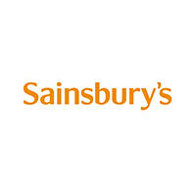
Figure 1: Sainsbury’s Logo
(Source: Sainsbury’s, 2023)
Sainsbury's, one of the oldest and best-known stores in the United Kingdom, was founded in 1869. John James Sainsbury and his wife, Mary Ann, started the firm in London. They opened their first store on Drury Lane, one of the city's busiest marketplaces. J Sainsbury plc results from the little store's devotion to quality throughout the years and strategic growth. The store was ahead of its time, even in the 1950s when it introduced the concept of self-service shopping. Since their first shop opened, they've made it their mission to provide customers with reasonably priced, high-quality food. Today, the company has 600+ supermarkets and 800+ convenience stores worldwide (Sainsbury's, 2023). Its dedication to its employees and clientele is shown in the mission's emphasis on honesty, reliability, and excellence in service.
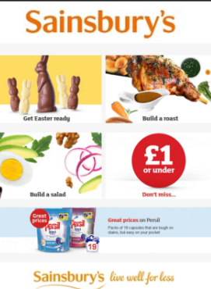
Figure 2 – Sainsbury’s products
(Source - (Sainsbury's, 2023)

Environmental Analysis

3.1 PESTLE Analysis
PESTLE analysis is advantageous in enhancing strategic planning through the identification of opportunities about the broader context of business. The disadvantage of the model is that it overlooks on industry details and lack in opportunities.
Political
As a UK-based retail giant, Sainsbury's is heavily impacted by national and regional politics. The results of Brexit are a notable case in point. The United Kingdom's decision to leave the European Union has disrupted commerce, tariffs, and the availability of EU migrant workers, all of which impacted the company's staff (Hoinaru and Năstase, 2019). Sainsbury's faces unknowns in the post-Brexit regulatory environment, although rules and compliance are commonplace for firms in the UK. This post-Brexit era is generally unfavourable as Sainsbury's faces several issues in the post-Brexit environment, including interrupted supply chains and the possibility of price increases owing to rising taxes on imported products (Feldmann and Morgan, 2021).
Economic
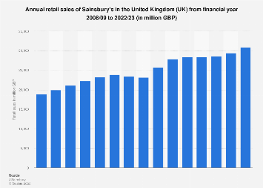
Figure 3: Annual retail sales of Sainsbury's in the United Kingdom
(Source: Statista, 2023a)
Sainsbury's success is closely related to the state of the UK economy. The firm rebounded from a decline in sales in 2016 and saw growth in revenue during most of 2017. The latter three quarters of 2018 saw no rise in sales, and it wasn't until March of 2019 that growth resumed at a rate of 1.8 percent. After taxes, the company's earnings in 2022 were approximately 677 million British pounds (Statista, 2023a). This shows an inconsistency in the companies’ economic environment. In economic distress, shoppers often tighten their expenses and go elsewhere for goods and services. This scenario can be both favourable and unfavourable for Sainsbury's. Sales of their more affordable store brands may increase, while those of their more expensive luxury brands may fall (Rusanen, 2023). The pound's volatility also impacts the cost of importing products, particularly after Brexit. A weak pound is bad for business since it reduces profits if the added expenses aren't passed on to customers.
Social
Sainsbury's is a business that caters to customers in a society where tastes are always shifting. Consumers nowadays care more about health and the environment. Sainsbury's response to these changes, which now sells organic, sustainably produced items and emphasises reducing plastic waste, is favourable since it reflects customer preferences. Furthermore, the company donated £3 million to FareShare in the early stages of the epidemic to alleviate the strain on already-struggling food banks, charities, and community organizations (Sainsbury’s, 2023).
Technological
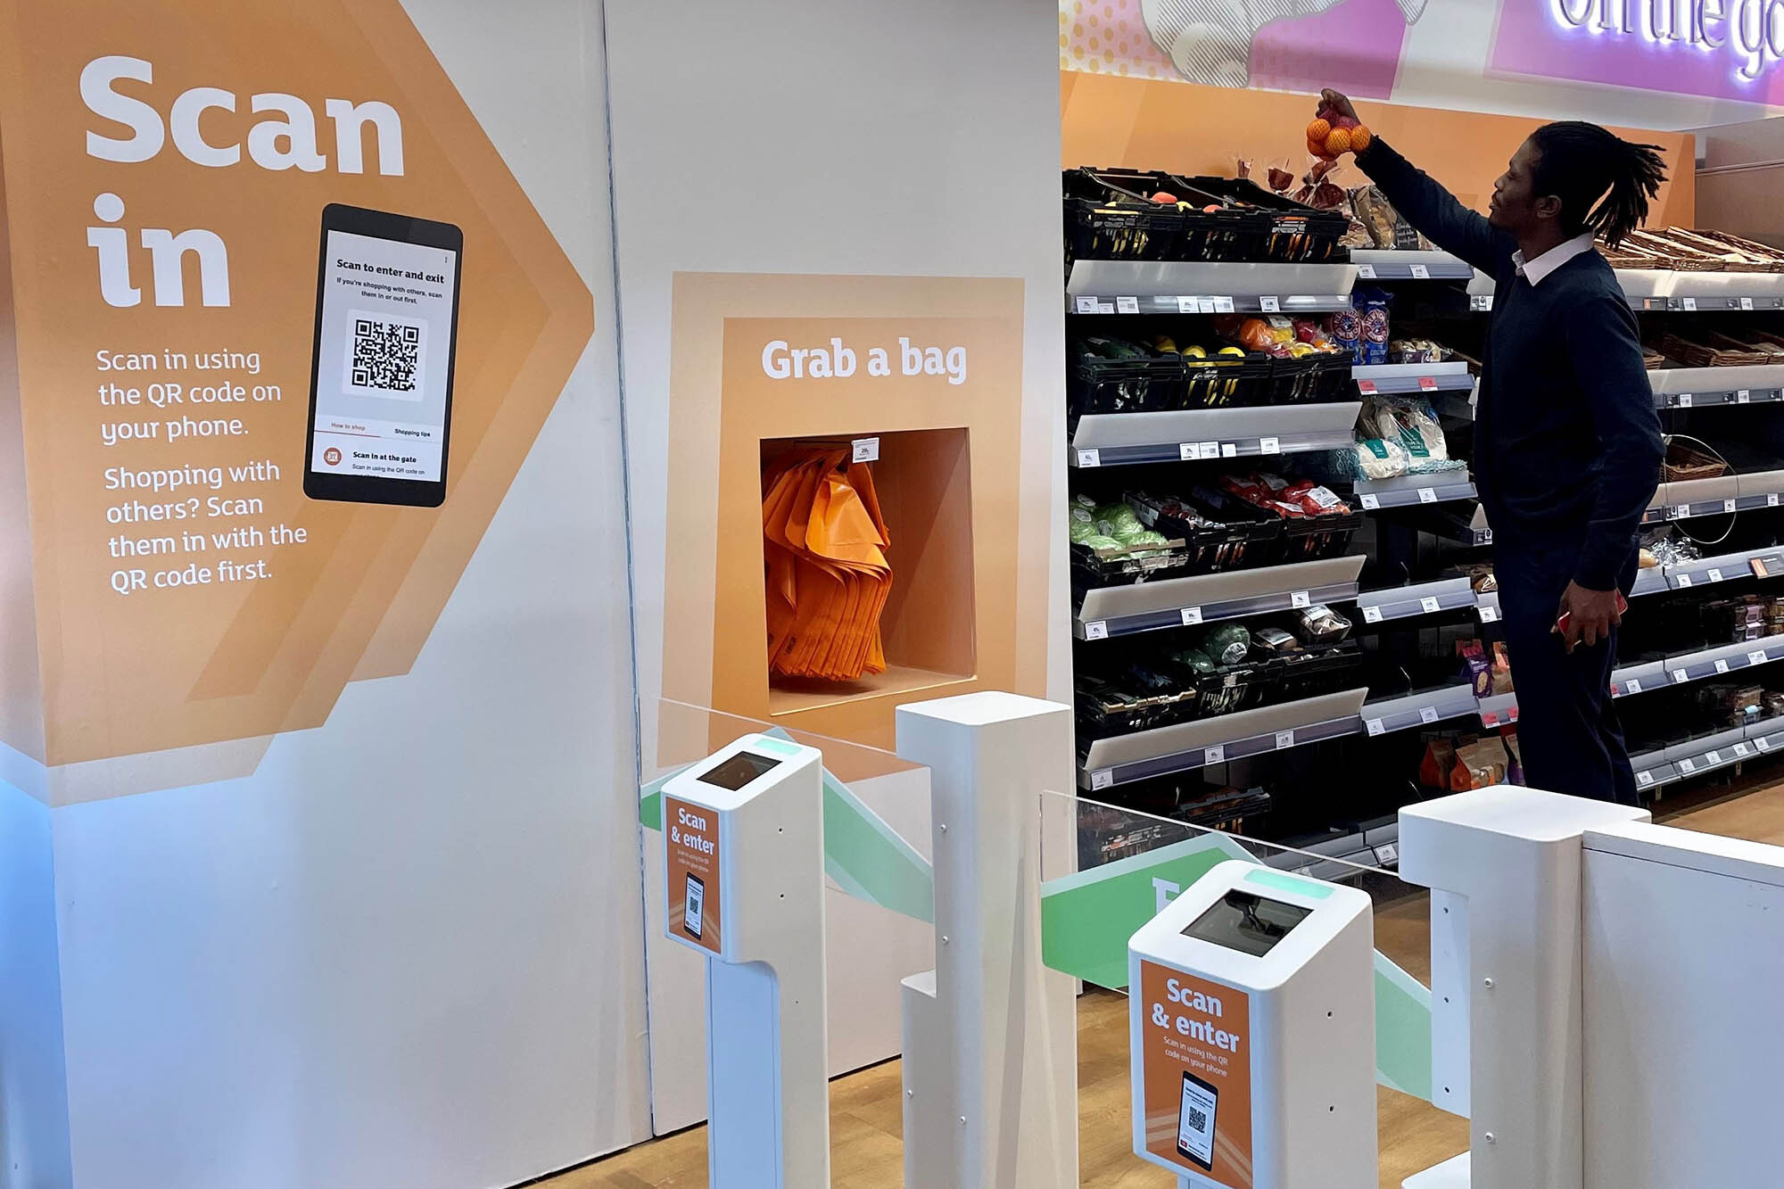
Figure 4: SmartShop Pick & Go utilizes Amazon's Just Walk Out technology
(Source: Amazon, 2021)
Technology now plays a crucial role in the retail industry. Sainsbury's is introducing a digital innovation in-store that will allow customers to purchase without using a traditional cash register. SmartShop Pick & Go utilizes Amazon's Just Walk Out technology, expanding on the previous year's 173% growth (Sainsbury’s, 2021). These are all favourable examples of how the company has invested in technology to improve the shopping experience and save costs. In addition, they're ahead of the competition thanks to their use of data analytics to understand customer preferences better and provide more personalized ads and products.
Legal
Sainsbury's business is directly affected by legal considerations in the United Kingdom. One such feature is the implementation of the National Living Wage. Fair pay and improved working conditions come at a cost to businesses, though. This is neutral to unfavourable for Sainsbury's (Galtung, 2019). While paying employees fairly might boost morale and productivity, it does come at an extra cost for Sainsbury's. Food safety laws are another area of emphasis.
Environmental
In today's commercial world, environmental concerns are at the forefront. The environmental goals that Sainsbury has set for itself, such as being a net-zero firm by 2040, align with what customers demand now and what may be required by law in the future (Newborne, 2022). At COP26, Sainsbury's led the supermarket industry in signing the WWF's Retailers' Commitment for Nature, an initiative to reduce the environmental impact of grocery shopping in the United Kingdom by half by 2030 (Sainsbury's, 2023). This proactive approach is favourable since it improves the company's standing with environmentally sensitive customers and positions it well in the event of more rigorous environmental rules in the future. m.

3.2 Porters 5 Forces model
Threat of New Entrants | Moderate
Bargaining Power of Suppliers | Moderate
Bargaining Power of Buyers | High
Threat of Substitute Products or Services | High
Competitive Rivalry within the Industry | High
Table 1: Porters 5 Forces model
(Source: Self-created)
Threat of New Entrants
Sainsbury's has a moderate level of competition from new entrants in the grocery sector, where it operates. Capital, supply chain knowledge, and a well-established distribution network are all necessities for launching a grocery chain. In addition, consumers have come to trust and choose well-known brands like Sainsbury's. However, the proliferation of digital platforms and the general trend toward online shopping have lessened entry barriers, making it simpler for new, online-only, or specialized companies to enter the market (Zelger, 2023). Thus, although conventional barriers are still high, the dynamic nature of retail has opened the door for new, more nimble competitors.
Bargaining Power of Suppliers
Sainsbury's suppliers have moderate negotiating leverage. The business works with many vendors, but the corporation specializes to those producing very popular goods. Suppliers demonstrate that their sustainable and ethically sourced goods have more negotiation leverage. Sainsbury's negotiation power might also be weakened if a supplier provides unique items or is the only source for certain commodities. On the other hand, Sainsbury's typically has substantial leverage over many of its suppliers, particularly those who depend substantially on the store for sales, owing to the volume of purchases and its standing in the market (Xiao et al., 2021).
Bargaining Power of Buyers
In the grocery store industry, customers have much negotiating power. Competition in the business is high since companies like Tesco, ASDA, and Morrisons provide identical product lines. Customers have several options because of price competition, discounts, and loyalty programs. Consumers have become more price-conscious due to the proliferation of digital platforms that allow them to compare costs easily (Eastman et al., 2021). Even though Sainsbury's is a well-known and respected company, it must compete in today's market by providing exceptional value to its consumers through low prices, high-quality products, and other unique offerings.
Threat of Substitute Products or Services
Sainsbury's faces severe competition from similar businesses. There are many options for shoppers in the grocery store and food retail industries. With many choices available to shoppers, from corner stores to specialized boutiques to online meal kit delivery services, Sainsbury's must stand out by providing something its competitors don't (Mason and Knights, 2019). This danger has been amplified by the prevalence of online resources and the rise of expedited shipping options. Sainsbury's has a wide selection of items, but it must find ways to differentiate itself from the market to compete with cheaper alternatives.
Competitive Rivalry within the Industry
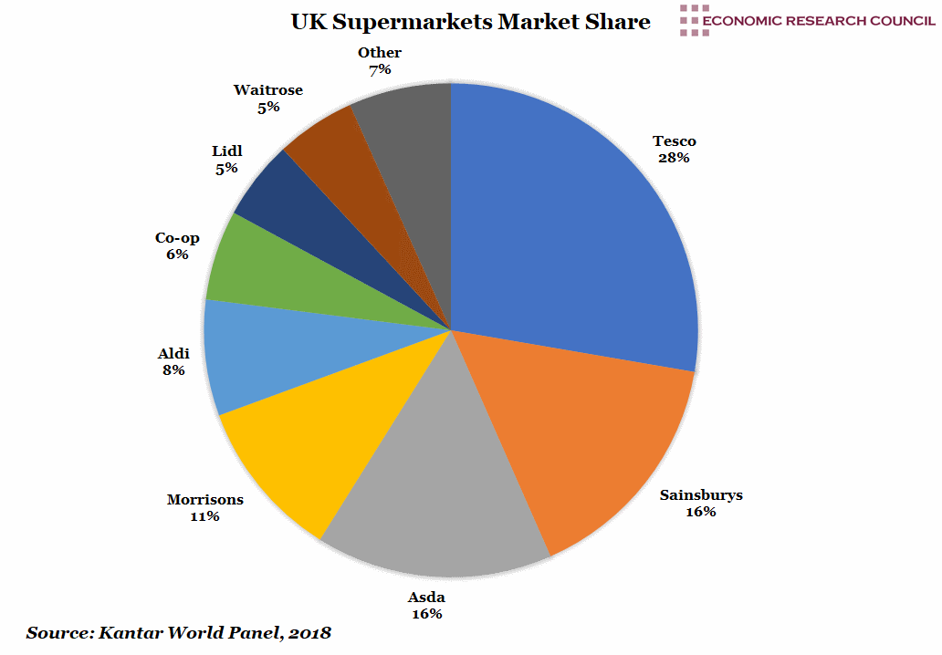
Figure 5: Sainsbury's competitors’ share
(Source: Economic Research Council, 2019)
The advertisement pattern of Sainsbury is around promotion of quality products, community and affordability involvement. The grocery business is known for its intense competitiveness. The grocery industry in the United Kingdom is very competitive, with several large chains fighting for customers. Several grocery stores in the United Kingdom compete with Sainsbury's, including Tesco, Morrisons, ASDA, and Aldi (Brand et al., 2020). Price wars, intensive advertising efforts, and new approaches to customer service are commonplace in this sector. Sainsbury's main food business is supported by its portfolio brands, which include Argos, Habitat, Tu, Nectar, and Sainsbury's Bank (Sainsbury's, 2023). Sainsbury's has made deliberate moves to retain and improve its competitive position. However, the level of competition necessitates that the business always is on the offensive and flexible in its approach.

Recommendations for future marketing strategies

4.1 Product Life Cycle Model
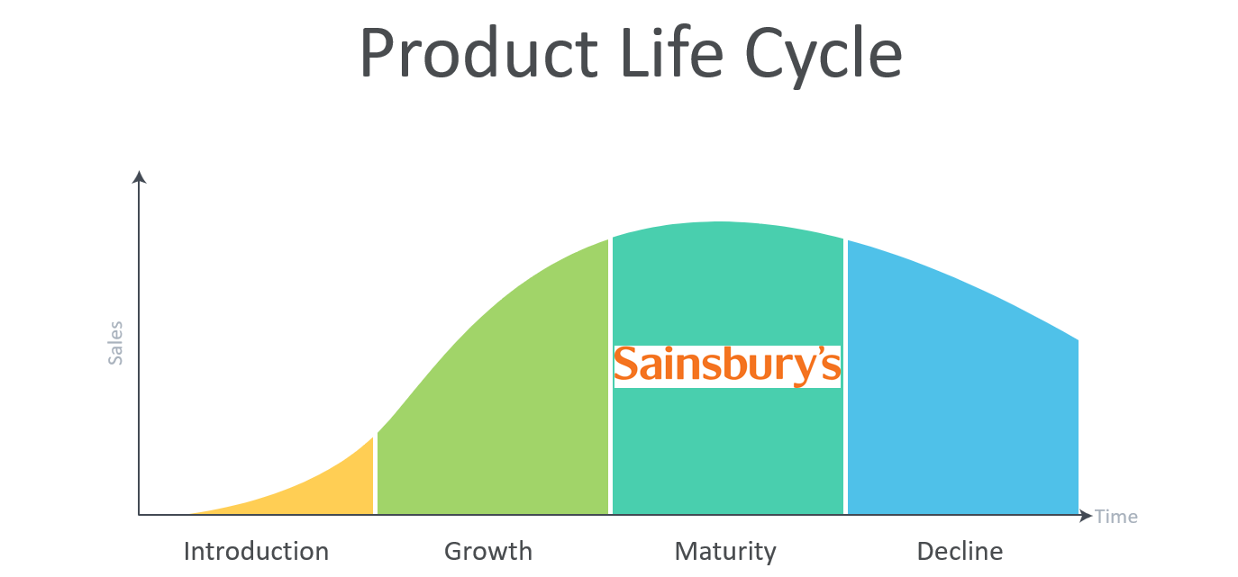
Figure 6: Sainsbury's position on the Product Life Cycle
(Source: Economic Research Council, 2019)
Sainsbury's stands at a critical point in the PLC's maturity phase. The brand can successfully go through this transitional period by using creative methods for increased penetration, extended use, and global market expansion strategies.
Increased Penetration Strategy: As the leading player in the UK supermarket environment, Sainsbury's can profit from its market position even further with a concentrated enhanced penetration plan. This necessitates more exploration of their current markets and client base. One option is to improve their Nectar customer loyalty program. Sainsbury's should better engage its present customers by catering to their preferences by providing discounts based on past purchases or providing them access to exclusive online offers (Bathla et al., 2023). Further market penetration may be achieved by focusing on certain regions or sectors with high development potential. E-commerce has grown rapidly in recent years, and businesses like Sainsbury's that provide a convenient and enjoyable online shopping experience and exclusive discounts to their customers online are poised for success.
Extended Use Strategy: The strategy will help Sainsbury's increase customer loyalty and shopping frequency. Brands become more indispensable to customers when they find creative ways to work into their everyday lives, such as via seasonal marketing and recipe integration (Bradford and Sherry Jr, 2023). It is because of this strategy customer will be encouraged to see Sainsbury's goods as fundamental to the rising popularity of cooking and baking at home. In addition, providing do-it-yourself meal packages will attract time-pressed consumers and boost sales by combining related items. In 2023, the ready-to-eat meal industry is expected to generate revenue of $0.6tn. The market is anticipated to expand at a CAGR of 6.68% between 2023 and 2028 (Statista, 2023b).
Global Market Expansion Strategy: Sainsbury's plans to expand internationally because the company recognizes a large market beyond the United Kingdom. It's a well-known brand in the United States, but there are opportunities to grow its reach abroad strategically. Online sales of non-perishable commodities should first be used to assess worldwide demand (Saghiri et al., 2023). Therefore, brick-and-mortar shops catering to British expats in major cities worldwide can act as a bridge by stocking British and local goods. This appeals to those who miss their home countries and presents the product to a new target audience. In addition, forming alliances with or acquiring local chains in target regions will help Sainsbury's learn the ins and outs of those markets and progressively introduce its product range to those consumers.
By combining them, these tactics provide Sainsbury's with a plan for long-term success. Maintaining market dominance helps assure consistent earnings. Keeping repeat business from existing clients is a certain way to maintain the brand in their minds. Meanwhile, Sainsbury's can better anticipate and respond to emerging opportunities and threats by branching out into international markets. Moreover, learning about other marketplaces might inspire new ideas at home. With this holistic approach, one tactic reinforces the others to keep Sainsbury's a competitive force in the retail industry at home and abroad.

Conclusion
Sainsbury's long history in the UK retail industry demonstrates its versatility and customer-centric mentality. The external elements and competitive pressures that the brand encounters are explored using the PESTLE and Porter's Five Forces analysis. Sainsbury's strategic methods, such as greater market penetration, extended product usage, and worldwide development, may pave the path for sustained success despite the hurdles, particularly in the unpredictable post-Brexit climate. To be relevant as the retail business evolves, Sainsbury's must adopt these tactics to strengthen its current position and pursue new development opportunities.

References
Amazon, 2021. Sainsbury’s becomes first international third-party customer to use Amazon’s Just Walk Out technology. [online] US About Amazon. Available at: https://www.aboutamazon.com/news/retail/sainsburys-becomes-first-international-third-party-customer-to-use-amazons-just-walk-out-technology. [Accessed on: 14/08/2023]
Bathla, D., Ahuja, R. and Singh, A., 2023. Impact of Customer Segmentation and Customer Loyalty With Reference to Big Data. In Promoting Consumer Engagement Through Emotional Branding and Sensory Marketing (pp. 226-233). IGI Global.
Bradford, T.W. and Sherry Jr, J.F., 2023. How marketers and consumers synchronize temporal modes to cocreate ritual vitality. Journal of the Academy of Marketing Science, pp.1-22.
Brand, C., Schwanen, T. and Anable, J., 2020. ‘Online Omnivores’ or ‘Willing but struggling’? Identifying online grocery shopping behavior segments using attitude theory. Journal of Retailing and Consumer Services, 57, p.102195.
Eastman, J.K., Iyer, R., Eastman, K.L., Gordon‐Wilson, S. and Modi, P., 2021. Reaching the price conscious consumer: The impact of personality, generational cohort and social media use. Journal of Consumer Behaviour, 20(4), pp.898-912.
Economic Research Council, 2019. UK Supermarkets Market Share. [online] Economic Research Council. Available at: https://ercouncil.org/2019/chart-of-the-week-week-12-2019/. [Accessed on: 14/08/2023]
Feldmann, M. and Morgan, G., 2021. Brexit and British business elites: Business power and noisy politics. Politics & Society, 49(1), pp.107-131.
Galtung, F., 2019. How impactful is Fair Trade? A paradigm shift in reporting would tell a better story. Journal of Fair Trade.
Hoinaru, R. and Năstase, M., 2019. A balanced approach: Brexit from political and business perspectives. In Proceedings of the International Conference on Business Excellence (Vol. 13, No. 1, pp. 804-816).
Mason, T. and Knights, M., 2019. Omnichannel retail: How to build winning stores in a digital world. Kogan Page Publishers.
Newborne, P., 2022. Crossed wires: public regulation and private action for water stewardship and sustainable farming. Water International, 47(7), pp.1169-1186.
Rusanen, O., 2023. The importance of resources.
Saghiri, S., Aktas, E. and Mohammadipour, M., 2023. Grocery omnichannel perishable inventories: performance measures and influencing factors. International Journal of Operations & Production Management, (ahead-of-print).
Sainsbury’s, 2021. Sainsbury’s introduces contactless, checkout-free shopping with SmartShop Pick & Go. [online] www.about.sainsburys.co.uk. Available at: https://www.about.sainsburys.co.uk/news/latest-news/2021/29-11-21-smartshop-pick-and-go#:~:text=Sainsbury. [Accessed on: 14/08/2023]
Sainsbury's, 2023. Annual Report and Financial Statements. https://www.about.sainsburys.co.uk/~/media/Files/S/Sainsburys/documents/reports-and-presentations/2023/annual-report-2023/annual-report-and-financial-statements-2023.pdf
Statista, 2023. Meal Delivery - Worldwide | Statista Market Forecast. [online] Statista. Available at: https://www.statista.com/outlook/dmo/online-food-delivery/meal-delivery/worldwide. [Accessed on: 14/08/2023]
Statista, 2023a. Sainsbury’s retail sales 2008-2022. [online] Statista. Available at: https://www.statista.com/statistics/386342/sainsburys-retail-sales-united-kingdom-uk/#:~:text=Sainsbury. [Accessed on: 14/08/2023]
Xiao, B., Chen, Q. and Yu, Z., 2021, April. Research on the Investment Value of Sainsbury’s. In 2021 6th International Conference on Social Sciences and Economic Development (ICSSED 2021) (pp. 108-115). Atlantis Press.
Zelger, B., 2023. Particularities of the Digital Economy. In Restrictions of EU Competition Law in the Digital Age: The Meaning of'Effects' in a Digital Economy (pp. 135-151). Cham: Springer International Publishing.

