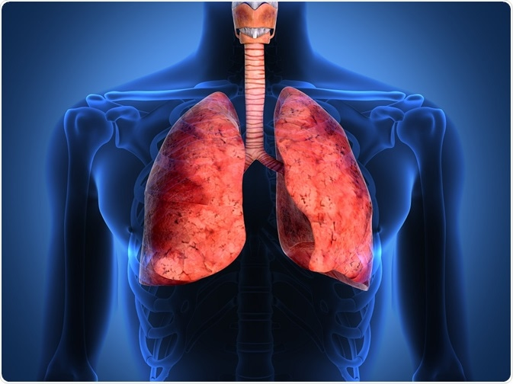
“Information Booklet: Long-Term Health Condition- Asthma for Health and Care Service Users”

Programme: | MSc Public Health and Social Care in Practice
Module: | Community Care and Management for Longer-term Conditions
Module code: | LCHS7003
Lecturer: | Dr. Brian Mashumba
Assignment Title: | Information Booklet of Long-term Condition Management: Asthma
Student Name: | Bilkis begum
Student ID: | 2432744
Word Count | 3118

Table of Contents
Introduction 3
Comprehending Asthma: Definition, prevalence, and Risk Factors 4
Prevalence of Asthma 5
Global 5
United Kingdom 6
Risk Factors for Asthma 6
Impacts of Asthma on Individuals, Families, and Evidence-Based Interventions 8
Physical Impact 8
Psychological Impact 8
Social Impact 9
Evidence-Based Treatments Available Through the NHS 9
Theoretical Frameworks and Models for the Management of Long-Term Conditions 11
UK Model: The Stepped Care Model 11
International Model: The Chronic Care Model (CCM) 12
Health and social care policy agendas at the local and national levels 13
National Health Policy Initiatives 13
Regional Policy 14
Investment and Implementation Initiatives 14
Recommendations for Person-Centred Care Approaches 16
Self-Management Support Framework 16
Technology-Enhanced Care 16
End-of-Life Care Considerations 16
Quality Improvement and Monitoring 17
Conclusion 18
References 19

Introduction
Bauer et al. (2019) assert that asthma is one of the most common chronic illnesses that plague people across the world. It is an inflammatory condition in the lungs, which results in tightness and blockage of the airways and difficulty in breathing by the patient. The booklet describes what asthma is, how it affects individuals and families, the evidence-based practice, the theoretical care, the policy programs, and alternative person-cantered care. People using healthcare services in the UK are the target audience. Asthma patients, their loved ones, and healthcare providers all play a part in this effort to raise awareness, improve asthma management, and ultimately benefit those living with the disease.

Comprehending Asthma: Definition, prevalence, and Risk Factors
In asthma, the airways constrict and enlarge, which may lead to an increase in mucus production (Bloom, Middleton and Lewis, 2025). This might make it harder to breathe, which could lead to dyspnoea, wheezing sound when you exhale, and coughing. Asthma is a bothersome condition for some people, but not for others. It could be a major problem that causes problems with daily living and might lead to a possibly fatal asthma attack for certain people.
Source: (Paoletti, 2023)
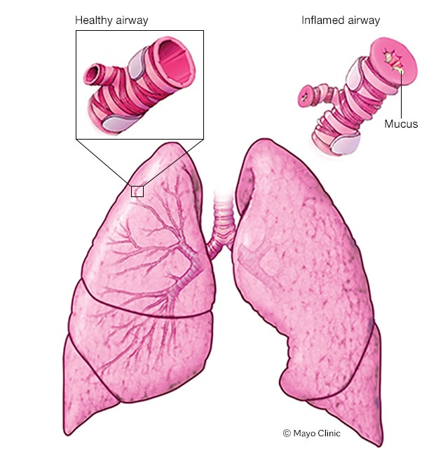
Symptoms
- Asthma symptoms vary from person to person.
- Trouble breathing
- Chest constriction or discomfort
- Wheezing upon exhalation, a prevalent indicator of asthma in paediatric patients
- Sleep disturbances resulting from dyspnoea, coughing, or wheezing
- Coughing or wheezing episodes exacerbated by a respiratory infection, such as a cold or influenza (Busby et al., 2021).
Certain individuals may have exacerbated symptoms with a cold or with fluctuations in weather conditions. Dust, smoke, fumes, grass and tree pollen, animal dander and feathers, as well as strong soaps and fragrances may potentially be contributing factors (Bush and Pavord, 2021).
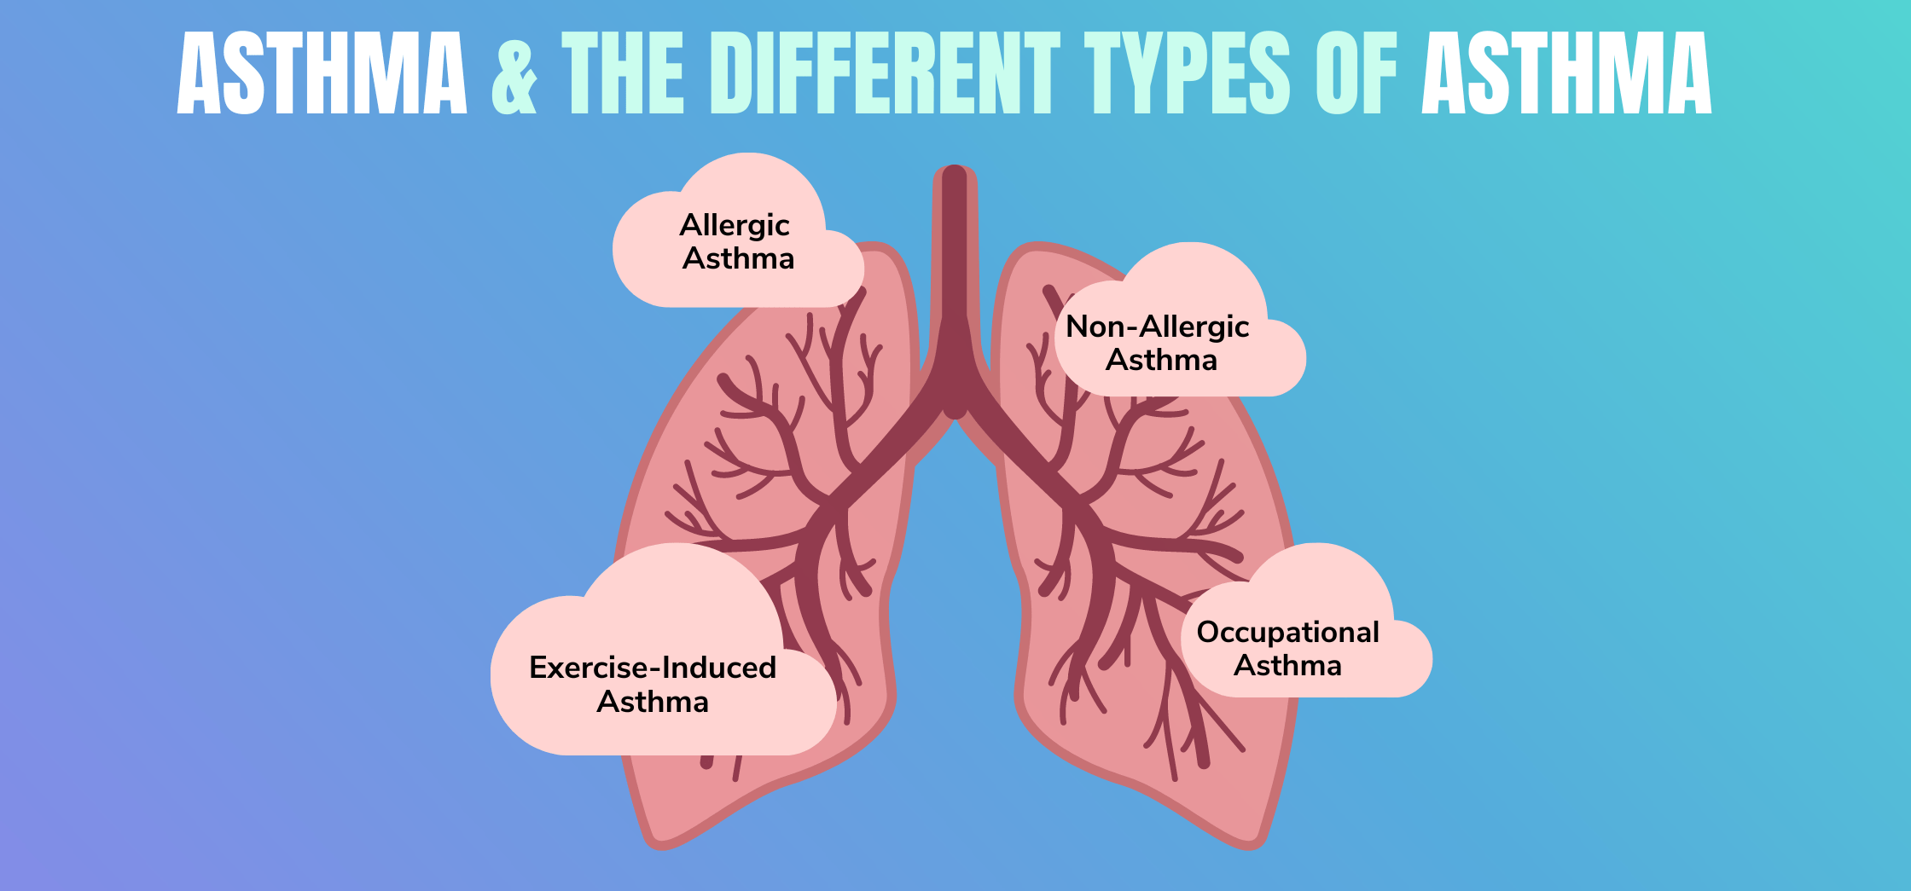
Types of asthma
Types of asthma include:
- Allergic asthma: when allergens provoke asthma symptoms
- Cough-variant asthma: characterised by a cough as the only symptom of asthma (Dharmage, Perret and Custovic, 2019).
- Exercise-induced asthma: when physical activity provokes asthma symptoms
- Occupational asthma: a condition whereby inhaled chemicals in the workplace induce the onset of asthma or precipitate asthma episodes.

Prevalence of Asthma

Global
- Asthma impacts around 262 million individuals worldwide and is the most prevalent chronic illness in children (Diwakar et al., 2025).
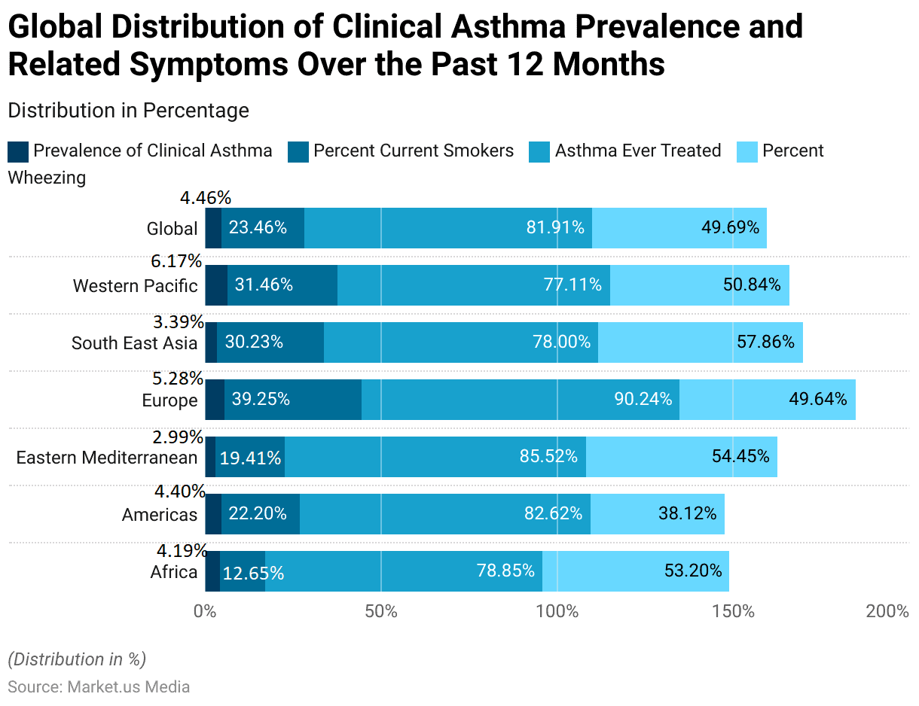
- Despite a considerable reduction in the age-standardized mortality rate since 1990, asthma resulted in over 450,000 fatalities in 2019, mostly in lower-income nations facing diagnostic and therapeutic obstacles (Yuan et al., 2025). The prevalence varies by geography, with Oceania and North America exhibiting greater rates than Asia and Africa.
- The incidence of disability-adjusted life years (DALYs) attributable to asthma decreased by more than 42% from 1990 to 2019 (Samruddhi Yardi, 2024).
Source:(Samruddhi Yardi, 2024)
From 1990 to 2021, the worldwide impact of increased body mass index (BMI) on asthma-related disability-adjusted life years (DALYs) increased by 4.3% (Yuan et al., 2025). MR studies have shown that increased BMI and smoking may boost the incidence of asthma.
Questionnaires were used in the first phase of the Global Asthma Network (GAN) to assess the frequency of asthma symptoms from 2015 to 2020. According to Richard et al. (2024) and the Global Asthma Network (2022), the first phase of GAN studied 101,777 children from 44 centres in 16 countries, 157,784 adolescents from 63 centres in 25 countries, and 193,912 adults (54% female, median age 38, interquartile range 33-43) from 43 centres in 17 countries.

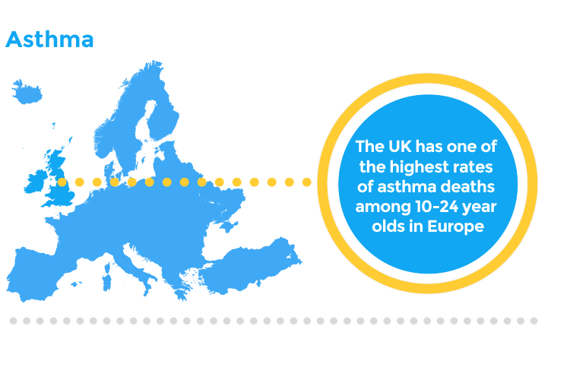
United Kingdom
In the United Kingdom, 7.2 million persons suffer from asthma (NHS England, 2023). This concerns 8 persons per 100. The illness may affect persons of any age; however, asthma often manifests in infancy. Approximately one-fifth of the population in both England and Scotland has been diagnosed with asthma. Moreover, around 10% of youngsters are afflicted with asthma (NHS Shropshire, Telford and Wrekin, 2025). The primary triggers for individuals in the UK are colds and influenza, followed by fluctuations in weather and dust.
Source: (RCPCH, 2020)
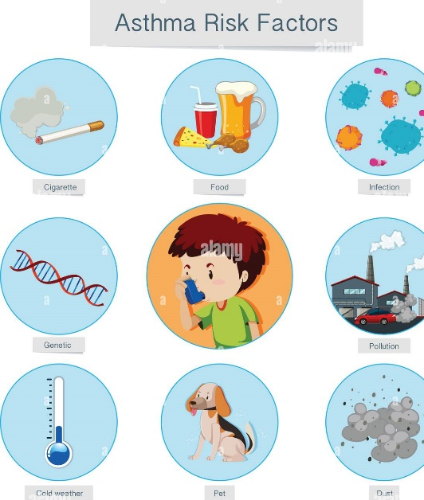
Salbutamol is the predominant bronchodilator prescribed in England for the treatment of obstructive pulmonary disorders, with more than 22.2 million units issued in 2020 (Statista, 2024). Approximately 40% of adult patients indicated in a study that they saw their asthma as somewhat managed, whereas a comparable proportion considered their illness to be uncontrolled (National HEalth Service, 2021).
Since 2000, the death rate from asthma in England and Wales has consistently decreased. In 2019, asthma resulted in 2.6 fatalities per 100,000 women and 1.63 per 100,000 males (Statista, 2024). The mortality rate for women has continuously exceeded that of males. A pervasive issue throughout the UK is that, in several places, less than fifty percent of asthma patients report getting fundamental asthma care.
Source: (Kuruvilla et al., 2019)

Risk Factors for Asthma
- Family History: Individuals with a familial predisposition to asthma or allergies possess an elevated chance of getting asthma (Bostock, 2021). Genetics significantly predisposes persons to asthma.

- Allergies: Allergic responses to prevalent items, including pollen, dust mites, pet dander, mould, and certain foods, may provoke asthma symptoms (Mayo Clinic, 2025). Individuals with allergic rhinitis (hay fever) have an elevated chance of acquiring asthma.
- Smoking: Smoking and exposure to second-hand smoke are substantial risk factors for the development of asthma, especially in youngsters (Dr. Mayank Saxena, 2024). Smoking exacerbates airway irritation and inflammation, hence intensifying asthma symptoms.
- Obesity: Excess weight or obesity elevates the likelihood of acquiring asthma and exacerbates its symptoms. Obesity is linked to inflammation in the body, especially the airways, which may exacerbate the onset and severity of asthma (Grant, Croce and Matsui, 2021).
- Atmospheric Contamination: Exposure to outdoor air pollution, such as vehicular emissions, industrial contaminants, and particulate matter, may aggravate asthma symptoms and elevate the chance of developing asthma, especially in metropolitan regions with elevated pollution levels (Jacobs et al., 2023).
- Indoor Air Quality: Subpar indoor air quality, characterised by exposure to allergens such as dust mites, mould, cockroach excrement, and pet dander, may facilitate the onset of asthma and intensify its symptoms (Kharaba et al., 2022).
- Exercise: Vigorous physical activity or exercise may provoke asthma symptoms, especially in those with exercise-induced asthma.

Impacts of Asthma on Individuals, Families, and Evidence-Based Interventions
Asthma, a chronic respiratory ailment, significantly impacts people on physical, psychological, and social levels, while also greatly affecting the families responsible for caregiving.

Physical Impact
Asthma is a major physical consequence on both young and old individuals. The disease has a significant impact on the quality of life through numerous ways. Asthmatic people experience:
- Respiratory Symptoms: Chronic coughing, wheezing, chest constriction, and dyspnoea are the primary physical symptoms (Kuruvilla et al., 2019). These symptoms can have different levels of severity and can be moderate, severe, frequent or occasional to different individuals.
- Operational Constraints: Asthma hinders the discharge of everyday life activities. According to research, 36 percent of patients are restricted in their ability to perform severe physical activities and 28 percent are restricted in their ability to do moderate physical activities (Lo et al., 2021). This would result in less time being taken on sports, exercise, and daily physical activity.
- Sleep Disturbance: Sleep quality is influenced by asthma, and 52% of patients with the disease are going to have sleep impairment (P Jane McDowell et al., 2023). Fatigue during the day can be ascribed to night-time symptomatology and cognitive disabilities.

Psychological Impact
The psychological aspect of asthma is great and is not always valued.
- Depression and Anxiety Disorders: The body of research also shows that depression and asthma are strongly correlated with each other, and an increase in inflammatory factors contributes to both disorders (Paoletti, 2023). Attention-deficit/hyperactivity disorder and other behavioural problems are more susceptible to children with asthma.
- Stress and Symptom Management: The presence of psychological stress has a direct impact on asthma management, causing the higher frequency of episodes and the growth of healthcare needs. The inflammation caused by stress intensifies the symptoms of asthma forming a vicious cycle of disease management.
- Adherence to Treatment: Depression and anxiety impact negatively medication adherence, which results in low levels of asthma control and high rates of severe exacerbations (Plaza-Gonzalez et al., 2022).

Social Impact
Asthma has extensive social implications for people and their communities.
- Impact on Education: Children with asthma are prone to school absenteeism, which affects their academic performance and social interactions. The insufficient understanding of asthma among instructors might exacerbate issues for pupils (RCPCH, 2020).
- Impact on Employment: Adult asthmatics have workplace limits, with 35% reporting an impact on their job performance (Richard et al., 2024). New-onset asthma may be exacerbated by work exposures.
Source: (NHS Shropshire, Telford and Wrekin, 2025)
- Social Isolation: Asthmatics have significant social limits, with 67% reporting that leisure activities constitute the primary limitation in their life (Richard et al., 2024). This may lead to a decrease in socialisation and issues in relationships.
Families and carers often assist individuals with asthma in managing the illness. Asthma attacks are erratic and need continuous management, inducing tension, anxiety, and concern in families (Stanescu et al., 2019). This mental burden may impact marriages and families. Healthcare expenses and absenteeism due to job or caregiving may also impact financial stability. The quality of life for carers is intricately linked to the severity of asthma, since inadequately managed asthma leads to increased family disturbance and distress.

Evidence-Based Treatments Available Through the NHS
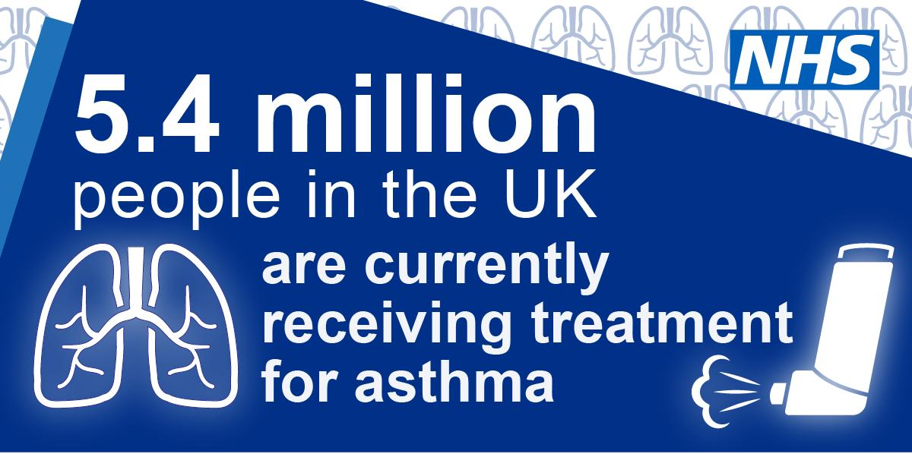
The NHS provides comprehensive evidence-based treatments for asthma management.
Individuals with asthma get assistance from a care team. This team consists of a general practitioner, a nurse, and sometimes a hospital expert. The care team will provide comprehensive guidelines on medication administration and timing, asthma surveillance, trigger avoidance, symptom alleviation, and management of exacerbated symptoms.
- Asthma inhalers
The principal therapy for asthma consists on inhaled drugs delivered using an inhaler (NHS England, 2019). Depending on the intensity of your symptoms, you may be offered either:
- An inhaler designated only for use during the onset of symptoms, referred to as an anti-inflammatory reliever (AIR) inhaler.
- A daily inhaler used to mitigate symptoms, as well as after their onset, is referred to as a maintenance and relief therapy (MART) inhaler (NHS England, 2019).
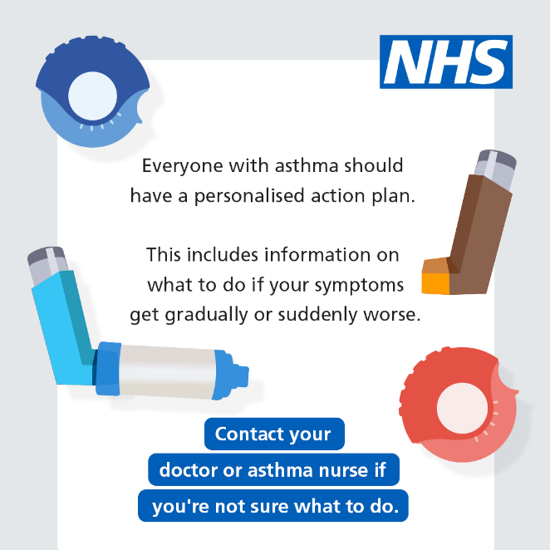
- Two distinct inhalers: a preventer inhaler for daily use to mitigate symptoms, and a blue reliever inhaler for symptomatic relief (the blue reliever inhaler should not be designated for exclusive usage) (NHS England, 2023).

- Biologic Therapies
The NHS offers biological medicines for severe asthma, including omalizumab, mepolizumab, reslizumab, benralizumab, and dupilumab (NHS England, 2023). These therapies focus on certain inflammatory pathways and are accessible at specialised severe asthma facilities.
- Hospital treatment for an asthma attack
A critical asthma episode that fails to improve may need hospitalisation for intervention. Hospital interventions may include:
- Oxygen delivered via a mask
- Employing a nebuliser to inhale increased amounts of medicine
- Steroidal pills or injections
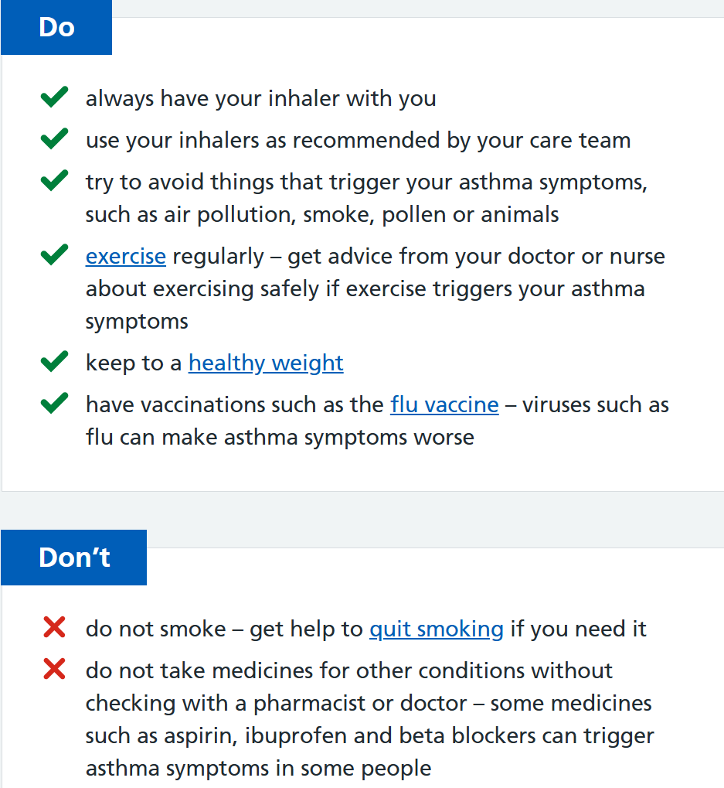
- Things you can do to help with asthma
Individuals with asthma may adopt strategies to alleviate symptoms and reduce the probability of asthma episodes (National HEalth Service, 2021).

Theoretical Frameworks and Models for the Management of Long-Term Conditions
Structured care models that direct therapy intensity and patient self-management are essential for managing chronic illnesses such as asthma. Individuals with asthma may enhance their results using the Stepped Care Model (UK) and the Chronic Care Model (CCM).

UK Model: The Stepped Care Model
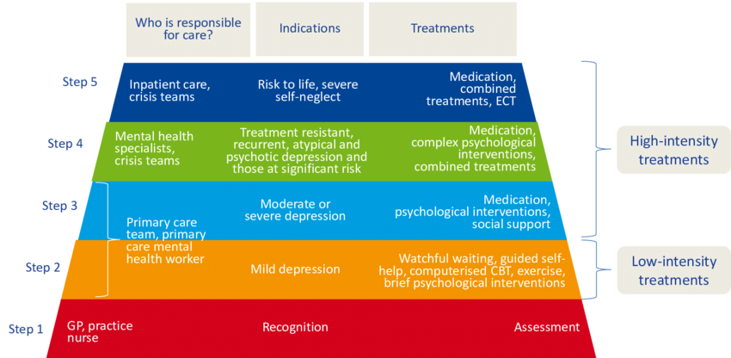
Short-acting beta-agonists used as relievers in asthma management are succeeded by preventive agents, including inhaled corticosteroids (ICS) and combination metered dosage inhalers, for chronic or severe asthma patients (Valero-Moreno, Montoya-Castilla and Pérez-Marín, 2023). Rescue inhalers are the first step in addressing minor and intermittent symptoms. If issues do not either improve or worsen, the therapy will progress to low-dose ICS (Step 2) and ultimately to higher dosages of ICS/LABA (Ghiyasvandian et al., 2021)
Source: (Kohn et al., 2016)
In the management of asthma, short-acting beta-agonists are used for intermittent symptoms, succeeded by preventive medications such as inhaled corticosteroids (ICS) and combination inhalers for chronic or severe cases (Kohn et al., 2016). The first step for modest intermittent symptoms is the use of as-needed relief inhalers. If symptoms deteriorate or increase in frequency, therapy escalates to low-dose ICS (Step 2) and higher dosages of ICS/LABA.
The model incorporates short-term increases in ICS dosage or bronchodilator use during acute exacerbations, subsequently decreasing following symptom resolution (Mareya et al., 2024). This plasticity enables asthma therapy to adjust to its variability.
The British Thoracic Society (BTS) and NICE advocate for frequent patient evaluations to evaluate management and modify treatment, endorsing the Stepped Care Model (Kohn et al., 2016). Personalised therapy reduces overtreatment and avoids undertreatment, enhancing symptom management and reducing exacerbations.

International Model: The Chronic Care Model (CCM)
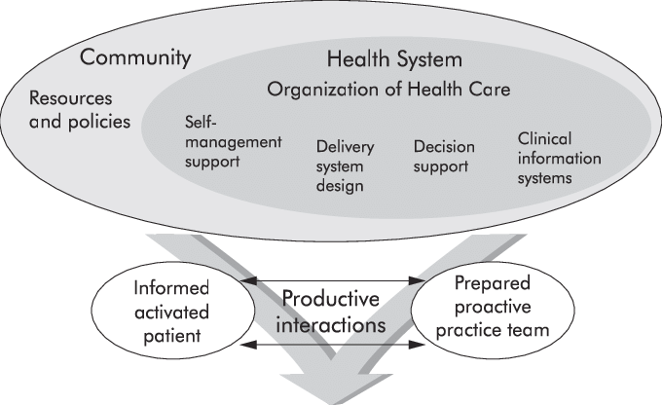
Wagner and associates developed the Chronic Care Model, a globally recognised framework for enhancing asthma treatment (Epping-Jordan, 2004). A methodical and proactive methodology for managing long-term conditions emphasises six interconnected elements:
Health System Organisation: Leadership dedication to excellent treatment and resource distribution.
Delivery System Design: Collaborative care with delineated responsibilities and scheduled appointments (Bostock, 2021).
Source:(Epping-Jordan, 2004)
Decision Support: Incorporation of evidence-based recommendations into routine practice.
Clinical Information Systems: Utilisation of registries and electronic records to monitor patient data and outcomes (Yeoh et al., 2018).
Self-Management Support: Equipping patients with knowledge, resources, and tailored action plans.
Community Resources: Connecting patients with community services and support networks.
The CCM facilitates asthma management by incorporating multidisciplinary treatment including primary care doctors, specialists, nurses, chemists, and educators (Yuan et al., 2025). Clinical information systems may facilitate regular evaluation of asthma control scores and drug adherence, prompting necessary interventions. Clinicians use decision support tools to adhere to best practices, while patients get personalised asthma action plans and self-management tools to identify and respond to symptom changes (Valero-Moreno et al., 2023).
The Stepped Care Model focusses on tailoring individual therapy based on symptom management, while the Chronic Care Model provides a broader perspective of the healthcare system, fostering sustained and high-quality care. In the UK, there is an increasing acceptance of these models via the incorporation of stepped care concepts into the CCM framework, therefore personalising it while maintaining systemic support.

Health and social care policy agendas at the local and national levels

National Health Policy Initiatives
The UK government has established extensive policy frameworks to enhance asthma management and results.
#AskAboutAsthma campaign aims

The objective of the campaign at the conclusion of week 38 is to ensure that all individuals responsible for the care of children and adolescents with asthma are adequately prepared (National HEalth Service, 2021). This week often sees a countrywide increase in asthma episodes as children return to school after the summer break. By providing effective education, accessible resources, and critical information, you can empower more children and adolescents to enquire about asthma and get the appropriate treatment they need.

NHS Long Term Plan (2019): Asthma was designated as a national clinical priority and respiratory ailment. The plan includes specific commitments to enhance the diagnosis and treatment of persons with respiratory conditions, along with the promotion of self-management assistance.
Quality Outcomes Framework (QOF): The revised GP contract for 2020/21-2023/24 has an improved QOF asthma domain. This framework ensures the maintenance of appropriate registries in all General Practice settings for asthma, and organised care in accordance with NICE guidelines (Diwakar et al., 2025).
Respiratory Clinical Networks: NHS England has established 13 respiratory clinical networks nationwide to provide clinical leadership and improve asthma treatment pathways (NHS England, 2023). These networks focus on care coordination and the implementation of evidence-based practices.

Regional Policy
England: NHS RightCare has developed extensive asthma toolkits for regional health systems. These toolkits emphasise patient self-activation, effective management, and individualised treatment. The program projects £13.3 million in non-elective asthma budget reductions if all Clinical Commissioning Groups implement best practices (NHS Shropshire, Telford and Wrekin, 2025).
Wales: The Welsh Government has proposed many Respiratory Health Delivery Plans, currently focussing on asthma-specific interventions. This includes the designation of asthma clinical leaders, establishment of specialised services, and formulation of All-Wales prescription routes (Bloom, Middleton and Lewis, 2025). The Quality Statement for Respiratory Disease has replaced traditional delivery plans with outcome-based quality statements.
Scotland: The Respiratory Care Action Plan 2021-2026 articulates the Scottish Government's vision on respiratory conditions. The plan outlines 12 promises in five key areas: prevention, diagnosis and treatment, self-management support, consistent access, and workforce development (Bush and Pavord, 2021).

Investment and Implementation Initiatives
- Substantial funding has been designated for asthma enhancement activities, with more than £1 million per year granted to the Welsh Respiratory Health Implementation Group for local trial projects and national programs (NHS England, 2023).
- The Accelerated Access Collaborative (AAC) has designated asthma biologics as Rapid Uptake Products, implementing unique programs to enhance access to new drugs. The AAC has developed consensus pathways for the treatment of uncontrolled asthma.
- NHS England has launched more than 80,000 first-tier courses, with 74% completed by educators and school personnel (Yuan et al., 2025). This is a substantial investment in the growth of the healthcare and education workforce.

Recommendations for Person-Centred Care Approaches

Self-Management Support Framework
Comprehensive Supported Self-Management: Research indicates that aided self-management is the most effective therapy for asthma. Studies indicate that treatments involving over two hours of assistance from healthcare professionals enhance quality of life and decrease emergency healthcare use (Grant, Croce and Matsui, 2021).
Personalised Action Plans: All individuals with asthma should have a detailed customised asthma action plan. These plans need to be:
- Accessible in all hospital environments
- Regularly reviewed and revised, especially after exacerbations (Kharaba et al., 2022).
- Digitally accessible for emergency use
- Comprising drug details and contraindications

Technology-Enhanced Care
Digital Health Integration: Person-centred care must integrate digital tools to improve self-management.
- Intelligent non-Adherence tracking inhalers
- Mobile applications for symptom monitoring and medication reminders
- Remote telemonitored healthcare consultations

End-of-Life Care Considerations
Palliative Care Integration: Palliative treatment should be included early in the illness trajectory for persons with severe, progressive asthma (Lo et al., 2021). This methodology emphasises:
- Symptom management and quality of life improvement
- Psychological and spiritual assistance
- Family-cantered care planning
- Discussions about advance instructions
Breathlessness Management: Palliative treatment for asthma must include thorough measures for managing dyspnoea.
- Non-pharmacological therapies include relaxation methods (P Jane McDowell et al., 2023).
- Pharmacological strategies for alleviating symptoms
- Alterations to the environment to enhance comfort
- Psychological assistance for anxiety associated with dyspnoea

Quality Improvement and Monitoring
Outcome Measurement: Person-centred care must include consistent assessment of:
- Patient-reported outcome measures (PROMs).
- Evaluations of quality of life
- Levels of patient activation
- Indicators for symptom management

Conclusion
Asthma is a major global health problem, with a high prevalence and mortality rate in the UK. A practice-based management approach should encompass interventions that are evidence-based, strong policies, and individualised care. Asthma affects the patient in physical, psychological, and social ways, in addition to bringing about financial strains to both the families and the NHS. Deaths that are caused by asthma are avoidable in two-thirds. The application of models like the Chronic Care Model and the recent UK guidelines improves the results. Future development has to be based on investment in workforce, technology and holistic care.

References
- Bauer, M.S., Miller, C.J., Kim, B., Lew, R., Stolzmann, K., Sullivan, J., Riendeau, R., Pitcock, J., Williamson, A., Connolly, S., Elwy, A.R. and Weaver, K. (2019). Effectiveness of Implementing a Collaborative Chronic Care Model for Clinician Teams on Patient Outcomes and Health Status in Mental Health. JAMA Network Open, 2(3), p.e190230. doi: https://doi.org/10.1001/jamanetworkopen.2019.0230.
- Bloom, C.I., Middleton, J. and Lewis, A. (2025). Qualitative study of patients experiences and perceptions of stepping down asthma medication in primary care across England. BMJ Open Respiratory Research, [online] 12(1), pp.e002898–e002898. doi: https://doi.org/10.1136/bmjresp-2024-002898.
- Bostock, B. (2021). Management of long-term conditions. A Nurse's Survival Guide to General Practice Nursing E-Book: A Nurse's Survival Guide to General Practice Nursing E-Book, p.149.
- Busby, J., Price, D., Al-Lehebi, R., Bosnic-Anticevich, S., van Boven, J.F.M., Emmanuel, B., FitzGerald, J.M., Gaga, M., Hansen, S., Hew, M., Iwanaga, T., Larenas Linnemann, D., Mahboub, B., Mitchell, P., Morrone, D., Pham, J., Porsbjerg, C., Roche, N., Wang, E. and Eleangovan, N. (2021). Impact of Socioeconomic Status on Adult Patients with Asthma: A Population-Based Cohort Study from UK Primary Care. Journal of Asthma and Allergy, [online] 14, pp.1375–1388. doi: https://doi.org/10.2147/JAA.S326213.
- Bush, A. and Pavord, I.D. (2021). Forthcoming UK asthma guidelines: an opportunity to improve asthma outcomes. The Lancet, 398(10314). doi: https://doi.org/10.1016/s0140-6736(21)02244-3.
- Dharmage, S.C., Perret, J.L. and Custovic, A. (2019). Epidemiology of Asthma in Children and Adults. Frontiers in Pediatrics, [online] 7(246). doi: https://doi.org/10.3389/fped.2019.00246.
- Diwakar, L., Subramanian, A., Shah, D.K., Subramaniam, S., Pelly, V.S., Greenfield, S., Moore, D. and Nirantharakumar, K. (2025). Prevalence trends and risk factors for allergic rhinoconjunctivitis, asthma and eczema in the UK. Allergy, Asthma & Clinical Immunology, 21(1). doi: https://doi.org/10.1186/s13223-025-00975-2.
- Dr. Mayank Saxena (2024). Asthma – Causes, Symptoms, Risk Factors & Treatment. [online] Fortis Healthcare. Available at: https://www.fortishealthcare.com/blogs/asthma-causes-symptoms-risk-factors-treatment.
- Epping-Jordan, J.E. (2004). Improving the quality of health care for chronic conditions. Quality and Safety in Health Care, 13(4), pp.299–305. doi: https://doi.org/10.1136/qhc.13.4.299.
- Ghiyasvandian, S., Shahsavari, H., Matourypour, P. and Golestannejad, M.R. (2021). Integrated Care model: Transition from acute to chronic care. Revista Brasileira de Enfermagem, 74(suppl 5). doi: https://doi.org/10.1590/0034-7167-2020-0910.
- Global Asthma Network (2022). The Global Asthma Report 2022. [online] globalasthmareport.org. Available at: https://globalasthmareport.org/burden/burden.php.
- Grant, T., Croce, E. and Matsui, E.C. (2021). Asthma and the Social Determinants of Health. Annals of Allergy, Asthma & Immunology, [online] 128(1), pp.5–11. doi: https://doi.org/10.1016/j.anai.2021.10.002.
- Jacobs, A., Wu, R., Tomini, F., De Simoni, A. and Mihaylova, B. (2023). Strong and graded associations between level of asthma severity and all-cause hospital care use and costs in the UK. BMJ open respiratory research, [online] 10(1), p.e002003. doi: https://doi.org/10.1136/bmjresp-2023-002003.
- Kharaba, Z., Feghali, E., El Husseini, F., Sacre, H., Abou Selwan, C., Saadeh, S., Hallit, S., Jirjees, F., AlObaidi, H., Salameh, P. and Malaeb, D. (2022). An assessment of quality of life in patients with asthma through physical, emotional, social, and occupational aspects. A cross-sectional study. Frontiers in Public Health, [online] 10. doi: https://doi.org/10.3389/fpubh.2022.883784.
- Kohn, L., Obyn, C., Jef Adriaenssens, Christiaens, W. and Marijke Eyssen (2016). MODEL FOR THE ORGANIZATION AND REIMBURSEMENT OF PSYCHOLOGICAL AND ORTHO PEDAGOGICAL CARE IN BELGIUM. [online] doi: https://doi.org/10.57598/R265S.
- Kuruvilla, M.E., Vanijcharoenkarn, K., Shih, J.A. and Lee, F.E.-H. (2019). Epidemiology and risk factors for asthma. Respiratory Medicine, [online] 149, pp.16–22. doi: https://doi.org/10.1016/j.rmed.2019.01.014.
- Lo, D., Beardsmore, C., Roland, D., Richardson, M., Yang, Y., Danvers, L., Wilson, A. and Gaillard, E.A. (2021). Risk factors for asthma attacks and poor control in children: a prospective observational study in UK primary care. Archives of Disease in Childhood, p.archdischild-2020-320110. doi: https://doi.org/10.1136/archdischild-2020-320110.
- Mareya, S., Watts, M., Zhao, L. and Olasoji, M. (2024). Exploring the Stepped Care Model in Delivering Primary Mental Health Services—A Scoping Review. International Journal of Mental Health Nursing, 33(6). doi: https://doi.org/10.1111/inm.13427.
- Mayo Clinic (2025). Asthma. [online] Mayo Clinic. Available at: https://www.mayoclinic.org/diseases-conditions/asthma/symptoms-causes/syc-20369653.
- National HEalth Service (2021). Asthma. [online] NHS. Available at: https://www.nhs.uk/conditions/asthma/.
- NHS England (2019). Childhood asthma. [online] England.nhs.uk. Available at: https://www.england.nhs.uk/childhood-asthma/.
- NHS England (2023). NHS England» RightCare asthma scenario. [online] www.england.nhs.uk. Available at: https://www.england.nhs.uk/long-read/rightcare-asthma-scenario/.
- NHS Shropshire, Telford and Wrekin. (2025). Ask About Asthma - NHS Shropshire, Telford and Wrekin. [online] Available at: https://www.shropshiretelfordandwrekin.nhs.uk/ask-about-asthma/
- P Jane McDowell, McDowell, R., Busby, J., M. Chad Eastwood, Patel, P., Jackson, D.J., Mansur, A., Patel, M., Burhan, H., Doe, S., Chaudhuri, R., Gore, R., Dodd, J., Subramanian, D., Brown, T. and Heaney, L.G. (2023). Clinical remission in severe asthma with Biologic Therapy: an analysis from the UK Severe Asthma Registry. The European respiratory journal, 62(6), pp.2300819–2300819. doi: https://doi.org/10.1183/13993003.00819-2023.
- Paoletti, D.G. (2023). Understanding the different types of asthma. [online] Airlyn. Available at: https://airlyn.io/title-understanding-the-different-types-of-asthma/.
- Plaza-González, S., Zabala-Baños, M. del C., Astasio-Picado, Á. and Jurado-Palomo, J. (2022). Psychological and Sociocultural Determinants in Childhood Asthma Disease: Impact on Quality of Life. International Journal of Environmental Research and Public Health, [online] 19(5), p.2652. doi: https://doi.org/10.3390/ijerph19052652.
- RCPCH (2020). Asthma – RCPCH – State of Child Health. [online] stateofchildhealth.rcpch.ac.uk. Available at: https://stateofchildhealth.rcpch.ac.uk/evidence/long-term-conditions/asthma/.
- Richard, Darush Attar-Zadeh, Harper, N., Mosgrove, F., Rush, L. and Singh, D. (2024). Results from a UK consensus about the optimal prescribing of medium strength triple therapy in uncontrolled adult asthma patients in the NHS. Journal of Family Medicine and Primary Care, [online] 13(12), pp.5885–5893. doi: https://doi.org/10.4103/jfmpc.jfmpc_1082_24.
- Samruddhi Yardi (2024). Asthma Statistics 2024 By Healthcare. [online] Market.us Media. Available at: https://media.market.us/asthma-statistics/.
- Stanescu, S., Kirby, S.E., Thomas, M., Yardley, L. and Ainsworth, B. (2019). A systematic review of psychological, physical health factors, and quality of life in adult asthma. npj Primary Care Respiratory Medicine, [online] 29(1). doi: https://doi.org/10.1038/s41533-019-0149-3.
- Statista (2024). Topic: Asthma in the United Kingdom. [online] Statista. Available at: https://www.statista.com/topics/3142/asthma-in-the-united-kingdom/#topicOverview.
- Valero-Moreno, S., Montoya-Castilla, I. and Pérez-Marín, M. (2023). Quality of life in patients with asthma: Medical indicators and psychological variables. Journal of Pediatric Nursing, [online] 69. doi: https://doi.org/10.1016/j.pedn.2022.12.030.
- Yeoh, E.K., Wong, M.C.S., Wong, E.L.Y., Yam, C., Poon, C.M., Chung, R.Y., Chong, M., Fang, Y., Wang, H.H.X., Liang, M., Cheung, W.W.L., Chan, C.H., Zee, B. and Coats, A.J.S. (2018). Benefits and Limitations of Implementing Chronic Care Model (CCM) in Primary Care programs: a Systematic Review. International Journal of Cardiology, [online] 258(1), pp.279–288. doi: https://doi.org/10.1016/j.ijcard.2017.11.057.
- Yuan, L., Tao, J., Wang, J., She, W., Zou, Y., Li, R., Ma, Y., Sun, C., Bi, S., Wei, S., Chen, H., Guo, X., Tian, H., Xu, J., Dong, Y., Ma, Y., Sun, H., Wenhua Lv, Shang, Z. and Jiang, Y. (2025). Global, regional, national burden of asthma from 1990 to 2021, with projections of incidence to 2050: a systematic analysis of the global burden of disease study 2021. EClinicalMedicine, [online] 80, pp.103051–103051. doi: https://doi.org/10.1016/j.eclinm.2024.103051.

