

Programme: Master of Business Administration (MBA)

Assignment Title:
Assessment component 1: Individual report

Student Name:
Marzana Hasan Mita

Student ID:
2504068

Module Name:
International Marketing: Principles and Practices

Module Code:
LCMB7026

Lecturer’s Name: Dr Mustakkima Afrin

AI use acknowledgement

I confirm that I have not presented any AI generated text as my own work. I confirm I have copies of my drafts, notes, and other resources I used before, and after the use of AI tools which I may be asked to provide in evidence.

Table of Contents
Section 1 5
Introduction 5
IKEA Company Background 6
2.1 Brief history and global business model 6
2.2 Overview of the international expansion and current presence of IKEA in the market 6
a.1 Comparative Macro-Environmental Analysis of the Markets 7
a.1.1 PESTEL Analysis - United Kingdom 7
a.1.2 PESTEL Analysis - China 7
a.1.3 Comparative Insights and Implications for IKEA 8
a.2 In-Depth Analysis of Social Factors: Culture, Consumer Behaviour and Implications 10
a.2.1 The Hofstede Cultural Dimensions of the UK and China. 10
a.2.2 Consumer Behaviour and Shopping Patterns in UK. 10
a.2.3 Shopping Behaviour and Patterns of Consumption in China. 10
a.2.3 Critical Comparison and Marketing Implication. 11
b.1 Comparative Analysis of STP Strategies 12
b.1.1 United Kingdom Segmentation, Targeting and Positioning. 12
b.1.2 Segmentation, Targeting and Positioning in China. 12
b.1.3 Strategic Insights, Strategies, Principal Differences and Strategies. 12
b.1.4 Comparative STP Analysis 13
b.2 Comparative Analysis of the International Marketing Mix (7Ps) 14
b.1.1 Product Strategy and Adaptation 14
b.1.2 Price Strategy 14
b.1.3 Place (Distribution & Retail Experience) Strategy 14
b.1.4 Promotion Strategy 15
b.1.5 People, Process and Physical Evidence Strategies 15
b.1.6 Overall Standardisation vs Adaptation Discussion (cultural and economic influences) 15
c.1 Analysis of IKEA’s Directional Development Strategy in China 17
c.1.1 Application of Ansoff Matrix 17
c.1.2 Current growth initiatives and future directional strategy in China 17
d.1 Evaluation of Ethical Issues Related to the Marketing Mix 19
d.1.1 Key ethical concerns in the UK and/or China (supply chain, sustainability, labour practices, marketing communications) 19
c.1.2 Critical assessment and link to marketing mix elements 19
e.1 Recommendations 21
e.1.1 Strategic recommendations for IKEA in the UK and China 21
e.1.2 Forward-looking international marketing strategy suggestions 21
Section 2 23
Reflective Account 23
Reference 26
Appendix 30
1. Hofstede Cultural Dimensions of China and the United Kingdom 30

Section 1

Introduction
This report is a critical analysis of the international marketing mix of IKEA in United Kingdom and China. It brings to its assessment the application and adaptation of the marketing strategies of the Swedish furniture giant in two different markets with opposite characteristics. The scope entails comparative PESTEL analysis of the macro environment, an intensive analysis of society and cultural determinants of consumer behaviour, STP, the extended marketing mix (7Ps). The report also presents directional development strategy in China, ethical concerns of marketing activities, and strategic recommendations to future growth. The report evaluates the conflicting nature between standardisation and localisation in international marketing using the current industry data up to the year 2026.
IKEA has been selected because it is one of the most successful stories of global retailing and has over 500 stores in 63 countries and its annual retail sales have gone past EUR39 billion (Ingka Group, 2025). The flat-pack design concept and democratic design philosophy makes the company a good fit to learn the principles of international marketing. The UK and China were chosen because of their good data availability and opposite market attributes. The UK is a long-established Western market with IKEA presence dating back to 1987 and now runs more than 21 stores making PS2.25 billion in FY2025. China on the other hand is a high potential emerging market with about 35-40 stores to which IKEA has made major adjustments in terms of local preferences, urban living standards as well as high rate of digital transformation (IKEA, 2024). The abundance of scholarly research, especially Burt, Johansson and Thelander (2011) offer great content to be critically compared, and the latest strategic changes (like switching to smaller-format stores by China) are an excellent addition to the arsenal.
After introducing, the report brings the background of IKEA and then macro-environmental and socio-cultural analysis. Later in the paper, the STP and 7Ps strategies are contrasted, directional growth in China is analyzed, ethical concerns are discussed, and finally recommendations are given. Such a structure is closely related to the module learning outcomes as it allows to critically compare cultural differences and similarities within a marketing situation and think over the modern ethical and practical frameworks of global marketing.

IKEA Company Background

2.1 Brief history and global business model
Ingvar Kamprad established IKEA in Almhult, Sweden in 1943. Its name is an acronym made up of Ingvar Kamprad, Elmtaryd (the farm where Kamprad was brought up), and Agunnaryd (his native village). The company began in 1948 with a focus on furniture and once more in 1953 it opened the first showroom, which was initially a mail-order business that sold pens, watches and small household items (IKEA, 2025).
The fundamental aspect of its global business model is its vision to make better everyday living of the many people possible by the aesthetic design - providing well-designed and functional furniture at reasonable costs. This is through an exclusive flat-pack feature, self-service stores, self-assembled by the customers and a highly efficient international supply chain. IKEA functions under franchise system, with the concept and brand being owned by Inter IKEA Systems B.V. and Ingka Group being the biggest franchisee with majority of its stores being operated by INGKA Group (IKEA, 2022).

2.2 Overview of the international expansion and current presence of IKEA in the market
The first store outside Sweden was opened in Norway in 1963 and this was the beginning of international growth of IKEA. It penetrated the United Kingdom in 1987 and in China in 1998. Nowadays, IKEA has a presence in 63 countries, and its total retail sales are EUR44.6 billion in FY25 (IKEA, 2025b). The company has developed into multi-channel retailer, starting with large out of town stores with smaller city centre formats; in the planning studios and high level of internet connectivity to make the company more accessible. The fact that it is in both developed markets such as the UK and other developing markets such as China presents a perfect example of studying adaptation strategies in international marketing.

a.1 Comparative Macro-Environmental Analysis of the Markets

a.1.1 PESTEL Analysis - United Kingdom
The United Kingdom is a stable mature market that IKEA has had since the 1987 entry. Politically, the aftermath of the Brexit has created minor trade frictions but the UK pro-retail policies and political stability have ensured that the foreign operations can be undertaken with little interference. Moderate GDP growth of 1.3% in FY25 and declining inflation have been negated by the continued cost-of-living effects, limiting discretionary furniture product expenditure (ONS, 2026). However, IKEA low-price business model has been resilient, and UK retail sales have gone to £2.25 billion in FY25 (IKEA, 2025c). Socially, individualism is very high, the population is ageing, and the sustainability concept is on the increase which leads to the demand of low-budget and environmentally friendly designs. Digital infrastructure has been advanced and resulted in 43.2% of the sales through which is facilitated by the omnichannel distribution (Statista, 2025). The UK net-zero 2050 goals are in line with the IKEA circular activities, as it has fulfilled 41.1% home deliveries using zero emission vehicles and aiming at to reach it to 90% by 2028 (IKEA, 2020). Laws Relatively there are no significant obstacles to consumer protection and employment laws that are legally strong.

a.1.2 PESTEL Analysis - China
Since the entry, IKEA has been in China, it has been a high growth, dynamic environment. There is supportive foreign investment policies and common prosperity agenda that is politically oriented in which the government supports retail growth but regulatory control on data and competition is rigorous. Economically, the consistent GDP growth (around 5% in FY25), the development of the middle class, and the consumption slowdown and apartment limitations in cities encourage the utilization of the traditional large-store format (World Bank Group, 2025). However, demand and consumption are slowing down, which makes the utilization of the traditional large-store format less competitive. Collectivist values and accelerating urbanisation are socially driving towards experiential shopping where consumers are seeking more aspirational but less expensive lifestyles (Dai, 2025). The Chinese mobile-first ecosystem (WeChat, Alipay) has enabled IKEA to move faster into the digital realm and become hyper-localised with smaller-format stores, all facilitated by technology (Taylor, 2023). The carbon-neutrality commitment of 2060 places pressure on IKEA in terms of environmental sustainability (Sun, Cui and Ge, 2022). It requires the company engage in increased sustainable sourcing, and legal issues like foreign investment catalogues and the privacy of personal information (PIPL) require constant localisation.

a.1.3 Comparative Insights and Implications for IKEA
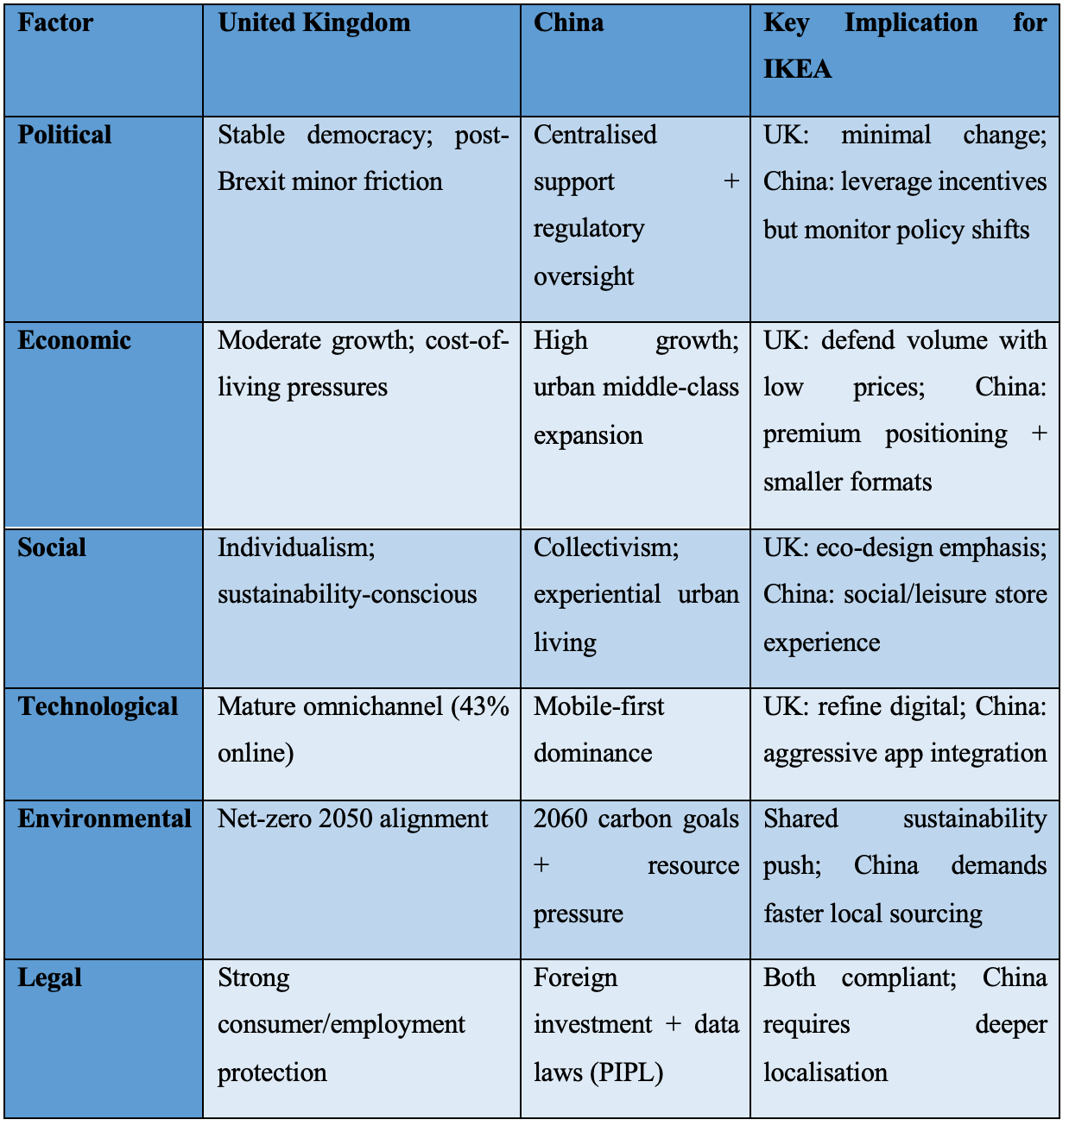
The PESTEL comparison in the table below demonstrates the extreme differences that have a direct influence on the adaptation strategies of IKEA. A more sustainable but slower growth environment in the UK needs an efficiency and focus on sustainability, whilst the dynamic macro forces in China need agility and localisation. The differences present opportunities and threats to the standardisation-versus-adaptation dilemma of IKEA.
Table 1 PESTLE Analysis (IKEA, 2020; Sun, Cui and Ge, 2022; Dai, 2025)
On the whole, the developed macro environment in the UK compensates the core flat-pack approach of IKEA by incremental innovation (e.g., city-centre formats and EV logistics). Conversely, China has undergone swiftly changing factors requiring massive adjustment, such as shutting down of large outlets, the introduction of “Do It For Me” services, and the opening of mixed-use Livat centres (e.g. Shanghai in 2024, costing of $1.14 billion) (Ma, Liu and Zhang, 2024). “Do It For Me” is the name of a professional shipment and assembly service of IKEA where a professional deliver and install the product at the customer’s location. These differences verify the prior results of Burt et al. (2011) and reflect the changes in 2025-2026. Here IKEA will have to strike a balance between world efficiency and hyper-local responsiveness to maximise its activities in China, yet maintaining the margins in the UK in a cost-conscious market. Not resolving such macro divergences will result in loss of competitive advantage in both cases.

a.2 In-Depth Analysis of Social Factors: Culture, Consumer Behaviour and Implications

a.2.1 The Hofstede Cultural Dimensions of the UK and China.
The six-dimensional model by Hofstede identifies some basic differences in culture that compel IKEA to juggle between global standardisation and local adaptation. United Kingdom has low Power Distance (35) and high Individualism (89) which depicts a society that is at ease with equality and self-dependence. Conversely, China has high scores on Power Distance (80) and low scores on Individualism (20) which shows that it embraces hierarchy and is highly group/family oriented. The two countries are also close to each other in Masculinity (UK 66; China 66) where competitive achievement is appreciated, but they have a wide gap in Long-Term Orientation (UK 51; China 87) and Indulgence (UK 69; China 24). The UK indulgent culture in the short term is more inclined towards instant satisfaction of cravings and leisure, whereas the long-term China is more about enduring and saving (Hofstede, 2025). A side-by-side comparison is presented in the Appendix 1.

a.2.2 Consumer Behaviour and Shopping Patterns in UK.
The British consumers are individualistic and DIY oriented. They treasure personal expression with home styling as they like an experience of self-assembly as an empowerment. The level of sustainability is high, and the need in environmentally-friendly materials and the circle economy grows. Shopping behaviour is a mix of a brick and click and mortar (more than 43% of furniture purchases are online), fueled by convenience and post-Brexit price consciousness (IKEA UK FY25). UK customers also use IKEA visits as practical shopping trips, but not as a social activity, because they anticipate fast and efficient shopping in line with time-starved lives (Burt et al., 2011).

a.2.3 Shopping Behaviour and Patterns of Consumption in China.
High urbanisation and living in small flats have led to collectivist, experiential behaviour of Chinese consumers. Purchases are strongly dependent on family and social status as the stores are a place of leisure where people can visit on weekends to go out, eat, and play with children. The conventional DIY business is largely disavowed as consumers seek “Do It For Me” assembly and delivery services as a result of lack of space, expertise and time (Burt et al., 2020). Aspirational middle-class consumers perceive IKEA as a lifestyle improvement and not necessarily cheap, which has motivated the need to localise the design and to have products that feel expensive. WeChat mobile-first shopping is designed to complement shopping in stores (Burt, 2021).

a.2.3 Critical Comparison and Marketing Implication.
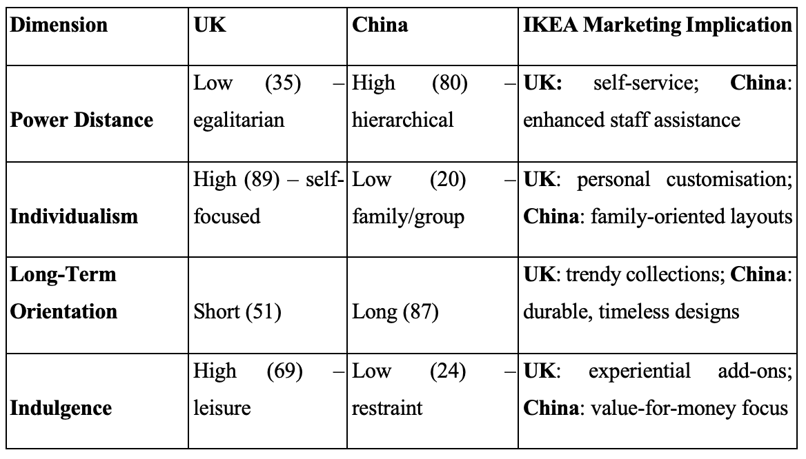
The cultural gap like shown in the table below brings out sharp consumer interaction. The UK individualism is aligned with the concept of the primary self-service model of IKEA requiring minimal adjustments, as it helps to strengthen brand loyalty by providing a sense of personal empowerment and sustainability. The collectivism and the long-term values of China require a deep localisation, such as turning a store into a social centre and paid services to address the initial resistance to the idea of flat-packs (Burt et al., 2020).
Table 2 Hofstede Cultural Dimensions (Burt et al., 2020)
These variations confirm the results by Burt et al. (2011) regarding the problem of standardisation and indicate evolution that IKEA has changed its strategy towards market-based standardisation in China to market-based adaptation, with smaller formats and localized designs. Any attempt to ignore these social-cultural finances would lead to either losing the Chinese consumers that are status conscious and want to enjoy the social experience, or over-localisation would lead to a weakening of the UK brand equity. Ulug’bek (2025) identified the secret to IKEA is glocalisation, which means to keep democratic design worldwide and fit the retail theatre to cultural needs, which will result in greater engagements and sales in the two markets.

b.1 Comparative Analysis of STP Strategies

b.1.1 United Kingdom Segmentation, Targeting and Positioning.
The UK IKEA uses a more or less standardised STP strategy that is very similar to the international model. Segmentation is based on both demographic characteristics- young to middle-aged families, students and urban professionals aged 25-45 and psychographic attributes- cost-conscious and DIY-driven consumers, and self-expression and sustainability (Dragičević, 2020). Targeting is aimed at the main middle-class market that pursues cheap quality. Positioning focuses on the principles of the so-called democratic design - giving customers the power with flat-pack self-assembly, modernity and value-for-money, solidifying individualism and practicality in a fully developed market with time-poor people (Burt et al., 2011).

b.1.2 Segmentation, Targeting and Positioning in China.
Segmentation in China holds on to similarities in demographics (urban middle-class families and young professionals aged 25-40) but adds more behavioural and psychographic factors that are influenced by collectivism and constraints of urban life (Burt et al., 2020). Targeting has changed to aspirational consumers who prefer to purchase furniture as an upgrade to their lifestyle and social experience. The positioning moves towards modern, experience-based, lifestyle brand where the stores are located as recreational centers with do-it-for-me services, family-friendly facilities, and culturally customized layouts to suit group decision-making (Hu, 2023).

b.1.3 Strategic Insights, Strategies, Principal Differences and Strategies.
The two markets are similar in terms of the core segmentation, which consists of cost-sensitive urban middle-class customers and the global positioning, which is based on low prices and democratic design. However, there arise largely distinct differences in depth of targeting and execution of positioning. Individualistic culture in the UK embraces little adaptation and self-service efficiency is one of the strong points. By contrast, the collectivist, high-power-distance situation in China requires even stronger localisation (Hofstede, 2025). The stores are turned into social spaces in China instead of functional warehouses, and positioning is focused on the aspiration and convenience, instead of DIY empowerment.

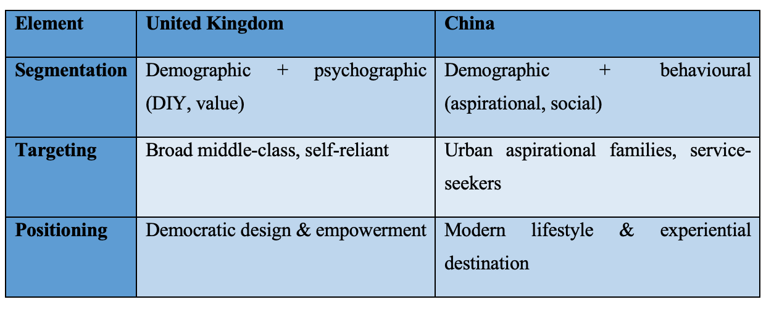
b.1.4 Comparative STP Analysis
Table 3 Comparison of STP of the UK and China (Ulug’bek, 2025)
These comparisons point to the initial results of Burt et al. (2011) regarding the limits of standardisation and also the subsequent findings of Burt (2020) on how IKEA changed its market-driven orientation in China. The UK is strategically in a position to gain consistent markets, maintaining brand equity and margins in an established industry. The adaptations made by China have contributed to the growth of volumes, which has become more complex and costly. The realization is also evident that although global STP is efficient, cultural misfit leads to adaptive selectivity. To maintain competitive advantage and prolonged development, IKEA needs to seek glocalisation - keeping original value positioning on a global scale and differentiating experiential and service aspect in high-context markets such as China (Ulug’bek, 2025).

b.2 Comparative Analysis of the International Marketing Mix (7Ps)

b.1.1 Product Strategy and Adaptation
The product strategy of IKEA is based on the global theory of democratic design comprising of cheap, practical, and well-designed furniture. Nevertheless, there is a dramatic difference in the level of adaptation in both UK and China because of cultural and economic reasons. The selection is still very standardised in the UK, with a focus on modular flat-pack products with more sustainability credentials. The current products, like the TAGGHAJ frying pan (at least 70% recycled aluminium) and the ZEBRASAV ceiling lamp (at least 50% recycled plastic), are the direct response to the increasing environmental awareness of British consumers and their desire to express themselves at home (Kohli, N., 2025, IKEA, 2026)). In China, the real estate is considerably smaller to include in the tiny urban apartments and is more family-friendly and multi-purpose. Local sourcing has grown in order to lower prices and attract collectivist ideals. Overall, the UK strategy would save global efficiency, whereas China needs to be more localised to address the spatial constraints and cultural orientation to the family as a usable factor.

b.1.2 Price Strategy
The pricing is based on the low-price philosophy of IKEA across the world, but the implementation on the market is based on market maturity. The UK has a stable value-for-money strategy that relieves some of the burden of cost of living using promotions and discounts to Family members. Price stability ensured that the volume grew, even though the sales declined by 2.1% to £2.25 billion in FY25 (Furniture News, 2025). China originally cut prices in order to enter the market but has started to play aspirational yet affordable prices to the middle class. New e-commerce integration within JD.com and selective discounts will be favouring the volume in a price-sensitive environment (Reuters, 2025). So, although the UK protects its margins with stability, China with pricing flexibility is also signaling its status, and this is an economic adjustment.

b.1.3 Place (Distribution & Retail Experience) Strategy
The most divergence is with distribution strategy. UK still has massive out-of-town stores topped by robust omnichannel development, and online purchase will amount to 43 percent of the overall income by expanding its delivery and collection options (Ingka, 2025).
China is radically changing. seven large stores will close in February 2026, and it is proposed to open more than ten smaller urban-format stores in Beijing and Shenzhen in the next two years. Stores are redesigned as social/ leisure spaces, with the assistance of the Livat mixed-use centres and delivery in a couple of hours (Wang Zhuoqiong, 2026). This comparison highlights the pressure on experiential localisation caused by macro changes in China against the UK efficient hybrid model.

b.1.4 Promotion Strategy
Marketing in the UK is still practical and personalistic and it is based on the use of catalogues, targeted online advertisements, and sustainability messages to attract independent customers (Ma, Liu and Zhang, 2024). On the oterh hand, China uses emotion-focused, collectivist campaigns through WeChat, Douyin, and KOLs donning warmness and closeness of the family, user-generated content challenges such as IkeaMagicMakeover, and narratives with undertones (Mansouri, et. al., (2025). Ovarall, the most profound cultural adaptation is that of promotion whereby passive UK communication is transformed into active community interaction in China.

b.1.5 People, Process and Physical Evidence Strategies
Self-service is dominant with little staff intervention and is popular in UK which has the culture of individualism (Hofstede, 2025). Efficiency is focused on by processes, and the global warehouse look is supported by physical evidence (store layout). China, on the other hand, changes everything: additional employees to help, “Do It for Me” assembly or delivery system, physical evidence has been changed into cozy social areas with restaurants and playgrounds (Ma, Liu and Zhang, 2024). So, the way these factors bring the differences in cultures into reality through actual customer experiences.

b.1.6 Overall Standardisation vs Adaptation Discussion (cultural and economic influences)
In general, IKEA implements the glocal strategy: the standardisation of the main brand DNA (flat-pack, low-price vision) coupled with the adjustment of the customer-related aspects. These decisions are determined by cultural areas (high individualism in the UK and collectivism in China) and economic situations (mature UK and dynamic China). The 2026 China shifts to smaller formats in recent years confirm the initial results of Burt et al. (2011) on the required adaptation, whereas the UK consistency safeguards the margins. Losing adaptability will spell doom in China and excessive adaptability will be a threat to brand dilution in the UK. Strategic insight: selective standardisation in the processes of the back-office and in-depth localisation in the front-line experience will provide sustainable competitive advantage.

c.1 Analysis of IKEA’s Directional Development Strategy in China

c.1.1 Application of Ansoff Matrix
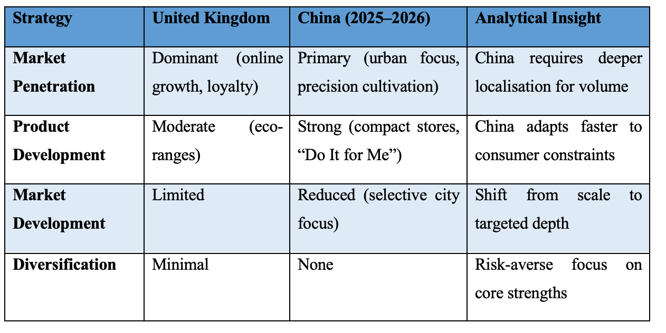
Ansoff Matrix is a useful tool to frame the directional strategy of IKEA in China that grows using existing/new products and markets. The strategy that the company mostly follows is market penetration- selling the already existing flat-pack products deeper into the already existing urban segments- and product development- introducing new store formats and superior services (Dragičević, 2020). It is a hybrid strategy that is not as aggressive as market development in previous expansion stages. By comparison, the UK market is still highly skewed towards pure market penetration by means of digital optimisation and slight product adjustments (e.g. sustainable collections), and little format innovation on the basis of well-established infrastructure (Ma, Liu and Zhang, 2024).
Table 4 Ansoff Matrix – Directional Strategy Comparison (Dragičević, 2020; Ma, Liu and Zhang, 2024)
Table 4 demonstrates that China is more dynamic in its strategy than the UK penetration model which is stable, a factor of economic instability and pressures of urbanisation.

c.1.2 Current growth initiatives and future directional strategy in China
This analytical change can be traced in current initiatives. As of February 2026, IKEA shut down seven big outlets in the suburbs (such as Shanghai Baoshan and Guangzhou Panyu) to reduce the operation and intends to open more than ten stores with the flexible format in Beijing and Shenzhen by 2028. New openings, including Dongguan, Tongzhou Beijing combine online-offline, Livat mixed-use centres and complete delivery, “Do It For Me” (Wang Zhuoqiong, 2026).
In future, IKEA should focus on smaller stores instead of increase of scale. Smaller stores minimise travel distance, promote accessibility and conform to collectivist experiential shopping. In comparison with the consistent refinement of the UK omnichannel, the strategy in China reduces the risk of slowed consumption in the country but capitalizes on the growth of the middle-class (Hu, 2023). More importantly, this glocal development enhances the long-term competitiveness by equalising global efficiency with hyper-local responsiveness, but it requires increased operational complexity compared to the more standardised approach in the UK.

d.1 Evaluation of Ethical Issues Related to the Marketing Mix

d.1.1 Key ethical concerns in the UK and/or China (supply chain, sustainability, labour practices, marketing communications)
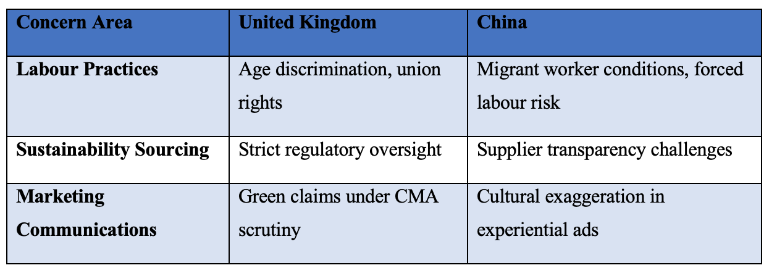
IKEA still experiences ethical scrutiny in its global value chain although some has been made through the IWAY supplier code. According to the Inter IKEA Group Sustainability Statement FY25, forced labour and child labour in the supply chain and franchise activities are listed as material negative impacts, and the risk of these continues to exist in the highly complex networks in Asia (Inter IKEA Group, 2025). The high rate of deploying “Do It for Me” services in China has increased the knowledge on the issue of exploitation and fair wages among migrant workers in delivery and assembly. According to Ethical Consumer (2025), in the UK, there are a series of challenges that impede unionisation and age discrimination in operations and indirect suppliers. Issues of sustainability focus upon the issue of sourcing wood, in which IKEA products have been cited to be the cause of illegal logging despite being FSC certified (Lehren, Luce and Schecter, 2021). This is where marketing communications can be susceptible to the greenwashing effect when aspirational tales of sustainability are outpaced by traceability that can be verified.
Table 5 Key Ethical Concerns – UK vs China (Lehren, Luce and Schecter, 2021)
Table 5 emphasizes that regulatory maturity in the UK increases the visibility of the problems, whereas the level of China presents greater operational weaknesses.

c.1.2 Critical assessment and link to marketing mix elements
These issues are critical in debilitating the effectiveness of the marketing mix of IKEA. The democratic design and sustainability positioning of product strategy (e.g., recycled materials) loses some credibility when the questions of sourcing ethics arise, which have a direct impact on consumer trust in both markets (Wang, Chang and Chen, 2021). The advertisement of China’s collectivist and experiential campaigns, and the UK digital advertisements with a focus on environment bear the risk of being accused of greenwashing, making it harder to make the claim of cultural adaptation (Lee, Cruz and Shankar, 2018). Place adaptations – the heavy-service Chinese “Do It for Me” model presents new threats on labour ethics in the distribution processes. The Chinese problems are more eputationnal than the UK because of volume and complexity. On the one hand, active actions are shown by improvements in the IWAY, and on the other hand, selective transparency restricts complete accountability. IKEA needs to incorporate ethical management in the 7Ps because it will have to balance global efficiency and local responsibility, or the short-term success in the market will compromise long-term validity both in the mature and new environments.

e.1 Recommendations

e.1.1 Strategic recommendations for IKEA in the UK and China
To maximise the performance in both markets, IKEA have to use a contingency-oriented glocal strategy. In the UK, it is necessary to continue with market penetration based on increasing sustainability positioning and refining omnichannel (Ulug’bek, 2025). With the high level of consumer environmental awareness and regulation pressure, IKEA needs to speed up the circular economy concept like furniture buy-back and rental programmes to enhance brand loyalty.
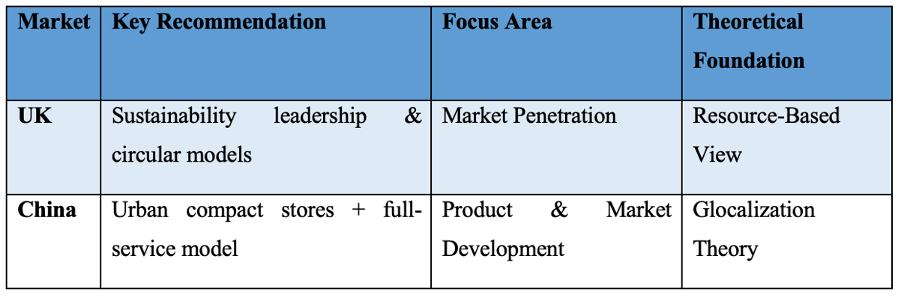
The company have to proceed with its strategic shift in China, which does not involve large-suburban stores but smaller urban ones. This is in line with shifting consumer lifestyles and 2026 store rationalisation programme (Hu, 2023). The more investment in the services of “Do it For Me” and localised products lines is necessary to satisfy the needs of collectivists and the lack of space.
Table 6 Strategic Recommendations for IKEA (Ulug’bek, 2025; Hu, 2023)
According to Table 6, the UK model utilizes internal competence in the competitive approach whereas China requires in place of greater adaptability to the globalization ideals (Ma, et. al., 2025).

e.1.2 Forward-looking international marketing strategy suggestions
Moving forward, IKEA needs to internalise the phenomenon of contingency approach to international marketing by establishing a so-called Glocal Excellence Framework (Ulug’bek, 2025). This entails having global consistency on the design of products and pricing, but allowing local teams more autonomy in the innovation of experience and services. AI-based personalisation and supply chain transparency investments will be used to promote sustainability targets identified in the IKEA Sustainability Strategy 2025-2030 as well as ethical marketing communications (Khan, et. al., 2021). Standardisation in the back-end processes and deep localisation in the front-end processes will enable IKEA to achieve long-term resilience and sustainable competitive advantage in both the mature and emerging markets.

Section 2

Reflective Account
1. Description
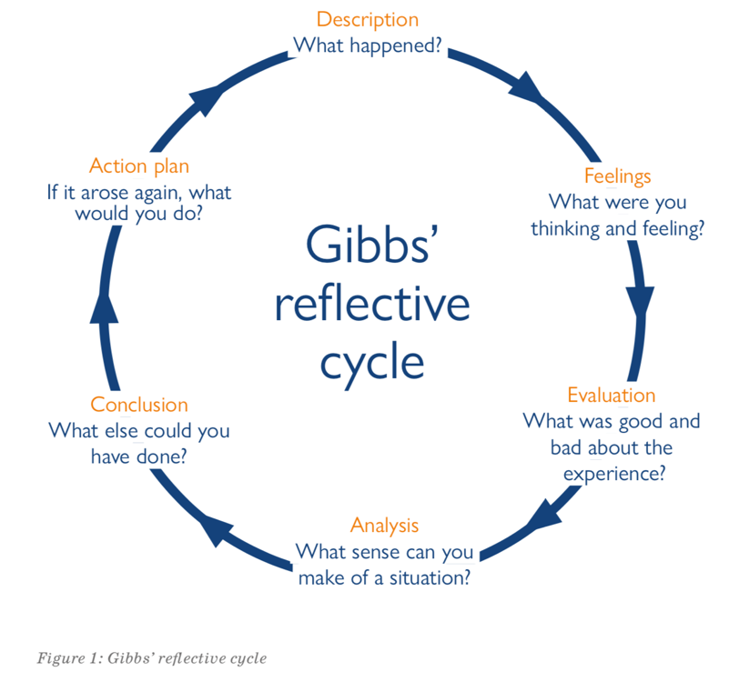
The assignment of developing a single report on the international marketing mix of IKEA in the United Kingdom and China has been completed. This section is going to reflect on the process using the steps Gibb’s reflection model shown in the figure below. The first step in responding to the assessment brief is choosing the brand. For that IKEA was chosen along with two comparison markets- the UK and China. The report was proceeded with systematic research and organization based on PESTEL analysis, detailed socio-cultural factors through Hofstede dimensions, STP strategies, the extended 7Ps, the directional growth in China through the Ansoff Matrix, ethical issues, and ultimately recommendations. This was done in about two weeks. The process was started with background reading, progressed to data collection, the application of theoretical frameworks, the writing of each section and finally, critical assessment and prospective recommendations. All the work was given in a single Microsoft word document with Harvard reference, Arial 12 font, 1.5 line spacing as required.
Figure 1 Gibb's Reflective Cycle
Source: (Markkanen et al., 2020)

2. Thinking
It was exciting and a bit overwhelming because of the magnitude of the task at the beginning. The selection of the UK and China also gave confidence due to the abundance of material that is available, but it was also concerning about how to be critical in depth throughout the report and still stay within the word limit. With the progress to the research phase, it started to feel more comfortable, especially when important journal articles and the most recent reports of the company was found. It was personally engaging when examining the drastic cultural discrepancies and innovations made by IKEA in China, and the practical applicability of the international marketing theory. The sense of achievement that it brought towards the end by the time the recommendations section was done and gave a feeling of creating a coherent and an analytical work. In general, the process enhanced the post-graduate learning drive.
3. Evaluation
The report was started with a systematic analysis. Google Scholar enabled to find quality resources in a short amount of time including Burt et al. (2011) and other more recent journal articles about IKEA China. The university library portal has access to full-text articles and downloading official IKEA and Ingka Group annual summaries directly on their corporate websites were reliable and up-to-date sources of financial and strategic data. World Bank reports and Statista present country-level data that provided me with credible statistics of the macro-environment. The drawing of the PESTEL, Hofstede and the STPs comparative tables turned out to be very helpful in terms of clarity and reading. The improvement points were on the basis of the initial struggle of trying to synthesise ethical issues with certain marketing-mix elements, this took numerous drafts before an appropriate critical linkage was met.
4. Analysis
The study experience brought to the fore some valuable knowledge on the practice of international marketing. Using Google Scholar and peer-reviewed journals allowed to conceptualize that standardisation versus adaptation is not the two-tier option but a spectrum that is influenced by cultural and economic forces. Downloading Hofstede Insights data and cross-checking it to academic papers allowed to go beyond description and critical comparison, involving the UK individualism and Chinese collectivism. Financial reports and company websites demonstrated how the new store rationalisation in China (2026) has been a calculated change in directional strategy at IKEA. This analysis was the one that was directly connected to the learning outcomes of the module. It would be unable to compare and contrast the cultural influences critically and think about the ethical framework in the international environment. The greatest lesson was that official sources of real-life data tend to contradict theoretical models, requiring more in-depth analysis. As an example, the previous research by Burt et al. on the poor adaptation in China has been evidently developed by the recent annual reports.
5. Conclusion
Finally, the assignment was a success since it used a systematic procedure of conducting research based on conventional academic and corporate references. A balanced and critical report was developed which fulfilled all brief requirements. It was an eye opener on the need to choose markets with deep data coverage and the usefulness of approaches such as the cycle itself by Gibbs in a systematic reflection (Markkanen et al., 2020). Without reading extra journal and company reports, the analysis would have just been superficial because otherwise lecture notes would be the only source of information. All in all, the project validated that the legal aspects of international marketing require global uniformity and local sensitivity.
6. Action Plan
Google Scholar will be carried out as initial source of academic literature in any future assignment and professional practice and verify the latest annual report of the company and World Bank data to ensure is up-to-date. More time will be dedicated in the ethical evaluation area, such as establishing a mind map by associating each of the factors of PESTLE to the possible concerns. Besides, writing comparative tables earlier into the process will enhance visual analysis. Lastly, the same Gibbs reflection technique right after every major task will be used in order to enhance learning. This systematic method will enable not only to create the even higher quality work at the level of the postgraduate but also to train to the international marketing practices where data-driven and culturally sensitive decisions are crucial.

Reference
Burt, S., Dawson, J., Johansson, U. and Hultman, J. (2020). The Changing Marketing Orientation within the Business Model of an International Retailer – IKEA in China over 10 Years. The International Review of Retail, Distribution and Consumer Research, [online] 31(2), pp.1–27. doi:https://doi.org/10.1080/09593969.2020.1857294.
Burt, S., Johansson, U. and Thelander, Å. (2011). Standardized Marketing Strategies in retailing? IKEA’s Marketing Strategies in Sweden, the UK and China. Journal of Retailing and Consumer Services, [online] 18(3), pp.183–193. doi:https://doi.org/10.1016/j.jretconser.2010.09.007
Dai, Z. (2025). Social Transformation of Chinese Society and Its Influence on Internal Ethical and Cultural Norms. Asia Pacific Viewpoint. doi:https://doi.org/10.1111/apv.12447
Dragičević, I. (2020). Integrated Marketing Communications on Social networks: a Case Study on IKEA. Marketing, 49(2), pp.93–104.
Ethical Consumer (2025). How Ethical Is IKEA Ltd? [online] Ethical Consumer. Available at: https://www.ethicalconsumer.org/company-profile/ikea-ltd [Accessed 6 Mar. 2026].
Furniture News (2025). IKEA UK sees sales decline in FY25 despite footprint growth. [online] Furniture News. Available at: https://furniturenews.net/news/ikea-uk-sees-sales-decline-in-fy25-despite-footprint-growth [Accessed 5 Mar. 2026].
Hofstede, G. (2025). Country Comparison Bar Charts - Geert Hofstede. [online] Geert Hofstede. Available at: https://geerthofstede.com/country-comparison-bar-charts/ [Accessed 5 Mar. 2026].
Hu, Q. (2023). The Observations of IKEA in Chinese Market. Academic Journal of Business & Management, 5(12). doi:https://doi.org/10.25236/ajbm.2023.051208.
IKEA (2020). Zero emissions for home deliveries – IKEA Global. [online] Ikea.com. Available at: https://www.ikea.com/global/en/our-business/sustainability/zero-emissions-for-home-deliveries/ [Accessed 4 Mar. 2026].
IKEA (2022). Home. [online] www.inter.ikea.com. Available at: https://www.inter.ikea.com/en [Accessed 3 Mar. 2026].
IKEA (2024). How Many Stores Does IKEA Have in the UK? - IKEA United Kingdom. [online] www.ikea.com. Available at: https://www.ikea.com/gb/en/customer-service/knowledge/articles/16b2503g-fe2f-4f1e-809e-0b5531gc438d.html [Accessed 7 Mar. 2026].
IKEA (2025a). About Us. [online] Ikea.com. Available at: https://www.ikea.com/gb/en/this-is-ikea/about-us/ [Accessed 7 Mar. 2026].
IKEA (2025b). IKEA Reports Stable Sales with Increased Volumes and Visitation. [online] Ikea.com. Available at: https://www.ikea.com/global/en/our-business/how-we-work/year-in-review-fy25/ [Accessed 4 Mar. 2026].
IKEA (2025c). In FY25 IKEA UK Continued long-term Accessibility journey, and Returned to Growth in Final Quarter. [online] Ikea.com. Available at: https://www.ikea.com/gb/en/newsroom/corporate-news/ikea-continued-long-term-accessibility-journey-pub773f0040/ [Accessed 5 Mar. 2026].
IKEA (2026). ZEBRASÄV Pendant Lamp Surprises. [online] IKEA. Available at: https://www.ikea.com/lv/en/p/zebrasaev-pendant-lamp-white-plastic-10522481/ [Accessed 5 Mar. 2026].
Ingka (2025). ​Ingka Group Annual Summary and Sustainability Report FY24 | Ingka Group. [online] Ingka Group. Available at: https://www.ingka.com/annual-summary-and-sustainability-report/ [Accessed 7 Mar. 2026].
Inter IKEA Group (2025). Inter IKEA Group Sustainability Statement FY25. [online] Inter IKEA Group, IKEA, pp.45–56. Available at: https://www.inter.ikea.com/-/media/interikea/igi/financial-reports/fy25-financial-reports/inter-ikea-group-sustainability-statement-fy25.pdf?rev=e31e4c25b5754ad998ed49a8b62c340d&sc_lang=en [Accessed 6 Mar. 2026].
Khan, A. and Shafiq, A.A., (2021). Internationalization challenges for retail firms in emerging Asian markets: a case study of IKEA.
Kohli, N., (2025). Sustainable business practices in IKEA: a study on consumers perceptions.
Lee, H.C.B., Cruz, J.M. and Shankar, R. (2018). Corporate Social Responsibility (CSR) Issues in Supply Chain Competition: Should Greenwashing Be Regulated? Decision Sciences, 49(6), pp.1088–1115. doi:https://doi.org/10.1111/deci.12307.
Lehren, A.W., Luce, D.D. and Schecter, A. (2021). Ikea kids’ Furniture May Be Tied to Illegal Russian logging, Report Says. [online] NBC News. Available at: https://www.nbcnews.com/science/environment/ikea-likely-sold-furniture-linked-illegal-logging-forests-crucial-earth-n1273745 [Accessed 7 Mar. 2026].
Ma, K., Liu, B. and Zhang, J. (2024). Factors Influencing Consumer Upcycling Behavior—A Study Based on an Integrated Model of the Theory of Planned Behavior and the Technology Acceptance Model. Sustainability, 16(21), pp.9179–9179. doi:https://doi.org/10.3390/su16219179.
Mansouri, N. and Zheng, Z., (2025). Balancing Global Consistency and Cultural Adaptation: A Comparative Study of IKEA’s Brand Communication in China and Sweden: Cultural Dimensions-Based Content and Interview Study.
Markkanen, P., Välimäki, M., Anttila, M. and Kuuskorpi, M. (2020). A Reflective cycle: Understanding Challenging Situations in a School Setting. Educational Research, 62(1), pp.46–62.
ONS (2026). GDP Monthly Estimate, UK: December 2025. [online] Ons.gov.uk. Available at: https://www.ons.gov.uk/economy/grossdomesticproductgdp/bulletins/gdpmonthlyestimateuk/december2025 [Accessed 3 Mar. 2026].
Reuters (2025). IKEA Bets on Online Growth in China with JD.com Launch. Reuters. [online] 8 Aug. Available at: https://www.reuters.com/business/retail-consumer/ikea-bets-online-growth-china-with-jdcom-launch-2025-08-08/ [Accessed 6 Mar. 2026].
Statista (2025). IKEA: e-commerce Net Sales 2025| Statista. [online] Statista. Available at: https://www.statista.com/forecasts/1218317/ikea-revenue-development-ecommercedb/ [Accessed 1 Mar. 2026].
Sun, L.-L., Cui, H.-J. and Ge, Q.-S. (2022). Will China Achieve Its 2060 Carbon Neutral Commitment from the Provincial perspective? Advances in Climate Change Research, 13(2). doi:https://doi.org/10.1016/j.accre.2022.02.002.
Taylor, M. (2023). From Alipay to the Digital Yuan: China’s Fintech Revolution. [online] Asia Paper. Institute for Security and Development Policy. Available at: https://www.isdp.eu//wp-content/uploads/2023/11/Asia-Paper-Taylor-Fintech-FINAL.pdf [Accessed 5 Mar. 2026].
Ulug’bek, O. (2025). How Multinational Companies Adapt to Local Markets: Glocalization in Action. International Journal Of Management And Economics Fundamental, 5(7), pp.5–9. doi:https://doi.org/10.37547/ijmef/volume05issue07-02.
Wang Zhuoqiong (2026). Ikea to Open Compact Stores in China Biz Revamp. [online] Chinadaily.com.cn. Available at: https://global.chinadaily.com.cn/a/202601/09/WS69606597a310d6866eb32dd6.html [Accessed 6 Mar. 2026].
Wang, C.-C., Chang, S.-C. and Chen, P.-Y. (2021). The Brand Sustainability Obstacle: Viewpoint Incompatibility and Consumer Boycott. Sustainability, 13(9), p.5174. doi:https://doi.org/10.3390/su13095174.
World Bank Group (2025). China | World Bank Group. [online] Worldbank.org. Available at: https://www.worldbank.org/ext/en/country/china [Accessed 4 Mar. 2026].

Appendix
- Hofstede Cultural Dimensions of China and the United Kingdom
Source: (Burt et al., 2020)


