
Master of Business Administration (MBA)

Module: Marketing Management
Module code: LCMB7024

Portfolio: Brand Development
A Sustainable Brand Extension – IKEA KRETSLOPP:
Circular Furniture-as-a-Service

Lecturer: Laila Maazouz / Taonga Kaonga / Sobere-Snithers

Student name: Vasukumar jayeshbhai Patel
Student ID: 2536674
Word count: 2500
Submission date: 02/08/2026

Table of Contents
1 Introduction 5
2 Element 1: Sustainable Brand Extension Poster 5
3 Element 2: Segmentation, Targeting, Differentiation and Positioning 7
3.1 Segmentation 7
3.2 Targeting 8
3.3 Differentiation and Positioning 8
4 Element 3: The Marketing Mix (7Ps) 9
4.1 Product 10
4.2 Price 10
4.3 Place 10
4.4 Promotion 11
4.5 People 11
4.6 Process 12
4.7 Physical evidence 12
5 Element 4: Reflection 13
5.1 Description 14
5.2 Feelings 14
5.3 Evaluation 14
5.4 Analysis 15
5.5 Conclusion 15
5.6 Action Plan 15
6 Conclusion 15
7 References 16
8 Appendix 19
8.1 Appendix A: Poster design rationale 19
8.2 Appendix B: Summary of the segmentation bases applied 19
8.3 Appendix C: Booking and reservation channel matrix 19

List of Figures and Tables
Figure 1 IKEA KRETSLOPP poster presentation (Ingka Group, 2026; WRAP, 2012). 4
Figure 2 Perceptual positioning map for IKEA KRETSLOPP (Hesse et al., 2022) 7
Figure 3 Global furniture rental market growth (FBI, 2026). 10
Figure 4 Marketing Mix (Hesse et al., 2022) 11
Table 1 The 7Ps configured for IKEA KRETSLOPP 8

Introduction
This portfolio showcases IKEA KRETSLOPP, a sustainable brand extension that was created for the module, Marketing Management. The intent of this introduction is to outline the idea behind the extension, and to examine its strategic rationale in advance of providing the supporting analysis in the elements that follow.
Main Idea
This portfolio is a presentation of IKEA KRETSLOPP, a sustainable brand extension for the module of Marketing Management. KRETSLOPP (Swedish for "cycle") is a circular furniture-as-a-service concept, where the customer's purchase of furniture is replaced by a subscription model for modular furniture, which is delivered, maintained, refurbished and re-leased. The model will help IKEA transition towards a circular product–service system based on repairs and reusability (Mont, 2002).
Evaluation of the Idea
The extension is good in terms of strategic fit with IKEA's well-known offering of low-cost, practical and sustainable home décor (Aaker and Keller, 1990; Keller, 1993). It also builds on IKEA's strengths such as its expertise in design, its store network and its Buyback programme. However, threats like brand credibility in the form of service failure and unsubstantiated sustainability claims could pose a risk (Hesse et al., 2022; Tran, 2023). KRETSLOPP is a business-relevant and business-aligned support for circular consumption, with a long-term value for the customer and IKEA alike.

Element 1: Sustainable Brand Extension Poster
The poster below (Figure 1) presents the sustainable brand extension, IKEA KRETSLOPP – a circular ‘furniture-as-a-service’ offer. It presents the company, the sustainability challenges the extension is trying to solve, explains the proposal and demonstrates how the proposal relates to the IKEA sustainability goals. The following written components (2–4) elaborate on the strategy.
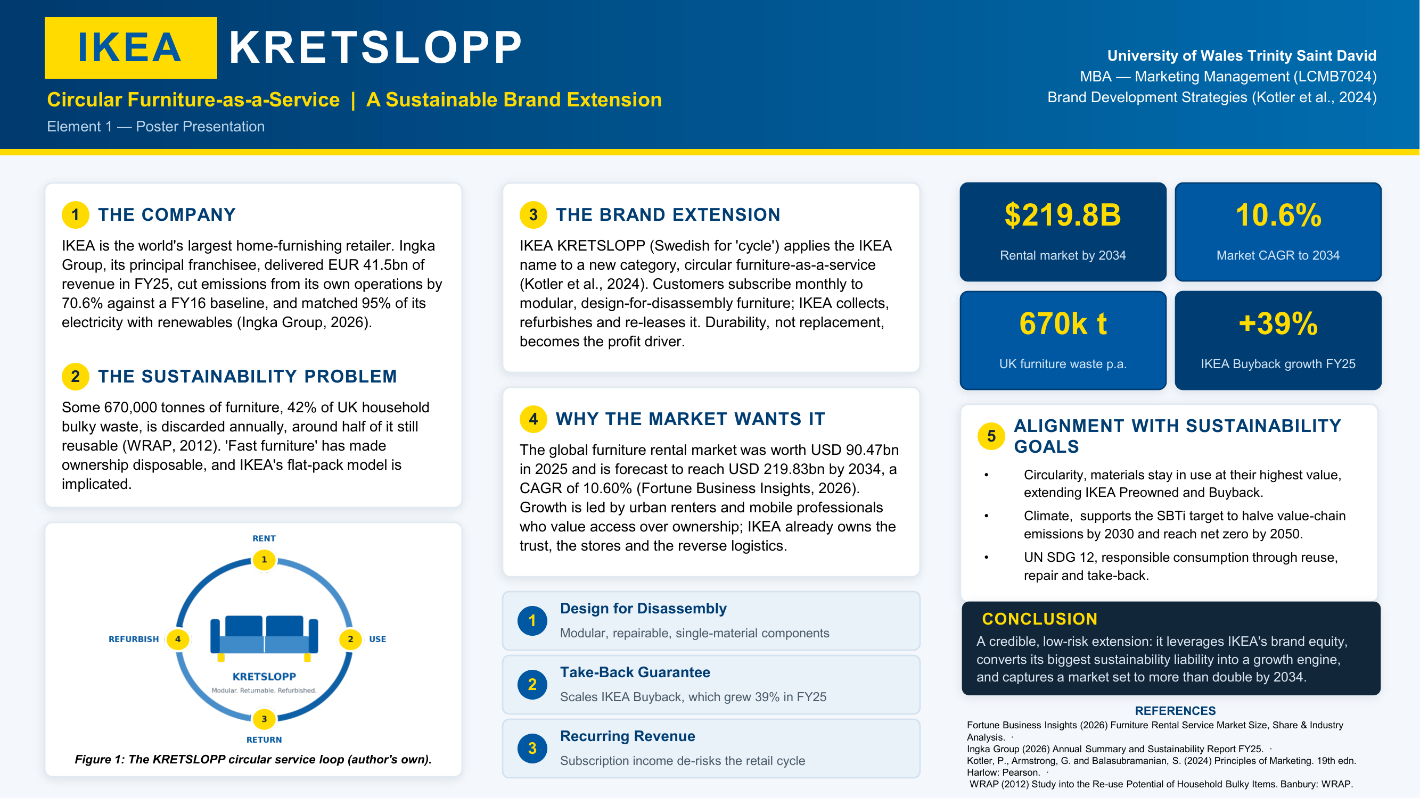
Figure 1 IKEA KRETSLOPP poster presentation (Ingka Group, 2026; WRAP, 2012).

Element 2: Segmentation, Targeting, Differentiation and Positioning
A brand extension is only successful if it reaches a well-defined target audience and is clearly positioned in their minds (Aaker and Keller, 1990). The segmentation, targeting, differentiation and positioning (STDP) framework (Armstrong, 2016) is used in this section when discussing IKEA KRETSLOPP.

Segmentation
Table 1 summarises the four segmentation bases. KRETSLOPP's geographical focus is high-density urban centres in the United Kingdom and Western Europe, where rents are highest, space is tight and residents are moving in and out of space frequently- London, Manchester, Berlin and Amsterdam. Asia-Pacific dominates the furniture-rental market with 48.9% (FBI, 2026) but Western Europe is the logical region to launch in due to Ingka's estate and live rental pilots in Germany, France and the Netherlands.
The core segment, demographically speaking, is the middle-income educated individuals (renters) who are 25-40 years old, deferring home ownership. Extension is psychographically aimed at people who value access rather than ownership of goods, a ‘liquid’ attitude to possessions (Bardhi and Eckhardt, 2012) and who have pro-environmental values. The segment is defined by behaviour, with people wanting flexibility, convenience and ‘sustainability’ proven; by usage occasion, as people relocate, form new households and go through life stage changes; and by showing a willingness to pay a premium for credibly green goods (Nguyen et al., 2025).
Table 1: Segmentation bases for IKEA KRETSLOPP
Segmentation base | Variables | IKEA KRETSLOPP target profile
Geographic | Region, city size, population density | High-density UK and Western European cities (London, Manchester, Berlin, Amsterdam) with high rental tenancy and resident churn
Demographic | Age, income, education, life stage | 25–40 years; students and early-career professionals; middle income; educated; renters or pre-homeowners
Psychographic | Values, lifestyle, attitudes | ‘Access over ownership’ orientation; mobile and time-poor; strong pro-environmental values
Behavioural | Benefits sought, occasion, loyalty | Flexibility, convenience and credible sustainability; relocation and life-stage transitions; willing to pay a premium for verified green offerings
The ‘green consumer' is not a single entity, but one that is critically plural. The results of the cluster studies are always found to be different in terms of the intensity of environmental attitudes and their conversion into environmental behavior (Jaiswal et al., 2021; Maťová et al., 2024); also, the demographic profiling is a poor predictor of green purchasing (Niedermeier et al., 2021). Because KRETSLOPP is segmented on values and behaviour, and not on demographics, this approach prevents the common pitfall of considering all consumers as ‘the green consumer'.

Targeting
KRETSLOPP adopts differentiated targeting strategy, so the main market is focused on those, who are called eco-pragmatists in towns. This segment is made up of young, mobile, consumers that take an interest in the design and sustainability of the furniture they are using, but don't expect to keep. It's an emerging rental market and closely related to the customer base of IKEA (FBI, 2026). The co-living operators, serviced apartments and corporate relocation providers are primary targets with firm B2B demand, and students are a tertiary market that will allow for early brand exposure. The selected target market is measurable, reachable in online and offline channels, big enough to be meaningful and suitable for IKEA's abilities (Armstrong, 2016).

Differentiation and Positioning
KRETSLOPP stands out because of its Buyback programme, which is offered by a trusted brand, affordable design and a wide network of stores alongside a new furniture subscription model. It also has a built-in quality assurance mechanism, refurbishment, flexible access and a guaranteed take-back, which are not found in traditional retail, rental start-ups or peer-to-peer resale platforms. The brand's position is to be an affordable and sustainable furniture subscription for an urban house that cares. To ensure low risk of greenwashing and brand dilution, the proposition is backed by clear sustainability evidence, such as the science-based targets, published Buyback data and disciplined service delivery (Aaker and Keller, 1990; Hesse et al., 2022; Tran, 2023).

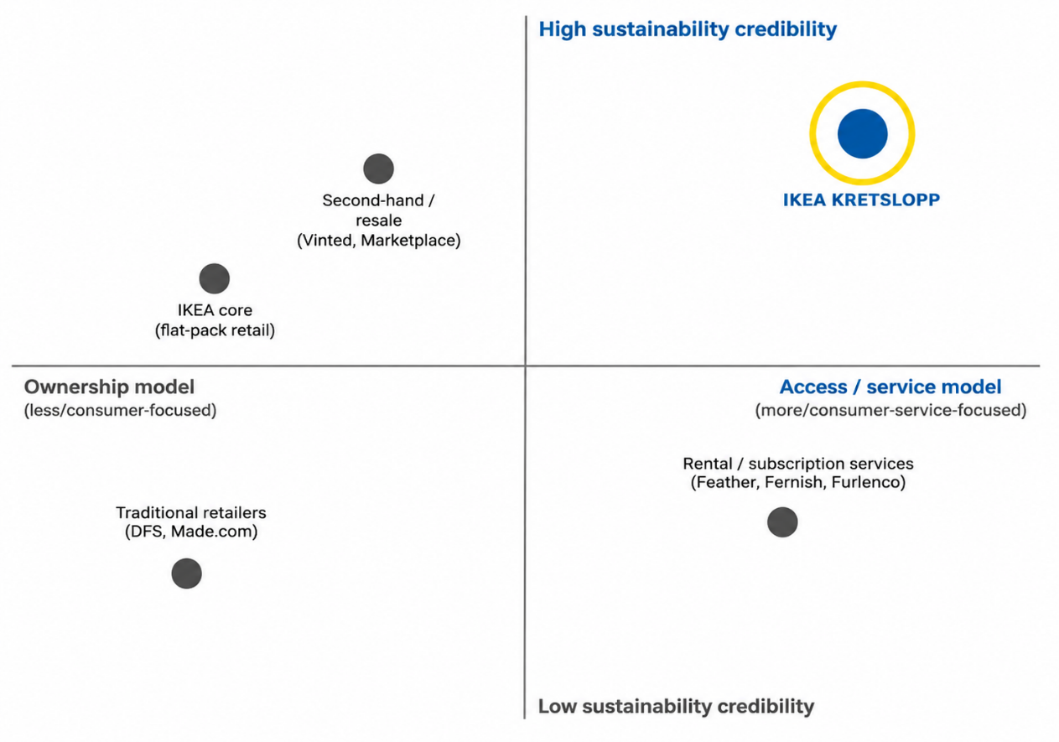
Figure 2 Perceptual positioning map for IKEA KRETSLOPP (Hesse et al., 2022)

Element 3: The Marketing Mix (7Ps)
The services marketing mix (7Ps), which consists of the classical 4Ps, people, process, and physical evidence, is the most appropriate one because KRETSLOPP is a service-dominant, subscription offering rather than a product sold once (Abdul-Hamid et al., 2017; Nguyen et al., 2025). The key decisions are summarised in table 2, which outlines how each element is set up to reinforce the sustainable strategy, and then explained and evaluated.
Table 1 The 7Ps configured for IKEA KRETSLOPP
Element | Strategic configuration for KRETSLOPP | Link to the sustainability strategy
Product | Modular, single-material, design-for-disassembly furniture offered as a service (PSS) | Durability and reuse replace replacement as the profit driver
Price | Tiered monthly subscription; value-based pricing with student/entry tiers | De-risks the retail cycle; reframes cost as total cost of access
Place | Omnichannel stores and app; bidirectional reverse logistics | Enables collection, refurbishment and re-leasing at scale
Promotion | Evidence-led circular storytelling; anti-greenwashing discipline | Builds green brand trust through verifiable proof points
People | Trained co-workers advising, grading and disclosing condition honestly | Credible service encounter sustains the green promise
Process | Closed loop: subscribe → use → collect → refurbish → re-lease | The stage at which circularity is operationally realised
Physical evidence | Refurbished quality standards, clear app interface, reusable packaging | Makes the intangible ‘circular’ claim tangible and trustworthy

Product
KRETSLOPP is a product–service system (PSS) that gives the customer access to modular furniture not ownership (Mont, 2002). Revenue comes from product durability, refurbishment and re-leasing rather than replacement. Offering comprises modular, reparable furniture with delivery, assembly, maintenance, swaps and end-of-life take-back. This circular model tackles the UK furniture waste issue and can help to lengthen the life of furniture (WRAP, 2012). To minimize customer concerns regarding hygiene and wear, the consistency of refurbishment and quality is viewed as an essential part of the product, thus alleviating concerns about used furniture (Bardhi and Eckhardt, 2012).

Price
KRETSLOPP has a subscription-based pricing model, offering tiered pricing options based on the needs of their customers. The pricing highlights the affordability aspect and not ownership, consistent with IKEA's value-based brand. Student and introductory plans become more affordable, and premium plans enable customers to pay for the convenience and sustainability features.

Place
With the combination of IKEA's stores, digital platforms and reverse logistics, KRETSLOPP adopts a multi-channel two-way distribution system. Existing stores become experience showrooms, collection points, refurbishment centres and the website and mobile app includes subscription, swap, return and account management. The well-developed Buyback programme, combined with a continually expanding zero-emission delivery fleet, enhances the efficiency and sustainability of the distribution network.
Booking and Reservation:
It offers customers access via the website, mobile app and phone. Each booking channel is tied into the same reservation system so there is no conflict in bookings and customers are not faced with different booking options all at once.

Promotion
Communication:
Communication communicates the circular concept of KRETSLOPP by bringing the message to life with clear stories backed up by facts, not general 'green' statements. A greater degree of transparency in published sustainability metrics and science-based targets increases the chances of green brand trust and decreases consumer scepticism around green extensions, (Hesse et al., 2022; Tran, 2023).
Definition of Integrated Marketing Communications (IMC):
Integrated Marketing Communications (IMC) unifies all communication tools to promote one brand message through the advertising, digital media, public relations and in-store communication (Armstrong, 2016). This uniformity helps to prevent the appearance of ‘greenwashing'.
Social Media Marketing Strategy:
Instagram and TikTok feature redo and modularity and LinkedIn is geared toward business customers. Monitoring of performance is done via engagement, conversion and sentiment analysis.

People
Front-line employees play a crucial role in the provision of KRETSLOPP's circular service by contributing to customer trust, service quality and green brand loyalty (Nguyen et al., 2025).
Training:
The four areas of training are: circular economy and product knowledge, condition grading and transparent disclosure, subscription platform processes and service recovery. This allows workers to confidently describe the leasing model, to implement the refurbishment standards uniformly and to deal with customer problems more effectively (Bardhi and Eckhardt, 2012).
Motivation:
Staff's salary is not dependent on number of sales but on subscribers held, refurbishment capability, and service quality. Recognizing, development, and empowering employees to resolve customers' issues helps in ensuring the continuity of the service provided and reinforce IKEA's brand promise for sustainability (Nguyen et al., 2025).

Process
In the closed loop model of subscribe, deliver, use, collect, refurbish and re-lease, aided by digital onboarding, easy returns and a digital product passport that documents the history of each product, KRETSLOPP is designed to provide a sustainable solution. KRETSLOPP is set up as a sustainable solution in the closed loop subscribe, deliver, use, collect, refurbish and re-lease model, with digital onboarding, easy returns, and a digital product passport that records the history of each product. This process makes it easier for customers and illustrates the application of circularity in practice (Mont, 2002).
Customer Complaint Process:
Laying a complaint is possible via the app, website, by phone or in-store service desk and is received within 24 hours. Issues are classified and front-line staff given the ability to deal with issues at once—replacing, repairing or offering a credit. Data from complaints is analysed regularly to ensure the refurbishment is improved, staff are trained further and the products are designed to be better, enhancing the confidence of customers and ongoing improvements to service.

Physical evidence
KRETSLOPP's circular value proposition is supported by visible quality cues, such as the state of refurbished products, reusable packaging, a user-friendly application, and a transparent product condition grading system. These are tangible factors that help to alleviate customers' fears about used furniture and build trust in the service.
Website Content:
The site is a major evidence point as it includes quality photos of refurbished products, clear condition grading criteria, refurbishment processes, price transparency and digital product passports. It also features verified sustainability data, customer reviews, and easy terms and conditions. Policy prioritization of hygiene, wear and take-back forms a credible proof of the circular model and helps to avoid greenwashing (Hesse et al., 2022; Tran, 2023).
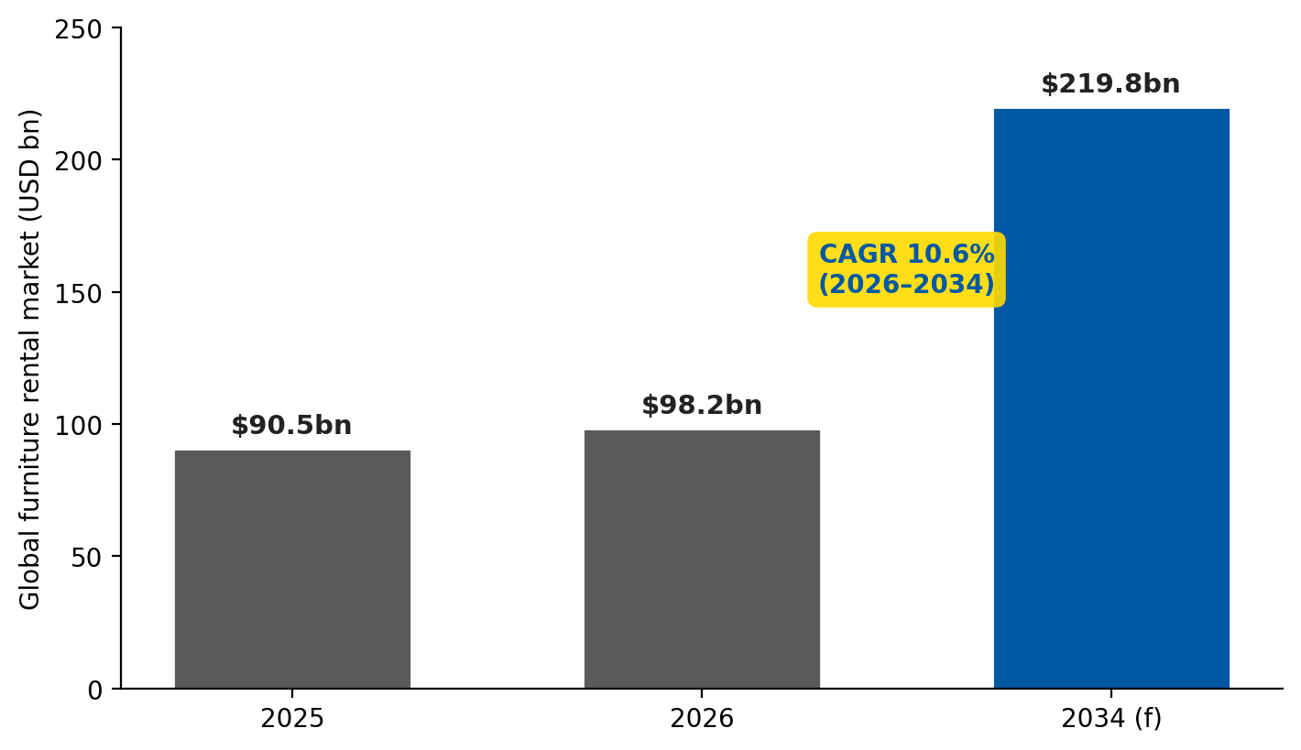
Figure 3 Global furniture rental market growth (FBI, 2026).
The 7Ps are all linked together: The Durable Modular Design (Product) allows the process of refurbishing (Process) to generate recurring revenue (Price), while the sustainability claims are supported by the physical evidence (Process). The biggest strategic threat in the blend is cannibalisation of IKEA's core retail sales, which is better described as an evolving transition to a more sustainable revenue stream that will be repeated over time. Success should be measured in terms of circular key performance indicators (KPIs) such as refurbishment yield, average leases per item and subscribers retained, not via one-off sales, and be aligned with the durability outcomes underpinning the entire proposition.
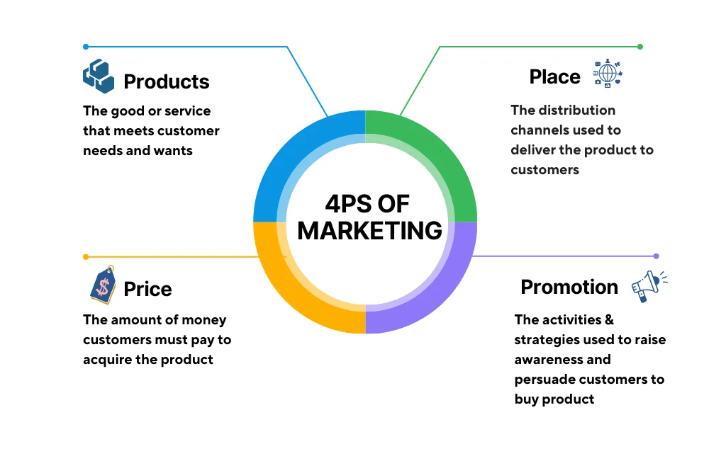
Figure 4 Marketing Mix (Hesse et al., 2022)

Element 4: Reflection
This reflection is explicitly based on the six elements of Gibbs' Reflective Cycle (1988) which is a process that helps students learn from their experiences by systematically moving from some description of the event in question to a plan for future action.
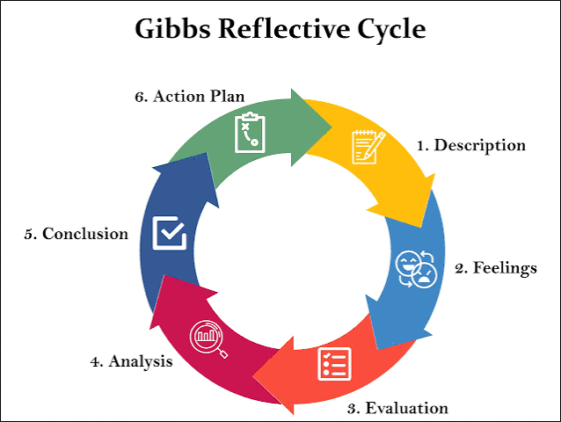
Figure: Gibbs Reflective Cycle (Gibbs, 1988).

Description
This assignment required the creation of a sustainable brand extension for IKEA and presentation in the form of a poster backed up by a portfolio. I developed a model called IKEA KRETSLOPP, a model of furniture-as-a-service based on leasing modular furniture that is then refurbished and re-leased. The project involved the application of STDP and extended 7Ps marketing mix, creation of a professional poster and presentation to peers and tutors.

Feelings
At first I was sure of the research and strategic analysis but not sure about making the poster and presenting. I worried that sustainability claims might be convincing but not backed up by evidence. My confidence grew during the presentation, since I could answer the questions based on the literature and research that I collected. However, I realised that there were some financial assumptions for which there was weak supporting evidence.

Evaluation
Overall, the project was successful. The portfolio has a logical progression starting from the opportunity identification, moving to segmentation, positioning and marketing mix, with academic literature to support the development. My Harvard referencing and use of current sources as well. The primary challenges were the level of information needed to be reduced to fit the poster, the financial assumptions being purely secondary data, and the time limitations for the presentation as there was not enough time to rehearse.

Analysis
I got to know the value of the marketing frameworks after putting them into practice. The STDP framework showed that values and behaviors rather than demographics need to be used in segmentation of sustainable consumers, which is in line with the study conducted by Niedermeier et al. (2021), Jaiswal et al. (2021). In parallel, the extended 7Ps revealed that in service businesses, people, processes and physical evidence are key elements to meet a credible sustainability promise. It also brought into focus the need for analytical thinking also to communicate the information visually and the constraints imposed by the lack of primary market research.

Conclusion
The project has validated my strengths as being in making decisions based on evidence and critical thinking, as well as in structured analysis. My limitations were relying on secondary data and lack of preparation for presentation. I also discovered that, rather than convincing consumers of one's sustainability, transparency and verifiability is of the upmost importance, and long-term brand trust is built on credibility.

Action Plan
In future projects, I will do primary research with surveys or interviews to test the willingness of customers to pay and validate my assumptions. I will enhance financial analysis by creating costing models for refurbishment and reverse logistics to prove the commercial feasibility. Last but not least, I will enhance my presentation skills by practicing with a timer and asking questions from others before I am assessed.

Conclusion
This portfolio is created and assessed of IKEA KRETSLOPP – circular furniture-as-a-service extension to support sustainable consumption in a way that also generated a long-term customer value. The analysis showed that there was good fit between this analysis and IKEA's brand identity and current capabilities such as modular product design, a large network of stores and existing take-back programs. Value-based market segments were identified using the STDP analysis and the extended 7Ps revealed that sustainability is provided by trained employees and efficient circular processes, not just through promotion. The proposal is based on secondary data and needs to be validated by primary research in the future but is a strategically aligned and commercially viable business model. A refurbishment rate measure, as well as subscriber retention and product life extension, rather than one-off sales, demonstrate the benefits of circular economy principles in terms of environmental performance and long-term competitive advantage, as illustrated by KRETSLOPP.

References
Aaker, D.A. and Keller, K.L., 1990. Consumer evaluations of brand extensions. Journal of marketing, 54(1), pp.27-41. https://journals.sagepub.com/doi/abs/10.1177/002224299005400102 (Accessed: 24 July 2026).
Abdul-Hamid, I.K., Hinson, R.E., Mahmoud, M.A. and Yaw, E., 2017, June. Sustainability marketing: The 7ps perspectives. In 5 th International Conference on Contemporary Marketing Issues ICCMI June 21-23, 2017 Thessaloniki, Greece (Vol. 595). https://www.researchgate.net/profile/Meletios-Niros/publication/318110302_Effective_branding_strategies_using_the_CET-CC_matrix_in_foreign_markets_The_Role_of_Consumer_Ethnocentrism_and_Confidence_on_Purchase_Intention/links/595a3cfa458515a5406fbf79/Effective-branding-strategies-using-the-CET-CC-matrix-in-foreign-markets-The-Role-of-Consumer-Ethnocentrism-and-Confidence-on-Purchase-Intention.pdf#page=595 (Accessed: 24 July 2026).
Bardhi, F. and Eckhardt, G.M., 2012. Access-based consumption: The case of car sharing. Journal of consumer research, 39(4), pp.881-898. https://academic.oup.com/jcr/article-abstract/39/4/881/1798309 (Accessed: 24 July 2026).
Fortune Business Insights (2026) Furniture rental service market size, share & industry analysis, 2026–2034. Available at: https://www.fortunebusinessinsights.com/furniture-rental-service-market-106643 (Accessed: 24 July 2026).
Gibbs, G., 1988. Learning by doing: A guide to teaching and learning methods. Further Education Unit. https://cir.nii.ac.jp/crid/1571417125052979584 (Accessed: 24 July 2026).
Ha, M.T., 2021. Optimizing green brand equity: The integrated branding and behavioral perspectives. Sage Open, 11(3), p.21582440211036087. https://journals.sagepub.com/doi/abs/10.1177/21582440211036087 (Accessed: 24 July 2026).
Hesse, A., Bündgen, K., Claren, S. and Frank, S., 2022. Practices of brand extensions and how consumers respond to FMCG giants’ greening attempts. Journal of brand management, 29(6), p.520. https://pmc.ncbi.nlm.nih.gov/articles/PMC8831008/ (Accessed: 24 July 2026).
Ingka Group (2026) Annual summary and sustainability report FY25. Leiden: Ingka Holding B.V. Available at: https://www.ingka.com/annual-summary-and-sustainability-report/ (Accessed: 24 July 2026).
Jaiswal, D., Kaushal, V., Singh, P.K. and Biswas, A., 2021. Green market segmentation and consumer profiling: a cluster approach to an emerging consumer market. Benchmarking: An International Journal, 28(3), pp.792-812. https://www.emerald.com/bij/article-abstract/28/3/792/66300 (Accessed: 24 July 2026).
Keller, K.L., 1993. Conceptualizing, measuring, and managing customer-based brand equity. Journal of marketing, 57(1), pp.1-22. https://journals.sagepub.com/doi/abs/10.1177/002224299305700101 (Accessed: 24 July 2026).
Armstrong, G., 2016. Principles of marketing. /Philip Kotler; Gary Armstrong. https://scholar.google.com/scholar?cluster=16813681526304238623&hl=en&as_sdt=2005&sciodt=0,5 (Accessed: 24 July 2026).
Maťová, H., Triznová, M.O., Kaputa, V., Loučanová, E. and Vlosky, R.P., 2024. Strategic Environmental Consumer Segmentation: An Exploratory Case Study in Slovakia. SAGE Open, 14(1), p.21582440241240638. https://journals.sagepub.com/doi/abs/10.1177/21582440241240638 (Accessed: 24 July 2026).
Mont, O.K., 2002. Clarifying the concept of product–service system. Journal of cleaner production, 10(3), pp.237-245. https://www.sciencedirect.com/science/article/pii/S0959652601000397 (Accessed: 24 July 2026).
Nguyen, K.M., Dinh, L.T.K., Ngo, T.T., Phan, T.T.T., Nguyen, P.D.H., Tran, H.P.M. and Nguyen, N.T., 2025. The impact of 7Ps green marketing mix on customer commitment and willingness to pay a premium price: Evidence from Vietnam. Journal of Promotion management, 31(4), pp.578-619. https://www.tandfonline.com/doi/abs/10.1080/10496491.2025.2484712 (Accessed: 24 July 2026).
Niedermeier, A., Emberger‐Klein, A. and Menrad, K., 2021. Which factors distinguish the different consumer segments of green fast‐moving consumer goods in Germany?. Business Strategy and the Environment, 30(4), pp.1823-1838. https://onlinelibrary.wiley.com/doi/abs/10.1002/bse.2718 (Accessed: 24 July 2026).
Tran, N.K.H., 2023. Enhancing green brand equity through environmental reputation: The important of green brand image, green brand trust, and green brand loyalty. Business Strategy & Development, 6(4), pp.1006-1017. https://onlinelibrary.wiley.com/doi/abs/10.1002/bsd2.294 (Accessed: 24 July 2026).
WRAP (2012) Study into the re-use potential of household bulky items. Banbury: WRAP. https://www.wrap.ngo/resources/report/study-re-use-potential-household-bulky-items (Accessed: 24 July 2026).

Appendix

Appendix A: Poster design rationale

Appendix B: Summary of the segmentation bases applied
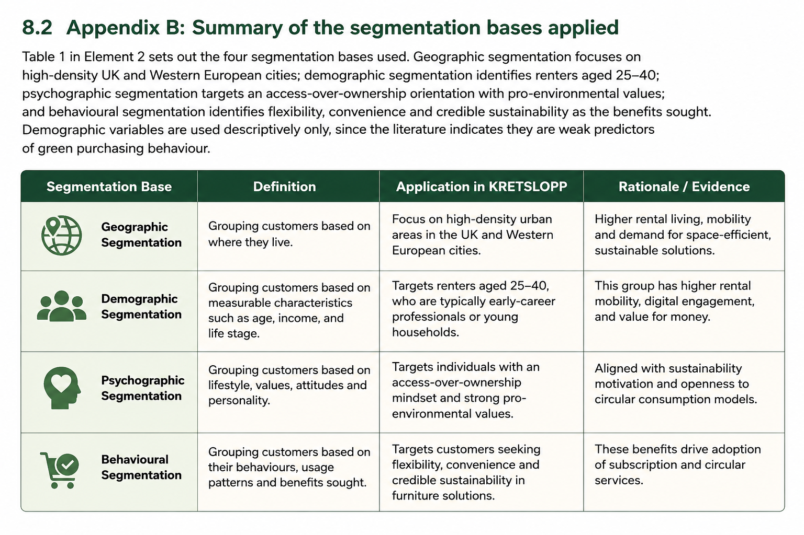

Appendix C: Booking and reservation channel matrix


