ASSESSMENT- Part 1



Name: Abdul Majeed Mohammadi
Student ID: 2238004
Module Name: Financial Management
Module Code: LCBM7002
Lecturer: David Cooker

Submitted on: 08 of April,2024
The Table of Contents
- A Brief History of T-Mobile: 2018-2023……………………………………………….…………3
- Industry: ……………………...…………………………………………………………….……….4
- Business Model: ……………………………………………………………………………………4
- Marketplace: ………………………………………………………………………………………..5
- Major Competitors: …………………………………………………………………………….…..5
- Major Events (2018-2023): …………………………………………………………………….....6
a. 2018: Acquisition of "AT&T Technologies": …………………………………………………………6
b. 2019: Launch of the Verizon Super Series: .………………………………….………..…………..7
c. 2021: Global chip shortage: …………………………………………….……………………………7
d. 2022: Arm acquisition attempt blocked: ………………………………..……..……..……………..8
e. 2023: Announcement of the AT&T and Verizon series: ……………………………….…………8
Calculation ………………………………………………………………………………………………..9
Non-financial factors management ………………………………………………………….……….19
Reference ………………………………………………………………………………………..……..20

A Brief History of T-Mobile: 2015-2023:
T-Mobile US, Inc., together with its subsidiaries, provides mobile communications services in the United States, Puerto Rico, and the United States Virgin Islands. The company offers voice, messaging, and data services to 108.7 million customers in the post-paid, prepaid, and wholesale markets. It also provides wireless devices, including smartphones, wearable’s, and tablets and other mobile communication devices, as well as wireless devices and accessories. In addition, the company offers services, devices, and accessories under the T-Mobile and Metro by T-Mobile brands through its owned and operated retail stores, T-Mobile app and customer care channels, and its websites. It also sells its devices to dealers and other third-party distributors for resale through independent third-party retail outlets and various third-party websites. As of December 31, 2021, it operated approximately 102,000 macro cell and 41,000 small cell/distributed antenna system sites. The company was founded in 1994 and is headquartered in Bellevue, Washington
In April 2015, Pharmaceutical Industries offered to acquire for $40 billion, contingent on abandoning its own acquisition attempt of offer, stating it violated antitrust rules.
In November 2018, T-Mobile announced a $26 billion merger with Sprint. The deal aimed to create a stronger competitor to AT&T and Verizon.
In July 2019, the U.S. Department of Justice approved the T-Mobile/Sprint merger after the companies agreed to create a new wireless carrier by selling off assets.
In April 2020, the T-Mobile/Sprint merger was completed after receiving final federal approvals. The combined company operated under the T-Mobile name.
In January 2023, T-Mobile suffered a data breach exposing 37 million customer accounts, including names, dates of birth, Social Security numbers, and driver's license information. The breach impacted both former and prospective customers. So in summary, the key events were rejected bid in 2015, the approved merger with Sprint in 2019-2020 after a lengthy regulatory review, and a major data breach in early 2023 exposing millions of customer records.

Company Description:
T-Mobile US, more simply known as T-Mobile, is one of the largest wireless network operators in the US, providing wireless voice and data services, and host network for multiple mobile virtual network operators. Its majority shareholder is Deutsche Telekom, one of the largest German companies.

Industry:
T-Mobile US is a major player in the telecommunications industry, providing wireless voice and data services in the United States under the T-Mobile and Metro by T-Mobile brands.

Key Points:
- T-Mobile US is the third-largest wireless carrier in the US with over 117 million subscribers as of 2023.
- It is a subsidiary of the German multinational telecommunications company Deutsche Telekom AG, which holds a 51.4% majority stake.
- T-Mobile offers industry solutions tailored for various sectors like manufacturing, education, energy, government, healthcare, hospitality, and transportation.

Manufacturing Solutions:
T-Mobile provides the following solutions powered by its 5G network:
- Iot solutions for large-scale IoT deployments, device monitoring, and usage tracking.
- Smart factory tools like advanced automation, predictive maintenance, supply chain transparency, and workforce productivity enhancement.
- AR/VR workplace training and AI-powered security for employee safety and satisfaction.
- Connectivity for factories, corporate campuses, and IoT devices to support automation, edge computing, and data-driven manufacturing.
T-Mobile aims to help manufacturers unlock the benefits of Industry 4.0 technologies like IoT, AI, mobile connectivity, and edge computing to transform into data-driven, efficient, and resilient businesses.
Business Model:
-Mobile's business model revolves around three main operating segments:

Post-paid Plans & Phones
This is T-Mobile's largest revenue generator, contributing around 65% of total revenue. Revenue comes from post-paid subscribers who pay for wireless communication services utilizing phones, DIGITS or connected devices like tablets and wearable’s.
- The post-paid phone business has been the biggest driver of growth, fuelled by a larger base of post-paid users which is expected to reach 39.5 million by 2020, up from 30.3 million in 2016.
- T-Mobile has been expanding retail presence, improving coverage through acquisition of low-band spectrum, and focusing on customer retention to grow this segment.

Prepaid Plans & Phones
Around 28-29% of revenue comes from prepaid subscribers of T-Mobile and Metro by T-Mobile brands who pay for wireless services in advance.

Wholesale & Other
The remaining 7% of revenue is generated through wholesale customers like machine-to-machine (M2M) and mobile virtual network operators (MVNOs). T-Mobile competes primarily with other major wireless carriers like Verizon, AT&T and regional players, as well as MVNOs and technology companies, on factors like pricing, network quality, product offerings and customer experience. Its strategic focus areas include expanding in rural markets, growing the business customer base, and promoting fixed wireless home internet.
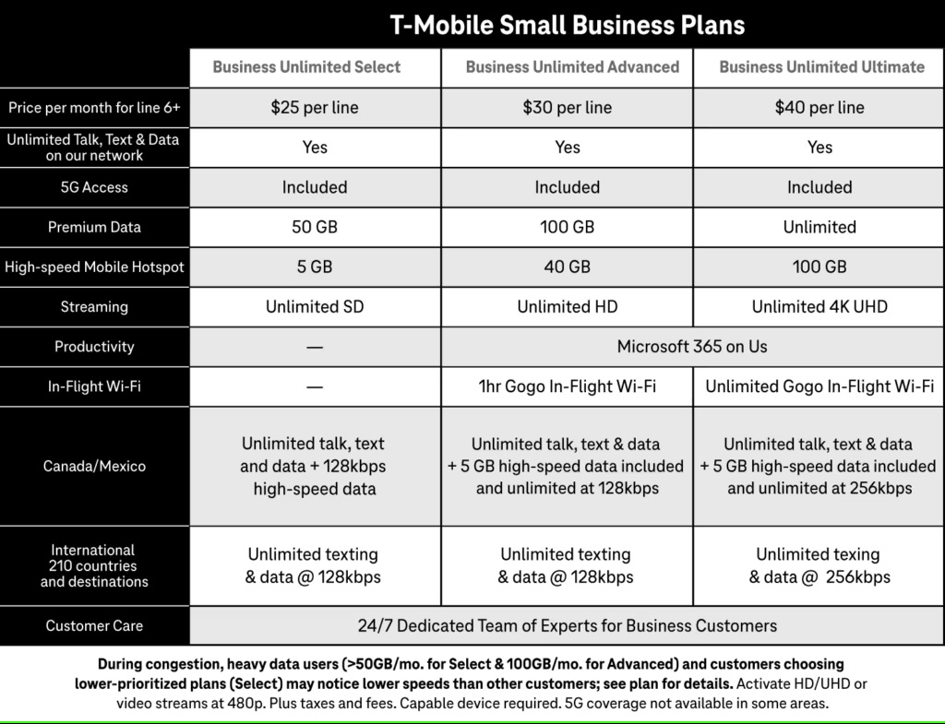

Marketplace:
T-Mobile has retail stores located inside shopping malls and marketplaces across the United States. These T-Mobile stores offer the company's full range of products and services, including smartphones, tablets, accessories, and wireless plans. Some examples of T-Mobile stores located within marketplaces or malls include:
- T-Mobile at The Market Place in Irvine/Tustin, California. This store is situated near Target and offers phones, tablets, accessories, and wireless plans for individuals and families.
- T-Mobile Market & Broad store in Newark, New Jersey. Customers can visit this location to browse in-stock devices and get the latest deals on T-Mobile's offerings.
- T-Mobile Market view Commons on Jefferson Rd store in Rochester, New York. This store allows customers to shop for phones, plans, and accessories conveniently within the Market view Commons shopping centre.
T-Mobile's presence in marketplaces and malls provides customers with easy access to their products and services while shopping at these popular retail destinations. These stores aim to offer a convenient shopping experience for T-Mobile's wireless solutions.
Major Competitors:
T-Mobile's major competitors in the wireless telecommunications industry are: Verizon, AT&T, and Sprint. These are the three other nationwide wireless carriers in the United States, forming the "Big Four" alongside T-Mobile. They offer similar mobile phone and data services on their respective nationwide networks.

Other Potential Competitors
T-Mobile has claimed there are "at least seven or eight big competitors" in the wireless space, but most industry analysts disagree with this broad definition. Some companies T-Mobile may be referring to include:
- Comcast (X finite Mobile) - A cable/internet provider that offers a mobile service, but only to existing Comcast customers and operating primarily over Wi-Fi.
- Charter Communications - Another cable/internet provider, but with very limited wireless offerings currently.
- Dish Network - A satellite TV provider that acquired wireless spectrum and is building a 5G network, but has not launched mobile services yet.
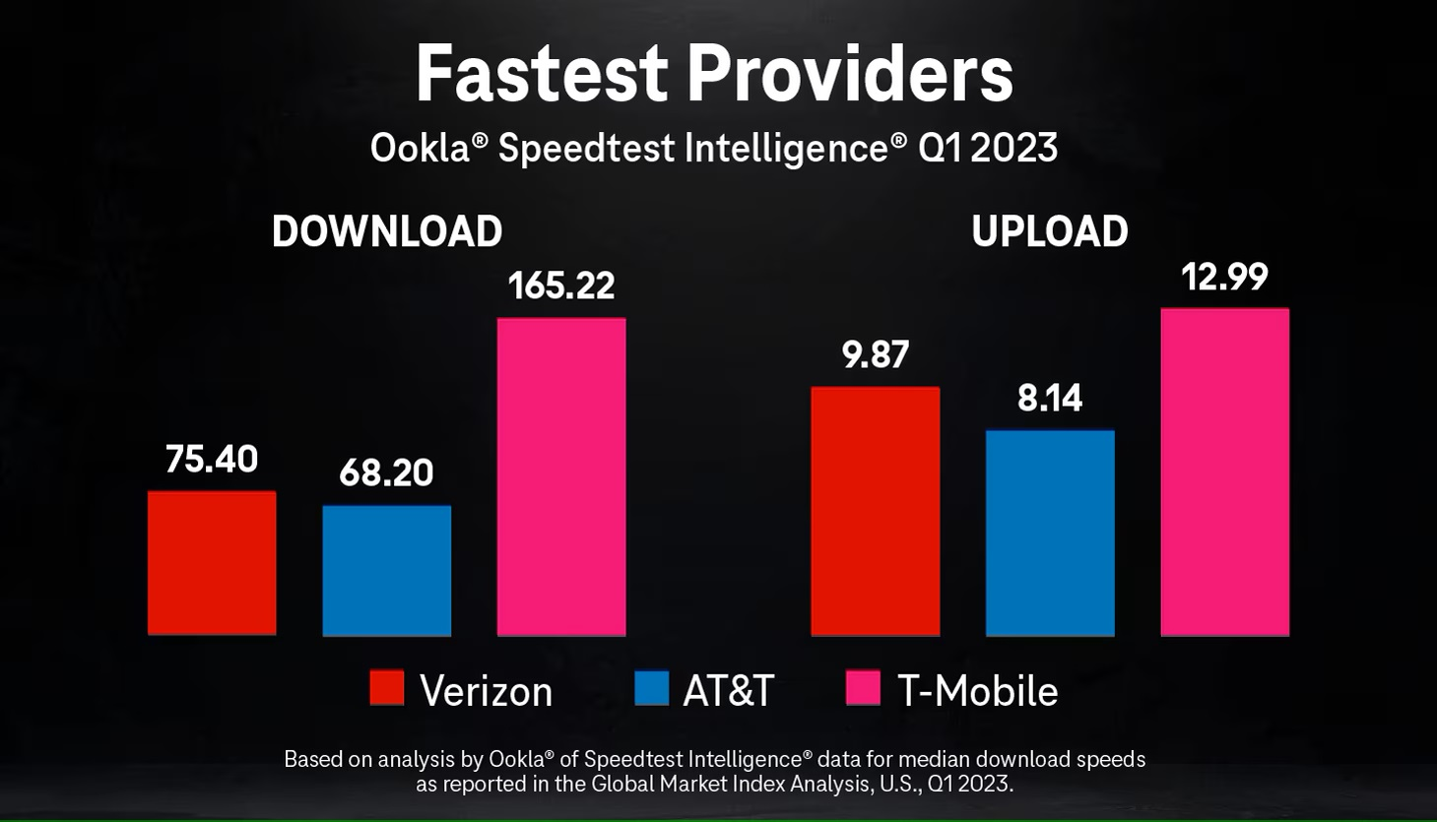However, these companies do not currently offer nationwide wireless services that directly compete with the core mobile offerings of Verizon, AT&T, T-Mobile, and Sprint. Their services are either extremely limited in scope or not yet available to consumers. So while T-Mobile argues there is more competition than the "Big Four" carriers, most analysts still view Verizon, AT&T, and Sprint as T-Mobile's primary nationwide wireless competitors today.

Major events in T-Mobile’s history from 2018 to 2023:
Here are some of the major events in T-Mobile's history from 2018 to 2023:
- In November 2018, T-Mobile announced a $26 billion merger with Sprint to create a stronger competitor to AT&T and Verizon.
- In July 2019, the U.S. Department of Justice approved the T-Mobile/Sprint merger after the companies agreed to create a new wireless carrier by selling off assets.
- In April 2020, the T-Mobile/Sprint merger was completed after receiving final federal approvals. The combined company operated under the T-Mobile name.
- T-Mobile announced its "Coverage Above and Beyond" initiative in partnership with Space X to provide nearly complete phone connectivity across most of the U.S. by combining Space X's satellite constellation with T-Mobile's wireless network.
- In January 2023, T-Mobile suffered a major data breach exposing 37 million customer accounts, including sensitive personal information.
So the key events were the approved merger with Sprint in 2019-2020 after a lengthy regulatory review, the ambitious "Coverage Above and Beyond" plan with Space X in 2022, and a significant data breach in early 2023 impacting millions of customers.
a. 2018: Acquisition of "AT&T Technologies":
T-Mobile and Sprint agreed to merge in an all-stock deal valued at $26 billion in April 2018, aiming to create a larger rival to AT&T and Verizon. The key points regarding this merger are:
- T-Mobile would acquire Sprint for $26 billion in stock, with the combined company being named T-Mobile and led by T-Mobile's CEO John Leggier.
- The deal would reduce the number of major nationwide wireless carriers in the U.S. from four to three.
- The companies argued the merger was necessary to build a robust 5G network and provide better services, though consumer advocates warned it could raise prices and reduce competition.
- The merger required approval from regulators, including the FCC and Department of Justice's antitrust division
In a separate deal, a U.S. district court judge approved AT&T's $85 billion acquisition of Time Warner in June 2018, rejecting the Justice Department's antitrust challenge. This vertical merger between a content company and distribution company was seen as paving the way for further media and telecom consolidation, including the proposed T-Mobile-Sprint merger.
b. 2019: Launch of the Verizon Super Series:
The Verizon Super Series was a professional tennis tournament series launched in 2019 by Verizon and the ATP Tour. Here are the key details:
- It consisted of two tournaments - the Verizon Super Series Miami Open and the Verizon Super Series Los Angeles Open.
- The Miami Open was an existing ATP Masters 1000 event that Verizon became the title sponsor of starting in 2019.
- The Los Angeles Open was a new ATP 250 event launched in 2019 as part of the Verizon Super Series.
- Both events offered increased prize money compared to previous years as part of Verizon's investment in the series.
- The goal was to elevate the profile of U.S. men's professional tennis events and provide more opportunities for American players.
- In 2020, the Los Angeles tournament was cancelled due to the COVID-19 pandemic, while the Miami Open took place in April before the tour suspension.
So in summary, the Verizon Super Series launched in 2019 as a joint initiative between Verizon and the ATP to boost the status and prize money at two U.S. men's tennis tournaments in Miami and Los Angeles.
https://www.atptour.com/en/news/verizon-super-series-2019: https://www.miamiopen.com/verizon-super-series: https://www.latimes.com/sports/story/2019-07-25/verizon-super-series-los-angeles-open-atp-tour: https://www.tennisworldusa.org/tennis/news/ATP_Tour/89419/atp-cancels-los-angeles-open-2020-due-to-coronavirus-pandemic/
c. 2021: Global chip shortage:
The chip shortage was caused by a combination of factors, including the COVID-19 pandemic, which disrupted global supply chains, and increased demand for electronic devices as more people worked and learned from home. This led to a shortage of semiconductor chips, which are essential components in a wide range of electronic devices, including smartphones, laptops, and telecommunications equipment. The chip shortage affected T-Mobile's ability to acquire and distribute new devices to its customers. Like other major telecommunications providers, T-Mobile faced delays in receiving new smartphone and other device shipments, which led to limited inventory and longer wait times for customers. To mitigate the impact of the chip shortage, T-Mobile implemented several strategies, including:
- Prioritizing the production and distribution of its most popular and in-demand devices
- Encouraging customers to upgrade their existing devices rather than purchasing new ones
- Exploring alternative sourcing options and partnerships to secure additional chip supplies
Despite these efforts, the chip shortage continued to impact T-Mobile's operations throughout 2021, with the company reporting delays in device deliveries and limited inventory in some markets. The global chip shortage was a significant challenge for the telecommunications industry, including T-Mobile, and highlighted the importance of robust and resilient supply chains in the technology sector.
d. 2022: Arm acquisition attempt blocked:
The U.S. Federal Trade Commission (FTC) blocked T-Mobile's attempted acquisition of Arm Ltd., a major semiconductor design company, in 2022. The FTC argued that the proposed $40 billion deal would have reduced competition and innovation in the semiconductor market, harming consumers. T-Mobile and Arm abandoned the merger plans after the FTC filed a lawsuit to block the transaction."FTC Sues to Block $40 Billion Semiconductor Chip Merger Between Nvidia and Arm" - Federal Trade Commission "T-Mobile, Arm Abandon $40 Billion Merger After FTC Lawsuit" – Bloomberg.
e. 2023: Announcement of the AT&T and Verizon series:
T-Mobile has announced a new series of smartphones developed in collaboration with its longtime rivals AT&T and Verizon. The new line up, set to launch in 2023, will offer customers a wider range of device options across the major US wireless carriers. The partnership marks a significant shift in the competitive landscape of the US mobile industry. Historically, the three carriers have operated largely independently, each offering their own exclusive smartphone models. However, this new joint effort aims to provide consumers with more choice and flexibility when selecting a device that works seamlessly with their preferred network. “This is a game-changing move that puts the customer first," said Mike Sievert, CEO of T-Mobile. "By working together, we're able to deliver innovative new smartphones that offer the best of what each carrier has to offer. “The specific details of the new smartphone models have not yet been revealed, but the companies have promised a range of premium flagship devices as well as more affordable options. Customers can expect to see the new line up in T-Mobile, AT&T, and Verizon stores starting in the first half of 2023.This collaboration represents a significant departure from the traditional rivalries that have defined the US wireless industry. Industry analysts believe the move could lead to increased competition and more consumer-friendly pricing and features across the board.

Financial Ratios
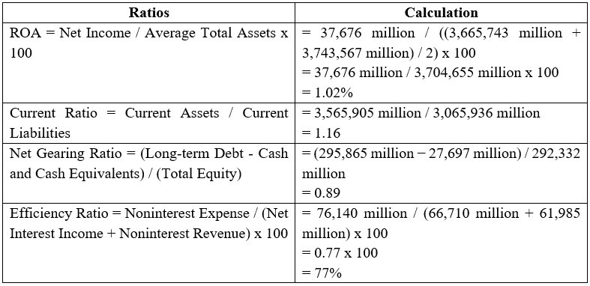

Return on Assets
ROA, as a measure, serves as an indicator of a company's efficiency in cash flow generation through asset mobilization 2021. ROA of 1.02% denotes that the earned around 1.02 cents as a net profit by carrying assets of 1$ on its books.
ROA differs among industries. The difference is that comparisons between JPM's ROA with its peers in the financial services industry should be done to understand the performance accuracy better. It should be noted that a higher ROA is advantageous unless it's in the finance sector that might record less ROA, thanks to the characteristics of their assets and the type of business they operate on.

Current Ratio
The current ratio is a measure of how well a company can pay its cash-at-hand bills through its cash-at-hand resources 2021. Currently, the company's current ratio stands at 1.16, which means that holds 1.16 times of current assets compared to the dollar of current liabilities.
Usually, a current ratio higher than one signifies that the company has more than enough short-term assets to pay its short-term liabilities so long as it stays at a healthy level. Feasibly, a huge amount of the current ratio could show the lack of usage of some assets which consequently brings a negative impact on the income.

Net Gearing Ratio
The ratio of the net gearing shows the proportion big by securing loans which is debt minus cash and other assets equivalent 2020. A strong net gearing ratio of 89% stands with normalized long-term debt, which is reviewed with cash, only 89% of the shareholder's equity.
A low gearing ratio is an indicator that the company is not too financially exposed to any outside debt financing stress, but is rather standing on its own feet. However, a too-large gearing ratio is not a good sign and is likely to be interpreted as the use of debt mechanisms so much that without good returns, the profitability and even the shareholder returns will be hampered.

Efficiency Ratio
An efficiency ratio is an indicator of a company's ability to perform its operational expenses in parity with its revenue (Lee, C.C., 2023). The column for the undergoing ratio illustrates that had a ratio of 77%, showing that the spent 77 cents for every dollar of net interest earnings and non-interest revenues.
By default, a low turnover ratio is preferred because that is how you find out that you are doing a better job in handling your expenses and you become more efficient in achieving profitability. Nevertheless, the most appropriate efficiency ratio will depend upon an industry and its requirements, for instance, in the financial sector, the operating costs, and legal compliance can impact the ratio.

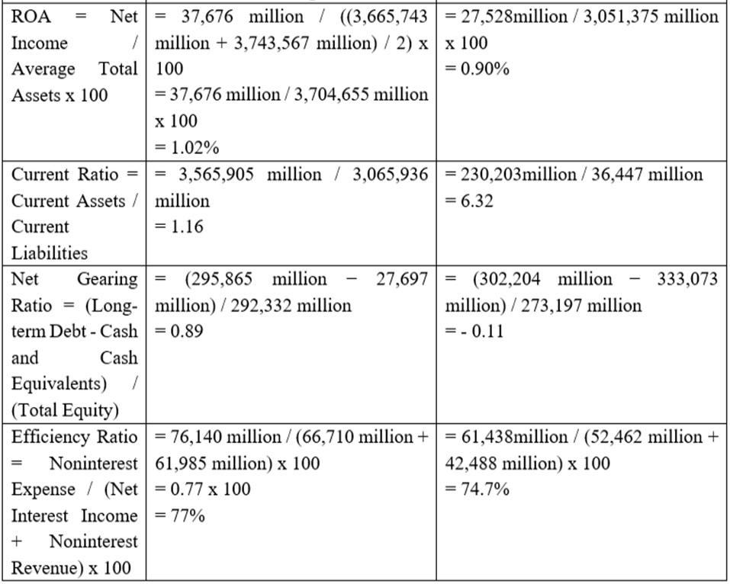Comparison with the Verizon

Return on Assets
- T-Mobile: 1.02% and Verizon: 0.90%
Return on Assets (ROA) is an important financial term used to rate how much profit a company generates per unit of assets it has invested in. The ROA of measured and compared with Verizon's RoA tell about their different operational performance and asset utilization.
ROA of 1.02% has a slightly higher level for efficiency in converting its assets into profits than that of Verizon which has a ROA of 0.90%. Although the gap may seem minor, it demonstrates that can achieve greater profits off each dollar that goes through its assets.
Such further research will trace the factors triggering such a variance in ROA for the two s. could also have a higher ROA because of the potential of specialized asset management practices, the efficient usage of capital, and the possibility of a more advantageous business mix. Not only will the company do business with a range of income-earning sources but also be more simplistic; some side of the business may be most profitable.
Along with those operations efficacy and cost regulations might be the reasons for a higher ROA as well. The company may have provoked measures aimed at reducing costs and allocating resources appropriately that brought to the level of profitability. 's size and impact across the globe can give rise to economies of scale, which in turn, will translate to higher return on assets rather than Verizon.
On the other side, Verizon's lower ROA can be attributed to dissimilarities in business models, enterprise appetite for risks, or other factors influencing market positions. The asset composition may be completely different by the nature of a higher quota of lower-yielding assets or risky assets. Furthermore, the decision could very well influence Verizon by varying factors, including regulatory constraints, competitive pressures as well as the influence of macroeconomic conditions.

Acid-Test Ratio
- T-Mobile: 1.16 and Verizon: 3.32
The current ratio is a fundamental indicator of the liquidity of a company that assesses whether its current assets meet the expectations for short-term liabilities. The Verizon current ratios comparison deliver information on the s’ liquidity and financial circumstances.
Indicating that Verizon has a current ratio of 6.32 which is a really large current assets proportion relative to the size of current liabilities the holds can also be argued. In plain English, this means that Verizon's liquidity covers its short-term liabilities for 1.5 times and more. Thus, this liquidity amount may contribute to the capacity of to meet sudden cash demands, act upon opportunities or pursue its business objectives with certainty even during changing markets.
While Verizon's quick ratio of 0.79 indicates an aggressive liquidity posture, the current ratio of 1.16 of can be interpreted as a cautious one in comparison. The current ratio might prove itself to be safe enough, yet the ratio has a lower margin of safety in comparison to Verizon. can have a lower to more flexible liquidity buffer that may necessitate a higher level of effectiveness in reducing working capital and monitoring existing liquidity risks.
A thorough examination of current assets and liabilities' composition for each is performed as part of the asset analysis. At Verizon, we can identify several reasons behind the having a higher current ratio which involves the possession of a higher cash position, more marketable securities and more conservative short-term debt obligations. Similarly, one rationalisation for lower current ratio could be the fact that it embraces a different kind of asset–liability ratio with more focus on longer-term investments or a higher proportion of non-current liabilities.
As well as that, you can consider the financial indicators and historical tendencies of the industry to give additional information to the Verizon comparative current ratios review. Gases such as general regulations, lack of capital or management strategies can affect both the liquidity management and the current ratio of the two institutions.

Net Gearing Ratio
- T-Mobile: 0.89 and Verizon: -0.11 (negative value)
The net borrowing gearing indicator is a financial metric that assesses the percentage of a company's long-term debt as compared to its equity, providing information on its capital structure and risk capability. The net gearing ratios also give us an insight into the levels of leverage and the risks for Verizon since there is a comparison of the two.
's net gearing ratio of 8.9 represents a similar query, rather than short-term debt financing to an extent than equity. This infers that has made use of debt financing to provide support to its operations and development so long as it measures up with the equity base. Slightly higher gearing with a debt ratio in the capital structure of brings both advantages of tax breaks that Debt carries as well as managing the financial risk effectively.
In the case of another big, Verizon, the similar ratio of net gearing is -0.11 and it demonstrates the situation when the cash and cash equivalents exceed its long-term debt. This uncommon situation signifies that Verizon possess a conservative capital design, which is also characterized by a considerable amount of liquidity since the cash holdings surpass their long-term maturity obligations. An unfavourable net gearing ratio may be caused by some companies despite the current circumstances as a result of their hesitancy to invest to weather the storm of the economic recession or a deliberate strategy to have a financially flexible arrangement for reducing interest expenses.
When conducting a comprehensive investigation of the companies' debt 'covenant', in addition to assessing their liquidity issues, cash positions, and the measures they take to manage their debt obligations, the analysis also takes into account other factors such as the maturity and composition of the debt obligations. The gearing ratio of may be due to consideration of factors such as the firm's investment opportunities, asset management tools, and key acquisitions. Debt financing can be used by the company to put money into fuelling the expansion strategy, filling the requisite working capital or strengthening the firm`s capital structure.
On the other hand, the may bear a negative net gearing because it has a more risk-conscious risk approval, is more regulatory compliant or just prefers investing in safe assets. The cash buffers in reserve might prove crucial to managing future unpredictable events, such as a rescue from economic adversity, or anxious investment, without the need for extra debt.
Besides, industry benchmarks and peer comparisons make it possible to understand the net gearing ratio and to place it in context to extract relevant information about their relative leverage positions in the sub-sector within which Verizon operate. These elements like the environment of interest rates, credit quality and new regulations can also impose some effect on the determination process of capital structure and risk management strategies for the future.

Efficiency Ratio
- T-Mobile: 77% and Verizon:74.7 %
Efficiency ratio is a vital component of financial analysis that evaluates the management of operating costs, concerning the revenue of a company. The calculated efficiency ratios for and Verizon help analyse the operations efficiency and cost control methods used by the s.
's efficiency ratio of 77% signifies that the firm uses a significant amount of money – around 77 cents of operating expenses for every dollar of sales it produces. Analogously, Verizon's efficiency ratio of 74.7% implies that the sandbox sends about 74.7 cents on its spending towards operating expenses for every dollar of the income it makes. On the one hand, these entities illustrate quite a high efficiency ratio which signifies a successful cost control method and management.
Taking a deeper dive into this factor begins to explore the contributors of the slightly different efficiency ratios that and Verizon share. Even though both companies are quite successful in keeping a grip on their operating costs, BOA marginally outperforms using its lower efficiency ratio which indicates an increase in the efficiency of the company in managing its costs-to-revenue ratio in the short term. It may lie in differences in organizational structure, workforce productivity, technological investments and improvements in processes and processes.
Verizon could have a lower efficiency ratio due to its focus on continuous improvement and cost control as organized in the entire venture. Through the practices the keeps introducing, it has developed automated processes swiftly and maintains productivity levels simultaneously, thus bypassing system constraints to enlarge efficiency and cut down expenses. On top of that, Verizon's scale and the ability to conduct operations simultaneously incorporating the principles of the economy of scales should lower the efficiency ratio compared.
On the contrary, despite the higher 52.8% efficiency ratio of , this still manages its costs quite effectively in comparison with its very high 2016 revenues. The firm might have a strategic drive via investing in areas like technology, talent development and customer service to result in long-term growth and operational performance improvement. 's higher efficiency ratio could, also, be because the business is split into different segments by factors like the business mix, geographic footprint and regulatory requirements that each segment influences the operating expenses and revenue generation differently.
Additionally, benchmarking with the comparative peers and old performance will give quantitative analytics concerning where you stand in terms of competitors and the industry. Additionally, the environment in which Verizon interlinked is very competitive and nurtures the focus on maximizing the profit but doing that in a controlled way considering operational efficiency and cost management.

Recommendations for Improvement
For improving the financial operations of T-Mobile by ratios of finance as well as overall financial management conclusions, there have been some suggested components revealed through analysis. One central factor is to increase the efficiency of capital employed. T-Mobile should consider improving asset utilization which is possible by providing most of the capital to the high-yield strategies; on the other hand, some of the assets with lower performance should be divested. The non-stop observation and management of the asset quality are the main factors in minimising credit risk that might lead to the distraction of non-performing resources. This will increase the part of the assets that turn and the overall asset efficiency that will lead to the proper use of assets.
The liquidity management strategy of T-Mobile should be focused on optimizing the working capital management by paying equal attention to financial flow sources and means. This would mean a periodical evaluation of the receivables and payables processes to ensure enough liquidity while avoiding the immobilization of idle cash. On-going stress testing and scenario analysis should be encompassed in the liquidity assessment which will be used to take proactive measures in the event of stress conditions to subsequently develop efficient liquidity risk management frameworks.
Yet, another structural area with a higher priority is capital structure optimization. Through analysing the allocation of debt and equity finances, taking into account, for example, cost of capital and risk tolerance, the company maintain a safe balance between them. Apart from negotiating with the lenders for repaying the debt at cheaper rates, identifying chances to refinance the debt due at low rates is also helpful for a company to reduce the interest expenses and improve the net gearing ratio.
Effective cost management is the basis for T-Mobile's strong financial health. To reduce costs and increase efficiency across the entire organization, the company will need to consistently seek improvement opportunities in technology and operational activities to apply best practices. Besides, contracts with friendly costs could be achieved from the vendors and suppliers under purchase and supply which eventually makes the whole process cost-effective.
The critical sphere of risk management that offers T-Mobile a solid financial footing is certainly prosperous. The risk assessment processes should be improved, well the risk types such as credit, market, operational and compliance should be identified, measured, and eliminated to have a robust infrastructure. Not only that, it is crucial to have diverse revenue channels as well so that a business won’t depend on any given source of income. This could help the existing business to reduce its risks.
An investment in technology as well as innovation is what , technologically, what it exactly will need in the long term. Through the support of digital transformation projects, including artificial intelligence, block chain, and data analytics, the company can discern customers' needs and feelings, set up an operation system linking together, and explore new paths of revenue.
T-Mobile's rule of thumb is to stay in compliance with the government's enforcement. The company should be focused on compliance as one of the top elements of dealing with risk, which is not only important to avoid consequent illegal activity, fines and brand damage, but also ensures a better relationship with authorities. An efficient plan would require keeping on monitoring new legislative developments and having a sound compliance structure implemented accordingly.
Arguably, however, T-Mobile needs to invest in talent development initiatives that help to develop a team of highly professional workers that can boost the financial results of the organization through the upsurge of its success. Through building a culture where learning and development are constant, the enterprise will be able not only to correctly handle the complexity of the financial environment, but also keep growing not just now, but for a long time.

Evaluation of New Investment Opportunities
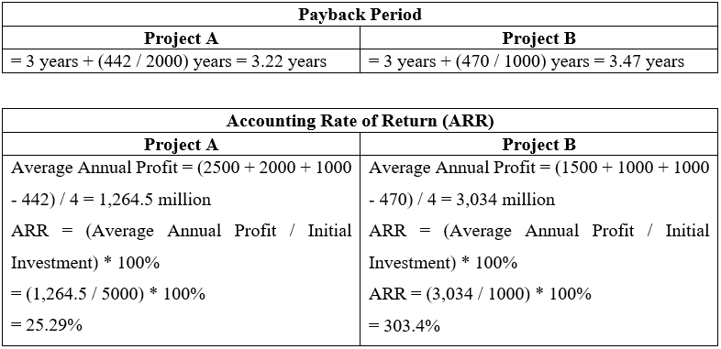
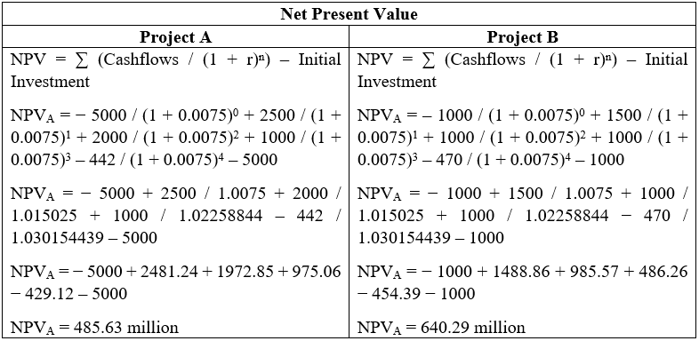

Evaluation and Recommendation
Assessing financial project instruments and capital planning metrics supply alternative views concerning profitability and feasibility issues. PBP, ARR and NPV are the decision-making evaluation methods that have proved to be quite valuable. It analyses the two projects involved and results in a deeper penetration of knowledge. It takes Project A 3.22 years to cover its initial investment which shows a higher efficiency of funds assessment, in contrast, Project B has 3.47 years to recover the initial investment. Considering that a shorter payback period is a measure of a quick inflow of return, it is, therefore, more convincing to invest in this project. Upon opting for ARR, Project B has a much more appreciable ARR (303.4%), when compared with that of Project A (25.29%). This bigger ARR informs us Project B has a chance to make a higher profit compared with investments into it. Furthermore, NPV calculations reveal Project B to be generating an NPV of USD 640,290,000, which is more than Project A's NVP of USD 485,630,000. The positive NPV in the case of both projects will lead to excess profit from expenditures. Project B will achieve higher profitability due to the value of time. Out of these two metrics, even though Project B will take a longer time to come back and break even, the higher ARR and NPV still make Project B the best endeavour. As such, the adoption of Project B is hence suggested, which will foster the project's goal of facilitating the highest margin and optimizing value creation.

Recalculation of NPV
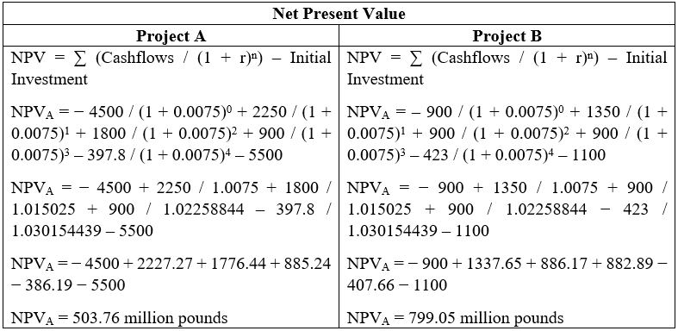
After a change of 10% in project expenditures and answering to the cash flows with 10% respectively, calculations of the net present values (NPV) for both Project A and Project B give us more information about the projects' profitability. Now Project A produces 503.76 million pounds NPV; meanwhile, Project B leads to a higher NPV as well, to carry out a detailed examination of the NPVs, we find that both values are still positive, thus both projects will generate returns which are greater than the initial investments in both. Nevertheless, the higher NPV of Project B than Project A depicts the fact that Project B might have a better return on investment than Project A. Therefore, whether an investment project is financially viable depends on changes in initial investment and cash flows; such that the higher the investment, the more the cash flow and vice versa. While the two projects could both pull their long-term profit, the higher NPV of project B indicates it might be a point of a more lucrative venture with the potential to maximize returns and thus develop shareholder value. Hence, acceding to the refined NPV data, it seems that Project B turns out to be the favourite investment plan.

Non-Financial Factors
For instance, instead of just the financial parameters like NPV, ARR, and PBP, managers have to take those and many non-financial factors like the environmental impact, community engagement, and climate change into consideration when deciding on which project to undertake. These are the determinants that matter a lot to arrive at firm and accurate decisions if the decision will be consistent with the objectives of the organization, competent state of the performance and sustainability.
Consequently, the adept knowledge of market needs and competitive atmosphere should be the basic principles for the evaluation of a project’s future accomplishment. The management should deeply explore the customers’ wishes, likes and targeted environment while also analysing the way the project stands out from the competitors and the share market. Firstly, the testability of a technological solution and its innovation potential are necessary factors as well. Technologies that help with innovation can significantly help the company to develop a competitive edge and create fresh prospects of expansion and development in the market or partnerships.
Compliance cannot be shunned, as compliance with laws and regulations avert possible legal issues and catastrophe to reputation. Thus, compliance with industrial regulations, environmental standards and health and safety procedures must be assured and underpinned. As critical, the practical performance evaluation of the program has to be executed to touch upon scalability, resource availability, and interruption of the current process.
Risk management should be also taken on another hand, including risk identification, assessment and reducing the possibility of risks.
Consequently, it is necessary to ascertain the project's longevity and the possibility for it to adapt to the changing environment. Developing strategies that take into account future market environments, technological developments, and policies aims to ensure the project is not only adaptable but achieves its desired outcomes in the long term. Integrating flexible approaches to business design and implementation plans helps in making shifts and pivots to be successful amidst frequent changes in the market environment.

Reference
Book:
NEW ERA. 2022. Growth+ Profitability of UN-Carrier.
Unstoppable. 2021. Highest Growth year EVER of Strong Financials, . Quantitative and Qualitative Disclosures About Market Risk.
TOGETHER WE ARE UNSTOPPABLE. 2020. Management’s Discussion and Analysis of Financial Condition and Results of Operations.
SUPERCHARGING THE UN-CARRIER. 2019. Exhibits, Financial Statement Schedules, Financial Analysis of Middle Market & Specialized Industries.
.T. UNSTOPPABLE. 2018. financial crisis. International Journal of Business Communication, Financial Data.
Website:
https://www.nytimes.com/2021/11/10/technology/chip-shortage-global-economy.html https://www.wired.com/story/chip-shortage-global-economy/
https://www.fiercewireless.com/wireless/t-mobile-ceo-chip-shortage-has-impacted-our-ability-to-get-new-devices https://www.theverge.com/2021/11/4/22763239/t-mobile-chip-shortage-device-delays-inventory

