
Effective Team Working and Communication
(BMSW4002_LON)

pERRINE VINCENT
2008110
Lecturer's name: Charles Oham

Table of content

I. Introduction 2
II. Models of communication 3
A) Shannon and Weaver Model 4
B) Schramm 6
C) Berlo 7
III. Communication skills 8
A) Verbal communication 9
B) Non-verbal communication 10
C) Listening 11
IV. Conclusion 12
V. References 13

I. Introduction

As the business environment grows in its complexity, the importance of an efficient communication becomes essential in the existence of organisations.
When we talk about communication, whether from a sociological point of view, according to the marketing approach, or in a more common sense, we are always talking about the transmission of a message or an information, which include thoughts, ideas, and emotions, from a source to a recipient.
Even though, during its transmission, the message can be affected by a huge range of barriers, whether physical, physiological, emotional or cultural, making its decoding more complex for its recipient.

Thus, the purpose of this study is to demonstrate a better understanding about effective communication by going through various models of communication in a first step and then, to go deeper in the analyse of the different types of communication that we are using every day: verbal and non-verbal communication.

II. Models of communication

The term “communication” can seem easy to understand at first but if you ask anyone around you to explain it, they will probably answer something like: “it is when two or more people are interacting”. In one sense this definition is very simple and true even through it is far to be enough for expert and scientist. Indeed, communication experts themselves have difficulty agreeing on one definition which could cover every situation.
However, over the centuries several theorists have taken an interest in the complex concept of communication process, resulted in the creation of various models of communication which aim to make the understanding of this process easier for us. Each of these models seeks to determine how a message travels from a source (where information is generated) to a recipient.

Before moving on to the first model of communication that we are going to explore, let us look at a case study showing a communication failure that we will use to illustrate the key concepts of our models.

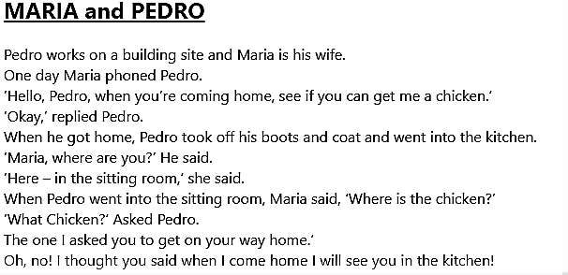

A) Shannon and Weaver Model

This theoretical model of communication also known as ‘Mother of all Models’ has been proposed by Shannon and Weaver, in 1949. It was first created to explain the transmission process of radio and television and was later adapted to human communication with the introduction of the concept of "feedback".

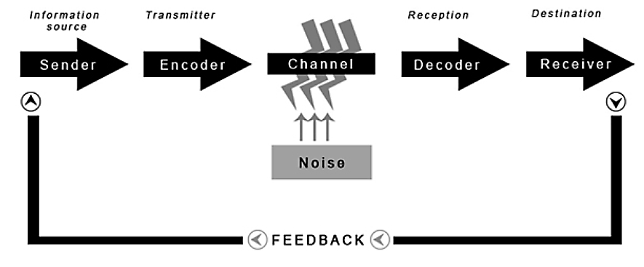

In their model, they state that there are eight variables that play on the communication process. They are listed below and illustrated with the case study see in the previous section:

-The sender/ source: it is where the process of communication starts. It may be a person or a group willing to convey a message to someone (e.g., Maria).

-The encoder: This is when the source transmits the message in a format that the receiver can understand (e.g., Maria uses verbal language through a telephone call).

-The message: the information sends to the recipient. (e.g., “When you are coming home, see if you can get me a chicken”).

-The channel: it is the means used by the sender to transmit his message to the recipient such as a letter, a speech, an audio... (e.g., phone call).

-The decoder: This is the action of interpreting the message by its recipient (e.g., Here Pedro is unable to interpret Maria’s message properly because of noise).

-The receiver: the person who gets the message of the sender (e.g., Pedro).

-Noise: it refers to all the barriers that arise during the communication process between the sender and the receiver and which may prevent the receiver from interpreting the message correctly or from simply receiving it (e.g., noise generated by the building site).

-Feedback. For communication to be effective, once the receiver has received the message, he or she must give a response to the person who sent it in the first place. In the case of Maria and Pedro feedback has not been transmitted, which has caused the misunderstanding.
It is at this point that Shannon and Weaver's model becomes cyclical or transactional.

The advantages of this Model are that the concept of noise allows us to understand and solve the problem that prevents communication from being effective and that both senders and receivers are consider equal in this two-way communication process. (Businesstopia, 2018).

B) Schramm

Having discovered the Shannon and Weaver model of communication, let us look at Schramm’s interactional model, proposed in 1954, and inspired by this first model itself.
For him, effective communication is based on two key elements: encoding and decoding.

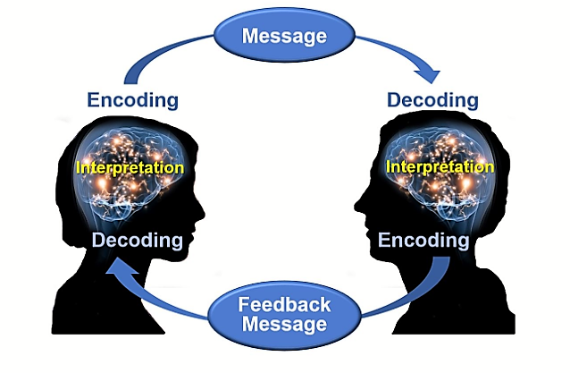
According to his model and supported by Barnlund (1962), Schramm also recognises that feedback plays an important role in a successful communication process. This means that the receiver is as responsible as the sender for the effect and effectiveness of the communication and that without feedback the process is incomplete and therefore ineffective. Furthermore, he believed that it is fundamental that both parties (sender and receiver) share a common field of experience, knowledge or culture. Overwise people may interpret the message in another way or not understand it at all.

C) Berlo

In 1960, the theorist David Berlo described in his “Sender-Message-Channel-Receiver (SMCR) model”, the elements that affect each of its component.

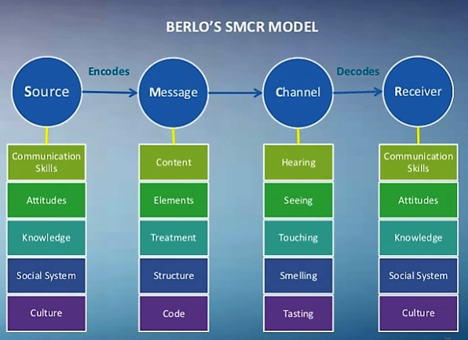

Berlo considers the ability, the culture, the experience and the personality of both parties (sender and receiver) and notes that it is the coding that makes communication process easy or complex.
This model fits all types of communication, whether interpersonal or group.
However, it could be argued that the SMCR model of communication does not mention the concept of feedback and noise or barriers, so it is a linear model in which the effect is not considered (Businesstopia, 2018).

III. Communication skills

Communication has three major objectives: to inform, to express feelings and to influence, through the use of both verbal and nonverbal means.
It is an important skill in any environment with human interactions that can reduce conflict and improve relationships between people.

However, within the process of communication, barriers and obstacles may occur and can lead to a listener’s inability to understand what a speaker means (Robinson & Robinson, 1976), such as:
- Physical distraction: noises, poor lighting, extreme temperatures.

- Language or vocabulary: In addition to language differences, jargon, or vocabulary specific to a group of people, of the same generation or working in a similar sector, for example, is sometimes difficult to understand for people who do not belong to that group.

- Physiological barriers: People can have physiological disabilities such as hearing difficulties or pain.

- Cultural differences: the meaning of a same sign can have different meaning depending on the country you live in.

- Lack of common experience (seen with Schramm’s model)

- Relationship between sender and receiver.

- Listening skill or interest of the receiver.

(Ludlow & Panton, 1992)

A) Verbal communication

Verbal communication refers to anything we say using words. It can be written or spoken. It therefore requires both a speaker (or writer) to send the message, and a listener (or reader) to interpret it.
For a verbal communication to be effective it is important to carefully choose the words that we want to use to explain a thought or an idea to someone. This can make the difference between the other person understand us or not. In fact, you would not use the same word or vocabulary when you are speaking with a friend, a child or your employer even if you are discussing the same subject.

Nevertheless, believe it or not, verbal communication is actually the least impactful element in face-to-face communication.
Indeed, according to the psychologist Mehrabian, during a face-to-face communication only 7% is verbal, while 93% is non-verbal. (Mehrabian, 1981).

B) Non-verbal communication

In opposition to the verbal communication the non-verbal communication is what we express not through words but through our body language, gestures, facial expression, voice of tone, symbols, signals and even our appearance (Quintanilla & Wahl, 2020).

According to Watzlawik and his model called the "iceberg model", 90% of the communication is transmitted via the relational level, established between the individuals who are interacting, and are therefore non-verbal. Consequently, the said, which represents about 10% of communication, plays only a secondary role (Ediger, 2020).
However, non-verbal communication is not as easy as it seems because the message may be ambiguous or may have a very different meaning depending on the culture of the sender and the receiver. For example, Americans indicate that something is fine by using the hand symbol "OK". However, in some Asian countries, this sign stands for "money". While for Argentinians and Europeans it means "zero" or "nothing".

Moreover, it is interesting to know how do verbal and non-verbal messages interact. In fact, non-verbal messages can:

- contradict verbal messages. When there is conflict between verbal communications and non-verbal clues, receivers tend to use the non-verbal clues to interpret the true meaning. For example, if someone has just had an accident and gets up pretending that everything is fine, but you see that his head is bleeding and his face is pale, you should be able to understand that he is not well and help him.

- substitute for verbal messages. It means that you do not have to hear any words to know exactly what messages is being communicated (see the example above concerning the "ok" sign).

- support and emphasize verbal messages. In this situation you illustrate your words by using body language. For example, when someone is angry, he tends to raise the volume of his voice and speak faster.
=> (Phutela, 2015)

Nonetheless, it is certain that non-verbal communication has a considerable impact on whether a person understands or not what we are transmitting.

C) Listening

Listening skills also play a significant role in an effective communication process. However, it is important, in a first time, to establish the difference between the term “hearing” and “listening”.
“Hearing” is the physical ability to receive or detect sounds whereas “listening” is a perceptual process that requires concentration on the messages being sent to interpret their meaning and evaluate the information received before giving a feedback. Listening well requires paying active attention to gestures, tone of voice and facial expressions (non-verbal clues) to see if they add meaning to the spoken words. Consequently, excellent hearing does not mean excellent listening.

Furthermore, in terms of listening, there are two concepts that play a huge part in effective communication. These are “active listening” and “effective listening”.
Active listening means that the listener attempts to understand as clearly as possible what the speaker says and feeds back to him or her what he heard, in his own words. You should use active listening at your workplace, when you are in relation with a client’s query or when you are receiving instructions or orders from you superior, to make sure that you are both on the same page and there is not misunderstanding between you and the person you are interacting with.
Effective listening is a similar concept but is the ability to display an active interest in what is being said and attempt to understand the perspective of the speaker. This could be eye contact, nodding, making agreeing noises, or asking questions at the end of the speech, in order to ascertain understanding and giving the speaker the correct impression that you are listening to what he or she is telling you.

IV. Conclusion

Communication is one of the essential skills that everyone needs in their lives to build relationships or simply to interact with other people, even though it can take a lifetime to master. Being aware of our own and others’ verbal and non-verbal communication is already a great start to reach communication effectiveness.

V. References
Barnlund, D. (1962) ‘Toward a Meaning-Centered Philosophy of Communication’, Journal of Communication, 12(4), pp. 197-211.
Berlo, D. (1960) The Process of Communication: An Introduction to Theory and Practice, 17 ed., New York: Rinehart and Winston.
Businesstopia (2018) Berlo’s SMCR Model of Communication. [Online]
Available at: https://www.businesstopia.net/communication/berlo-model-communication [Accessed 10 April 2021].
Businesstopia (2018) Shannon and Weaver Model Of Communication. [Online]
Available at: https://www.businesstopia.net/communication/shannon-and-weaver-model-communication [Accessed 10 April 2021].
Ediger, N. (2020) Communication Models – Which One Is The Best?. [Online]
Available at: https://cleverclipstudios.com/en-ch/blog/whats-the-best-communication-model/ [Accessed 10 April 2021].
Ludlow, R. & Panton. F. (1992) The Essence of Effective Communication, New York: Prentice Hall.
Mehrabian, A. (1981) Silent messages: implicit communication of emotions and attitudes, 2nd ed., Belmont: Wadsworth.
Phutela, D. (2015) ‘The Importance of Non-Verbal Communication’, The ICFAI journal of soft skills, 9(4), p. 43.
Quintanilla, K. M. & Wahl, S. T. (2020) Business and Professional Communication: KEYS for Workplace Excellence, 4 ed., Los Angeles: SAGE Publications.
Robinson, E. J. & Robinson, W. P. (1976) ‘The young child's understanding of communication’, Developmental psychology, 12(4), pp. 328-333.
Schramm, W. & Roberts, D. (1971) The process and effects of mass communication, 2 ed., Urbana: University of Illinois Press.
Shannon, C. E. (2001) ‘A mathematical theory of communication’, Mobile computing and communications review, 5(1), pp. 3-55.
Shannon, C. E., & Weaver, W. (1949) The mathematical theory of communication, Urbana: University of Illinois Press.

