LEVEL 4 ASSESSMENT SPECIFICATION
Student Name: Malado Fall
Student ID number: 2526130
Programme: CertHE Computing Skill for Workplace
Module: Learning in the Digital Era
Module code: ACCA4025
Contribution to Overall Module Assessment (%): 50%
Lecturer: Mohammed Ben Farah, Masud Siddiqui
Internal Verifier: Sadhana Jha
Assignment Title: Assignment 1: E-Portfolio
Word count (or equivalent): See 4 tasks below
Submission deadline: March 9, 2026, 2:00PM
Return date of provisional marks & written feedback:
17th April, 2026, 2:00PM

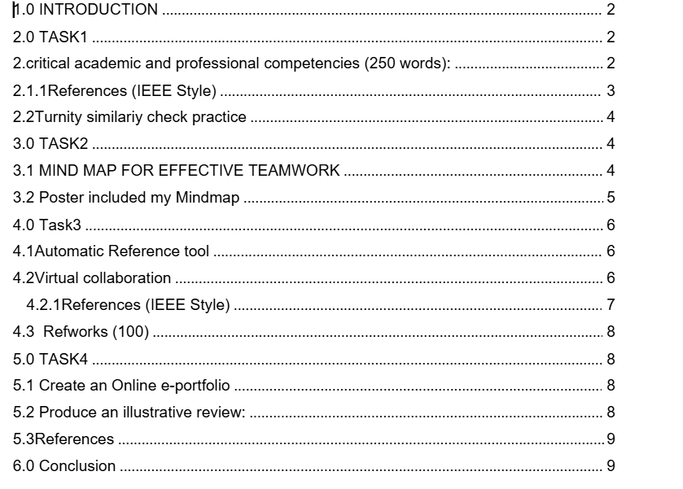

NEW PAGE: e-Portfolio.
1. A link to the online e-portfolio homepage.
https://sites.google.com/view/malado-fall-4025-eportofoglio/
2. A screenshot of the e-portfolio homepage.
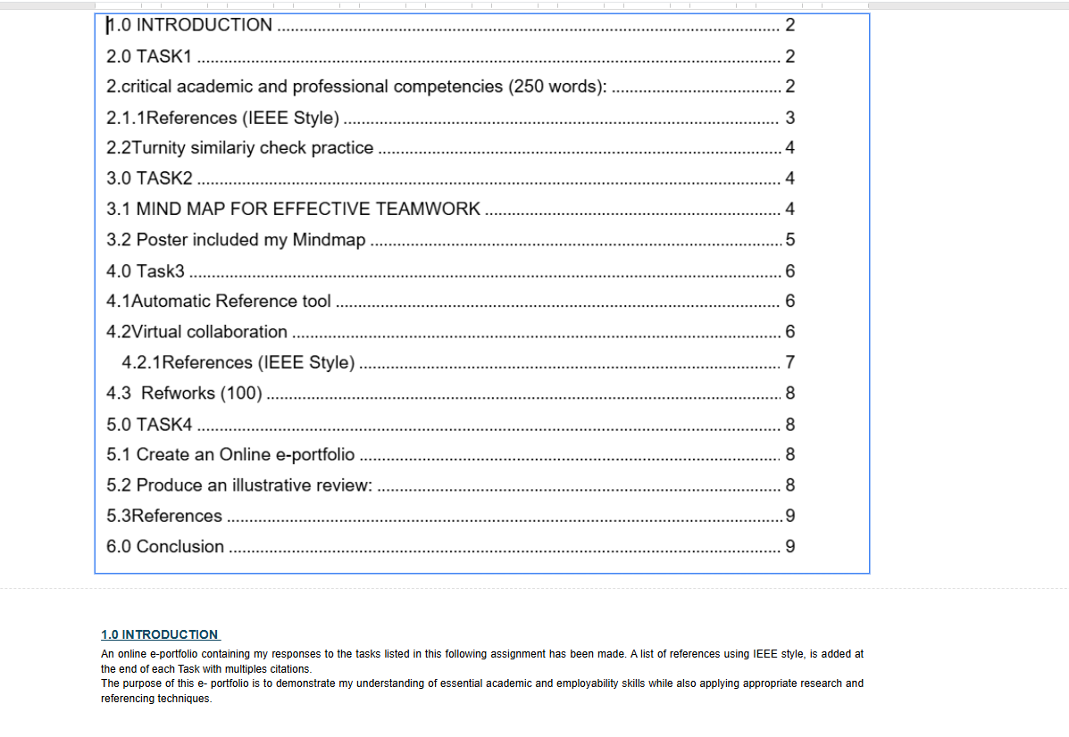

Task 1 – Written summary.
* A screenshot/s of the task answer in the e-portfolio.
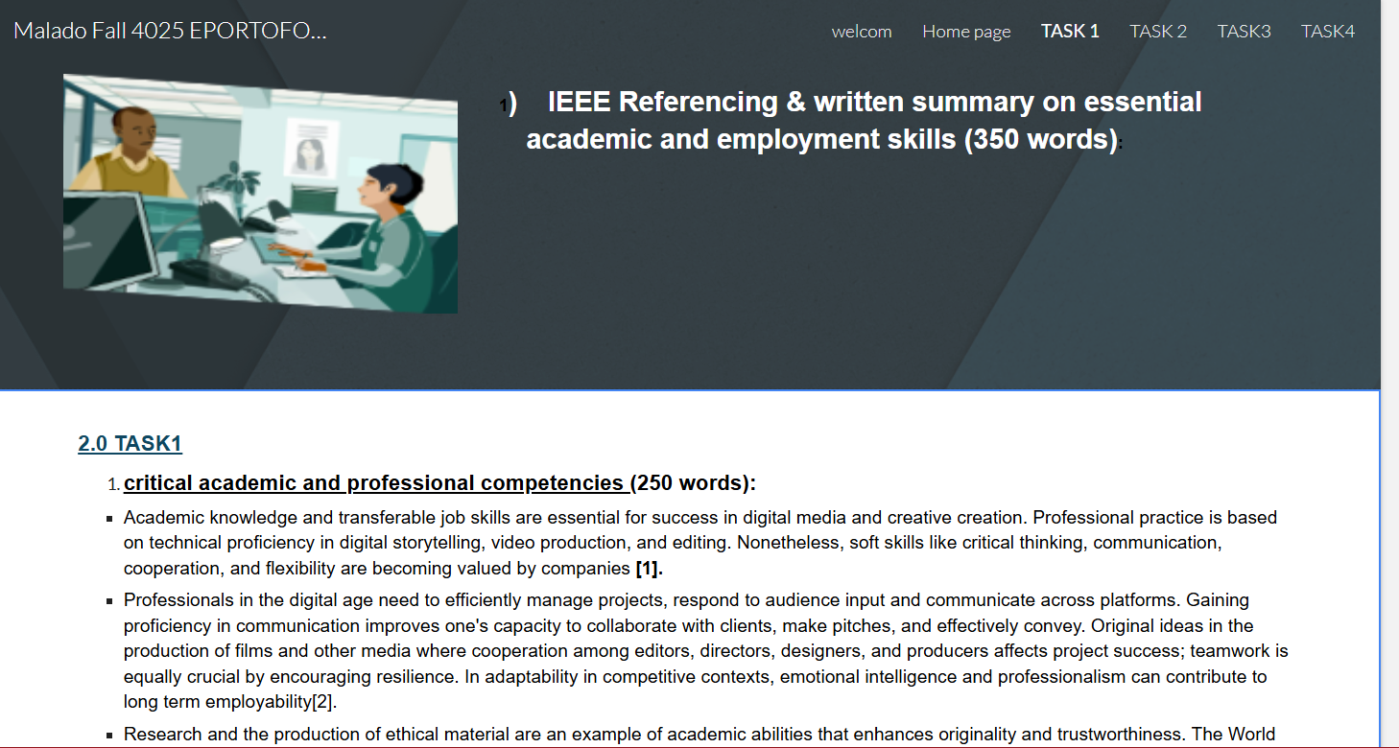
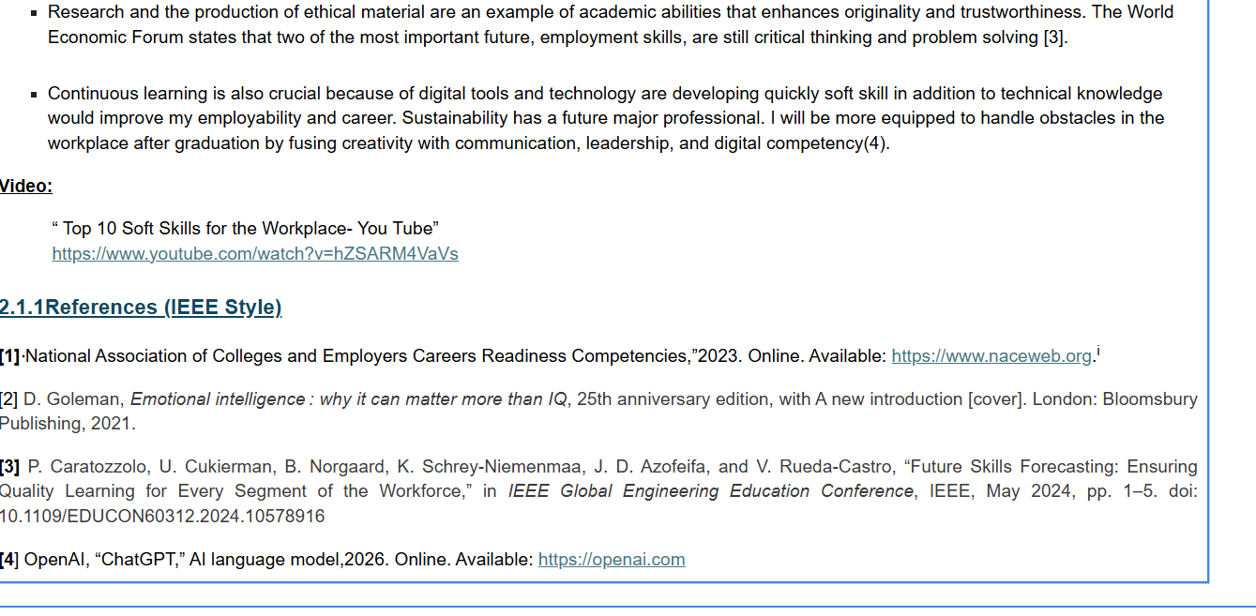
Task 2 – Mind Map & Academic poster.
1. A screenshot of the Mind-map.

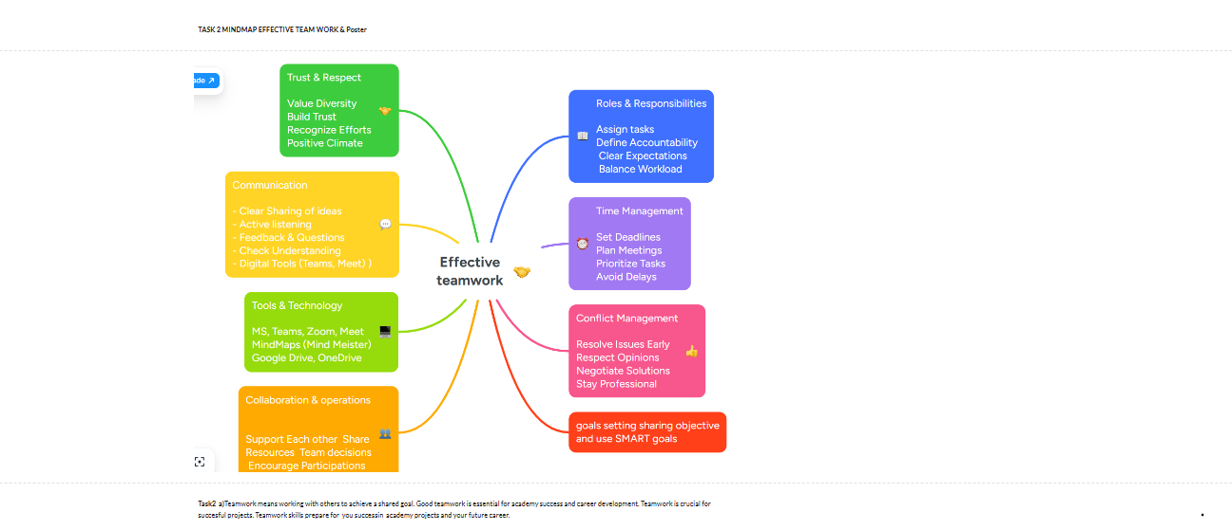
And a link to view the Mind-map online.

https://mm.tt/map/3955556811?t=TKsD6sqkB1
2. A screenshot of the Poster

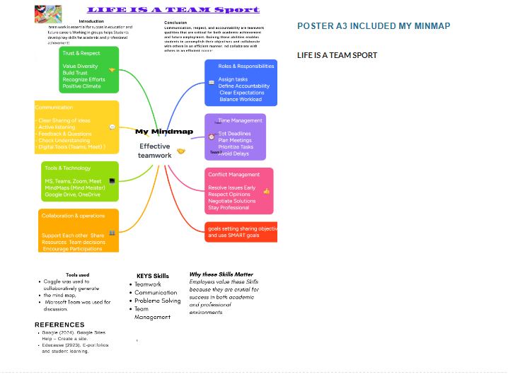
. And a link to view/download the Poster from it’s cloud storage (e.g. OneDrive, Google drive).
https://www.canva.com/design/DAHDYn3Dm0w/d2NS9dNMmvBqAxhC4_j7Ng/edit?utm_content=DAHDYn3Dm0w&utm_campaign=designshare&utm_medium=link2&utm_source=sharebutton
Task 3 – Automatic Referencing tool.
* A screenshot of the task answer in the e-portfolio

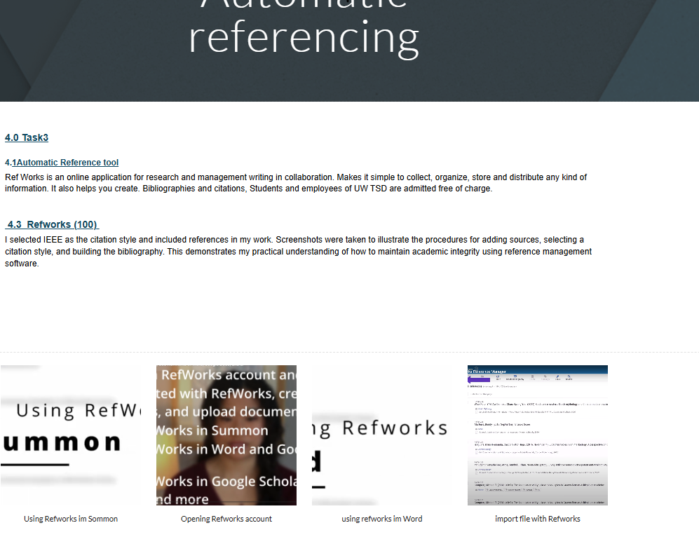

Task 4 – e-Portfolio creation and review.
* Include a screenshot of each page of your e-portfolio.


