24/04/2026
Aliyah Dorathy Hamilton-Hastings (2513397)
london campus
Assignment 1
Learning in the Digital Era
Module Name: Introduction to Web and Database Concepts
Module Code: ACCA 4023
Student Name: Aliyah Hamiton Hastings
Student ID: 2513397
Group No: 2
Lecturer’s Name: Anum Paracha
Submission Deadline: 24th April 2026
Contents
Introduction 2
Requirements 3
Implementation 4
Main page: 4
Login/signup: 4
Accessories: 5
Samsung: 5
Iphones: 6
Sales: 6
Contact: 7
3. Mood board 7
Validation 8
Evaluation 9
An evaluation of my completed website 9
Compare two live websites 11

Introduction
This report evaluates my Mobile World website, focusing on usability, accessibility, search engine optimization (SEO), and a comparison with professional sites. It introduces the site as a platform for purchasing mobile phones and accessories aimed at general consumers. Key concepts such as usability and accessibility are discussed, supported by research on improving user experience and online visibility. The evaluation highlights the site's strengths and weaknesses along with recommendations for enhancements like better mobile optimization. SEO techniques employed are analysed, including keyword usage and image optimization. Accessibility is assessed against WCAG 2.1 principles, addressing support for diverse users. Concluding that the website is well-designed, effective, and has strong development potential.

Requirements
My website Mobile World serves as an accessible and user-friendly platform for purchasing mobile phones and accessories at competitive prices. It emphasizes customer convenience, enabling users to easily locate products without facing unnecessary obstacles. The primary objective is to blend affordability and quality while ensuring a seamless online shopping experience.
Focusing on mobile technology, the site includes a variety of products such as smartphones, chargers, cases, and headphones
A significant feature of Mobile World is its organized layout, particularly the sales page, which showcases discounted products. This feature allows users seeking deals to navigate quickly and discover affordable alternatives without the need to browse the entire site, consequently enhancing usability and customer satisfaction.
Moreover, the design of the website prioritizes accessibility and ease of navigation. Clear menus, simple page structures, and quick loading times contribute to a smooth experience for all users. A thoughtful use of colours and bold fonts enhances readability and highlights key content while maintaining a tidy design, catering to users with visual impairments or specific accessibility needs.
Additionally, my website features a well-marked contact page to ensure customer support is easily accessible for any inquiries or issues, further affirming the site's commitment to service reliability.
The target audience encompasses a broad demographic, focusing on individuals in search of affordable mobile devices, and general consumers who appreciate convenience and simplicity. Overall, Mobile World aims to provide a fast, accessible, and satisfying online shopping experience for its diverse user base.

Implementation

Main page:
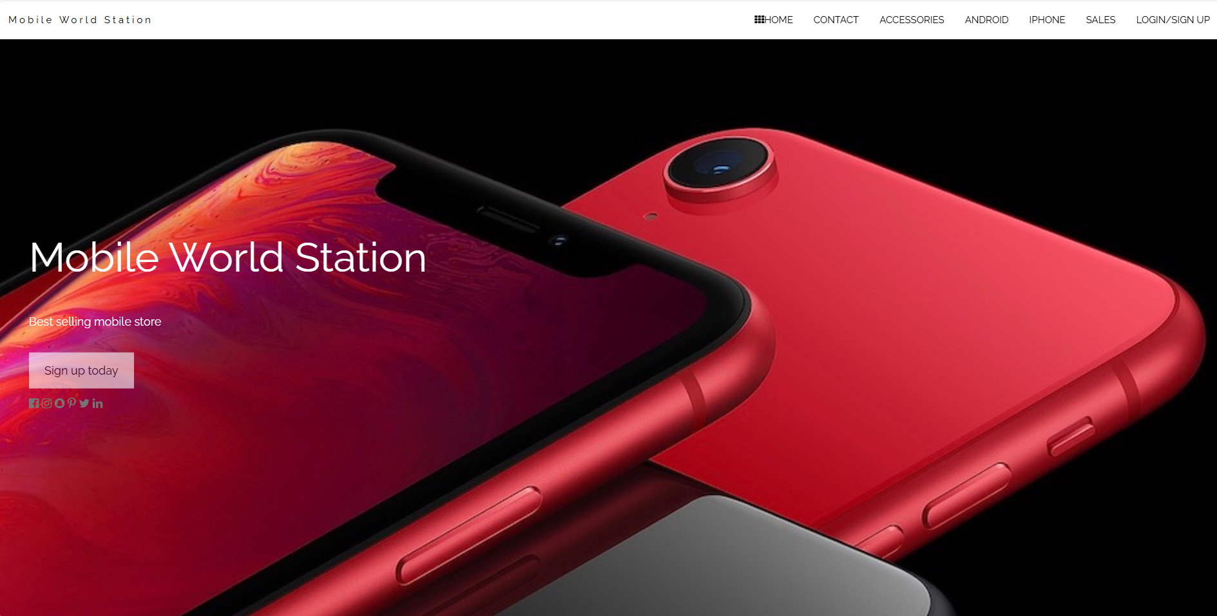

Login/signup:
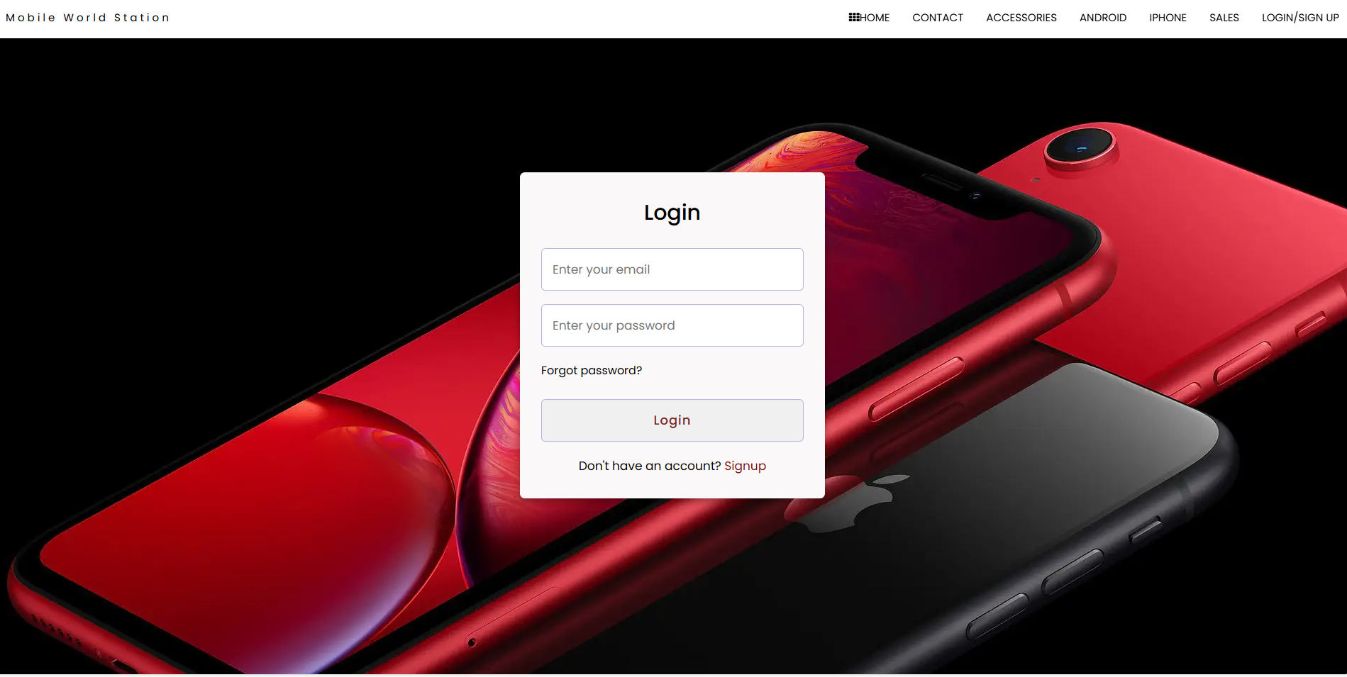

Accessories:
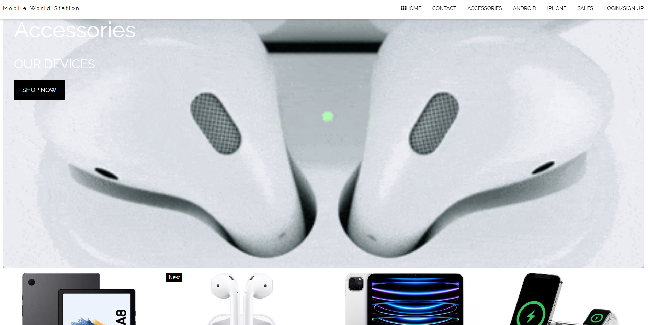

Samsung:

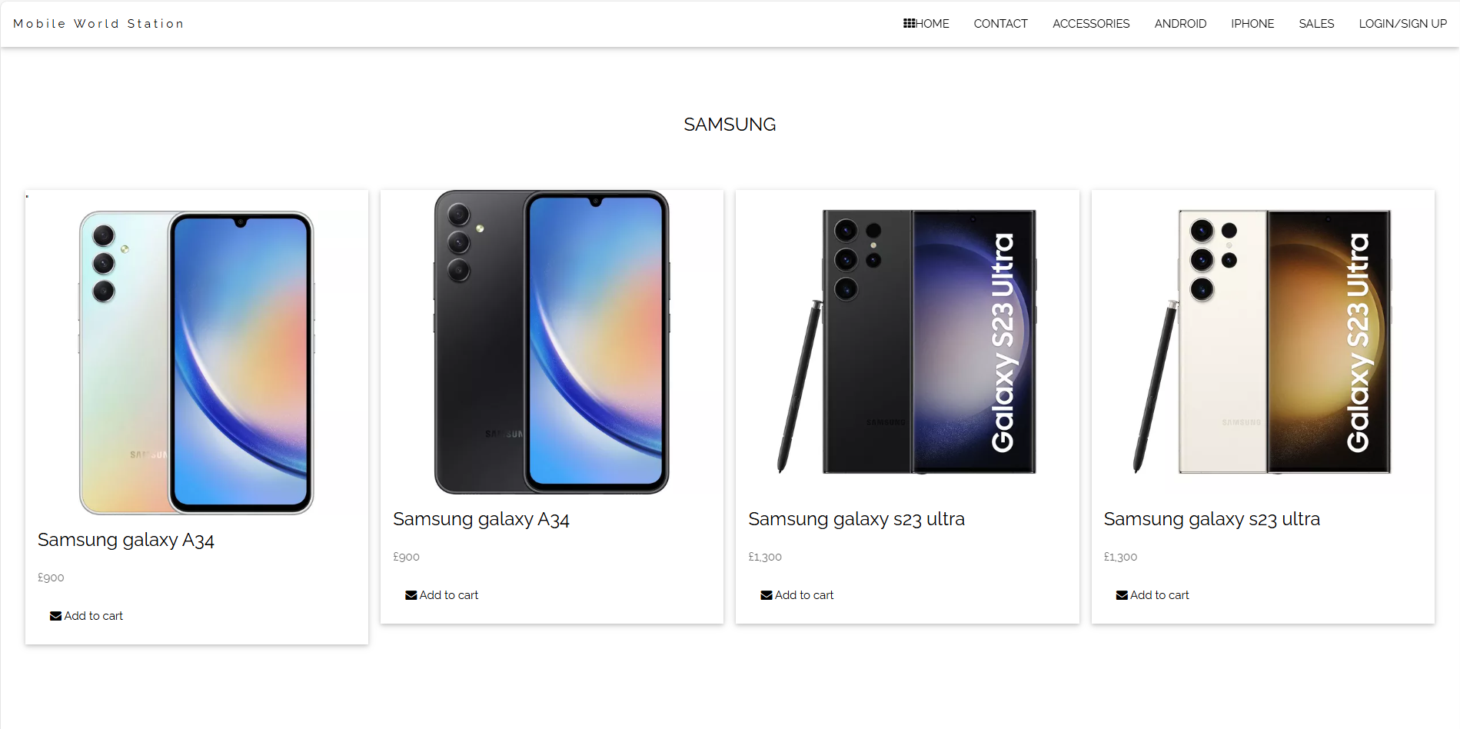

Iphones:

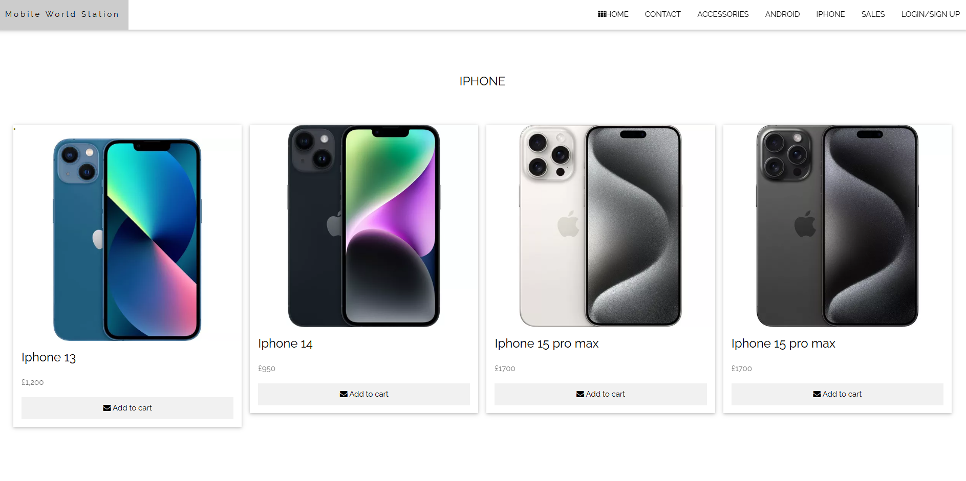

Sales:
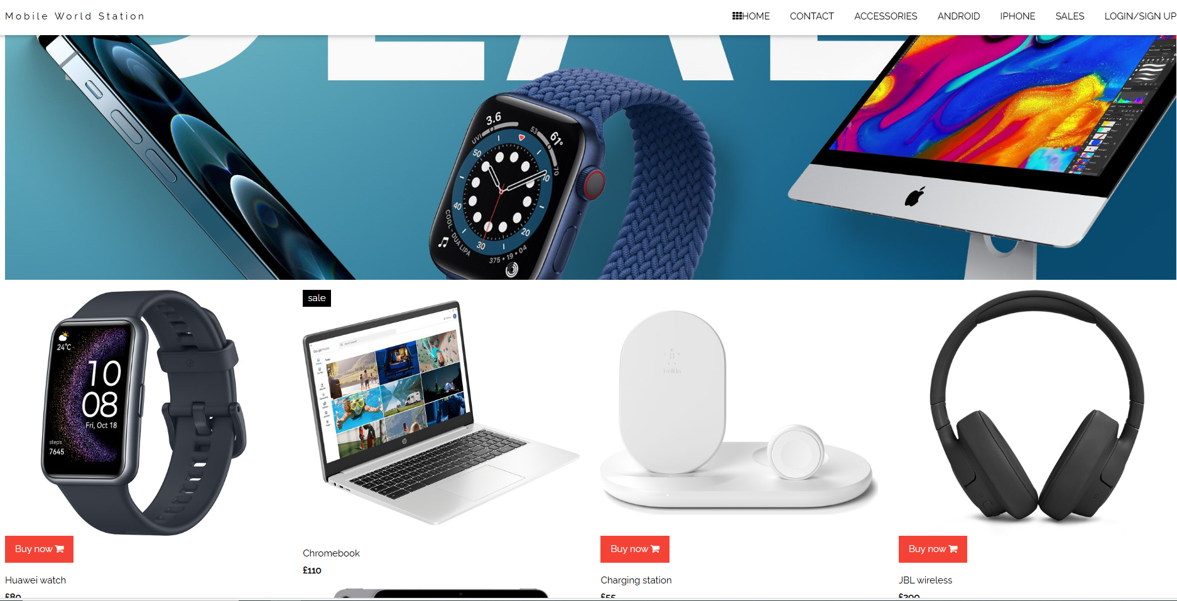

Contact:
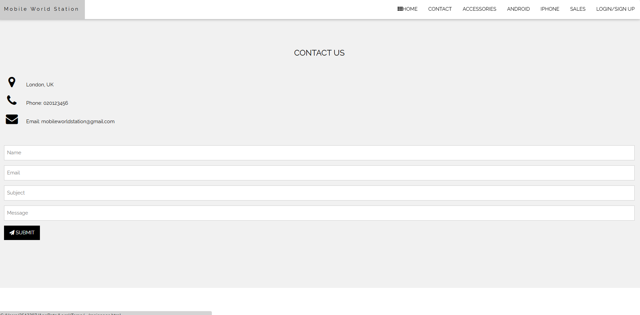

3. Mood board
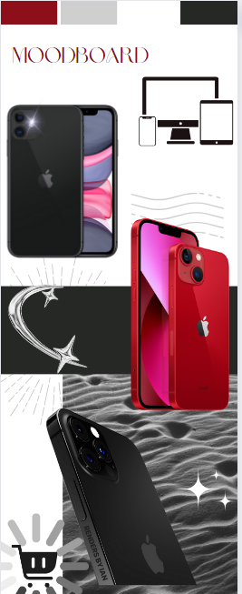

Validation

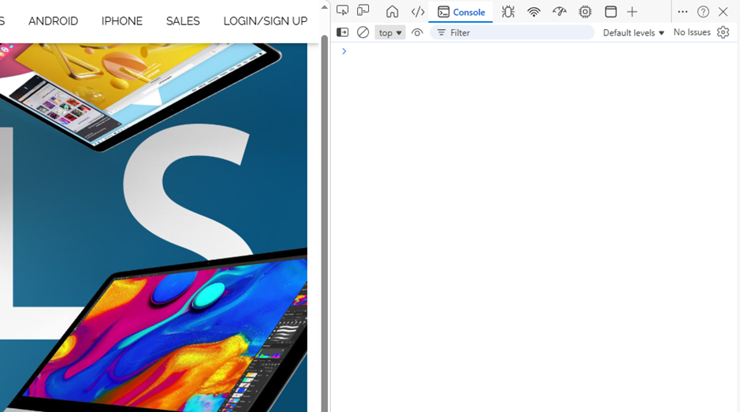

This screenshot demonstrates that the application operates smoothly without any bugs or issues. All buttons have been tested and respond accurately to user interactions, and the interface remains consistent throughout, showing no glitches or unexpected results. The code is well-structured and free from visible mistakes or logical errors, with all features functioning as intended. The system fulfills all required functionalities, ensuring a reliable and seamless user experience. Currently, only minor validation improvements are needed to enhance data handling and reliability. Overall, the application is stable, polished, and showcases a clean, bug-free build with operational features.

Evaluation
Website quality is evaluated through three interconnected concepts: usability, accessibility, and search engine optimisation (SEO).
**Usability** reflects how effectively users can achieve their goals on a website. Defined by standards like ISO, it includes aspects such as intuitive navigation, clear layout, quick loading times, and minimal errors. Research reveals that poor usability hampers user experience and task completion, with studies identifying crucial factors such as content organization and interface design. User-centered design processes and usability testing practices are essential in developing usable websites.
**Accessibility** aims to make websites usable by individuals with disabilities, ensuring that they can perceive, understand, navigate, and interact with content. This includes designing for compatibility with assistive technologies, providing alternative text, and supporting keyboard navigation. Studies highlight unique accessibility challenges faced by disabled users, underlining the necessity for inclusive design approaches guided by standards like WCAG, which are increasingly recognized as both legal and ethical requirements.

Search Engine Optimisation (SEO) is a critical process aimed at enhancing a website's visibility in search engine results, thereby increasing its traffic. Key techniques involved in SEO include the use of relevant keywords, optimizing meta tags, structuring content with headings, and improving page speed. In the domain of web development, SEO is essential as it facilitates easier access for users and helps search engines effectively crawl and index the site, leading to improved rankings. A study conducted by Egri and Bayrak (2014) indicates that websites exhibiting superior SEO and user usability report higher user engagement and conversion rates. The research highlights the correlation between SEO and user experience, asserting that well-structured and user-friendly websites tend to perform better in search rankings.
In conclusion, usability, accessibility, and SEO are essential pillars of web development that collectively contribute to creating high-quality websites that are user-friendly, inclusive, and easily discoverable online.

An evaluation of my completed website
Three main factors—functionality (utility), usability, and content quality are how I assess my website's efficacy.

In terms of effectiveness, my website performs its main tasks, with essential components like interactive elements and navigation menus operating as intended. I am aware, though, that the website may be made more dynamic by adding features of an interactive layout or a search function.

In terms of usability, I have created a simple layout that improves aesthetic appeal and simplifies navigation. I make good use of headings and spacing to increase information accessibility. Nevertheless, I could improve mobile responsiveness even further and cut down on the number of clicks needed to access important material. In order to enhance user interaction, I also intend to use visual cues like hover effects.
When it comes to content, I made sure that it is relevant to my intended audience and organized in a way that makes it easy to read. I do admit, though, that including more thorough explanations and multimedia components—like pictures or videos—would boost participation.
In order to make my website better, I intend to:

- Include more interactive elements and a search bar.
- Improve responsiveness on mobile devices
- Boost visual hierarchy by using more contrast and spacing.
- Add more information and supporting media to the content.
There are a number of on-page methods that I utilize for Search Engine Optimization (SEO). I will use title tags to increase exposure in search results, and I incorporate pertinent keywords into headings and paragraphs. In order to facilitate readability and indexing, I also efficiently manage HTML header tags. In order to help SEO and accessibility, I also optimize photos using alternative language and informative file names. I will use internal linking to make it easier for search engines to crawl my website and effectively direct users.

To enhance SEO, I would includes several strategies: improving page load speed through image compression and code optimization, building backlinks to bolster site authority, regularly updating content for relevance, and implementing structured data to boost search visibility. Additionally, an evaluation of website accessibility reveals that most pages are perceivable, featuring readable text contrast and alt text for images. However, there are opportunities for improvement in contrast levels and the addition of captions. Never the less The site is generally operable with clear menus, yet there's a need for thorough testing and enhancement of keyboard navigation. While the content is logically structured and understandable, the aim is to further refine consistency and clarity across all pages.

Compare two live websites
Apple's website emphasizes usability with a minimalist design, allowing easy navigation through product categories like iPhone and Mac. While its clear visuals enhance user experience, the minimal text may necessitate additional navigation for detailed specifications. In accessibility, it adheres to WCAG 2.1 principles, but heavy animations may challenge users with cognitive disabilities. SEO is strong with clean structures and product names, yet relies on visuals over text. Mobile responsiveness is excellent, ensuring smooth usability across devices.
In contrast, Samsung's website provides extensive product information, making it very functional for user research, but this richness can lead to a cluttered interface. Usability is multifaceted with various navigation options, though it may be less intuitive for newcomers. Access to WCAG 2.1 principles is present, though some elements face challenges in navigation optimization. Its content-heavy approach boosts SEO significantly, including detailed product descriptions and FAQs. Mobile responsiveness is adequate; however, page loading can be slower, impacting the experience. Overall, Samsung excels in functionality and SEO but needs improvements in usability and mobile performance.
Overall, a comparison of the Apple and Samsung websites with *Mobile World* highlights each site's strengths. Apple emphasizes simplicity and visual design, while Samsung excels in content detail and SEO. However, *Mobile World* effectively merges these strengths, providing a balanced, user-focused experience characterized by clear layout, simple navigation, and well-organized content. Designed with WCAG 2.1 principles, it ensures high accessibility compared to Apple’s animations and Samsung’s contrast issues. Its focused SEO strategy balances readability and visibility, making it efficient for its scale. Furthermore, *Mobile World* features excellent mobile responsiveness, optimizing performance and clarity for smaller screens. Consequently, it emerges as a competitive, user-friendly solution that avoids the common weaknesses of larger commercial sites.

