Report 1

Moodle | Web Services
StudentName | Chuanliang Yao
StudentNo | 1904781
Lecturer | Michael Dacey, Tim Bashford,  Kemi Ademoye
Major | Msc Software Engineering
Faculty | Computing and Engineering

Category

Contents 2
1.Introduction to RESTful web services 3
2.Recommendations for best practices for implementing RESTful web services 4
3.Show the appropriate code snippet to demonstrate how my application follows these best practice recommendations 7
Reference 9

- Introduction to RESTful web services.
RESTful Web Services is more popular nowadays, it is mainly used to solve and deal with the communication connection problems between different structural systems. There are many sites and applications that can provide APIs for them, and they all correspond to RESTful style Web Services. REST introduces a style of web architecture that contains a set of conditions and related guidelines that constrain its architecture. However, conforming to the RESTful style is corresponding to some designs or applications that are subject to these constraints and principles. RESTful Web Services are RESTful Web Services. The four categories such as GET, POET, DELETE, and PUT are based on the REST architecture. GET refers to providing read-only access to resources, POST refers to creating new resources, DELETE stands for delete, and the final PUT is to put Update existing resources or regenerate new resources.
The service functions of RESTful Web also include: identifying resources by URI, so that clients can benefit from this to directly access RESTful Web services. From the perspective of the client server, constraints represent a clear separation of problems. Separating the concerns between the client and the server helps improve the portability of the client and the scalability of the server components. Both the request between the client and the server contains relevant information for user identification, and the response is cacheable and controllable. The URI connection between resources makes it extremely easy to change the state between clients. Layered components-intermediaries (such as proxy servers, cache servers, gateways, etc.) can be inserted between clients and resources to support performance, security, etc. Users can access content in multiple formats because their resources are separated from them.
The RESTful architecture divides servers into two categories: front-end and back-end servers. The back-end servers provide corresponding interfaces for their front-end servers, and the front-end servers directly interact with users through views without models. After the command requesting the view is sent, the existing AJAX function in the view directly obtains the relevant model from the interface. This architecture is easy to develop in teams. Due to the particularity of HTTP requests in the RESTful architecture, it can reduce the load on the server, so that the failure model obtained can also be displayed. This architecture is suitable for some small projects, otherwise it will increase the complexity of the project.

2.Recommendations for best practices for implementing RESTful web services.
Examples of best practices for implementing RESTful web services: first define a simple resource or service, model a selected instance through JSON, build a framework that maps JSON to a Java model, and store it in a database Because it can be accurately represented by JSON, the url format must be correct and concise. Then add appropriate data verification to the resources in the service. The user needs to find the error code in HTTP and process or transfer the error information. The error status of the client needs to be resolved in a timely manner. In some cases, it can be restarted, and then a series of new codes are generated.
It is not so easy to define the right granularity and the right type for business events. The user may need several iterations to do it well. A better suggestion is not to over-design: try to keep it simple and refactor when new use cases arise. Adding cache is also an important aspect. The Web infrastructure provides a rich cache mechanism including the last modification information, cache duration, etc. Learn mechanisms and check whether users can use them to improve service performance and scalability.
In terms of RESTful Web API best practices, developers can also provide people with a good API design style. First, developers can use nouns instead of verbs. Then the Get method and query parameters can keep the state stable. It is best to use plural nouns. Do not confuse the singular and plural nouns in the design process. In order to keep it simple, only use plurals for all resources. Use sub-resources to express relationships. If a resource is related to another resource, it is recommended to use sub-resources. Use the Http header to declare the serialization format. Generally, both the client and the server must know the communication format. The format is specified in the HTTP-Header. For example, Content-Type defines the request format, and Accept defines the series of acceptable response formats. Using HATEOAS-Hypermedia as the Engine of Application State hypermedia as the engine of the application state, hypertext links can establish better text browsing, such as the following information: {
"id": 711,
"manufacturer": "bmw",
"model": "X5",
"seats": 5,
"drivers": [
{
"id": "23",
"name": "Tom",
"links": [
{
"rel": "self",
"href": "/ api / v1 / drivers / 23"
}
]
}
]
}
Here href points to the next URL
Developers can also provide functions such as filtering, sorting, selection, and paging for collections, such as Filtering: filtering using unique query parameters. Sorting: allows sorting on multiple fields. Here GET / cars / sort = -manufactorer ,+ model, this is to return the set of cars arranged in descending order of producer and ascending model. Field selection: The mobile terminal can display some of these fields. They do not actually need all the fields of a resource, giving the API consumer the ability to select a field. This will reduce network traffic and improve API availability. Paging paging, including using limit and offset. To achieve paging. Default limit = 20 and offset = 0; GET / cars / offset = 10 & limit = 5 In order to send the total number to the client, use a custom HTTP header: X-Total-Count. Link to the next or previous page can In the link specification of the HTTP header, the Link regulation should be followed here. Versioned APIs make API versions mandatory. Do not publish APIs without versions, use simple numbers, and avoid decimal points such as 2.5. Use Http status code to handle errors. Http status code provides 70 errors, people only need to use about 10: for example 200-OK-everything is normal
201-OK-The new resource has been successfully created
204 – OK – Resources have successfully excelled
304 – Not Modified – client uses cached data
400 – Bad Request – The request is invalid, additional details such as "JSON invalid" are required
401 – Unauthorized – request requires user authentication
403-Forbidden-The server has understood the request, but denial of service or access to such a request is not allowed.
404 – Not found – The resource was not found
422 – Unprocessable Entity – Only used when the server cannot process entities, such as images cannot be formatted, or important fields are lost.
500 – Internal Server Error – API developers should avoid this error. It is permissible to have a method of overriding http. This means that some proxies only support the POST and GET methods. In order to use these limited methods to support RESTful APIs, a method is needed to override the original method of http. All of the above can improve the effectiveness of best practices for good design of RESTful APIs.
In summary, the best practices for RESTful Web Service include: the general steps of RESTful Web Service design, specifically: planning the data set, dividing the data set into resources, naming the resource with URI, exposing a subset of the unified interface, design Representation from the client, design the representation sent to the client, use hyperlinks to link resources with existing resources, and consider possible errors. Then there is the resource design, that is, the pre-defined one-time resource, the resource corresponding to the data item, and the resource of an algorithm result on the data. In terms of URI design, the design of service URI should have a certain meaning and good design. The URI exposed by the resource should be the main body rather than the action. The path variable is used to divide the URI in a hierarchical manner, and the comma and semicolon separate the same level Content, unified interface design, resource link design, services with no links or few links require clients to be familiar with the construction of the URI corresponding to each resource, and by providing links, you can shield changes in resource representation to a certain extent. The analogy of programming languages ​​is like encapsulating some functions through functions or classes. When users use the service, they only need to follow the link to go down, without having to be familiar with the construction of each URI. Then there is the design of the return value, common error return and versioning of the service.
About the advantages and disadvantages of restful front and back end separation and restful api. The advantages of front-end and back-end separation are: pc / app / pad multi-end adaptation, the SPA development model has become popular, front-end and back-end development responsibilities are unclear, the front-end has always cooperated with the back-end, capacity is limited, development efficiency issues, front-end and back-end wait for each other, background development The high degree of coupling between language and templates has led to severe dependence on development languages. The disadvantages of front-end and back-end separation are: the threshold for front-end and back-end learning is increased (more data to be processed by the front-end, and the new data must be met by the back-end); data dependence leads to increased document importance, increased front-end workload, and difficulty in SEO Increase, the migration of back-end development model increases costs (projects that previously relied on template development). Regarding the restful api part: it is currently the best practice for front-end and back-end separation. Lightweight, directly through http, without additional protocol, post / get / put / delete operation. Resource-oriented, self-explanatory at a glance. The data description is simple, and data communication is generally done through json or xml.

3.Show the appropriate code snippet to demonstrate how my application follows these best practice recommendations.
In HTTP, four common operation methods are provided: GET, POST, PUT, and DELETE. These four operation modes correspond to the four basic operations one by one: GET is used to obtain resources, POST is used to create new resources (also used to update resources), PUT is used to update resources, and DELETE is used to delete resources.
I used the get request, which is the query, as shown in the following code:
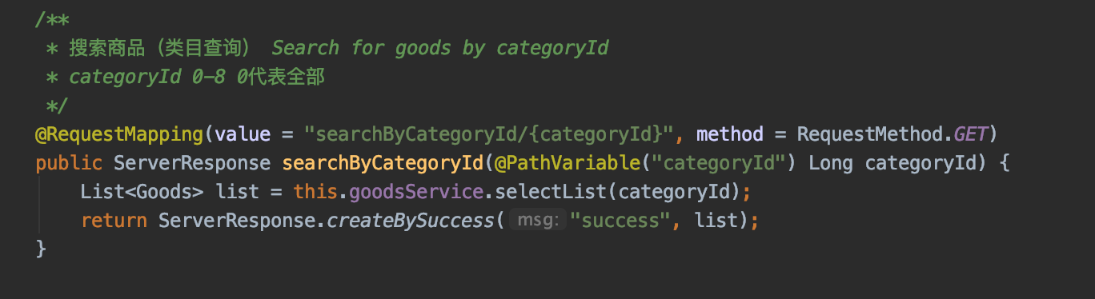
The following figure represents the project presentation of get on the web page:

To cite a case, this is a query for a commodity classified as 7, as shown in the following code:
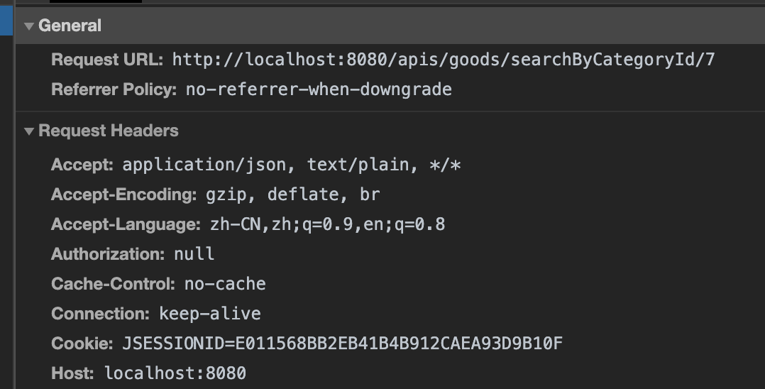
In fact, post can also be used as a request server resource, and get can be easily understood by users.
I used post and put requests, which are the functions of creating and updating resources, as shown in the following code:
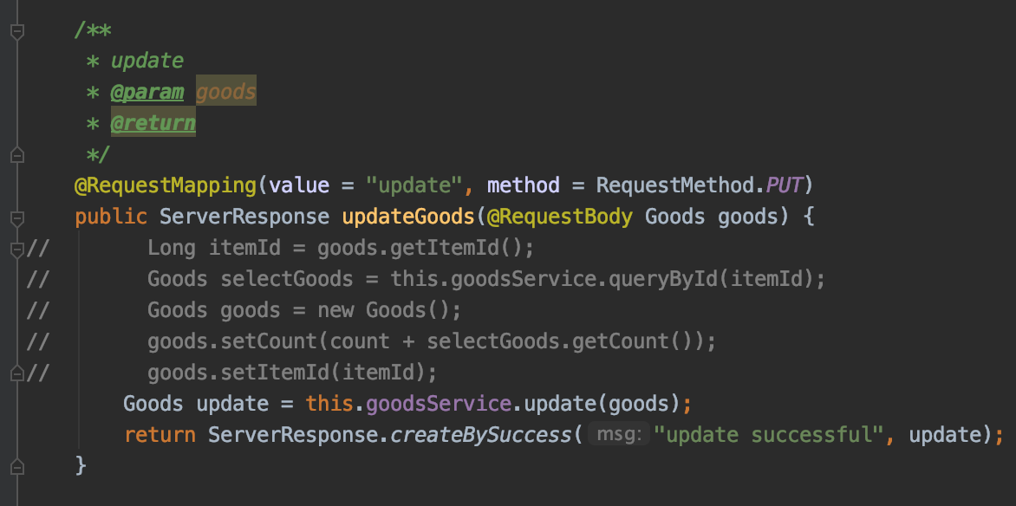
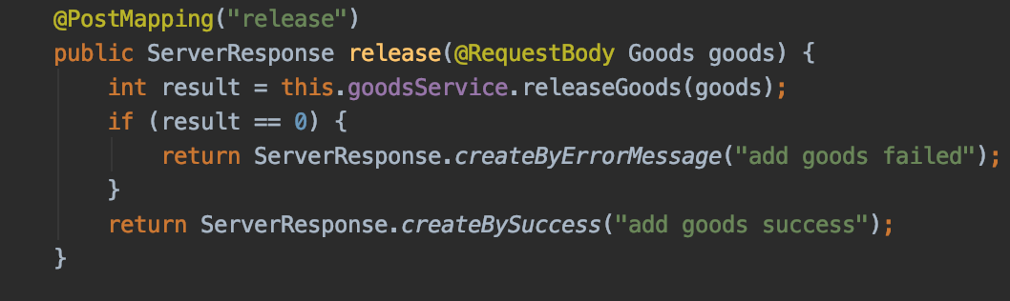
I used the delete request, which is the function of deleting resources, as shown in the following code:
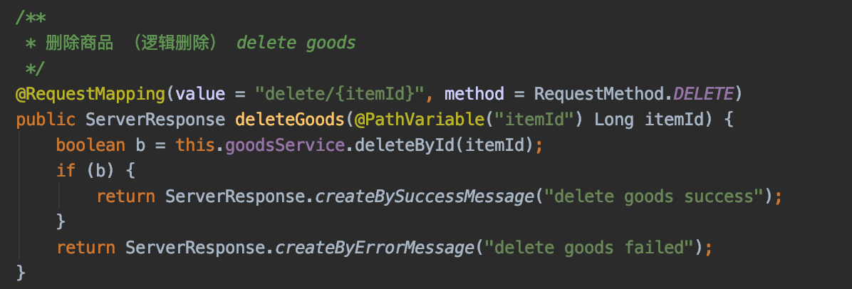
To give an example of deletion, delete / 5 ------> corresponds to delete the product with id 5
Formerly delete? id = 5 If the front end and back end write the id differently, an error will be reported.

Reference
[1] Wang Lei, Sun Fan, Chen Xudong. Application of RESTFUL, SOAP and ICAP in mobile networks [J]. Post and Telecommunications Design Technology, 2015, (9): 35-38 Superstar [reference date 2019-09-03].
[2] Architectural Styles and the Design of Network-based Software Architectures. Baidu Academic [reference date 2019-06-17].
[3] Design and implementation of service-oriented data mining prototype system based on RESTFUL China HowNet [reference date 2019-06-17].
[4] Zhou Shaojing, Ying Jie, Pan Hongbin, etc. Application Research of RESTful Architecture [J]. Digital Technology and Application, 2018, (5): 59-60． Superstar [reference date 2019-09-03].
[5] Elkstein, M. What is REST?. Retrieved on 2009-07-04.

Report 2

Category

Contents 11
1.“Serverless” technologies and their relevance to web hosting. 12
2. The circuit breaker pattern and the rationale for its implementation in modern web development. 14
Reference 17

1.“Serverless” technologies and their relevance to web hosting.
Serverless technology refers to serverless computing that allows customers to run applications, operate services, and build businesses without considering the server. The user does not need to manage any server items in the application, and various types of applications and related background services can be built as serverless applications by the user. The relevant cloud service provider can provide all the support needed for the application.
Firstly, the idea of serverless does not equal the actual state of the technology. There is actually a separate server inside, but users don't need to spend money to buy, maintain or monitor it. The management of the server is handled by others, and the user's cloud infrastructure adds related levels of abstraction. In the view of the developers of this technology, this helps to improve the ability of the server to configure the background and promote the relationship between it and the creation of applications. From an enterprise's perspective, the time to market for the application is faster. You can meet the user earlier. Enterprises can focus more on developing and managing many applications instead of spending time on the server's background configuration. Generally speaking, business can drive related serverless methods, there are third parties to deal with user's technical issues, and users deal with delivery issues themselves.
The advantage of serverless applications is that they do not require additional management services and do not depend on other software to run; they are very fault-tolerant in terms of expansion and contraction. The amount of usage and the number of servers are not affected by this change; when running applications, no server can provide users with high applications; this technology has no unnecessary losses, it does not need to consider the relevant capacity occupied by calculation and storage , Developers can focus on the code of their products, so there is no need to consider the running process of the cloud or local server.
The relevance of serverless to virtual hosting is that serverless computing can provide a high level of abstraction, which is different from using virtual machines or some relatively low-end technical management applications. They have many abstractions and so-called trigger sets. In the field of computing, a specific function and trigger correspond to an abstraction, which belongs to an event. Using the database as an example, this abstraction may represent a table, and the trigger may perform related query and search functions on it, thereby generating a series of events in the table. To give an example, there is a mobile game app, and users are allowed to design ranking tables for those high-level players on various platforms. Once this information is requested, the request is passed from the application to the relevant API interface. Relevant functions are generated in the API interface, or some serverless functions. These functions read a lot of data from the database and return the top ranked data. Once this build is complete, the application can be reset in the mobile and web game versions. This is different from the initially set server. No specific server is required, just wait for the request. The environment is a necessary condition for event triggering, and the response logic of an event is limited to the response of the event. At this level, only the large amount of resources needed to run these functions can be created while the functions are running, and building applications benefits from the efficient methods that are generated in it.
On the other hand, serverless architectures basically rely on third-party services related applications or put their custom code to run in temporary containers (FaaS). FaaS is only part of the event-driven processing within this technology system. From the perspective of the application, some modules such as data flow, data cycle, message passing, and personnel management are indispensable. It helps achieve end-to-end functionality. It is worth noting that some programs without FaaS components can still be classified as applications in serverless technology. When it comes to virtual hosting, users don’t need to consider physical servers when they need virtual hosting. If there is a cloud service provider, personnel can directly place the webpage content in the storage bucket, and then open the static virtual host to manage their webpage. There are also cases of using back-end services for authentication and data processing, all of which can use serverless technology, and finally combine their functions with a virtual host.

2. The circuit breaker pattern and the rationale for its implementation in modern web development.
The circuit breaker mode belongs to a kind of safety protection mechanism. In the current distributed environment, especially in the distributed system of the microservice structure, there are many cases where the software system calls another system remotely. The participant may be another process or a new host across the network. The failure rate of this remote call is a bit higher in terms of internal calls. Even if it fails, it may not be able to get any response. Finally overtime crash. A more serious situation is that if multiple users call a single suspended service, the timeout of one service will directly affect the entire distributed system, which is equivalent to the butterfly effect. It will exhaust a lot of resources in the system and directly lead to The entire system is paralyzed. In addition, if a service is very busy, a failure in one part of the system may cause a cascading failure. For example, the operation of invoking the service can be configured to execute timeout, if the service fails to respond within this time, it will reply with a failure message. However, this strategy may cause many concurrent requests to the same operation to be blocked until the timeout period expires. These blocked requests may store critical system resources such as memory, threads, and database connections. Therefore, these resources may be exhausted, leading to the failure of other potentially unrelated parts that need to use the same resource system. In this case, it will be the preferred operation to fail immediately, and only attempt to call the service if it is likely to succeed. Please note that setting a shorter timeout may help solve this problem, but the timeout should not be so short, most of the time the operation fails, even if the request for the service will eventually succeed. The circuit breaker mode is to prevent a series of collapsed situations in the distributed system. Similar to the protection of the circuit, once a problem occurs in an electrical appliance, the fuse of the circuit will blow to prevent fire and other situations. The circuit breaker is similar to the fuse in electricity. Its idea is relatively simple. It encapsulates the remote service that needs to be protected, and records the number of failures in it. Once the failure number reaches a critical point, the circuit breaker will directly terminate the subsequent call. The task is intercepted and returned directly to the corresponding caller. The wrong service will be terminated to protect the caller and the entire system will not crash due to timeout.
The structure of the circuit breaker is shown in the following figure:
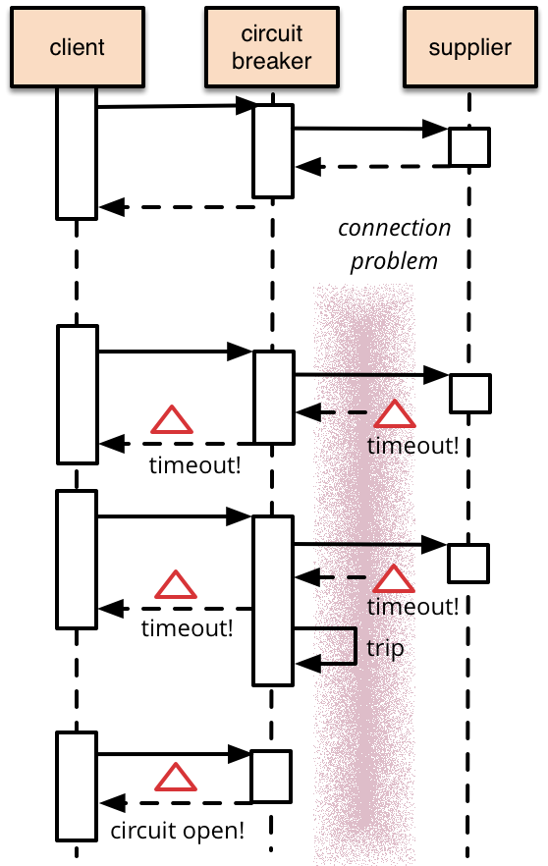
It is divided into two basic states and a basic trip action:
In the case of close, the service request initiated by the client to the supplier is not hindered by the circuit breaker, and the return value of the supplier is directly returned to the client by the circuit breaker.
In the case of open, after the service request initiated by the client to the supplier, the circuit breaker will interrupt its request to the supplier, and then return to the client, and their access is cut off.
Trip means that in the case of close, if the supplier continues to time out and report an error, after the specified threshold is reached, trip will occur and the circuit breaker will immediately enter the working state.
It also has an extended mode, as shown in the following figure:
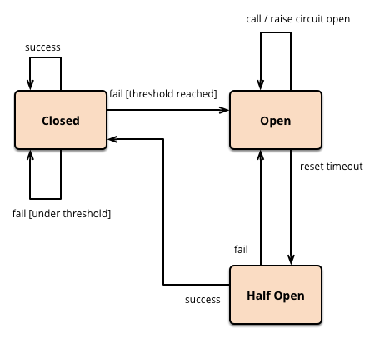
In the basic circuit breaker mode, it is guaranteed that when the circuit breaker is in the open state, the protection supplier will not be called, but we need additional measures to reset the circuit breaker after the supplier resumes service. A feasible method is that the circuit breaker periodically detects whether the supplier's service is restored, and once restored, sets the status to close. The state of the circuit breaker when retrying is half-open.
The application principle of circuit breaker in modern WEB is also reflected in a series of functions, such as exception handling and exception type. The application calls an operation through the circuit breaker and must be prepared to handle the exception that can be raised if the operation is not available. The way such exceptions are handled will be application specific. For example, an application may temporarily reduce its functionality, call another operation to perform the same task, or obtain the same data, or report an exception to the user and ask them to try again later. The circuit breaker monitors various types of abnormalities in real time and regulates and intervenes in these abnormalities. The same circuit breaker can access multiple instances at the same time, preventing excessive overhead. The circuit breaker can record the details and types of each request, and allocate resources reasonably to make appropriate remote calls.
The advantage of the circuit breaker mode in web applications is that it consolidates the flexibility and stability of the system, reduces the damage to the system by the fault and enhances the recovery of its performance. The response time of the system is not affected by the circuit breaker mode. This mode can be customized by developers, and the working time and response efficiency of the circuit breaker are controllable, which has very important significance for the development of application programs.
Regarding the application of circuit breakers in web development, there are also relevant regulations. Generally, when a supplier is relatively stable, it needs a long time to repair after a failure, or that the inspection time is longer and the repair and control cannot be performed efficiently in a short time. The circuit breaker mode makes up for this shortcoming well and can be well adapted to this situation. But in other occasions, such as a remote service to be called by an application, or the resources between them need to be shared, once the failure rate of this operation is relatively high, the circuit breaker mode is not so suitable. Also in the case of local resource calls, the application accessing the local resource of the host is similar to some data structures. If these data structures are in the internal memory, using the circuit breaker mode is not suitable for this kind of situation, because the use of The circuit breaker will increase some unnecessary system overhead.

Reference
[1] New Opportunities for Cloud Computing Serverless Computing Will Explode [N]. China Informatization Weekly, 2017-10-30 (014).
[2] Serverless backup. TechTarget storage [reference date 2015-06-03].
[3] Research and implementation of high-performance server framework based on Windows completion port, 2011-05-20.
[4] Circuit Breaker pattern,Github,2017-06-23.
[5] Circuit Breaker Mode and Modern Web Development. July 23, 2015 [reference date 2016-07-21].

