BA Computer Animation
Introduction to Character Animation
ADGD4005

Table of Contents

PowerPoint Slides…………………………………………………………………………………2
Link to Video…………………………………………………………………………………………6
Bibliography………………………………………………………………………………………….7

PowerPoint Slides
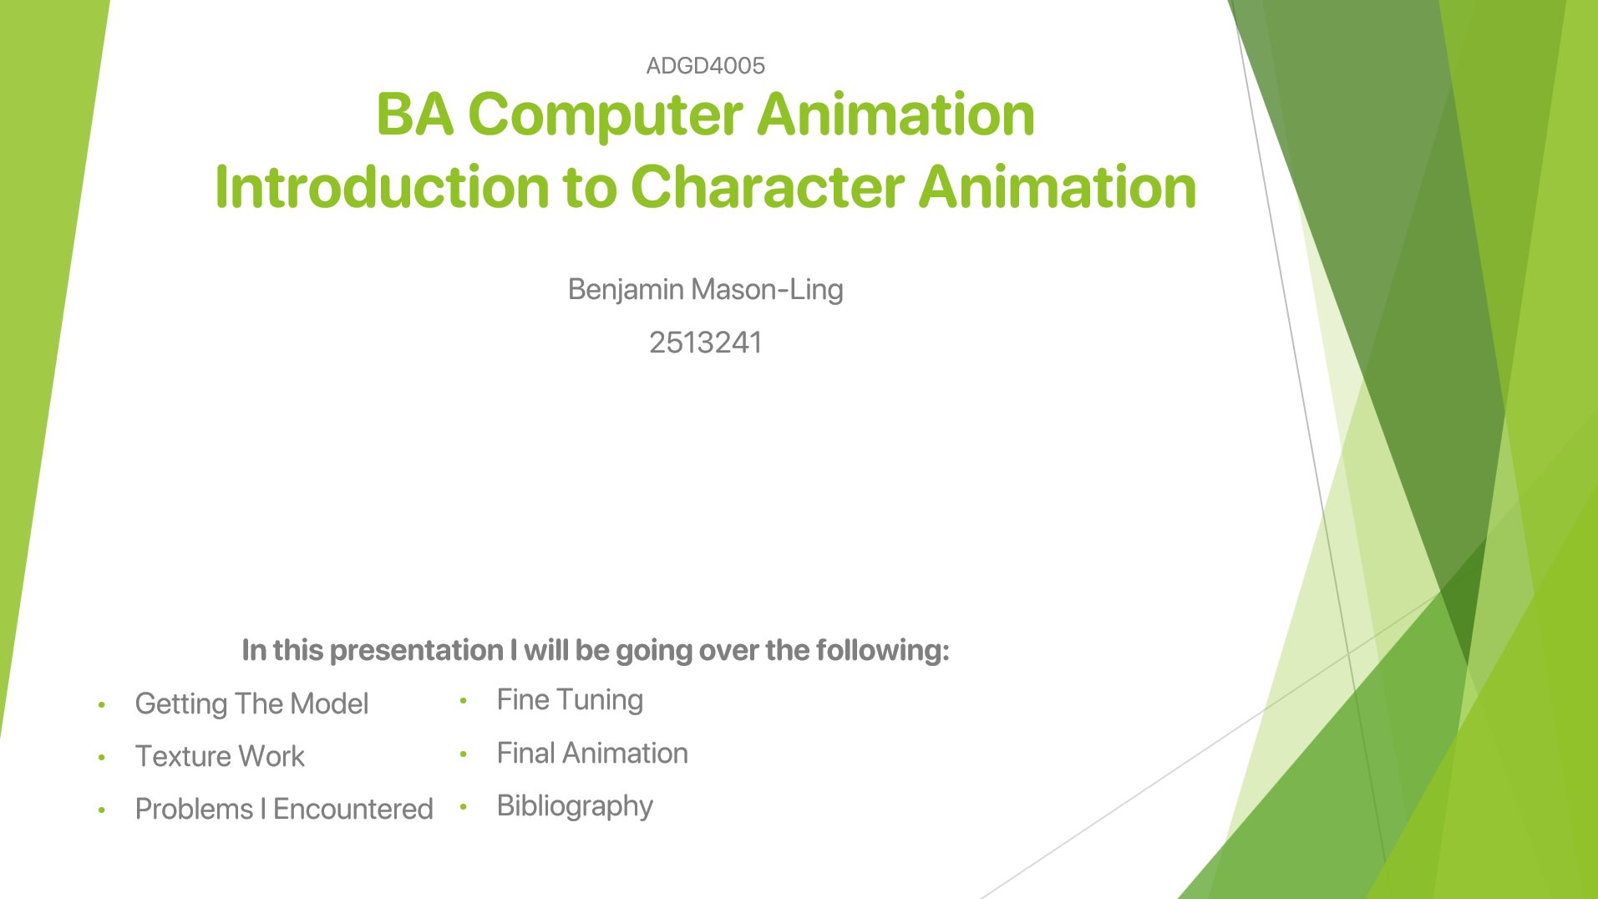
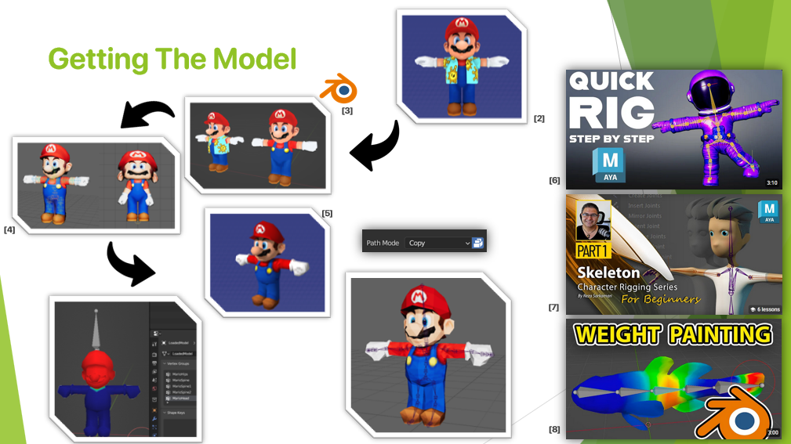
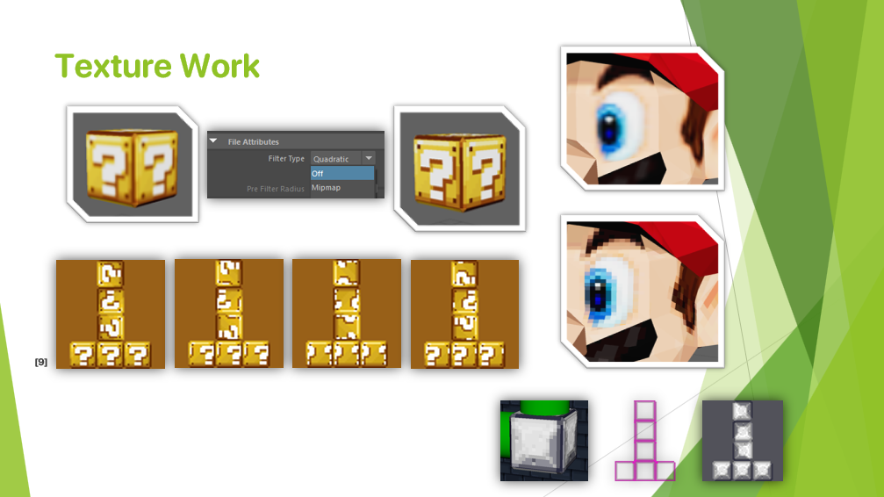
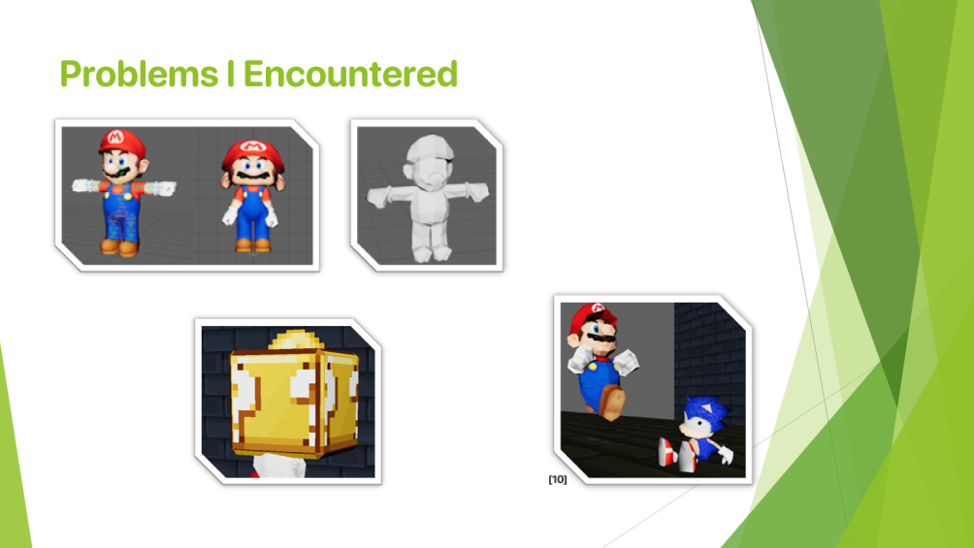
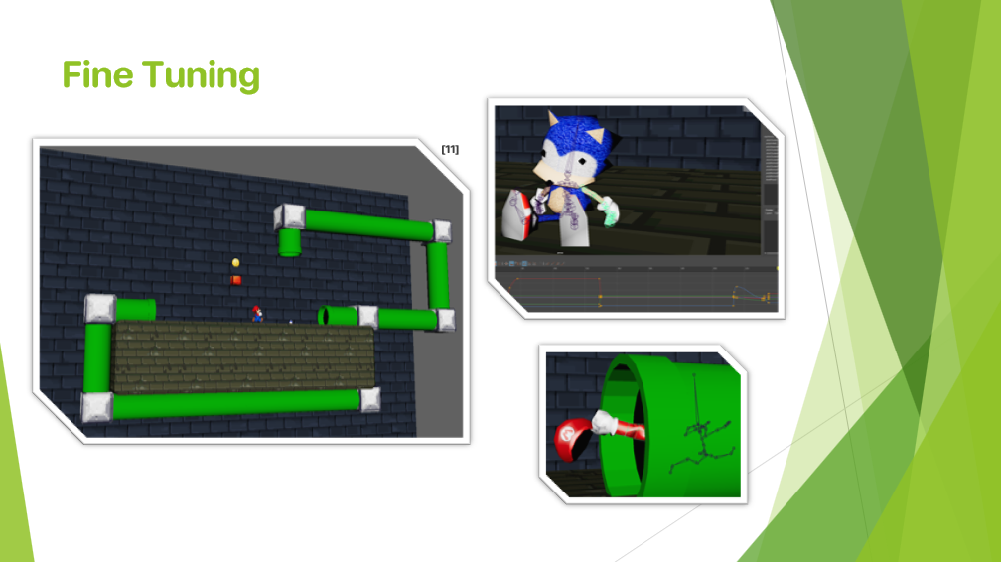
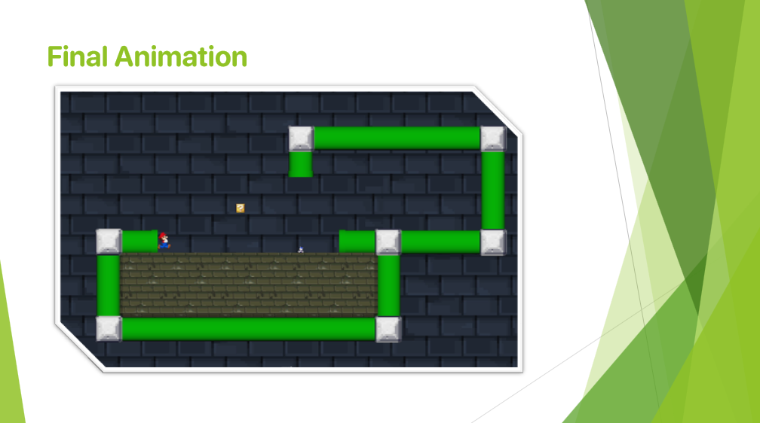
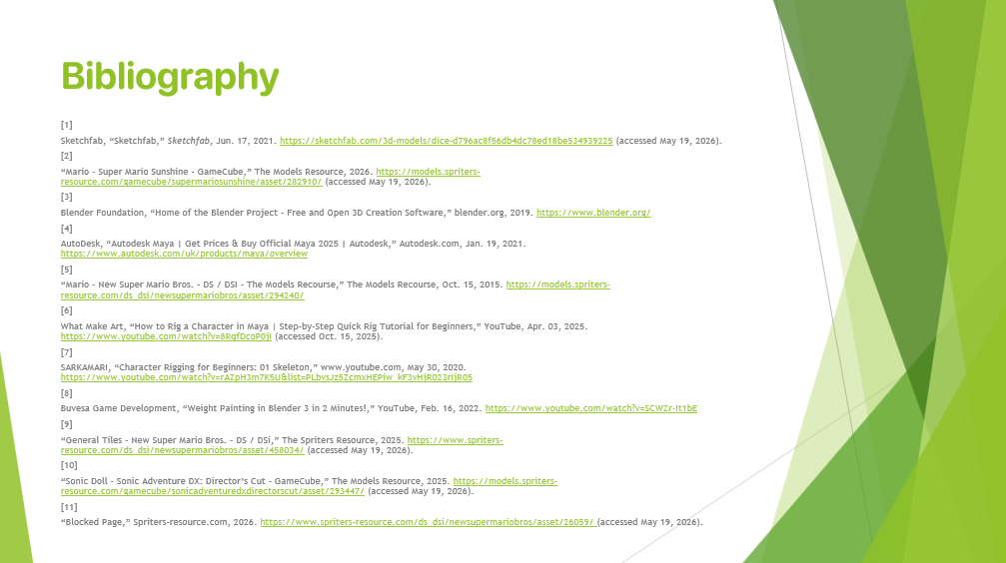

Link to Video

Video can be viewed here: https://www.youtube.com/watch?v=m_M0m3Iu2q4

Video Uploaded onto YouTube:
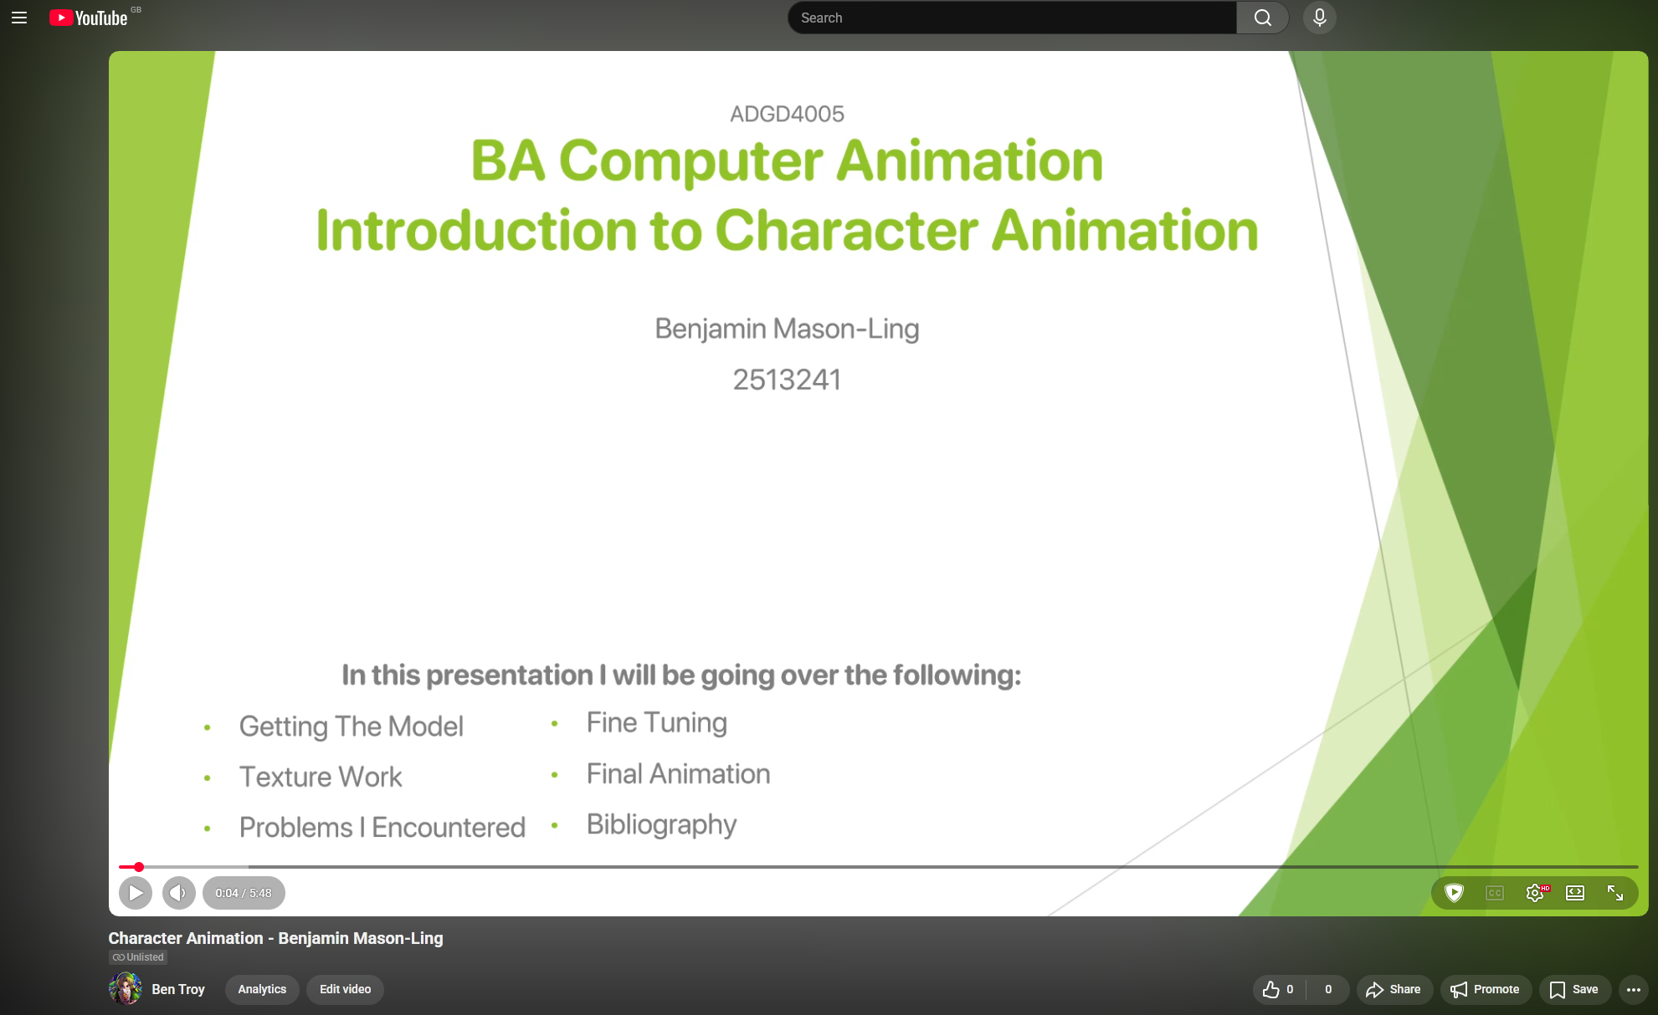

Bibliography
[1]
Sketchfab, “Sketchfab,” Sketchfab, Jun. 17, 2021. https://sketchfab.com/3d-models/dice-d796ac8f56db4dc78ed18be534939225 (accessed May 19, 2026).
[2]
“Mario - Super Mario Sunshine - GameCube,” The Models Resource, 2026. https://models.spriters-resource.com/gamecube/supermariosunshine/asset/282910/ (accessed May 19, 2026).
[3]
Blender Foundation, “Home of the Blender Project - Free and Open 3D Creation Software,” blender.org, 2019. https://www.blender.org/
[4]
AutoDesk, “Autodesk Maya | Get Prices & Buy Official Maya 2025 | Autodesk,” Autodesk.com, Jan. 19, 2021. https://www.autodesk.com/uk/products/maya/overview
[5]
“Mario - New Super Mario Bros. - DS / DSI - The Models Recourse,” The Models Recourse, Oct. 15, 2015. https://models.spriters-resource.com/ds_dsi/newsupermariobros/asset/294240/
[6]
What Make Art, “How to Rig a Character in Maya | Step-by-Step Quick Rig Tutorial for Beginners,” YouTube, Apr. 03, 2025. https://www.youtube.com/watch?v=8RqfDcoP0jI (accessed Oct. 15, 2025).
[7]
SARKAMARI, “Character Rigging for Beginners: 01 Skeleton,” www.youtube.com, May 30, 2020. https://www.youtube.com/watch?v=rAZpH3m7K5U&list=PLbvsJz5ZcmxHEPiw_kF3vHjR023rIjR05
[8]
Buvesa Game Development, “Weight Painting in Blender 3 in 2 Minutes!,” YouTube, Feb. 16, 2022. https://www.youtube.com/watch?v=SCWZr-It1bE
[9]
“General Tiles - New Super Mario Bros. - DS / DSi,” The Spriters Resource, 2025. https://www.spriters-resource.com/ds_dsi/newsupermariobros/asset/458034/ (accessed May 19, 2026).
[10]
“Sonic Doll - Sonic Adventure DX: Director’s Cut - GameCube,” The Models Resource, 2025. https://models.spriters-resource.com/gamecube/sonicadventuredxdirectorscut/asset/293447/ (accessed May 19, 2026).
[11]
“Blocked Page,” Spriters-resource.com, 2026. https://www.spriters-resource.com/ds_dsi/newsupermariobros/asset/26059/ (accessed May 19, 2026).

