Assignment – Research and case scenario in Data Security and Compliance

Student name: Geminiano (Gio) Aguilar
Student number: 2001127
Module: Data Security and Compliance
Module code: ACCA5034

Table of contents
Introduction
Task 1
- Importance of data security in organizations
- Solutions to minimize risk
- Security framework

PCI DSS
Who must follow the PCI DSS?
Risks associated if failure to comply
Importance of PCI DSS

- Cryptography
- Security technologies
- Conclusion

Task 2
- The purpose of a security unit
- Structure/chart
- Policies
- Compliance
- Risk management
- Security planning
- Protection mechanisms
- Conclusion

Summary
Reference list

Introduction
What is data security?
Data security is vital as technology continues to expand and the number of users are increasing daily. The growth in the technology field opens more risks for data. Data security refers to the practices, controls, and regulations that organizations use to protect and maintain their assets from data loss and cyber-attacks [1]. High levels of data security are implemented within organizations to help minimize the risk of sensitive data being exposed [2]. Security measures such as authentication, encryption and access controls help prevent data from being tampered and misused by third parties. Sensitive data such as customer related information, bank details, business plans and medical records must be kept confidential and inaccessible by invalid users.
Task 1 – Research in Data Security and Compliance
Importance of data security in organizations
High standards of data security must be implemented within an organization to prevent the loss of data. Organizations must also prepare in the event of a cyber-attack or data breach. Organizations store and handle sensitive data such as employee records, customer records, transactions, business plans, purchases and more. Cyber criminals can access this data if there are weak points in an organizations system. The loss of data can lead to a bad reputation for the organization [3]. Customers and clients will lose trust in the organization which will eventually lead to the end of the organization.
Not only that the reputation of the organization is affected, the customers and clients are at high risk. Sensitive data related to the customers and clients are now exposed to third parties. Third parties can use this data for cybercriminal activity such as scams, make purchases with stolen credit cards, identity theft and more.
Additionally, there is a possibility of a data breach to take place. Organizations must create a plan and be prepared. Organizations must be able to act in a quick manner and have resources available to respond to a data breach [4].
Shown below is a line graph of the amount of data breaches that took place from 2005 to 2020.

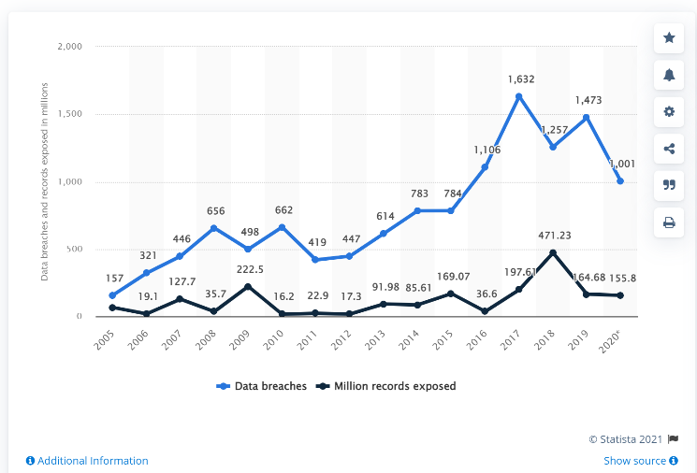
[19] J. Johnson, “Cyber crime: number of breaches and records exposed 2005-2020"
As shown from the graph, the number of data breaches have increased drastically over 15 years. Additionally, this indicates that the risk of data being exposed into the public is also increasing. This line graph indicates that the risk of data exposure will steadily increase in the upcoming years. Organizations must prepare and have a plan in case of the occurrence of a data breach.

Solutions to minimize risks
There are several methods used to safeguard an organization’s data from hackers, intruders, and cyber-criminal activity. These methods ensure that data can only be accessed by intended users. Users with the correct credentials and validity can only access information that is specified for them. Furthermore, security measures enable for data to be available whenever needed. This ensures that authorized parties can retrieve and use this data at any time. Lastly, security measures certifies that data has not been altered. This means that the data is in its original state and has not been tampered by other users.
Below are several, more in-depth solutions to minimize the risk of an organizations data being stolen and misused for different purposes by cyber criminals, hackers, or intruders:

Security framework
An organization can implement the use of security frameworks to provide protection of their data. Security frameworks are a structured guideline that consists of regulations that an organization should strictly comply with to safeguard their data [5]. Security frameworks are not mandatory to comply with; however, it is recommended to follow the structure for stronger security within an organization [6].
Organizations can benefit from the use of security frameworks as it provides organizations with a set of procedures and functions to protect themselves against malicious activity. These procedures assist with enhanced defenses against attacks, respond swiftly when data has been compromised, and recover in a quick manner after an event such as a data breach takes place [7]. In addition, frameworks help organizations to keep track of their measurements and protocols and update them when necessary. Updating and tracking will decrease the risk of anomalies in the system to occur.
Furthermore, frameworks can offer a clearer insight on the risks with external partners that an organization associate with. For example, companies associated with the organization such as, software manufacturers, business associates, healthcare providers could be at risk if there is a data leakage [8].
Security frameworks are providing organizations with measures to ensure that all members of an organization can react appropriately when the system has been compromised. Listed below are examples of security frameworks that organization should follow:

PCI DSS (Payment Card Industry Data Security Standard)
PCI DSS is a data security framework created in 2004. It is intended for organizations and businesses that handle consumer card data. The framework consists of regulations and standards that organizations and businesses should follow to protect card holder data [9]. The PCI DSS’s goal is to ensure that consumer card data transactions are protected against invalid users.

Who must follow the PCI DSS?
It is a legal requirement for all organizations, businesses that handle, process, store and transmit card related data to comply with the PCI DSS. This security framework ensures that businesses and organizations are protected against data theft and fraud. Businesses and organizations that fail to comply with PCI DSS regulations can face fines [11].
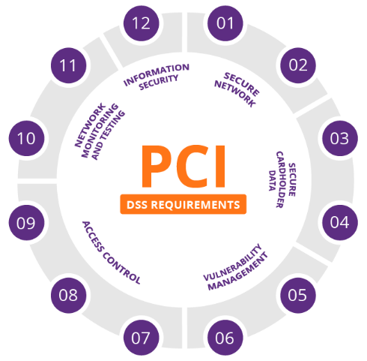

[20] Imperva, “PCI DSS requirements”
The image above represents the 12 requirements of the PCI DSS. There are a total of 6 main requirements and sub requirements within them.

The 12 PCI DSS requirements
The PCI DSS consists of 6 key requirements that businesses and organization must comply with to protect customer card data. Within these requirements there are 12 regulations that relate to these requirements as explained briefly below:
- Secure network
A safe and secure network environment must be built in organizations to prevent malicious activity. The use of security technologies such as firewalls, can help keep networks in organizations secure. Additionally, strong and unique passwords must be used to lower the risk of hackers or intruders gaining access to sensitive information. Default passwords must be avoided as hackers and cyber criminals can easily guess default passwords and gain entry to sensitive data.

- Protection of cardholder data
Encryption algorithms must be used on data (in all states – storage, transit and processing) to protect data from being tampered with and exposed. Encryption will prevent data from being intercepted by unauthorized users.

- Maintain a vulnerability management program
Systems in organizations must have anti-virus software to maintain integrity. Anti-virus software detects and removes any malicious activity occurring in systems or computers. This ensures that the integrity and availability of sensitive data is protected.

- Access control
Access control measures refers to individuals or groups that have privileged access to information. All information related to the cardholder must be kept private and on a “business need-to-know basis”. This means that data must be kept confidential and must not be shared. This certifies that cardholder data is kept private and reduces the risk of getting exposed to unwanted users.

- Testing and monitoring
Software and systems must be regularly tested and scheduled to identify any anomalies or to implement updates to enhance security. Activity related to cardholder data must be monitored closely to track users who has accessed the information.
- Information security policy
All employees must be informed of the possible risks that can occur within the systems. Informing employees about the associated risks can help with quick recovery if sensitive data has been accessed, altered or removed from systems. Additionally, security policies must be reviewed on a regular basis to maintain network security.
[10]

Risks associated if failure to comply
Businesses and organizations who handle and process cardholder data that fails to comply with the PCI DSS regulations will face consequences. These include:
Penalties and fines
Businesses and organizations will face fines if they are not compliant with the PCI DSS framework. All organization who are not compliant will be fined no matter how large the organization is [13]. The amount fined to the organizations are dependent on which and the number of regulations that the organizations have failed to follow [14].
Legal costs/lawsuits
Lawsuits can be filed against businesses and organizations by customers that have failed to protect their data. The cost of these lawsuits can be expensive which will lead to more costs for the company [15].
Loss of reputation
The reputation of an organization or business can be impacted negatively if customers data has been exposed to the public. Exposed data can be accessible by anyone which further on leads to data theft and fraud. Customers will lose trust in the company therefore they lose clients and customers. This will make it difficult for organizations and businesses to bring traffic to their brand.
Future risks
Businesses and organizations may not be liable to use card payments as a payment method if they fail to comply with the PCI DSS. This will have a large negative impact on the organization as most preferred payments are done by credit cards.

Fraud losses chart
Bar chart to show the amount of fraud losses from 2011-2018 sourced from researchgate.net.
[21] Credit card fraud and ID theft statistics in US 2011-2018

As shown from the bar chart [21], the number of ‘credit card fraud losses’ have steadily increased over the years. The positive trend of the graph highlights that the number of losses over the upcoming years will increase.
Organizations must implement the use of the PCI DSS framework in their environment to protect themselves as well as their customers from credit card fraud.

Small businesses
Although breaches within small businesses do not appear on the mainstream media, they still do occur. Cyber criminals aim towards attacking smaller businesses due to them not having enough resources to keep up with the PCI standards. This highlights that card data within small businesses are more at risk than card data stored in larger businesses [27].
Importance of PCI DSS
PCI DSS is one of the important regulations/frameworks that companies who accept and handle card holder data must follow. The Payment Card Industry Security Standards Council set the standards of the PCI DSS and ensures that all organizations comply with them. The PCI DSS purpose is to maintain secure card data and prevent card data theft, breaches and fraud. Regulations within the PCI DSS keeps card data protected by implementing security techniques such as access control mechanisms, data encryption, updating systems/software regularly and creating secure networks. These techniques will make data inaccessible to hackers, employees respond quickly to data breaches, and maintain a safe environment for data to be stored.

Cryptography
The main function of cryptography is to provide security to data being transmitted on a network, data in storage and data being processed. Cryptography prevents adversaries from accessing, modifying, and deleting data [18]. As described by A. Guru, “cryptography is an art of hiding data or information from unauthorized users” [26].
Cryptography achieves this by performing an encryption algorithm that converts plain text into an unreadable format. This unreadable format is known as ciphertext [27].
Process of cryptography
The process of cryptography involves the use of encryption/decryption keys, mathematical functions. The most basic method of cryptography is when both the sender and recipient use public and private keys to encrypt and decrypt data. Firstly, the sender of the message encrypts plain text with the user of a public key. The data is now transformed into an unreadable format preventing hackers or intruders from viewing the information in plain text. Afterwards, the encrypted data is sent over to the recipient over a network. The recipient can access the data by using the same key. Without the same key, the recipient cannot view the data.

Types of cryptography

- Symmetric Key Cryptography
[21] Figure 1. Symmetric encryption
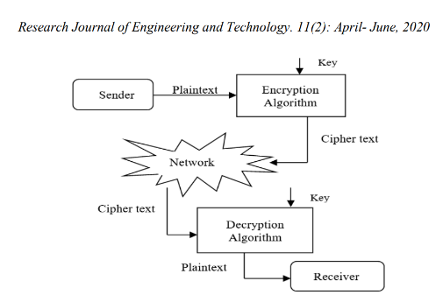
As shown of the diagram [21], symmetric key cryptography, also known as secret key cryptography, involves the use of one key to encrypt and decrypt data. Plain text will be encrypted with a key and the message will be decrypted with the same key. The data or message cannot be accessible by anyone who does not have the corresponding key.

Uses of symmetric key
Card payments, generating random numbers/hashing and validating users involve the user of a symmetric key [23]. Symmetric encryption is efficient at dealing with large amounts of data. The symmetric key has a good level of security as the encrypted data cannot by decrypted with a different key.
However, if a third party has access or obtain the same symmetric key, the data can be compromised. The unintended user can modify and install hidden viruses to the data. The intended user is now at risk from data exposure as the data could contain malicious software that could spy on the intended user and reveal sensitive information. The confidentiality, integrity and availability of the data will be affected and at risk.

- Asymmetric Key Cryptography
Similarly, to symmetric key encryption, the asymmetric key encryption involves the use of keys. As symmetric uses only one key to encrypt and decrypt data, asymmetric encryption uses two keys.
Firstly, the message is encrypted with the use of the receiver’s public key. Then, the message is sent to the intended user. After, the intended user decrypts the message with their private key. To verify that the message was sent by the original sender:
The sender sends a message which is encrypted with the receiver’s public key and the sender’s private key. The receiver will decrypt the message with their own private key and the sender’s public key to verify the original sender of the message.
Unlike symmetric key cryptography, asymmetric cryptography involves the use of a private key. Intruders or third parties cannot access the private keys of users but are able to access the public key of users. This ensures that symmetric key cryptography is not as secure as asymmetric key cryptography.
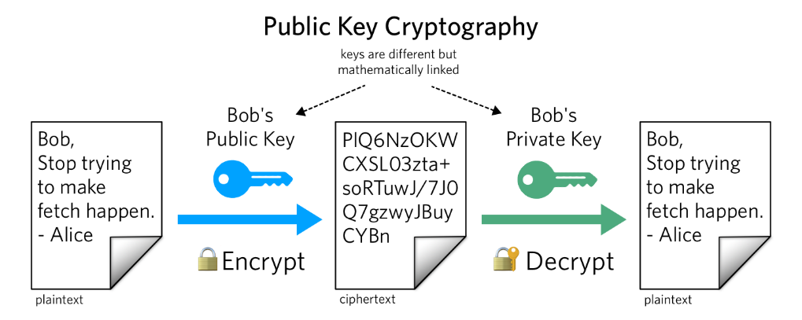
[25] What is Public Key Cryptography?
The diagram from www.twilio.com demonstrates the function of public key cryptography.

Importance of cryptography in networks
It is crucial for organizations and businesses to implement cryptography techniques within their systems to enhance data security to avoid data being stolen by adversaries. Encryption offers confidentiality and integrity of information. Encryption provides this by transforming plaintext into cipher text (unreadable text). In addition, authentication and non-repudiation methods are used to ensure the message is being sent to individuals with the correct credentials and only authorized users can access information.

Conclusion
It is critical for organizations to implement high standards of data security methods within their environment to protect their data. All organizations most important asset is their data. Without it, the organization are unable to keep track of sales, stock, customer information, business plans etc. Data must be kept confidential and inaccessible from malicious users to prevent data loss and theft.
Organizations must implement security measures within their environment to safeguard their sensitive data from breaches and exposure. Security measures such as following frameworks/regulations and the use of data security techniques such as encryption can aid with high levels of the confidentiality, integrity, and availability of data.
All organizations should realize the importance of protecting data and the risks associated if the data has been compromised.

Task 2 – Case scenario

What is an information security unit?
An information security unit comprises of practises and regulations that organisations should implement and adhere to protect valuable data [28]. Data is the most valuable asset that organisations and businesses possess, therefore data that is stored, processed, and transmitted must be protected and secure at all times. There are several regulations and frameworks that can be applied in organizations to ensure that data is being safeguarded.
Additionally, information security units are responsible for the security aspect in an organisation. Listed below are several responsibilities and duties that information security deal and manage: [29]
- Reporting and manage security incidents, threats, and attacks.
- Track user access on electronic hardware and devices.
- Enforce and update new standards and regulations related to the security of data.
- Inform individuals and members of the organisations the practises and responsibilities when handling data.
Data security measures, tracking, handling, and incident reporting are maintained by the data security unit. They are responsible for informing new regulations, and keep employees and employers updated about changes within the system. Essentially, the data security unit are the backbone of maintaining of keeping data security at a high standard.

What makes a high standard security unit?
The protection and maintenance of data within organisations is crucial. Without the protection of data, sensitive information will be exposed and available to malicious third parties.
In order for an organisation to maintain a high standard security unit, they must have a strong structure that mainly involves the use of: [30]

- Regulations, frameworks, and policies – to make individuals in the organisation aware of the procedures that must be followed to ensure data is secure.

- Risk management – informs individuals in the organisation of the potential risks related to data and how to respond to the risks in a efficient manner.

- Security planning – Involves the processes and security methods to protect data from unauthorized users.

- Reporting/assessing – Refers to reporting and find out the causes of data security incidents such as data loss and breaches.

Tracking the organisations plans and keeping up to date with them is crucial. Tasks and objectives will be clearer to follow, and spotting data breaches and anomalies will become less complex.
Implementation
In relation to the scenario, I will be implementing a security unit which involves several solutions, practises, and methods that will aid in protecting and safeguarding FlowTech’s data and sensitive information. As mentioned above, data is the most valuable asset, therefore it must be well protected and maintained correctly.
A well-maintained security unit will involve several processes to ensure secure data. These several process will be monitored, managed, and updated regularly to avoid old and redundant information that could possibly affect the FlowTech’s performance. Below are the solutions involved to help create FlowTech’s security unit.

Risk management
ISRM (information security risk management) refers to the procedures that identifies, assesses, and manages risks associated with data. The main objective of risk management is to ensure that the confidentiality, integrity, and availability of data is kept at a high standard. FlowTech can implement the use of risk management to identify and maintain the risk level where their company lies.
As FlowTech is a “fast-growing threat intelligence and consultancy company”, their risk level could reach high levels as their company is expanding at a high rate.
I will be implementing risk management procedures as one of the solution’s for FlowTech’s security unit as risk management methods can “direct and control an enterprise with regard to risk” [31]. The ISO 31000 standard comprises of seven phases that aid in handling risks in an organisation. Listed below are the seven phases:
- Establishing the context
- Risk identification
- Risk analysis
- Risk evaluation
- Risk treatment
- Communication and consultation
- Monitoring and review
These phases of the standard must be acknowledged and implemented well in an organisation to help manage risks [32]. Figure 1 below shows the different phases in a context diagram:
Figure 1: Risk management process [33]


Establishing the context
Security staff discuss and approach the level of risk that is posed against the organisation and solutions to mitigate risks. Communication is a vital skill that individuals in the team must possess as new ideas are being presented. Knowing and sharing the main approach and solutions to minimise the risks will aid in recovering from disasters and help prevent them.
Risk identification
Identifying the risks are a crucial step involved in the process. Identification can help spot patterns and trends which will prevent the organisation from making the same mistake or mitigate from threats in a more efficient manner.
Risk analysis
Analysing the risks is another important step to discover faults and anomalies within the organisation and help solve these issues quickly. Risk analysis can briefly inform team members of risks involved and how to react to them prominently.
Risk evaluation
Evaluating the risks refers to what exactly are the risks posed against the organisation? How can we mitigate these risks? And how can we prevent these risks from occurring in the future? These are the types of questions that are discussed when evaluating risks. Evaluation is an overview of the scope of the organisation and the risks that are posed against them.
Risk treatment
This phase involves brainstorming solutions and steps to mitigate the risk. Risks are being treated with solutions and are being dealt with when they occur.
Communication and consultation
This phase is where team members discuss the whole process and the steps they have taken when they have dealt with risks.
Monitoring and review
The whole process is being reviewed. Activity within the organisation is monitored to prevent the same risks from posing in the future.

Overview
As mentioned, FlowTech is a fast pace growing company. This highly indicates that they are vulnerable to more risks and exposed to threats and cyber-attacks. A solution such as risk management can help safeguard FlowTech in their processes, activities and data if implemented well and correctly. Risk management can give FlowTech an insight on the potential risks and ways in which they can be mitigated efficiently. As they are working with clients through online, cyber attack strategies such as DDoS, viruses, SQL injection etc. are likely to occur. Risk management is a crucial standard as without it, the organisation will be left at high risk and will be an easy target for cyber criminals.

Policies
As security threats are increasing over the years, it is important for organisations like FlowTech that deal with clients online to have strong security implemented. Policies ensure that organisations follow a set of procedures and rules to help prevent threats and out of reach from cyber-attacks and criminals [34].
Furthermore, policies provide organisations with a vision on their data, systems, and their vulnerabilities to give them an overview on the steps they need to take to enhance their organisation. ISP (Information System Policy) is a standard that organisations use to follow security protocols. These protocols will help members of the organisation aware and updated of new and already made regulations. There are eight key elements of the ISP standard that helps organisations protect themselves from external threats:
1. Purpose
This element explores the purpose of the policy. Users need to know exactly why they are creating this policy and what will it be used for. This element is the foundation to the start of mitigating threats [35].
2. Audience
The users planning must know which members of the team that the policies apply to. The policies must be targeted at a specific audience.
3. Information security objectives
Employees in the sector must be informed of the team’s objectives. The CIA triad model can be implemented to help employees understand the different states of data security. Confidentiality focuses on the intended user receives the information. Integrity refers to the data is in its original state and has not been modified. Lastly, availability is the accessibility of data [36].
4. Authority and access control policy
Authorization prevents malicious and external parties from accessing and receiving information related to the organisation. Only specified users can access certain and specific types of information.
5. Data classification
Data is categorised into different sections that rank their importance.
6. Data support and operations
Data must be protected at all times in all their different states (in transit, process or storage).
7. Security awareness and behaviour
Members of the organisation should be alerted of the risks and threats that occur in the organisation’s system and must be prepared to respond to them.
8. Responsibilities, rights, and duties of personnel
Staff must be informed of their responsibilities. Staff also must be trained and have knowledge of the system as a whole, the regulations and policies.

Overview
Policies will be implemented in FlowTech’s security unit as policies provide organisations with the fundamentals of security awareness and mitigation techniques. Policies enforce strict rules and regulations which ensures that members of the organisation will have knowledge on the risks and threats that are posed against the organisation. As FlowTech is expanding, the number of clients they have will also increase meaning that more policies and regulations must be reviewed and implemented.

Conclusion
The two solutions that I will implement in FlowTech’s security unit are risk management and policies. Both of these security standards will aid in keeping FlowTech’s security management and maintain the protection of their data. Keeping data secure in a fast-growing environment is vital as larger organisations that communicate with an increasing number of clients are exposed and more vulnerable to threats. These solutions will ensure that sensitive data that FlowTech poses is kept only accessible, visible and attainable by members from their organisation and out of reach from other parties who are not liable.

Reference list
Task 1 references
[1] IBM, “Why is data security important?”, ibm.com, Oct. 27, 2019 [Online] Available: https://www.ibm.com/topics/data-security [Accessed Oct. 11, 2021]
[2] imperva, “What is data security?”, imperva.com, Mar.09, 2020 [Online] Available: https://www.imperva.com/learn/data-security/data-security/ [Accessed Oct. 11, 2021]
[3] IndustryToday, “The importance of data security for your company”, IndustryToday.com, Oct. 07, 2020, [Online] Available: https://industrytoday.com/the-importance-of-data-security-for-your-company/ [Accessed Oct. 17, 2021]
[4] J. Steven, “How business should prepare for a data breach”, finextra, Jun. 01, 2020, [Online] Available: https://www.finextra.com/blogposting/20398/how-businesses-should-prepare-for-a-data-breach [Accessed Oct. 17, 2021]
[5], [6], [7], [8] L. Kim, “Cybersecurity frameworks explained”, HIMSS, Aug. 30, 2019, [Online] Available: https://www.himss.org/resources/cybersecurity-frameworks-explained, [Accessed Oct. 17, 2021]
[9], [10] E. Zhang, “What is the PCI DSS Compliance Framework and How Can You Meet Requirements?”, zeguro, Dec. 17, 2019, [Online] Available: https://zeguro.com/blog/what-is-the-pci-dss-compliance-framework-and-how-can-you-meet-requirements [Accessed Nov. 01, 2021]
[11] J. Fruhlinger, “PCI DSS fines”, CSO, Jul. 17, 2020, [Online] Available: https://www.csoonline.com/article/3566072/pci-dss-explained-requirements-fines-and-steps-to-compliance.html [Accessed Nov. 01, 2021]
[12], [13], [15] opayo, “PCI DSS: Failure to comply”, opayo, Sep. 22, 2020, [Online] Available: https://www.opayo.co.uk/blog/pci-dss-failure-to-comply [Accessed Nov. 08, 2021]
[14] A. Gouveia, “Understanding the Consequences of Failing PCI Compliance”, reciprocity, Mar. 10, 2020, [Online] Available: https://reciprocity.com/understanding-the-consequences-of-failing-pci-compliance/ [Accessed Nov. 08, 2021]
[17] R.E. Blahut, Cryptography and secure information: 5 - Information-theoretic methods in cryptography, Cambridge: Cambridge University Press, 2014, 5.
[18] Rishabhreddy, “WHAT IS CRYPTOGRAPHY?”, medium.com, Nov. 08, 2019, [Online] Available: https://medium.com/@rishabhreddy18/importance-of-cryptography-and-its-applications-83ed8ae38e3d [Accessed Nov. 10, 2021]
[19] J. Johnson, “Cyber crime: number of breaches and records exposed 2005-2020" https://www.statista.com/statistics/273550/data-breaches-recorded-in-the-united-states-by-number-of-breaches-and-records-exposed/ .
[20] Imperva, “PCI DSS requirements”, https://www.imperva.com/learn/data-security/pci-dss-certification/
[21] A. Guru “A Study of Cryptography to Protect Data from Cyber-crimes”, A. Cryptography, vol.11, Iss. 2, pp. 45.
[22] https://www.researchgate.net/figure/Credit-card-fraud-and-ID-theft-statistics-in-US-2011-2018-Source-Steele-2017_fig3_335243928
[23] P. Smirnoff, “Symmetric Key Encryption - why, where and how it’s used in banking”, cryptomathic.com, Jan. 18, 2019 [Online] https://www.cryptomathic.com/news-events/blog/symmetric-key-encryption-why-where-and-how-its-used-in-banking [Accessed Nov. 22, 2021]
[24] K. Robinson, “What is public key cryptography?”, twilio.com, Sep. 21, 2018 [Online] https://www.twilio.com/blog/what-is-public-key-cryptography [Accessed Nov. 22, 2021]
[25] A. Guru “A Study of Cryptography to Protect Data from Cyber-crimes”, abstract, vol.11, Iss. 2, pp. 45.
[26] A. Guru “A Study of Cryptography to Protect Data from Cyber-crimes”, introduction, vol.11, Iss. 2, pp. 45
[27] D. Clapper, “Small business compliance with PCI DSS”, History of PCI enforcement, Vol. 19, Iss. 1, (2016), pp. 03.

Task 2 references
[28] J. Fruhlinger, “What is information security? Definition, principles, and jobs”, CSO, Jan. 17, 2020, [Online] https://www.csoonline.com/article/3513899/what-is-information-security-definition-principles-and-jobs.html [Accessed Dec. 03, 2021].
[29] Missouri State, Information Security Unit Organization: Policy statement, Missouri State University, 2014.
[30] imperva, “What is data security?”, imperva.com, Mar.09, 2020 [Online] Available: https://www.imperva.com/learn/data-security/data-security/ [Accessed Dec. 03, 2021]

[31], [32], [33] M. Gupta, “Information Technology Risk Management and Compliance in Modern Organizations”, introduction, chapter 1: pp. 01.
[34] https://www.exabeam.com/information-security/information-security-policy/

